Nickolas Vela
CSCI 226
Assignment 4
ER Diagram

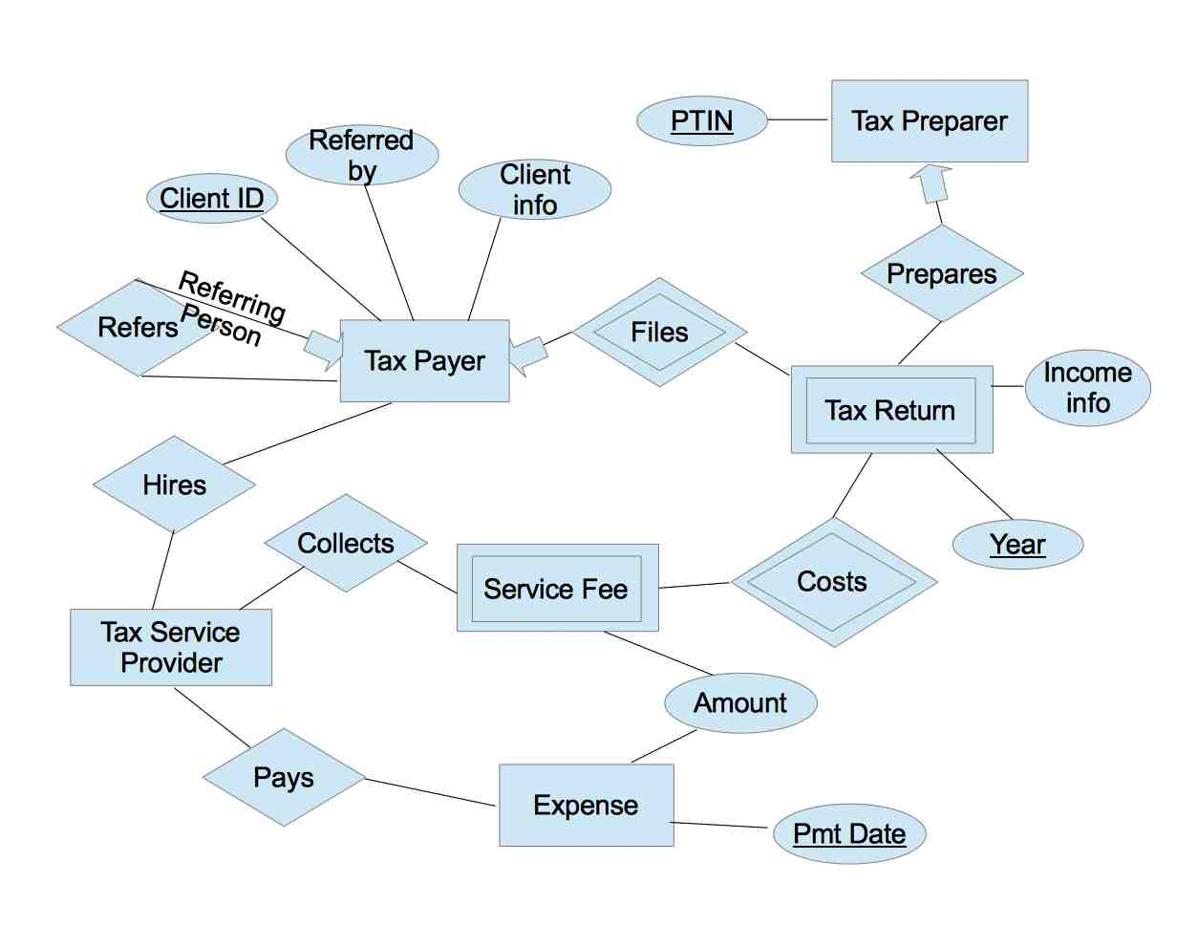
This ER Diagram represents the domain for my project, which is a tax service business. This domain revolves around the details of the relationships between tax service providers, tax payers and tax returns. From this domain, interesting data primarily relates to tax payers, tax returns, tax preparers, and expenses. The database will serve tools that are useful for customer service, accounting and business decision making operations.
The target users of these tools are represented as tax service providers, which has three relationships in the diagram. The first relationship is that a tax payer hires a tax service provider. The service fee for the hires relationship is not treated as an attribute of the relationship. Instead, the service fee is treated as an entity where the service provider collects the service fee. The determination of the service fee will be discussed later. While doing business, the service provider incurs expenses. The service provider pays expenses.
Since the target users are presumed to want customer service tools beyond the tax preparation tools, the tax payer is a very important entity in this database. As the diagram reflects, the tax service provider may be interested to know when a tax payer refers a new tax payer to the service provider. This is a many-one relationship because a tax payer may refer many tax payers, and a tax payer may only be referred by one tax payer. The “referred by” attribute is dependent on this relationship as a foreign key constraint. Other attributes, such as name and spouse, that are helpful for client record keeping are represented by “client info”.
The target users are presumed to want to keep records of the service provided beyond the actual tax preparation tools. The service is to help when a tax payer files their tax return, and the tax return entity represents the service that is provided. This entity is weak because a given tax return depends on the tax payer entity in order to be identified as unique for tax filing purposes. That is why the key for a tax return is the key for a tax payer and the tax year for the return. Furthermore, this is a many-one relationship because a tax payer may file many returns, and a return may only be filed by one tax payer entity.
Since the target users are presumed to use return filing tools through another technology, only relevant data of the tax return is represented as an attribute set named “income info”. Additionally, users may want to know which tax preparer prepares a given tax return. The tax preparer has a unique IRS issued ID, which is used as the key for tax preparer entity. This relationship between preparer and return is many-one, because a preparer may prepare many returns, and a return may only be prepared by one preparer.
The business model depends on the ability of the service provider to collect a service fee for the tax return, as mentioned earlier. From the perspective of the tax return, the tax return costs the “amount” of the service fee. Once the cost of the service is determined, the service provider collects the service fee. The service fee is weak because it depends on the tax return entity.
Since providing this service incurs expenses for the target users, they are presumed interested in tools that help them keep records of expenses for accounting operations. These records may be represented by a relationship between the service provider entity and the expense entity. In particular, the service provider pays an “amount” for an expense at a certain “payment date”, which is used as the key for the expense entity.
The ER Diagram reflects a basic set of relationships between tax service provider, tax payer and tax return. With the details of these relationships, a service provider makes business decisions. To help service providers, a database will be developed to serve tools that the target users may employ to conduct business more conveniently.

