Nickolas Vela
CSCI 226
Fall 2013

Project Write-Up: Tax Preparation Manager Domain

The domain for my project is the accounting data of an income tax preparation business. The motivation to take up this domain is that I help manage a family business, and I want to build some tools to facilitate record keeping operations. My project runs on top of a MySQL database that is managed by a web development framework called Django. The project renders easy to use web tools for keeping accounting records of a tax preparation operation. The target users are tax preparation office managers who do not necessarily have technical skills beyond those necessary for managing an office and preparing tax returns.
To design a set of tools to interact with this domain, the data and the relationships of the different aspects of the domain were described using an entity-relationship data model. The ER diagram shown below represents the details of the relationships between tax preparation service providers, tax payers and tax returns. Since the project is meant to address customer service and business decision making operations, only the entities and relationships that relate to these operations are represented. In other words, data that relates only to tax law or the IRS are not included.
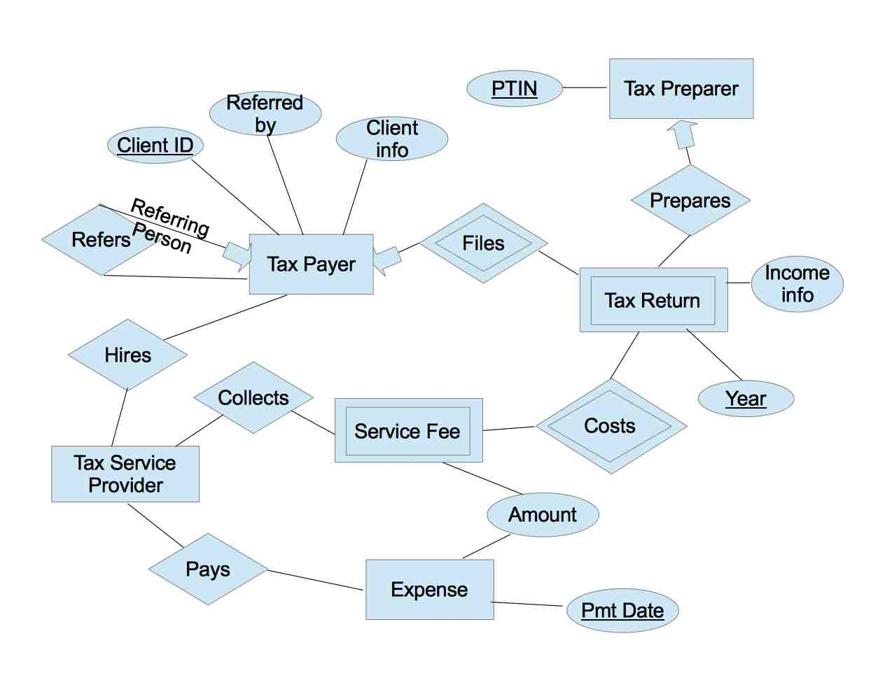
Because the target users are tax service providers, the diagram focuses heavily on this entity of the diagram. The diagram shows that a tax payer hires a tax service provider. The service provider collects a service fee that costs a certain amount according to the type of tax return. The tax payer files the tax return that is prepared by an individual tax preparer. The tax service provider pays business expenses. For marketing reasons, the service provider is also interested in knowing whether a new tax payer is referred by an existing client.
From the ER diagram, database tables with their attributes were derived and were eventually programmed into a MySQL database. This kind of database was chosen because it is free, flexible, and relatively easy to install. Although MySQL has many online resources to support database development, this factor did not play a major role in choosing MySQL because MySQL is managed “behind-the-scenes” by Django, which is the web framework that controls the features of the project.
An brief overview of the web tools for this project will provide a context for the examples used in explaining the details of the project development. The project implements a website because it is accessible from any computer with internet, and the browser interface is familiar to non-technical users. The website consists of a home page and three pages of data input and/or content display. The “clients” page allows the user to view and edit details of the clients. The “expenses” page allows the user to view and input expenses for the current year. Lastly, the “tax returns” page allows the user to view tax return details according to a selected tax year and input new returns. These web pages are the result of functional requirements of the target user.
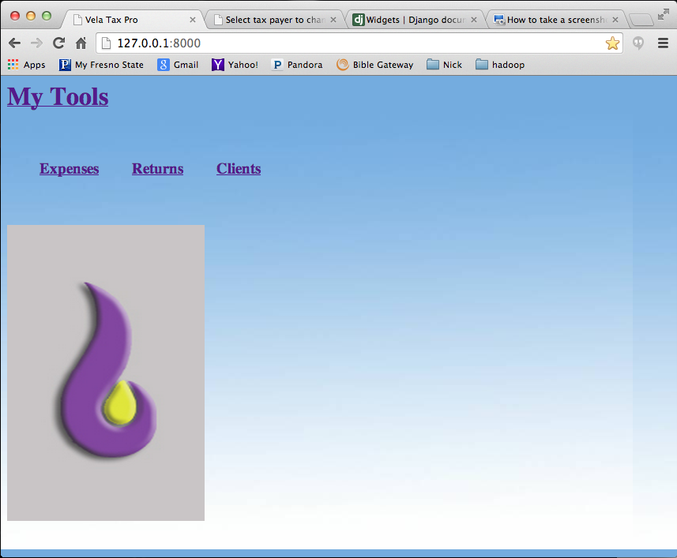
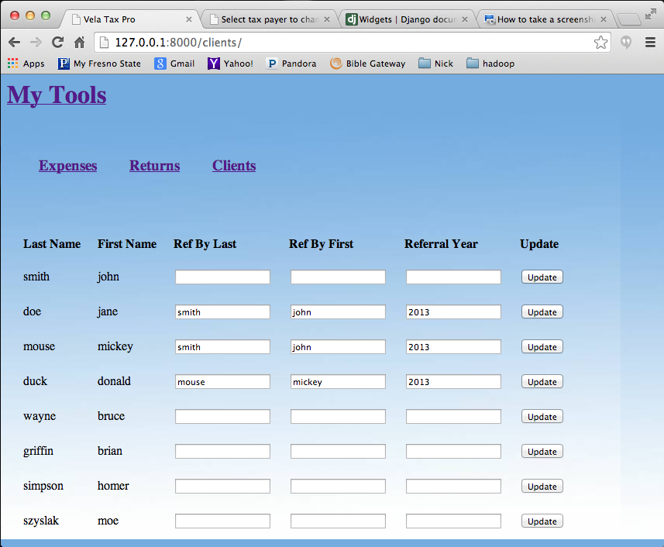
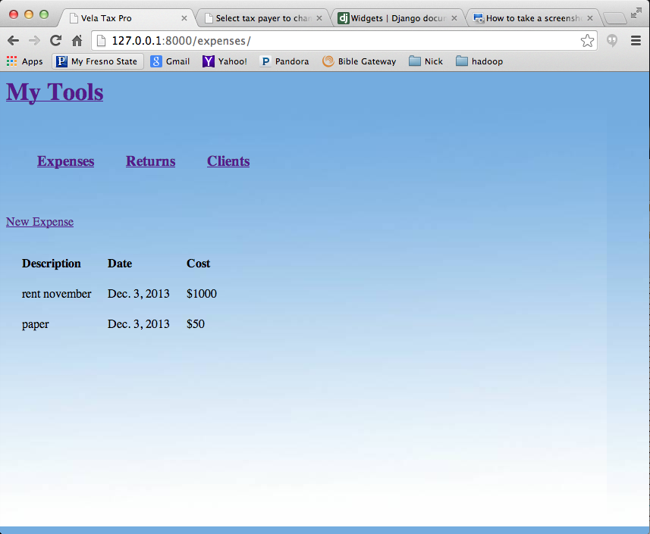
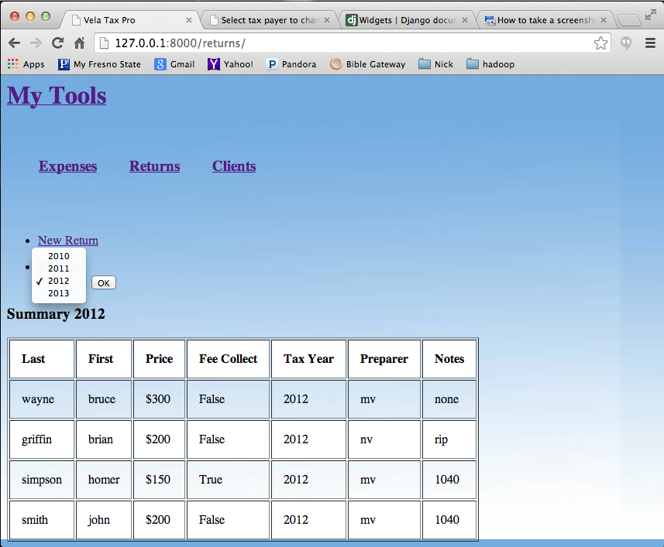
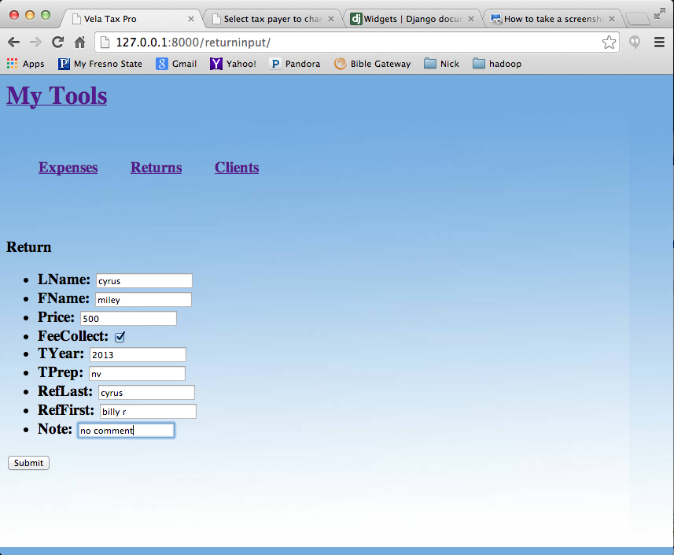
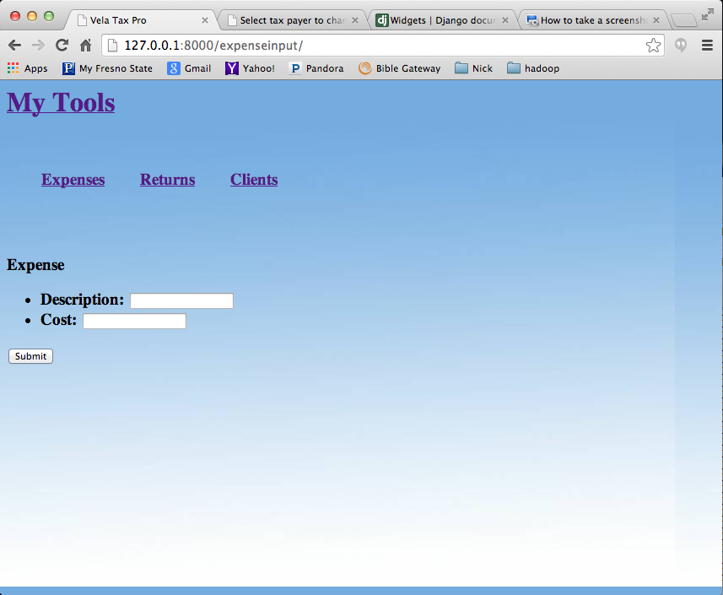
Django, an open source, python-based web development framework, underlies the back-end and front-end of the project. To access Django resources, python must be installed and the Django framework must be installed on top of it. Django runs on a server, thus the framework provides a development server that does not require internet hosting. In addition, Django is designed to use a database for data management, therefore a MySQL server is required to use the major features of Django with MySQL.
The database tables derived from the ER diagram were programmed in python code using a Django library defined in models.py. Since the back-end of Django development is written in python, the syntax to define the database is different from the chosen database language, and there are a few disadvantages to this arrangement. Models.py does not allow the developer to use the full flexibility of the database language, for example, by not allowing for the creation of a table with a multi-attribute key. This disadvantage was encountered in the case of attempting to designate a multi-valued key for tax returns, where a unique tax return is defined by the tax payer and the tax year of the return. Instead, the models library automatically creates a key that guarantees uniqueness of table instances.
An advantage to using Django models is that it provides one standard way to create tables regardless of which database language is used. This is advantageous for web developers who want to develop data-intensive apps, but do not wish to specialize in database administration. For example, by allowing foreign key constraints, complex table relationships can be enforced with little knowledge of a database language.
Django models are translated into the selected database language, as illustrated with the expense model of this project. Creating the expenses table would look like this in MySQL:
create table expense(
id int not null primary key auto_increment,
cost int not null,
eDate date not null,
description varchar(40) not null
);

When inserting into the table, all values must be provided in the insert statement. For this project, it is preferable auto populate the “eDate” field with the date of the insertion. To do this in MySQL requires a trigger or stored procedure, which demands a significant amount of familiarity with MySQL. Using Django models, this table is defined in the following way:
class expense(models.Model):
cost = models.IntegerField()
eDate = models.DateField(default=date.today)
description = models.CharField(max_length=40)

This model definition automatically generates the primary key. Also, the default “eDate” value of the current date can be defined in the creation statement with a function as a parameter. That is, a trigger or stored procedure is defined by the models library to automatically put today's date as the “eDate” attribute in the insertion operation. In terms of Django back-end development, this is an example of leveraging python convenience on top of MySQL flexibility.
Inserting into the database with data given by the user requires front-end functionality. Django allows the developer to integrate the front-end operation of data collection with the back-end operation of storing the data using the forms.py library. One of the prevailing ways to collect data from a web browser is to use html forms. With Django, a form can be defined according to a particular model with relative ease in python and minimal html programming. Using Django forms is an advantage, because it can simplify the form creation and handling process.
This project took advantage of this feature by defining a database model to directly correspond to the form that will collect the tax return data from the web page. Using the Django forms library provides automatic form validation, which can potentially be tedious form handling work for a web developer. Once the form data is validated, it can be inserted into the database with a simple python code line. That is, the heavy lifting of data input for this project lies in the Django model definitions. In this way, Django model definitions have some more advantages over MySQL table definitions, because it provides convenience in the data processing operations from table creation all the way to table data insertion.
These advantages are exploited in this project by using a specific table for tax return data input. When the tax return data is inputed, the form is then validated and the data inserted into the input data model. Then this project calls a function, called a view, that inserts the data into the appropriate models for data storage and accessing operations. By separating the data input models from the data storage models, this project leverages the data input convenience of Django on top of the MySQL functionality.
With the data models and data input forms defined, this project utilizes the Django tools to access the data. The disadvantage of using Django to access data is that Django's queries are not as flexible as MySQL queries. In particular, the Django queries reflect the “select-from-where” scheme, without the ability to “join”. In the case of accessing tax return data to display to the user, data from two models must be accessed, which are the “taxPayer” model and the “taxReturn” model. These models are separate to avoid redundancy in client data since a single client may file multiple returns with the service provider.
The problem arises when trying to join the two tables into one table. Basically, there is no simple way to join two tables since the standard Django query can only access one table at a time. What is very straight forward through a MySQL join constructor is relatively messy as a chain of Django queries with the help of a for-loop. A single query returns a list of model objects according to a given condition. Combining two lists of objects after the two separate queries are executed requires the developer to make sure that both lists are ordered to correspond to each other.
To display content to the user, this project uses Django views (i.e. functions) to send relevant data to Django templates. Django views are used to respond to the user by preparing data and returning the appropriate template to the browser, while a template is an html file that Django can write to. This feature is convenient because the html code is laid out in an html file, as opposed to being generated completely from a php or javascript file where it is difficult to make sense of the html code. In the Django template, delimiters are used to insert python code within the html markup. For this project, the delimiters are mainly used for programming loop constructors and passing arguments into the html markup.
To access the web pages, Django provides a way to set intuitive URL patterns and configure web page access separately from the python and html code. The advantage is that reorganizing files and functions that run a particular web page will not necessarily change the URL pattern for that web page. Thus, simple URLs are used, such as “/returns” and “/returninput” to help the user make sense of their place in the web page.
The experience of developing this project was educational, interesting and useful. The project was an opportunity to learn about the process of designing a data model that represents an interesting domain. It became clear to me through this process that data cannot be represented and handled without a clear vision of what the data is meant to communicate and how it may be useful to the target user. There is often a sense that data lives in an objective reality, however, I had to frame and reframe the domain to understand the appropriate solution to my data challenges. Then I was able to make choices on how to store, access and present the data to the target user that is non-technical yet powerful.

