May 16, 2023

Paul Noble, M.D.

Senior Editor

*eLife*

Dear Dr. Noble:

We are finally ready to resubmit our manuscript now entitled, “MYC overrides HIF-1α to regulate proliferating primary cell metabolism in hypoxia.” We have attempted to address all of the reviewer concerns as outlined in detail in our point-by-point response. We did not address a couple of points that, in our opinion, would have required a substantial investment of time and resources to address important questions raised by the present work. Additionally, we acknowledge that our efforts to streamline and focus the manuscript were hampered by the large amount of data presented (more so following the revision experiments) and a desire to place our work in the context of similar investigations previously performed in the study of cancer cell biology. We hope these largely stylistic decisions would not preclude future publication in *eLife.*

Thank you for your consideration of our revised manuscript. This is our laboratory’s first paper, and we would be delighted to see it published at *eLife*! We are excited by our findings detailing a new paradigm for HIF-MYC crosstalk in the metabolic response of human primary cells to hypoxia. We anticipate these results will raise important questions for future research, including what role other HIF-independent events play in the hypoxia response, how MYC activity is regulated by hypoxia, and whether these regulatory pathways contribute to hypoxia responses *in vivo*, all of which should be of interest to the broad readership of *eLife.*

Sincerely,

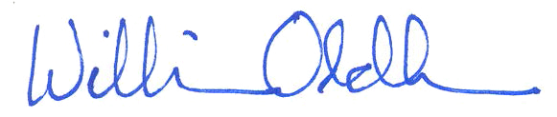

William M. Oldham, M.D., Ph.D.­­­