# Set up performance monitoring for Windows Server 2012

Text with grey background = Optional changes. So if you are uncertain, skip steps 2 and 3.

1. Download and/or extract all files in the zip archive to a folder, for example C:\temp
2. If you need to change counter sampling interval (default every 15th second) -> open *PerformanceMonitorTemplate_WindowsServer2012.xml* in a text editor and find *<SampleInterval>15</SampleInterval>* and adjust it accordingly. The value is in seconds.
3. If you need to change destination of the trace files the following paths needs/can to be changed:
   1. (optional change) copy-scripts.ps1, line 1 and 2.
   2. (mandatory change) PerformanceMonitorTemplate.xml, line 14, 16-17 (<LatestOutputLocation>, <OutputLocation>, <RootPath>)
   3. (mandatory change) Remove old logs - Scheduled Task.xml, line 44 (<Arguments>)
   4. (mandatory change) Zip Perfmon Logs - Scheduled Task.xml, line 44 (<Arguments>)
4. Start *PowerShell* as *Administrator*.
5. Navigate to the folder where the files are (Ex: Type “cd C:\temp” and press *Enter*).
6. Type “Set-ExecutionPolicy RemoteSigned -Force” and press *Enter*.
7. Type “.\copy-scripts.ps1” and press *Enter*.  
   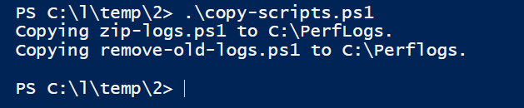
8. Type “.\Make-PerfmonTemplate.ps1 –Servername <MyServer> -Template PerformanceMonitorTemplate_WindowsServer2012.xml” and press *Enter*. Replace <MyServer> with the name of the server (the individual node name if cluster).  
   
9. Start *Performance Monitor (perfmon.exe)*.   
   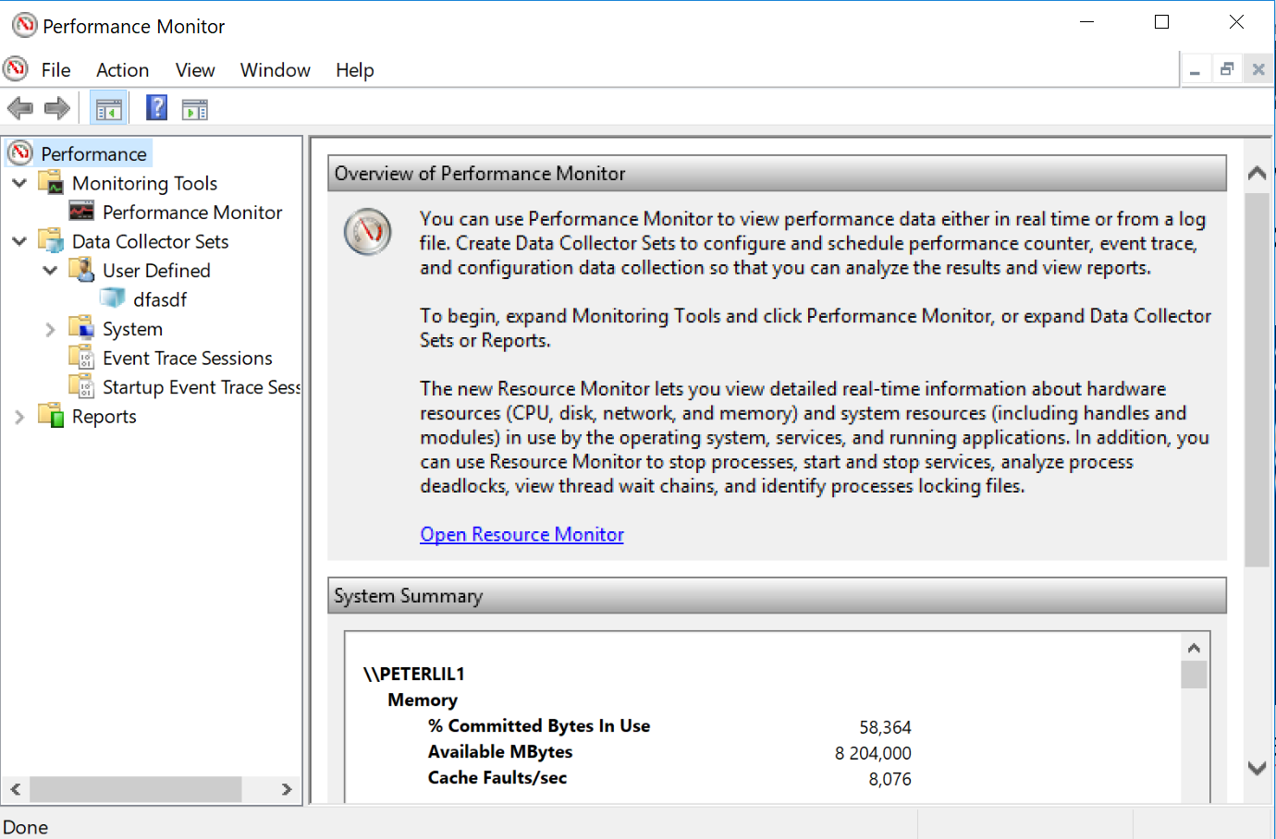
10. Right click *Performance->Data Collector Sets->User Defined* and select *New->Data Collector Set*.
11. Type “*VM Performance Trace*” as *Name* and select *Create from a template* and click *Next*.
12. Click *Browse…*.
13. Browse for *<MyServer>-PerfmonTemplate.xml* and click *Open*.
14. Click *Finish*.
15. Type “.\schedule-the-tasks.bat” in the *PowerShell* window and press *Enter*.  
    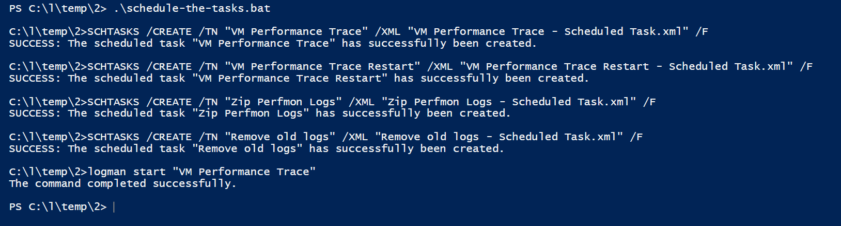
16. Done.

# Zip file content

|  |  |
| --- | --- |
| **Filename** | **Description** |
| copy-scripts.ps1 | Copies *remove-old-logs.zip* and *zip-ogs.ps1* to *C:\PerfLogs*. |
| remove-old-logs.ps1 | Scripts for removing old trace logs. |
| zip-logs.ps1 | Script for zipping trace log files. |
| Make-PerfmonTemplate.ps1 | Creates Performance Monitor template files for the target environment to be used when setting up the trace. |
| PerformanceMonitorTemplate_WindowsServer2012.xml | Perfmon template file used to create the target environment performance monitor template to use when setting up the trace. |
| Remove old logs - Scheduled Task.xml | Scheduled task template for executing *remove-old-logs.ps1*. By default it removes zip-files in the *c:\PerfLogs\Admin* *VM Performance Trace* folder which are older than 60 days.  This task executes once a day. |
| schedule-the-tasks.bat | Batch script for scheduling the tasks:   * Remove old logs * VM Performance Trace * VM Performance Trace Restart |
| VM Performance Trace - Scheduled Task.xml | Scheduled task template for starting the perfmon trace. This task executes once an hour and after boot. In practice it means that if the trace was stopped, this job will start it again within the hour. |
| VM Performance Trace Restart - Scheduled Task.xml | Scheduled task template for restarting the perfmon trace. In some cases it has shown that if the server loses connection with SAN drives, the trace needs to be restarted to start monitoring the drives again. This script restarts the trace at midnight every day. |
| Zip Perfmon Logs - Scheduled Task.xml | Scheduled task template for executing *zip- logs.ps1*. By default it compresses *.trc files in the *c:\PerfLogs\Admin* *VM Performance Trace* folder which are older than 7 days.  This task executes once a day. |