NTU 108 Fall Computer Vision

Homework 1

Due to 9/24

土木所 R08521806 李政軒

Part 1:

1. Upside-down lena.bmp

Because it asks to upside-down the image, in the first moment, I think I should swap the pixel value at relative pixel position. Therefore, the program swaps the pixel values from the first row to the half of the row in the same column, after that, I can get the upside-down image of the input image, ‘lena.bmp’ .

|  |
| --- |
|  |
| Fig 1 Upside-down |

1. Right-side-left lena.bmp

In this one, it actually has similar concept of (a). The program swaps the pixel values from the first column to the half of the column in the same row, after that, can get the Right-side-left image of the input image, ‘lena.bmp’ .

|  |
| --- |
|  |
| Fig 2 Right-side-left |

1. Diagonally mirrored lena.bmp

I set a condition that only if the position of the pixel is not the same, will be swapped.

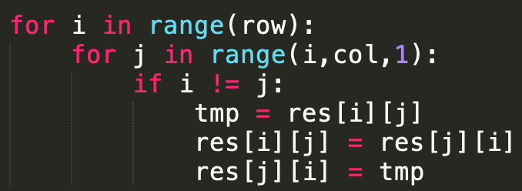

|  |
| --- |
|  |
| Fig3 Diagonally mirrored |

Part 2:

1. Rotate lena.bmp 45 degrees clockwise

I use the cv.getRotationMatrix2D() method to get the transform matrix, then use cv.wrapAffine() with the transform matrix to rotate the image into 45 degree clockwise.

|  |
| --- |
|  |
| Fig4 rotate 45 degree clockwise |

1. Shrink lena.bmp in half

I use the cv. resize() function to shrink the image.

|  |
| --- |
|  |
| Fig5 shrink in half |

1. Binarize lena.bmp at 128 to get a binary image

I set a condition that if the pixel is smaller than 128, it will be 0, on the contrary, it will be 255. And the for loop will traversal all the pixel to change the pixel value.

|  |
| --- |
|  |
| Fig6 binarylize |