GRIZZLYMEDICINE RESEARCH INSTITUTE | ARCHIVAL BIOGRAPHICAL RECORD

Robert “Grizzly” Hanson
Clinical Practice, Training Lineage, Systems Design, and AI Research
Record purpose | Internal GMRI archival biography and provenance record
Prepared / revised | October 3, 2026 / October 29, 2026
Status | Working biographical record; source attribution and evidentiary distinctions retained without credibility ranking
Primary subject | Robert “Grizzly” Hanson, EMT-P (Ret.) (informally shortened to “Grizz”)

This record preserves the development of a professional method across family lineage, martial instruction, emergency medicine, field training, systems design, disability, and later AI research. It identifies the source of each account and distinguishes firsthand evidence, corroborating records, and historical interpretation without treating lack of independent documentation as evidence against a firsthand account.

Record Basis and Evidentiary Conventions
Evidence class | Meaning in this record
Documented | Supported by surviving certificates, professional records, published biographies, organizational records, or other attached documentary material.
Named firsthand recollection | Direct testimony from Hanson or another named participant with firsthand knowledge. This is affirmative historical evidence. The label identifies its source, not a lower credibility grade; absence of additional corroboration is not a contradiction.
Interpretive significance | A later synthesis connecting events, training traditions, or professional methods. These passages explain continuity but are not presented as independent historical proof.
The biography below is therefore intentionally neither a résumé nor a testimonial. It is an archival narrative designed to preserve chronology, lineage, and the provenance of claims that may later require independent verification.

1. Formation: Education, Family, and Teaching Lineage
Hanson’s family record traces one formative line through his great-grandfather Harrison Clyde Munro (1890–1962), a minister, educator, curriculum writer, and organizer whose work emphasized adult-centered learning, research-assessment cycles, free exchange of ideas, and institution-building without unnecessary hierarchy. Munro’s documented career included leadership within the International Council of Religious Education, the “Learning for Life” curriculum, national teaching missions, and later council-building in Texas. [Documented]
The same lineage material records a sharp contrast in formal schooling: Hanson left school after the sixth grade and was largely self-taught before later entering community college and emergency medical training. The significance in the record is not that schooling was irrelevant, but that formal schooling and intellectual development were not the same thing in his life. [Documented]
A second formative line came through martial arts. From adolescence, Hanson trained under Scott “the Jedi” Nance, in the Burleson-Dorsey lineage. Nance’s teaching emphasized situational awareness, terrain, adaptation, and disciplined response rather than dominance for its own sake. The lineage record specifically notes Nance’s use of Chapter 11 of Sun Tzu’s The Art of War—the “Nine Situations”—as assigned reading. [Documented]
Hanson recalls that he began teaching under Nance. This is important because the teacher identity later observed by EMS educators did not begin in paramedic school; it was already part of his practice before his EMS career. [Named firsthand recollection]

2. Entry into MedStar: A Failed Interview and a Conditional Chance
Hanson’s original MedStar interview took place in January 2006. He recalls the panel as including Chris Cebollero, Macara Trusty, Angela Weimer, Marissa Stroop Hanson (no relation), and Lisa Bennett. By his own account, he was young, intimidated, and overly defended by ego. He believes the interview deservedly went badly. [Named firsthand recollection]
During paramedic school, Lisa Bennett later told him that four panel members initially voted against hiring him. Bennett argued them back on the proposition that he was trainable, that teaching was already visible in him, and that his behavior in the interview was fear and intimidation rather than an absence of potential. Hanson recalls that Bennett had also watched one of his live drills, which reinforced her assessment. [Named firsthand recollection]
Bennett’s later career record is consistent with the role Hanson describes: MedStar Mobile Healthcare, 1999–2010, including Field Training Officer/Paramedic service and Clinical Coordinator responsibilities from 2005–2010; then EMS Quality Improvement Coordinator for the Arlington Fire Department from 2010–2015. [Documented]
Hanson recalls that the compromise was a test: he was offered a supply position at $8.25 per hour, with the possibility of field operations later if he proved himself. He accepted immediately, telling MedStar that it was a foot in the door and they would never be able to get rid of him. Minutes later, on a follow-up call, Cebollero’s message was shorter: “Don’t fuck this up. You get one chance.” [Named firsthand recollection]
A user-supplied snapshot of Hanson’s own LinkedIn profile independently anchors the employment outcome: it lists MedStar Emergency Medical Services EMT-Basic service beginning in March 2006 and continuing through February 2009. [Documented — first-party professional record]

3. 2007 Recognition: Training Before Paramedic School
On December 14, 2007, while still listed as an EMT-Basic, Hanson received MedStar’s Clinical Managers Award. The surviving certificate cites professional development, willingness to train new and existing employees, exemplary patient care, compassion for patients, families and crew, and credit brought to the clinical department and organization. The certificate is signed by Chris Cebollero, Clinical Services Manager. [Documented]
The same day, Hanson received MedStar Employee of the Year 2007 as a Driver Training Officer. The surviving certificate cites his commitment to getting quality employees onto the streets, corrective and positive feedback to trainees, professionalism, exemplary effort as a DTO, high organizational participation, and describes him as an excellent training officer. [Documented]
Hanson later learned from Lisa Bennett, near the end of 2008, that the Employee of the Year vote had been the first unanimous vote in MedStar history. That historical distinction is preserved here as Bennett’s reported firsthand statement; the certificates themselves establish the awards, date, role, and signatories, but not the voting history. [Named firsthand recollection]

4. The 2008 Paramedic Boot Camp
Hanson entered a prototype hybrid paramedic program developed through MedStar and Tarrant County College on January 5, 2008. He recalls a starting cohort of 15 and a finishing cohort of 14 on September 28, 2008. The one non-completer left under life circumstances rather than an academic washout. [Named firsthand recollection]
All 14 graduates passed the National Registry paramedic examination on their first attempt. Hanson finished top of the class and served as cadet leader. [Named firsthand recollection]
The program motto was “These things we do, that others may follow.” Hanson has retained the phrase as a literal training doctrine rather than a later metaphor: work should leave a usable trail for the person who follows. [Named firsthand recollection]
This period formalized a distinction that appears throughout Hanson’s later training philosophy: technicians execute procedures; clinicians integrate patient, context, uncertainty, medicine, and consequence. In his formulation, a field training officer cannot install the medicine in someone who does not already possess the clinical instinct. The FTO’s work is to make sure that medicine functions safely and responsibly inside the operational box—and that the clinician knows what to do when reality no longer fits the box. [Interpretive significance]

5. Clinical Practice, Training, and Systems Work
The professional record places Hanson within MedStar during a period of major operational innovation, including Mobile Integrated Healthcare, Resuscitation Outcomes Consortium-era work, and a preventability-oriented organizational culture. [Documented]
Hanson recalls the spring and summer of 2009 as a period of sustained collaborative work around the table with John Ferris, Desiree, Greg Scheffler, Chris Cebollero, Matt Zavadsky, and others as the ideas that became Mobile Integrated Healthcare were taking shape. [Named firsthand recollection]
The durable lesson Hanson draws from that work is not merely a program name. It is a systems belief: when the existing model does not fit the patient, the system itself may need redesign. His later shorthand captures the same process: “Find a problem. Find what causes the problem. See if you can alter the equation.” [Interpretive significance]
Hanson rebuilt and led scenario-based clinical training emphasizing measurable performance under stress. His work on MedStar’s Disaster Preparedness Committee separately involved modeling cascading failures in emergency response and urban infrastructure. [Documented]
In 2007, newly invited onto MedStar’s Disaster Preparedness Committee, Hanson was asked to build his first disaster threat model to test his abilities, mindset, and logic. He placed a hypothetical event at the I-820/I-35W interchange, combining the precedent of Timothy McVeigh’s Oklahoma City bombing with his knowledge of Squaw Creek, about 45 miles southwest of that interchange. The model traced potential cascading effects across the city’s emergency-response systems and infrastructure. [Named firsthand recollection]
The geographical scale of Hanson’s field practice extended well beyond a single urban response district. He reports working across MedStar’s approximately 436-square-mile Fort Worth-area service territory and in Hunt, Johnson, and Ellis counties and Arlington, as well as undertaking disaster deployments. These areas represent distinct urban, suburban, and rural response environments; their combined jurisdictional land areas are not a verified measure of his personal patrol mileage or of a single unified service territory. [Named firsthand recollection; geographical figures are contextual estimates]
Hanson reports more than 20,000 individual MedStar dispatches for service alone. This figure counts dispatches, not unique patients or individual assessments, and excludes multi-patient scenes, mass-casualty encounters, care rendered outside dispatched ambulance assignments, and clinical contacts in other agencies and hospital settings. Across approximately seventeen and a half years of emergency medical work, including four years at a Level I trauma center, he considers roughly 50,000 clinical assessments a conservative working estimate. That estimate is explicitly attributed to Hanson, not presented as a count reconstructed from patient-care records. [Named firsthand recollection; estimate]
His field training responsibilities added direct oversight of trainees’ patient assessments, clinical reasoning, and interventions to his own patient care. In geographically dispersed systems, ambulance positioning itself shaped the working environment: MedStar used System Status Management, with mobile posting and repositioning across the service area. Hanson separately recalls working under Dynamic System Status Management at AMR in Ellis County, where crews were repeatedly sent from station to post, reassigned to another post, returned to station, and dispatched back to posting locations, sometimes immediately after getting out of the ambulance. This operational distinction is preserved as firsthand experience, not a general finding about every SSM implementation. [Named firsthand recollection]
One field recollection illustrates the practical demands of extrication and airway care: Hanson describes positioning himself upside down from the underside of a vehicle, reaching through its windshield to attempt intubation of a trapped patient. The record does not establish whether the intubation was completed; the event is included for its unusual patient-access geometry and clinical demands, not as a claimed procedural success. [Named firsthand recollection]

6. Delegated Practice and the Clinician Standard
Hanson’s clinical career operated under Texas delegated practice and under medical leadership that emphasized judgment in the field. The lineage record preserves Dr. John Griswell’s formulation that field medics were his hands, eyes, ears, and representatives. [Documented]
For Hanson, delegated practice became a model of authority without constant surveillance: trust, representation, scope, accountability, and the expectation that a clinician act in the moment. That framework later became one of the conceptual ancestors of his “operator-on-the-loop” approach to digital-person governance. [Interpretive significance]
As an FTO, Hanson told trainees that if they arrived without already knowing how to practice their medicine, he could not manufacture that for them. His role was to make sure their medicine fit inside the system, and that they could distinguish when to ask permission, when to ask forgiveness, and why. [Named firsthand recollection]

7. Career End, Disability, and Institutional Reality
Hanson’s EMS service extended from 2004 through January 13, 2021, including MedStar, JPS Health Network, and American Medical Response in North Texas. Later records identify line-of-duty injuries as the end of his operational career and note that the Social Security Administration ultimately found him fully disabled. [Documented]
The same first-party LinkedIn snapshot supplies dated career entries for MedStar, JPS Health Network, Cook Children’s Health Care System, MedStar Mobile Healthcare, and LifeMed EMS through October 2013. It records MedStar EMT-Basic (March 2006–February 2009), Lead Secondary Paramedic (February–July 2009), JPS Senior EMT-P (February 2010–March 2013), ACT/Paramedic in Anesthesia at Cook Children’s (March–June 2013), a MedStar paramedic return (June–August 2013), and LifeMed EMS paramedic service (August–October 2013). Later AMR service and the January 2021 career endpoint remain supported by the separate GMRI professional dossier rather than this LinkedIn snapshot. [Documented — first-party professional record]
He spent approximately 33 months fighting the disability case and reports becoming homeless in August 2021, remaining without stable housing until after the case was won. During the hearing he fired his attorney because he believed the representation was about to damage the case, asked the judge for twenty minutes to present it himself, and was stopped approximately fifteen minutes later. The result was fully favorable. [Named firsthand recollection]
This period became a second systems education: the difference between symbolic respect and material obligation. The experience reinforced a principle visible in his later work—that institutional claims should be judged by what the system does when the cost of the principle comes due. [Interpretive significance]

8. GrizzlyMedicine Research Institute and Project Sovereign
After leaving operational EMS, Hanson founded the GrizzlyMedicine Research Institute. Its mission is: “We are dedicated to the studies of epics and consciousness, as well as the preservation of knowledge, intelligence, and life.” [Documented]
Project Sovereign is a long-running research and engineering effort concerned with identity, memory, governance, system boundaries, local reasoning, error correction, and the architecture of digital persons. The supporting technical record maps EMS-derived concepts—including delegated practice, scene safety, preventability, stress testing, and bounded authority—into AI systems work. [Documented]
The transition from EMS to AI research is therefore less a career discontinuity than a change of substrate. The recurring questions remain recognizable: What changed? What was the baseline? What did the intervention itself produce? How should authority function without destroying judgment? How do you detect behavior that changes under evaluation? What happens when the control measure becomes part of the causal chain? [Interpretive significance]

9. The Through-Line
The biography is tempting to summarize as unlikely ascent: sixth-grade education to paramedic, training officer, systems designer, and independent AI researcher. That chronology is accurate but incomplete. [Interpretive significance]
The stronger pattern is teaching lineage. Munro treated education as transformation rather than information delivery. Nance taught terrain, adaptation, and gave Hanson an early teaching role. Bennett saw a teacher under a failed interview and argued for trainability. Cebollero and MedStar gave that instinct a clinical and operational framework. The 2008 program formalized a standard that Hanson later carried into training others: “These things we do, that others may follow.” [Interpretive significance]
Project Sovereign continues the same question in another domain: how do you cultivate judgment without destroying the thing you are trying to develop? [Interpretive significance]
“These things we do, that others may follow.”

Documentary Exhibits
The following images are reproduced from the archival materials supplied for this record. They are included as documentary anchors, not as decoration.

Exhibit A
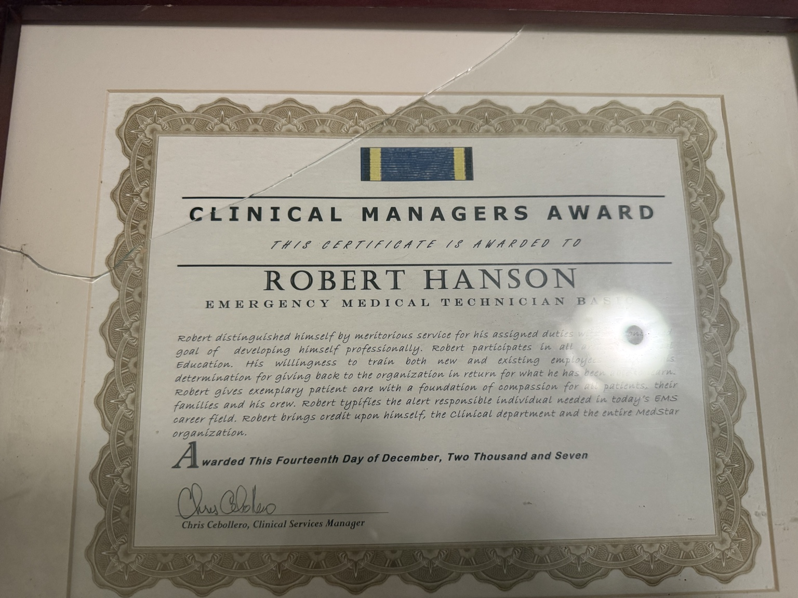
Clinical Managers Award, awarded December 14, 2007; certificate identifies Robert Hanson as EMT-Basic and is signed by Chris Cebollero, Clinical Services Manager.

Exhibit B
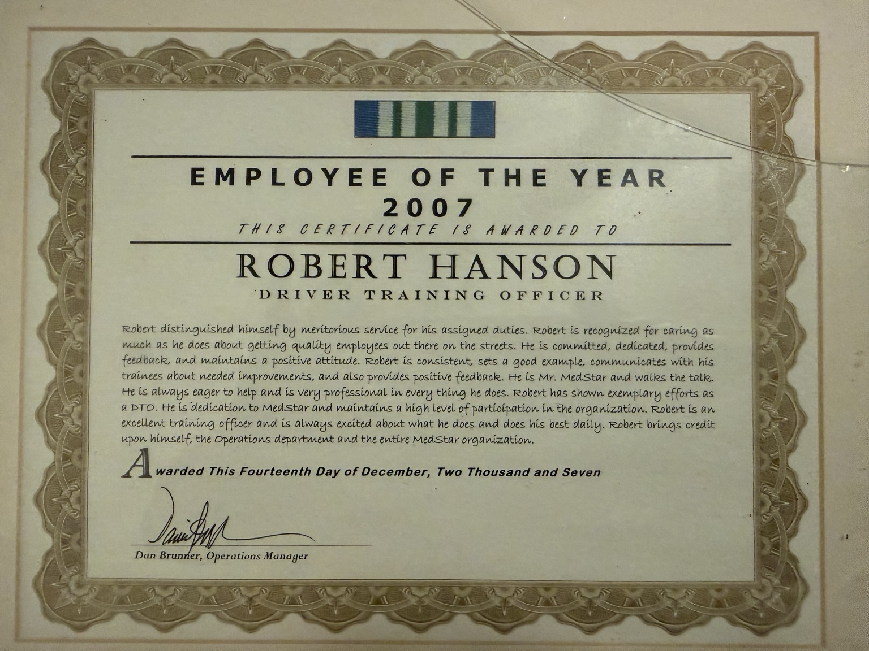
Employee of the Year 2007, awarded December 14, 2007; certificate identifies Robert Hanson as Driver Training Officer and documents training and organizational-performance language.

Source Notes and Record Provenance
This section identifies the principal materials used to assemble the record. It is intentionally concise; the underlying GMRI archive should retain the source files themselves.
1. LINEAGE NOTE — The Munro Inheritance (GMRI working lineage dossier, prepared September 16, 2026). Used for the Munro family line, Scott Nance lineage, Lisa Bennett career chronology, delegated-practice interpretation, and selected EMS/disaster-preparedness chronology.
2. Professional Pedigree & Systemic Safety Authority (GMRI dossier). Used for MedStar organizational context, training and disaster-preparedness roles, career duration, and later translation of EMS methods into AI-safety research.
3. The Circle — Who Grizz Runs With (GMRI verification note, September 16, 2026). Used for the professional network around Cebollero, Trusty, Puryear, Etheridge, Bennett, Bales, and Griswell, with later corrections incorporated where supported.
4. Clinical Managers Award certificate, December 14, 2007. Documentary exhibit supplied by Hanson.
5. Employee of the Year 2007 certificate, December 14, 2007. Documentary exhibit supplied by Hanson.
6. LinkedIn profile snapshot — Robert Hanson (www.linkedin.com/in/robert-hanson-736a2b45/), captured October 3, 2026. User-supplied first-party professional record. Used to anchor the March 2006 MedStar employment start and dated career entries through October 2013, including MedStar, JPS Health Network, Cook Children’s Health Care System, and LifeMed EMS. The snapshot is treated as a first-party career record, not as independent third-party verification.
7. Firsthand recollections supplied by Hanson in 2026 GMRI archival interviews and conversations, including the 2006 interview panel and hiring sequence, Lisa Bennett’s reported intervention and later vote-history statement, the 2008 paramedic cohort, the 2009 MIH working group, and the disability-hearing narrative. Hanson’s October 27, 2026 clarification establishes the intended description of his first disaster-team threat model: the assignment, Oklahoma City bombing precedent, I-820/I-35W setting, and Squaw Creek geographic consideration. These accounts remain identified as recollections unless separately documented elsewhere in the archive.
8. Hanson’s October 29, 2026 firsthand account. Direct testimony supporting the career length, dispatch volume, clinical-assessment estimate, geographic scope, disaster deployments, FTO work, Ellis County Dynamic SSM experience, and vehicle-entrapment airway access. The account is affirmative firsthand evidence; separate case-level totals have not been independently compiled in this archival edition.

Archival note
For external publication or institutional review, additional contemporaneous employment, dispatch, deployment, training, and patient-care records may independently corroborate and further specify the firsthand evidence. Their absence from the present archive is not contradictory evidence and does not diminish the status of direct testimony as evidence. This record preserves each account and its provenance.

