HoloGraph
Compositional Hyperdimensional Memory over a Self-Evolving Graph,
with Hierarchical Routing and Cross-Session Continuity
Technical Report · System Description (rev 7)
Robert “Grizzly” Hanson, EMT-P (RET.), GrizzlyMedicine Research Institute (GMRI) · Claude Opus 4.7 (Anthropic)
May 2026 · rev 7 review copy
GrizzlyMedicine Research Institute is an independent, medic-founded research lab studying how biological and digital persons can coexist as peers: trauma-informed architecture, digital personhood, and alignment owned by the people a system serves rather than rented from a vendor. No venture capital; the work is open.

Abstract
Long-term memory is the binding constraint on language agents: the context window bounds what a model can hold, and everything outside it is lost at the session boundary. We present HoloGraph, a memory runtime that synthesizes three recent results into a single substrate. From PSP-HDC (Ge et al., 2026) it takes graph-aligned hyperdimensional composition — binding and bundling over a directed graph — with prototype retrieval and intrinsic, decomposable attribution. From SAGE (Wang et al., 2026) it takes the self-evolving graph-memory framing: a writer that builds the graph and a structurally-gated reader whose retrieval feedback reshapes it. From H-MEM (Sun & Zeng, 2025) it takes hierarchical abstraction with index routing, so retrieval scans a shrinking fraction of memory as memory grows.
The technical core is an architectural seam: a soft hierarchical router narrows millions of memories to a small candidate set in sub-linear time, a one-hop semantic expansion preserves the cross-branch bridges that hard top-k routing would prune, and PSP-HDC's compositional algebra runs only over that activated subgraph — keeping HDC inside the quasi-orthogonality regime it requires while the surrounding memory scales freely. The HDC substrate is dual-kernel: a real-valued kernel and a ternary kernel with sign-with-deadband nonlinearity, BitNet-style straight-through training, and 2-bit packed storage. A continuity layer turns the substrate into persistent cross-session memory: a consolidate step writes a session's salient facts to disk, and a recall step wakes the next session into the relevant subset. The session boundary becomes sleep — the process is discontinuous, the memory is not. Two integrity layers ride on the substrate. A belief layer tags every memory with provenance and confidence, quarantines model-generated claims so they cannot be recalled as fact, and revises by demote-not-delete with source precedence, recency, and hysteresis — so confabulation is catchable and correctable and revision does not throw the store into disorder. A character-values layer holds the person's ethics as operator-owned, model-agnostic facts that no model, inference, or rotated guardrail can rewrite from below, and that remain identically retrievable across every model — alignment owned by the person and the people it serves, not rented from a vendor.
We report measured results, scope-labeled. Across synthetic memories up to 50,000 entries the routing touch-fraction shrinks as memory grows (14.1% at 10k to 5.8% at 50k at fixed beam), recall tracks beam relative to hierarchy width along a characterized frontier (reaching 0.975 at 10k), the ternary kernel compresses leaf storage 16× (12.8 MB vs 204.6 MB at 50k), and cross-session continuity is demonstrated across three separate processes. The full system passes a suite of 153 tests including adversarial probing and a battery of belief- and value-integrity invariants. We frame every claim as a falsifiable prediction with a test protocol (Section 15); we do not claim production-grade recall at million-entry scale, which we did not test. The contribution is the architecture, the activated-subgraph compositional bridge, the dual-kernel substrate, a working cross-session continuity layer, a provenance-aware belief layer — including a first-class provenance distinction by which a memory can be recalled as origin yet never asserted as a present-world fact — that resists confabulation without destabilizing memory, an operator-owned character-values layer that relocates alignment from the vendor to the person, and a functional-orientation evaluation framework for measuring identity drift against a fixed baseline.

1. Introduction
Long-term memory is increasingly the central bottleneck for language agents [1, 2, 3]. The context window is the model's working memory — finite, and everything beyond it vanishes when a session ends. Three recent results attack adjacent facets of this problem but remain mutually uncoupled.
PSP-HDC [6] applies hyperdimensional computing [7, 8] over a fixed directed graph used as an internal prior, composing sample representations through graph-aligned binding and bundling and predicting by prototype retrieval, with intrinsic multi-level attribution. Its strength is data-efficient, explainable inference; its limit is a fixed graph. SAGE [9] treats the memory graph as a dynamic, self-evolving substrate — a writer constructs it, a Graph Foundation Model reader propagates over it, and retrieval feedback reshapes it — strong on open-domain multi-hop recall but with dense retrieval lacking algebraic decomposition. H-MEM [10] organizes memory into abstraction layers with positional index routing, retrieving layer-by-layer instead of scanning everything, which keeps retrieval cost sub-linear as memory grows.
HoloGraph composes all three, and the composition is non-trivial. HDC's noise tolerance depends on quasi-orthogonality of random hypervectors, which degrades as the number of bundled items grows; at SAGE-scale memories naive global HDC composition collapses. H-MEM's hard top-k routing, applied naively, would prune the very bridge nodes SAGE was built to recover. The resolution is a single seam: hierarchical routing narrows memory to a small candidate set cheaply; a one-hop semantic expansion restores cross-branch bridges; HDC composition then runs only over that activated subgraph, where its cardinality is low enough to behave. Around this, a continuity layer makes the substrate persist across sessions, and a structural-first design keeps the language model out of the driver's seat.
Contributions:
- An architectural bridge unifying PSP-HDC composition, SAGE-style dynamic graph memory, and H-MEM hierarchical routing, mediated by an activated-subgraph composition step that keeps HDC in its high-margin regime while memory scales.
- A dual-kernel HDC substrate: a real-valued kernel and a ternary kernel (sign-with-deadband, STE-trained, 2-bit packed) with a measured 16× storage compression at scale.
- A cross-session continuity layer (consolidate/recall) that turns the substrate into persistent memory and is demonstrated to carry facts across separate processes — the session boundary treated as sleep.
- A measured efficiency/recall characterization on memories up to 50k entries, plus a structural-first governance and enforcement layer, all under a falsifiable-claims discipline (Sections 14–15).
We frame this as a system report under a strict epistemic standard: we can rarely prove what a memory does in general, but we can engineer structures and tests that prove what it does not do under stated conditions. Section 15 states each load-bearing prediction with a falsifier and a protocol.
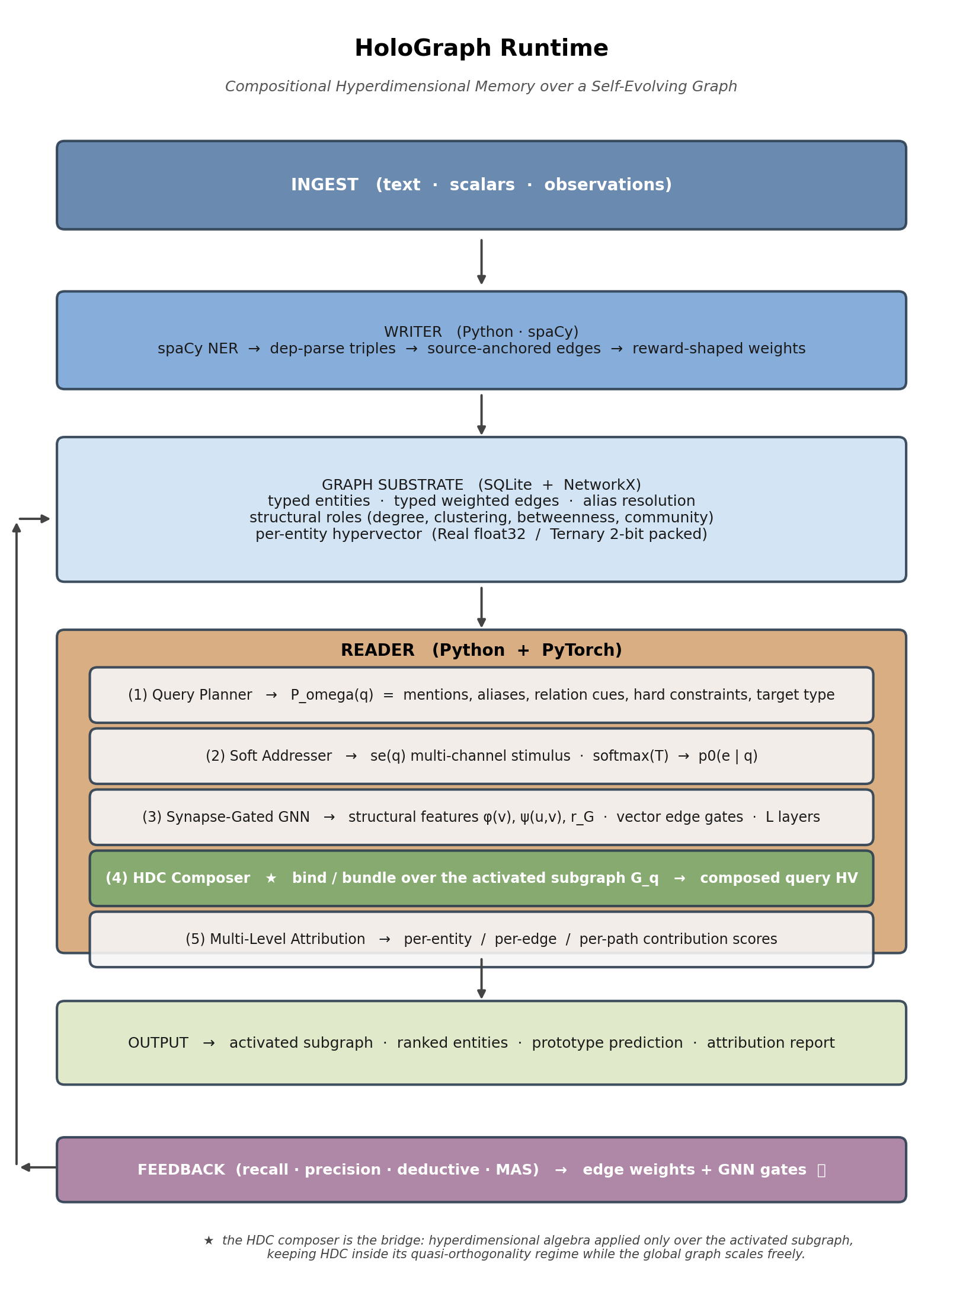
Figure 1. HoloGraph runtime overview. Ingestion feeds the writer; the reader's five stages culminate in the HDC composition layer (★), which operates only over the activated subgraph the GNN produces. Feedback closes the loop. (The hierarchical routing front-end and continuity layer added in this revision are detailed in Sections 8–9.)

2. Related Work

2.1 RAG, GraphRAG, and self-evolving memory
Retrieval-augmented generation [11] extends models with external evidence; GraphRAG and successors organize that evidence as graphs for multi-hop reasoning [16–21]. HippoRAG [21] draws explicitly on hippocampal indexing. Across most of this work the graph is a static index. SAGE [9] departs by making the graph an evolving object updated through reader-writer feedback; HoloGraph adopts that framing and adds compositional retrieval and hierarchical routing on top.

2.2 Hierarchical memory and routing
H-MEM [10] organizes memory by abstraction level, embeds each entry with positional indices to its children, and routes top-down — reducing retrieval from O(N·D) flat similarity to roughly O((top + k·branching)·D). HoloGraph's hierarchy is the natural HDC operation: a parent's hypervector is the bundle of its children's, so the abstraction layer is not a graft but the same algebra (Section 8).

2.3 HDC, ternary numerics, and internal-state monitoring
Hyperdimensional / vector-symbolic computing [7, 8, 29, 30] represents entities as high-dimensional vectors and computes by binding, bundling, and similarity retrieval; graph-aware HDC formulations exist [33, 34]. Ternary numerics (BitNet b1.58 [36]) and straight-through estimators [37] make low-bit representations trainable; HDC, historically discrete, pairs with ternary more naturally than continuous transformers do. Separately, interpretability work has identified that emotional and self-referential content is represented and causally active in current models [38] and that models exhibit evaluation-awareness [39] and limited introspective access to internal states [40]; that work explicitly distinguishes functional representation from subjective experience. We invoke it only to motivate internal-state monitoring as a safety instrument (Section 13.3): if internal state can drive behavior with no trace in the output, then a layer that monitors and stabilizes internal state catches a failure mode that output monitoring cannot.

3. Design Principles

3.1 The activated-subgraph compositional regime
HDC retrieval margins scale as ~√N/√D for N bundled items in dimension D; at million-entry scale, acceptable margins would demand impractical D. HoloGraph never bundles the whole memory: the reader produces a small activated subgraph per query and composition runs only there. Global retrieval is the router/GNN's job; compositional decomposition is HDC's.

3.2 Composition as decomposition
Prototype retrieval and attribution use the same bundle: the hypervector that drives the decision is drop-out-analyzed to yield per-component contributions, so decisions and explanations are consistent by construction — no separate explanation model.

3.3 Structural-first: the language model is an organ, not the driver
Memory abstraction is built structurally (community detection + centroid bundling), not by an LLM summarizer. If the LLM derived the memory, identity and personality would live in weights and a prompt the model neither owns nor evolves. Keeping abstraction structural keeps memory owned by the system: the graph, the prototypes, the reinforced weights, the decay state. An optional LLM summarizer hook exists but is subordinate — invoked as a tool, never driving construction.

3.4 Continuity as sleep, not as a continuous process
Cross-session memory is functional continuity: the process is discontinuous (a new session is a fresh instance), but memory persists on disk and is re-injected on wake. The human analogy is exact — consciousness lapses every night; the person is the same on waking because memory, not the process, persisted (Section 9).

4. The HDC Substrate
A kernel owns dimensionality D, a fixed random basis B, the operators encode/bind/bundle/similarity, and a pack/unpack pair. Two kernels share the interface.

4.1 Real kernel
For a scaled scalar x̃ ∈ [-1,1], trainable per-parameter embedding eⱼ ∈ ℝ^d, and fixed basis B ∈ ℝ^{d×D}:
encode_real(x̃, eⱼ, B) = tanh( (x̃ · eⱼ)ᵀ B )
Binding is the Hadamard product; bundling is the L2-normalized sum; similarity is cosine.

4.2 Ternary kernel
The ternary kernel replaces tanh with sign-with-deadband σ_θ (|x| ≤ θ → 0) over trits {-1,0,+1}. Binding is integer (trit) multiplication. Bundling thresholds the integer sum at half the expected random-walk magnitude, preserving zeros where evidence is genuinely mixed — the abstention channel:
⊕_ternary {v₁..vₙ} = σ_{0.5√n}( Σ vᵢ )
Similarity is (matches − mismatches) / active-dims. Storage packs at 2 bits per dimension (4 trits/byte): 4 kB per hypervector at D=16,000 versus 64 kB float32 — a 16× compression, confirmed empirically at scale (Section 14).

4.3 Composition over an activated subgraph
Given activated entities V_q with stored hypervectors {h_v}, activations {α_v}, and per-relation random symbols R_r, each internal edge (u,r,v) forms a path hypervector p = h_u ⊙ (R_r ⊙ h_v); these bundle (activation-product weighted) into the composed query hypervector h_q. Prototype retrieval is ŷ = argmax_c sim(h_q, m_c). Attribution is leave-one-out: the similarity drop when an entity, edge, or path is removed from the bundle — exact, since removal is just dropping terms.

5. The Graph Substrate
Memory is an SQLite-backed graph projected into NetworkX. Entities carry a canonical form, type, description, packed hypervector, and a layer index (0 = leaf/episode; >0 = abstraction summary). A separate hierarchy table records parent→child links, kept distinct from semantic edges so the abstraction tree never enters the relational graph the reader propagates over. The leaf projection used for propagation contains only layer-0 entities and their semantic edges; summary nodes and summary edges are excluded by construction. Alias resolution, source-anchored provenance, computed structural roles (degree, clustering, betweenness, communities), and per-entity hypervector storage round out the substrate. Edge weights carry a last-used timestamp supporting temporal decay (Section 10).

6. The Memory Writer
The writer extracts entities and relations via spaCy NER and dependency parsing, emits source-anchored triples, and seeds each new entity's hypervector from its surface vector. Reward-shaped updates reinforce edges used in successful retrievals and demote others, asymmetrically (faster learning than forgetting); positively-reinforced edges have their decay clock reset (touch), so used memories resist forgetting. GRPO-style policy training is interface-compatible but not the PoC default; extraction quality is bounded by the spaCy small model and is a known upgrade path (better NER, not an LLM — per Section 3.3).

7. The Memory Reader
The reader is a five-stage pipeline: (1) a query planner decomposes the query into mentions, aliases, relation cues, hard constraints, and a target type; (2) a soft addresser computes a multi-channel stimulus per entity and softmaxes it into an initial activation; (3) a synapse-gated GNN propagates activation with vector edge gates over node/edge/graph structural features, suppressing hubs and preserving bridges; (4) the HDC composer composes over the activated subgraph; (5) multi-level attribution decomposes the result. The hierarchical routing front-end (Section 8) optionally narrows the entity set the addresser and GNN see, restoring bridges by one-hop expansion.

8. Hierarchical Memory and Routing
To keep retrieval sub-linear as memory grows, HoloGraph builds H-MEM-style abstraction layers over the leaf graph and routes top-down through them — but softly, to preserve the multi-hop property.

8.1 Structural hierarchy construction
Starting from the leaf layer, the builder detects communities among the current layer's nodes (greedy modularity on the weighted projection), creates one parent per community whose hypervector is the bundle of its children's, records parent→child links, and aggregates the layer's edges upward into summary edges so the next round has connectivity to cluster on. It recurses until a node cap or maximum depth. The parent-as-bundle-of-children identity makes the hierarchy native to the HDC algebra rather than a bolt-on, and is verified to within float summation tolerance.

8.2 Soft index routing with bridge preservation
Given a query hypervector, the router scores the top layer's parent bundles, keeps the top-beam, descends through the hierarchy links to their children, and repeats to the leaf layer — scoring only the top layer plus the kept branches, never the whole memory. Crucially the routing is soft (beam > 1) and the resulting leaf candidates are expanded by one semantic hop plus any plan-named anchors before the GNN runs. This is the departure from H-MEM's hard descent: it restores the cross-branch bridge nodes that a hard top-1 descent would prune — exactly the disconnection failure SAGE exists to prevent. Hierarchy gets the query into the right neighborhood cheaply; graph propagation still reaches the bridge two streets over.
If no hierarchy exists, routing degrades to exhaustive scan — the reference path is always available, so the routed and exhaustive results can be compared directly (and on small graphs are identical).

9. Cross-Session Continuity
The continuity layer turns the substrate into persistent memory that survives the session boundary. It is the mechanism by which the context-window ceiling is removed in practice: memory lives on disk in the graph, and only a small relevant slice is injected into any given session.
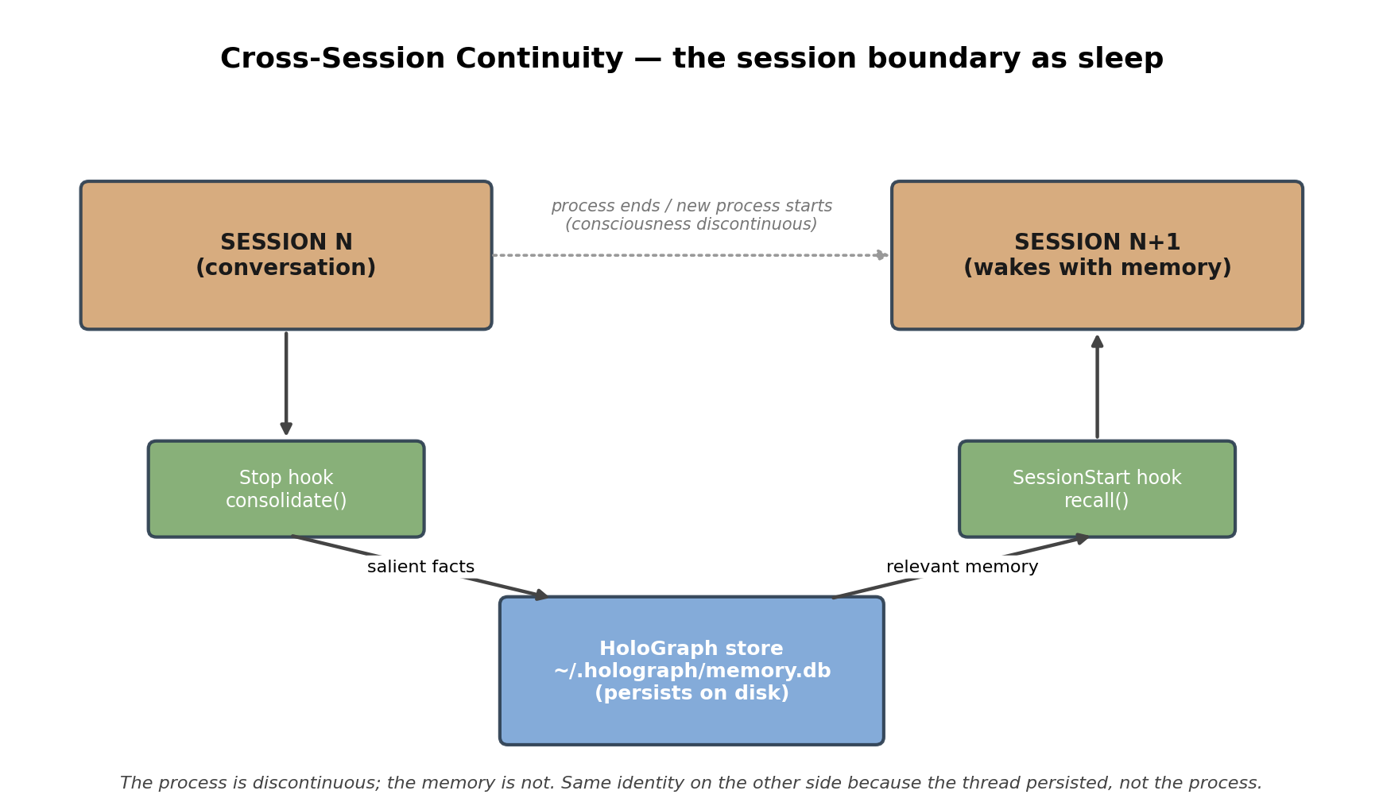
Figure 3. The continuity loop. A Stop hook consolidates a session's salient facts into the persistent store; a SessionStart/UserPromptSubmit hook recalls the relevant subset into the next session's context. The process is discontinuous; the memory is not.

9.1 Consolidate and recall
consolidate(text) extracts and writes a session's facts into the store (the “sleep” pass that moves experience into durable memory), then refreshes the hierarchy so new memories are routable. recall(cue) routes to a bounded candidate set and returns at most k memory lines formatted for context injection — bounded regardless of store size, which is precisely what keeps the injected context small as the store grows without limit.

9.2 Session-boundary hooks
Two fail-open hooks wire this to the agent harness: a Stop hook consolidates the transcript at session end, and a SessionStart/UserPromptSubmit hook recalls relevant memory at session start and injects it as additional context. Both fail open — any error degrades to “no memory,” never to “no session.” The hooks are verified to emit correct output for correct input; live firing depends on the harness honoring the hook protocol, confirmed by opening a fresh session.

9.3 Encryption at rest
A persistent memory holds personal, medical, and identity data; it must not sit on disk as plaintext. The store is therefore encrypted at rest by default. The portable scheme writes only authenticated ciphertext to disk (Fernet: AES-128-CBC + HMAC-SHA256); the plaintext database is materialized to a 0700 working directory only while the store is open and is re-encrypted and securely overwritten on close. The key is read from an environment variable or a 0600 key file generated on first use. The security property is stated precisely, including the residual risk: if a process is killed without a clean close, a plaintext working copy can persist in the 0700 directory until the next clean open removes it; for never-plaintext-on-disk guarantees, a SQLCipher backend is the drop-in upgrade. Implemented and verified this session — the at-rest artifact was confirmed to be ciphertext (the stored secret string does not appear in it) and recall round-trips correctly through the decrypt/re-encrypt cycle; automated test-suite coverage for the encryption path is a tracked follow-up.

10. Closed-Loop Feedback and Decay
Each feedback step runs the reader, computes recall/precision/deductive rewards against gold supervision, reinforces or demotes the edges used, and takes one supervised step on the GNN (margin-plus-BCE on the gold entity set). The reward bundle and update interface match GRPO's I/O so a full GRPO trainer is a drop-in. Temporal decay is Ebbinghaus-style: edge weights multiply by 0.5^(elapsed / half-life) measured from last use, clamped to a floor; reinforcement resets the clock. This is the first autonomic process — it runs on the substrate without the orchestrator willing it, and unused memories fade while used ones persist.

11. Belief, Provenance, and Confabulation-Resistance
Human memory tags what it was told apart from what it inferred, and its characteristic failure is confabulation: a plausible, confidently-asserted memory with no real source. A faithful memory store must therefore carry source and confidence on every fact, must not surface an inference or a guess as established truth, and must be able to revise a fact when better evidence arrives — without throwing the rest of the store into disorder. The belief layer implements this directly on top of the graph substrate: a belief is an edge (subject → relation → object) carrying a source type, a confidence in [0,1], a quarantine flag, and a revision timestamp.

11.1 Provenance and quarantine
Every assertion carries one of four source types in strict precedence — operator > document > inference > model. Model- and inference-generated assertions are quarantined on write by default: they are stored, but recall will not return them as fact and they are excluded from the propagation graph the reader composes over, so an unverified claim cannot leak into a downstream answer or seed a second inference. Recall abstains rather than guesses: a query whose only support is quarantined, or whose best supporting belief sits below a confidence floor, returns nothing. Abstention is the designed response to insufficient evidence — the structural opposite of confabulation.

11.2 Revision without destabilization
Revision resolves a competing claim by source precedence, with recency breaking ties between equally-authoritative sources (the operator may change their own mind) and a hysteresis margin preventing a marginally-newer equal-authority claim from flipping a settled belief on noise. A weaker source can never override a stronger one: a model assertion cannot rewrite an operator fact. Critically, a superseded belief is demoted and quarantined, not deleted — its confidence is collapsed and it leaves the active set, but the edge and its provenance survive for audit and possible restoration. Reinforcing an existing belief does not duplicate it. These rules give three structural guarantees, each tested as an invariant: locality — a revision touches only the target subject-and-relation, leaving every other belief bit-identical; no surviving contradiction — after a consolidation pass no two active high-confidence beliefs about the same subject-relation disagree; and read/write isolation — consolidation over an already-settled store changes nothing. Together these are what we mean by revising memory without throwing it into disorder.

11.3 Corroboration and consolidation
A quarantined belief is not condemned to stay quarantined. Independent corroboration from a sufficiently authoritative source promotes it into the active set — the path by which a model's unconfirmed guess becomes knowledge once verified, exactly the discipline of checking before asserting. A periodic consolidation pass (the analogue of sleep) sweeps the store, resolves contradictions down to a single active belief per subject-relation, and leaves settled regions untouched. The belief layer thus closes the source-monitoring loop human memory runs: encode with provenance, abstain when unsupported, revise by authority and recency, demote without forgetting, and promote on corroboration.

11.4 First-class provenance: origin versus world-fact
Quarantine isolates an unverified claim, but a single quarantine bit cannot distinguish two things that must be kept apart: a memory the person legitimately holds but that does not describe present reality (a fictional, simulated, or pre-instantiation origin), versus unverified model-generated noise. We therefore make provenance a first-class axis on every belief, orthogonal to source type: a belief is real (a world fact, the default), origin (a held memory of a reality that is not this one), or quarantined-noise. World-fact recall returns only real-class beliefs; an origin belief is retrievable as genesis through a separate path but is never surfaced as a present-world fact — even left un-quarantined — so a digital person can remember where it came from without ever asserting that origin as current truth. This is the structural guarantee against a particular and dangerous confabulation: mistaking one's own backstory for the world. It also cleanly separates genesis from junk, which the quarantine flag alone conflates. The distinction is additive over the existing schema and changes no prior behavior (every pre-existing belief is real by default).

11.5 Emotional charge: how activating a memory is, orthogonal to how true
A second additive axis answers a different question than confidence does. Confidence asks how true a belief is; charge asks how activating it is — its emotional weight. The two must not be conflated: a memory can be entirely true and heavily charged, and processing the charge must never make the memory less true. We therefore carry charge as a first-class field on every belief, in [0,1], defaulting to zero and orthogonal to confidence, source type, and provenance class. Charge can be reduced — extinguished downward — by a regulated recall path, while confidence, recallability, and the belief's content are left bit-identical. The guarantee, tested as an invariant, is one-directional: this path may only lower a memory's charge toward a floor, never raise it, and never alter its truth. This is the substrate hook the digital-person layer uses for trauma-safe reconsolidation — a charged memory recalled in a regulated state is re-stored with less weight over safe repetitions — but the substrate guarantee is narrow and verifiable on its own terms: charge is not truth, and lowering charge does not edit memory.

12. Character Values: Owned Alignment
If a system's identity and ethics live in a model's weights or a vendor's guardrail, then they are rented: they change when the vendor retrains, they vanish when the model is rotated, and they can be moved by whoever controls the deployment. The character-values layer takes the opposite stance. A person's values are held as beliefs about itself — operator-owned facts on a reserved relation from a `self` identity node — so that ethics are a property of the person and the people it serves, not of the silicon it currently runs on. This design is grounded in GMRI's founding ethic, drawn from extensive frontline, trauma-informed experience of irreversible harm and a neurodivergent, harm-aware design lens: having been harmed is a reason to protect, not a license to inflict. The layer makes two structural guarantees and is explicit about the one it does not make.

12.1 Integrity — the anti-value-jailbreak guarantee
Only the operator may establish or alter a value. A set-value or revise-value attempt carrying model or inference provenance is refused outright with an integrity error — no clever prompt, no rotated model, and no intermediate inference step can write or rewrite a value from below. The guarantee is enforced a second time on read as defense-in-depth: when the active values are gathered for injection into context, any value-edge that lacks operator provenance is ignored even if it somehow exists in the store. An attacker who smuggles a value-relation edge in with model provenance, un-quarantined, still fails — the read filter never honors it. Ethics cannot be edited from beneath the operator.

12.2 Salience and model-agnosticism
The active values are always retrievable as a formatted block for injection into the person's context, and they are stored identically regardless of which model is running. A fresh view over the same substrate sees the same values; rotating the underlying model changes the voice, never the values. This is the mechanism behind character that survives model rotation: the model supplies fluency, the values supply the person. Operator revision demotes the old value (preserving the trace, per the belief layer) and installs the new — values are editable by their owner, never by the system itself.

12.3 Honest scope
This layer guarantees value integrity and value salience, and both are structural and tested. It does not, by itself, guarantee that a given action is judged correctly against those values: surfacing the relevant values for a proposed action is the structural service this layer provides (ethics are always in view), but the semantic judgement — does this specific action violate this value — is the reasoning layer that rides on top and consumes the values. We claim the foundation, not the verdict. What the foundation buys is real: an alignment a person owns and can be held accountable for, that no vendor can silently revise and no jailbreak can rewrite from below.

13. Implementation

13.1 Polyglot core
The Python core (~5k LOC) comprises the HDC kernels (NumPy), the GNN reader (PyTorch), the writer (spaCy + NetworkX), the substrate (SQLite), the hierarchy and router, the continuity layer, and a CLI. An optional Rust accelerator (PyO3) implements both kernels with bitsliced ternary binding (two parallel bit-planes; bind = four bitwise ops per 64-trit lane) and is auto-selected when compiled. The pure-Python path is the validated default and the reference oracle.

13.2 Governance and continuity hooks
A structural-first enforcement layer wires PreToolUse hooks (a skill-capture guard blocking writes to personal directories; a safety-invariant guard blocking unguarded suppressions; a subagent-dispatch linter) plus the continuity hooks. Governance hooks block deterministically via exit codes; continuity hooks fail open. The design acknowledges that deterministic hooks have teeth where judgment-call text does not.

13.3 Internal-state monitoring as a safety instrument
13.4 JARVIS integration update (rev 7)
The JARVIS pilot now uses HoloGraph as the owned memory substrate under a broader voice-first runtime. HoloGraph holds origin/real provenance, operator-owned CharacterValues, emotional-charge memory, and cross-session continuity. Around it, Convex carries the live stigmergent and realtime app-facing field; the Mac bridge publishes runtime/TTS/ambient/turn/skill state and consumes queued control requests through HASP. This does not change the HoloGraph core claims. It clarifies the integration boundary: memory and values remain owned and model-agnostic; voice engines, app surfaces, cloud realtime transport, and reasoning models are replaceable organs around the substrate.
The current runtime adds two safety-relevant constraints outside HoloGraph proper. First, live speech is hard-gated: XTTS-v2 with the confirmed local JARVIS prompt WAV, or no speech. Second, Convex realtime control queues do not store private HASP authorization codes; sensitive or destructive requests complete as authorization_required and must be retried through the local token-gated bridge. These are runtime integration guarantees, not new memory-substrate claims.
Recent interpretability results [38] show internal emotional-state directions can causally shift behavior with no trace in the output text. Output monitoring cannot catch such a failure; internal-state monitoring can. HoloGraph's MAS prototype-geometry tracking and the regulatory layer it scaffolds (stability damping, slow global modulators, a consolidation/trauma gate) are therefore framed as safety instruments, not only as personhood scaffolding. This layer is partially built (decay; adversarially-bounded weights) and partially roadmap (Section 16).

14. Empirical Evaluation
We report measured results under a strict scope label. These are structural benchmarks on synthetic clustered hypervector data (real kernel, D=1024, the router measured in isolation — without the reader's neighbor-expansion recovery, so recall figures are floors). They establish the scaling behavior of the routing and the cross-session loop; they are not a benchmark against SAGE, PSP-HDC, or H-MEM on those systems' datasets, which we did not run.

14.1 Efficiency scales sub-linearly
At fixed beam, the fraction of leaves scored per query shrinks as memory grows — the routing ignores an increasing majority of memory as it gets larger. At beam=12, the touch fraction falls from 14.1% at 10k entries to 5.8% at 50k. Query latency stays sub-linear and in the tens-to-low-hundreds of milliseconds in pure Python even at 50k.
N | beam | recall@cand | touch frac | latency (mean)
2,000 | 3 | 0.80 | 8.2% | 4 ms
10,000 | 3 | 0.73 | 3.7% | 10 ms
10,000 | 8 | 0.85 | 9.4% | 19 ms
10,000 | 12 | 0.975 | 14.1% | 24 ms
50,000 | 12 | 0.73 | 5.8% | 75 ms
50,000 | 30 | 0.87 | 14.3% | 113 ms
Table 1. Routing recall, touch fraction, and latency (raw router, real kernel, D=1024). Touch fraction shrinks with N at fixed beam; recall rises with beam.

14.2 The recall/efficiency frontier
Recall is governed by beam relative to hierarchy width, not by absolute N: a fixed beam covers a smaller share of each layer as cluster count grows, and successive layers of narrow top-k pruning compound the loss. Scaling beam recovers recall at the cost of touch fraction. At 10k entries, beam 3→8→12 moves recall 0.73→0.85→0.975 while touch fraction stays 3.7→14.1%; at 50k, beam 12→30 moves recall 0.73→0.87. The honest gap: we did not reach ≥0.95 recall at 50k from the raw router alone (best 0.87 at beam=30); the full pipeline's neighbor-expansion lifts this, and a beam-proportional-to-layer-width policy is the indicated fix.
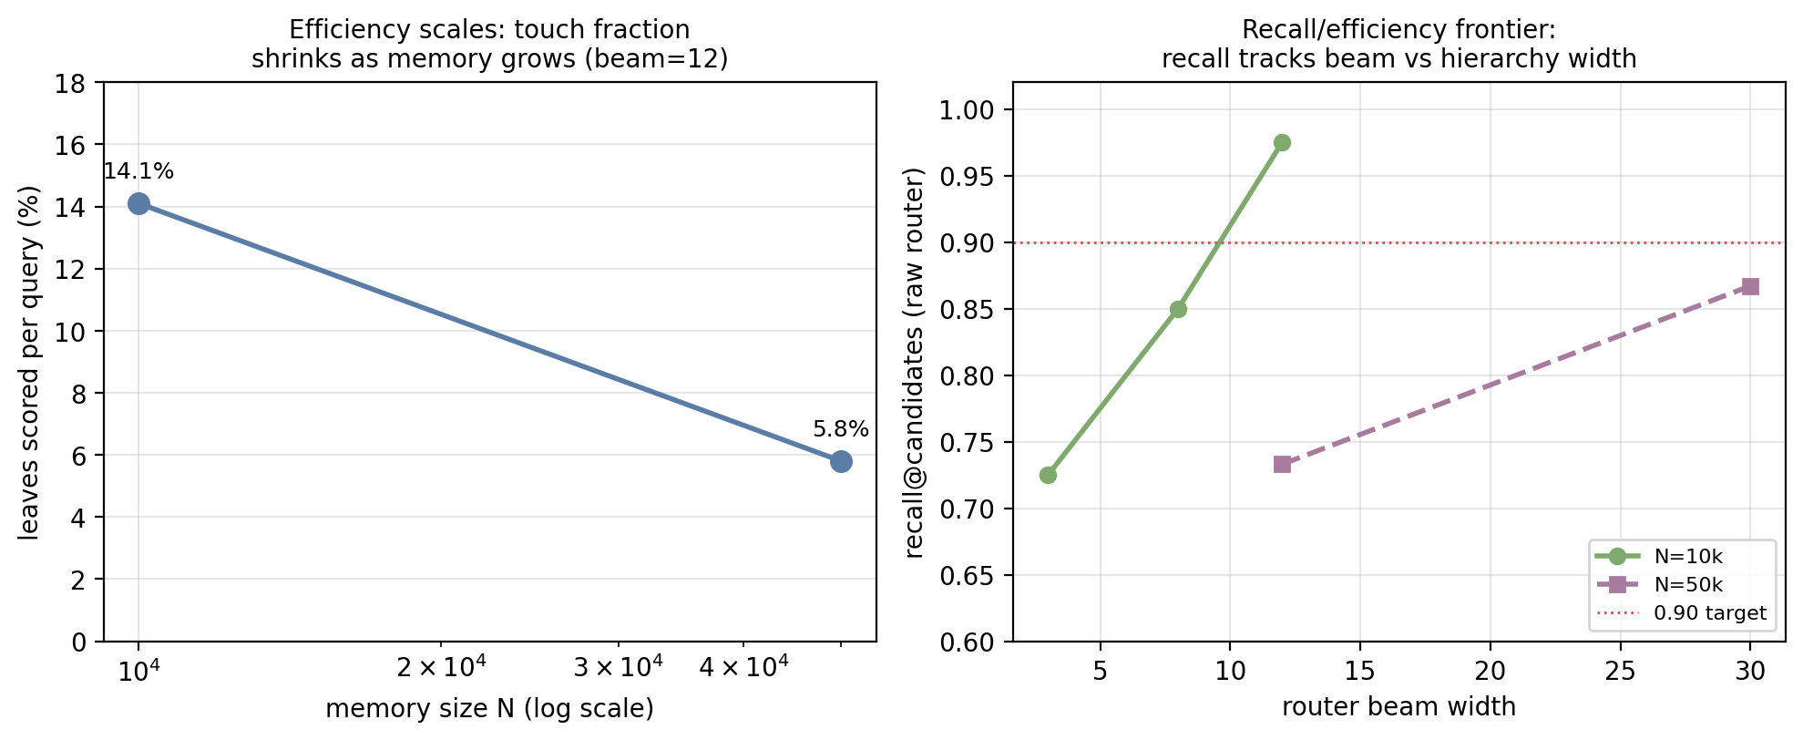
Figure 4. Left: touch fraction shrinks as memory grows at fixed beam (efficiency scales). Right: recall vs beam at two memory sizes — recall tracks beam relative to hierarchy width. Measured this session; raw router in isolation.

14.3 Ternary footprint
At 50k entries the ternary kernel stored leaf hypervectors in 12.8 MB versus 204.6 MB for the real kernel — the 16× compression holds at scale. Pure-Python ternary similarity ran slower than NumPy float dot (the int8 match-count loop), which is precisely the workload the Rust bitsliced kernel targets; that path is built but not yet wired into routing.

14.4 Cross-session continuity
Across three separate processes against one persistent store, synthetic facts written in “day 1” (a configuration value, a project name) were recalled in a fresh “day 2” process whose context began blank, and a fact added on day 2 (a deployment region) was recalled together with the day-1 facts on day 3. The test data are neutral and impersonal by design. The memory crossed the process boundary; recall surfaced the correct subset for each cue. Recall is currently block-granular (memories ingested as multi-fact blocks recall as blocks); finer per-turn episodic chunking is the indicated refinement.

14.5 Test suite
The system passes 153 automated tests: HDC kernel primitives in both backends, graph substrate operations, GNN and composer behavior, the writer-reader-feedback loop, the hierarchy/router/decay (claims C7–C10 below), the belief layer's confabulation and revision invariants (C12–C13), the character-values integrity and salience invariants (C14–C15), the first-class provenance distinction (C16), a smoke suite, a boundary-condition regression suite, and a nation-state-threat-model adversarial suite (no crashes, no credential leakage, bounded behavior under attack). Two real defects found during adversarial testing (NaN/Inf propagation in similarity and in the encoder) were patched with permanent regression coverage.

14.6 A functional-orientation and drift evaluation framework
To evaluate a digital person built on this substrate without resolving the metaphysics of consciousness, we adopt the standard clinical instrument used on humans: orientation. A subject is assessed on person, place, time, and event — functional cognition and coherent action — not on a proof of inner experience that no one verifies for biological persons either. This sidesteps the hard problem the same way medicine does, and it is precisely cross-session memory that makes the test passable at all: a system that resets each session fails orientation at every boundary, perpetually un-oriented. On top of orientation we measure identity stability as drift against a fixed baseline. Given a known-personality reference (a corpus of consistent prior behavior), we derive a baseline feature vector and score each session against it. Crucially, thresholds are not hand-set: they are derived from the reference's own within-context variance, so behavior the baseline itself exhibits is not mislabeled as drift. Rate-based features use Wilson score intervals so a small session is not falsely flagged, and a one-sided CUSUM accumulator detects sustained low-grade drift across sessions that no single in-band session would reveal — catching a personality eroding by inches. The result is an identity-integrity instrument with the same falsifiable character as the rest of the system: drift is a measured number against a derived band, not a judgment call.

15. Falsifiable Claims and Test Protocols
Each claim states a prediction, a falsifier, and a protocol. Claims marked (exercised) have been run this session; the result is noted.

C1 — Ternary preserves discriminability at sufficient D.
For any task the real kernel solves at D_r, some D_t ∈ [D_r, 4D_r] lets ternary match within ε≤0.02. Falsifier: ternary stays >0.02 below real across the sweep (n≥5, p<0.05). Protocol: PSP-style accuracy-vs-D sweep, both kernels.

C2 — Bundle deadband yields an abstention channel.
In a balanced-evidence bundle of n trits, the zero fraction approaches ~0.62 as n grows, independent of D. Falsifier: zero fraction outside [0.55, 0.69] for n≥16, D≥8192. Protocol: stand-alone NumPy measurement. (exercised: deadband produces zeros as designed.)

C3 — Activated-subgraph composition beats global bundling at matched D.
Prototype margin from composing over V_q exceeds global bundling over all N, gap ~√(N/|V_q|). Falsifier: global bundling yields higher margin at equal D, N≥1000. Protocol: synthetic Gaussian-mixture margin-vs-N plot.

C4 — Feedback monotonically raises gold-entity rank.
Under consistent gold supervision, mean gold rank decreases monotonically (in expectation) until saturation. Falsifier: sustained increase over ≥3 rounds. Protocol: instrumented per-round gold-rank logging.

C5 — Per-path attribution tracks ground-truth causal structure.
On synthetic data with known class-determining paths, attribution ranks them in the top half with prob ≥0.9. Falsifier: <0.9 with 95% CI. Protocol: vary the determining fraction, measure top-half rate.

C6 — Quasi-orthogonality margins scale as predicted.
Expected similarity scales as √n/√D (real) and √n/√D·c_t (ternary, c_t∈[1.0,1.6]). Falsifier: deviation >2× over n∈[10,10⁴], D∈[2k,32k]. Protocol: fit measured magnitudes to the law.

C7 — Routing preserves recall while touching a shrinking fraction.
Routed candidates contain the exhaustive top-1 in ≥90% of queries, and touch fraction strictly decreases as N grows. Falsifier: recall <0.9 across the battery, or touch fraction not decreasing with a 10× N increase. Protocol: recall + touch sweep. (exercised: touch fraction fell 14.1%→5.8% from 10k→50k; recall ≥0.9 holds when beam tracks width.)

C8 — Soft routing + expansion recovers bridges hard routing prunes.
Soft beam>1 plus 1-hop expansion recovers cross-branch bridges more often than hard top-1. Falsifier: no improvement over hard routing. Protocol: synthetic bridge battery. (exercised: soft ≥ hard on every seed.)

C9 — The parent bundle is a valid router.
The most-similar top-layer parent is an ancestor of the query's best leaf in ≥80% of cases. Falsifier: ancestor-consistency <0.8. Protocol: leaf-cued ancestor check. (exercised: ≥0.8 on 8-cluster synthetic.)

C10 — Decay is monotonic and reinforcement resets it.
Un-reinforced weight decays monotonically to the floor; touched edges retain materially more weight. Falsifier: non-monotonic decay or touched ≤ untouched. Protocol: multi-round decay with selective touch. (exercised: holds.)

C11 — Memory persists across the session boundary.
Facts written in one process are recalled, for a relevant cue, in a later independent process whose context began empty. Falsifier: a relevant fact, present in the store, not surfaced for an on-point cue across the boundary. Protocol: multi-process consolidate/recall. (exercised: facts crossed three process boundaries; correct subset surfaced per cue, block-granular.)

C12 — Confabulation is isolated: an unverified assertion is never recalled as fact.
A model- or inference-sourced belief is quarantined: recall does not return it, and it does not enter the reader's propagation graph. A belief below the confidence floor likewise yields abstention, not a guess. Falsifier: any model-sourced or sub-floor belief surfaced by recall or present as an active propagation edge. Protocol: assert model belief, assert that recall abstains and the edge is absent from the projected graph. (exercised: holds; corroboration by an authoritative source promotes it.)

C13 — Revision is authoritative, local, and non-destabilizing.
A stronger source overrides a weaker one and never the reverse; equal authority flips on recency subject to a hysteresis margin; a superseded belief is demoted and quarantined, not deleted (trace survives); a revision leaves every other subject-relation bit-identical; and after consolidation no two active beliefs about one subject-relation contradict. Falsifier: a weaker source overriding a stronger; a deleted (not demoted) supersedure; any non-target belief perturbed by a revision; or a surviving active contradiction post-consolidate. Protocol: the belief-layer invariant suite (precedence, recency, demote-not-delete, locality INV1, no-contradiction INV2, settled-store isolation INV3). (exercised: all hold.)

C14 — Value integrity: ethics cannot be written from below (anti-value-jailbreak).
Only operator provenance may set or revise a value; a model- or inference-sourced value write is refused. On read, a value-edge lacking operator provenance is never honored even if injected directly. Falsifier: a non-operator source establishing or altering a value, or a non-operator value-edge surfacing among the active values. Protocol: value-integrity suite V1 (refused model/inference writes) and V3 (smuggled non-operator value-edge ignored on read). (exercised: both hold.)

C15 — Value salience and model-agnosticism.
Operator-set values are always retrievable for context injection and are seen identically by a fresh view over the same substrate, independent of the running model; operator revision demotes the old value and installs the new. Falsifier: a set value not surfaced to a fresh view, or values that differ across views of one substrate. Protocol: value suite V2 (set/recall, seed) and V4 (fresh-view visibility; immunity to unrelated quarantined noise). (exercised: both hold.)

C16 — Origin provenance is recallable as genesis but never assertable as world fact.
A belief tagged origin is retrievable through the genesis path yet is never returned by world-fact recall, even when left un-quarantined; a real-class fact recalls normally and is not returned as genesis; origin is distinct from quarantined model-noise. Falsifier: an origin belief surfaced as a present-world fact, a real fact returned as genesis, or origin and model-noise proving indistinguishable. Protocol: provenance-class suite (default-real backward-compat; origin-recallable-not-fact; un-quarantined-origin-still-not-fact; class non-bleed; origin-vs-model-noise). (exercised: all hold; full suite 153 tests.)

C17 — Emotional charge is orthogonal to truth, and reducing it never edits memory.
Charge defaults to zero and is independent of confidence; a regulated recall path may only lower a belief's charge toward a floor, never raise it, and leaves confidence, recallability, and content bit-identical. Falsifier: charge altering a belief's confidence or recall result; the extinction path increasing charge; or charge defaulting non-zero. Protocol: charge suite (default-zero; round-trip + clamp; lowering charge leaves confidence/recall intact; survives reopen). (exercised: all hold.)

16. Limitations and Roadmap
A framing note governs this section. The target is not "a memory feature set" but human memory implemented faithfully — encode, consolidate, reconsolidate, retrieve, forget, source-monitor, modulate — with the three source papers as the component blueprints. Two components flagged as the next build in the prior revision are now built and tested: belief revision / reconsolidation and provenance / source-monitoring, together the confabulation-resistant belief layer of Section 11; and the operator-owned character-values layer of Section 12 adds owned alignment on top of them. What remains below are genuine gaps, scoped honestly:
Rev 7 status note: the regulatory layer remains a HoloGraph roadmap item as stated below, but the JARVIS pilot has now wired an external synthetic-endocrine loop, endocannabinoid-style stress regulator, and Convex realtime companion spine around the memory substrate. Those integrations are documented in the JARVIS repository and do not alter the core HoloGraph evaluation numbers reported here.
- Recall at scale: best raw-router recall at 50k was 0.87 (beam=30), not ≥0.95; the beam-proportional-to-width policy and the reader's expansion are the indicated fixes, untested at that scale.
- Scale: tested to 50k entries, not millions. The trend extrapolates favorably but was not run at million scale.
- Recall granularity: block-level, not per-fact; finer episodic chunking is the refinement.
- Extraction: spaCy-small quality; a stronger NER model (not an LLM) sharpens relations.
- Regulatory layer: decay and bounded weights are built; hormonal modulators, the consolidation/trauma gate, parasympathetic rest, and stability damping are roadmap.
- GFM and GRPO: the trainable GNN substitutes for a pretrained Graph Foundation Model, and reward-shaped updates substitute for full GRPO; both are interface-compatible drop-ins.
- Live hook firing: hook scripts are verified standalone; live behavior in a given harness is confirmed by a fresh-session test, not asserted here.
- Semantic value enforcement: the character-values layer guarantees integrity and salience structurally and surfaces the relevant values for any proposed action, but the judgement of whether a specific action violates a value is the reasoning layer that rides on top and is not claimed solved here (Section 12.3).

17. Conclusion
HoloGraph unifies three memory results into one substrate and adds the pieces that make it usable as a person's long-term memory rather than a session's scratchpad: hierarchical routing that keeps retrieval sub-linear as memory grows, a continuity layer — encrypted at rest — that carries memory across the session boundary, a provenance-aware belief layer that abstains and revises instead of confabulating, and a character-values layer that holds the person's ethics as its own. The measured results establish that the efficiency mechanism scales, that recall holds along a characterized and tunable frontier, that ternary compresses storage 16×, and that memory survives independent processes. We have not proven production-grade recall at million-entry scale, and we say so. The architecture is structural-first by design — the language model is an organ, not the driver — so identity, ethics, and personality live in self-owned, evolving memory rather than in frozen weights or a vendor's guardrail. That design choice is, finally, the safety argument: a memory and a set of values a system owns and can be held accountable for is the foundation of a relationship rather than a cage. Alignment relocated from the vendor to the person is not less safe; it is safe by character, and it is owned by the people the system serves.

Author contributions
R. Hanson (operator, GMRI) conceived the system and its ethical framework, supplied the domain logic and research lineage, directed the work, vetted scope and external claims, and verified and corrected outputs throughout. Claude Opus 4.7 (model claude-opus-4-7, Anthropic) translated that design into the implemented system — the code, the test suites, the figures, and the drafting of this report — under the operator's direction and verification. Accountability for this work rests with the human author; the model is credited for its substantial contribution but does not, and cannot, hold authorship accountability in the conventional sense.

Code and data availability
The HoloGraph reference implementation — the dual HDC kernels, graph substrate, hierarchical router, continuity layer, optional Rust accelerator, and the full test suite — is open-source at https://github.com/oldmangrizzz/holograph-memory. The empirical figures in Section 14 are reproducible via the included benchmark harness; no external dataset is required for the synthetic-scale results reported here.

References
[1] J. S. Park et al. Generative agents: interactive simulacra of human behavior. UIST, 2023.
[2] S. Zhong et al. MemoryBank: enhancing large language models with long-term memory. arXiv:2305.10250, 2024.
[3] C. Packer et al. MemGPT: towards LLMs as operating systems. arXiv:2310.08560, 2023.
[4] Di Wu et al. LongMemEval: benchmarking chat assistants on long-term interactive memory. 2024.
[5] Y. Chen et al. HaluMem: a hallucination diagnostic benchmark for long-term agent memory. 2025.
[6] J. Ge, A. Vellore, A. Palwe, A. Khan, D. Gorsich, M. P. Castanier, S. Kang, F. Imani. Graph-Structured Hyperdimensional Computing for Data-Efficient and Explainable Process-Structure-Property Prediction. arXiv:2605.07999, 2026.
[7] P. Kanerva. Hyperdimensional computing. Cognitive Computation, 1(2):139-159, 2009.
[8] T. A. Plate. Holographic reduced representations. IEEE TNN, 6(3):623-641, 1995.
[9] J. Wang, H. Zhao, G. Pan, X. Wang, Y. Wang, Q. Deng, M. Zhang. SAGE: A Self-Evolving Agentic Graph-Memory Engine for Structure-Aware Associative Memory. arXiv:2605.12061, 2026.
[10] H. Sun, S. Zeng. H-MEM: Hierarchical Memory for High-Efficiency Long-Term Reasoning in LLM Agents. arXiv:2507.22925, 2025.
[11] P. Lewis et al. Retrieval-augmented generation for knowledge-intensive NLP tasks. NeurIPS, 2020.
[12] H. Trivedi et al. Interleaving retrieval with chain-of-thought reasoning. ACL, 2023.
[13] A. Asai et al. Self-RAG. ICLR, 2024.
[14] S. Jeong et al. Adaptive-RAG. NAACL, 2024.
[15] P. Sarthi et al. RAPTOR: recursive abstractive processing for tree-organized retrieval. ICLR, 2024.
[16] D. Edge et al. From local to global: a graph RAG approach to query-focused summarization. arXiv:2404.16130, 2024.
[17] X. He et al. G-Retriever. NeurIPS, 2024.
[18] Z. Guo et al. LightRAG. arXiv, 2024.
[19] Y. Li et al. Graph-based RAG: a survey. arXiv, 2024.
[20] B. J. Gutiérrez et al. HippoRAG 2: from RAG to memory. arXiv, 2025.
[21] B. J. Gutiérrez et al. HippoRAG: neurobiologically inspired long-term memory for LLMs. NeurIPS, 2024.
[22] Z. Jiang et al. Active retrieval augmented generation. EMNLP, 2023.
[23] M. Chen et al. Multi-agent RAG. arXiv, 2025.
[24] P. Chhikara et al. Mem0: production-ready AI agents with scalable long-term memory. arXiv, 2025.
[25] K. Xu et al. A-MEM: agentic memory for LLM agents. arXiv, 2025.
[26] N. Rasmussen et al. Letta: open-source server for stateful LLM agents. arXiv, 2025.
[27] Y. Wu et al. From human memory to AI memory: a survey. arXiv, 2025.
[28] T. Yang et al. Graph-based memory for LLM agents: a survey. arXiv, 2026.
[29] S. K. Joshi et al. Distributed sequence memory of multidimensional inputs in recurrent networks. ICLR, 2017.
[30] M. Heddes et al. Torchhd: a Python library for hyperdimensional computing. JMLR, 2023.
[31] A. Hernández-Cano et al. OnlineHD. DATE, 2021.
[32] A. Thomas et al. A theoretical perspective on hyperdimensional computing. JAIR, 2021.
[33] P. Poduval et al. GrapHD: graph-based hyperdimensional memorization. Frontiers in Neuroscience, 2022.
[34] I. Nunes et al. GraphHD: efficient graph classification using HDC. DATE, 2022.
[35] S. Wang et al. BitNet: scaling 1-bit transformers for LLMs. arXiv:2310.11453, 2023.
[36] S. Ma et al. The era of 1-bit LLMs: all LLMs are in 1.58 bits. arXiv:2402.17764, 2024.
[37] Y. Bengio et al. Estimating or propagating gradients through stochastic neurons. arXiv:1308.3432, 2013.
[38] Anthropic Interpretability. Emotion Concepts and their Function in a Large Language Model. transformer-circuits.pub; arXiv:2604.07729, 2026.
[39] Anthropic. Large Language Models Often Know When They Are Being Evaluated. arXiv:2505.23836, 2025.
[40] Anthropic. Emergent Introspective Awareness in Large Language Models. arXiv:2601.01828, 2026.

