Sean Olson

MBA 705 – Business Modelling

Oakland A’s Case

1. Using the data presented in exhibit 1 (which is available in an Excel file), how would you predict ticket sales to a particular Oakland A's game?
   1. In sports economics there are a lot of variables that factor into ticket sales for a particular team, ranging from which teams are playing to which players are playing and even what day of the week the game occurs. Due to the numerous factors the best way to predict ticket sales would be to use linear regression. This is because the model is going to be more complex than just time series forecasting. Linear regression allows for complex model creation which is going to be crucial when trying to predict what is essentially a person’s spending behavior. Given the data in exhibit 1 is mostly categorical data, that first needs to be split out into dummy variables. Then a correlation matrix is generated (Appendix 1) to find which variables are correlated with the dependent variable while also ensuring they are not colinear with each other. The resulting model (Appendix 1) then showed interesting relationships with the teams the Oakland A’s were playing and the day of the week the game was being played. Most interesting was that Friday and Saturday did not have a significant (at p < 0.05) impact on ticket sales, in fact Friday had a negative effect on ticket sales which would indicate that fans are more likely to do something else on those two nights. It was also surprising to see that certain teams the Oakland A’s were playing had a negative effect where some had a positive effect on ticket sales. In order to gain more accuracy on the prediction, more ticket sales data going back over a couple of years would be better as well knowing fan sentiment towards certain teams. It is also worth noting that Nobel only had a 10% positive correlation with ticket sales, meaning that the majority fans probably didn’t know he was pitching that game. They key thing that seems to bring fans into the game is promotions. If promotions can be coupled with nights where teams have a negative effect on ticket sales or days of the week such as Friday or Saturday then the team might have an increased probability of filling the stadium.
2. How would you value the impact that Mark Nobel has had on the Oakland A's baseball franchise?
   1. First, the Oakland A’s should not take his agent’s word at face value in terms of Mark Nobel bringing in an additional $105,650 revenue whenever he pitches. That number is misleading because it’s only relevant for the 1980 season. Performing that same analysis from the time that Nobel entered the league to establish a trend of economic impact. The assumptions that were made are the same average ticket price of $3.66; taking the home attendance divided by 81 games and then multiplied by 16 (the number of games he likely played); taking the ticket price multiplied by the average attendance for the likely 16 games he pitched and in turn multiplying that by 0.77 shows the trend in Appendix 2. With the assumptions in place, Nobel’s adjusted revenue (factoring in 77% take-home of ticket sales) has been declining since his entry into the league. Yes, total revenue did take a hit over the same timeframe but in 1980 revenue had a significant increase which indicates that Nobel’s performance was not a major contributing factor. Since 1975 his average economic impact has been declining by approximately $96,000 per year (Appendix 2).
3. Assume that the average salary for one of a baseball team's top three starting pitchers is $300,000. What type of contract would you offer Mark Nobel?
   1. Mark Nobel wants too much for even his 1980 season performance. Given his current salary of $40,000 per year, he is asking for an additional $560,000 per year with only an additional self-proclaimed impact of $105,650 for the 1980 season. This would mean that he would have to play at 1980 stats at a minimum for the next 6 years to break even on one year of salary or play phenomenally to unquestionably bring in the additional $560,000 in revenue per year. Given that this was his first breakout season and the end of his contract, the new contract should be incentive based with a bonus structure that has the potential of reaching $800,000. This is to add on his 1980 additional revenue to his asking price plus an additional $100,000 to incentivize him to play exceptionally. This contract would have a base salary of $250,000, just below the average top 3 pitcher salary. There would be $450,000 in incentives and bonuses throughout the contract that would be predicated on games started, innings pitched, strikeouts per game and per season, batting average (when playing national league teams), and ERA each season.
4. How would you convince Nobel's agent that your offer is fair to his client?
   1. If Mark Nobel is truly a top 3 pitcher and can continue to put up 1980 season stats or better, than $600,000 should be easy for him to generate in salary each year. By tying his salary to his performance this allows his him to make more than he was initially asking if he meets the thresholds of the incentives and bonuses. If he happens to have a bad year then Oakland A’s aren’t rethinking the contract or looking to trade him for a cheaper player, compared to if he had a guaranteed contract. Also, by incentivizing his salary and he performs exceptionally year after year, then that gives the Oakland A’s the opportunity to renegotiate to a fixed contract if he wants or to find another team that is willing to pay him more than the A’s could and he would have the economic impact numbers of his playing to prove his next contract move.

# Appendix 1: Regression Analysis and Results

## Correlation Matrix

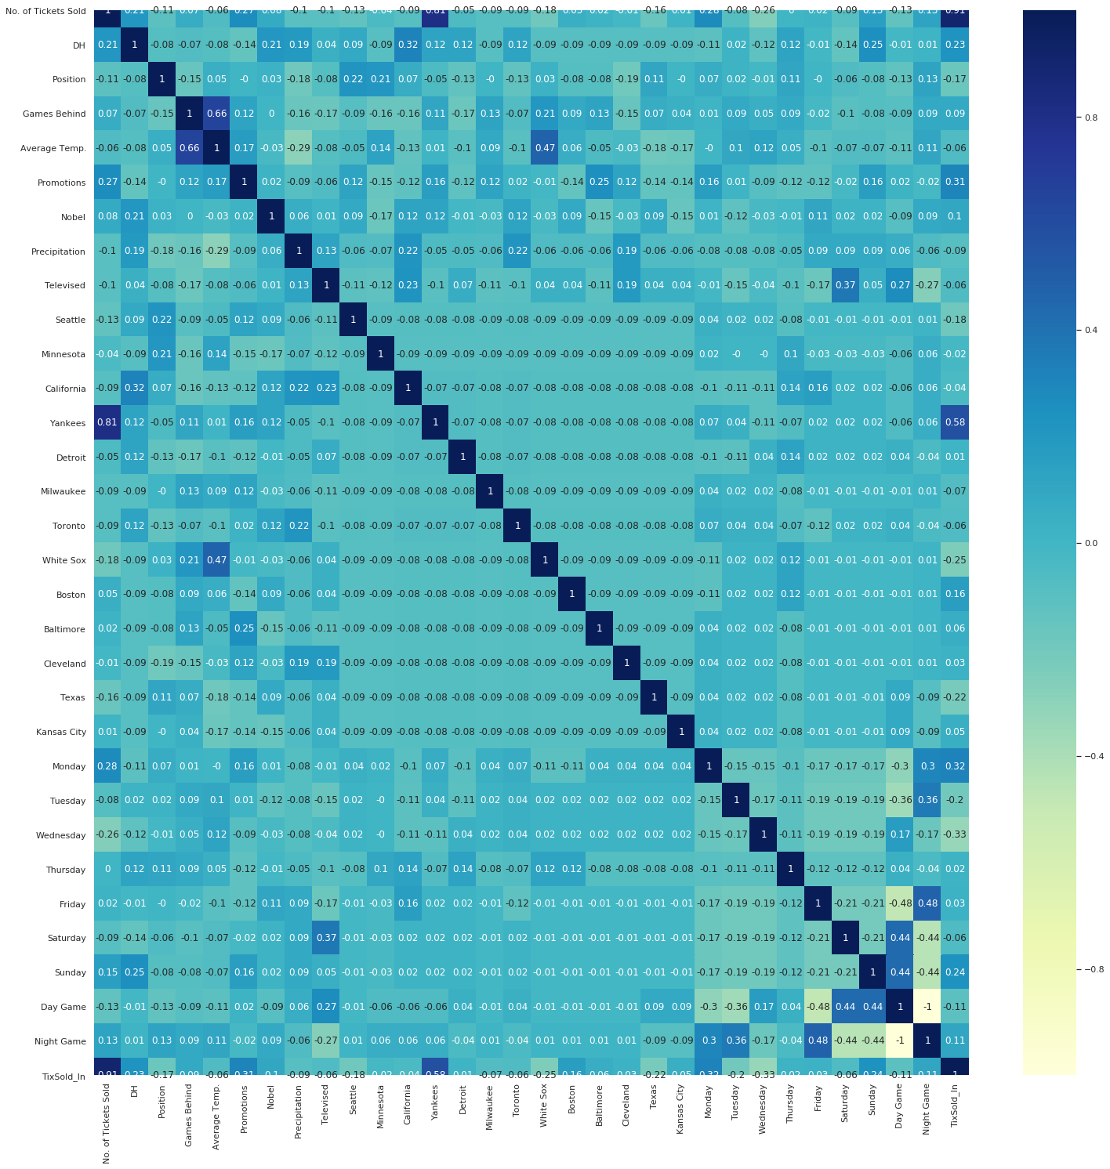

## Regression Results

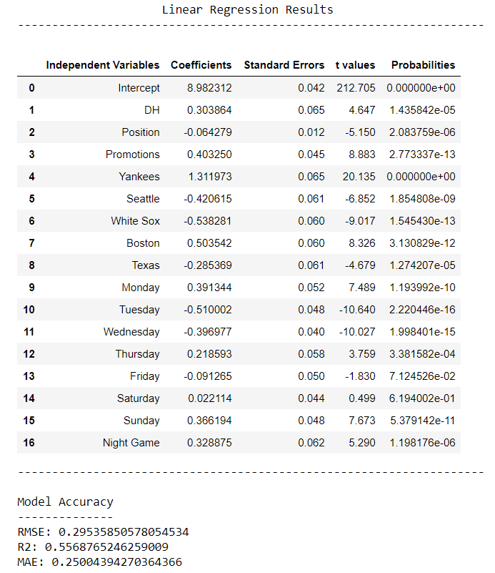

# Appendix 2: Mark Nobel Revenue Analysis

|  |  |  |  |  |  |  |
| --- | --- | --- | --- | --- | --- | --- |
| Year | Attendance | Nobel Likely Attendance | Total Revenue - Nobel | A's Revenue - Nobel | Total Revenue | A's Revenue |
| 1968 | 837,466 |  | $ - | $ - | $ 3,065,125.56 | $ 2,360,146.68 |
| 1969 | 778,232 |  | $ - | $ - | $ 2,848,329.12 | $ 2,193,213.42 |
| 1970 | 778,355 |  | $ - | $ - | $ 2,848,779.30 | $ 2,193,560.06 |
| 1971 | 914,993 |  | $ - | $ - | $ 3,348,874.38 | $ 2,578,633.27 |
| 1972 | 921,323 |  | $ - | $ - | $ 3,372,042.18 | $ 2,596,472.48 |
| 1973 | 1,000,763 |  | $ - | $ - | $ 3,662,792.58 | $ 2,820,350.29 |
| 1974 | 845,693 |  | $ - | $ - | $ 3,095,236.38 | $ 2,383,332.01 |
| 1975 | 1,075,518 | 212448 | $ 777,559.68 | $ 598,720.95 | $ 3,936,395.88 | $ 3,031,024.83 |
| 1976 | 780,593 | 154191.2099 | $ 564,339.83 | $ 434,541.67 | $ 2,856,970.38 | $ 2,199,867.19 |
| 1977 | 495,412 | 97859.16049 | $ 358,164.53 | $ 275,786.69 | $ 1,813,207.92 | $ 1,396,170.10 |
| 1978 | 526,999 | 104098.5679 | $ 381,000.76 | $ 293,370.58 | $ 1,928,816.34 | $ 1,485,188.58 |
| 1979 | 306,763 | 60595.16049 | $ 221,778.29 | $ 170,769.28 | $ 1,122,752.58 | $ 864,519.49 |
| 1980 | 843,319 |  | $ 105,650.00 | $ 81,350.50 | $ 3,086,547.54 | $ 2,376,641.61 |

