卸载：

cd /usr/local/cuda/bin

./cuda-uninstaller

空格选择

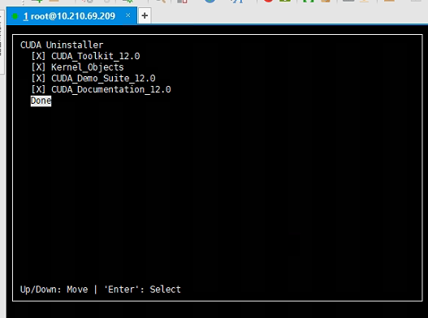

Var/log/cuda-uninstall*

安装

./cuda_10.1.*.run

日志



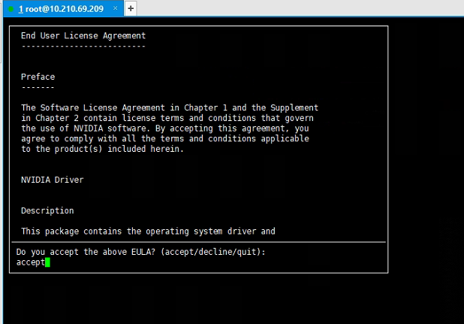

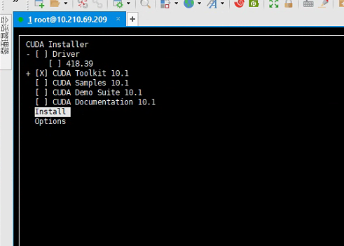

Cudnn安装

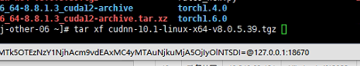

sudo cp cuda/include/cudnn*.h /usr/local/cuda/include

sudo cp -P cuda/lib64/libcudnn* /usr/local/cuda/lib64

sudo chmod a+r /usr/local/cuda/include/cudnn*.h /usr/local/cuda/lib64/libcudnn*