Data Structure Program Assignment #1  
(Due: PM: 6:00, Feb. 22, 2022)

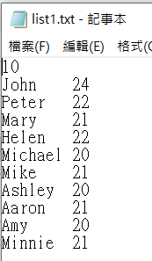**Introduction**This homework is provided for you to understand how to design a struct datatype to include more than one simple datatype for one record. A demonstration program is provided for you to learn to design your own programs. You are asked to modify the demonstration program to enhance its capability to deal with student grades and compute their average then print out the all data.

**Steps**

1. In the class, we demonstrated a program that can read student data from one file, “list1.txt”.
2. A demo program is provided for you to quickly familiar how to design CPP programs by using typedef struct{}. The program reads student records from the file, list1.txt, stores them in the memory, and then outputs the student records one by one, as shown below:

typedef struct {

char name[80];

int age;

} student;

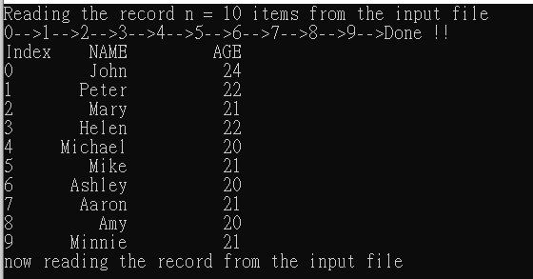

1. Now another file, “list2.txt”, with more data is provided. It additionally comprises personal ID, student ID, department, and scores of midterm1, midterm2, and term examinations, as compared to the list1.txt.  
   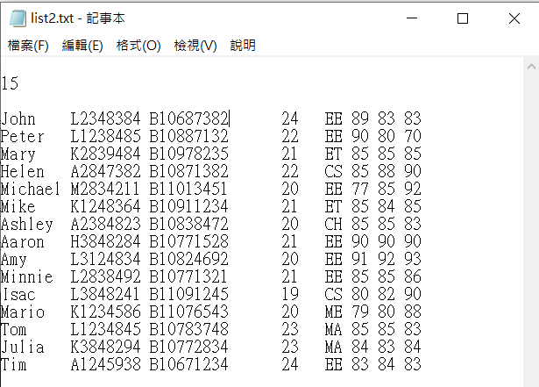
2. You are asked to modify the program such that when the input file is changed to list2.txt, your new program can read and store them in the computer memory.
3. Sort the average score ascendingly (see lecture1 notes basic-53) and print out the student list data. (shown below)
4. You had to output these data in the following format. (Note that the output **data format should strictly be identical** to the one shown below.) You had to print out the full student record with the highest final score. For example, the figures

|  |
| --- |
|  |

1. For you to quickly start your programming, a reference project with a demo program is provided for you. After decompressing the zip file, click and open the “student.sln” with the visual studio 2022 to edit and design your program, as shown below:

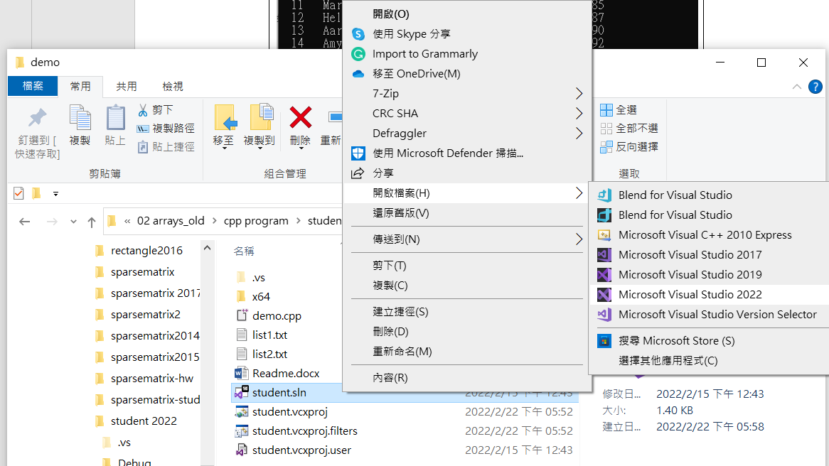

1. You are asked to:
2. Describe your program by writing notes for each instruction. What is the smallest size required to store one student record?
3. Compress the whole project programs you have finished.
4. Upload to the moodle website before the due date.