Data Structure Program Assignment #2  
(Due: PM: 6:00, March 11, 2022)

**The design of a Complex number object**

* **Introduction**  
  This program is provided for you to learn how to design a functional complete object for a complex number. An initial template is provided for you to write the program that is yet to be finished.
* **Requirements**

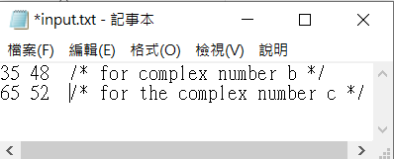Please finish the program segment in the complexi.cpp, such that the main.cpp can be executed. When you execute the complex.exe < input.txt in the command window, you will get the following output.

Note that the “input.txt” file should be placed in the Release directory.  
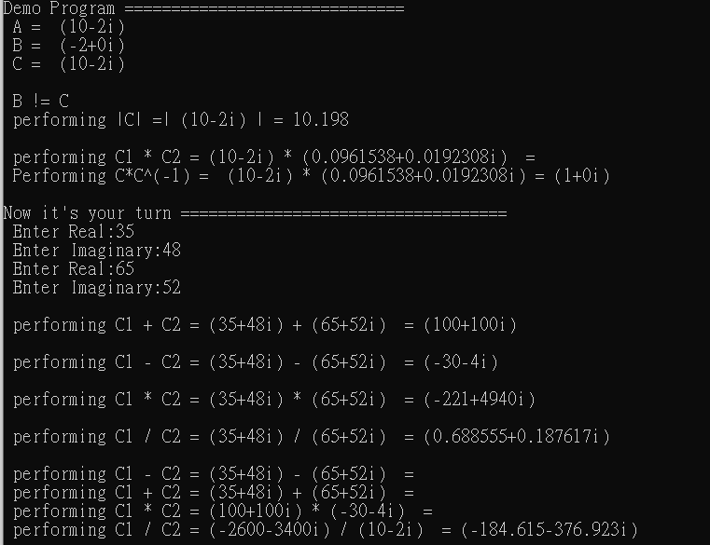

* **Steps:** 
  1. Please double click the file complex.sln and modify the program complexi.cpp to design the program.
  2. Demo programs are provided for you to quickly start the programming without encountering time-consuming try and error debugging problems.
  3. When you finish the entire project, set the Visual Studio System to “Release” Mode.
  4. Go to the Release directory and type “cmd” in the command line to open the command window.

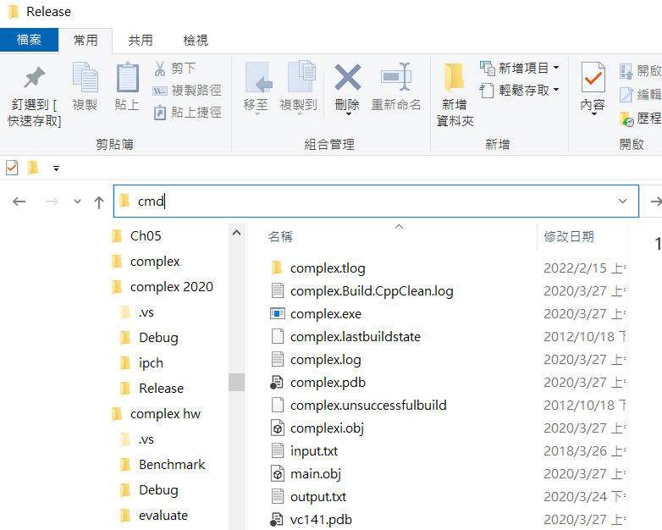

* 1. Execute the program at the Release directory on this command window:

complex < input.txt > output.txt   
type output.txt

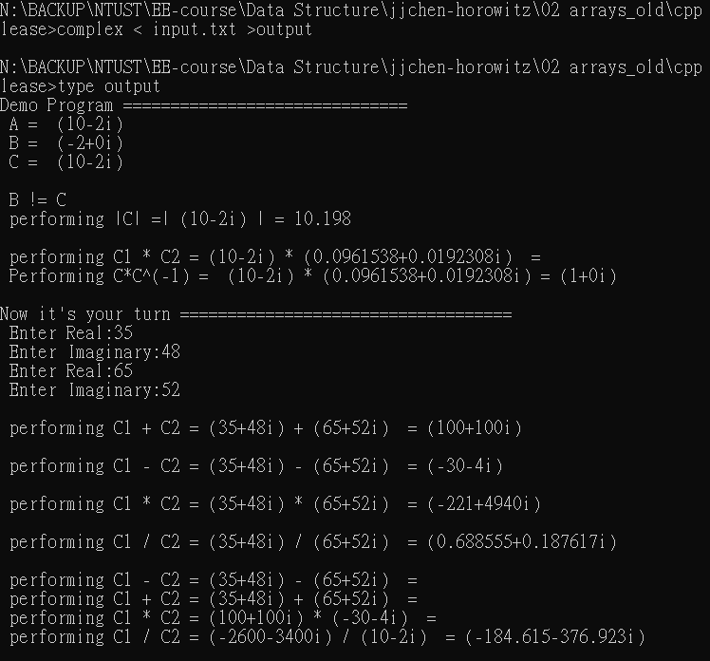

* 1. You can check the correctness of your program by the output.txt.
  2. You are asked to:

1. Write a short report to describe what you have done in this project.
2. Describe your program by writing notes for each instruction.
3. Compress the whole project programs you have finished.
4. Upload to the moodle website before the due date.
   1. **Evaluation Criteria:**

Correctness: 70%

Program notes: 15%

Report: 15%

* Note: Everyone is encouraged to write the program from scratch by yourself.