Images to key include images with 1 or 2 days data, in tabular form, including hand-drawn forms. See Example 3. If an image has 3 days of tabular data, which has not yet been seen, please contact NCDC to determine if image should be keyed.

Images with 3 days or more of observations should be marked, but not keyed, and will be reviewed by NCDC for a possible Phase 3 keying. A new set of instructions will be created for the Phase 3 keying if data is determined significant or if budget allows for more keying. See example 4 for sample images that will not be keyed in Phase 2.

Do not key data that has been marked through. See example 5. If an hourly ob has been marked through do not key that hour. If a whole day has been marked through, as with example 5, do not key any data from that day.

A tilde (~) is to be inserted by the keyers whenever an entry cannot be determined due to poor legibility. This will indicate that there was an entry on the form but that the keyer could not determine the value. Every effort should be made to enter the value and to only enter a tilde as a last resort. If original data are entirely missing for any field, the field should be left blank. In the keying format, blank universally indicates missing data.

A pound (#) is to be inserted by the keyers whenever an entry does not fit the requirements of the keying format; i.e., when the keyers encounter an alpha character, on an observation form, where the keying format provides for only numeric values a “#” sign will be entered, left justified and blank-filled. These entries will be reviewed once keying is complete, and a determination of the proper entry will be made.

Attachment A – English East India Company (EIC) Logbooks (data records)

Data Record – one per day
COLUMNS | #CHARACTERS | DESCRIPTION | KEYING INSTRUCTIONS
1-24 | 24 | Ship Name  1 | Key the index value of the Ship Name. This is also commonly located at the top of the pages with observations of weather, and may not be recorded on the cover. Left justify, blank fill. An adjunct Excel spreadsheet (from Clive’s EIC Ships Working Document) is provided that contains an easy-to-read list of ship names for correct spelling.
25-31 | 7 | Logbook ID 2 | Key the index value of the Logbook ID. This is the Batch ID in WSSRD.
32-35 | 4 | Image Sequence Number 3 | Key the image sequence number found in the “Sequence Number” column in WSSRD (or last 4 numbers in file name just before “.pdf”, if keyed from disk).
36-39 | 4 | Year 4 | yyyy -- Key the year of the observational record.
40-41 | 2 | Month  5 | mm – Key 1-12 as recorded in the date boxes right side of the form, top or center. You may have to interpret the date from the Remarks or elsewhere on the form, so look at the entire form – you may have to look at the previous or next form to help you determine the date. Right justify, zero fill.
42-43 | 2 | Day 6 | dd – Key 1, 2, 3, etc., from the value in the date boxes, right side of form, top or center. Right justify, zero fill.
44-51 | 8 | Latitude 7 | DD or DD.MM. or DD.MM.SS -- where DD means Degrees, MM means Minutes, and SS means Seconds. These values are given in the boxes containing noon obs, at the foot of each day’s hourly obs, and occasionally in the bottom of the remarks section, i. Key only one Latitude, “Lat. obs”. If “Lat. obs” is not available, key “Lat. act.”. Key the value as it is recorded, right justify.  Hour is assumed to be Noon (24). If value is not recorded in boxes at the foot of the hourly obs, also look in Remarks section, in case it is recorded there.
52 | 1 | Latitude Hemisphere 8 | Key ‘N’ for North and ‘S’ for South. Leave blank if not recorded.
53 | 1 | Latitude Source  Indicator 9 | Key:  1 if keyed latitude is from “Lat. obs” (Observation)  2 if keyed from “Lat. act.” (Dead Reckoning)  Blank if no latitude recorded.
54-62 | 9 | Longitude 10 | (D)DD or (D)DD.MM. or (D)DD.MM.SS -- where (D)DD means Degrees, MM means Minutes, and SS means Seconds. These values are given in the boxes containing noon obs, at the foot of each day’s hourly obs. Key only one longitude, “Lon. Chr.”. If “Lon. Chr.” is not available, key “Lon. in.”. Key the value as it is recorded, right justify. Hour is assumed to be Noon (24). If value is not recorded in boxes at the foot of the hourly obs, also look in Remarks section, in case it is recorded there.
63 | 1 | Longitude Hemisphere  11 | Key ‘W’ for west and ‘E’ for East. Leave blank if not recorded.
64 | 1 | Longitude Source  Indicator 12 | Key:  1 if keyed longitude is from “Lon. Chr.”(Chronometer)  2 if keyed from “Lon. in.” (Dead Reckoning)  Blank if no longitude recorded.
65-69 | 5 | Meridian Distance 12.1 | Look for value in noon box labeled “MD” at the foot of each day’s hourly  obs. If available, key this value as it is recorded, right justify, blank fill. If a  colon is recorded within the numerical values, key a decimal in place of  the colon.
70-76 | 7 | Ship’s Course 13 | Key the “Course” located in the boxes at the foot of each day’s hourly  obs. Hour is assumed to be Noon(24).  Key as follows:  Left justify, blank fill. If the direction is given as a standard  16-point direction code, e.g.: N, NNE, NE, etc., key it as is. If the direction  is given as a text entry, convert the text into a standard direction code,  e.g.: N, NNE, etc. If given as one direction “by” another, e.g.: WNW by N,  key as WNWXN. If given as a combination of alphanumerics, e.g.: N45E,  S67E, key as given. If given as one direction “to” or “through” another,  e.g. NNW to/through N, key as NNWTN. If given using a combination of  directions and fractions, e.g.: “SW ¾ W”, convert the fraction to a  three-digit decimal value, using the table below, and key as “SW750W”.  1/16 = 063  1/8 = 125  ¼ = 250  1/3 = 333  3/8 = 375  ½ = 500  5/8 = 625  2/3 = 667  ¾ = 750  7/8 = 875  If you encounter any other fractional value, convert it to a 3-digit decimal  value, rounding the third digit as necessary, enter it into the table, and  inform CDMP of the new fractional (decimal) value encountered.
77-79 | 3 | Ship’s Distance Traveled  In Previous 24 hours  14 | If ‘Ship’s Course’ is keyed, also key numeric value in “Course and Distance” field located in the boxes at the foot of the day. This value should not be enclosed within 2 directions; it sometimes precedes “miles”; and is typically recorded after the direction. Right justify, blank fill.
80 | 1 | Pressure Units  15 | Key:  1 if English Inches (default, unless specified otherwise on the form)  2 if Millimeters  Leave blank if pressure is not recorded.
81-85 | 5 | Barometric Pressure  16 | Key digits from the “Barom.” field located in the boxes at the foot  of the day in the form of Ttht: Tens, tenths, hundredths,  thousandths(e.g. 29.000). Ignore decimal points. Left justify, zero fill. If in  millimeters, value will be in HTt: Hundreds, Tens, tenths (~760.0). Hour is  assumed to be Noon (24).  Example: ‘30’ recorded would be keyed as ‘30000’; or 29.6 recorded  would be keyed as ‘29600’, or ‘29 ¼’ recorded would be keyed as ‘29250’,  or ’29.8¼’ recorded would be keyed as ‘29825’.  Note: Pressure recorded in inches should be somewhere in the ranges of  25.50 – 32.00” and only major extremes would fall outside this range.
86 | 1 | Air Temperature Units  17 | Key:  1 for Fahrenheit (default, unless specified otherwise on the form)  2 for Celsius  3 for Réamur  Leave blank if temperature is not recorded.
87 | 1 | Minus Sign for Air  Temp 18 | If air temperature is negative, minus sign will be keyed here.
88-91 | 4 | Air Temperature  19 | Key given value in “Ther.” field located in the boxes at the foot  of the day. Positions 90 & 91 are reserved for tenths and hundredths,  respectively. Decimal is implied and hour is assumed to be Noon (24).  Positions 90 & 91 will be left justified and zero filled(e.g. 69 will be keyed  as 6900, 69.2 will be keyed as 6920, and 69.25 will be keyed as 6925).  For observations recorded with fractions, e.g. 69¼, convert the fraction to  decimal value and key in positions 90 & 91. For example 69¼ would be  keyed as 6925.
92-98 | 7 | Wind direction  20 | Key the Noon wind direction located in the “12” (24) hourly observation of  the ‘Wind &c.” column immediately preceding the boxes at the foot of  each day, and usually recorded on the left side of this column(and should  not be followed by a numerical value – see Notes, Example 2a. The  direction should also not be preceded by ‘Com’ or Com^{d’} as in Example  2b).  If wind direction is not available in hour “12” (24), key the next available  up the list, e.g. “11” (23), or “10” (22), etc. but do not key any before  “4” (16).  If “ditto” or “do” is recorded, key the next available wind direction recorded  above the “ditto” or “do”.  If none is available in said hourly observations (16-24), look in the  remarks section for wind direction recorded in description of “Latter” or  “Latterly” (recorded with wind force). If none is recorded in hourly obs or  In description of “Latter(ly)” part of day, then look in the remarks for  ‘Throughout’, in that sequence. If none are available in hourly obs,  Latter(ly) or Throughout, then leave this field blank.  Key as follows:  Left justify, blank fill. If the direction is given as a standard 16-point  direction code, e.g.: N, NNE, NE, etc., key it as is. If the direction is given  as a text entry, convert the text into a standard direction code, e.g.: N,  NNE, etc. If given as one direction “by” another, e.g.: WNW by N, key as  WNWXN. If given as Variable, Var, Vrb, or Baffling, key  Variable types = V, and Baffling = B. If given as one direction  “through” another, e.g.: “Variable E through W”, key as VETW. If given as a  combination of alphanumerics, e.g.: N45E, S67E, key as given. If given as  one direction “to” or “through” another, e.g. NNW to/through N, key as  NNWTN. If given using a combination of directions and fractions, e.g.:  “SW ¾ W”, convert the fraction to a three-digit decimal value, using the  table below, and key as “SW750W”.  1/16 = 063  1/8 = 125  ¼ = 250  1/3 = 333  3/8 = 375  ½ = 500  5/8 = 625  2/3 = 667  ¾ = 750  7/8 = 875  If you encounter any other fractional value, convert it to a 3-digit decimal  value, rounding the third digit as necessary, enter it into the table, and  inform CDMP of the new fractional (decimal) value encountered.
99-100 | 2 | Hour of Keyed Wind  Direction 21 | Key the hour, 16-24, of the keyed wind direction above. If keyed from the  remarks under “Latter” key ‘L’ (left justify, blank fill). If keyed from the  remarks under “Throughout” key ‘T’. Leave blank if no wind direction is  keyed. For cases where recorded from ‘ditto’ or ‘do’, key  the hour where the ‘ditto’ or ‘do’ is recorded (see wind direction above).
101-106 | 6 | Wind Force  22 | Key the Noon wind force located in the “12” (24) hourly observation of the  ‘Wind &c.” column immediately preceding the boxes at the foot of each  day. If wind direction is not available in hour  “12” (24), key the next available up the list, e.g. “11” (23), or “10” (22), etc.  but do not key any before “4” (16).  If “ditto” or “do” is recorded, key the next available wind force recorded  above the “ditto” or “do”. Be careful to differentiate “ditto”(s) and “do”(s)  recorded for Wind Direction (above) and Wind Force.  If none is available in said hourly observations (16-24), look in the  remarks section for wind force recorded in description of “Latter” or  “Latterly”. If none is recorded in hourly obs or  In description of “Latter(ly)” part of day, then look in the remarks for  ‘Throughout’, in that sequence. If none are available in hourly obs,  Latter(ly) or Throughout, then leave this field blank.  This section will be finalized upon completion of the project as more terms  are being added as they are encountered. Please use the following 3 digit  codes for values keyed in positions 101-103 and 104-106.
  Airs | 001
  Air | 001
  Breezes | 002
  Breeze | 002
  Calm | 003
  CALMS | 003
  Gales | 005
  Gale | 005
  Hard | 006
  Hurricane | 007
  Monsoons | 008
  Monsoon | 008
  Puffs | 009
  Puff | 009
  Stormy | 010
  Storm | 010
  Tempest | 012
  Trades | 013
  Trade | 013
  Typhoon | 014
  Winds | 015
  Wind | 015
  Baffling | 041
  Blows | 042
  Blowing | 042
  Blew | 042
  Brisk | 043
  Changeable | 044
  Declining | 045
  Easy | 046
  Faint | 047
  Feint | 047
  Fine | 048
  Fresh | 049
  Furious | 050
  Gentle | 051
  Good | 052
  Hard | 053
  Heavy | 054
  Increasing | 055
  Leading | 056
  Less | 057
  Light | 058
  Little | 059
  Moderate | 060
  Nice | 061
  Pleasant | 062
  Powerful | 063
  Severe | 064
  Small | 065
  Smart | 066
  Steady | 067
  Stiff | 068
  Strong | 069
  Top-Gallant | 070
  Tremendous | 071
  Unsteady | 072
  Variable | 073
  Violent | 074
  Whole | 075
  FRESHNING | 079
  FRESHINING | 079
  FRESHENING | 079
  MODERATING | 080
  GUSTS | 082
  SETTLED | 084
  GUSTY | 085
  INCLINING | 086
  DECREASING | 089
107-108 | 2 | Hour of Keyed Wind  Force 23 | Key the hour, 16-24, of the keyed wind force above. If keyed from the  remarks under “Latter” key ‘L’ (left justify, blank fill). If keyed from the  remarks under “Throughout” key ‘T’. Leave blank if no wind force is  keyed.
109-208 | 40 | Present Weather/Visibility  24 | Key all “Present Weather/Visibility” text from the hourly observations or  remarks as they are recorded. Comma separate, left justify. Do not  duplicate values recorded multiple times for one day.
209-308 | 16 | State of Sea  25 | Key all State of Sea text from the hourly observations or  remarks as they are recorded. Comma separate, left justify. Do not  duplicate values recorded multiple times for one day.

NOTES:
The mariners’ day is divided into 3 parts: first, middle and latter. The ‘first’ part is typically from Noon-8PM, the ‘middle’ from 8PM-4AM, and
the ‘latter’ from 4AM-Noon.

A mariner’s day begins at 1PM (01) and continues through Noon (24). The hourly observation for Noon (24) is always the last
observation of the Day marked ‘12’. It is located immediately above the boxes with the Course and Distance, Latitudes/Longitudes, pressure
and temperature, which are also Noon observations. Below (Example 1) are the times as they are recorded on the forms and their corresponding
keyed times (with “Latter” part of day in bold):

EXAMPLE 1:

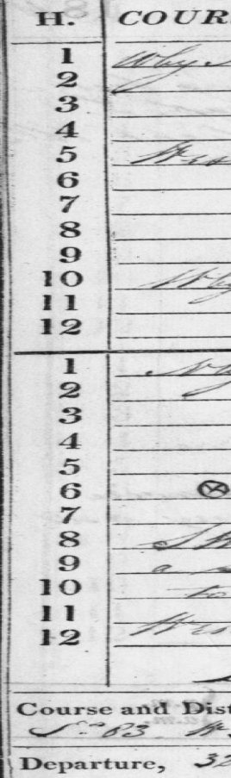 | On Form Keyed As  - 01  - 02  - 03  - 04  - 05  - 06  - 07  - 08  - 09  - 10  - 11  12 12  ------------------  - 13  - 14  - 15  - 16  - 17  - 18  - 19  - 20  - 21  - 22  - 23  12(Noon) 24

EXAMPLE 2a:

Wind Directions recorded in “Wind &c.” column:
Many times when a ship was in company with another ship the observer would record the bearing to the other ship in the “Wind &c.” column. This
looks very similar to the wind direction. Below is an example (Example 2).
Note that there are directions recorded: one set on the left side of this column(e.g. SSE, vble, S, vble, SEbS, etc) and another set on the right side
of the column (e.g. SSW1/2, do, SSW1/2, do, ESE1, etc).
For this form and many others like it, the wind direction to be keyed will be located on the left side to middle of the column, while the ship’s
bearing to the other ship in company will be on the right.
A good way to differentiate the wind direction from the ship’s bearing is from the numerical value recorded with the direction(e.g. ESE1). This
numerical value is not a wind force but rather the bearing distance of the other ship. Wind forces are typically recorded in word format (e.g. fresh
breeze, light airs, etc). Any wind direction followed by a numerical value is likely bearing rather than wind direction.
If directions are consistently recorded both on the left side of the column and on the right side of the column, as shown in the example below,
please key the left as the wind direction and ignore the values on the right as the bearings will not be keyed.

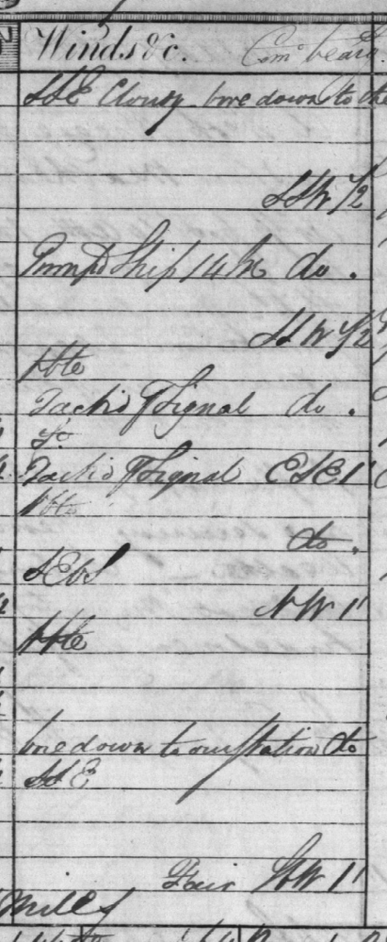

Example 2b – Do not key directions preceded by “Com“ or “Com^{d}“ and followed by a numerical value.
See hour ‘8’ below.
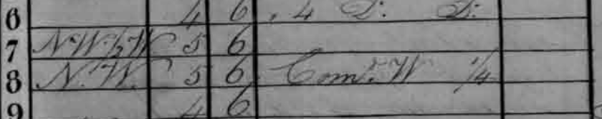

Example 3 – Images to key; 2 days of tabular data:
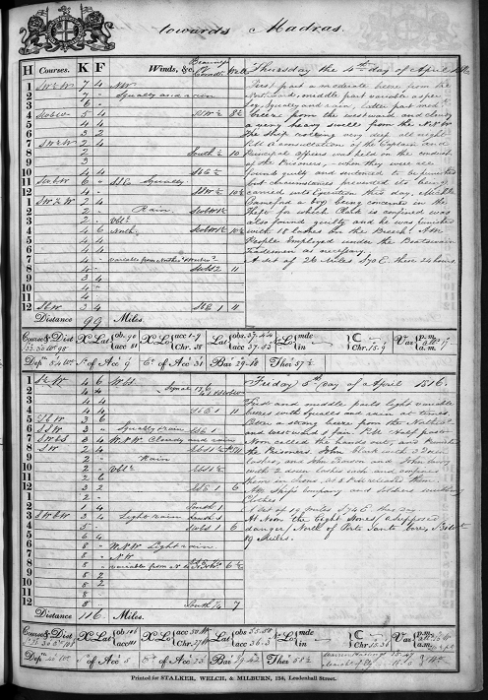

Example 4 – Images to not key, but mark for possible P3 review; no tabular data:

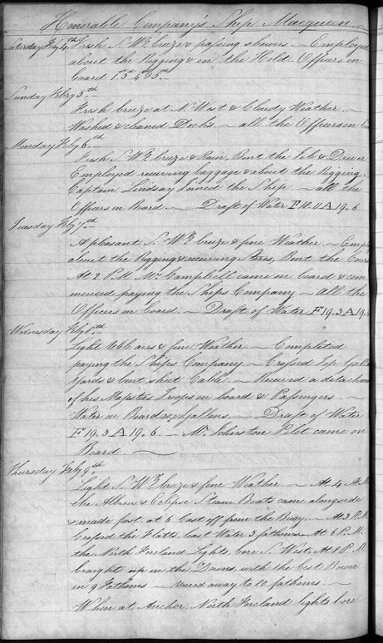

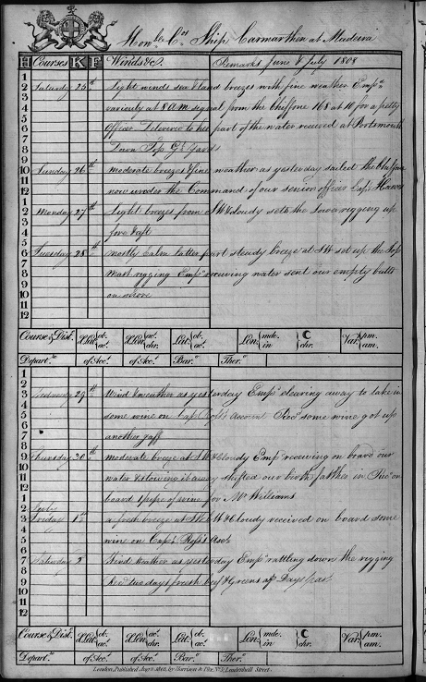

Example 5 – Data to not key due to marking through; erroneous data on bottom of image.
