-----------------------------<(M File)>-------------------------------

X0=[0;0];%initial condiitons are zero

TR=[0 10];%time response RANGE

%t=0:0.1:50;

[t,x]=ode45(@func1,TR,X0);

Displacement=x(:,1)

Velocity=x(:,2)

plot(t, Displacement)

hold on

plot(t,Velocity)

acceleration = gradient(Velocity,t);

hold on

plot(t,[0;acceleration])

ylabel('x,v,a')

xlabel('time')

legend("displacement","velocity","acceleration");

%state variables give the following function

function dx = func1(t,x)

M=10;B=5;K=5;F=5;

dx(1)=x(2)%for x dot

dx(2)=(F-B\*x(2)-K\*x(1))/M %for x dot dot

dx = dx';

end

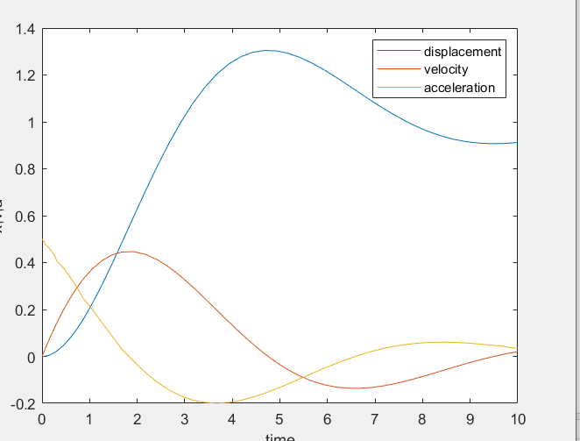

-----------------------------<(Simulink)>-------------------------------

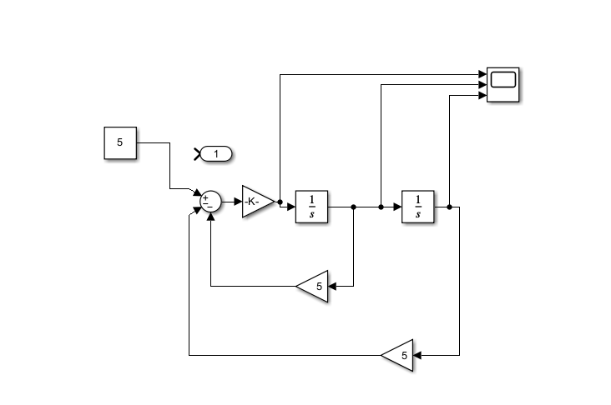

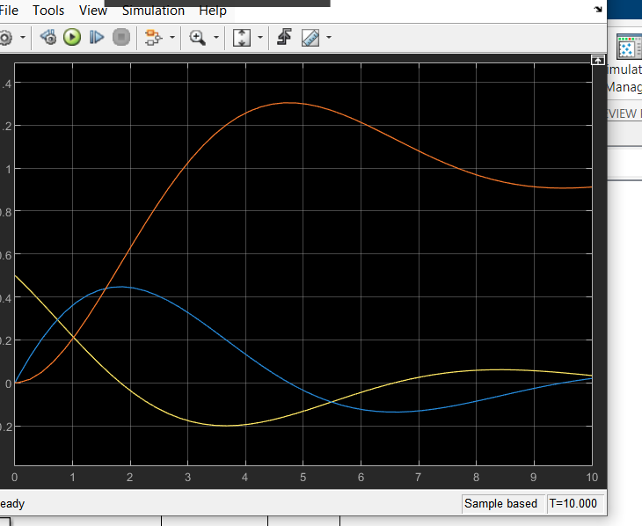

-----------------------------<(SIMSCAPE)>-------------------------------

