-----------------------------<(M File)>-------------------------------

syms s zrdot

A=[(mu\*s^2+(bs+bt)\*s+ks+kt) , -(ks+bs\*s) ; -(ks+bs\*s) , (ms\*s^2+ks+bs\*s)];

B=[(kt/s+bt)\*zrdot;0];

C=A\B;

zs=C(1);

G=zs/zrdot;

G=collect(G,s);

[num,den]=numden(G);

num=sym2poly(num);den=sym2poly(den);

num=num/den(1); %dividing by den(1) means dividing by the leading coefficient of denominator i.e., 20 in this case. Done to match the outputs.

den=den/den(1);

G=tf(num,den)

-----------------------------<(Simulink)>-------------------------------

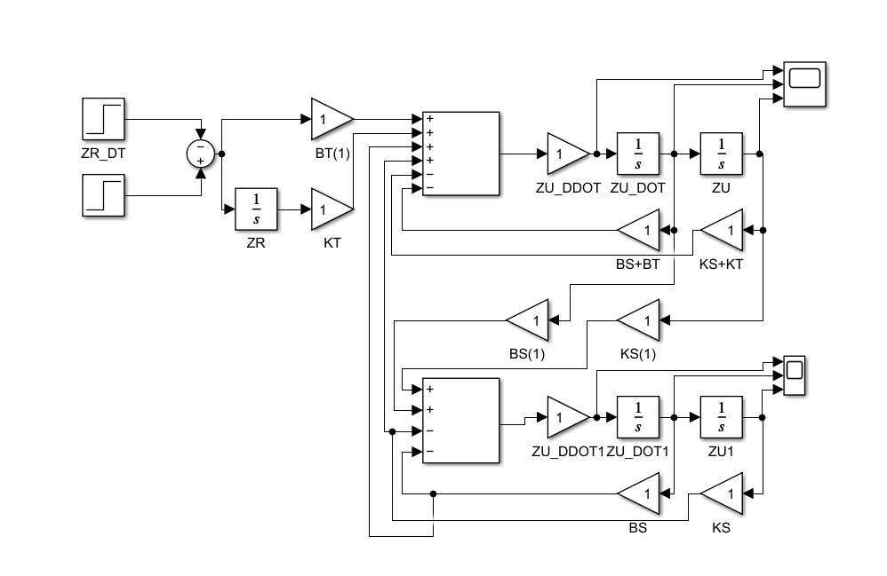

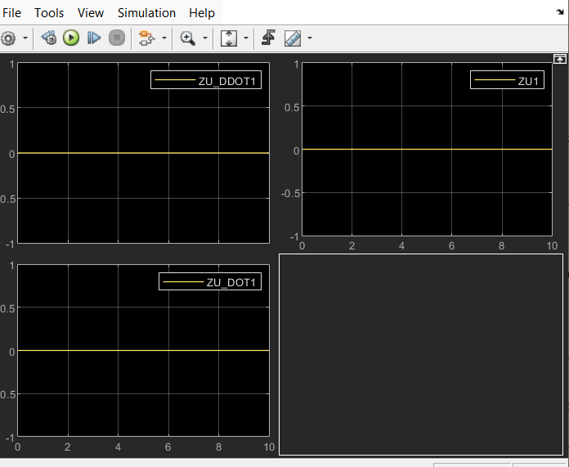

-----------------------------<(SIMSCAPE)>-------------------------------

