-----------------------------<(M File)>-------------------------------

clc;

TR=0:0.01:10;

x0=[0;0;0;0;0];

[t,x]=ode45(@Task2Fun,TR,x0);

x1=x(:,1);

x1_dot=x(:,2);

x1_ddot=gradient(x1_dot)./gradient(t);

x2=x(:,3);

x2_dot=x(:,4);

x2_ddot=gradient(x2_dot)./gradient(t);

subplot(2,3,1);

plot(t,x1);xlabel('time');ylabel('x1');

subplot(2,3,2);

plot(t,x1_dot);xlabel('time');ylabel('x1 dot');

subplot(2,3,3);

plot(t,x1_ddot);xlabel('time');ylabel('x1 double dot')

subplot(2,3,4);

plot(t,x2);xlabel('time');ylabel('x2');

subplot(2,3,5);

plot(t,x2_dot);xlabel('time');ylabel('x2 dot');

subplot(2,3,6);

plot(t,x2_ddot);xlabel('time');ylabel('x2 double dot')

%%%%%%%%%%%%%%%%%%%%

function dy=Task2Fun(t,y)

f=1;

dy(1)=y(2);

dy(2)=1/4*(f - 8*y(2) - 5*y(1) + 8*y(4) + 5*y(5));

dy(3)=y(4);

dy(5)=1/4*(5*y(1) + 4*y(4) - 5*y(5));

dy(4)=1/4*(8*y(2) + 4*dy(5) - 16*y(4));

dy=dy';

end

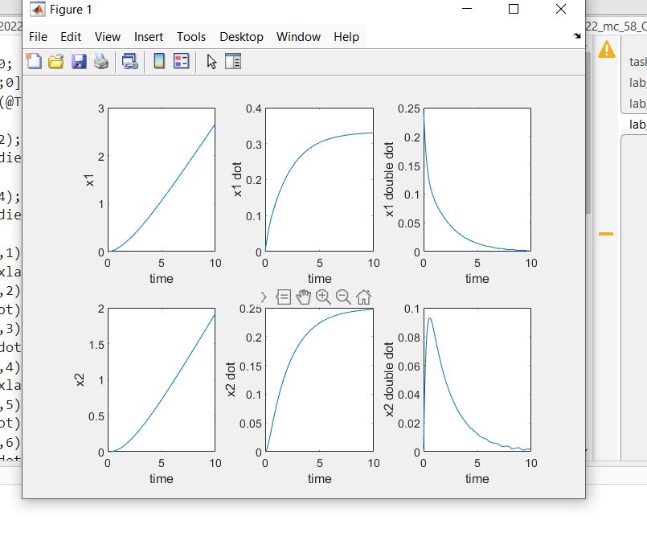

-----------------------------<(Simulink)>-------------------------------

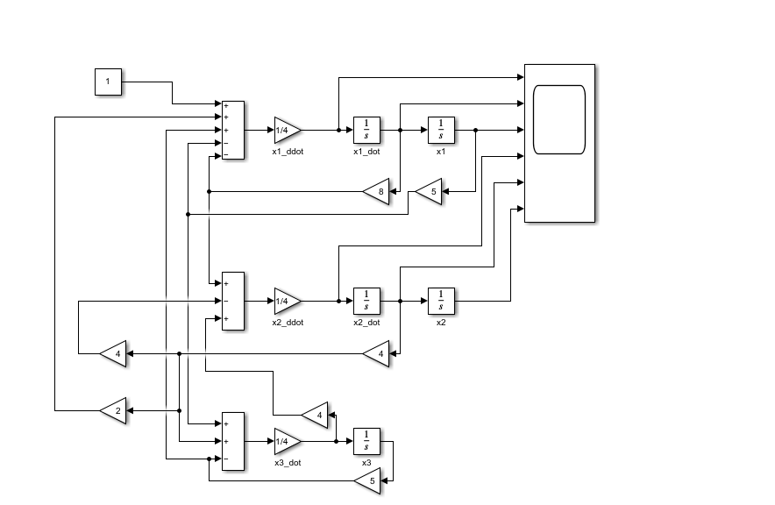

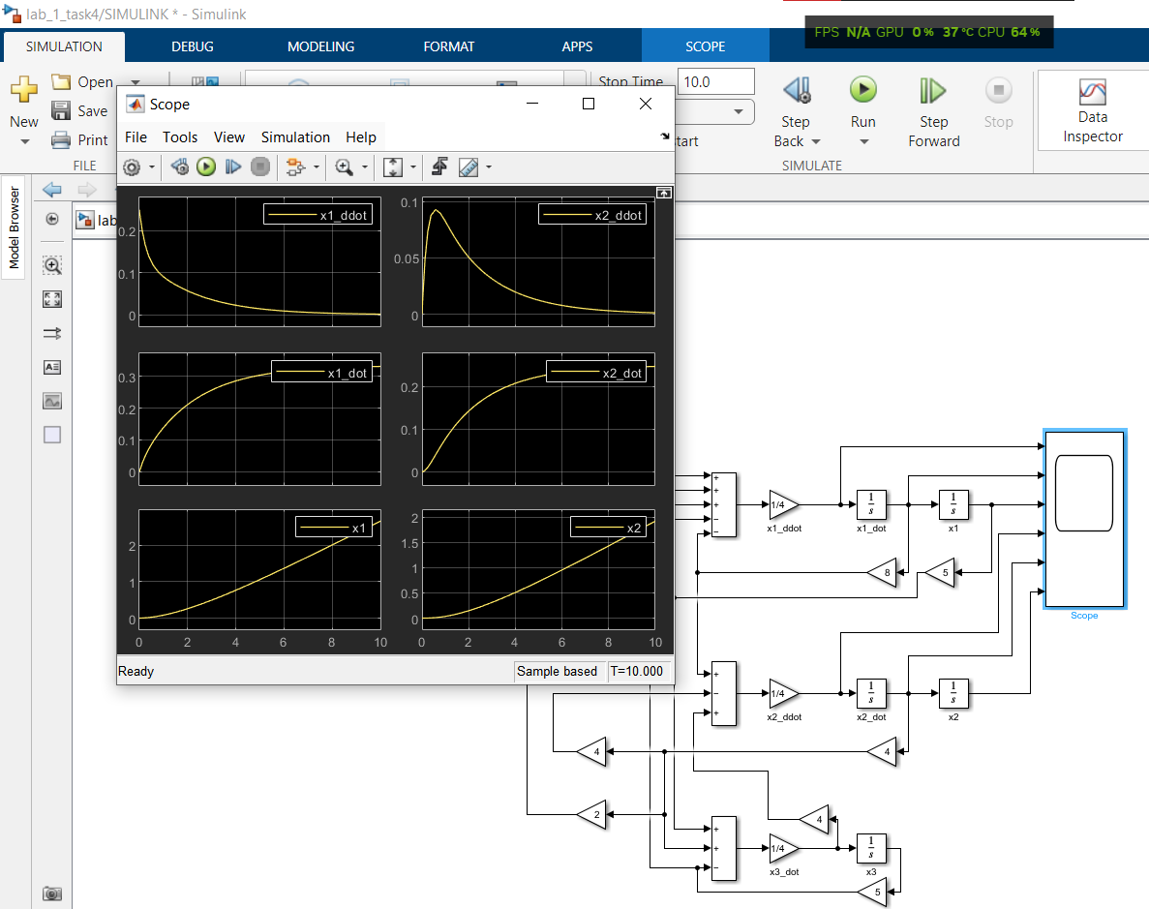

-----------------------------<(SIMSCAPE)>-------------------------------

