-----------------------------<(M File)>-------------------------------

function dy=Task4Fun(t,y,f)

m1=1;

m2=4;

k1=3;

k2=2;

k3=1;

c1=0.03;

c2=0.02;

c3=0.01;

dy(1)=y(2);

dy(3)=y(4);

dy(2)=1/m1\*(f-(k1+k2)\*y(1)-(c1+c2)\*y(2)+c2\*y(4)+k2\*y(3));

dy(4)=1/m2\*(-(c2+c3)\*y(4)-(k2+k3)\*y(3)+k2\*y(1)+c2\*y(2));

dy=dy';

end

clc;

query=input('Do you want to analyze the system at single Force (5N) or on a range of forces? (Single/Range) >> ','s');

TR = [0 10];

X0 = [0;0;0;0];

if query=="Single" || query=="single"

range=[5,5];

inc=1;

elseif query=="Range" || query=="range"

range=input('Please enter a start and an end value for the force in the format [start,end] >> ');

inc=input('Please enter an increment value >> ');

end

for F=range(1):inc:range(2)

[t,y]=ode45(@(t,y) Task4Fun(t,y,F),TR,X0);

x1=y(:,1);

v1=y(:,2);

x2=y(:,3);

v2=y(:,4);

subplot(1,4,1);

plot(t,x1);

hold on;

xlabel('time');

ylabel('Displacement-1');

subplot(1,4,2);

plot(t,v1);

hold on;

xlabel('time');

ylabel('Velocity-1');

subplot(1,4,3);

plot(t,x2);

hold on;

xlabel('time');

ylabel('Displacement-2');

subplot(1,4,4);

plot(t,v2);

hold on;

xlabel('time');

ylabel('Velocity-2');

end

text="";

for i=range(1):inc:range(2)

text(end+1)=sprintf("%dN force",i);

end

text=text(2:end);

for i=1:4

subplot(1,4,i);legend(text);

end

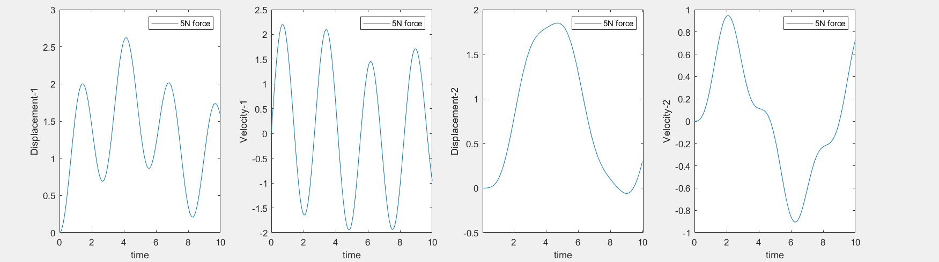

-----------------------------<(Simulink)>-------------------------------

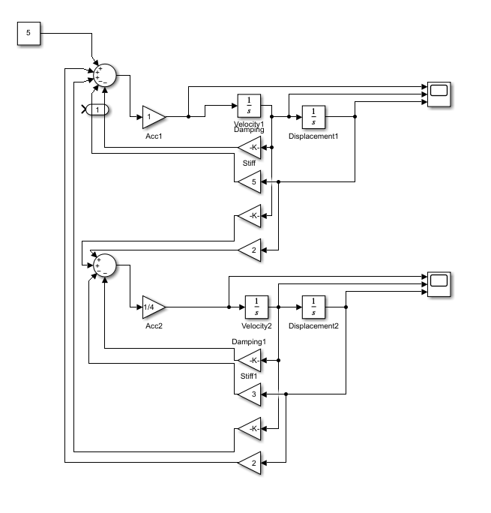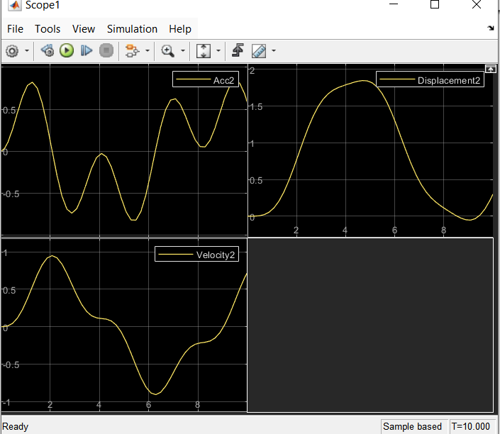

-----------------------------<(SIMSCAPE)>-------------------------------

