EXAMPLE_1

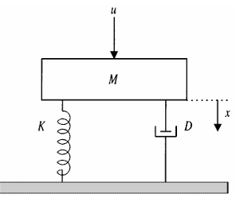

-----------------------------<(M File)>-------------------------------

X0=[0;0];%initial condiitons are zero

TR=[0 10];%time response RANGE

%t=0:0.1:50;

[t,x]=ode45(@func1,TR,X0);

Displacement=x(:,1)

Velocity=x(:,2)

plot(t, Displacement)

hold on

plot(t,Velocity)

acceleration = gradient(Velocity,t);

hold on

plot(t,[0;acceleration])

ylabel('x,v,a')

xlabel('time')

legend("displacement","velocity","acceleration");

%state variables give the following function

function dx = func1(t,x)

M=10;B=5;K=5;F=5;

dx(1)=x(2)%for x dot

dx(2)=(F-B*x(2)-K*x(1))/M %for x dot dot

dx = dx';

end

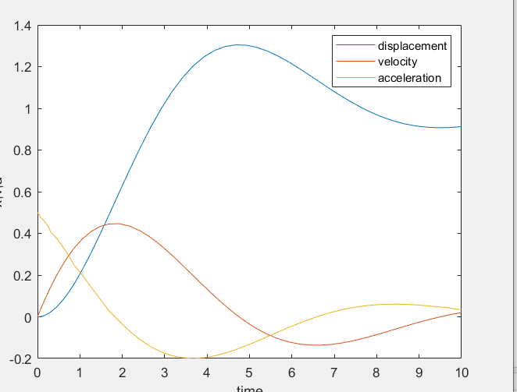

-----------------------------<(Simulink)>-------------------------------

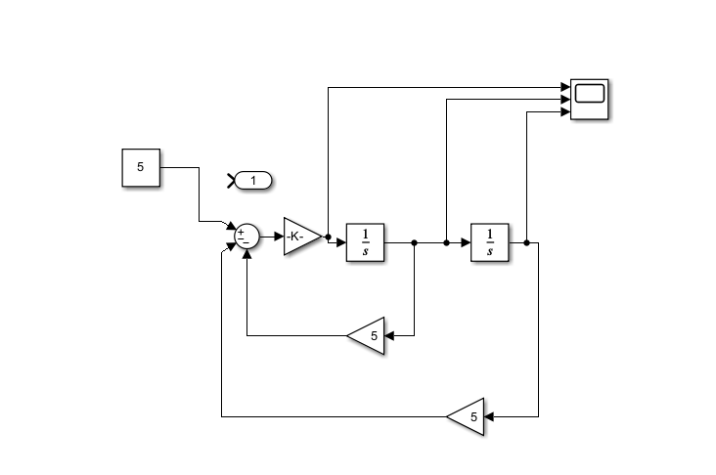

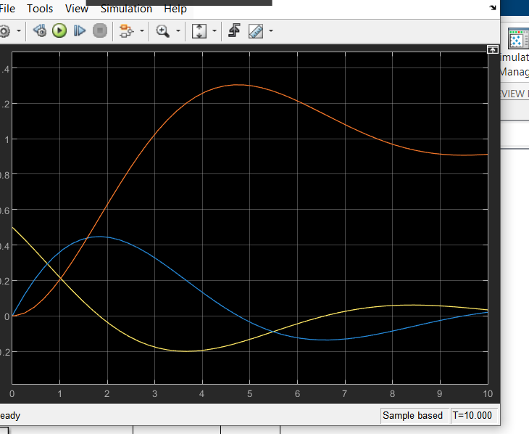

-----------------------------<(SIMSCAPE)>-------------------------------

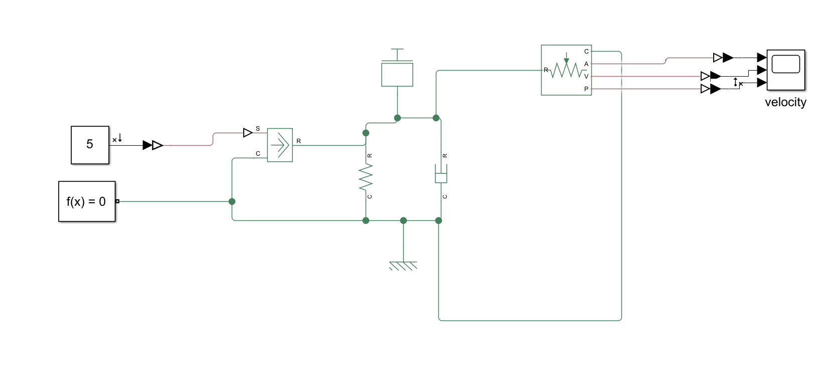

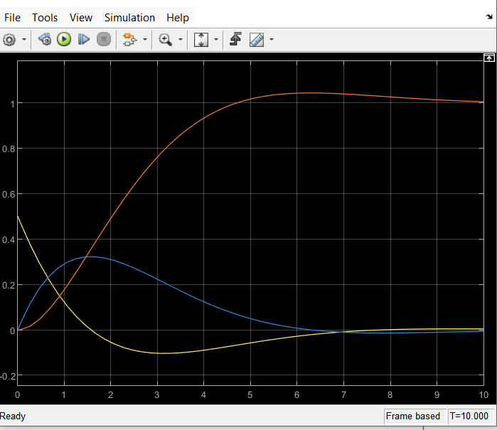

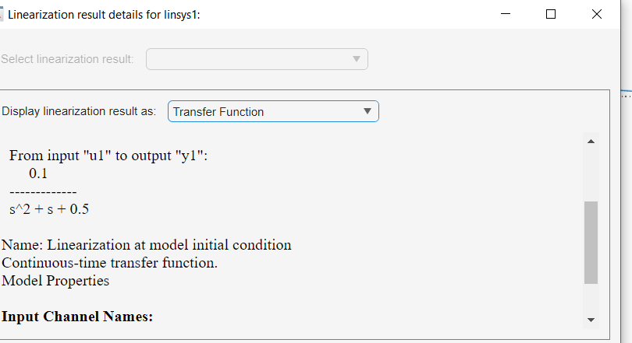

EXAMPLE_2

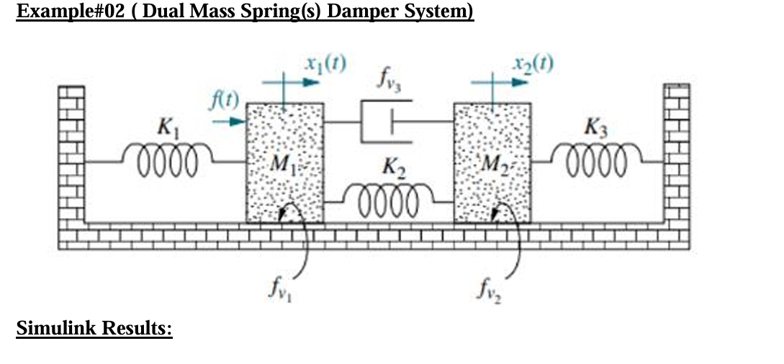

-----------------------------<(M File)>-------------------------------

% For constant tourque 5Nm

clc

clear

TR = [0 5]; % time RANGE

X0 = [0;0;0;0];%initial conditions

[t,z] = ode45(@func1, TR, X0);%calling thr ide solver to solve by function

%storing given array as vectors

theta1 = z(:, 1);

AngVel1 = z(:, 2);

theta2 = z(:, 3);

AngVel2 = z(:, 4);

%plotting the angular displacements and velocities

acc1 = diff(AngVel1);

acc2= diff(AngVel2);

plot(t,theta1,t,AngVel1,t,[0;acc1],t,theta2,t,AngVel2,t,[0;acc2]);

xlabel('time')

legend('Angular Displacement 1','Angular Velocity 1','Angulara acceleration 1','Angular Displacement 2','Angular Velocity 2','Angulara acceleration 2')

ylabel('position & Velocity')

title("m-file")

%function containing the differentialequations

function dx = func1(~, x)

% Values of Coefficients

J1=1; J2=10; D1=0.9; D2=0.02; k=3;T=5;

% State Equations

dx(1) = x(2);

dx(3) = x(4);

dx(2) = (T-D1*x(2)-k*x(1)+k*x(3))/J1;

dx(4) = (-k*x(3)-D2*x(4)+k*x(1))/J2;

dx = dx';

end

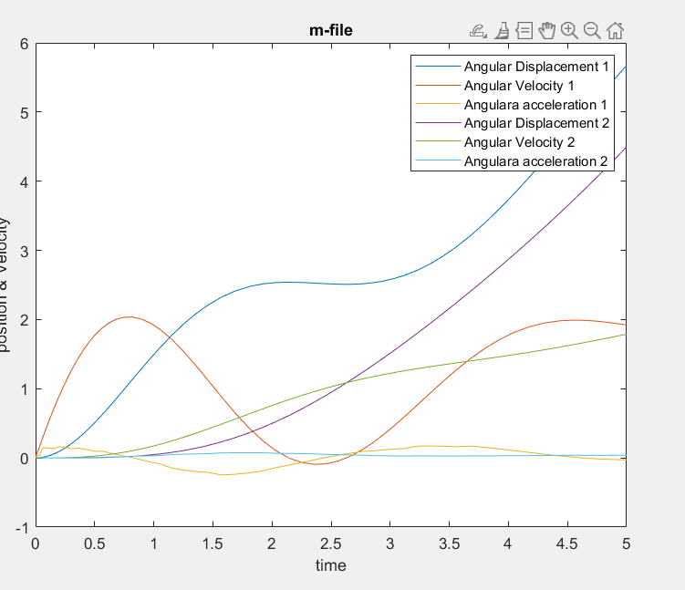

-----------------------------<(Simulink)>-------------------------------

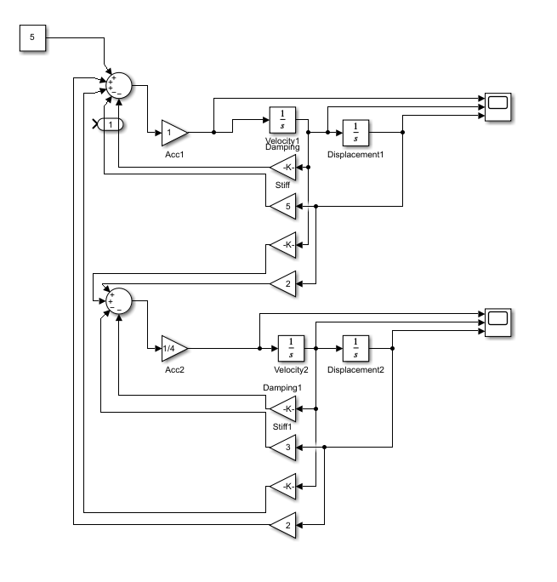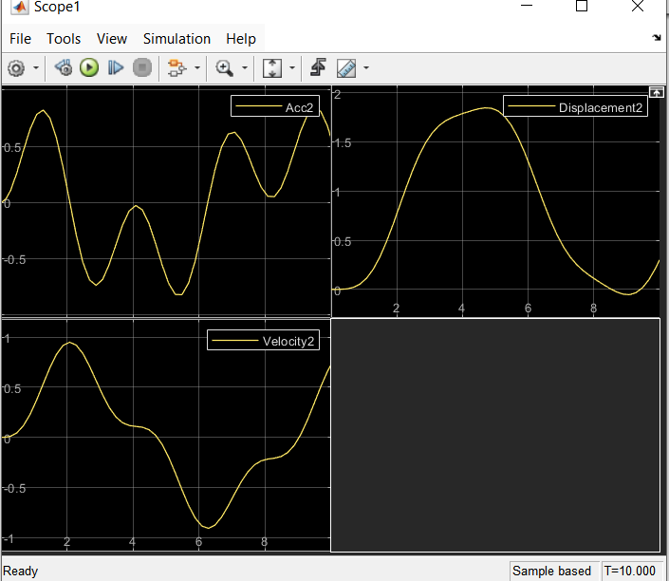

-----------------------------<(SIMSCAPE)>-------------------------------

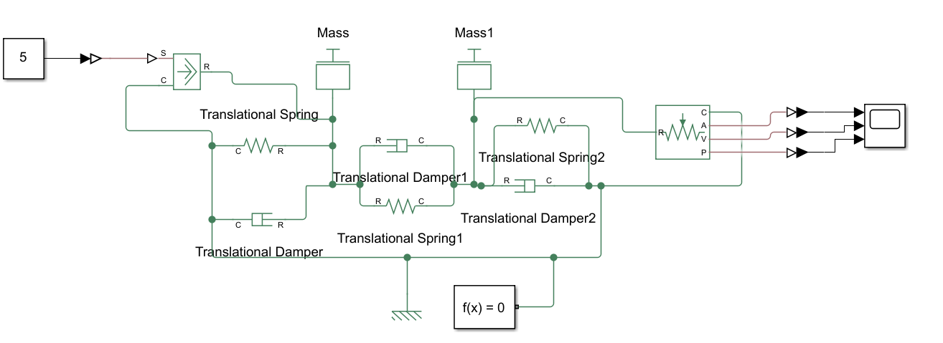

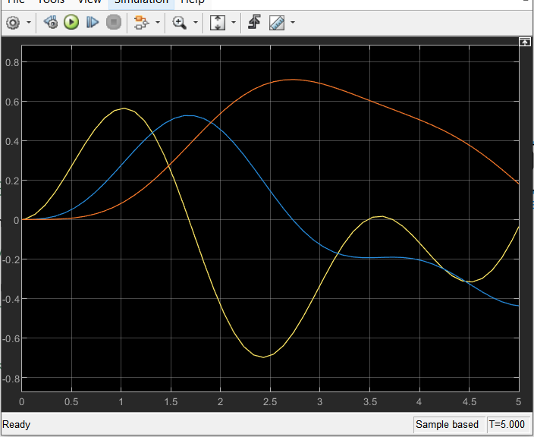

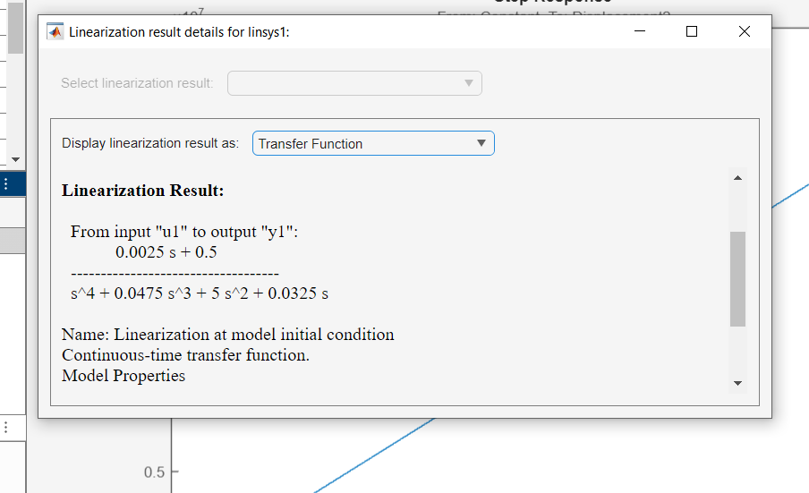

EXAMPLE_3

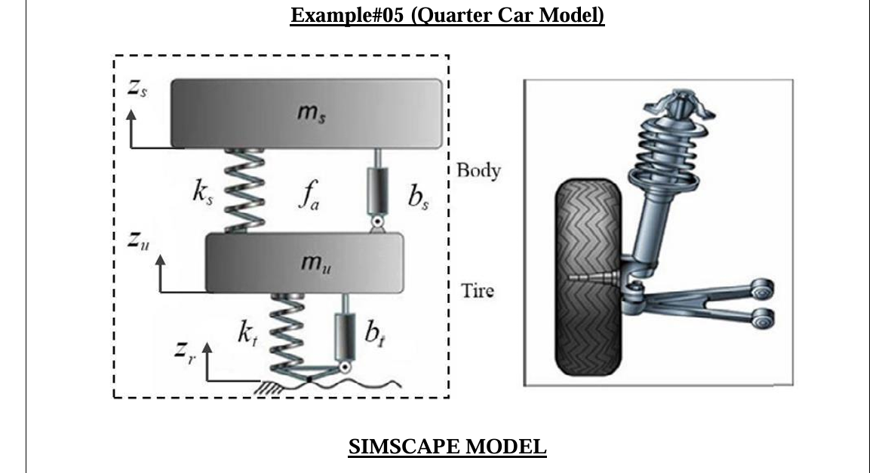

-----------------------------<(M File)>-------------------------------

syms s zrdot

A=[(mu*s^2+(bs+bt)*s+ks+kt) , -(ks+bs*s) ; -(ks+bs*s) , (ms*s^2+ks+bs*s)];

B=[(kt/s+bt)*zrdot;0];

C=A\B;

zs=C(1);

G=zs/zrdot;

G=collect(G,s);

[num,den]=numden(G);

num=sym2poly(num);den=sym2poly(den);

num=num/den(1); %dividing by den(1) means dividing by the leading coefficient of denominator i.e., 20 in this case. Done to match the outputs.

den=den/den(1);

G=tf(num,den)

-----------------------------<(Simulink)>-------------------------------

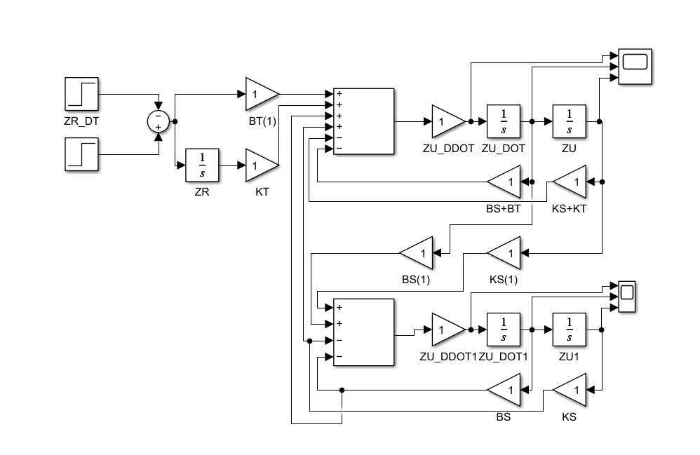

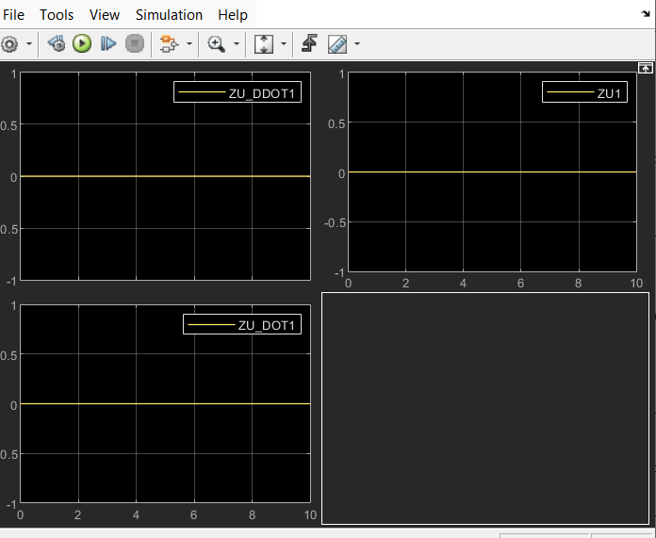

-----------------------------<(SIMSCAPE)>-------------------------------

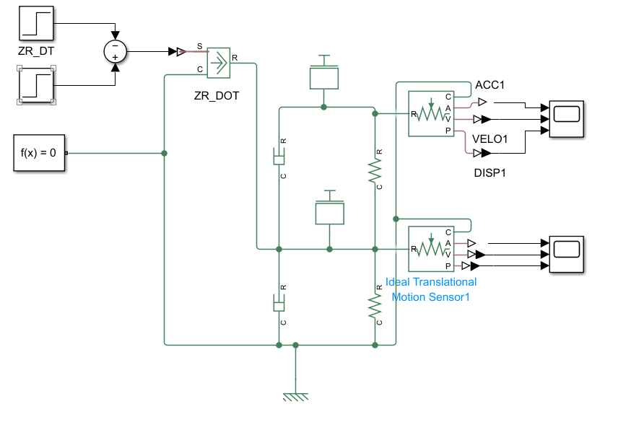

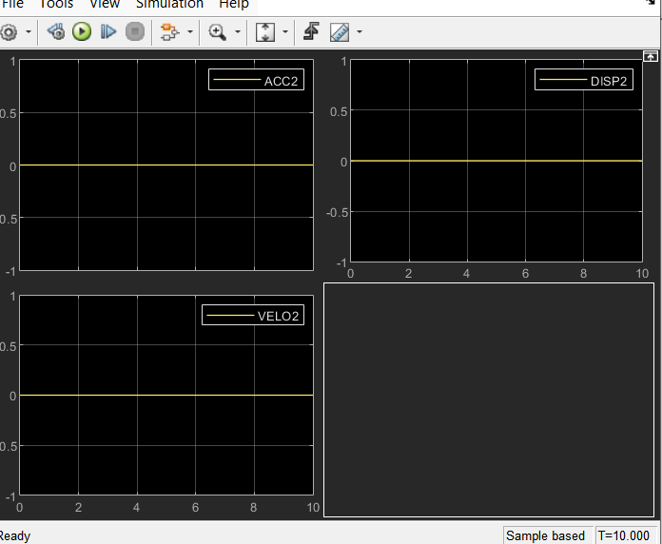

EXAMPLE_4

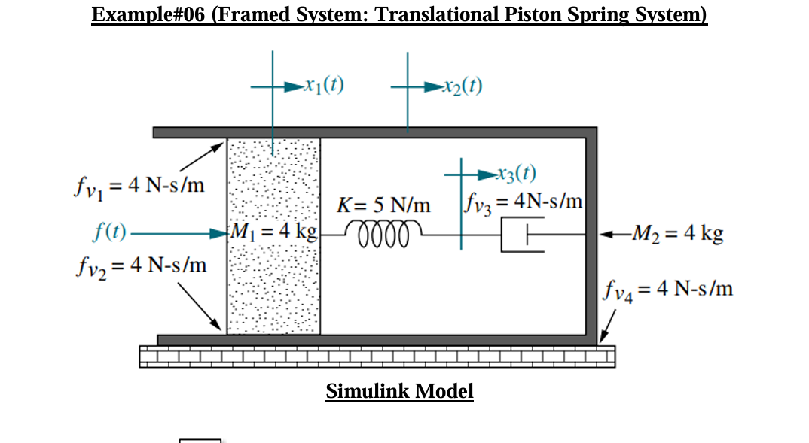

-----------------------------<(M File)>-------------------------------

clc;

TR=0:0.01:10;

x0=[0;0;0;0;0];

[t,x]=ode45(@Task2Fun,TR,x0);

x1=x(:,1);

x1_dot=x(:,2);

x1_ddot=gradient(x1_dot)./gradient(t);

x2=x(:,3);

x2_dot=x(:,4);

x2_ddot=gradient(x2_dot)./gradient(t);

subplot(2,3,1);

plot(t,x1);xlabel('time');ylabel('x1');

subplot(2,3,2);

plot(t,x1_dot);xlabel('time');ylabel('x1 dot');

subplot(2,3,3);

plot(t,x1_ddot);xlabel('time');ylabel('x1 double dot')

subplot(2,3,4);

plot(t,x2);xlabel('time');ylabel('x2');

subplot(2,3,5);

plot(t,x2_dot);xlabel('time');ylabel('x2 dot');

subplot(2,3,6);

plot(t,x2_ddot);xlabel('time');ylabel('x2 double dot')

%%%%%%%%%%%%%%%%%%%%

function dy=Task2Fun(t,y)

f=1;

dy(1)=y(2);

dy(2)=1/4*(f - 8*y(2) - 5*y(1) + 8*y(4) + 5*y(5));

dy(3)=y(4);

dy(5)=1/4*(5*y(1) + 4*y(4) - 5*y(5));

dy(4)=1/4*(8*y(2) + 4*dy(5) - 16*y(4));

dy=dy';

end

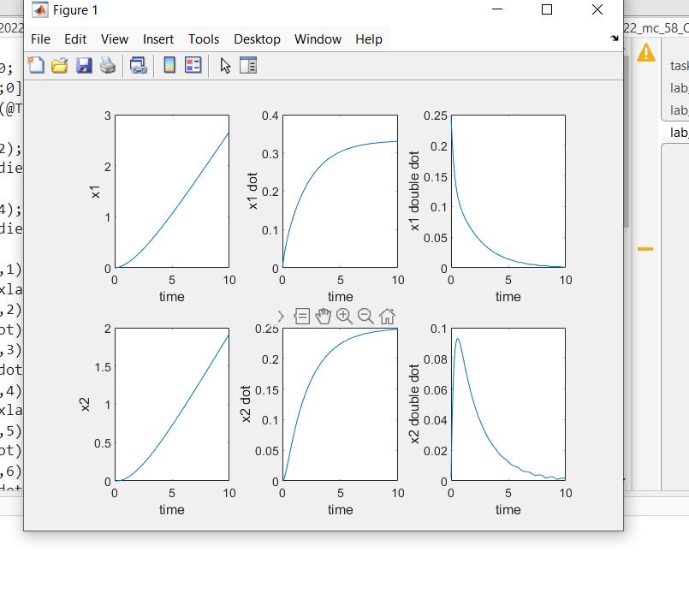

-----------------------------<(Simulink)>-------------------------------

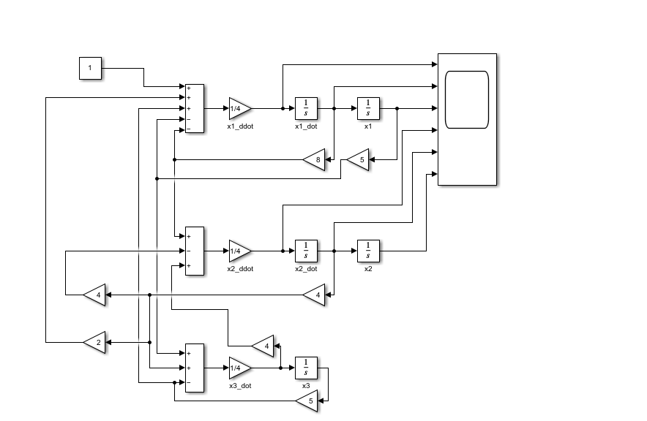

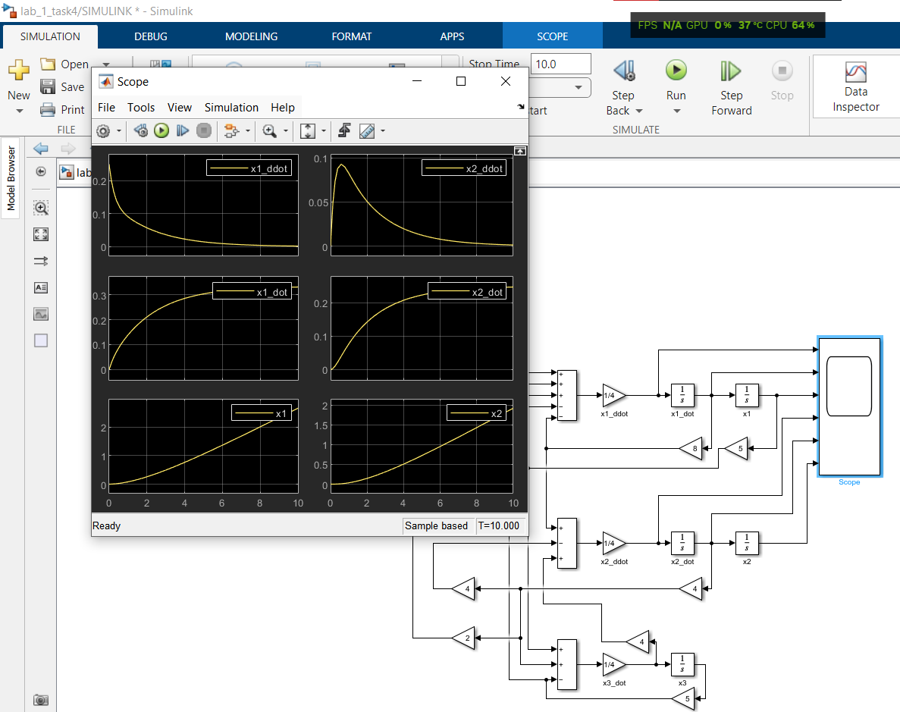

-----------------------------<(SIMSCAPE)>-------------------------------

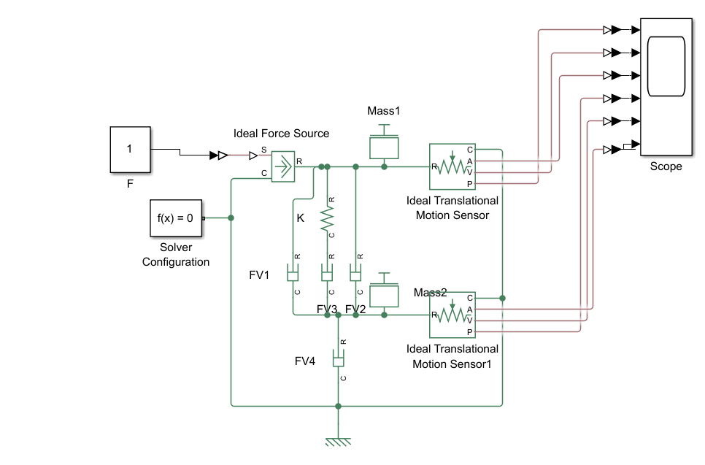

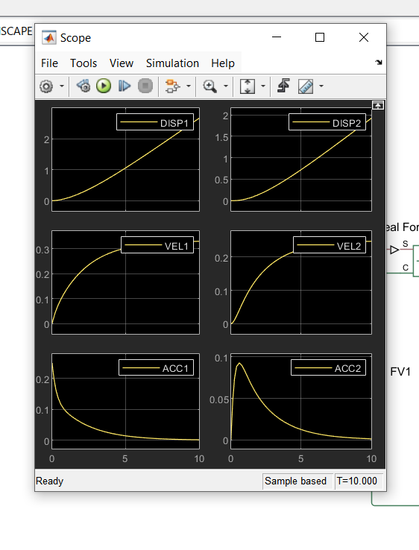

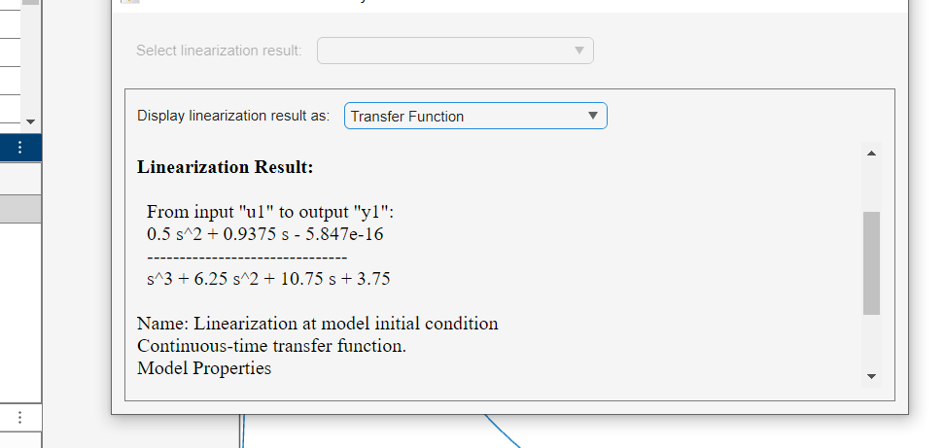

Example_5

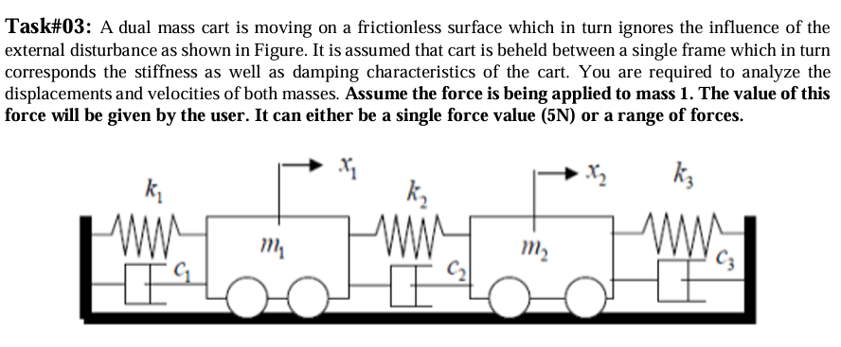

-----------------------------<(M File)>-------------------------------

function dy=Task4Fun(t,y,f)

m1=1;

m2=4;

k1=3;

k2=2;

k3=1;

c1=0.03;

c2=0.02;

c3=0.01;

dy(1)=y(2);

dy(3)=y(4);

dy(2)=1/m1*(f-(k1+k2)*y(1)-(c1+c2)*y(2)+c2*y(4)+k2*y(3));

dy(4)=1/m2*(-(c2+c3)*y(4)-(k2+k3)*y(3)+k2*y(1)+c2*y(2));

dy=dy';

end

clc;

query=input('Do you want to analyze the system at single Force (5N) or on a range of forces? (Single/Range) >> ','s');

TR = [0 10];

X0 = [0;0;0;0];

if query=="Single" || query=="single"

range=[5,5];

inc=1;

elseif query=="Range" || query=="range"

range=input('Please enter a start and an end value for the force in the format [start,end] >> ');

inc=input('Please enter an increment value >> ');

end

for F=range(1):inc:range(2)

[t,y]=ode45(@(t,y) Task4Fun(t,y,F),TR,X0);

x1=y(:,1);

v1=y(:,2);

x2=y(:,3);

v2=y(:,4);

subplot(1,4,1);

plot(t,x1);

hold on;

xlabel('time');

ylabel('Displacement-1');

subplot(1,4,2);

plot(t,v1);

hold on;

xlabel('time');

ylabel('Velocity-1');

subplot(1,4,3);

plot(t,x2);

hold on;

xlabel('time');

ylabel('Displacement-2');

subplot(1,4,4);

plot(t,v2);

hold on;

xlabel('time');

ylabel('Velocity-2');

end

text="";

for i=range(1):inc:range(2)

text(end+1)=sprintf("%dN force",i);

end

text=text(2:end);

for i=1:4

subplot(1,4,i);legend(text);

end

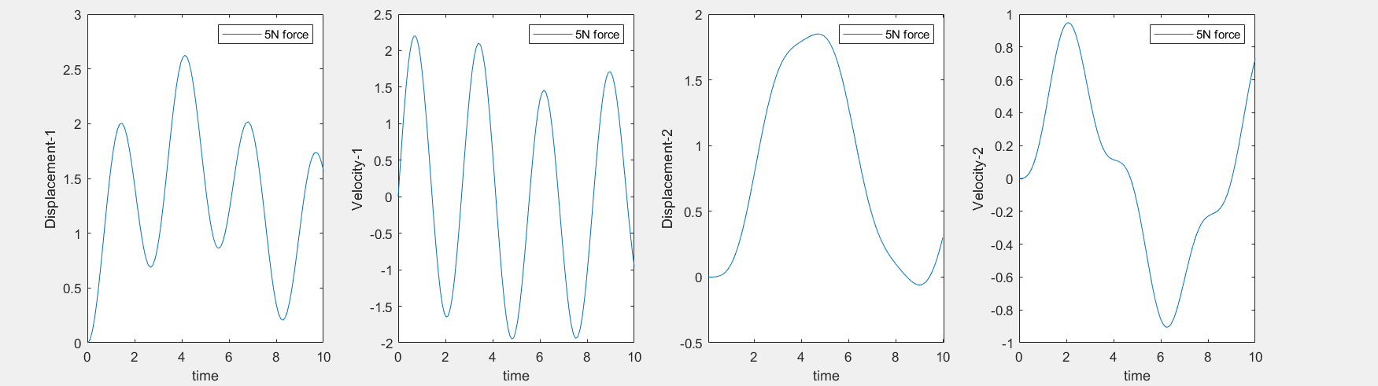

-----------------------------<(Simulink)>-------------------------------



-----------------------------<(SIMSCAPE)>-------------------------------

