ECE295 Written Document 1
Prepared By Team 06
PRA 0105
Date: 2025. Feb, 9th

1.0 Receiving Chain of Software Defined Radio (SDR)

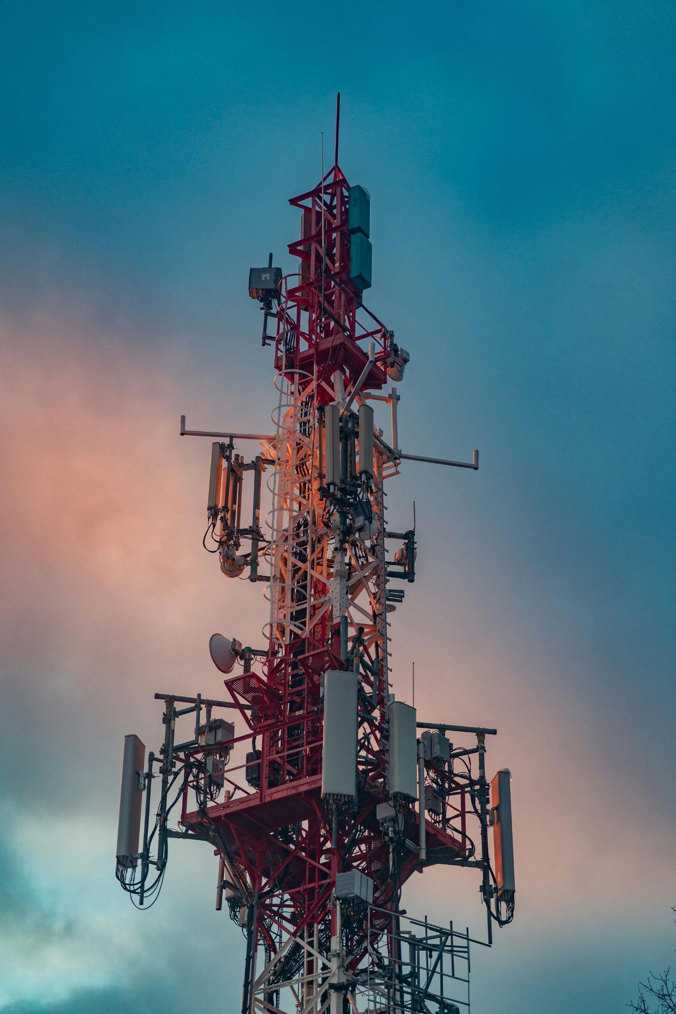
Data transmission has evolved over decades. One significant innovation in telecommunication is SDR. SDR integrates hardware and software components to perform signal processing for data transmission and receiving [2]. Analog hardware serves as the front-end component in SDRs, an interface between the internal processor and antenna. It performs signal processing to the analog readings before it reaches the demodulator.

We intend to develop a hardware system consisting of modules to achieve signal filtering and processing. The output signal allows demodulators to perform analog-to-digital conversion (ADC) [6]. This system is compact and efficient. It is hardware reconfigurable to adapt to any receiving chain of SDR nowadays.
Figure 1. Antenna [1]

2.0 Theory of Operation: Signal Processing
Our design filters, limits, frequency convert and voltage amplification for the incoming signal. The modules collectively output a precise analog signal for ADC.

2.1 Bandpass Filter
The bandpass filter (BF) ensures only shortwave radio signals are passing through. It takes input directly from the antenna. Internal components block the signal in the amplitude-modulated and frequency-modulated frequency range [4]. The output obtains an analog signal within 8 MHz to 16 MHz range [3] and results in an isosceles triangle-shaped cutoff depicted in Figure 2.
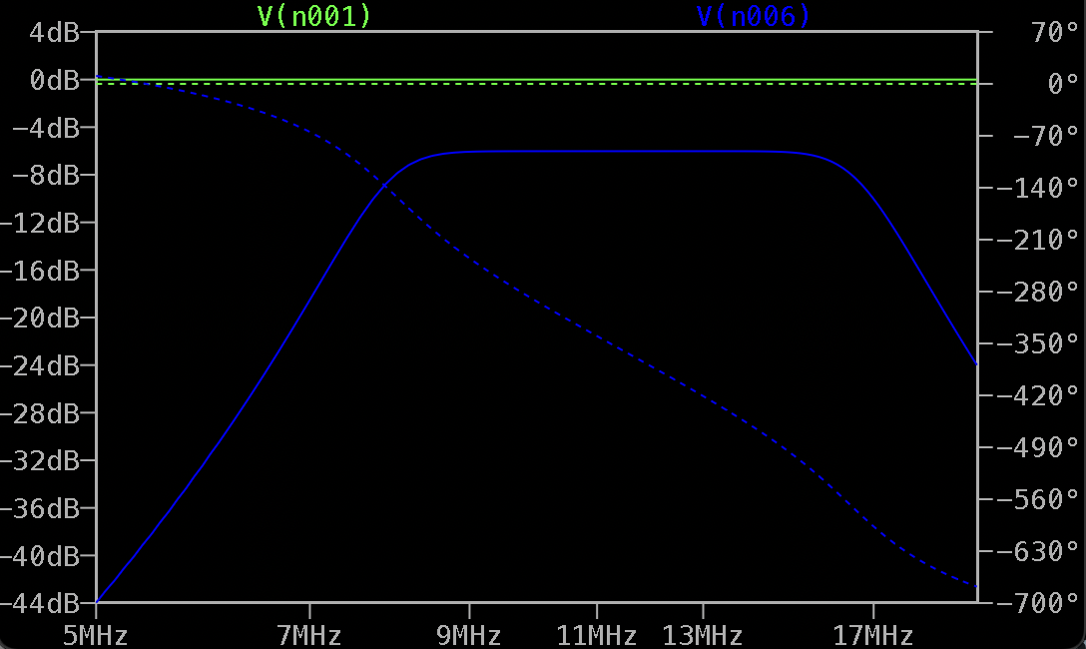
Figure 2. Vin and Vout signals of BF

2.2 Limiter
The limiter ensures that the sensitive components are protected from excessive power. Signals from the antenna have various amplitudes and energy. The limiter detects when the voltage exceeds a threshold of ±0.7V [3] and protects the printed circuit board (PCB) by clamping the overvoltage to dissipate high transient power surges as depicted in Figure 3.
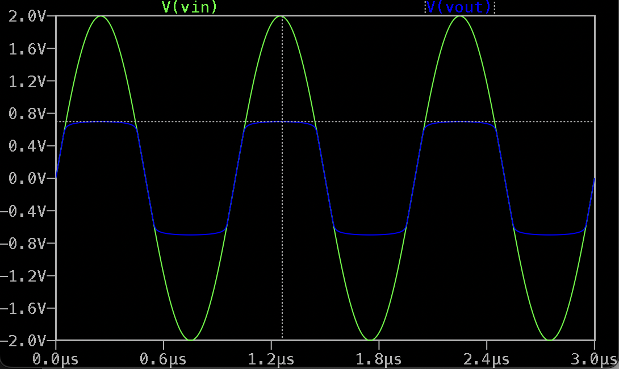
Figure 3. Vin and Vout signals of limiter

2.3 Quadrature Mixer
In demodulation, downconverted in-phase and quadrature signals (I/Q) are required. The quadrature mixer parallelly processes the incoming signal by mixing with two orthogonal (90° phase difference) signals from local oscillator (LO) to shift the signal down to the baseband frequency as shown in Figure 4 with a low-pass filter while preserving amplitude and phase information [5].
RF
LO
f_{IF} = f_{LO} - f_{RF}
IF
f
dB
Difference frequency at Quadrature Mixer
Figure 4. Expected output of quadrature mixer

2.4 I/Q Amplifier
The antenna signal has weak energy and the process of filtering and mixing introduces energy losses, making ADC impossible. The I/Q amplifier increases the amplitude of I/Q signals while maintaining a low noise figure, while providing a voltage upshift to both signals by 2.5V [3]. This reconfigures the post-mixed signal to become a clear waveform with proper voltage amplitude. The output signal is connected to the demodulator of Subsystem B.

t
V
I/Q Amplifying Process
Amplified + Offset
Original
2.5 V
Figure 5. Expected output of I/Q amplifier

3.0 Proposed Analog Signal Receiver System Design
We use electronic components including capacitors, inductors, diodes, transistors, resistors, and operational amplifiers (Op-amp) to design circuits to perform the required task. All design specifications of each component and overall structure of the subsystem is carefully considered to ensure the overall performance achieves the expectation.

3.1 Targeted requirements
There are various aspects of performance requirements, thoroughly explained in Table 1, according to the ICD [3].

Table 1. Modules and requirements
Modules | Function | Metrics | Requirement Specification | Explanation
BF | Filter unexpected signal | dB  (decibels) | 3dB cutoff at 8MHz and 16Mhz | Pick up targeted signal
Limiter | Limit voltage | V(volts) | Limit signal to ± 0.7V | Protect circuit element
Quadrature mixer | Preserve phase integrity | Hz (hertz) | I/Q maintains 90°±12.5° phase difference, Q lagging I | Maintain essential characteristics of original signal
 | Preserve amplitude similarity | dB  (decibels) | I/Q amplitudes must not differ more than 1dB
 | Downconvert frequency | Hz (hertz) | Cutoff frequency of 96 kHz | Create readable signals for demodulator
I/Q amplifier | Amplify signal | dB (decibels) | 30dB minimum gain | Signal clarity
 | Offset voltage | V (volts) | I/Q signal between 0-5V | Assist ADC process

3.2 Component Description
In this section, we discuss our approach for each module in the block diagram, see Figure. 6, and the reasoning behind our decisions.
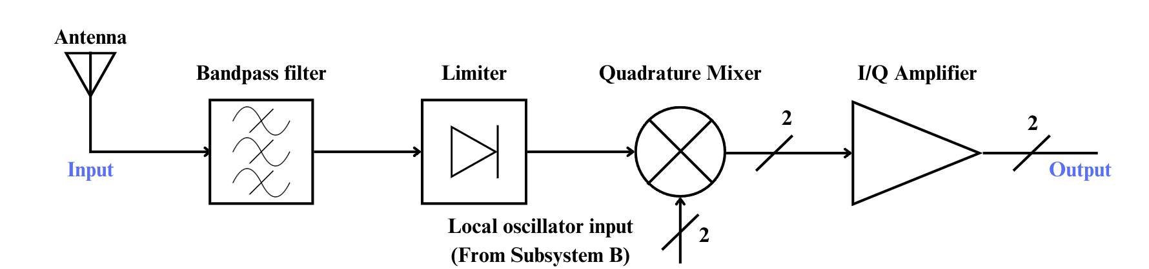
Figure 6. Modular block diagram

3.2.1 BF

A BF removes unwanted frequency without any significant loss of signal intensity. We use capacitors and inductors (LC) for the BF because they vary impedance, opposition to the signal, to frequency while minimizing power loss [7]. In LC, energy is stored and transferred to maximize efficiency, see Figure 7(a). With multiple LCs, a sharper frequency response of unwanted signals is expected, minimizing their influence on signal processing.

3.2.2 Limiter

We use silicon diodes for the limiter because diodes act like short circuits when voltage across them reaches a certain value. It should ensure the received signals do not exceed ± 0.7 V which protects downstream components like the quadrature mixer. For silicon diodes, the threshold is 0.7 Volts. By configuring two diodes D1 and D2 in parallel with opposite connections shown in Figure 7(b), the limiter clips both positive and negative peaks of the signal to ensure the output stays within ± 0.7 V.
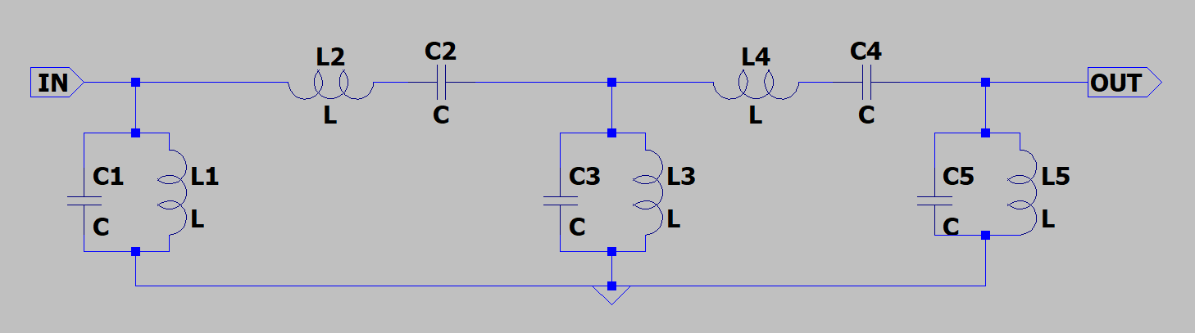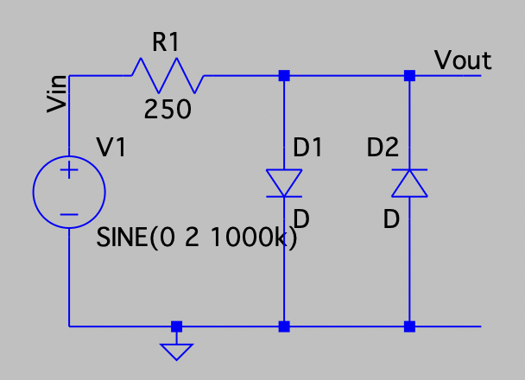
(a) Schematic of multi-staged LC BF (b) Schematic of limiter
Figure 7. Design for BF and limiter

3.2.3 Quadrature Mixer (Appendix B)

We choose two pairs of diode-based mixers in combination with LC lowpass filters. Such configuration is efficient. The diode mixer is passive and draws no external power, reducing the complexity compared to other mixers. It generates the difference frequency and picks the down-converted signal with an LC lowpass filter, ensuring the precision of the desired down-converted signal. With such a combination, we can extract the signal at a desired frequency [5].

3.2.4 I/Q Amplifier

Op-amps have been selected for our application. Op-amp provides high gain, low distortion, and low noise, critical for maintaining signal integrity after the filtering and mixing stage [12]. The linear property of op-amp allows precise control of the gain. We also use an op-amp to produce an offset.

4.0 Post-Design Verification
The post-design verifications are performed after the component value selection. The prototype of each module would be built on a protoboard and corresponding equipment would be used [8][9][10][11]. Rapid-prototyping and iterative design process is expected before the finalization of the PCB to address issues during verification.

4.1 BF Frequency Analysis
This experiment focuses on the circuit response, cut-off frequency and signal attenuation, to a range of frequency input. The following equipment and procedures are required to perform the analysis in Table. 2.

Table 2. BF tests
Equipment | Procedure | Expected
- Prototype circuit  - Function generator  - Oscilloscope | 1. Select a 2 Vpp Sine wave of 1kHz  2. Sweep the signal from 1MHz to 20 MHz  3. Connect function generator to input port  4. Wire oscilloscope to output and observe | - Isosceles triangle-shape  - 3dB cutoff at 8 MHz and 16 Mhz [3]

4.2 Voltage Protection Verification
This test focuses on the prevention of voltage overload on the receiving chain. Test specification is demonstrated in Table. 3.

Table 3. Limiter tests
Equipment | Procedure | Expected
- Function generator  - Protoboard  - Oscilloscope | 1. Generate a 2 Vpp, 8MHz sinusoidal waveform via function generator as input  2. Connect the oscilloscope to the output  3. Sweep frequency of the input waveform from 8Mhz to 16Mhz  4. Observe through an oscilloscope | - Output electric waveforms need to be clamped within the ± 0.7 V

4.3 Quadrature Mixer Amplitude and Phase Verification
The mixer amplitude and phase verification ensure a precise down-conversion of the antenna signal and the phase difference of the IQ signal. Table. 4 provides a detailed procedure for such verification.
Table 4. Quadrature Mixer tests
Equipment | Procedure | Standard
- Prototype circuit  - Function generator  - Oscilloscope | 1. Generate two 3.3Vpp, 12MHz sine signals with 0°and 90° phase differences using function generator  2. Generate a 0.5Vpp, 90°±12.5° signal  3. Connect the two signals to the LO inputs and the 10 MHz signal to RF input  4. Observe the I/Q on oscilloscope | - IQ phase between 90°±12.5° at all frequencies of RF inputs  - Cutoff frequency of 96kHz

4.4 I/Q Amplifier Performance Test
This test focuses on amplitude gain, output frequency and linearity, as displayed in Table 5.
Table 5. IQ amplifier tests
Equipment | Procedure | Standard
- Prototype circuit  - Function generator  - Oscilloscope | 1. Select a 2Vpp Sine wave of 1kHz  2. Sweep the signal up to 96kHz  3. Connect function generator to input port  4. Wire oscilloscope to output and observe | - Minimum gain of 30dB  - Linear response to all frequency  - Output between 0-5V  - I/Q outputs have an amplitude balanced at 1dB

4.5 Failure Procedure
Failure analysis is conducted on substandard results and failure; furthermore, we will reconfigure the module to ensure a rapid design process while maintaining the overall performance of the subsystem.

5.0 Conclusion
Our signal processing design has wide applications in telecommunications and great potential due to its modular design. The proposed design theoretically meets all target requirements with thorough consideration.

Next, we would finalize the design specification through computer simulation and component selection from vendors. The functionality of modules will be tested on the protoboard before PCB assembly.

Reference

[1] A. Stec, "Steel telecommunication antenna," Pexels, [Online]. Available: https://www.pexels.com/photo/steel-telecommunication-antenna-20520576/. Accessed: Feb. 2, 2025.

[2] Wikipedia. “Software-defined radio” Wikipedia.com. Accessed: Jan. 19,2025. [Online]. Available:
https://en.wikipedia.org/wiki/Software-defined_radio

[3] S. V. Hum. Flexible Radio Transceiver (FLRTRX) Interface Control Document. (2025, Winter). Hardware Design and Communication. Toronto, Canada: University of Toronto

[4] S. V. Hum. Radio Fundamentals. (2025, Winter). Hardware Design and Communication. Toronto, Canada: University of Toronto

[5] K. Cox, "A Quick Guide to Mixer Topologies," Mini-Circuits, Mar. 7, 2022. [Online]. Available: https://blog.minicircuits.com/a-quick-guide-to-mixer-topologies/. Accessed: Feb. 7, 2025.

[6] ElectronicsTutorials, “Analogue to Digital Convertor” electronics-tutorial.ws. Accessed: Feb. 9, 2025. [Online]. Available: https://www.electronics-tutorials.ws/combination/analogue-to-digital-converter.html

[7] Isaac Physics, “Electrical Impedance” isaacpyshics.org. Accessed: Feb. 9,2025. [Online]. Available: https://isaacphysics.org/concepts/cp_electrical_impedance

[8] EDU36311A Triple Output Programmable DC Power Supply, Keysight Technologies., Bayan Lepas, Penang, Malaysia, 2021.

[9] EDU34450A 5 1⁄2 Digit Digital Multimeter, Keysight Technologies., Bayan Lepas, Penang, Malaysia, 2021.

[10] Keysight InfiniiVision 1200 X-Series and EDUX1052A/G Oscilloscopes, Keysight Technologies, Inc., Colorado Spring, Colorado, USA, 2020

[11] EDU33210 Series Trueform Arbitrary Waveform Generator, Keysight Technologies., Bayan Lepas, Penang, Malaysia, 2021.

[12] ElectronicTutorials, “Operational Amplifier Basics” electronics-tutorial.ws. Accessed: Feb. 9, 2025. [Online]. Available: https://www.electronics-tutorials.ws/opamp/opamp_1.html

[13] ElectronicTurotials, “NPN Transistor” electronics-tutorial.ws. Accessed: Feb. 9, 2025. [Online]. Available: https://www.electronics-tutorials.ws/transistor/tran_2.html

Appendix A: Attribution table

Part number | Responsible Member
1.0 | Enpei
2.0 | Enpei
2.1 | Enpei, Jacky
2.2 | Jacky
2.3 | Minghan
2.4 | Minghan
3.0 | Enpei
3.1 | Enpei, Minghan, Jacky
3.2 | Enpei, Minghan, Jacky
4.0 | Minghan, Jacky
4.1 | Enpei
4.2 | Jacky
4.3 | Jacky, Minghan
4.4 | Minghan
5.0 | Jacky, Enpei

Appendix B: Switch Base Mixer

In parallel, the team is developing a switch base mixer. The BJT acts like an active switch driven by the signal from the local oscillator [13]. When the signal from the LO is high (5 volt), the switch is closed and the output is 0 volt. When the LO signal is low (0 volt), the switch is open and the output is the voltage of the signal waveform. The result of the output signal maintains the original signal while creating different frequencies shown in the Fourier Transform Analysis (figure 10). Combined with a LC low pass filter, a down converted signal will be captured.

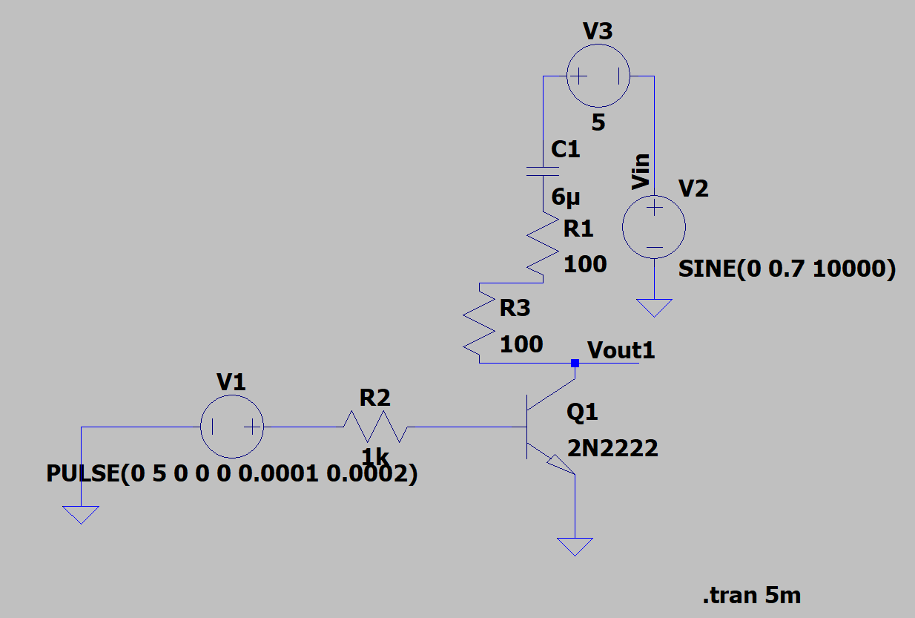
Figure 8, circuit schematic design
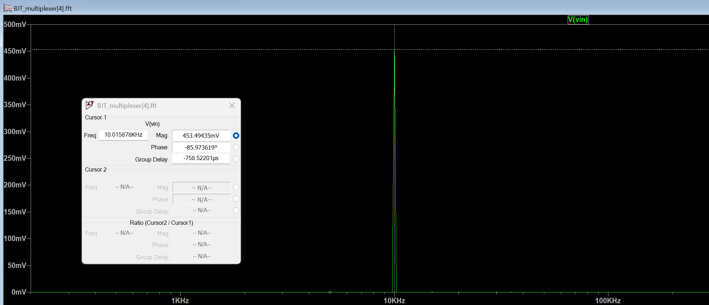
Figure 9, Fourier Transform Analysis of the input signal, only 10kHz
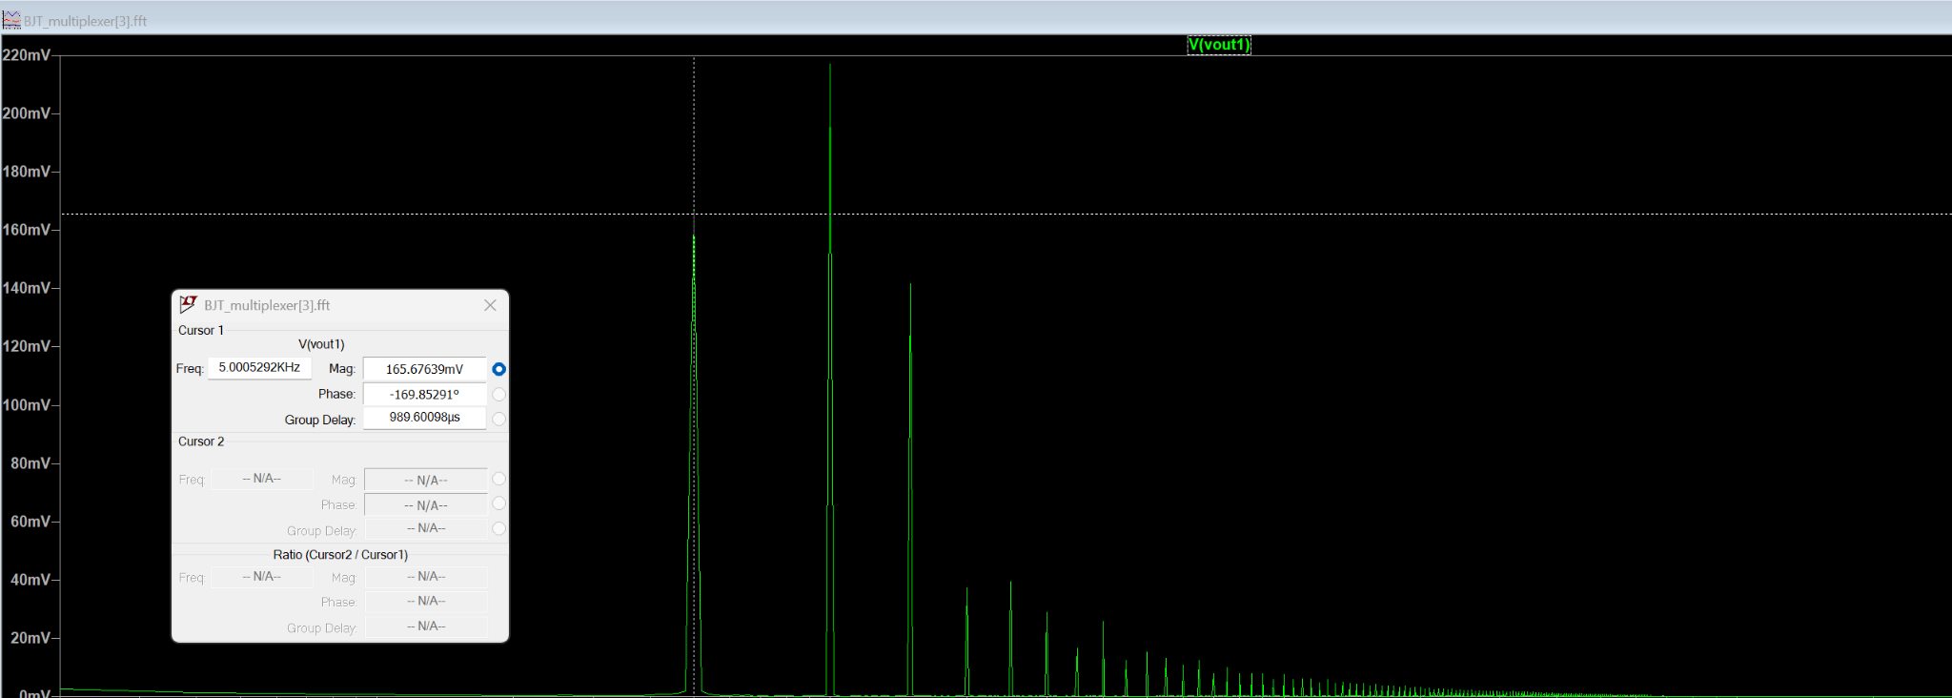
Figure 10, Fourier Transform Analysis of the output signal, a component with 5kHz (down converted) is in the plot

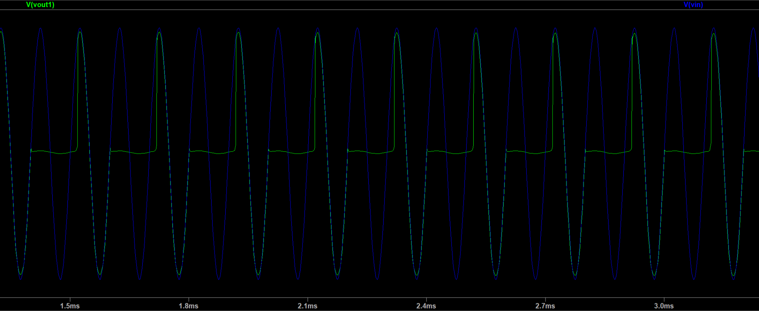
Figure 11, Input signal (blue) and output signal (green)

