A Modular Energy-Minimising Economic MPC for a Single-Stage SAG Grinding Mill: Decoupling Mill Control from Plant-Wide Economics

Batbold Sangi
WA School of Mines
Curtin University
Perth, Australia
batbold.sangi@postgrad.curtin.edu.au
Agus Saptoro
WA School of Mines
Curtin University
Kalgoorlie, Australia
agus.saptoro@curtin.edu.au
Laurence Dyer
WA School of Mines
Curtin University
Kalgoorlie, Australia
laurence.dyer@curtin.edu.au
Moses O. Tadé
WA School of Mines
Curtin University
Perth, Australia
m.o.tade@curtin.edu.au

Abstract—Grinding has been acknowledged as the largest energy consumer in a mineral concentrator. Consequently, the selection of an economic objective for a semi-autogenous grinding (SAG) mill controller matters both economically and structurally. This paper compares the two objective candidates, profit maximisation and energy minimisation, across three supervisory architectures on a single-stage SAG circuit. The benchmarked architectures comprise classical steady-state RTO over three PI loops (SSRTO+3PI, the industrial reference), a two-layer economic MPC, and a single-layer economic MPC. All six combinations were run on identical synthetic ore-hardness realisations, an identical product-size floor, and a common augmented extended Kalman filter over a 218 h transient protocol. In the literature, such a like-for-like comparison is rarely attempted. Published architectures each come with their own model, estimator, constraint set and tuning, and thus reported differences confound the control structure with its configuration. Two results stand out. First, at a matched product-size floor, the specific energy of all architectures and both objectives clusters within about two percent. It follows the ore-hardness disturbance. A well-chosen optimisation reaches the achievable SEC. The SEC is set by the ore hardness and the quality floor instead of the architecture or the objective. Second, both objectives reach the same specific energy. Profit optimisation suits the plant-wide level, and energy minimisation suits the SAG mill level. Energy minimisation avoids saturated feed and speed, keeps the mill near its safer lower limits, and supports operator derating. Through the feed-demand and product-size interface it gives the mill full modularity. As a result, the SAG controller does not implement the economic optimisation of the other circuits. Among the architectures, the two-layer EMPC combines smooth actuation with about a third less computational load than that of the single-layer EMPC, making it a preferable candidate. This study includes early-stage results on a synthetic plant, obtained within a deliberately contained simulation set-up. Calibration against operating plant data is ongoing and will be reported in the near future.
Keywords—economic MPC, real-time optimisation, SAG mill, comminution, specific energy, plant-wide control

Introduction
Comminution, the crushing and grinding of ore, is the most energy-intensive stage of mineral processing. Grinding alone can account for roughly half of a concentrator’s operating cost, and comminution consumes on the order of a few percent of global electricity. Any systematic reduction in specific energy consumption (SEC, in kWh per tonne) therefore has both an economic and an emissions payoff, as recent industrial trials confirm [7], [9].
A semi-autogenous grinding (SAG) mill is difficult to operate near its economic optimum because it rarely settles. Ore hardness drifts on an hour-to-shift timescale, feed-size distribution varies, and liner wear changes the mill geometry over weeks. This operating reality motivates economic model predictive control (EMPC). EMPC embeds the process economics directly in a receding-horizon optimisation. It can therefore track a moving optimum during transients, rather than waiting for the plant to settle as a classical real-time optimiser (RTO) must.
The way a supervisory layer decides the economically best operating point spans a well-known continuum. It runs from steady-state RTO (SSRTO) to EMPC, where the economic objective is folded into the regulatory controller itself [5], [6]. Published EMPC studies of grinding circuits, however, mostly share one design choice, although modified profit cost functions have also been tried [3]. This paper revisits that choice and benchmarks a pure energy cost function against it. Their economic objective is a plant-wide net smelter return, a revenue term built from the downstream flotation concentrate mass flow, its grade and the metal price, minus operating cost [2], [3]. Embedding downstream economics in the mill controller couples it to a calibrated flotation model, a specific ore body and a specific market state. The controller must then be re-identified whenever any of these change [8]. In the most directly comparable study [3], the coupled objective was compared only at steady state.
This paper adopts the opposite separation and makes two contributions. First, we argue and demonstrate that on a single-stage SAG mill the revenue term dominates. Electricity cost is a small fraction of revenue, so a profit-maximising objective has no interior optimum. It drives the feed rate and mill speed to their upper limits and holds them there. We therefore propose a modular, mill-specific objective. It minimises specific energy alone, subject to a product-size floor and a throughput demand supplied by a higher-level plant-wide economic optimisation [2]. This interface decouples the mill controller from downstream economics and makes it portable across ore bodies and plants. Second, we report a like-for-like simulation benchmark of the supervisory continuum. All architectures run on a common reduced-order plant, under a common transient scenario, with common tuning. They can therefore be compared fairly on the metric that matters, specific energy. The value here is the fair comparison and the modular formulation, not a plant-certified saving.

Circuit and Reduced-Order Model
All controllers act on the same simulated plant. It is a single-stage closed grinding circuit consisting of a SAG mill, a sump, and a hydrocyclone (Fig. 1). The plant dynamics follow the reduced-order, control-oriented Hulbert model in its single-stage SAG configuration [1]. The model lumps the size structure of the charge into rocks, solids and fines and adds water and ball hold-ups. This gives eight nonlinear states.
The manipulated variables (MVs) are the mill feed solids MFS (t/h), the cyclone feed flow CFF, the sump feed water SFW, and the mill speed φ_{c}, the fraction of critical speed. Mill speed is a manipulated variable, giving the optimiser a fourth degree of freedom. The controlled variables (CVs) are the mill charge filling JT, the sump slurry volume SVOL, and the product particle-size estimate PSE. PSE is the fraction of cyclone-overflow product finer than 75 microns.
The governing equations follow the single-stage form of [1]. Population volume balances describe the mill hold-ups of water, solids, rocks and fines (m³):
Xmw=MIW+Vcwu-Vmwo (1)
Xms=1-αr MFS/DS+Vcsu-Vmso+RC (2)
Xmr=αr MFS/DS-RC (3)
Xmf=αf MFS/DS+Vcfu-Vmfo+FP (4)
where MIW is the mill inlet water, D_{S} the feed-ore density, and the V terms are the discharge and cyclone-underflow flows. Three analogous balances govern the sump, and a fifth mill state tracks the ball hold-up. The feed splits by two ore parameters: α_{r} is the rock fraction of the feed and α_{f} its fines fraction. Breakage is driven by mill power:
RC=Pmill φDS φr⋅XmrXmr+Xms (5)
FP=PmillDS φf1+αφfLOAD/vmill-vPmax (6)
where φ is an empirical slurry-rheology factor and LOAD the total charge volume in the mill volume v_{mill}. The two ore-hardness parameters sit here. φ_{r} (kWh/t) is the energy required per tonne of rocks broken. φ_{f} (kWh/t) is the power needed per tonne of fines produced, with α_{φf} a small filling correction. Mill power draw is parabolic in the charge and the rheology and scales with the mill speed [1], [4]:
Pmill=Pmax1-δPvZx2-δPsZr2 φc (7)
where Z_{x} measures the charge against the filling at maximum power, Z_{r} measures the rheology factor against its value at maximum power, and the cross term and speed exponent of [1] are at their default values. In the benchmark, all other model parameters are held constant. The parameters α_{r} and φ_{f} are the main varying parameters, representing the varying ore disturbance (Section V).
The model was fitted and validated on a real single-stage plant [1], has been dynamically validated against industrial step-test data [4], and is a de facto standard testbed in the milling control literature.
Every controller in this study estimates the plant state with the same augmented extended Kalman filter (EKF). It estimates the eight hold-up states plus a slowly varying ore-hardness parameter as a ninth state. Using one estimator across all controllers keeps the comparison apples-to-apples, so that only the control law differs.
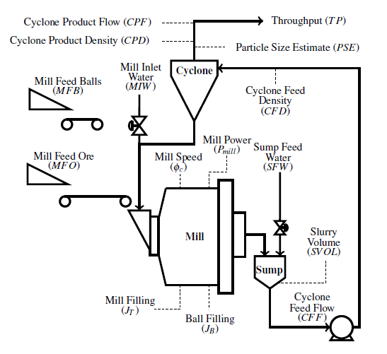
- Single-stage SAG grinding circuit with mill, sump and hydrocyclone. The manipulated variables are the feed solids, the mill inlet and sump water, the cyclone feed flow and the mill speed. The controlled variables are the mill filling, the sump volume and the product size.

A Modular Energy-Minimising Cost Function

The plant-wide economic objective
The economic objective of a grinding mill extends beyond the mill itself. Following the plant-wide framework of le Roux and Craig [2], the comminution circuit’s scalar economic objective is inherited from the larger plant:
$J_{comm}=A\left(PSE\right) TP-B P_{mill}$ (8)
where TP is throughput, P_{mill} is mill power, and B is the effective energy-plus-media price in dollars per kWh. The term A(PSE) is a net return per tonne. It folds in the flotation recovery and the concentrate grade, both empirical functions of PSE. The plant-wide layer maximises this objective for the whole plant and hands the comminution circuit a desired throughput. The desired product size comes from the downstream flotation requirement [2]. In this study we take A as a constant to simplify the calculation. The PSE-dependent part of A is a second-order effect over the narrow PSE band the quality floor allows.
The key observation is that this interface, a product-size floor and a throughput demand, is exactly what a mill-level controller needs as its constraints.

Mill-level profit maximisation and its side effects
If the revenue term is instead placed directly in a mill controller, as −A·TP + B P_{mill}, the objective pursues two goals at once. It maximises revenue and minimises mill power. The energy half still disciplines every tonne. The two goals are not balanced, though. Revenue exceeds energy cost by more than an order of magnitude (Section V). The stage cost is therefore near-affine in throughput, and its optimum sits on a constraint boundary. The optimiser raises feed and mill speed until a limit stops them, and holds them there. Running the mill at maximum speed continuously, regardless of throughput, is neither good nor common practice.
Our simulations confirm this directly (Section VI). The profit runs park the feed near its upper bound, the energy runs settle at the demanded floor, and their specific energies are essentially identical.

The modular energy-minimising objective
We therefore lift the revenue term out of the mill controller entirely. The plant-wide layer sets the product-size floor and the throughput demand. The mill controller minimises mill energy for those targets:
$min B P_{mill} \text{s.t.} PSE≥{PSE}_{min}, MFS≥{TP}_{dem}$ (9)
together with the safety envelope on charge, sump volume and power. The feed settles at the demand floor, so minimising P_{mill} is equivalent to minimising SEC = P_{mill}/MFS. SEC is the reported metric, computed as total energy over total tonnes and suitable for comparison.
One caveat carries over from the affine structure. When the quality floor is already satisfied, energy cost is nearly flat in feed. With no clear optimum, the controller swings between its actuator bounds. The cure is a longer prediction horizon and keeping the quality constraint binding. The two-layer architecture of the next section is built to do exactly that.

Benchmark Architectures
We retain three architectures that span the practical range from industrial practice to fully economic control. Each is run twice, once per economic objective (energy minimisation and profit maximisation). This gives six 218 h closed-loop runs.

SSRTO over three PI loops (classical reference)
This is the popular industrial archetype. A steady-state RTO solves a parameter-estimation and economic optimisation problem whenever a steady-state detector declares the plant settled. It hands set-points to three decentralised PI loops (feed to filling, cyclone feed to sump volume, sump water to product size). Mill speed is applied directly from the optimiser. Between steady-state detections the set-points are held.

Two-layer EMPC (main candidate)
A slow upper EMPC computes the economic operating point over a long horizon and publishes a validated set-point-and-input plan. A fast lower tracking MPC with move suppression executes it (Fig. 2). The economic decision is decoupled from the moment-to-moment actuation, which removes the single-layer bang-bang failure mode. The expensive economic problem is also solved far less often.

Single-layer EMPC
The economic objective sits directly in the receding-horizon regulator, so the economics are re-optimised every 30 s. This is the most responsive formulation, but it is prone to occasional bang-bang actuation (Sections III, VI).
Basic regulatory variants, a tracking single-layer MPC and a decentralised 3PI holding fixed set-points, were also studied and excluded from the benchmark. They contain no economic optimisation to compare.
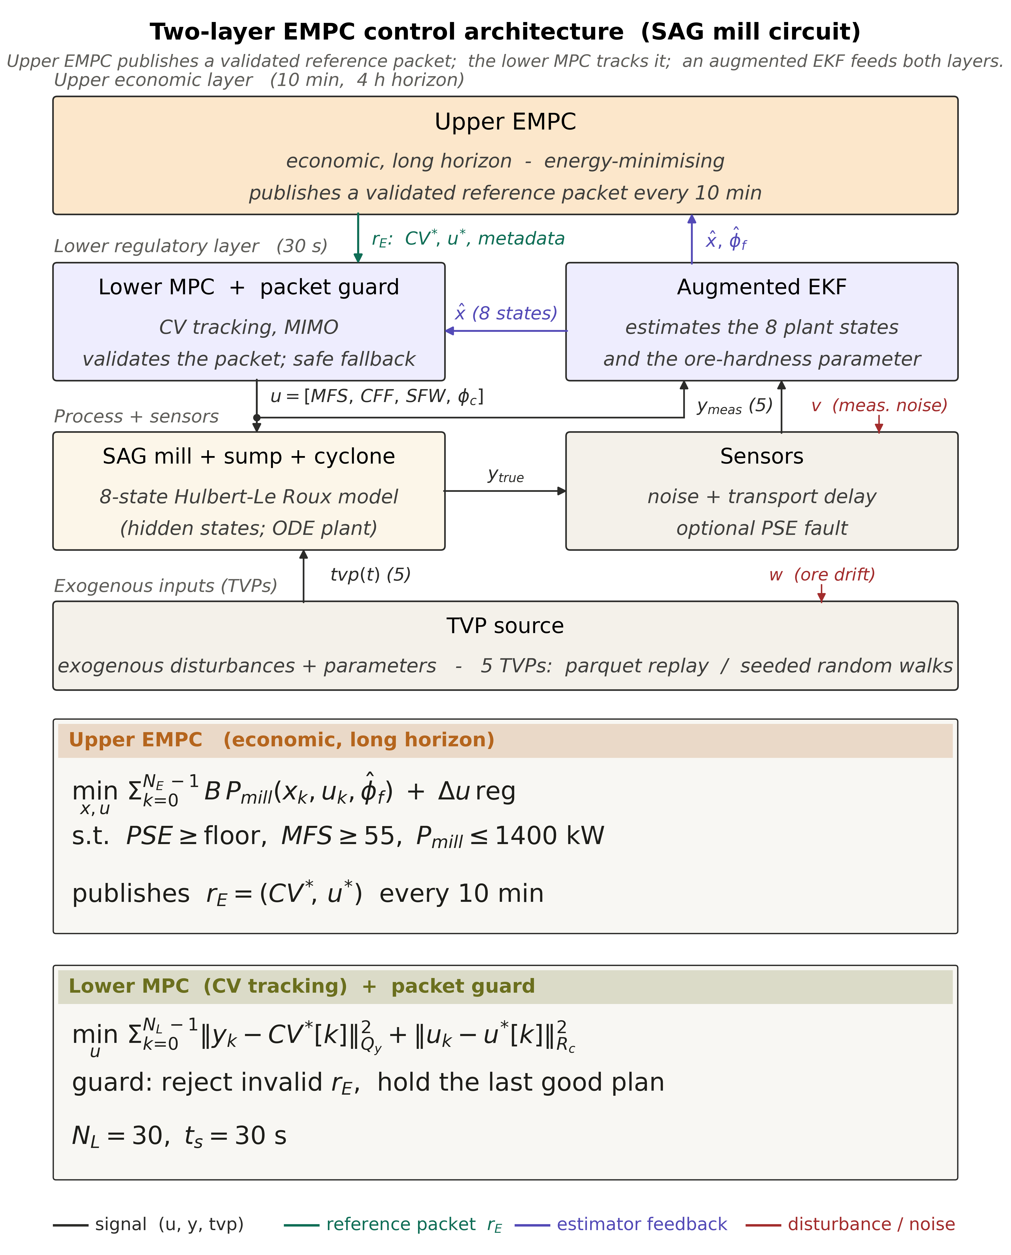
- Two-layer economic MPC architecture. The upper layer minimises mill energy for the product-size floor and throughput demand inherited from the plant-wide layer. It publishes a validated set-point-and-input packet. A guard admits or rejects each packet before the lower tracking MPC and the augmented EKF close the loop on the plant.

Benchmark Design
Common plant and scenario. The plant is integrated with a stiff solver on a 30 s control interval. Every run sees the same 218 h three-phase scenario. The first 50 h are a quiescent warm-up. Sensor noise and bounded ore-hardness disturbances then switch on together. The noise is a per-channel ladder calibrated to plant instrument noise, from 0.1 to 2 percent of each signal. The ore-hardness parameters move inside bands of 15 percent (α_{r}) and 10 percent (φ_{f}) around nominal. At 75 h the product-size floor steps up by ten percent (0.65 to 0.715). The ore-hardness realisation, shown in the upper panels of Fig. 3, follows triangle-wave trends with two extended joint holds. The identical realisation is replayed to every controller, so differences downstream are attributable to the architecture and objective alone.
Matched constraint set. All six runs share one operating envelope. It includes the feed-demand floor, the mill-filling and sump-volume bands, a power ceiling, and, critically, the same stepped product-size floor. The floors and limits are verified identical across all packages.
Objectives and economics. The energy objective minimises B P_{mill} at the demanded throughput. The profit objective minimises −A·TP + B P_{mill} with A = 71 $/t and B = 0.06 $/kWh held fixed across all runs. The headline metrics are specific energy (total energy over total tonnes on the post-warm-up window), mean throughput, and the accumulated profit proxy.

Results
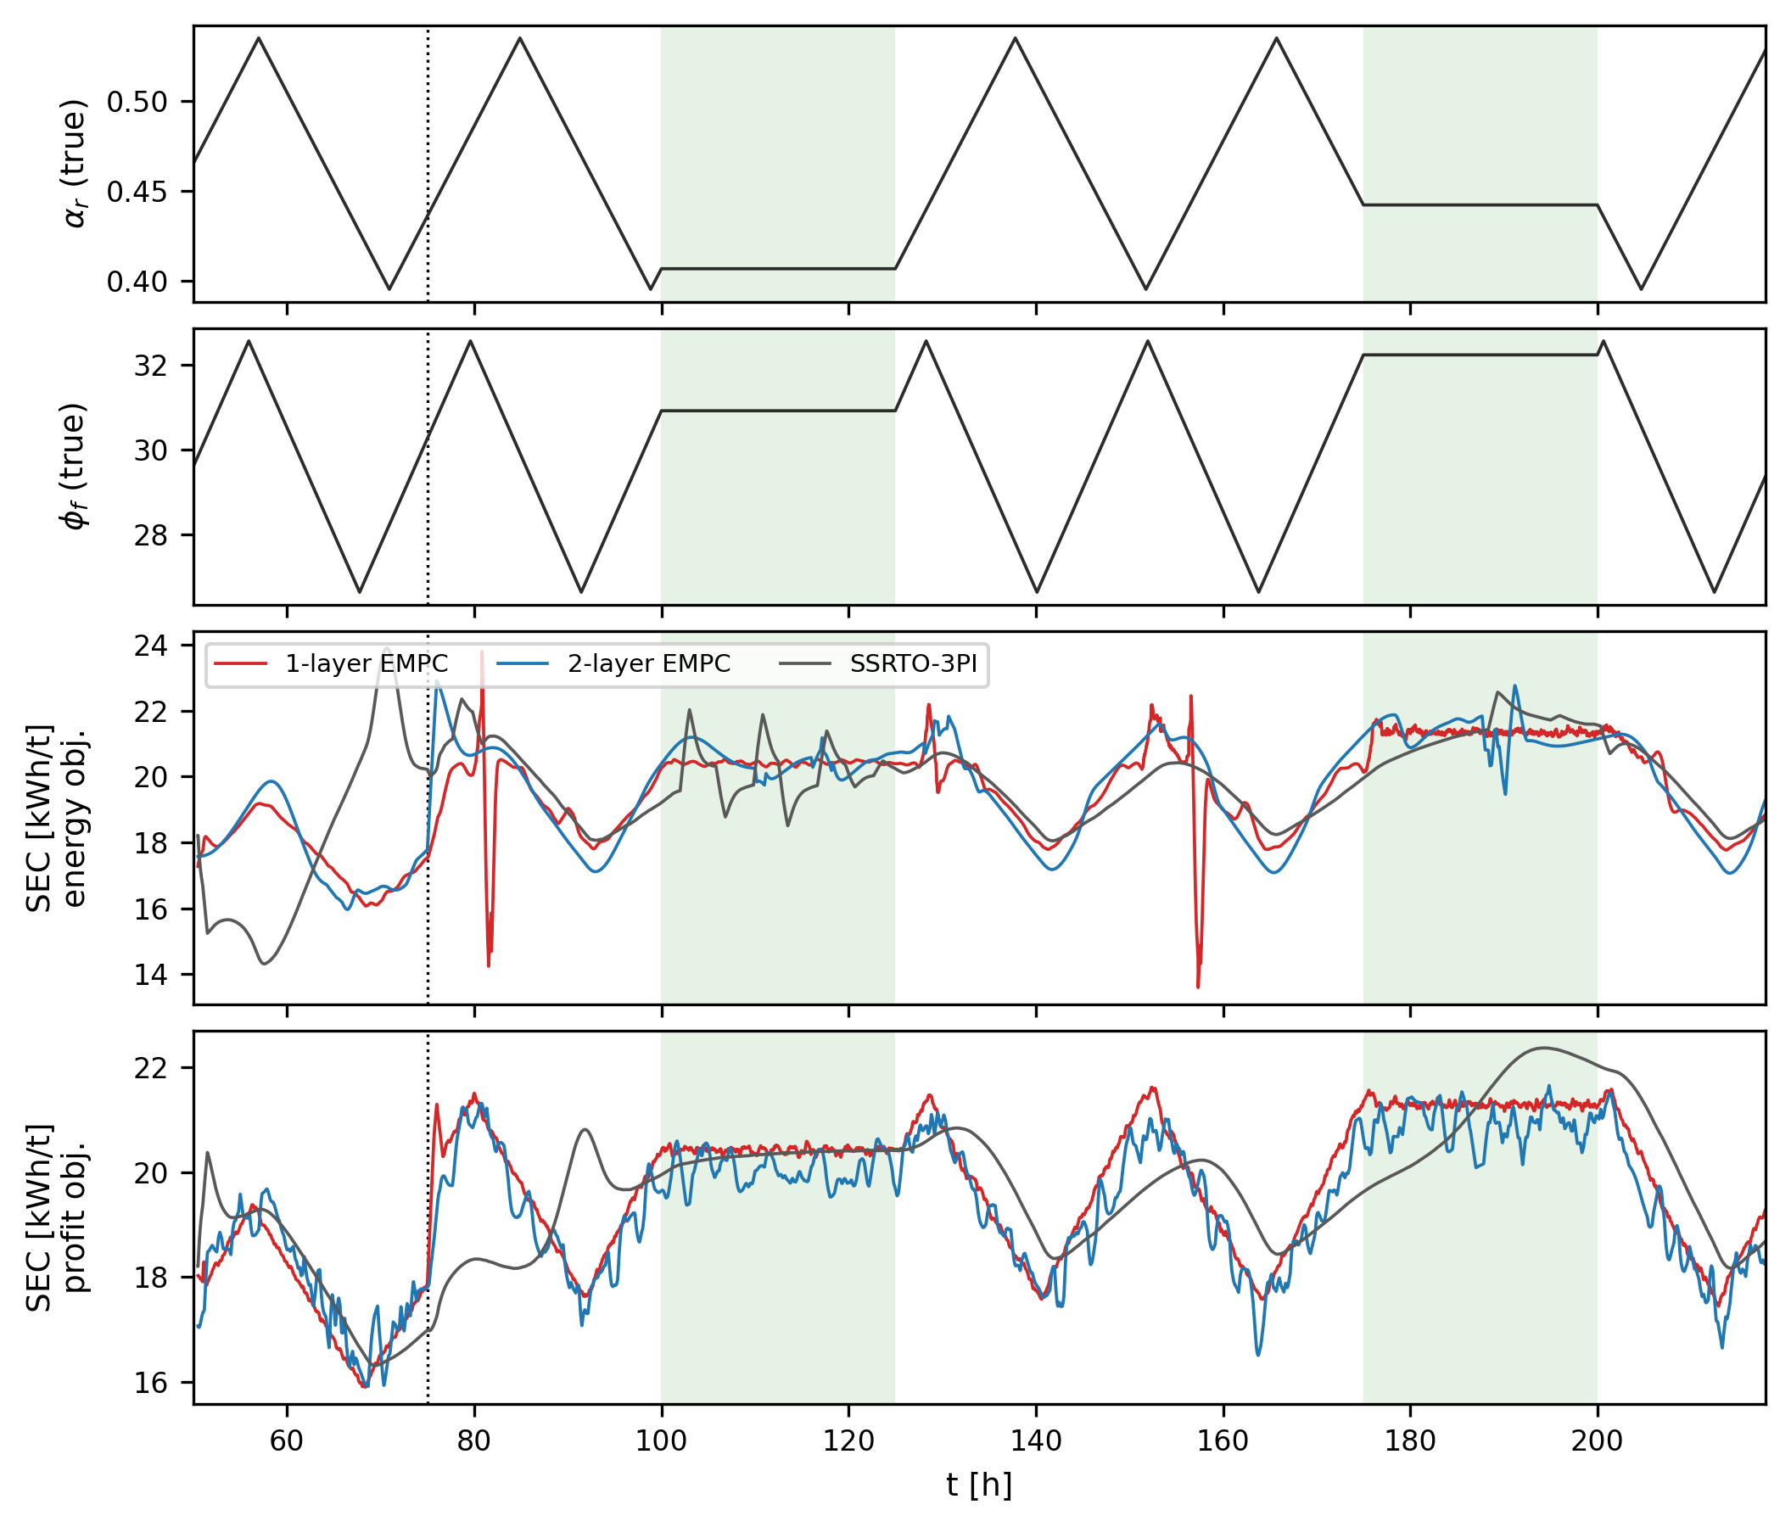
- The top two panels show the v5 ore-hardness realisation (rock fraction α_{r} and feed-size parameter φ_{f}), identical in all six runs. Shaded bands are the ore holds. The dotted line is the product-size floor step. The bottom two panels show the 1 h rolling specific energy of the three architectures under the energy objective and the profit objective. SEC is flat where the ore holds and varies where it ramps, for every architecture and both objectives alike. The isolated spikes in the single-layer energy trace are its occasional bang-bang episodes.
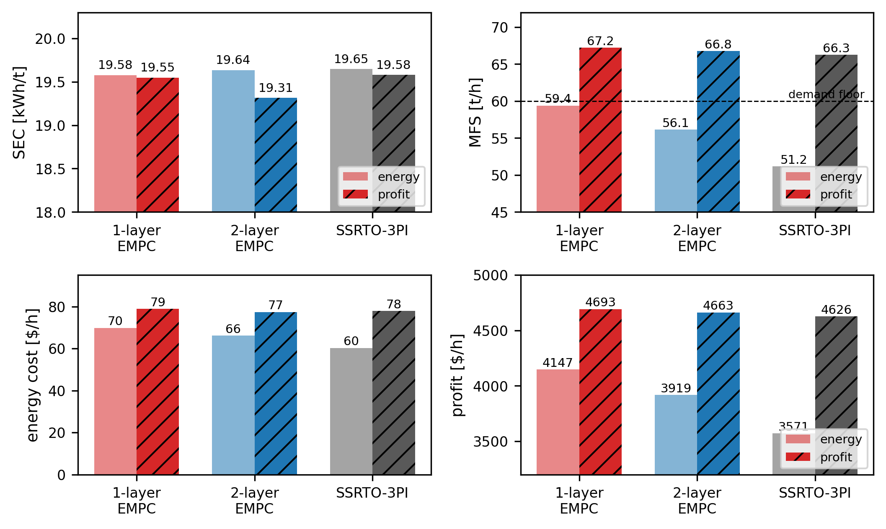
- Run-average specific energy, feed rate, energy cost and profit proxy for the three architectures under both objectives. SEC clusters within about two percent across all six runs, while the operating points differ. The profit objective lifts every architecture to 66–67 t/h, and under the energy objective each architecture settles at a different feed despite identical limits. The bottom row shows the economics. Energy cost (60–79 $/h) is under two percent of revenue in every run, which is why the profit ranking is decided by tonnes.
- Six matched-floor 218 h runs: specific energy, mean feed, energy cost, and profit proxy (A = 71 $/t, B = 0.06 $/kWh), post-warm-up window.
Architecture | Objective | SEC | MFS | Energy cost | Profit
 |  | (kWh/t) | (t/h) | ($/h) | ($/h)
1-layer EMPC | energy | 19.58 | 59.4 | 70 | 4147
1-layer EMPC | profit | 19.55 | 67.2 | 79 | 4693
2-layer EMPC | energy | 19.64 | 56.1 | 66 | 3919
2-layer EMPC | profit | 19.31 | 66.8 | 77 | 4663
SSRTO+3PI | energy | 19.65 | 51.2 | 60 | 3571
SSRTO+3PI | profit | 19.58 | 66.3 | 78 | 4626

The SEC cluster and its ore-hardness origin
Table I and Fig. 4 give the central result. At the matched product-size floor, the six runs span only 19.31 to 19.65 kWh/t. That is a spread of under two percent across three architectures and two objectives. Fig. 3 adds that the specific energy of every run tracks the ore-hardness trajectory closely. SEC is flat through the ore holds. It rises and falls with the feed-size parameter through the ramps, with all three architectures moving together.
The model makes this connection explicit. Ore hardness enters the reduced-order model as φ_{f}, the power needed per tonne of new fines produced inside the mill, in kWh/t [1]. Specific energy is its operational counterpart in the same unit. SEC = P_{mill}/MFS is the energy spent per tonne of fresh feed processed. Fines production is driven by mill power through φ_{f}. A pinned product-size floor fixes the fraction of each feed tonne that must be ground to fines. SEC is therefore essentially a scaled copy of φ_{f} (about 19.6 kWh/t against φ_{f} ≈ 29.6 kWh/t here, the ratio reflecting the fines already present in the feed). The two quantities share one unit because they express the same underlying physics, the energy the ore requires at the demanded fineness. This is why every architecture returns nearly the same SEC under both objectives, energy and profit (revenue minus energy), and why the SEC trajectories in Fig. 3 follow the ore-hardness distribution so closely. Both objectives carry the energy term, and that term is what pushes SEC to its achievable minimum. An objective without an energy term would not settle at these values.
The controllers differ only in how well they avoid wasting energy (over-grinding, poor set-point choices). None can grind below the energy the ore demands. The distribution of achievable SEC is therefore a property of the ore hardness distribution rather than of the supervisory architecture or the economic objective.
One exception may apply to the SSRTO. Its set-points refresh only when the steady-state detector triggers. If the ore hardness trends strongly and rapidly in one direction without flattening, the detector cannot trigger, and the SSRTO result can differ significantly. The disturbance in Fig. 3 instead fluctuates inside a bounded band of 10 to 15 percent. The plant then keeps reaching steady states inside that band, and the held set-points stay reasonable even when the detector does not trigger. This can be why the SSRTO stays inside the two-percent cluster here.

Same limits, different operating points
The clustering does not mean the architectures behave identically. Under the energy objective the three architectures face the same feed-demand floor, product-size floor and objective function. They still settle at visibly different feeds of 59.4, 56.1 and 51.2 t/h for the single-layer, two-layer and SSRTO respectively (Fig. 4, right). Each optimiser allocates the remaining degrees of freedom (mill speed, cyclone feed, sump water) differently. The SSRTO in particular drifts to lower feed between its steady-state updates. Specific energy is the invariant. The operating point is not. Under the profit objective the picture collapses. All three lift feed to 66–67 t/h and mill speed to its bound, confirming the constraint-seeking behaviour of Section III-B. The profit proxies land within 1.4 percent of one another (4626 to 4693 $/h).

Profit versus energy
For each architecture the profit objective earns 13 to 29 percent more profit proxy than its energy twin. Essentially all of the gain comes from throughput. SEC changes by at most 0.33 kWh/t between the twins. The gain is largest for the SSRTO only because its energy run sits at the lowest feed. In other words, the profit objective adds tonnes by saturating feed and speed limits, while its energy half holds SEC at the same level as the energy runs. Which objective is appropriate therefore depends on whether the mill is the right place to decide throughput, which is the subject of the next section.

Secondary separations
The architectures do separate on non-economic metrics. The single-layer EMPC shows occasional bang-bang episodes (isolated SEC spikes in Fig. 3, roughly two percent of post-step intervals), inherited from its near-affine objective. Because its set-point refreshes only at steady-state detections, the SSRTO holds its product-size floor more loosely than the EMPCs between updates. The PI loops themselves behave exactly as designed. The two-layer EMPC shows neither behaviour and uses about a third less CPU time than the single-layer (Section VII-C). This combination, rather than any economic advantage, is why we carry it forward as the main candidate.

Comparison with the HPGR circuit study
Our results are consistent with the HPGR, ball mill and flotation study of Thivierge and co-authors [3]. They compared basic regulatory control (BRC), advanced regulatory control (ARC), a profit EMPC (EMPC1) and a power-penalised EMPC (EMPC2). Their ARC and EMPC1 performed identically because the economic optimum sits at the process constraints. We see the same mechanism under the profit objective (Section VI-B). Their EMPC2 reduced specific energy by only 0.4 to 2.9 percent relative to the profit optimum, at the cost of 3.6 to 3.9 percent of net value. Our energy-versus-profit twins show the same pattern (Section VI-C). Finally, our own excluded regulatory variants (Section IV) used significantly more energy, in line with their BRC result and with recent industrial experience [9].

DiscussionS

Plant-level profit, mill-level energy, and their interface
The results give an operational answer to the objective question. Profit optimisation is the natural plant-wide objective. Only at that level do the downstream circuits (flotation recovery, concentrate value, market prices) enter. At the SAG level the same objective reduces to feed-and-speed saturation, which removes every degree of freedom that could otherwise be used for efficiency or robustness. Energy minimisation, by contrast, is well posed at the mill. It has a defined task, to grind the demanded tonnes to the demanded fineness for the least energy. As Section VI shows, it concedes nothing in specific energy relative to the profit objective.
Once quality is pinned, the achievable specific energy is set by the ore. The remaining economic decision is how many tonnes to process, and that decision belongs to the plant-wide layer. The two levels meet at a two-number interface. The plant-wide profit optimisation, which sees all circuits, decides the throughput demand TP_{dem}, a floor on MFS. The downstream circuits’ requirements set the product-size floor PSE_{min}. Inside those limits the mill runs autonomously and never needs to maximise MFS directly. Re-targeting the mill is a change of two numbers rather than a re-identification.
The interface also carries a safety and flexibility argument. The mill works around the lower and safer limits rather than pushing to a maximum. The operator or the plant-wide layer can therefore derate it through the same knobs. Examples are capping MFS during downstream maintenance or during an electrical demand event. The controller then simply optimises energy inside the tighter envelope. A profit-maximising mill leaves no such flexibility. It holds the mill speed φ_{c} at its maximum, which is not a safe condition for continuous operation.

Two-layer EMPC as the practical embodiment
The two-layer EMPC splits the mill controller into two timescales. The slow upper layer solves the economic problem inside the interface limits, and the fast lower layer tracks it. Our benchmark indicates this costs nothing measurable in specific energy relative to the single-layer ideal. It removes the bang-bang failure mode and retains transient responsiveness that the classical SSRTO reference lacks. The SSRTO’s quality tracking between steady-state updates, however, is loose.

Computational challenge and load comparison
The main computational challenge is running a nonlinear economic optimisation in real time, every 30 s, for hundreds of hours. The resolution is to solve the expensive problem less often. The two-layer architecture re-solves the economic problem only about every ten minutes and leaves a cheap tracking problem at the fast clock.
The computational loads themselves separate the architectures clearly. The 218 h protocol has 26 160 control intervals of 30 s. The single-layer EMPC re-solves the full economic problem at every interval. It spent about 5.5 hours in its solver. The two-layer spent about 3.7 hours. Its economic solve uses a longer prediction horizon, 4 h against the single-layer’s 30 minutes. The longer horizon is also one way to reduce the well-documented bang-bang issue [3], [6] (Section III). The SSRTO solves for a single steady-state operating point, with no prediction horizon, and only when steady state is detected. It spent about five minutes in total, two orders of magnitude less. All three are fast enough for real time on an ordinary desktop computer, the slowest needing less than one second of the 30 s between decisions.

ConclusionS
On a single-stage SAG circuit with identical ore, estimator and constraints, we benchmarked three supervisory architectures under both candidate economic objectives. Two findings stand out.
The first is the SEC similarity. Once every requirement is made identical, the specific energy of all six combinations converges to within about two percent and follows the ore-hardness disturbance. With a well-chosen optimisation, energy minimisation or a profit objective that includes the energy term, the controller reaches the achievable SEC. The SEC is directly correlated with the ore hardness. None of the controllers can grind below the energy the ore demands. The SEC distribution is therefore a property of the ore hardness distribution rather than of the supervisory architecture or the economic objective. The architectures still choose different operating points under identical limits, so the equivalence is in energy per tonne, not in behaviour.
The second is the choice between profit and energy optimisation. Profit maximisation does two things at once. It maximises throughput and minimises energy, which is why it too reaches the achievable SEC. Maximising throughput can be a good choice in some cases, for example when the mill is the plant bottleneck. In general it is bad practice. It holds feed and mill speed at their limits continuously. Liner and media wear grow steeply with speed, liner changes are long downtime events, and high speed at low charge throws balls directly onto the liners. Energy minimisation is the better objective for the SAG circuit. It also makes the mill completely modular. Once profit optimisation is removed, the SAG mill becomes independent of the other circuits and of the plant. Through the MFS and PSE interface it can be integrated into any plant and any circuit. A heat map of MFS, PSE and SEC, where SEC represents the ore hardness, defines the best working regions. Such maps summarise the dynamic model and can be used in complex plant-wide calculations.
This suggests a direction for real-time optimisation practice. At the plant-wide level, economic calculations run together with planning and scheduling information, and steady-state calculations are the practical choice. At the circuit level, transient operation can be exploited through EMPC with an objective consistent with the plant objective. Forcing the same states and the same optimisation onto both levels can be bad practice. It is worth remembering that the classic SSRTO applies the steady-state assumption at both levels and waits too long for the plant to settle.
This study is an early stage of an ongoing research program. We kept its scope deliberately small so that the comparison stayed clean. Slowly varying effects such as liner wear are left for future work. The next steps are to calibrate the model against historical operating data and to run longer, more varied scenarios so the architectures can be separated with statistical confidence.

AcknowledgmentS
The authors would like to thank Curtin University for providing the John Curtin Graduate Research (JCGR) Scholarship (CMPRS) to the first author. This work is also enabled by the financial supports from Western Australian School of Mines and Resources Technology and Critical Minerals Trailblazer.

References
- J. D. le Roux, I. K. Craig, D. G. Hulbert, and A. L. Hinde, “Analysis and validation of a run-of-mine ore grinding mill circuit model for process control,” Minerals Engineering, vol. 43–44, pp. 121–134, 2013.
- J. D. le Roux and I. K. Craig, “Plant-wide control framework for a grinding mill circuit,” Industrial and Engineering Chemistry Research, vol. 58, pp. 11585–11600, 2019.
- A. Thivierge, J. Bouchard, and A. Desbiens, “Comparing economic model predictive control to basic and advanced regulatory control on a simulated HPGR, ball mill, and flotation circuit,” Journal of Process Control, vol. 122, pp. 159–171, 2023.
- J. D. le Roux and C. W. Steyn, “Validation of a dynamic non-linear grinding circuit model for process control,” Minerals Engineering, vol. 187, p. 107780, 2022.
- J. Matias, J. P. C. Oliveira, J. D. le Roux, and J. Jäschke, “Steady-state real-time optimization using transient measurements,” Journal of Process Control, vol. 115, pp. 181–196, 2022.
- M. Ellis, J. Liu, and P. D. Christofides, Economic Model Predictive Control: Theory, Formulations and Chemical Process Applications. Springer, 2017.
- T. Pinto, M. T. da Silva, G. V. Raffo, and T. A. M. Euzébio, “Specific energy reduction in a semi-autogenous grinding mill circuit by an automatic control system,” Scientific Reports, vol. 15, 21398, 2025.
- H. K. Mittermaier, J. D. le Roux, and I. K. Craig, “Model-plant mismatch diagnosis using plant model ratios for a grinding mill circuit under model predictive control,” Minerals Engineering, vol. 227, 109278, 2025.
- P. K. Costa, P. N. Vaz, M. F. Calixto, D. S. Torga, M. G. Bergerman, and H. Delboni Jr., “Performance assessments of an advanced control system in an iron ore industrial grinding circuit,” Minerals, vol. 15, no. 11, 1172, 2025.

