Digital Signature

1.Terminal Manu

=== menu Digital Signature ===

1. build Key Pair

2. sign

3. check sign

0. exit

Please select (0-3):

2.select [1] : gen key

2.1 private_key.pem

2.2 public_key.pem

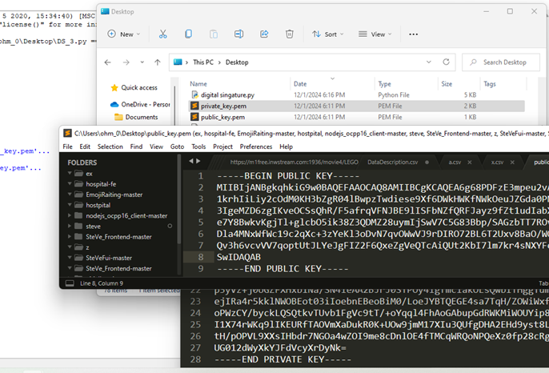

3. Sign

3.1 build sign file

For me check1234.txt

(same folder)

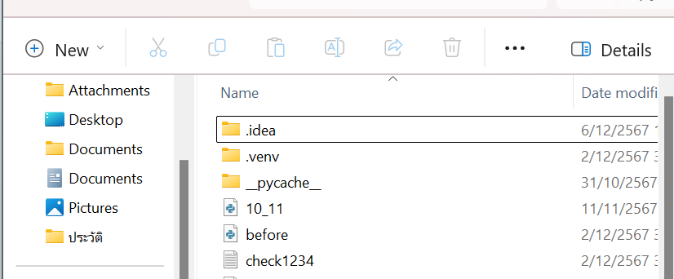

3.2 select [2] : sign

Type file sing :check1234.txt

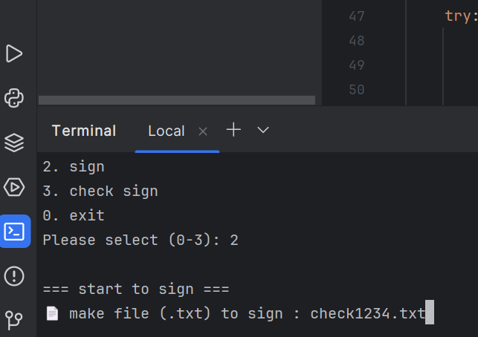

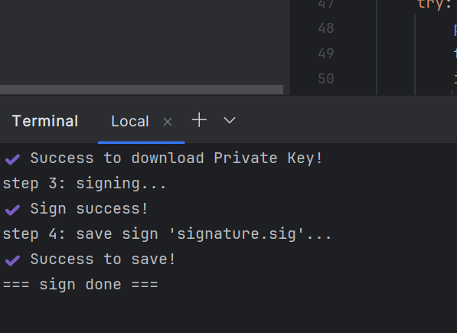

4.Check

4.1 Check in normal case

select [3] :for check sign

filename .txt for check sing :check1234.txt

signfilename.sig for check key :signature.sig

