Data Dictionary (2023/09/15)

Version History
- 9/11/23 – updated to account for drop of R2, completion of most data cleaning and scoring tasks
- 9/15/23 – corrected TLX source weight calculation; separated measured and adjusted drop times in car times; included PWI related columns and updated drop time columns in car results

Introduction
This document describes the data collected in combined_results.xlsx under the IRB “The Effects of Augmented Instruction on Manufacturing Assembly Training.” When complete, it will include the data from the first investigation of that study (AR) as follows:
- Recruitment 1 (R1) – Auburn University
  - Phase 1 – Learning
  - Phase 2 – Recall
  - Phase 3 – Retention (party)
A summary of the status of the data transcribed for each recruitment is tabulated below. Details for each follow.
Data Type | Tab Name(s) | R1 Status
Demographics | demographics | Complete
Behavior Control Survey | bcs raw data | Complete
NASA TLX | tlx scores | Complete
System Usability Scale | system usability scores | Complete
Car Times | car times | Complete
Car Outcomes | car outcomes | Complete
Car Results | car results | Complete
Data from Phase 3 is not yet collected.
In addition to this xls file, a summary report has been generated for each participant in markdown format, located in the data/reports directory. These are a work in progress and can easily be converted to formatted PDFs if desired.
Finally, a collection of all recorded comments is being assembled to facilitate sentiment analysis, clustering, etc. of feedback. This will be provided in a (near) future update.

Transcription Methodology
Except as noted, no changes were made to the raw data during transcription other than encoding it as described. Other issues noted were investigated and/or corrected during the data ingestion and cleaning process. This approach allows us to explicitly document the changes made, and improves reproducibility.

Processing Methodology
Data was processed using a combination of Python and R Scripts. Car data (times and outcomes) was collected from a combination of video, photographs, and observer notes. Each video was annotated with start and end times for a variety of event types. This data was directly exported from the annotation tool as XML data. Python was used to extract data from the XML files and compile it into CSVs and markdown reports. R was then used to clean and process the CSVs. This was an iterative process during which some minor data issues were discovered. Corrections were made by patching the data in R, which provides a record of all such changes.
For each car built by each participant in each phase of the experiment, two types of data were recorded. The car outcomes table records the result of each car attempt (completed, retired, etc.), including the numbers and types of errors made. The car times table records the start, end, and elapsed times for a variety of event types that might occur during each car assembly task, including those that might affect participant or system performance.
Analysis of the treatment effect on car times and outcomes requires that we combine these tables. A process was developed that would identify parent events (car build times) and their children (things that happened during a car assembly task, e.g. the participant refers to instructions or a system disruption occurs). This was complicated by the fact that some child-like events overlapped more than one car or occurred between them. Once complete, each parent event in the times table corresponded with a single observation in the outcomes table, allowing the two to be joined. Still, the child events created a “one to many” relationship between the tables, preventing them from being combined without aggregating or otherwise combining the event data for each car. As such, the results offered here include both a joined version of the data, along with the original outcomes and events table.
Some of the tables here are provided in traditional “wide” format, with one line per participant and columns for various attributes / observations. This is people-friendly but not ideal for processing. Other tables are provided in “tidy” format, where every column is a variable, every row is a single observation, and every cell contains a single value. This makes the data much “longer” and less people-friendly than the traditional format, but it is very well suited to efficient manipulation in R. The style of each table is indicated in parenthesis after each heading below. If you find you would like any table in an alternate format, just let me know.
Details for each tab type follow. In all tabs, the value “N/A” is used to indicate where values aren’t appropriate, or data was not collected.

Demographics (Wide)
Summarizes the participant characteristics, primarily from the Participant Intake Sheet (PIS), including the following columns:
- Participant – the assigned participant number, numeric field
- Age – reported age in years, numeric field
- Height – the participant’s reported height, in inches; numeric field
- Gender – one of the allowed values from the PIS, coded as follows:
  - F = Female
  - M = Male
  - O = Other
- Race – one of the allowed values from the PIS, coded as follows:
  - 1 = American Indian or Alaska Native
  - 2 = Asian
  - 3 = Black or African-American
  - 4 = Native Hawaiian or Other Pacific Islander
  - 5 = White
  - 6 = More than one race
  - 7 = Unknown or not reported
- Ethnicity – one of the allowed values from the PIS, coded as follows:
  - 1 = Hispanic or Latino
  - 2 = Not Hispanic or Latino
  - 3 = Unknown or not reported
- Country – country of origin, text field
- Language – language spoken at home, coded as:
  - English
  - Other
- Education – highest level completed / degree received; PIS values coded as:
  - 1 = Less than high school degree
  - 2 = High school degree or equivalent
  - 3 = Some college but no degree
  - 4 = Associate degree
  - 5 = Bachelor degree
  - 6 = Master degree
  - 7 = Doctorate degree
- College – the college currently enrolled in, text field (e.g. ENG, BUSI, LA)
- Program – the program currently enrolled in, text field (e.g. INSY, MNGT)
- LEGO – experience building LEGO models; PIS values coded as:
  - 1 = Little to no experience
  - 2 = Some experience
  - 3 = Lots of experience
  - 4 = Expert builder
- Manuf – level of experience in manufacturing; PIS values coded as:
  - 1 = No experience
  - 2 = Taken one or more classes
  - 3 = Held a part time or temporary position
  - 4 = One or more year’s experience
- Lenses – does the participant normally wear corrective lenses; coded as:
  - G = Glasses
  - C = Contacts
  - N = Neither
- Worn – does the participant plan to wear their glasses during the experiment; Y / N
- ColorBlind – is the participant color blind; Y / N
- Condition – does the participant have another condition that might affect their performance in the study; Y / N
- Runner – has the participant ever run an event of 5k or more; coded as:
  - 5 = 5k
  - 10 = 10k
  - H = Half-Marathon
  - M = Marathon
  - T = Triathalon
  - Y = Yes, unspecified
  - N = No
- Referral – how did the participant learn about the study; coded as:
  - Class names PYTHON, BET, ERGO, or some combination (e.g. PYERGO)
  - GSE = Graduate School Email
  - FLYER = flyers posted around campus
  - SCREEN = screens in ACLC, Mell, or the Library
  - FF = friends or family
- Recruit – which recruitment are they in; coded as:
  - AU = Auburn University
  - IND = Manufacturing Industry
- Treatment – the assigned treatment; coded as:
  - PWI = Paper Work Instructions
  - PAR = Projected AR (LightGuide)
  - AR = Augmented Reality (area tracking, aka “port”)
  - MR = Mixed Reality (model tracking, aka “advanced”)
- Notes – text field for misc notes
- Trial_Datetime – date and time of the trial
One change was made to the raw data when transcribing. Where participants that are known to be degree-seeking AU students incorrectly marked “High school degree or equivalent,” their status was changed to “Some college but no degree”.

Car Outcomes (Wide)
This tab consists of one row for each car assembly task attempted and information related to the result, including error counts and types. 744 rows, less 124 comments (one per car and phase = 2 x 62 participants), gives 620 cars completed.
- Participant – the assigned participant number, numeric field
- Treatment – the assigned treatment (PWI, PAR, etc. – from the demographics table)
- Phase – the phase number
  - 1 = learn
  - 2 = recall
  - 3 = retention
- Sequence – the order of outcomes within each participant, phase group
- UIDO – unique identifier for outcomes, combines the participant, phase, and sequence into one string
- Result – the result of the car assembly task
  - Comment: to provide a comment for each participant, phase
  - Complete: a completed car
  - Incomplete: assembly task was not completed, either due to time expiring or an interruption to the experiment that forced us to start a new car
  - Retired: an irreparable breakage occurred that prompted the participant to set the car aside for rework and move on to the next one
- CE – the count of corrected errors observed during each assembly task
- UCE – the uncorrected errors counted for each assembly task
- SEL – the number of uncorrected errors that were related to the placement of parts that were not called for
- POS – the number of uncorrected errors related to the incorrect positioning of parts
- ROT – the number of uncorrected errors related to the incorrect rotation of parts
- Count – for incomplete cars, the number of parts installed before work was suspended
- Error Codes – details of the error types in a condensed syntax that describes the part number, location, and error type; this may change and will be documented when finalized
- Outcome_comment – observations made during the trial and/or logged on the data collection sheets

Car Times (Wide)
This tab consists of one row for each event recorded during all car assembly tasks, including the start, end, and elapsed event time. 1,113 rows for the 620 cars, including 493 child events.
- Participant – the assigned participant number, numeric field
- Treatment – the assigned treatment (PWI, PAR, etc. – from the demographics table)
- Phase – the phase number
  - 1 = learn
  - 2 = recall
  - 3 = retention
- Sequence – the order of outcomes within each participant, phase group
- UIDT – unique identifier for events (Times), combines the participant, phase, sequence, and event into one string. For example:
  - 1001-P1-C1-T00 = first / parent event (T00) of the first car (C1) in phase 1 (P1) for participant number 1001
  - 1005-P2-C1-T01 = first child (T01) of the first car in phase 2 for #1005
- Event – the type of event recorded. The types for parent events differ from child events. Parent events mirror the results listed for the Outcomes table (e.g. car, breakage, etc.). Child events are categorized as:
  - Drop: AR tracking issue that causes an interruption in the display of instructions
  - PWI: records an instance of the participant referring to the paper work instructions during phase two of the experiment
  - Repair: noted whenever a participant takes time to correct a breakage that occurred during the task
  - System: other system-related events that affect performance through down time
- Type – used to identify parent or child events
- Start Time – the start time of the event, in seconds from the video start
- Duration – the elapsed time of the event, in seconds
- End Time – the end time of the event, in seconds from the video start
- Drop_adj_percent – a measure of the impact of each drop event on the participant’s performance; some drops had no effect, others completely stopped work (values range from 0.0 to 1.0)
- Adj_drop – for all drop events, this is the product of the drop_adj_percent and the event duration
- Event_comment – comments for each event

Car Results (Wide)
This tab combines the car outcomes with aggregated time data. There are 620 rows, one for each outcome. Each row includes the set of all columns from the outcomes and times tables, except for times/event and times/type as those are only relevant to child events. Some columns have been renamed for clarity in this combined format. The remaining columns aggregate the number and total time of each child event type:
- Drop_event_count: the number of drop events that occurred during the car assembly task
- Drop_event_tot_time: the total time of those drop events
- Drop_event_tot_time_adj: the total of time-adjusted drop events
- Repair_event_count: the number of repair events that occurred
- Repair_event_tot_time: the total time of those repair events
- System_event_count: the number of system events that occurred
- System_event_tot_time: the total time of those system events
- Pwi_event_count: the number of times the participant referenced the PWI in phase 2
- Pwi_event_tot_time: the total duration of the PWI references

BCS Raw Data (Long / Tidy)
The BCS tab includes the columns described below. This data was not processed to calculate scores.
- Participant – the assigned participant number, numeric field
- Question – gives the number of the question
- Value – gives the response for the corresponding question, coded as:
  - 1 = Never
  - 2 = Rarely
  - 3 = Sometimes
  - 4 = Often
  - 5 = Very Often
The coding described for question responses may not align with the instrument’s scoring method. If so, these values can be adjusted during subsequent analysis.

TLX Scores (Long / Tidy)
Collects data and resulting scores from the NASA TLX instruments. Each participant completed the TLX three times, once as part of the orientation (TLX-0), and then again after each of the two phases (TLX-1 and TLX-2). TLX-0 was administered as directed in the survey instructions.
- Participant – the assigned participant number, numeric field
- Treatment – the assigned treatment (PWI, PAR, etc. – from the demographics table)
- Phase – the TLX administration number
  - 0 = trial / practice
  - 1 = after learn
  - 2 = after recall
- Source – the relevant source of workload
  - MD: mental demand
  - PD: physical demand
  - TD: temporal demand
  - PF: performance factor
  - EF: effort factor
  - FF: frustration factor
  - Combined: used for the combined task workload
- Type – the type of value given
  - Source weight – the tally from pair-wise source of workload comparisons (0-5)
  - Source rating – the rating given to each source (0-100)
  - Source workload – source weight * source rating (0-500)
  - Task workload – total of source workloads for each (participant, phase) group / 15 (0-100)
- Value – the score described by the other fields
These scores were derived from the following source data (survey responses), which are still available:
- S1 through S15 – each column describes the participant’s choice in the 15 pair-wise Sources of Workload comparisons; coded as:
  - 1 = Top choice
  - 2 = Bottom choice
- R1 through R6 – each column gives the Rating for each of the six factors, on a scale of 0 to 100, as described in the TLX instructions:
  - R1 = Mental Demand Rating (MD)
  - R2 = Physical Demand Rating (PD)
  - R3 = Temporal Demand Rating (TD)
  - R4 = Performance Rating (PF)
  - R5 = Effort Rating (EF)
  - R6 = Frustration Rating (FF)
- Notes – text field for misc notes
S1 through S15 correspond to the cells below, numbered left to right, top to bottom. For instance, S1 corresponds to the top-left cell (Effort or Performance), S8 (correct below) is the middle cell (Frustration or Effort), and S15 is the bottom-right cell (Frustration or Mental Demand). Therefore, a value of 2 in S11 would indicate that the participant felt Physical Demand was a greater contributor to the perceived workload of the relevant task than Effort.
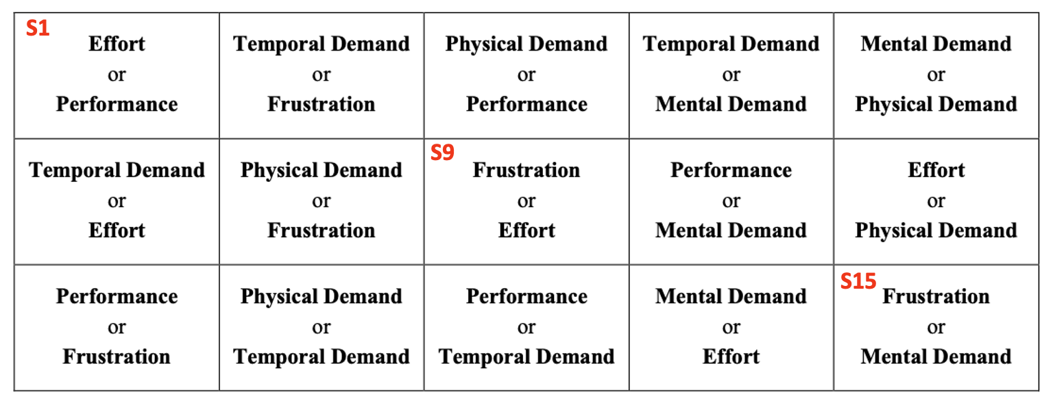
R1 through R6 were transcribed based on the position of the participant’s mark along each scale, which is divided into 20 equal 5-point intervals representing a total range of 0 to 100. Any mark made between ticks was recorded as the value of the right tick (rounded up).
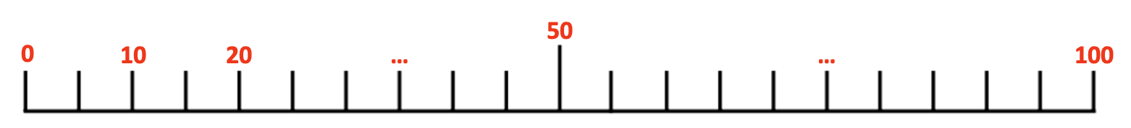
Note that the first 5 participants scored their rankings using a Likert-style scale with values from 1 to 7. This is reflected in their notes. Those values will be mapped to the 100-point scale prior to analysis.
Finally, some participants may have mistakenly scored their Performance Rating. While other factors employ a scale progressing from left to right, with descriptors ranging from Very Low to Very High, the Performance scale is labeled with Perfect and Failure at its endpoints, reflecting the inverse correlation between performance and perceived workload. Despite the consistency of a rightward increase in perceived workload for all factors, participants might erroneously associate higher ratings with enhanced performance. This issue is noted in the TLX instructions and explicitly pointed out to participants, but suspicious values appeared during the transcription process. We will address potential issues during the data processing and cleaning stages.

System Usability Score (Long / Tidy)
Collects scores from the System Usability Study surveys. Each participant completed the SUS twice, after completing the Learning and Recall phases (SUS-1 and SUS-2).
- Participant – the assigned participant number, numeric field
- Treatment – the assigned treatment (PWI, PAR, etc. – from the demographics table)
- Phase – the phase number
  - 1 = learn
  - 2 = recall
- SUS – system usability score for that participant, phase
These scores were derived from the following source data (survey responses), which are still available:
- Q1 through Q10 – gives the response for the corresponding question using the scale values 1 (Strongly Agree) to 5 (Strongly Disagree)
- Notes – text field for misc notes
The coding described for question responses may not align with the instrument’s scoring method. If so, these values can be adjusted during subsequent analysis.
Participant 1058 scored themself using a reversed scale for SUS-1. That was corrected during transcription as indicated in the XLS.

