Spore Lock - The Final Step: Mould Remediation Instructions
Spore Lock is to be used after full remediation as per accepted guidelines has been conducted. It is a last step to improve the removal of airborne mold spores by mechanical means.
Mixing:
Add entire contents of Spore Lock bottle to 1 litre of room temperature water.
Concentrate is an eye hazard. Wear goggles when mixing product
Empty mixture into cold fogger

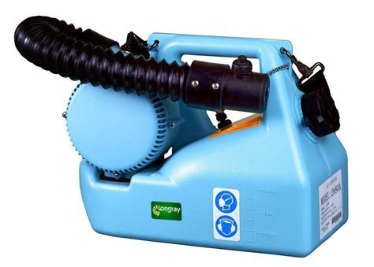
Application:
- Use a cold fogger for best application results. Fog entire room at a rate of 1 litre per 800 square feet.
- Set fogger application rate to fine spray
- Apply to all surfaces within room with aim of locking all possible reservoirs of mould
- Wipe off any excess caused by over spraying with microfiber cloth
- Wipe off glass and shiny (chrome) surfaces to prevent water marks
- If porous surfaces such as carpet are in the immediate area, apply liberally to carpet fibers
Personal Protective Equipment
- As per that required for mould remediation.
- Eye protection such as full face mask, N95 cartridges, gloves and Tyvek suit

Safety and Handling
A. PRODUCT INFORMATION | CONCENTRATE |  |  | DILUTED WORKING SOLUTION
Composition: | 3 (trimethoxy)silylpropyldi-methyloctadecyl ammonium chloride diluted to 42% active ingredients by weight with methanol |  |  | 3.0% by weight of the concentrate in water
Appearance: | Clear to yellow |  |  | Clear to yellow tint
Hazard Classification | Flammable liquid due to methanol |  |  | Not flammable
B. STORAGE |  | CONCENTRATE |  |  | DILUTED WORKING SOLUTION
Flammability: |  | Flammable |  |  | Not Flammable
Shelf Life: |  | 12 months in closed container. |  |  | Up to 6 months in closed containers with no water evaporation or external contaminants.
Recommended  Storage Temp: |  | Ambient.^{3,4} |  |  | Ambient³  Protect from Freezing
D. HANDLING |  | CONCENTRATE | EMERGENCY FIRST AID |  |  | DILUTED WORKING SOLUTION
Skin Contact: |  | Can cause irritation.  Wear gloves and appropriate skin protection | Flush exposed area with water |  |  | No effect on skin.¹
Eye Contact: |  | Severe effect on eyes, can cause blindness. Wear goggles or a face shield to prevent contact with eyes. | Flush eyes with water for 15 minutes.  Obtain medical help. |  |  | Slight irritation.  Poses no hazard from incidental contact.¹
Inhalation: |  | Prolonged or repeated exposure to undiluted material may have an intoxicating effect.  Provide adequate ventilation and use an appropriate respirator | Remove to fresh air. |  |  | No effect.
Ingestion: |  | Large doses can cause blindness or be fatal. | If swallowed, drink a large quantity of water and obtain medical attention. |  |  | Poses no hazard from ingestion incidental to commercial handling.
*Always wear standard safety apparel and protective devices when handling chemicals*

Full SDS is available for review at www.moldscience.net

