

**Homely Furniture Store**

**Ecommerce Website built on the Django Framework**

**Group 11**

**Oleg Glingeanu – X00161834**

**Hamsa Alrawe – X00178778**

**Gabriel Ariesan – X00162461**

**Supervisor : Elizabeth Sherry**

Student Compliance with Academic Integrity

All students are expected to complete their courses in compliance with University regulations and standards. No student shall engage in any activity that involves attempting to receive a grade by means other than honest effort, for example:

1. No student shall complete, in part or in total, any examination or assignment for another person.
2. No student shall knowingly allow any examination or assignment to be completed, in part or in total, for himself or herself by another person.
3. No student shall plagiarize or copy the work of another and submit it as his or her own work.
4. No student shall employ aids excluded by the instructor in undertaking course work.
5. No student shall knowingly procure, provide, or accept any materials that contain questions or answers to any examination or assignment to be given at a subsequent time.
6. No student shall procure or accept assignments from any other student from current or prior classes of this course.
7. No student shall provide their assignments, in part or in total, to any other student in current or future classes of this course.
8. No student shall submit substantially the same material in more than one course without prior authorization.
9. No student shall alter graded assignments or examinations and then resubmit them for regrading.
10. All programming code and documentation submitted for evaluation or existing inside the students computer accounts must be the students original work or material specifically authorized by the instructor.
11. Collaborating with other students to develop, complete or correct course work is limited to activities explicitly authorized by the instructor.
12. For all group assignments, each member of the group is responsible for the academic integrity of the entire submission.

**N.B to be filled out by each member of the team.**

By including my name in the form below, I declare that I understand and will abide by the University Regulations and Policies covering Academic Integrity. I accept that each member of the group is responsible for the academic integrity of the entire submission. I will retain a copy of this agreement for future reference.

|  |  |  |  |
| --- | --- | --- | --- |
| **Student Name (1):** | Oleg Glingeanu | **Student No.:** | X00161834 |
| **Student Name (2):** | Hamsa Alrawe | **Student No.:** | X00178778 |
| **Student Name (3):** | Gabriel Ariesan | **Student No.:** | X00162461 |
| **Module title:** | **Year 2 Project** | | |
| **Programme Title:** | **Computing with Software Development** | | |
| **Date: DD/MM/YYYY** | **24/04/2021** |

**Members responsibilities**

**Oleg**

Oleg’s responsibilities were to make sure everyone on the team was doing their part and pushing their code to the remote repository at all times. Oleg built the Cart app , Wishlist app and the Account dashboard.

**Hamsa**

Hamsa’s responsibilities were to make sure the DevOps Board items like each Use Case is up to date and completed in the given time frame. Hamsa built the Accounts app ,Voucher app and Order app.

**Gabriel**

Gabriel’s responsibilities were to make sure all the code was right and help everyone with the debugging of any code that does not work as intended. Gabriel built the Search function, Item Category and Paginator Function

**Table of Contents**

1. COVER PAGE.…………………………………………………………………………………………………………… 1
2. DECLARATION OF INTEGRITY ………………………………………………………………………………….. 2
3. MEMBERS REPOSIBILITIES ………………………………………………………………………………………. 3
4. INTRODUCTION ………………………………………………………………………………………………………. 4



**Introduction**

E-commerce portal allows the marketers to turn any leads into potential sales. The portal facilitates online transactions of goods and services through means of the transfer of information and funds. The E-commerce platform manages the interactions between the customer and the supplier for your business.

As a group our goal with this project was to develop and design a working general purpose e-commerce web portal called Homely Furniture Store. Homely is an interactive solution providing the users with a platform where products like chairs, tables, cushions and more can be bought from the comfort of the customers home with the use of the Internet.

It was evident as we were working through each iteration that we were making it a bigger challenge for ourselves as we were implementing new features every new iteration as we were trying to make the website as user friendly as possible.

We took a very minimalistic approach at the websites design, it was inspired by a combination of other websites we researched prior to starting the project and it came down to using a white background with grey accents. For our testing we used Selenium IDE and the test cases for each feature that we have implemented into the website

Homely Furniture features offers the following functionalities:

* Promotion and discount code tools
* Search Engine tool
* Wishlist Function
* Customer Accounts
* Order app
* Account dashboard
* Cart app accompanied by
* Order app

**Year 2 Project**

**Group 11**

**Members:**

X00178778 - Hamsa Alrawe

X00161834 - Oleg Glingeanu

X00162461 - Gabriel Ariesan

1. **Goals of the project**

• **What are you planning to achieve in the project? Who are the key users? What is the main functionality?**

• The purpose of this project is to build a working and functional website to sell Furniture to households, the store will include furniture for Bedrooms, kitchens, Living rooms, Outdoor, Home Office and bathrooms, etc.

Our purpose behind setting up this project is to sell and deliver high-quality furniture at reasonable prices that anyone can purchase to supply their homes with what they need. We aim to sell high-quality furniture that lasts for years for a reasonable price.

**Key users:**

• The main key user is a customer who wants to buy furniture for their home.

• The second key user is the admin of the website who can add items, make edits to website and product details.

* The last Key user is the Manager who is responsible on the Stock of the Products.

**Main Functionality:**

The main functionality of the project is to build a big store that have all the items that the customer could ask for, also the store will be well organized and easy for the Customers to find what they are looking for by well organized Category and the search bar so the customer can type the keyword for what they are looking for and they will get the items that have the same keyword. Furthermore, to that we will do seasonal discounts and sale on many items that we sell on our store. Enabling the customers to edit their cart so they can add more Items, remove, and save for later/add to wish list. Also, the customers will have the ability to edit their account details such as: password, address, and mobile number.

1. **Feasibility of project**

**• How feasible is the project within the given timeframe? Identify any risks, discuss contingency plans, etc.**

* The project is very feasible as we have divided the work evenly between the group members.
* Dividing the project with the team members makes the work easier so everyone knows what to do.
* Putting a specific time for each step that we need to work on so we can always do the work on the time.
* We will do market analysis by finding similar stores selling the same products and have a clear idea from them of how our store needs to be.

**Risks:**

* In the case of any issues or errors that could happen to our repositories, we need to have a backup copy of the work to get back to, instead of losing all our work.
* In case one of our team members is absent or sick we need to save our work on Azure DevOps and update any changes made. By doing this, we will have access to his/her work, and we can complete it on time.
* To ensure we make our deadlines and get everything finished on time, we will regularly check up on each member’s progress and help them out if they are falling behind.

1. **Analyse requirements**

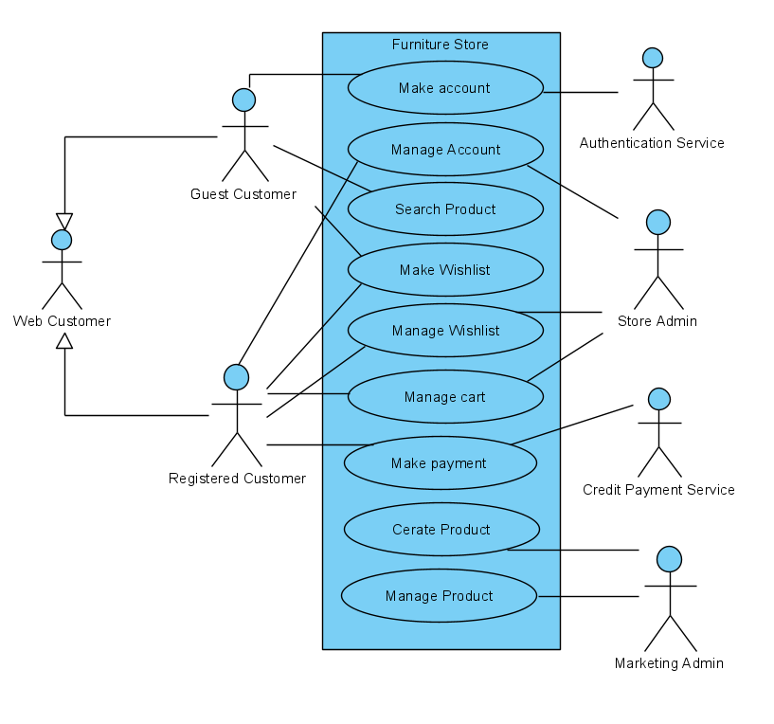

**Use Case Model 1:** **Register as Customer**

|  |  |
| --- | --- |
| **Use Case:** | **Register as Customer** |
| **Actor (s):** | Unregistered User |
| **Goal:** | Allow the user to successfully Register as a customer on the website |
| **Overview:** | The User, who is an unregistered customer, wishes to register to the website to be able to use the other useful website functions such as wish-list. The user can register to the website. Once the user successfully registers to the website an account is created for the user, with all the registered functions. |
| **Pre-Condition:** | User not registered on the websites/database, website’s registration page working perfectly |
| **Post Condition:** | User’s account successfully created and registered on to website and the website database |
| **Successful Scenario:** | 1. User visits the website. 2. The user wishes to create an account on the website. 3. The user clicks on the register button. 4. The user is brought to the website’s register page. 5. The user inputs the required information in the fields shown. 6. The user is then redirected to a page with a prompt to verify the email of the account to verify the user is a real person and not a bot. 7. The user verifies the email associated with the account. 8. The user successfully creates an account and registers on to the website |
| **Alternative Scenario (s)** | 1. The user visits the website. 2. The user wishes to create an account on the website. 3. The user clicks on the register button. 4. The user typing the personal details. 5. The user creates the password. 6. An error message displayed “the password entered does not meet the minimum criteria, re-enter password”. 7. The user trying to re-enter the password. 8. The user gets an error message again and cannot create an account. 9. The user reports the error to the support email about the Issue with creating a password. |
|  |  |
|  |  |
|  |  |
|  |  |

**Use Case Model 2:** **Manage Items**

|  |  |
| --- | --- |
| **Use Case:** | **Manage Items** |
| **Actor (s):** | Admin |
| **Goal:** | Give the User the option to edit (add more quantity, remove and save for later) and make the shopping easier for them. |
| **Overview:** | The Website has an admin area where admin users can add new items for the store and edit pre-existing items that are in the store. The admin user can also add on going discounts to items that are in the store. |
| **Pre-Condition:** | The website designed perfectly and the user using the website has admin privileges |
| **Post Condition:** | The admin has edited pre-existing items and has edited them to the user’s preference |
| **Successful Scenario:** | 1. The admin logs in to the website’s admin panel. 2. The admin opens the item’s page. 3. The admin clicks on an item. 4. The items separate webpage opens where the admin can edit the item’s different attributes. 5. The admin changes and item’s price 6. The admin goes to the website main page. 7. The admin checks the item price. 8. The item price has changed to the new admin set price. |
| **Alternative Scenario (s)** | 1. The admin opens the admin panel. 2. The admin logs in 3. The admin panel page loads up. 4. The admin trying to change the price of an item. 5. The Admin cannot save the change that made. 6. The Admin got an Error message displayed, “the price entered exceeds the price range”. |

**Use Case Model 3:** **Check Out**

|  |  |
| --- | --- |
| **Use Case:** | **Check Out** |
| **Actor (s):** | Guest users and Registered users |
| **Goal:** | Allow the Users to review the basket before being brought to a secure page to checkout where they can pay for their items securely and safely |
| **Overview:** | The Websites checkout function will allow the users to change and edit their cart as a form of review before they continue to the payment screen, The payment screen will ask for the customer's details and address, once filled out their total + shipping will be displayed for them to see and a new "Card payment" screen will show up prompting the user to fill in their details, Once the payment is complete the users are brought to a confirmation screen where they will be given their confirmation number and digital receipt. |
| **Pre-Condition:** | The cart function to be working perfectly, The User has at least 1 item in their cart |
| **Post Condition:** | Order gets placed and the customer has item delivered to them |
| **Successful Scenario:** | 1: The customer has added an item to their cart that they wish to purchase.  2: The User clicked on "Proceed to checkout".  3: The User is asked to fill in their details and address.  4: The User reviews their basket and is prompted to fill in their "Card Payment" details  5: Transaction is complete.  6: User gets put on a new page with confirmation number and their digital receipt. |
| **Alternative Scenario (s)** | 1: User clicks proceed to checkout without having items in the basket,  2: User is told "No items in the basket, cannot proceed to checkout”.  3: User is brought to the homepage of the website.  4: User adds an item to the basket and clicks to continue to checkout.  5: User is told again that "No items in the basket, cannot proceed to checkout”.  6: The user is brought back to the start of the checkout page.  7. The user then contacts the support email complains about the checkout issue. |
|  |  |

**Use Case Model 4:** **Search Function**

|  |  |
| --- | --- |
| **Use Case:** | **Search Function** |
| **Actor (s):** | User (Registered Customer / Unregistered Customer) |
| **Goal:** | The user looks up an item on the search bar function on the website and the website shows all the results of items with the name of what the user has looked up |
| **Overview:** | A user uses the website and needs to look up an item they cannot find, the user uses the search bar, and the website returns all the items with the search keyword in their name that the use has input into the search bar. |
| **Pre-Condition:** | The website designed perfectly with the search function implemented and working |
| **Post Condition:** | The website returns a page with the items that have the keyword that the user has looked up in the name of the items |
| **Successful Scenario:** | 1. The user navigates through the website. 2. The user cannot find the item they wish to find. 3. The user inputs “Wooden Chair” in the search bar 4. Once the website has loaded it returns all the items with the name “Wooden Chair “ 5. After that. the user will choose the “Wooden chair” that they like and complete the purchase process. |
| **Alternative Scenario (s)** | 1. The user navigates through the website. 2. The user cannot find the item they wish to find. 3. The user inputs “Wooden Chair” in the search bar 4. Once the page loads, it returns a message to the user says, “no product matches for "Wooden chair". 5. The user notices the search bar does not work and is not implemented right. 6. The user then contacts the support email complains about the search bar issue. |

**Use Case Model 5:** **Wishlist Function**

|  |  |
| --- | --- |
| **Use Case:** | **Wishlist Function** |
| **Actor (s):** | Guest users and Registered users |
| **Goal:** | Give the Users a function where they can save items for later or keep an eye on the price of said items |
| **Overview:** | The Wishlist Function will allow Users to store items for later, whether they are waiting for a sale to happen or they are waiting to get paid, the items are stored on their Wishlist where they can access them at any moment. |
| **Pre-Condition:** | The user must be registered to use this function |
| **Post Condition:** | Items are saved in a wish-list that can be accessed at any later point where an option to "add to card" exists for each item. |
| **Successful Scenario:** | 1: The user is a registered user to the website.   2: The user searches for an item they want.   3: The user adds 3 items to their wish-list, (2 waiting for a sale, 1 out of stock)  4: The user now has the 3 items in their wish-list.  5: One of the user’s items goes on sale and the out of stock one is back in stock.  6: The user clicks the "add to cart" button beside the items he wishes to buy from the wish-list.  7: The items are then added to the user’s cart and then the user is brought to the checkout. |
| **Alternative Scenario (s)** | 1: A non-registered user clicks on the "Add to wish-list" button for an item.  2: They are told to register to use the function.  3: The user registers and re-add the items to their wish-list.  4: The user waits for a sale to occur.  5: A sale for that item does not occur but, in the meantime, the item goes out of stock.  6: The users click the "Inform me when back in stock" button beside the item in their wish-list.  7: The user receives an email when the item is back in stock and available for purchase again. |

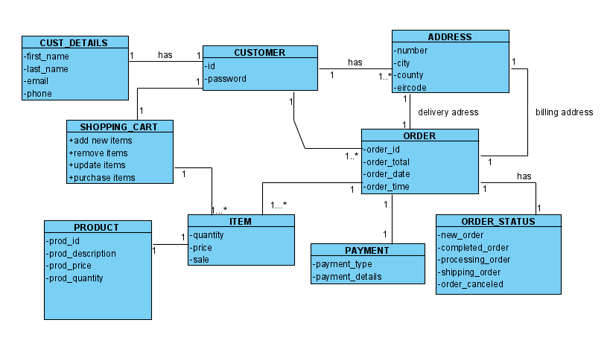

**Iteration 1**

**Group 11**

**Oleg Glingeanu – X00161834**

**Hamsa Alrawe – X00178778**

**Gabriel Ariesan – X00162461**

For out iteration 1 we manage to setup our website and website database. We have also populated the database and styled a few parts of the website. The Admin part of the website works perfectly and as intended , Adding new items and categories works without any problems as showing in our Test case matrix. We also added the cart function and all the tests are perfect for the cart. The cart also is up to date with the database as when we have 10 of an item in stock we can only add up to 10 or how ever many there is in stock. The search function is also a very good part of the website as it works perfectly and searches for any product you are looking for and there is no problems with it

The cart is also styled along side with the website and each item and the items description, We have breadcrumbs implemented in the website so you can always go back and you can always see what direction you went. Every page has 6 items per page and can be edited.

The website was designed in a very good manner as the team members took a task each , for example first member implemented the search function the second member populated the database and so on. Once we all pushed the code we all worked together on any errors that there was in the code such as any bugs , typos and or anything coded wrong.

Testing the website was an easy task as all the code was already up and running and debugged. Each member took their time and tested their test case carefully.

|  |  |  |  |  |  |
| --- | --- | --- | --- | --- | --- |
| **Test Case Matrix** | | | | | |
| **Test Case No** | **Test Case Name** | **Input** | **Expected Outcome** | **Actual Outcome** | **Result (Pass/Fail)** |
| NR 1 | Add an item category | Category Name + Picture | New Category Created | New Category was created | Pass |
| NR 2 | Add an item | Item details | New item created | New item was added to the database | Pass |
| NR 3 | Adding an item to the basket | Pressing “Add to cart “ | The item is added to the cart | The item was added to the cart | Pass |
| NR4 | Adding max amount of items | Max amount of an item | Item is added till there is no more in stock | Item was added up to the remaining stock | Pass |
| Nr5 | Search for a specific item | An item name in the search bar | The item we are looking for to be shown back to us | The item we looked for was the outcome from searching | Pass |
| Nr6 | Use the category drop down button | Press on category and choose a category | The items under that category to be retrieved and given as the output to the user | The items under the category was given back to us | Pass |
| Nr7 | Cart button after adding new items in the cart | Press the cart button after adding multiple new items | Expected outcome is that the cart will have all the new items added after adding them to the cart | All the new items were in the cart as intended and no problems | Pass |
| Nr8 | Deleting an item from the cart | Delete an item from the cart completely | The item and its quantity to be completely erased from the cart | The item is gone and the price changed as intended | Pass |
| Nr9 | Check if the breadcrumbs work as intended | Press on one of the breadcrumbs after going into an items view page | Brings the user back to the item / page they clicked on from the breadcrumbs | The user was brought back to the intended page they clicked on | Pass |

**Iteration 2**

**Group 11**

**Oleg Glingeanu – X00161834**

**Hamsa Alrawe – X00178778**

**Gabriel Ariesan – X00162461**

**Iteration 2 – Revised Prototype:**

After building the website we were having many bugs and issues in some website’s functionalities and we had to fix such as:

- bugs in the Category – the button was now working, and the category was having only two types of products, so we fixed the button and the customers now can click on the category button and can have a list of products also will have the opportunity to view all the products that we have on the website.

- issue with the sign-up page: asking the customer for their age was an unneeded step, so we removed this part and the customer now can sign up without entering their age.

After fixing the remaining bugs from iteration 1 for out iteration 2 we manage to setup our website and get all the core functions working. At the start we had some problems with the Wishlist function as it was buggy and did not work as we intended it to work. Once we got the Wishlist working we implemented it with the website and added more functions like adding to the cart from the Wishlist and telling the user if the item is out of stock. The other functionalities that we implemented in iteration 2 is Vouchers that can be used at checkout and works perfectly with the stripe payment as it updates. We also added order details for each customer and they can track their previous orders and see what they ordered in that specific order.

Another functionality is the account dashboard. The Account dashboard allows the user to view their account , edit their account , view the previous orders , change password and see their Wishlist. The dashboard connects all the functionalities together and gives the user an easy access to use the new implement functionalities.

We tested the website using selenium IDE as it gives us more information on what we were doing and made sure everything works as intended. A few tests we did manually as we just needed to check if the test cases passed. Each member took responsibility to do the specific test case given to them and they ran the test cases twice to make sure we have a good result that represents the test case.

The demo of the website prototype went really well as all the Functionalities worked really well and the website was styled very nicely. The sign up template was also styled and looked really well. The website was working perfectly for iteration 2 demo as we did the thorough testing and made sure everything is perfect for the demo.

|  |  |  |  |  |  |
| --- | --- | --- | --- | --- | --- |
| **Test Case Matrix** | | | | | |
| **Test Case No** | **Test Case Name** | **Input** | **Expected Outcome** | **Actual Outcome** | **Result (Pass/Fail)** |
| **1** | Using a voucher | Voucher “EXTRA10 “ at checkout page | The total price to be deducted by 10% | The price has been deducted by 10% | Pass |
| **2** | Adding to Wishlist | Press the Add an item to the Wishlist button | Item gets added to the users personal Wishlist | Item gets added to the Wishlist | Pass |
| **3** | Change Password | Old Password , New Password , New Password | The users password to change and be able to log in with the new password | The users password changed and successfully logged in | Pass |
| **4** | Wishlist – out of stock check | Set a product to 0 trough admin | Users Wishlist says out of stock | The users Wishlist says out of stock | Pass |
| **5** | Checking Order history | Click on the check order history | All of the users orders show up in chronological order | The users Orders show up | Pass |
| **6** | User Detail change | User inputs new details in the specified fields | The users specified details are changed | The details change as intended | Pass |
| **7** | Check Order Details | Press on view order while in the Order history tab | The users specific order details will be displayed on the screen | The users order details are shown to the user | Pass |
| **8** | Using a voucher after expiry date | Voucher “EXPIRY TEST “ | The discount voucher should not apply the percent which the voucher is attributed | The amount is still subtracted | Fail |
| **9** | Using a weak password | Input 12345678 as the password at the password change | The password should not change as the password is too weak | The password did not change as it was too weak | Pass |

**Iteration 1**

**Group 11**

**Oleg Glingeanu – X00161834**

**Hamsa Alrawe – X00178778**

**Gabriel Ariesan – X00162461**

For our last iteration, we focused on rigorous testing of the various features of the website, some done by hand while most were tested using Selenium IDE, some of the tested features included Changing passwords, Adding multiple items to the cart, using expired coupons, Failed logins.

Since we shared the work evenly between the group we were able to get the testing done within 2 days, each person had a list of tests to run and then report on, if problems arose then we all joined together to fix it so that we don’t waste too much time.

For the User specifications we used Selenium while for the detailed design we used unit test and on top of that we also tested certain aspects by hand just to make sure they don’t fail on us or in case the tests weren’t accurate

We also corrected some code where we had small mistakes made, each member looked the features they added to make sure they work as intended, apart from those features bits of code were cleaned up and fixed where we had unexpected errors.

|  |  |  |  |  |  |
| --- | --- | --- | --- | --- | --- |
| **Test Case Matrix** | | | | | |
| **Test Case No** | **Test Case Name** | **Input** | **Expected Outcome** | **Actual Outcome** | **Result (Pass/Fail)** |
| NR 1 | Log-in | Email + Password | The user is logged into the site | The User was logged into the website | Pass |
| NR 2 | Buying multiple items | Multiple items in the cart and buying | Order made for the items | All of the items were included in the order | Pass |
| NR 3 | Adding new items | Adding items using the admin tools | A new item is added to the respective category | New item was added to the category | Pass |
| NR 4 | Ordering an item out of stock | Buying an item not in stock | The order is not made as the item is not in stock | Order wasn’t processed as item wasn’t in stock | Pass |
| NR 5 | Search for a specific item | An item name in the search bar | The item we are looking for to be shown back to us | The item we looked for was the outcome from searching | Pass |
| Nr6 | Ordering new stock | Ordering new stock | Once the new stock is ordered the number of items goes up | After new items were ordered the stock of the items went up to new value | Pass |
| Nr7 |  |  |  |  |  |
| Nr8 |  |  |  |  |  |
| Nr9 |  |  |  |  |  |