# Business Layer 3NF

## Definitions & Acronyms

SQL: Structured Query Language, used for managing and querying data in the database.

• (PK) (Primary Key): A unique identifier for a record in a table.

• (FK) (Foreign Key): A field in one table that uniquely identifies a row of another table, creating a relationship between the two tables.

• SQL (Structured Query Language): The standard language used to communicate with and manipulate databases.

• PL/pgSQL: A procedural language supported by PostgreSQL that allows for more complex operations and control structures in SQL scripts.

m:m

: Many-to-many relationship in the database, where multiple records from one table can be associated with multiple records from another table.

1:m (m:1)

: One-to-many (many-to-one) relationship in the database, where one record from a table is associated with many records from another table.

1:1

: One-to-one relationship in the database, where one record from a table is associated with one record from another table.

(PK): Primary Key, a unique identifier for each record in a database table.

(FK): Foreign Key, a reference to a Primary Key in another table to establish a relationship between two tables.

NOT NULL: attribute in a table must have a value.

## Logical Scheme

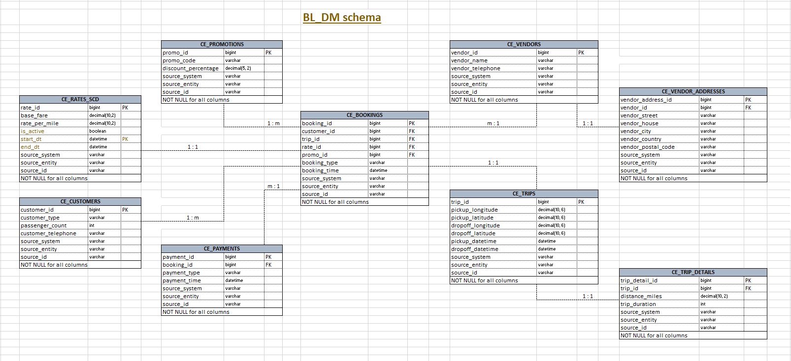

## Objects

1. **CE_VENDORS table description**

This table stores information about taxi companies. It also includes metadata for tracking the source of the data and the entity within the source system.

|  |  |  |  |
| --- | --- | --- | --- |
| Table Name | Field name | Field Description | Data Type |
| CE_VENDORS | vendor_id | unique identifier for each vendor (PK) | bigint |
| vendor_name | vendor name | varchar |
| vendor_telephone | vendor telephone number | varchar |
| source_system | system where the data originates from (datasets) | varchar |
| source_entity | entity within the source system | varchar |
| source_id | unique identifier within the source system | varchar |

Comments on table relationships:

* CE_VENDORS ↔ CE_BOOKINGS: one-to-many (1:m) relationship;
* CE_VENDORS ↔ CE_VENDOR_ADDRESSES: one-to-one (1:1) relationship.

Additional constraints: NOT NULL for all columns

1. **CE_VENDOR_ADDRESSES table description**

This table stores information about taxi companies. It also includes metadata for tracking the source of the data and the entity within the source system.

|  |  |  |  |
| --- | --- | --- | --- |
| Table Name | Field name | Field Description | Data Type |
| CE_VENDOR_ADDRESSES | vendor_address_id | unique identifier for each vendor address (PK) | bigint |
| vendor_id | foreign key referencing to the ce_vendors (FK) | bigint |
| vendor_street | vendor street | varchar |
| vendor_house | vendor telephone house | varchar |
| vendor_city | vendor city | varchar |
| vendor_country | vendor country | varchar |
| vendor_postal_code | vendor postal code | varchar |
| source_system | system where the data originates from (datasets) | varchar |
| source_entity | entity within the source system | varchar |
| source_id | unique identifier within the source system | varchar |

Comments on table relationships:

* CE_VENDORS ↔ CE_VENDOR_ADDRESSES: one-to-one (1:1) relationship.

Additional constraints: NOT NULL for all columns

1. CE_CUSTOMERS table description

The CE_CUSTOMERS table stores information about customers, including a unique identifier, customer type, number of passengers, and contact details. It also includes metadata for tracking the source of the data and the entity within the source system.

|  |  |  |  |
| --- | --- | --- | --- |
| Table Name | Field name | Field Description | Data Type |
| CE_CUSTOMERS | customer_id | unique identifier for each customer (PK) | bigint |
| customer_type | Individual/Business | varchar |
| passenger_count | passenger count | int |
| customer_telephone | customer telephone | varchar |
| source_system | system where the data originates from (datasets) | varchar |
| source_entity | entity within the source system | varchar |
| source_id | unique identifier within the source system | varchar |

Comments on table relationships:

* CE_CUSTOMERS ↔ CE_BOOKINGS: one-to-many (1:m) relationship.

Additional constraints: NOT NULL for all columns

1. CE_BOOKINGS table description

The CE_BOOKINGS table contains information about customer bookings, including a unique identifier, associated customer, trip, rate and promo IDs, booking type, and the time of booking. It also tracks the source of the data and the entity within the source system.

|  |  |  |  |
| --- | --- | --- | --- |
| Table Name | Field name | Field Description | Data Type |
| CE_BOOKINGS | booking_id | unique identifier for each booking (PK) | bigint |
| customer_id | unique identifier for each customer (FK) | bigint |
| trip_id | unique identifier for each trip (FK) | bigint |
| rate_id | unique identifier for each rate (FK) | bigint |
| promo_id | unique identifier for each promotion (FK) | bigint |
| booking_type | booking type | varchar |
| booking_time | booking time | datetime |
| source_system | system where the data originates from (datasets) | varchar |
| source_entity | entity within the source system | varchar |
| source_id | unique identifier within the source system | varchar |

Comments on table relationships:

* CE_CUSTOMERS ↔ CE_BOOKINGS: one-to-many (1:m) relationship;
* CE_BOOKINGS ↔ CE_RATES_SCD: one-to-one (1:1) relationship;
* CE_BOOKINGS ↔ CE_PROMOTIONS: many-to-one (m:1) relationship;
* CE_BOOKINGS ↔ CE_VENDORS: many-to-one (m:1) relationship;
* CE_BOOKINGS ↔ CE_TRIPS: one-to-one (1:1) relationship;
* CE_BOOKINGS ↔ CE_PAYMENTS: many-to-one (m:1) relationship.

Additional constraints: NOT NULL for all columns

1. CE_PAYMENTS table description

The **CE_PAYMENTS** table stores information about payments made for bookings, including a unique payment identifier, the booking ID it relates to, payment type, and the time of payment. It also includes metadata for tracking the source of the data and the entity within the source system.

|  |  |  |  |
| --- | --- | --- | --- |
| Table Name | Field name | Field Description | Data Type |
| CE_PAYMENTS | payment_id | unique identifier for each payment (PK) | bigint |
| booking_id | unique identifier for each booking (FK) | bigint |
| payment_type | payment type | varchar |
| payment_time | payment time | datetime |
| source_system | system where the data originates from (datasets) | varchar |
| source_entity | entity within the source system | varchar |
| source_id | unique identifier within the source system | varchar |

Comments on table relationships:

* CE_CUSTOMERS ↔ CE_PAYMENTS: one-to-many (1:m) relationship;
* CE_BOOKINGS ↔ CE_PAYMENTS: many-to-one (m:1) relationship.

Additional constraints: NOT NULL for all columns

1. CE_RATES_SCD table description

This table stores historical rate information for transportation services. It is structured to track changes over time using Slowly Changing Dimensions (SCD) Type 2, capturing the historical data of each rate, including start and end dates, status of the rate (active or inactive), and additional metadata to trace when and why a rate change occurred.

|  |  |  |  |
| --- | --- | --- | --- |
| Table Name | Field name | Field Description | Data Type |
| CE_RATES_SCD | rate_id | unique identifier for each rate (PK) | bigint |
| base_fare | base fare for the transportation service | decimal(10,2) |
| rate_per_mile | Rate per mile for the transportation service | decimal(10,2) |
| is_active | Indicates if the rate is currently active | boolean |
| start_dt | Start date of the rate's validity (SCD Type 2 field) | datetime |
| end_dt | End date of the rate's validity (SCD Type 2 field) | datetime |
| source_system | system where the data originates from (datasets) | varchar |
| source_entity | entity within the source system | varchar |
| source_id | unique identifier within the source system | varchar |

Comments on table relationships:

• CE_BOOKINGS ↔ CE_RATES_SCD: one-to-one (1:1) relationship.

Additional constraints: NOT NULL for all columns

1. CE_PROMOTIONS table description

This table stores promotional information related to transportation services. It tracks active and past promotions, including the promotional code, the discount offered, and metadata about the source system from which the data originates.

|  |  |  |  |
| --- | --- | --- | --- |
| Table Name | Field name | Field Description | Data Type |
| CE_PROMOTIONS | promo_id | unique identifier for each promotion (PK) | bigint |
| promo_code | promotion code | varchar |
| discount_percentage | discount percentage | decimal(5,2) |
| source_system | system where the data originates from (datasets) | varchar |
| source_entity | entity within the source system | varchar |
| source_id | unique identifier within the source system | varchar |

Comments on table relationships:

• CE_BOOKINGS ↔ CE_PROMOTIONS: many-to-one (m:1) relationship.

Additional constraints: NOT NULL for all columns

1. CE_TRIPS table description

This table stores information about individual trips, including geographic data related to pickup and drop-off locations, as well as timestamps for the trip's start and end. It serves as a core component for tracking the details of transportation journeys. It also includes metadata for tracking the source of the data and the entity within the source system.

|  |  |  |  |
| --- | --- | --- | --- |
| Table Name | Field name | Field Description | Data Type |
| CE_TRIPS | trip_id | unique identifier for each trip (PK) | bigint |
| pickup_longitude | Longitude of the pickup location | decimal(10,6) |
| pickup_latitude | Latitude of the pickup location | decimal(10,6) |
| dropoff_longitude | Longitude of the drop-off location | decimal(10,6) |
| dropoff_latitude | Latitude of the drop-off location | decimal(10,6) |
| pickup_datetime | Date and time when the trip was picked up | datetime |
| dropoff_datetime | Date and time when the trip was completed (dropped off) | datetime |
| source_system | system where the data originates from (datasets) | varchar |
| source_entity | entity within the source system | varchar |
| source_id | unique identifier within the source system | varchar |

Comments on table relationships:

* CE_TRIPS ↔ CE_TRIP_DETAILS: one-to-one (1:1) relationship;
* CE_BOOKINGS ↔ CE_TRIPS: one-to-one (1:1) relationship.

Additional constraints: NOT NULL for all columns

1. CE_TRIP_DETAILS table description

This table stores detailed information about each trip, including metrics such as distance traveled and trip duration. It provides additional context to the CE_TRIPS table by linking a trip with its operational details, such as the distance in miles and the total duration. It also includes metadata for tracking the source of the data and the entity within the source system.

|  |  |  |  |
| --- | --- | --- | --- |
| Table Name | Field name | Field Description | Data Type |
| CE_TRIP_DETAILS | trip_detail_id | unique identifier for each trip details (PK) | bigint |
| trip_id | Unique identifier for each trip (FK) | bigint |
| distance_miles | Total distance of the trip in miles | decimal(10,2) |
| trip_duration | Duration of the trip in minutes | int |
| source_system | system where the data originates from (datasets) | varchar |
| source_entity | entity within the source system | varchar |
| source_id | unique identifier within the source system | varchar |

Comments on table relationships:

* CE_TRIPS ↔ CE_TRIPS_DETAILS: one-to-one (1:1) relationship.

Additional constraints: NOT NULL for all columns