

|  |
| --- |
| **NYC taxi trip** |
|  |

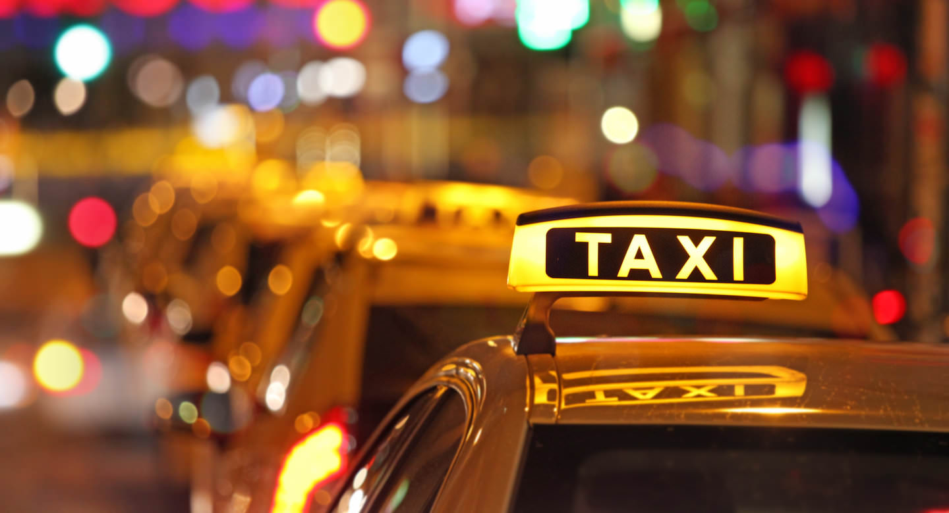

# Business Layer Dimensional Model

## Logical Scheme

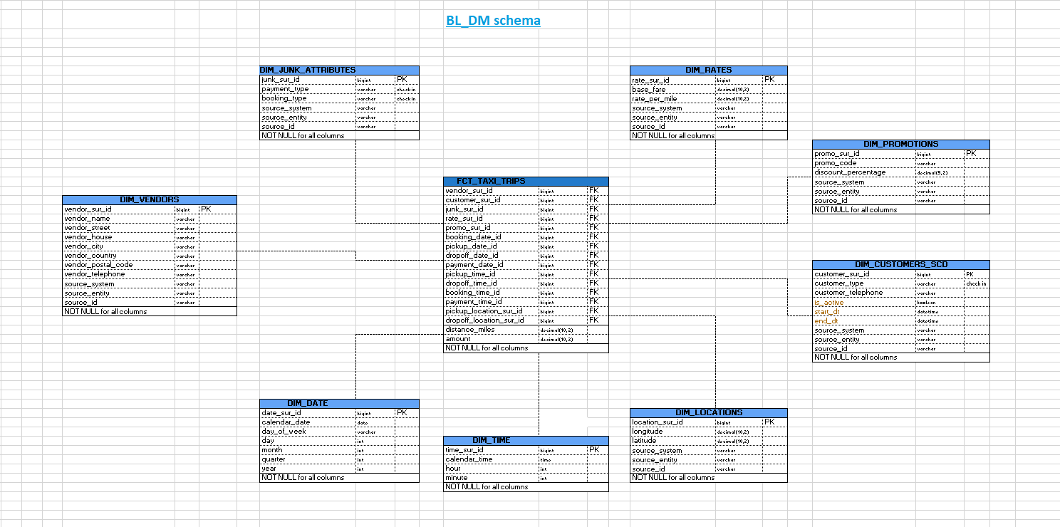

## **METRICS Description**

DIM_JUNK_ATTRIBUTES

* payment_type: Describes the type of payment for a trip (e.g., Credit, Cash);
* booking_type: Represents the type of booking (e.g., Phone/Street).

DIM_RATES

* base_fare: The initial charge for a trip, usually fixed;
* rate_per_mile: The charge for each mile traveled during the trip.

DIM_PROMOTIONS

* promo_code: The code for a specific promotion;
* discount_percentage: The percentage discount offered by the promotion.

DIM_VENDORS

* vendor_name: The name of the vendor;
* vendor_street: The street address of the vendor;
* vendor_house: The house number of the vendor;
* vendor_city: The city where the vendor is located;
* vendor_country: The country where the vendor operates;
* vendor_postal_code: The postal code for the vendor;
* vendor_telephone: The contact telephone number of the vendor.

DIM_CUSTOMERS_SCD (used SCD2)

* customer_type: Defines the type of customer (e.g., Individual/Business);
* customer_telephone: The telephone number of the customer;
* is_active: Indicates whether the customer is currently active;
* start_dt: The start date of the customer record;
* end_dt: The end date of the customer record;
* pickup_location_sur_id: A reference to the location where the customer was picked up;
* dropoff_location_sur_id: A reference to the location where the customer was dropped off.

FCT_TAXI_TRIPS (fact table)

Context:

* vendor_sur_id: Foreign key referencing a vendor;
* customer_sur_id: Foreign key referencing a customer;
* rate_sur_id: Foreign key referencing a rate;
* promo_sur_id: Foreign key referencing a promotion;
* booking_date_id: Foreign key referencing the booking date;
* pickup_date_id: Foreign key referencing the pickup date;
* dropoff_date_id: Foreign key referencing the dropoff date;
* payment_date_id: Foreign key referencing the payment date;
* pickup_time_id: Foreign key referencing the pickup time;
* dropoff_time_id: Foreign key referencing the dropoff time;
* booking_time_id: Foreign key referencing the booking time;
* payment_time_id: Foreign key referencing the payment time.

Measurements:

* distance_miles: The total distance traveled during the trip in miles;
* amount: The total fare amount for the trip.

DIM_DATE

* calendar_date: The date for the record;
* day_of_week: The name of the day (e.g., Monday, Tuesday);
* day: The day of the month;
* month: The month of the year;
* quarter: The quarter of the year;
* year: The year of the trip or record;

DIM_TIME

* time_sur_id: Primary key for time records;
* calendar_time: The specific time during the day;
* hour: The hour part of the time;
* minute: The minute part of the time.

DIM_LOCATIONS

* longitude: The longitude of the location;
* latitude: The latitude of the location.

These metrics cover the various elements of a taxi trip, such as rates, vendors, customers, locations, time and promotions. The main fact table (FCT_TAXI_TRIPS) will likely be used to store transactional data about each trip.

# Logical Scheme

# Data Flow

# Fact Table Partitioning Strategy