

|  |
| --- |
| EPAM Systems, RD Dep., RD Dep.  **POWER BI** |
| Project Design Essentials |

# Building a simple Power BI Report

## Working with Power BI Model

1. Open the report created in Lab work 01.
2. Switch to Modelling View. Check the relationship that were automatically created during data load
3. Review the Cardinality, Cross filter direction and Active/Inactive relationships. We are going to work with OrderDate as the main Date for the analysis, so remove other relationships between **FactInternetSales** table and **DimDate** and make the OrderDate connection active.

## Working with Power BI Report

1. Switch to the report view and start building visualizations. Use the visuals panel for choosing a graph.
2. Add a Slicer. It should contain Full Name from DimCustomer table. Try to have in two types – List and Dropdown. Add Search to the slicers, since there are a lot of customers, so let’s simplify user experience.
3. Let’s add a custom visual to the page. To do to that you must use Import from **AppSource**:
4. Choose any Custom Visual in the Marketplace and click Add:

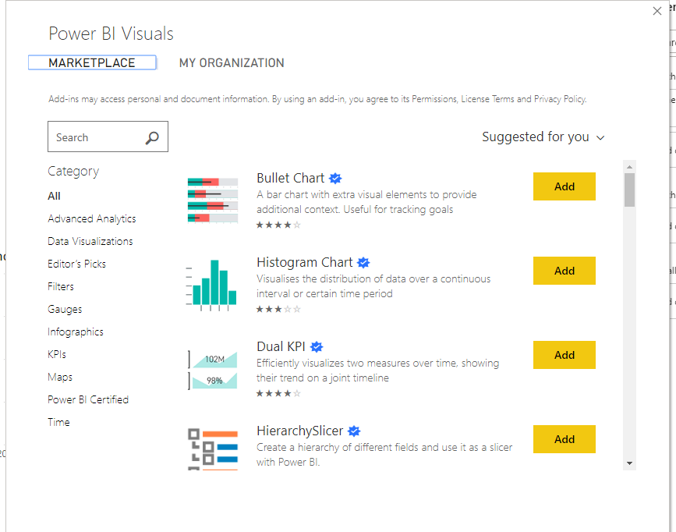

# Create lab report

Create a report based on the data loaded. The report should fulfil the following requirements:

1. The report should have a header with report name and company logo.
2. The report should contain 3 different types of Slicers (Filters) – drop-down, list box and date filter.
3. The report should contain at least 5 different visual types from standard list and at least 2 custom visuals. Explain the choice of custom visuals in the lab report.
4. Disable interactions between one of the slicers and one of the visuals in your report. Don’t forget to include description of this step into you word document.
5. The report should be developed using a chosen color palette to be visually appealing – e.g., the colors of the bars and lines in the chart should correspond to the logo colors.
6. Add and configure a Map visual to the report. Add necessary tables from the AdventureWorks DWH if needed.
7. Configure mobile layout for your report.
8. Publish the report to Power BI Service Portal and include the screenshot of published report into lab work results email.
9. Install Personal Gateway and configure data refresh once a day and include the screenshot into lab work results email.
10. Share the report with your mentor and send email notification to him/her.
11. **Create and include into lab report the URL link that will have a built-in filter in it (e.g., the link will open the report filtered by one Country)

Create lab report and .commit to gitlab the below artifacts:

1. Word document with screenshots and progress description
2. PBIX file with the resulting report.