

|  |
| --- |
| **Household Appliances Store** |
|  |

# 

# Model description

## Definitions & Acronyms

Customer: An individual who purchases products from the electronics store. Attributes include customer_id, cust_name, cust_surname, cust_email, and cust_phone.

• Order: A transaction made by a customer. Attributes include order_id, customer_id, employee_id, and ord_date.

• Product: An item available for purchase. Attributes include product_id, prod_name, prod_brand, prod_model, prod_price, and prod_description.

• Supplier: A provider of products to the store. Attributes include supplier_id, sup_name, sup_contact_name, sup_phone, and sup_email.

• Employee: A staff member of the store. Attributes include employee_id, emp_name, emp_surname, emp_position, emp_hire_date, emp_email, and emp_phone.

• Inventory: A record of product quantities. Attributes include inventory_id, product_id, inv_quantity, and inv_last_updated.

• Procurement: The process of acquiring products from suppliers. Attributes include procurement_id, supplier_id, product_id, employee_id, proc_date, proc_quantity, and proc_total_cost.

• Order Details: Specifics of products within an order. Attributes include order_id, product_id, ord_det_quantity, ord_det_unit_price, and ord_det_status.

• PK (Primary Key): A unique identifier for a record in a table.

• FK (Foreign Key): A field in one table that uniquely identifies a row of another table, creating a relationship between the two tables.

• RLS (Row-Level Security): A feature that allows control over which rows are visible to users based on their role or other criteria.

• SQL (Structured Query Language): The standard language used to communicate with and manipulate databases.

• PL/pgSQL: A procedural language supported by PostgreSQL that allows for more complex operations and control structures in SQL scripts.

m:m

: Many-to-many relationship in the database, where multiple records from one table can be associated with multiple records from another table.

1:m (m:1)

: One-to-many (many-to-one) relationship in the database, where one record from a table is associated with many records from another table.

1:1

: One-to-one relationship in the database, where one record from a table is associated with one record from another table.

PK: Primary Key, a unique identifier for each record in a database table.

FK: Foreign Key, a reference to a Primary Key in another table to establish a relationship between two tables.

NOT NULL: attribute in a table must have a value.

## Logical Scheme

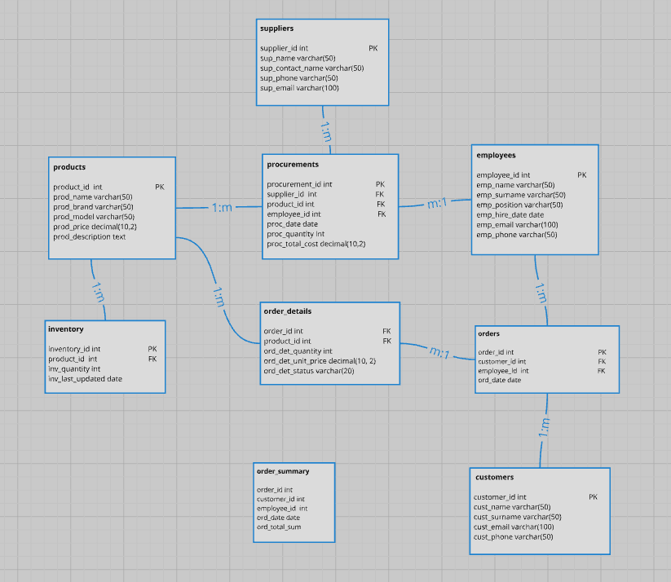

## 

## Objects

1. **Products table description**

This table stores information about products.

|  |  |  |  |
| --- | --- | --- | --- |
| Table Name | Field name | Field Description | Data Type |
| products | product_id | unique identifier for each product PK | int |
| prod_name | product name NOT NULL | varchar (50) |
| prod_brand | product brand | varchar (50) |
| prod_model | product model | varchar (50) |
| prod_price | product price | decimal(10,2) |
| prod_description | product description | text |

Comments on table relationships

* products ↔ inventory: one-to-many (1:m) relationship;
* products ↔ orders: many-to-many (m:m) relationship, via order_details;
* products ↔ employees: many-to-many (m:m) relationship, via procurements.

|  |  |
| --- | --- |
| climb_id | name |
| 1 | Everest Expedition |
| 2 | Zakopane Morske Oko |
| 3 | Alpine Challenge |

1. **Climb_schedule table description**

This table manages the scheduling of climbs.

And so on … No time to wait …