**Task 1**

**Establish connection to AWS account**

**Connect to VPN**

Install GlobalProtect 64, choose folder where logs will saved and connect using server : vpn.epam.com

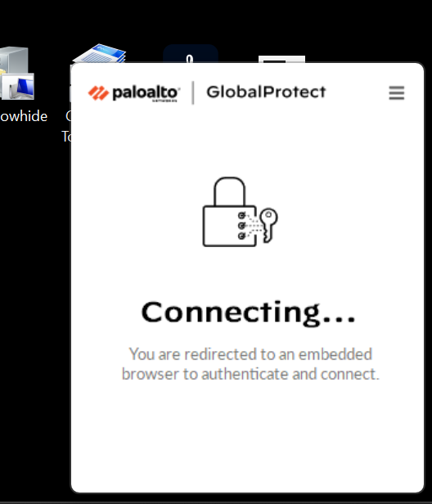

Choose best aviable gateway … it is automatically added

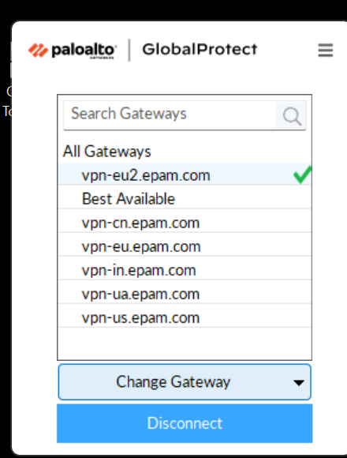

Then I open our AWS console with SSO by EPAM provided email link

**Switch role**

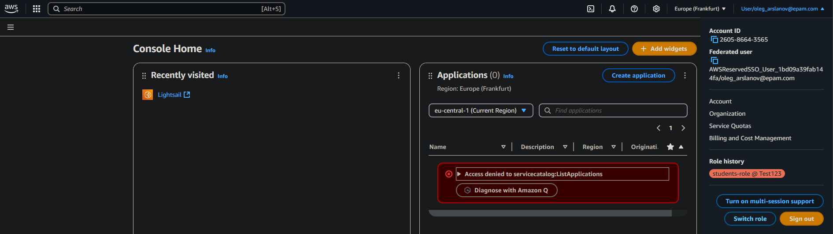

Switch role to students-role … interesting thing here that account id prepared from EPAM and I can not use another account id 😊

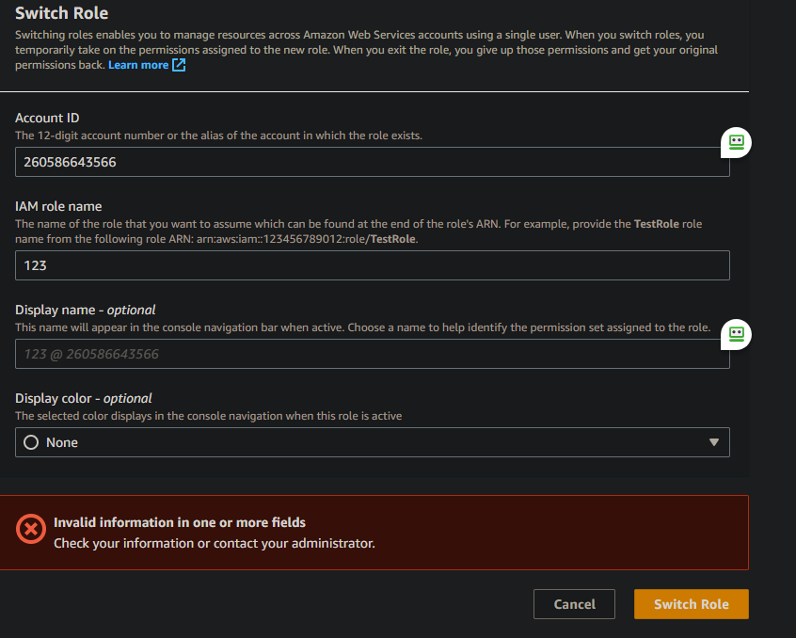

So I did like on instruction and sucsesufully connect

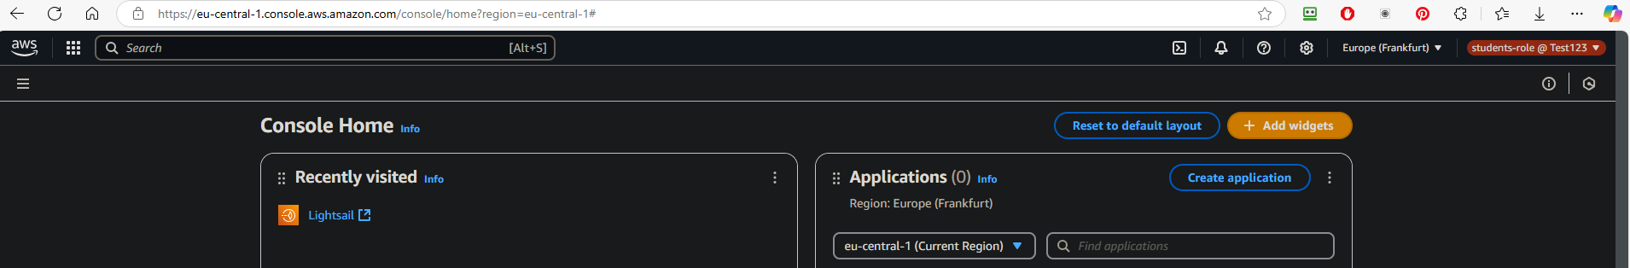

Next I download and install AWS CLI v2

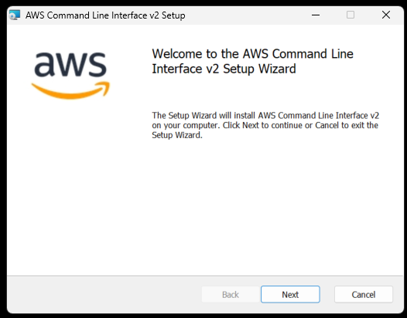

**Configure CLI from aws configure**

Next need to configure AWS CLI with keys provided from credentials for User (must click on Access keys)

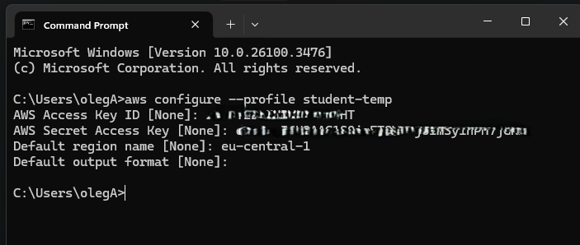

Adding aws_session_token to student-temp profile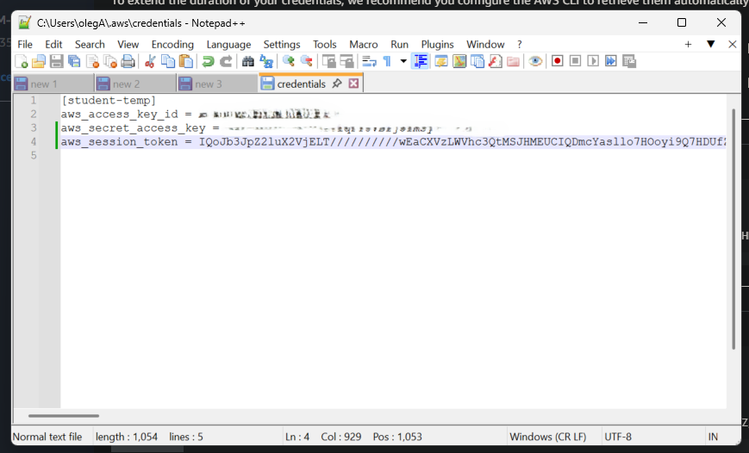

Then we modify config file

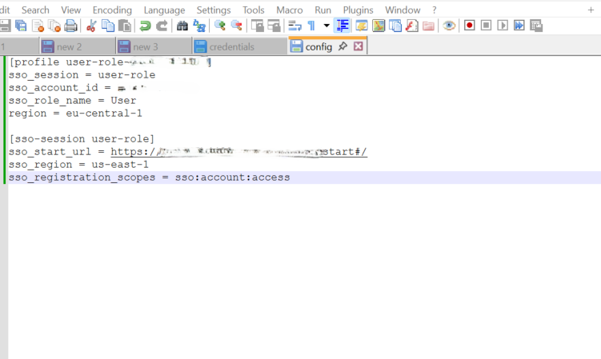

And now we connect to AWS with SSO login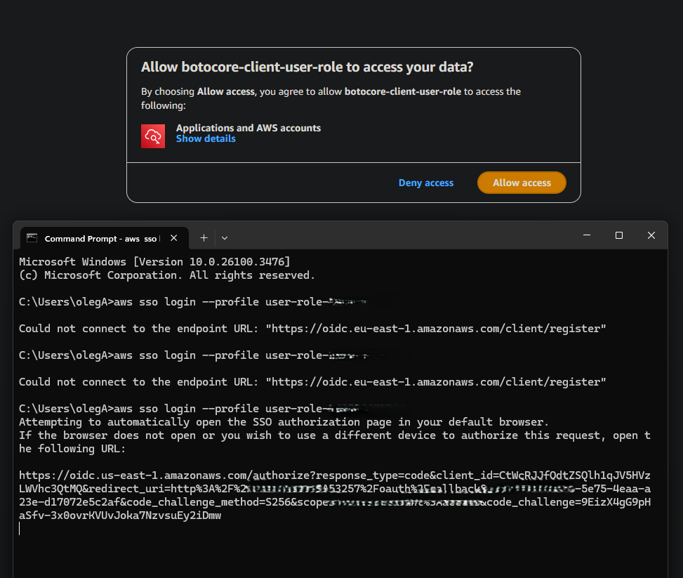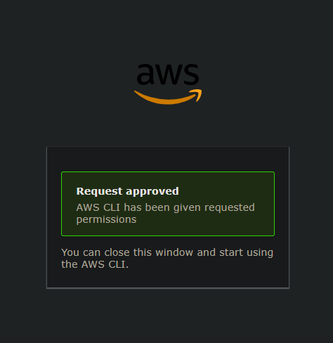

**Now assume students-role from user-role- 260586643565**

Modify config file 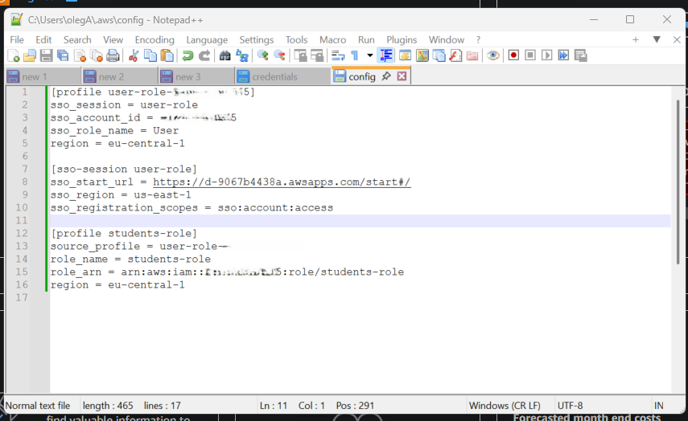

Test it from cmd

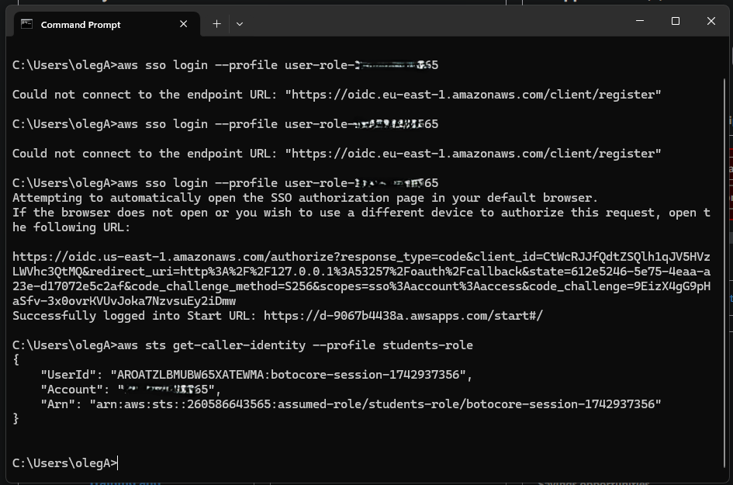

**2. Working with AWS services**

Create own bucket and then tag it with owner = student

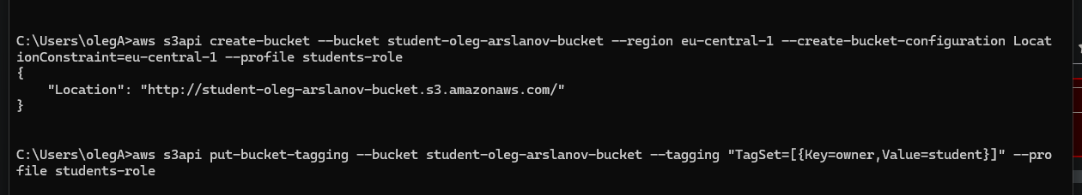

Verify that bucket have tag

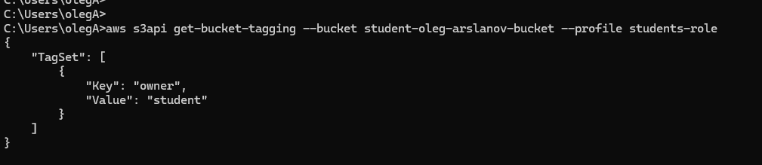

Upload file to S3 bucket

Upload all 9 tables from bl_dm

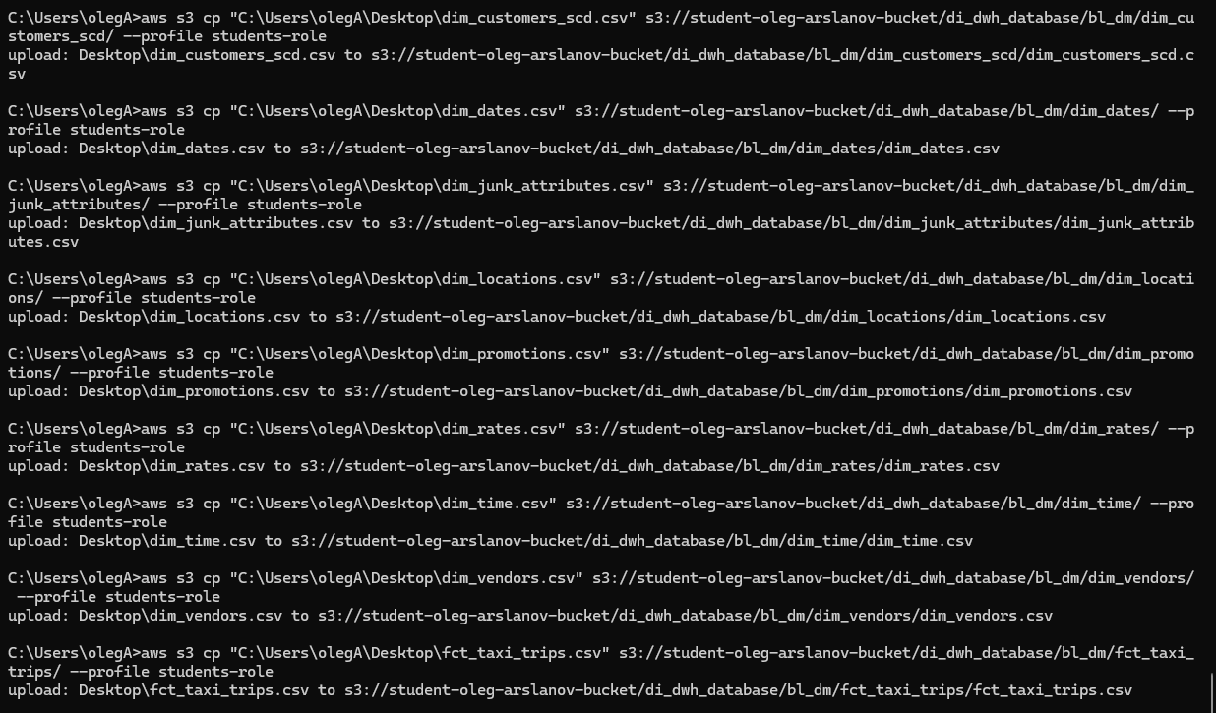

**Create crawler**

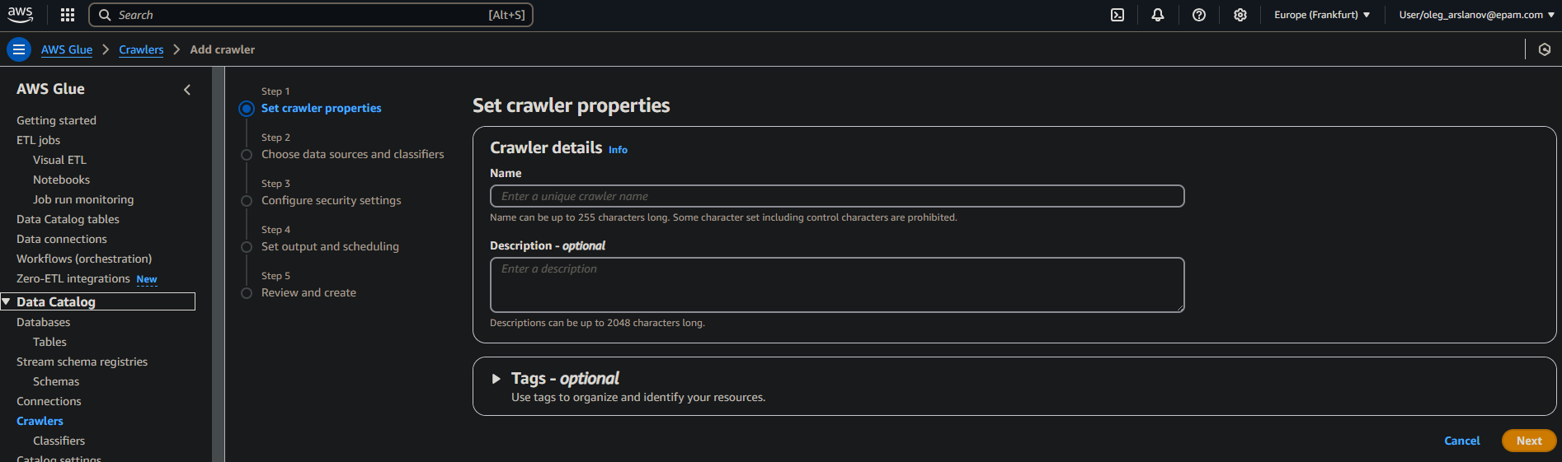

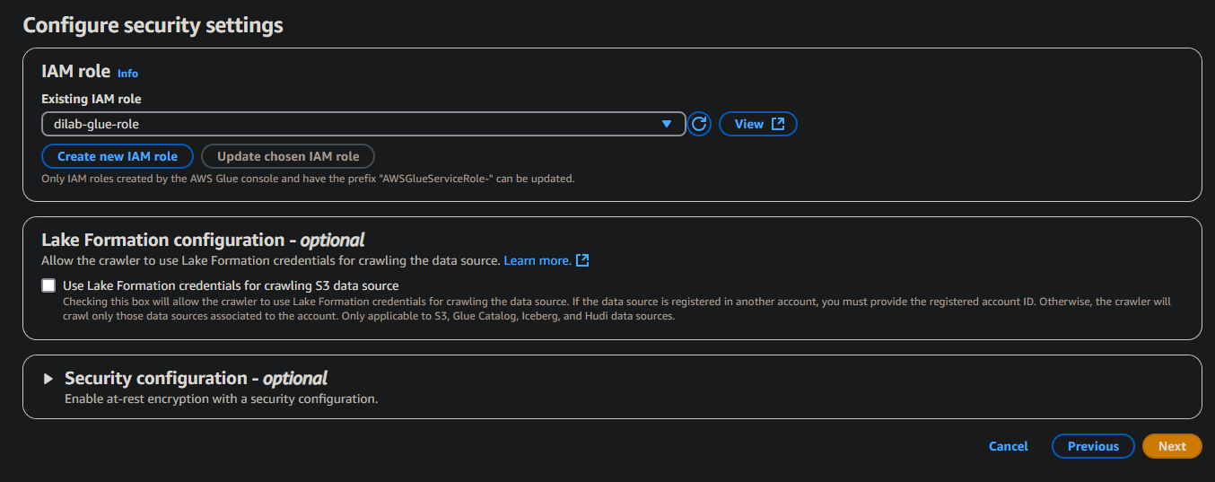

**AWS glue**



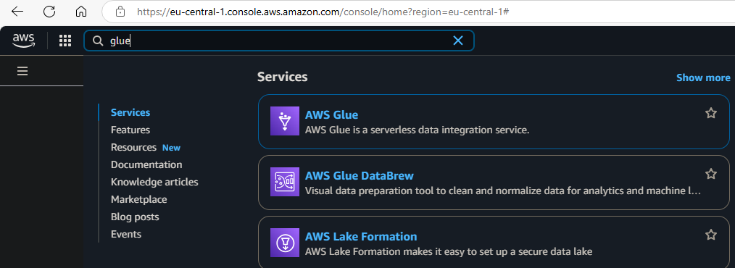

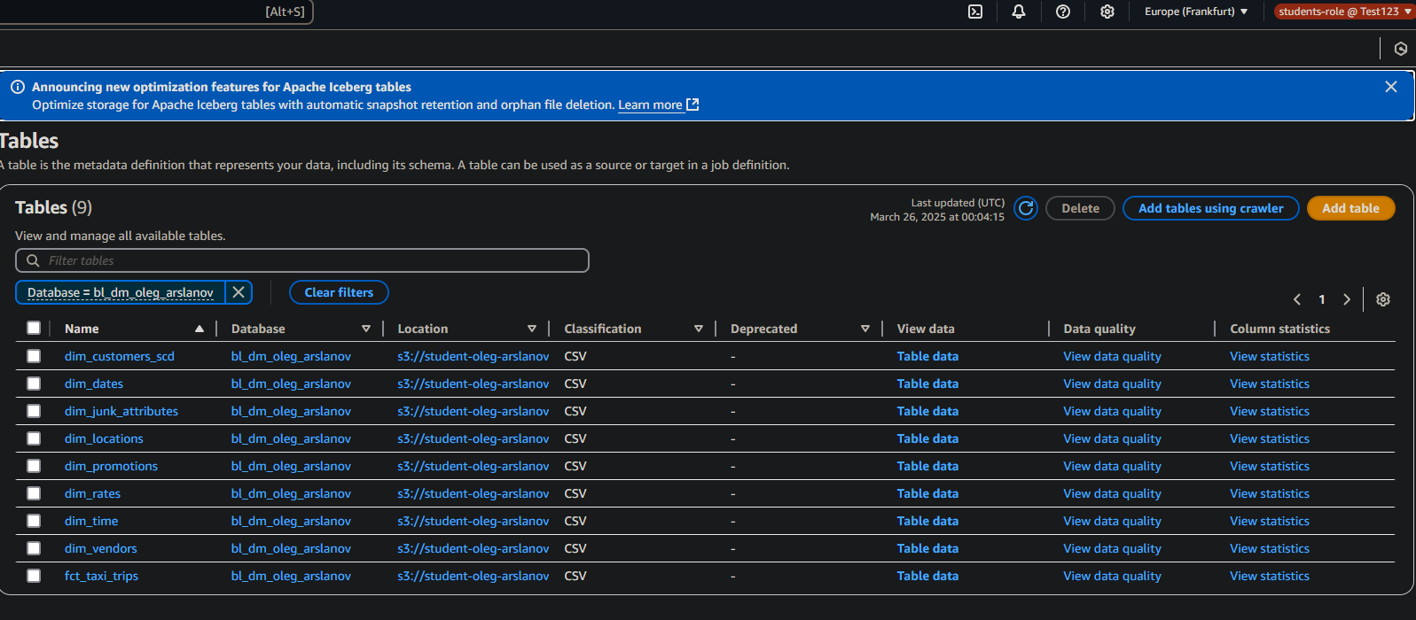

**AWS Athena**

I check all tables have data inside

