

|  |
| --- |
| , RD Dep.  **AWS Cloud for Data Engineering** |
| EC2 |

# Tasks

**NB: Do not forget to add tag owner=student to all resources you create!**

1. The cheapest way of creating a database in Cloud - take just a virtual machine (EC2 in our case) and install database by your own. Let’s do it.
2. Create EC2 t2.micro instance (EBS volume size should be not more than 10GB and security group should be “dilab-training”) and add **AWS_EC2_full_access_S3** role to it to allow S3 access for your EC2 machine. Name of the instance as always should be **recognizable**. As an **Important** security requirement ensure that *Metadata Service Version 2* is enabled: on *Launch an instance*page click *Advanced details* and ensure that *Metadata accessible* is set to Enabled and *Metadata version* set to V2 only.

**NOTE:** Use any suitable free distributions of Linux as OS in the EC2 VM.

**NOTE:** In the lecture you saw creation of 128GB disks for EC2, it is just an example for you to understand that EC2 instance could have root volume and mounted volumes, no need to create same big volumes, one 8GB root volume and one 10GB mounted volume will be enough.

1. Install Oracle/ or PostgreSQL/ or MySQL on the EC2.

**NOTE:** If OS picked in a. is Linux, use the command line to perform the installation.

1. Connect to this database from any SQL client (e.g. DBeaver - very useful IDE because of community edition and possibility to work with almost all most famous databases).
2. Insert your connection configuration (host, database, user, password) for mentors to check the connectivity, screens that you have connected to the db on your EC2 into the Report.

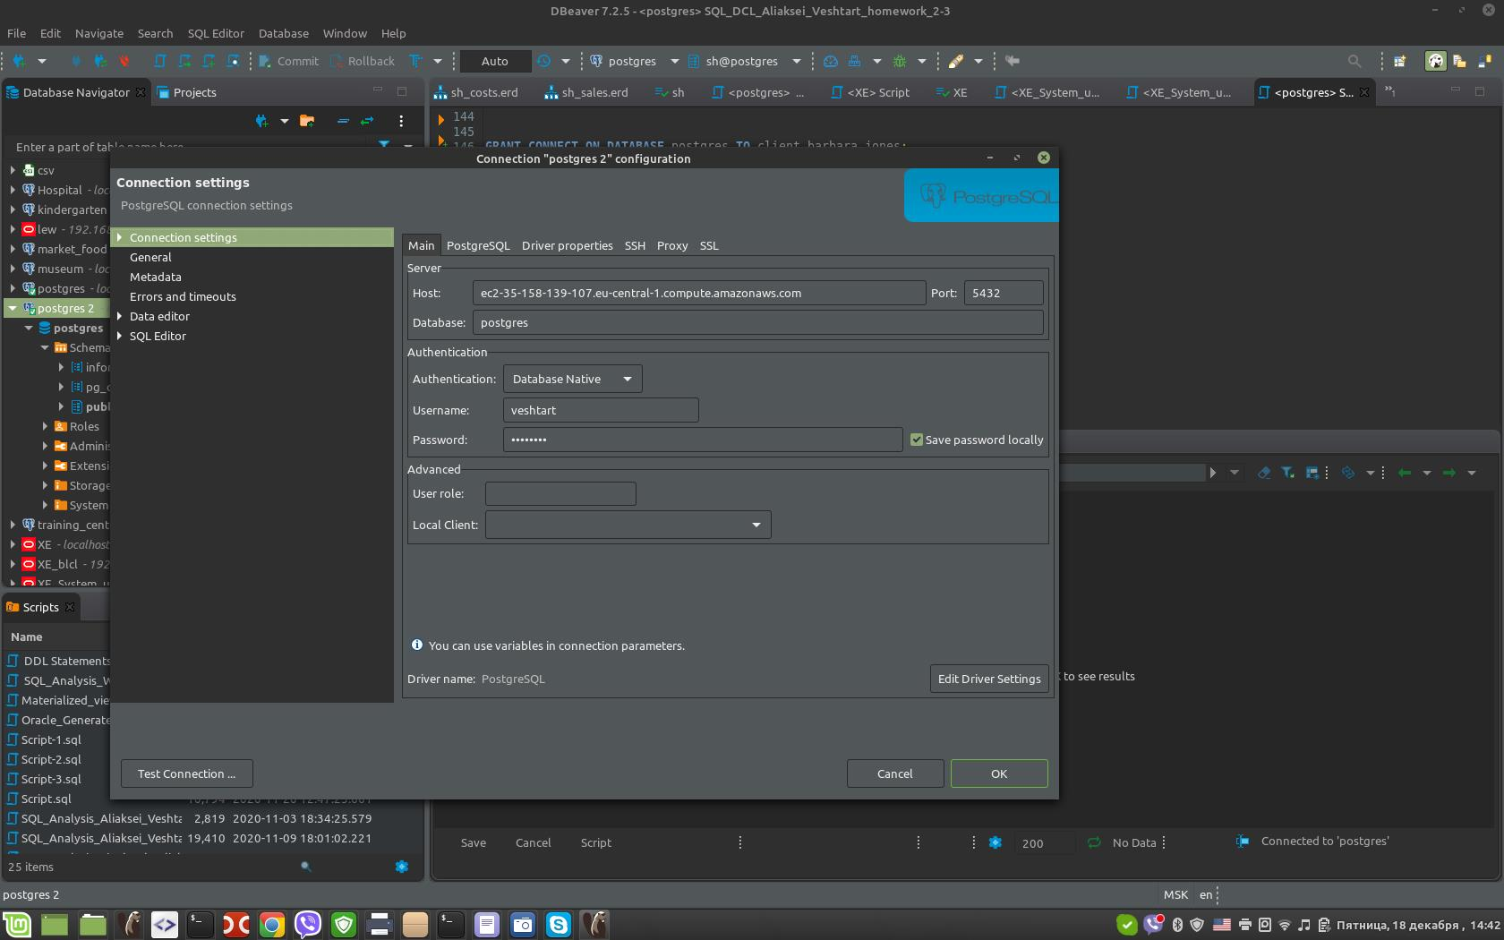

1. Create several objects in the created database ( at least one table, view, procedure ).
2. Take any file from your S3 bucket and copy it into the EC2 using **AWS_EC2_full_access_S3** role that has been attached to the virtual machine on the first step. Screen of the files inside the EC2 into the Report.
3. For you EC2 a separate EBS volume was allocated. Let’s create snapshot of this EBS volume. Afterwards, let’s create AMI **(identifiable name)** from the created previously snapshot. It will be a copy (image) of your EC2 machine.
4. From the image (AMI) you've made on the step 3, raise a copy of the EC2. As an **Important** security requirement ensure that *Metadata Service Version 2* is enabled: on *Launch an instance*page click *Advanced details* and ensure that *Metadata accessible* is set to Enabled and *Metadata version* set to V2 only.

Show that the data file you put to the EC2 on the step 2 has been saved into the server copy as well. Save the screen into your Report.

1. Create your first web page, install apache web server and push any html to the standard directory /var/www/html (apache web server installation and html example will be in the general folder).

Check that the page is available by IP address from the browser and insert link to this page and screens into the Report. Using link mentors should have a possibility to see your web page.

1. You will have the rights to create SNS notifications.

Create **Senseful** CloudWatch Alarm for any events exceeding your EC2 resources and create your own SNS queue, that will send the results to your email (you specify email when creating SNS). Appropriate screens to the Report.

1. Try to create same EC2 virtual machine using a CloudFormation script. Save the script into your bucket and to the Report.
2. Extra tasks:
   1. * Install any database or any program in EC2 using docker and provide access to this service from the outside.
   2. * Schedule any .sh script (or any other script) using cron for executing something on the docker service created by you (just simple sql call to the database for example).

**NOTE:** Please, stop your EC2 virtual machines when you complete the task or not actively work with them!

All screens, queries with results, intermediate steps result, and mentioned in the task activities please consolidate into the Word-based report and put it into your own bucket.