Task2
Firstly I check all is ok or now with our model … I did modificate remove errrors from Task 1 😊
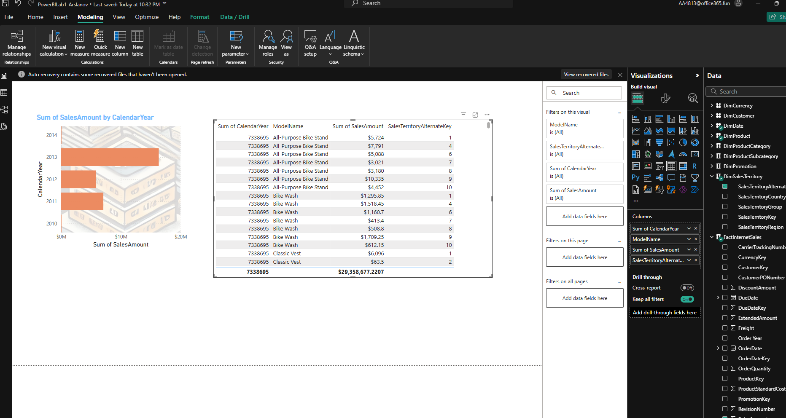
Then I go to my report it nice and very informative 😊 (really maybe in future)

5 visuals + 2 custom
In this Power BI report, two types of custom visuals are used:

Custom Visual - Synoptic Panel (Map Visualization)
This visual represents a custom SVG map displaying sales performance across different countries.
Highlighted countries (e.g., Canada, Australia, United Kingdom, France, Germany, United States) indicate regions where sales are recorded.
The color coding helps distinguish sales activity levels in different geographic areas.

Custom Visual - Bullet Chart (Employee Sales Performance)
This visual compares employee sales against their quotas.
Each bar represents an employee, with:
Black bar: Actual sales.
Green, Yellow, Red sections: Different performance thresholds (e.g., below target, near target, exceeding target).
This helps quickly assess who met or exceeded their targets and who underperformed.
Standard Table Visual (Sales by Products and Clients)

A default Power BI table visual summarizing sales transactions.
Displays product names, categories, customers, order dates, sales amounts, and quantities.
The total row at the bottom aggregates key metrics.
This report provides a geographical sales overview, employee performance tracking, and detailed sales data in a structured format.
This Power BI report contains four key visualizations:

Order Quantity by Month/Year (Line Chart)
Displays the sum of order quantities over time.
Shows a gradual increase in orders, with a noticeable spike around 2013.
Sales Amount by Product Category (Bar Chart)

Compares sales across different product categories.
Bikes generate the highest revenue, followed by Accessories and Clothing.
Sales Amount by Sales Region (Pie Chart)

Shows the distribution of total sales by region.
Australia and Southwest have the largest sales shares.
Sum of Sales Amount by Postal Code (Map)

Uses a map visualization to display sales amounts based on postal codes.
The blue dots represent sales density across different regions.
This report helps analyze sales trends, regional performance, product category revenue, and geographic distribution.
Disable iteraction between one slicer “Product category” (Format → edit iteractions). So I can choose one or more visuals to disable…

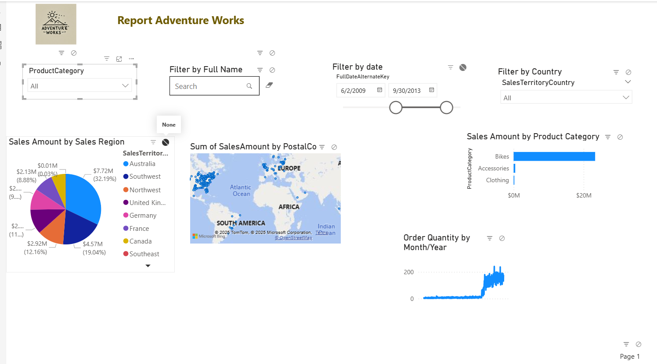
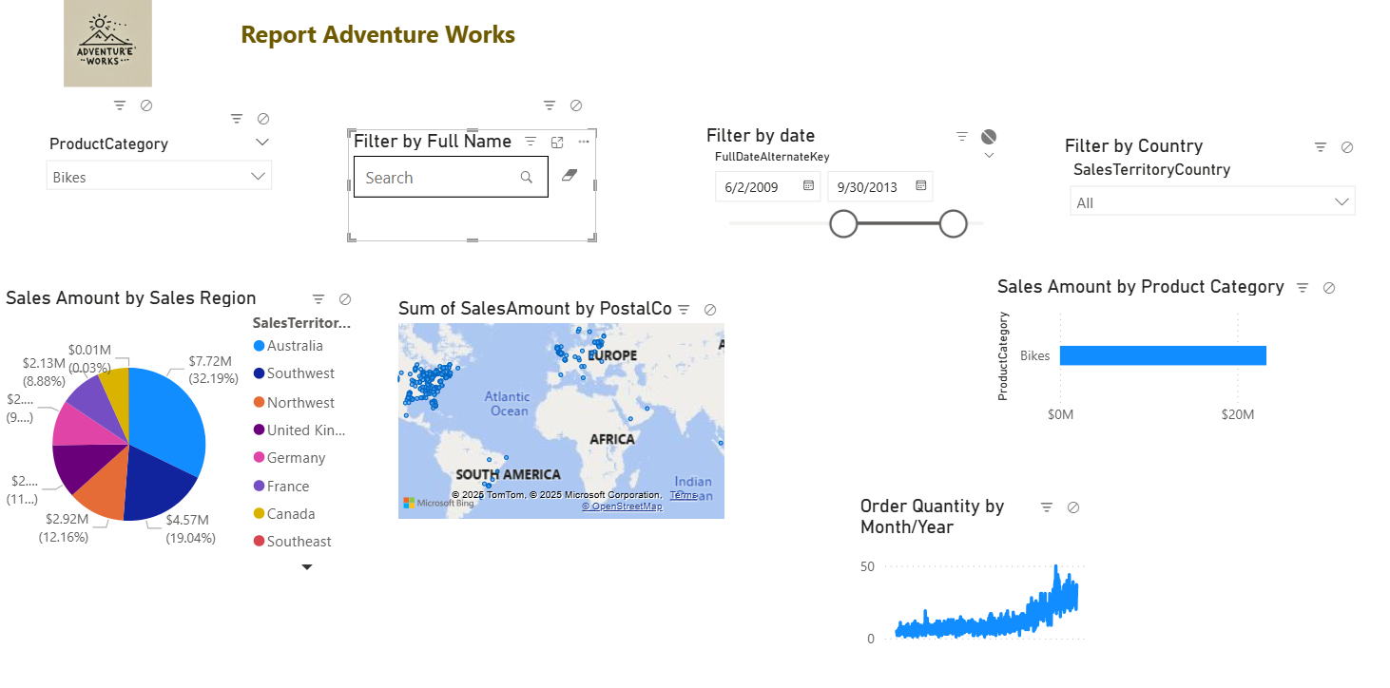

I can view my report on mobile telephone 😊 (2 pages)
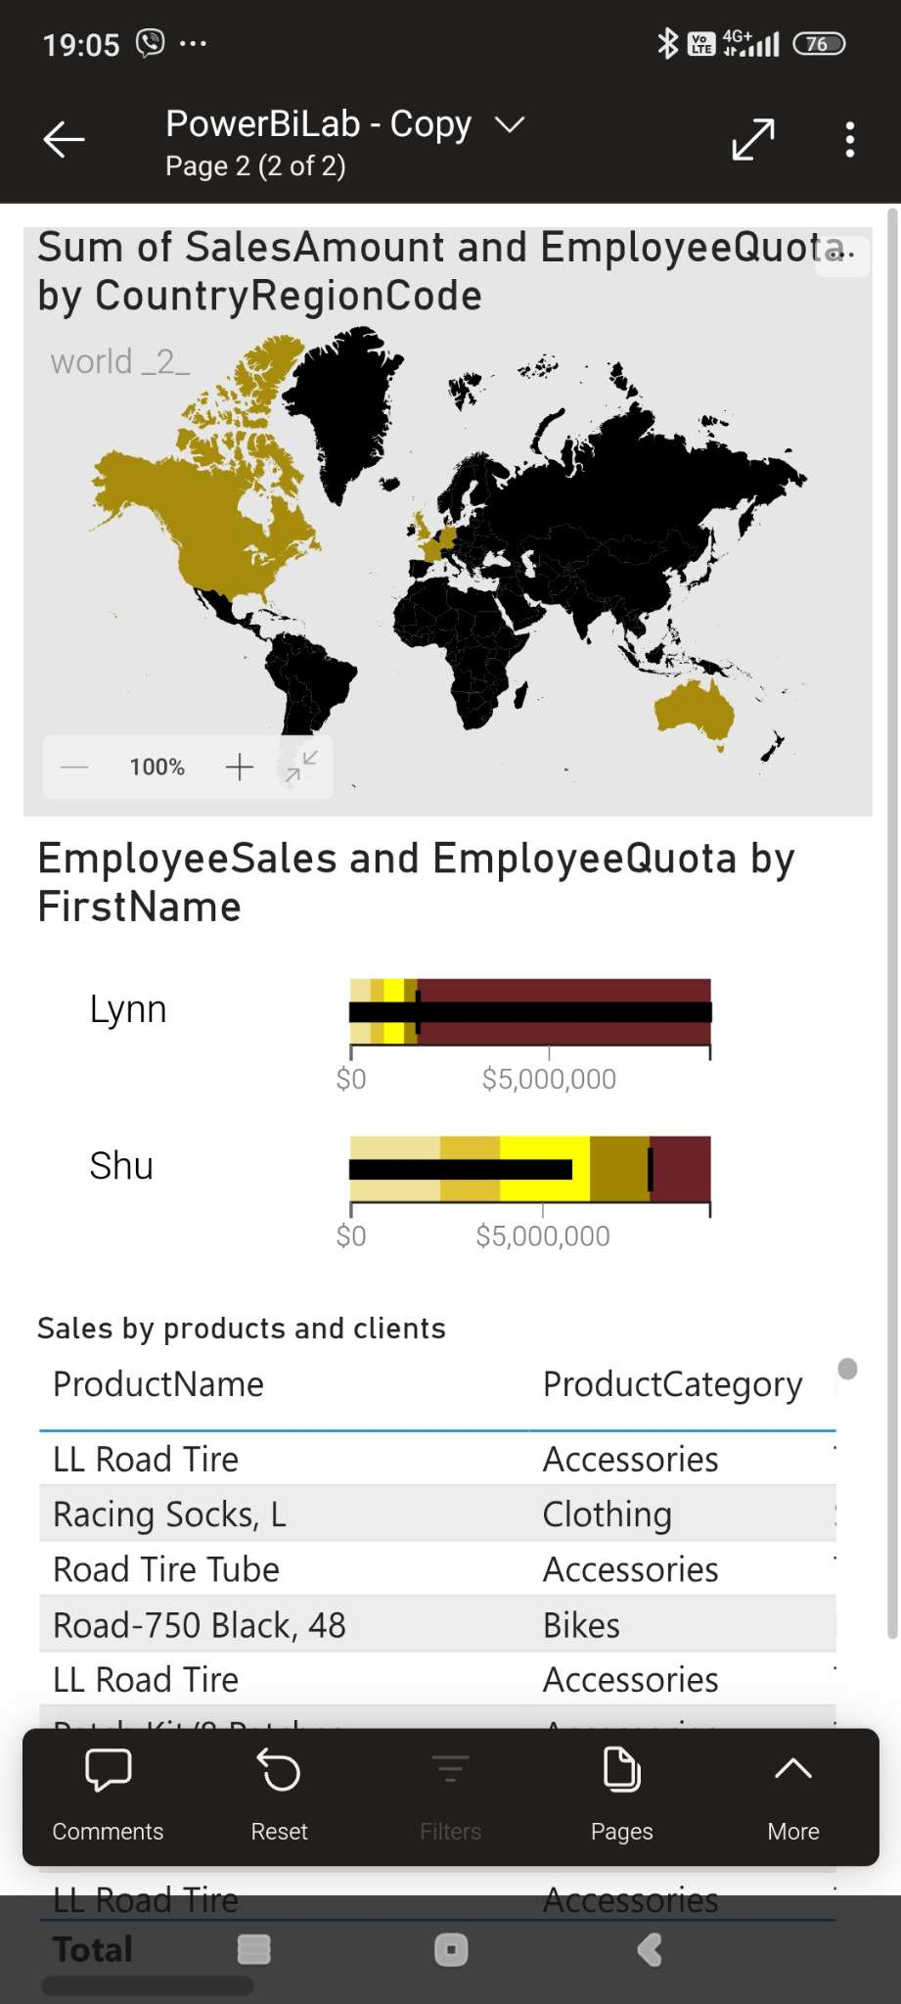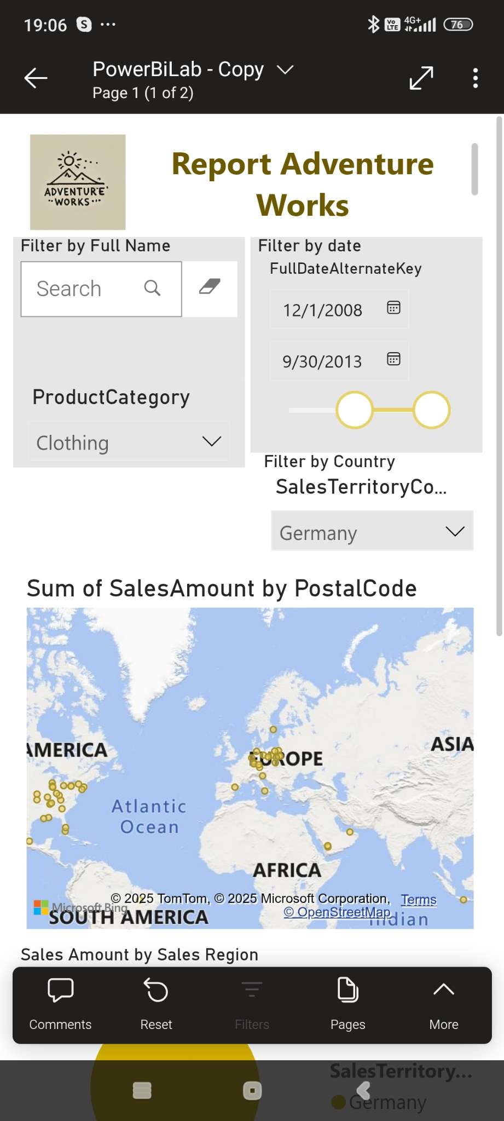

Next I made report daily on my work email 😊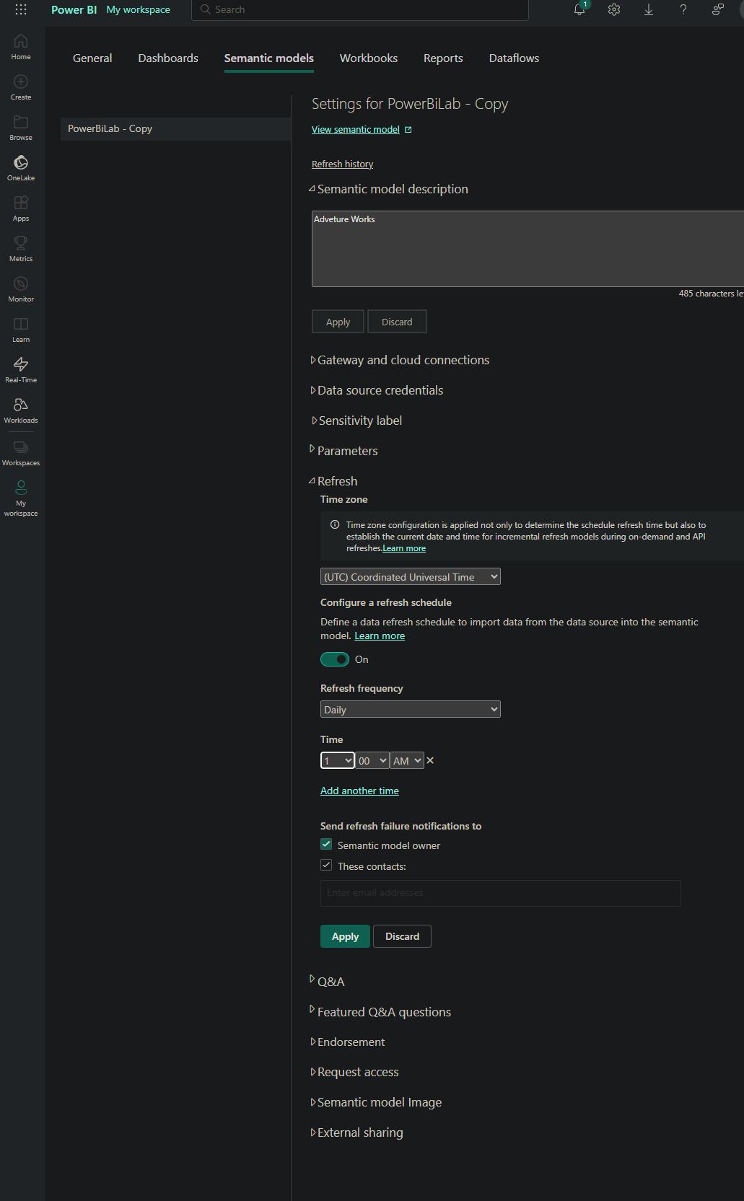

I send to my mentor report link 😊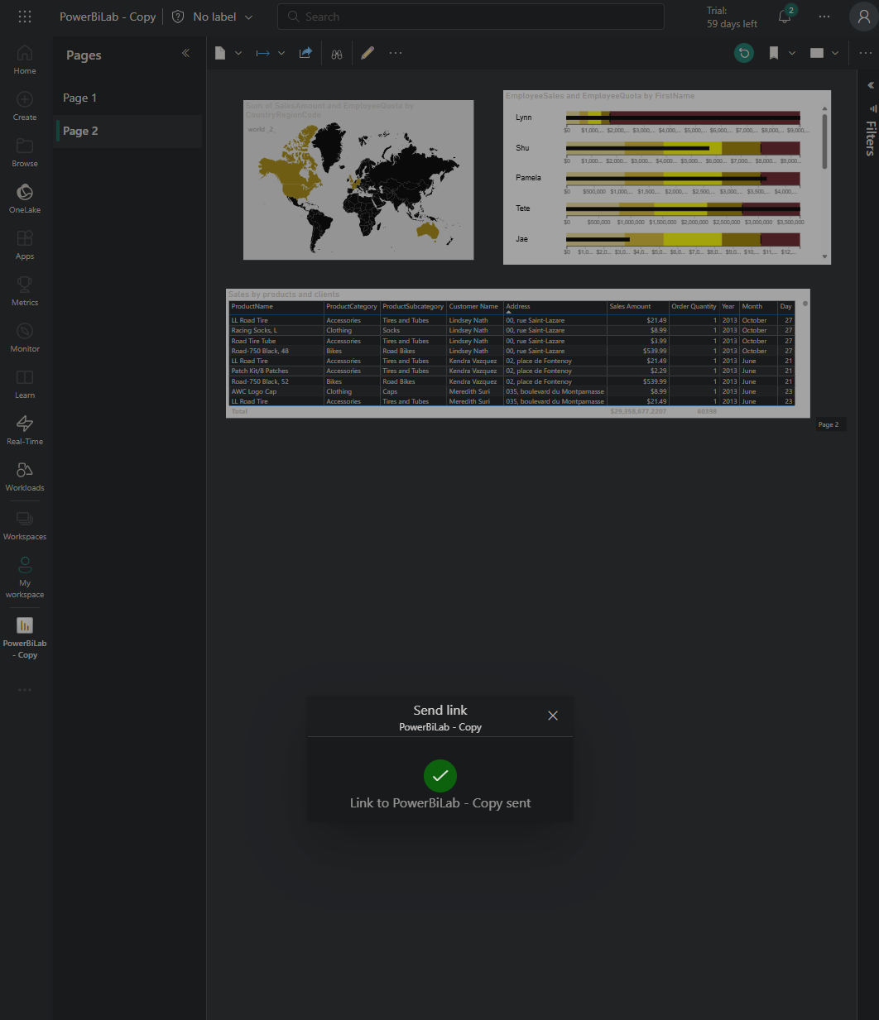

Report with choose Germany filter … only Germany 😉
PowerBiLab - Germany - Power BI

