TASK 1 – PERFOMANCE WITH UNLLOGED TABLES
-- It takes about 0.910 s
insert into labs.test_simple values (generate_series(1,1000000));

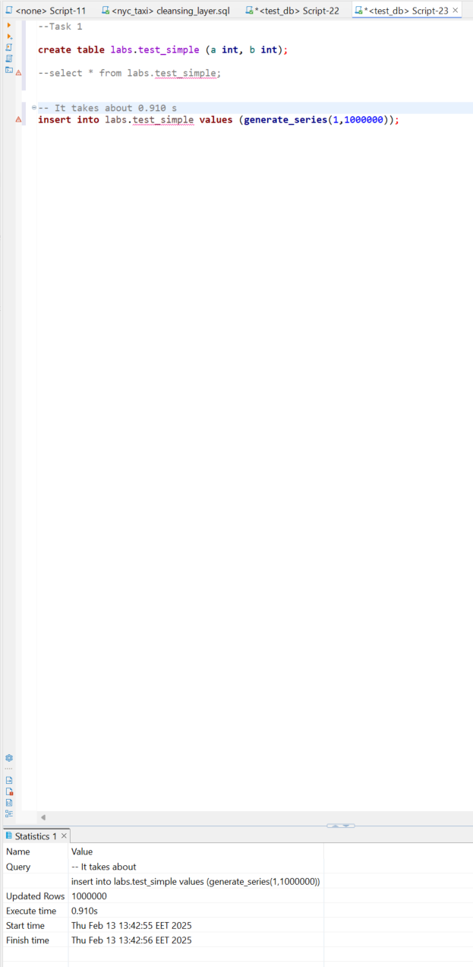

--It takes about 4.610 s
insert into labs.test_simple values (generate_series(1,5000000));

Time is proporcing for quantity

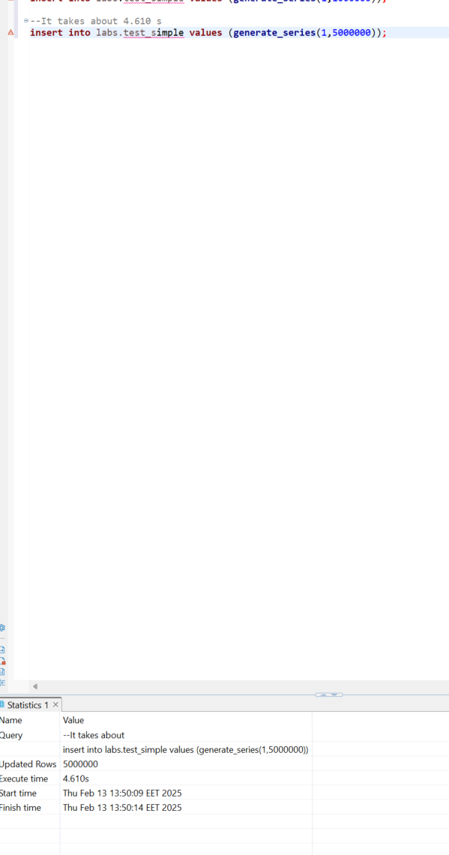

--It takes about 0.889 s .. little bit faster that usual table
insert into labs.test_unlogged values (generate_series(1,1000000));

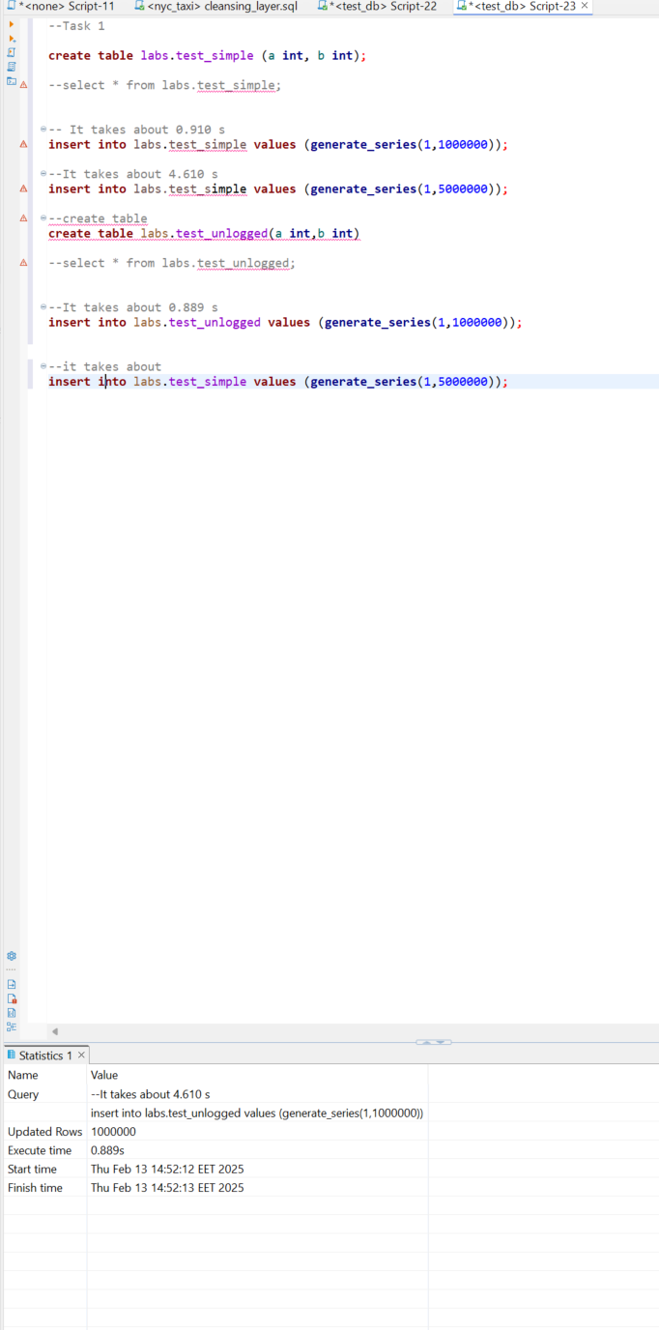

--it takes about 4.535 s .. little bit faster that usual table
insert into labs.test_simple values (generate_series(1,5000000));

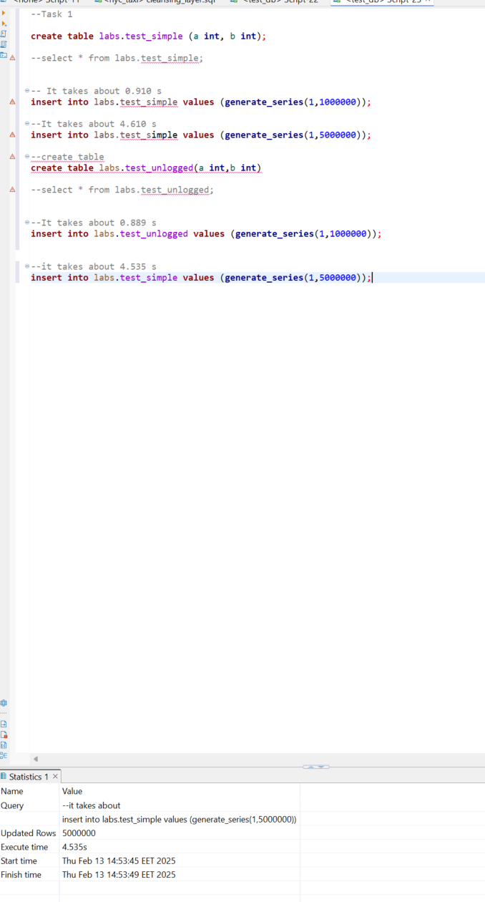
UNLOGGED tables can indeed be faster when data durability is not required, as they do not use the WAL, saving resources and speeding up operations. In our case, the insert into the UNLOGGED table is faster due to this lack of WAL writing. However, they should be used with caution.

TASK 2 – UNDERSTANDING INHERITED TABLES

We create table with inheritance from labs.users, that means we have more colums 😊
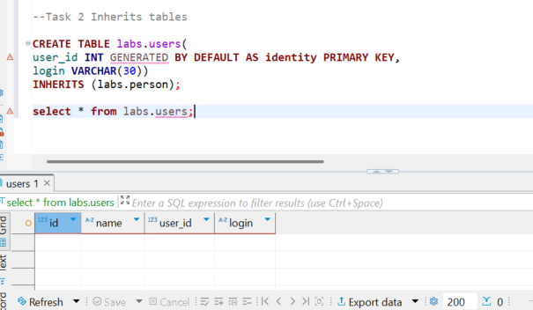

When we add new rows in new table ‘users’ with inheritance we can see only inserted rows, plus inherited columns
When we look at person table we see all rows old + inherited (new added).
When we use ONLY with person table we see only rows that belong to original person table.

So parent table inherit all rows from children table. And children table inherit structure of parent table

Modify data in all tables
UPDATE person
SET name = 'not Bob'
where id = 1;

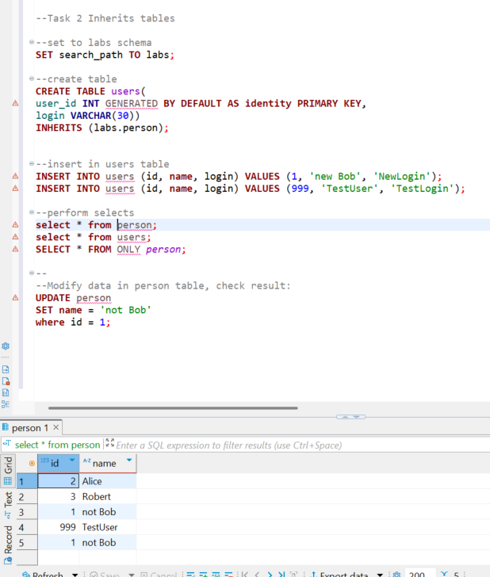

When I want change value only in parent table: I can uze only
UPDATE only person
SET name = 'not super Bob'
where id = 1;

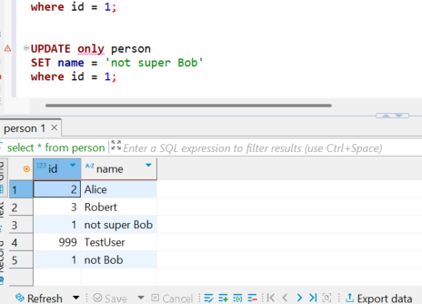

--Alter person table and check structure and constraints on both users and person tables:
ALTER TABLE person ADD COLUMN status integer DEFAULT 0;
ALTER TABLE person ADD CONSTRAINT status CHECK (status in (0,1)) no INHERIT;
ALTER TABLE person ADD CONSTRAINT id UNIQUE (id, name);

All is working

TASK 3 - BRIN VS B-TREE
;
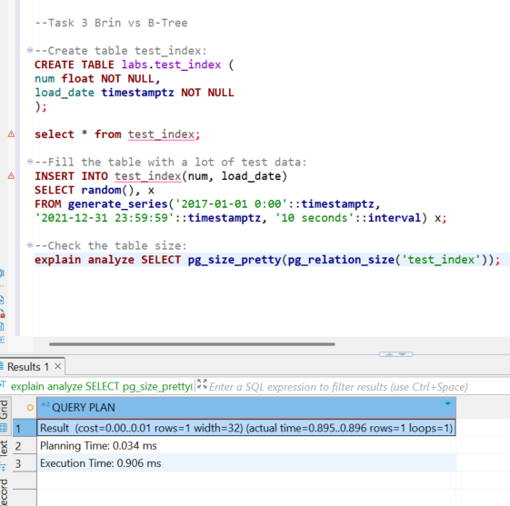

I use EXPLAIN ANALYZE for get info:
- cost is very low for estimating 0.00 ..0.01
- we will get 1 row
- planning execute 0.034 ms
- query execute time 0.906 ms

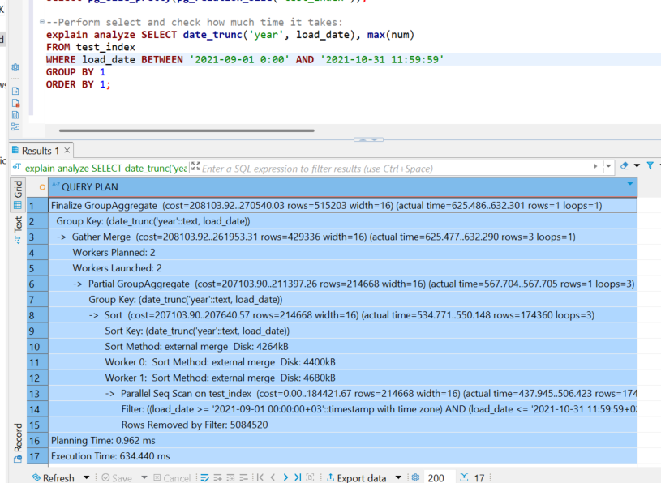
This is aggreagation command (there
At all:
Cost = 208103.92 .. 270540.03
Rows will be operated: 515203
Operation time : 625.486..632.301
Operation return rows: 1
Fact time: 634.440 ms

Now create B-Tree index on test_index table for load_date column
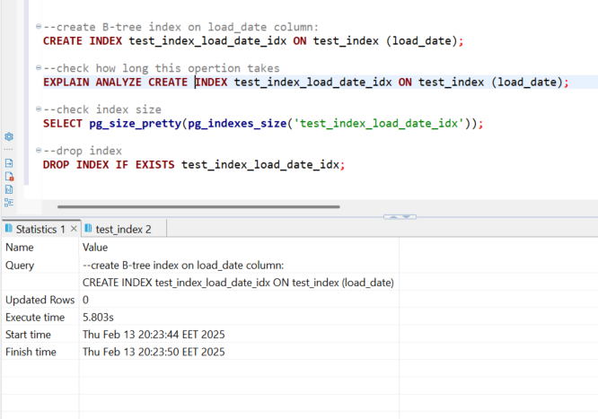
It is takes 5.803s

When I want use explain analyze … it is not working (I think it is better for select commands)
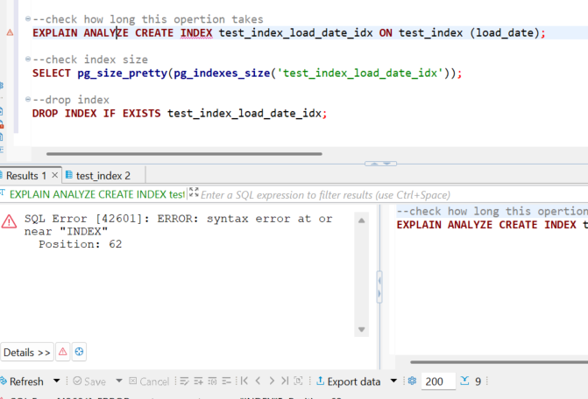
Index size is 338 MB I think it is not ok, because BRIN index only 40 kB

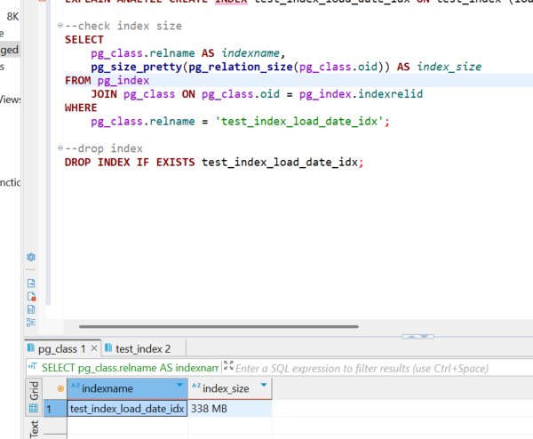

Create BRIN Index on test_index table for load_date column

1.080s this operation takes.
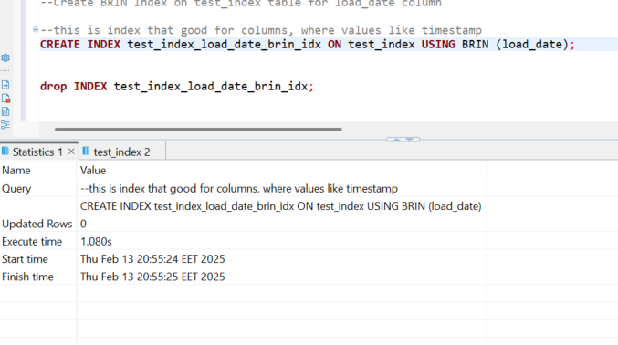
Index size is 40 kB
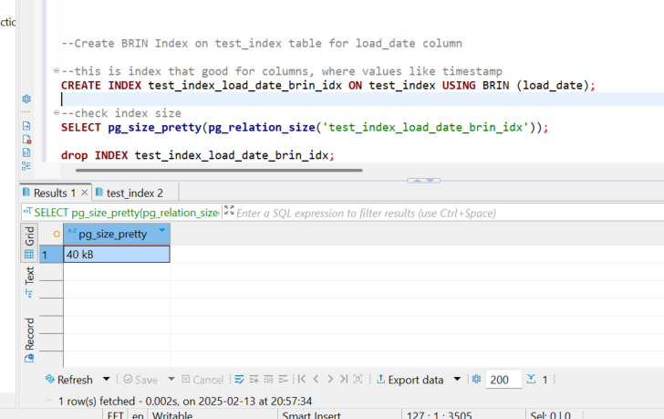
I can see it on test_index table properties too
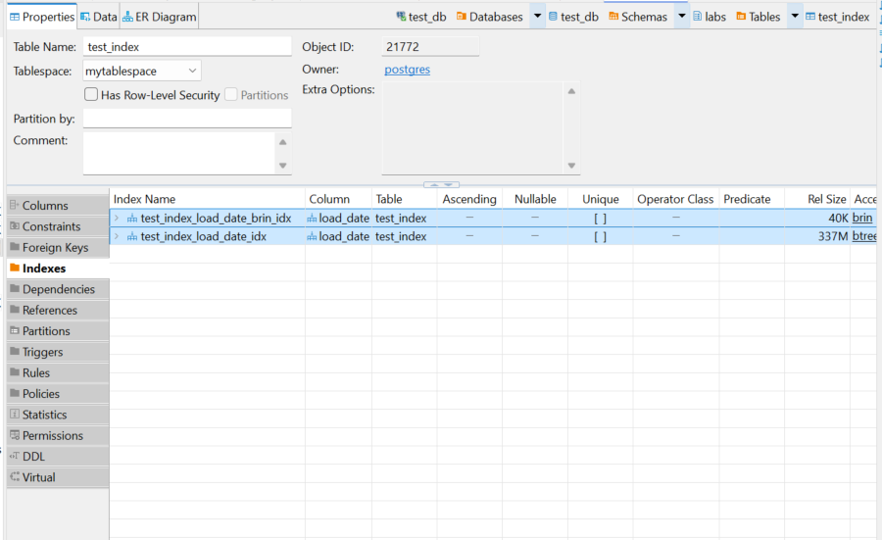

B-tree index is well-suited for most data types and queries with exact values and ranges, but it can take up a lot of space, especially for tables with unique values.
BRIN index is ideal for data distributed over ranges (e.g., time intervals). It takes up less disk space but is less efficient for exact queries.

TASK 4 - GIN VS GIST

CREATE TABLE test_index AS
SELECT id, md5(id::text) as t_hash
FROM generate_series(1, 10000000) AS id;

Size of table is 652 MB
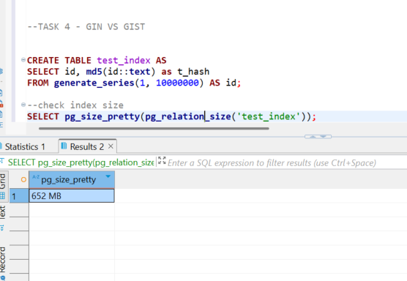

--Perform select and check how much time it takes:
explain analyze SELECT * FROM test_index WHERE t_hash LIKE '%ceea167a5a%';
So that select takes: 694.357ms

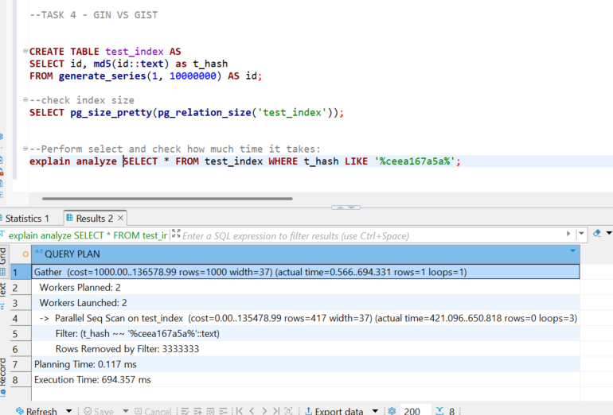

For create GIST index for text we need create extension:

CREATE EXTENSION IF NOT EXISTS pg_trgm;
CREATE INDEX idx_text_index_gist ON test_index USING gist(t_hash gist_trgm_ops);

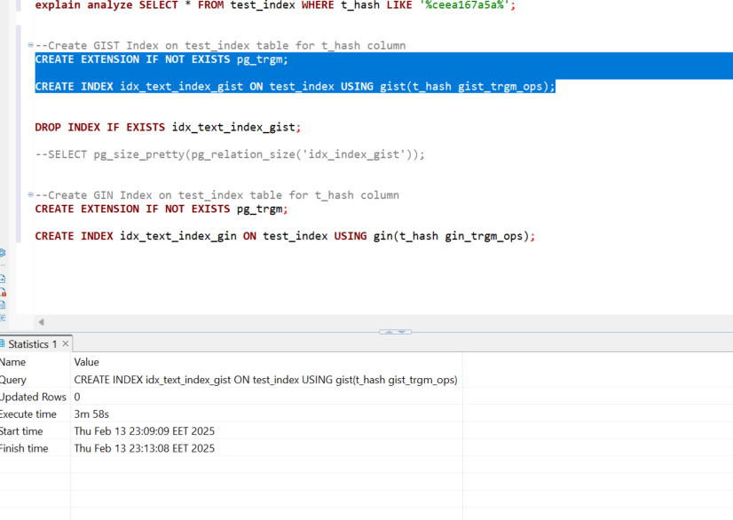

Create index GIST operation takes 3m 58 s.

GIST Index size is 1769 MB

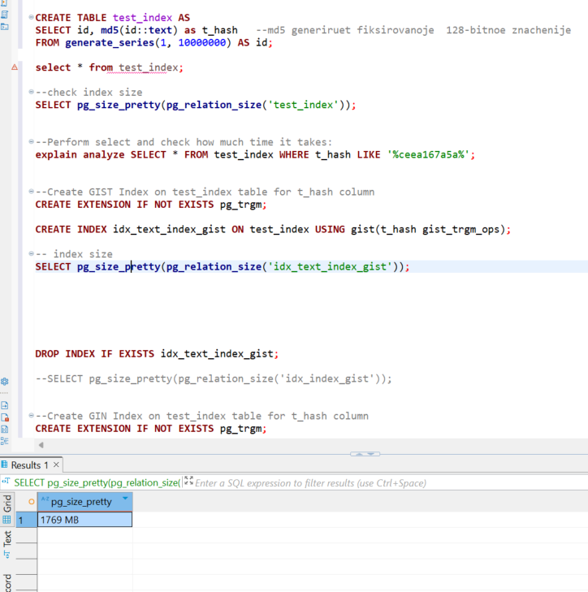

Create index GIN operation takes 1m 43 s

GIN Index size is 613 MB

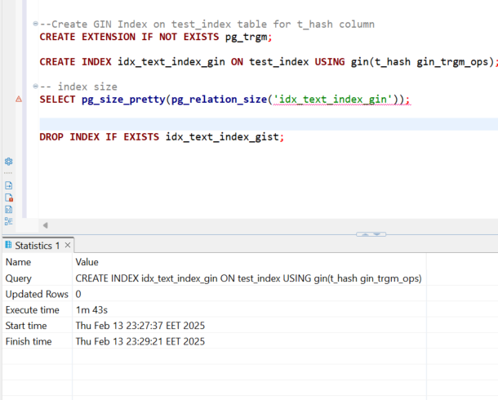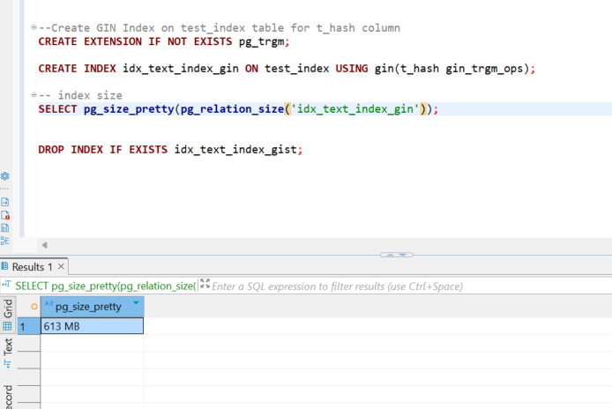

So GIN index is more than two times quicker and memory usage on disk

TASK 5 – CSV FILE AS A TABLE

Created materialized view

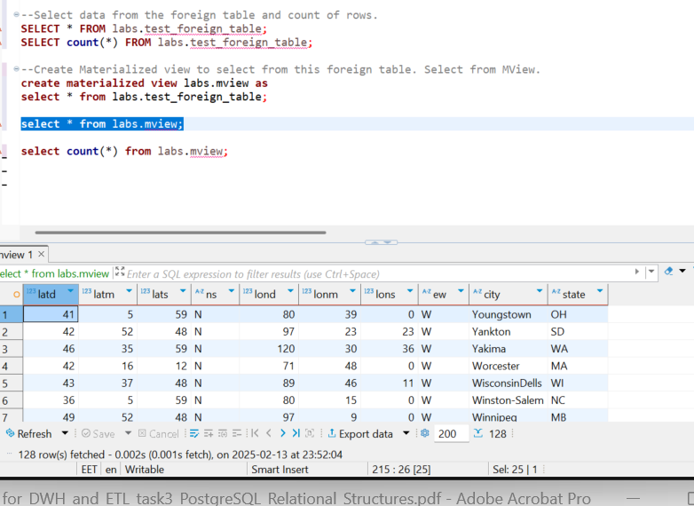

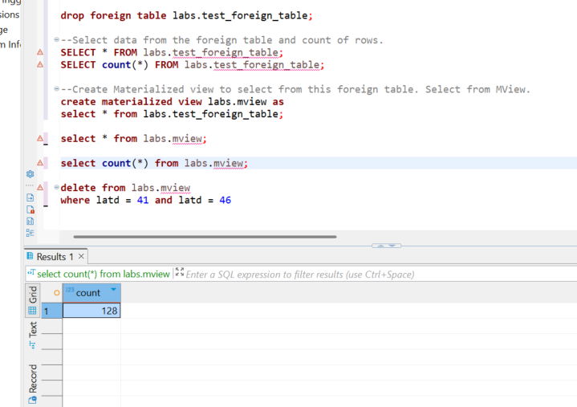

I can not delete from materialized view rows … so we did another way.
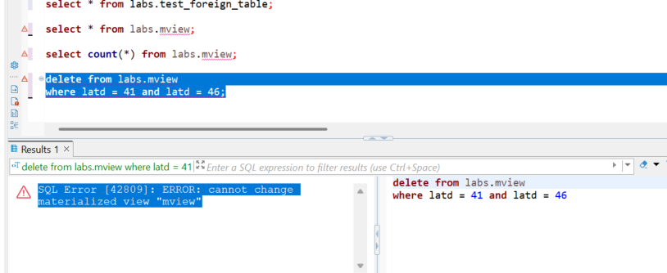

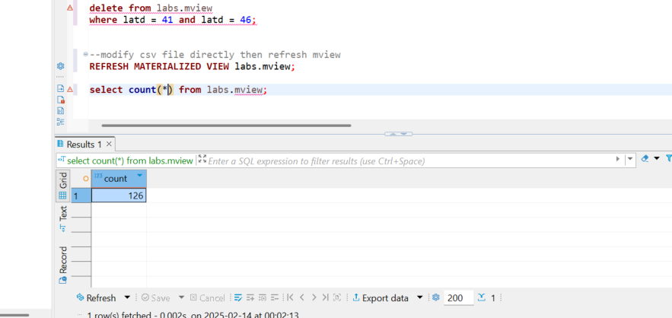

So first we modify directly file, then refresh mview (because mview is directly show what csv file have inside)

Thank You 😊

