Task 3
Create line chart Sales by Date
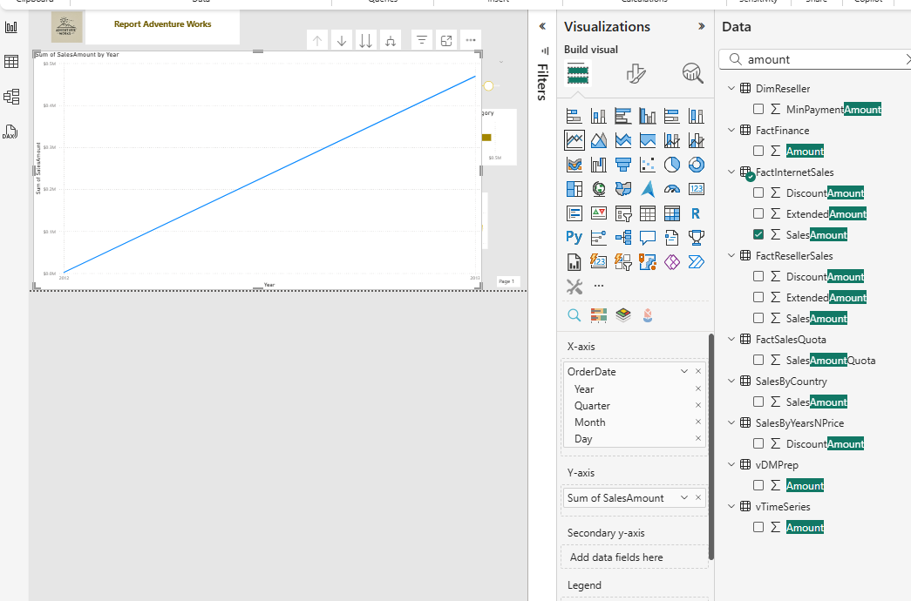
I found this solution with filtering >= 2013
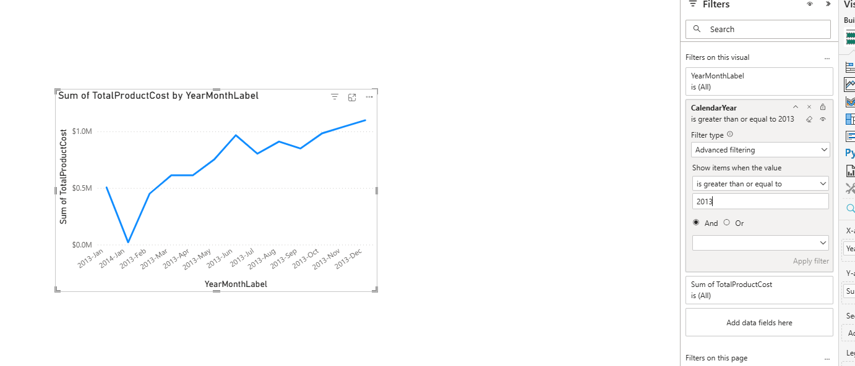

Insert today date . Use Card visualisation inser DAX Today date:
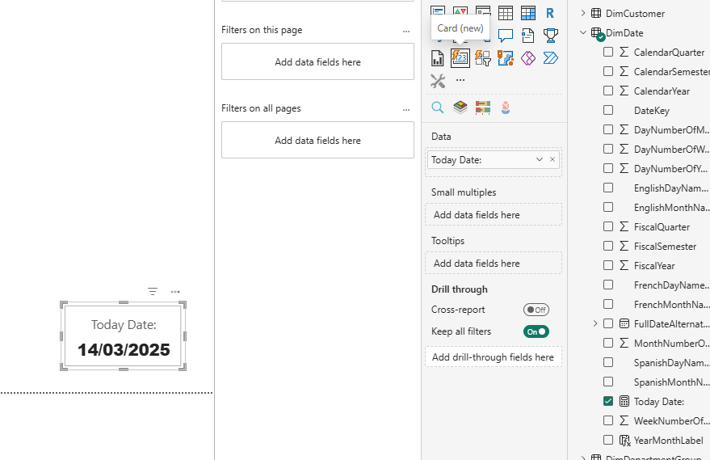

Report
So I use DAX code for current period (sum all order quantity by period of time) … and use DAX for previous period
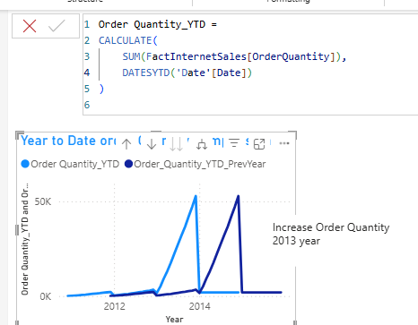
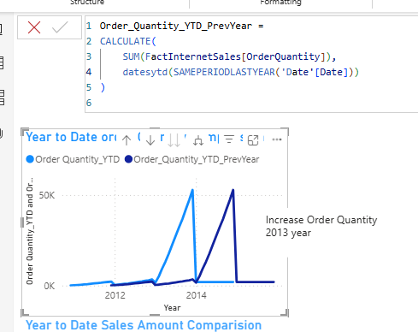

This is doing for analyze with prevous period of time … that we can easily comparise .. same with Sales amount

Welcome message … I open visual “Card” and use DAX code
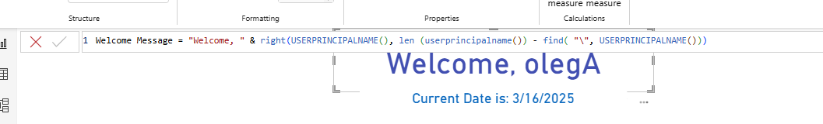

Next we need to create table that shown percent of order quantity by product name color and date …
So I additionaly create new table Date. Generate dates from 2010 to 2030 years. I add new column “Year month Label” with specifed format like on picture. Then I create new measure “Order Quantity Percent” (divide Order Quantity of each row by product name, color, year/month from sum of all orders quantity) … but there is one problem “Year Month label” is text type so I added one more column YearMonthSort … so we got numbers and it is sorting well.
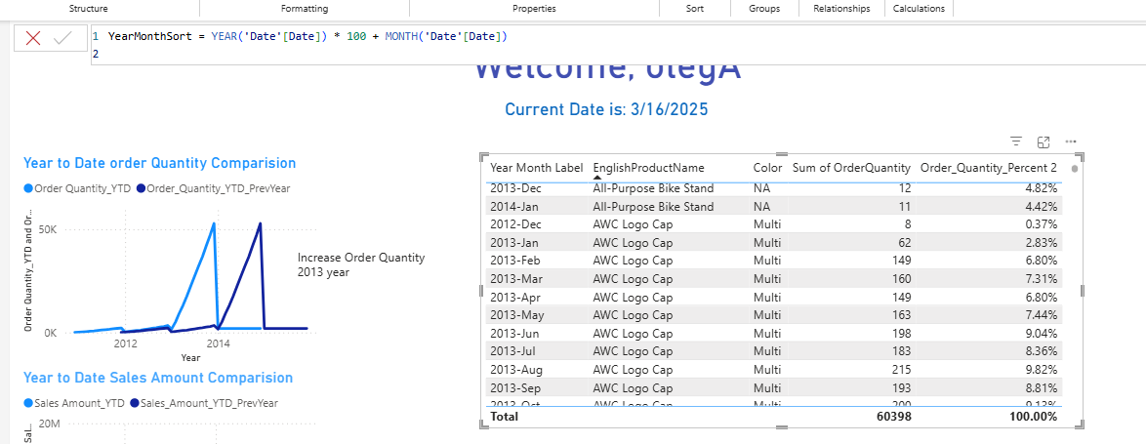

Here I calculate order quantity sum by only product name, color, date 😊 And then divide it and got percent then.
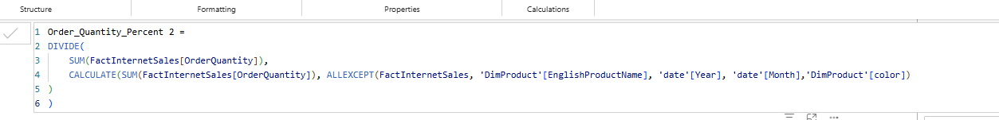

For Sales Amount for Maximum aviable Order date. I created measure “Max_OrderDate” and choose max Order Date. When I have maximum date I can find by this max date sum of sales amounts … but when I use it in Dax I got error
I can use calculate for sum of Sales Amount with filter by max date (I can not use in filter measure, because filter use values by content)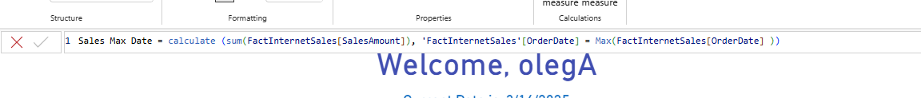
So I need only one measure for do that + MAX function, because DAX don’t allow use one time before declarated value 😊 it is need calculate it is exactly right now for current filtering

I found maxSales amount by year having country. I use DAX code . First I declare variable then RETURN that variable with function Concatenatex, because I want that returns Country name and Sales amount.
In variable I use function Summirize … here we show table with data, group by (year, country) and agregate total sales amount in new column. TOPN function for show first value order by desc.

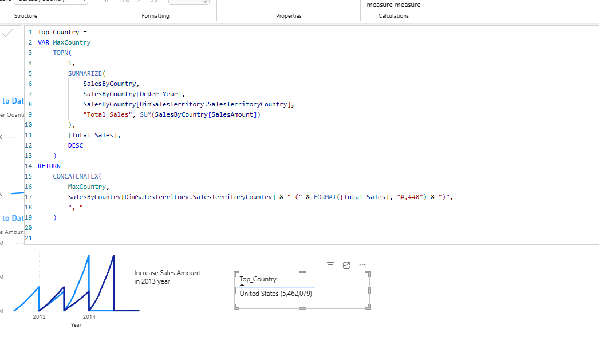

For ranking visual. I need use two existing table for do that, but they don’t have keys for relation. So First I made additional table SalesByCategory with two columns: columnsProductCategory and TotalSales. This table use fo future calculates.
Then I made measure ProductCategoryRank. I use inside function RANKX for rank positions. ALL function is remove all filters and sum all SalesAmount of all table. Calculate is needed for iterate process.

