Human Resources report bugs

- ‘Welcome’ page

Bug 1: Welcome page is missing

Summary | Missing Welcome page in the PowerBi report  How not to do:  Do not add ‘Welcome” page in the PowerBi report according to the requirements  How to do:  Need to add ‘Welcome’ page with message: “Hi, my dear friend! Happy to see you using our report”
Description | STR (Steps to Reproduce):  1. Open the Power BI report  2. Check the list of pages in the report  3. Try to find the "Welcome" page  AR (Actual Result):  The "Welcome" page is not available in the report  ER (Expected Result):  The report should contain a first "Welcome" page with welcome message: “Hi, my dear friend! Happy to see you using our report”
Environment | PowerBI Version: 2.140.1577.0 64-bit (February 2025)  Windows Version: 11 PRO Version 24H2  Screen Resolution: 1920 x 1080
Attachments | 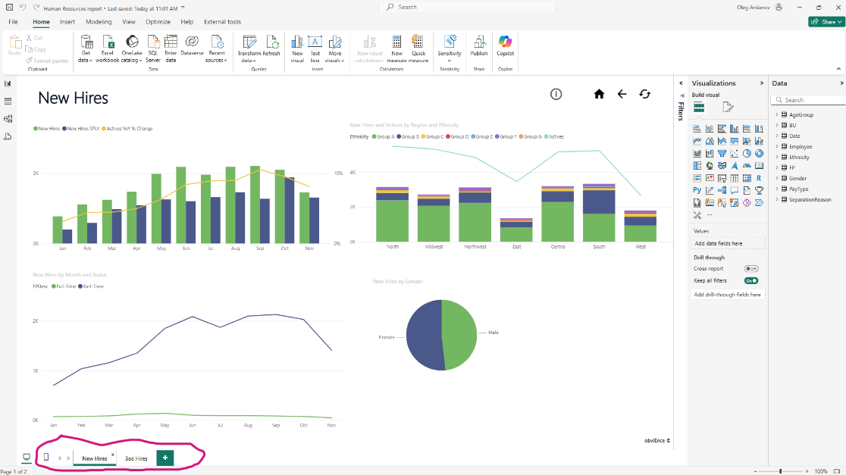
Priority | Medium
Severity | Major
Assignee | Oleg Arslanov

- ‘New Hires’ page
2A. Visual ‘New Hires over Months’

Bug 2: Incorrect Chart Type Used

Summary | Line and Clustered Chart used instead of required Bar Chart  How not to do:  Use Line and Clustered Chart on the New Hires over Months visual according to the requirements  How to do:  Use Bar Chart on the New Hires over Months visual according to the requirements
Description | STR (Steps to Reproduce):  1. Open the Power BI report  2. Navigate to the visual displaying new hires  3. Observe the chart type used  AR (Actual Result):  Used Line and Clustered Chart for New Hires over Months visual  ER (Expected Result):  A Bar Chart should be used, as per the report requirements
Environment | PowerBI Version: 2.140.1577.0 64-bit (February 2025)  Windows Version: 11 PRO Version 24H2  Screen Resolution: 1920 x 1080
Attachments | 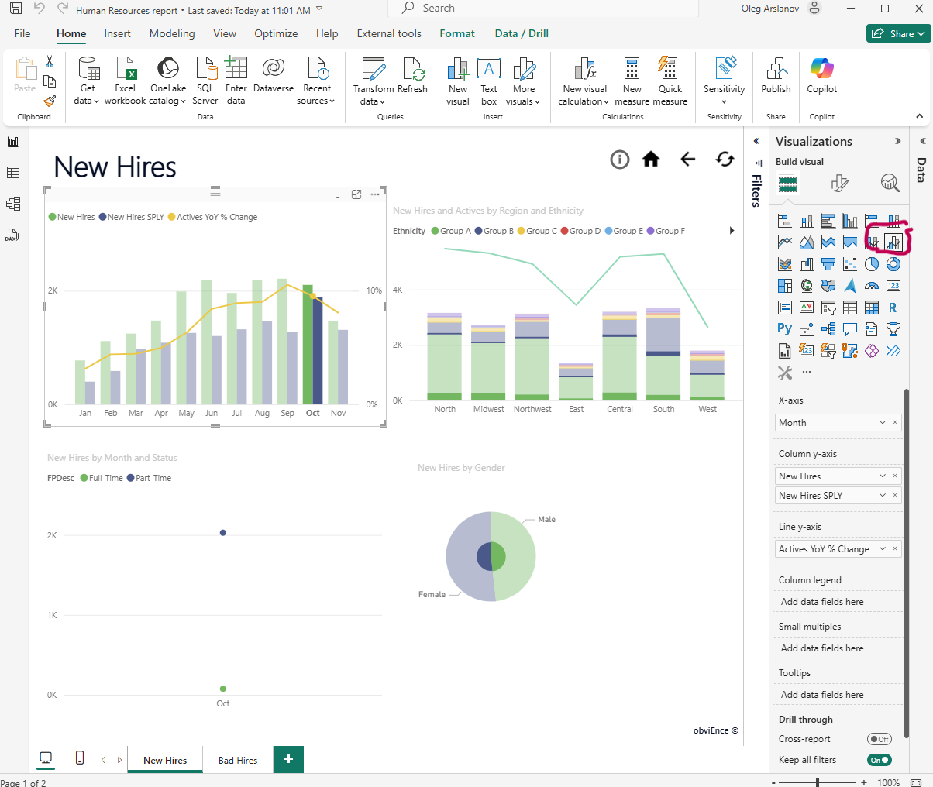
Priority | Medium
Severity | Minor
Assignee | Oleg Arslanov

Bug 3: Extra Metric Displayed on Y-Axis

Summary | Both “New Hires” and “New Hires SPLY” shown on Y-axis; only “New Hires” required  How not to do:  Used Line and Clustered Column Chart with additional metric ’New Hires SPLY’ on Y-axis, that not according requirements  How to do:  Need to use Bar Chart, with only ‘New Hires’ metric on Y-axis (X-axis is good)
escription | STR (Steps to Reproduce):  1. Open the Power BI report  2. Navigate to the chart showing new hires  3. Check the Y-axis metrics  AR (Actual Result):  Y-axis shows New Hires and New Hires SPLY  ER (Expected Result):  Only New Hires should be displayed, according to the requirements
Environment | PowerBI Version: 2.140.1577.0 64-bit (February 2025)  Windows Version: 11 PRO Version 24H2  Screen Resolution: 1920 x 1080
Attachments | 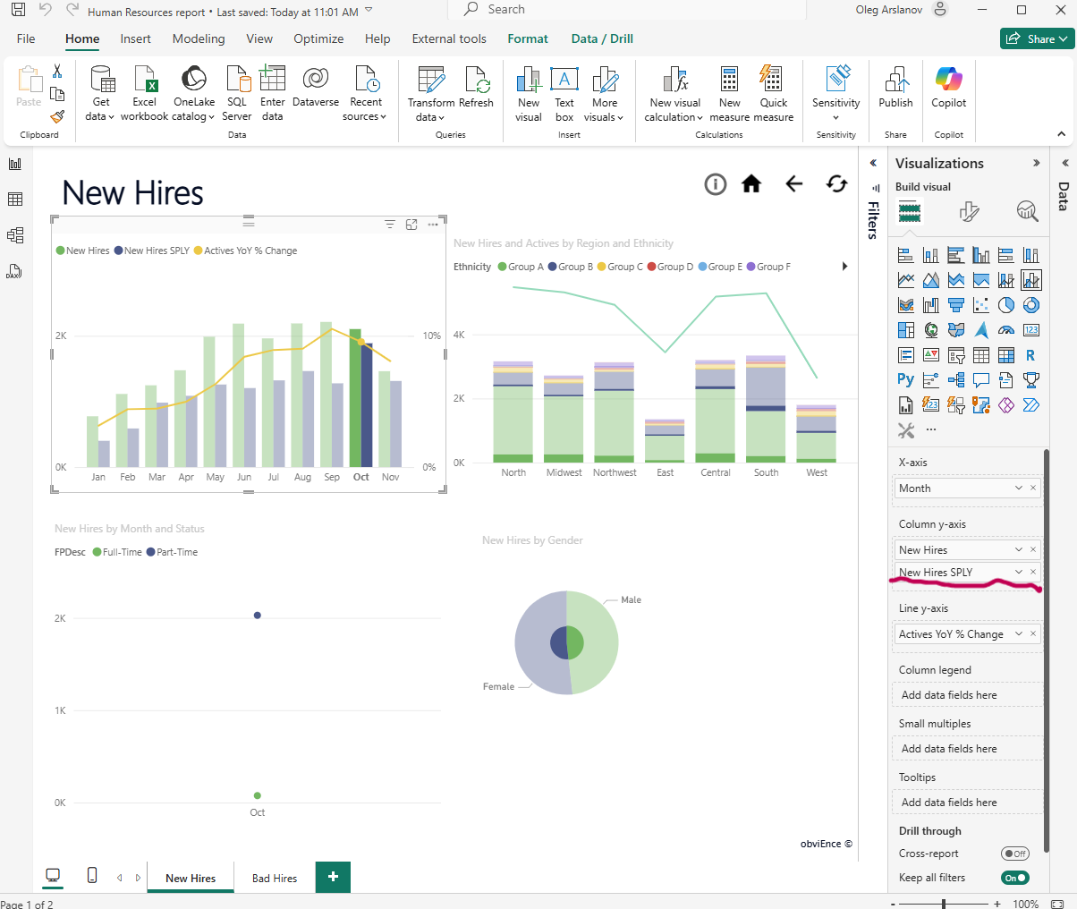
Priority | High
Severity | Major
Assignee | Oleg Arslanov

Bug 4: Missing title on visual displaying New Hires data
Summary | Missing title on visual  How not to do:  The visual does not include a title  How to do:  Add a clear and concise title “New Hires per Month”
escription | STR (Steps to Reproduce):  1. Open the Power BI report  2. Navigate to the chart showing new hires  3. Add visual title “New Hires per Month”  AR (Actual Result):  The Visual does not include a title  ER (Expected Result):  Visual need to have title “New Hires per month”
Environment | PowerBI Version: 2.140.1577.0 64-bit (February 2025)  Windows Version: 11 PRO Version 24H2  Screen Resolution: 1920 x 1080
Attachments | 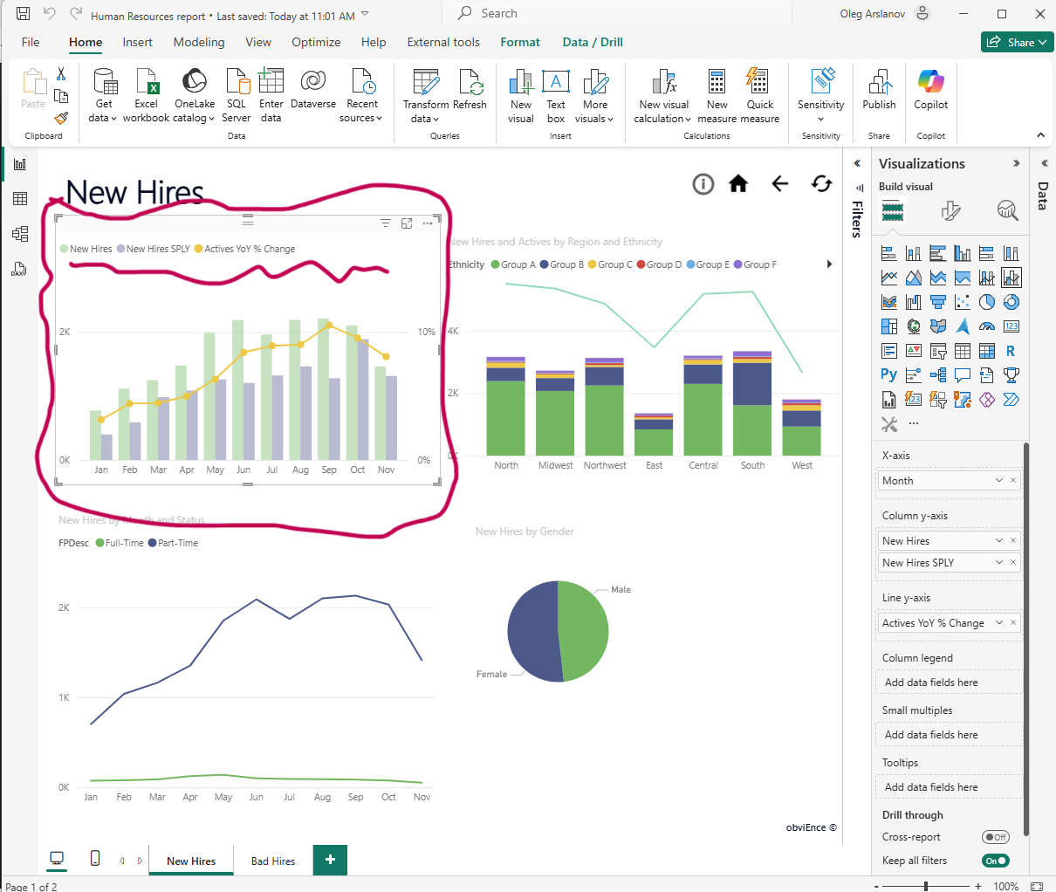
Priority | Medium
Severity | Medium
Assignee | Oleg Arslanov

2B. Visual ‘New Hires and Activities by Region and Ethnicity’

Bug 5: Incorrect Chart Type Used

Summary | Line and Stacked Chart used instead of required Bar Chart  How not to do:  Use not Bar Chart on the New Hires and activities by Region and Ethnicity visual according to the requirements  How to do:  Use Bar Chart on the New Hires and activities by Region and Ethnicity visual according to requirements
Description | STR (Steps to Reproduce):  1. Open the Power BI report  2. Navigate to the visual displaying new hires  3. Observe the chart type used  AR (Actual Result):  Used Line and stacked column Chart for New Hires and Activities by Region and Ethnicity visual.  ER (Expected Result):  A Bar Chart should be used, as per the report requirements
Environment | PowerBI Version: 2.140.1577.0 64-bit (February 2025)  Windows Version: 11 PRO Version 24H2  Screen Resolution: 1920 x 1080
Attachments | 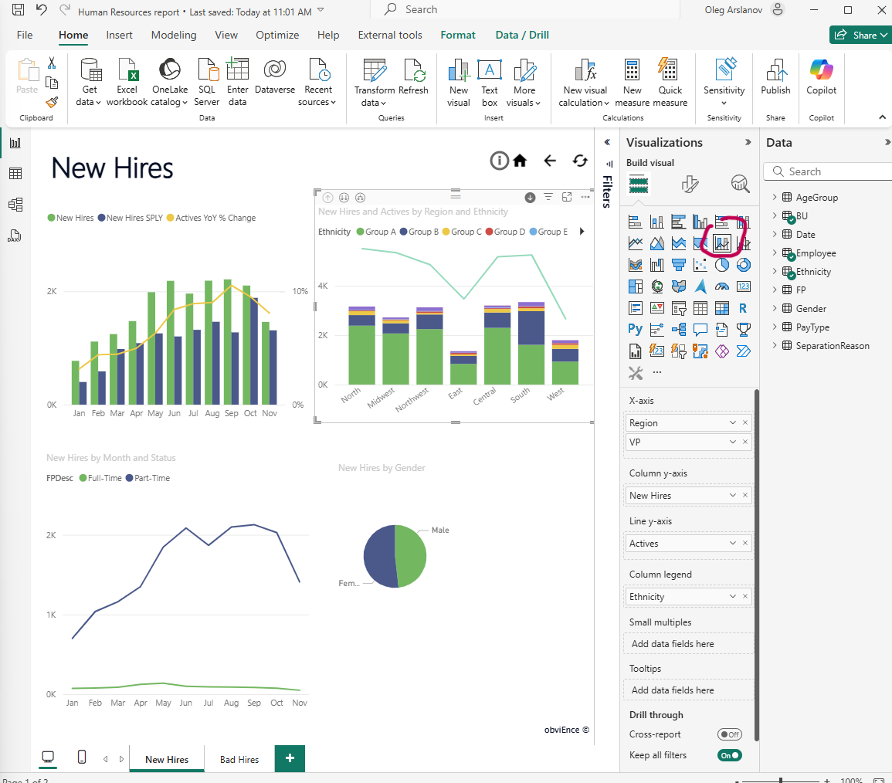
Priority | Medium
Severity | Minor
Assignee | Oleg Arslanov

Bug 6: Incorrect Chart Type Used

Summary | Redundant and confusing hierarchy buttons in "New Hires and Activities by Region" visual  How not to do: Include multiple hierarchy navigation buttons (e.g., “Expand all down one level in the hierarchy” and “Go to the next level in hierarchy”) without clearly defining their purpose. This may confuse users, especially when the report requirements mention only one level of drill-down.  How to do: Keep only the required and clearly described hierarchy navigation button according to the report requirements. Ensure the visual uses a single, intuitive control for drilling down — for example, allow users to drill to a lower level using only the "Go to the next level" button if that matches the intended functionality.
Description | STR (Steps to Reproduce):  1. Open the report  2. Go to the “New Hires” page  3. Hover over the visual “New Hires and Activities by Region”  4. Observe the available hierarchy navigation buttons  AR (Actual Result):  Two similar buttons are available: “Expand all down one level in the hierarchy” and “Go to the next level in hierarchy”, which may confuse users  ER (Expected Result):  Only one appropriate button should be available according to requirements to avoid redundancy and confusion
Environment | PowerBI Version: 2.140.1577.0 64-bit (February 2025)  Windows Version: 11 PRO Version 24H2  Screen Resolution: 1920 x 1080
Attachments | 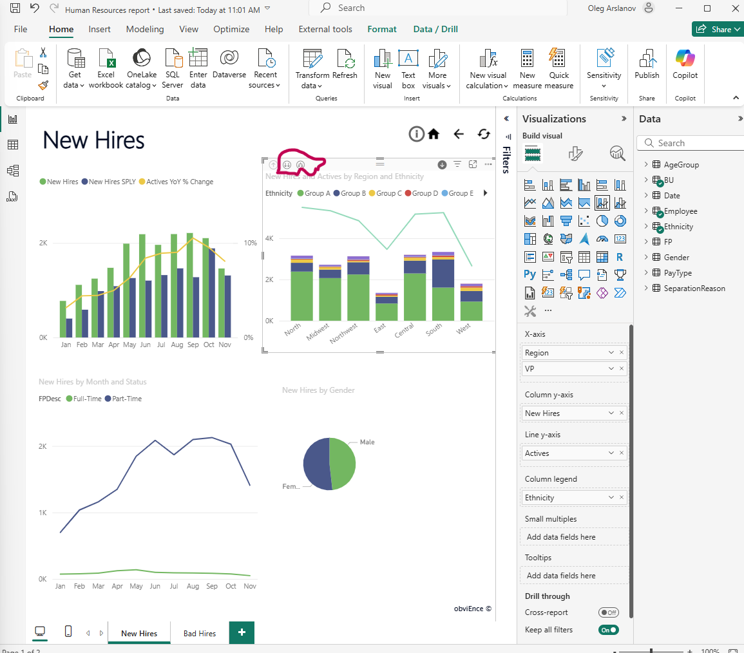
Priority | High
Severity | Medium
Assignee | Oleg Arslanov

Bug 7: Incorrect Label Used for hierarchy navigation

Summary | Incorrect label used for hierarchy navigation — should be "Drill down", not "Go to the next level in the hierarchy"  How not to do: Use inconsistent or unclear button labels such as “"Go to the next level in the hierarchy” that are not mentioned in the report requirements and may confuse users about their actual purpose.  How to do: Use the correct and expected label for drill-down actions — "Drill down" — to maintain consistency with the requirements and ensure intuitive user experience.
Description | STR (Steps to Reproduce):  1. Open the report  2. Go to the “New Hires” page  3. Hover over the visual “New Hires and Activities by Region”  4. Observe the button label for drill down  AR (Actual Result):  The drill down option appears as “"Go to the next level in the hierarchy”  ER (Expected Result):  The button should be labeled “Drill down” to align with expected terminology and user understanding
Environment | PowerBI Version: 2.140.1577.0 64-bit (February 2025)  Windows Version: 11 PRO Version 24H2  Screen Resolution: 1920 x 1080
Attachments | 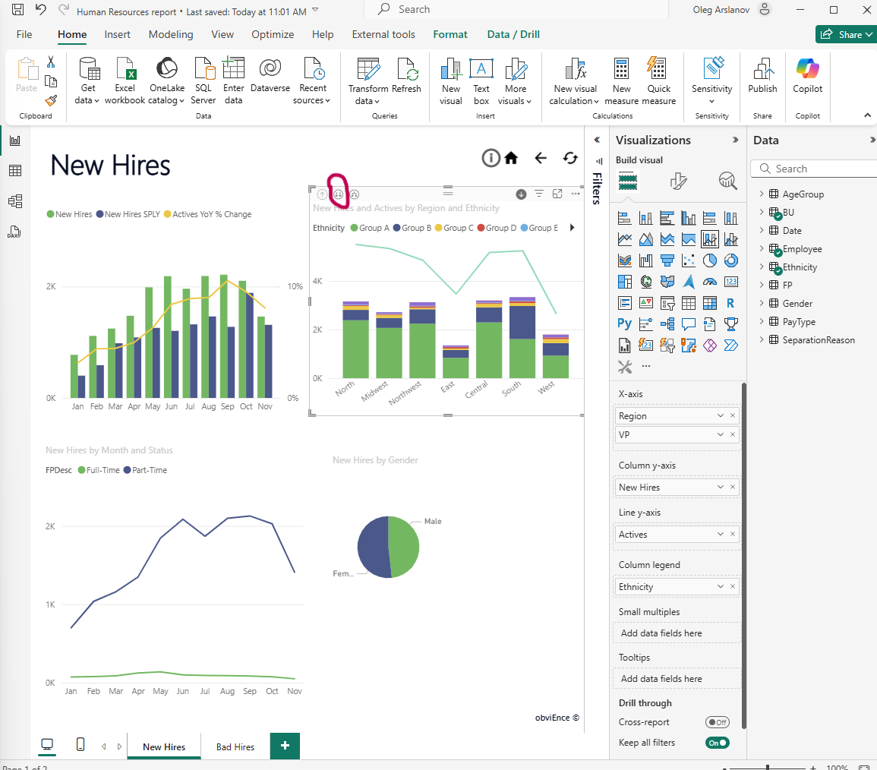
Priority | Medium
Severity | Medium
Assignee | Oleg Arslanov

2C. Visual ‘New Hires by Month and Status’

Bug 8: Incorrect Label Used for visual

Summary | Incorrect label used for visual — should be "New Hires by Month and FPDesc" instead of current title  How not to do: Use a visual label that does not match the report requirements  How to do: Rename the visual to "New Hires by Month and FPDesc" as per requirements
Description | STR (Steps to Reproduce):  1. Open the report  2. Go to the “New Hires” page  3. Locate the visual with title “New Hires by Month and Status”  AR (Actual Result):  The visual is labeled “New Hires by Month and Status”  ER (Expected Result):  The visual should be labeled “New Hires by Month and FPDesc”
Environment | PowerBI Version: 2.140.1577.0 64-bit (February 2025)  Windows Version: 11 PRO Version 24H2  Screen Resolution: 1920 x 1080
Attachments | 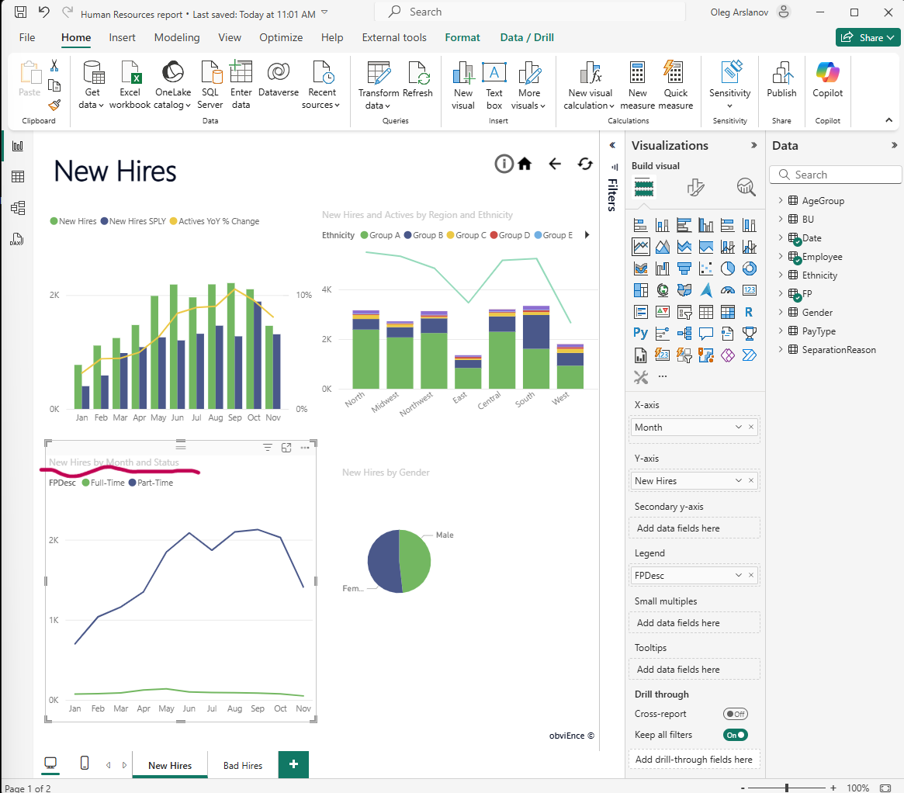
Priority | Medium
Severity | Medium
Assignee | Oleg Arslanov

- ‘Bad Hires’ page
3A. Slicer

Bug 9: Missing Region 'West' in Slicer on 'Bad Hires' Page

Summary | Region ‘West’ is missing from the slicer on the ‘Bad Hires’ page  How not to do: Display a slicer with an incomplete list of regions, excluding ‘West’, which is expected to be included  How to do: Ensure the slicer includes all available regions including ‘West’
Description | On the ‘Bad Hires’ page, the slicer for region selection does not show the ‘West’ region. This might lead to incomplete data filtering and inconsistent user experience.  STR (Steps to Reproduce):  1. Open the report  2. Go to the ‘Bad Hires’ page  3. Check the region slicer  4. Observe the missing ‘West’ region  AR (Actual Result):  Region ‘West’ is not available in the slicer  ER (Expected Result):  Region ‘West’ should be present in the slicer along with other regions
Environment | PowerBI Version: 2.140.1577.0 64-bit (February 2025)  Windows Version: 11 PRO Version 24H2  Screen Resolution: 1920 x 1080
Attachments | 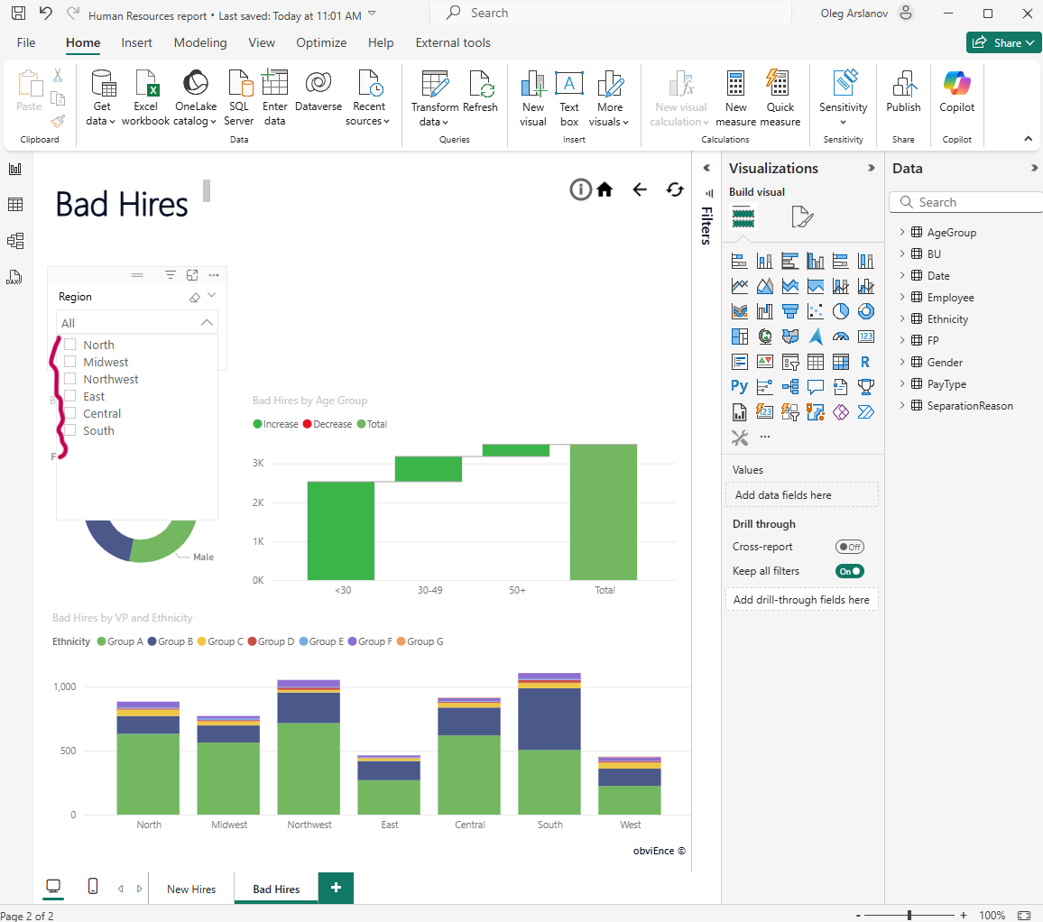
Priority | High
Severity | High
Assignee | Oleg Arslanov
3B. Visual ‘Bad Hires KPI’

Bug 10: Missing KPI Visual 'Bad Hires KPI' on 'Bad Hires' Page
Summary | KPI visual ‘Bad Hires KPI’ is missing from the ‘Bad Hires’ page  How not to do: Do not include the required KPI visual that displays the BadHires metric  How to do: Add a KPI chart named ‘Bad Hires KPI’ with value showing BadHires on the ‘Bad Hires’ page
Description | The ‘Bad Hires KPI’ visual, which should present the BadHires metric using a KPI chart, is not found on the ‘Bad Hires’ page. Its absence may hinder quick insights into key performance indicators.  STR (Steps to Reproduce):  1. Open the report  2. Go to the ‘Bad Hires’ page  3. Look for a KPI visual titled ‘Bad Hires KPI’  AR (Actual Result):  No KPI visual titled ‘Bad Hires KPI’ is present  ER (Expected Result):  A KPI chart named ‘Bad Hires KPI’ should be included, displaying the BadHires value
Environment | PowerBI Version: 2.140.1577.0 64-bit (February 2025)  Windows Version: 11 PRO Version 24H2  Screen Resolution: 1920 x 1080
Attachments | -
Priority | High
Severity | High
Assignee | Oleg Arslanov

3C. Visual ‘Bad Hires by Age Groups’

Bug 11: Incorrect Metric Used on Y-axis in ‘Bad Hires by Age Groups’ Visual
Summary | Y-axis in ‘Bad Hires by Age Groups’ visual uses Bad Hires SPLY instead of required BadHires%ofActivities  How not to do: Use Bad Hires SPLY as Y-axis metric in the ‘Bad Hires by Age Groups’ waterfall chart  How to do: Use BadHires%ofActivities as the Y-axis metric to accurately reflect the percentage of bad hires per activity
Description | The visual titled ‘Bad Hires by Age Groups’ is currently displaying incorrect Y-axis data. The metric Bad Hires SPLY is used, which does not meet the requirements. According to the specification, the correct measure is BadHires%ofActivities. This misalignment could lead to misinterpretation of the chart.  STR (Steps to Reproduce):  1. Open the report  2. Go to the ‘Bad Hires’ page  3. Locate the visual ‘Bad Hires by Age Groups’  4. Inspect the Y-axis metric  AR (Actual Result):  Y-axis shows Bad Hires SPLY  ER (Expected Result):  Y-axis should show BadHires%ofActivities
Environment | PowerBI Version: 2.140.1577.0 64-bit (February 2025)  Windows Version: 11 PRO Version 24H2  Screen Resolution: 1920 x 1080
Attachments | 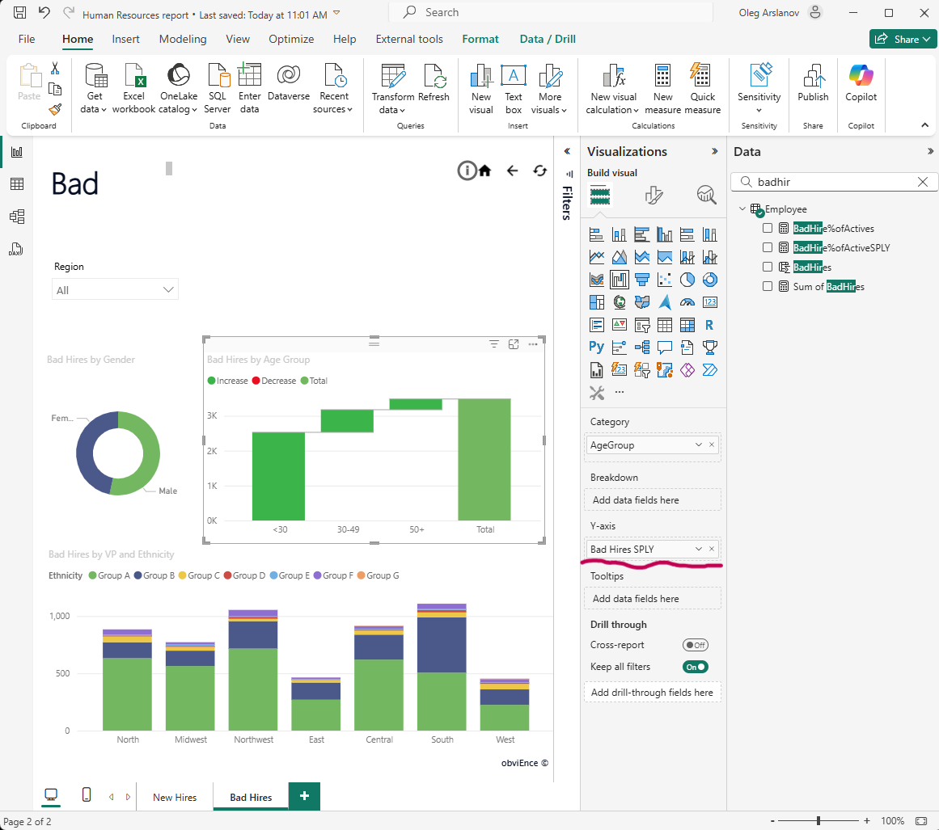
Priority | Medium
Severity | Major
Assignee | Oleg Arslanov
Bug 12: Incorrect Visual Title — Should Be ‘Bad Hires by Age Groups’

Summary | Visual title is incorrect — should be ‘Bad Hires by Age Groups’  How not to do: Name the visual ‘Bad Hires by Age Group’ (singular form)  How to do: Use the correct visual title: ‘Bad Hires by Age Groups’
Description | The title of the waterfall chart on the ‘Bad Hires’ page uses ‘Bad Hires by Age Group’, but the correct label according to the naming convention and clarity should be ‘Bad Hires by Age Groups’.  STR (Steps to Reproduce):  1. Open the report  2. Go to the ‘Bad Hires’ page  3. Look at the title of the visual showing bad hires by age  AR (Actual Result):  Title shows ‘Bad Hires by Age Group’  ER (Expected Result):  Title should be ‘Bad Hires by Age Groups’
Environment | PowerBI Version: 2.140.1577.0 64-bit (February 2025)  Windows Version: 11 PRO Version 24H2  Screen Resolution: 1920 x 1080
Attachments | 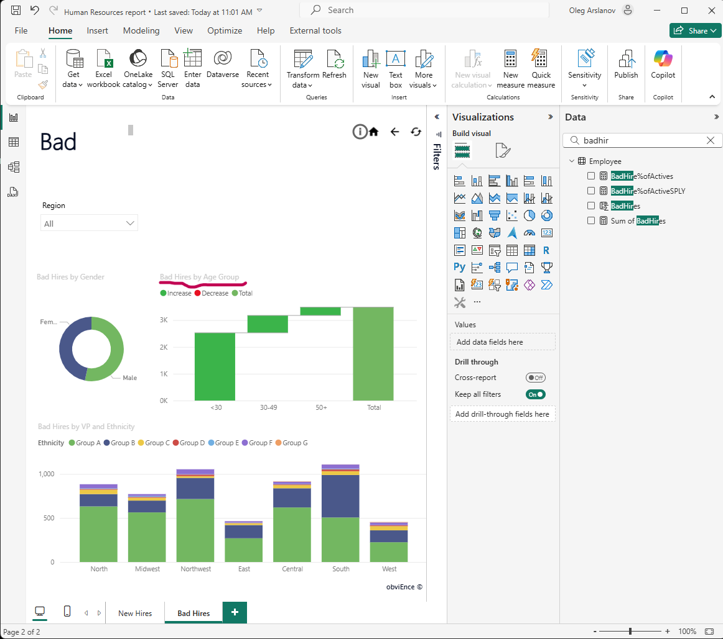
Priority | Low
Severity | Minor
Assignee | Oleg Arslanov

3D. Visual ‘Bad Hires by VP and Ethnicity’

Bug 13: Incorrect Chart Type Used
Summary | Stacked Column Chart used instead of required Bar Chart  How not to do:  Use not Bar Chart on the Bad Hires by VP and Ethnicity visual according to the requirements  How to do:  Use Bar Chart on the Bad Hires by VP and Ethnicity visual according to the requirements
Description | STR (Steps to Reproduce):  1. Open the Power BI report  2. Navigate to the visual displaying new hires  3. Observe the chart type used  AR (Actual Result):  Used Stacked Column Chart for Bad Hires by VP and Ethnicity visual  ER (Expected Result):  A Bar Chart should be used, as per the report requirements
Environment | PowerBI Version: 2.140.1577.0 64-bit (February 2025)  Windows Version: 11 PRO Version 24H2  Screen Resolution: 1920 x 1080
Attachments | 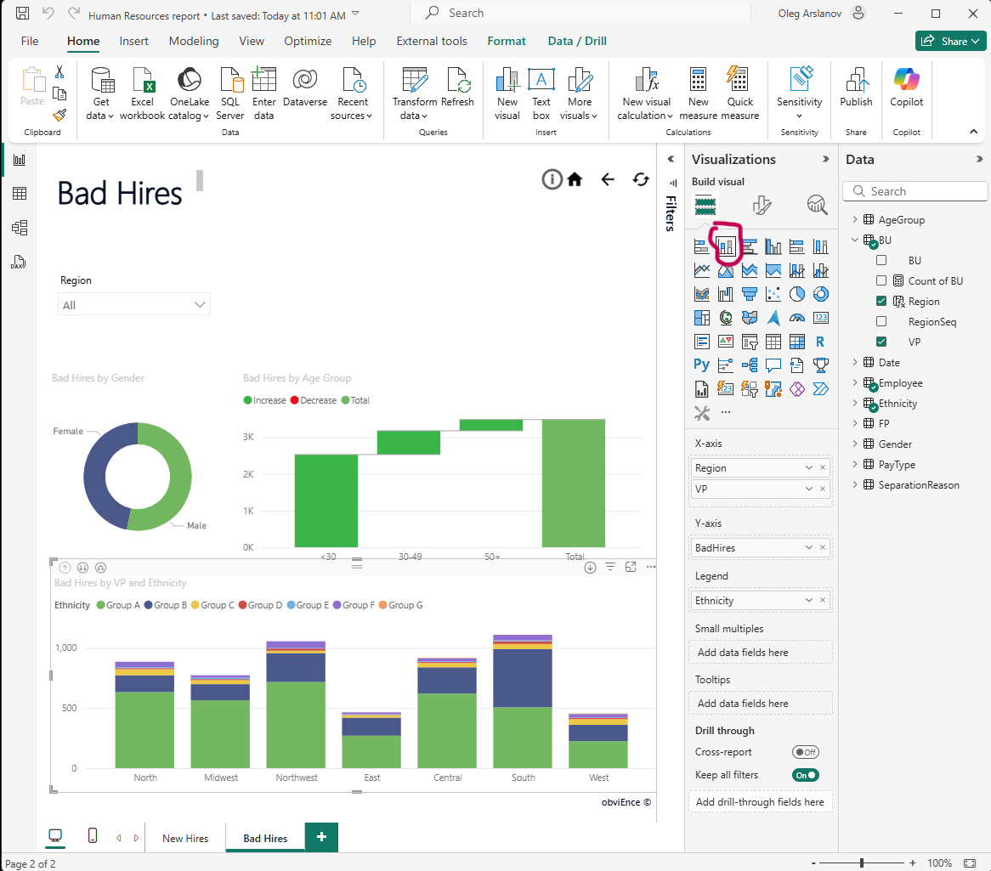
Priority | Medium
Severity | Minor
Assignee | Oleg Arslanov

Bug 14: Incorrect Label Used for Hierarchy Navigation

Summary | Incorrect label used for hierarchy navigation — should be "Drill down", not "Go to the next level in the hierarchy"  How not to do: Use inconsistent or unclear button labels such as “"Go to the next level in the hierarchy” that are not mentioned in the report requirements and may confuse users about their actual purpose.  How to do: Use the correct and expected label for drill-down actions — "Drill down" — to maintain consistency with the requirements and ensure intuitive user experience.
Description | STR (Steps to Reproduce):  1. Open the report  2. Go to the “New Hires” page  3. Hover over the visual “Bad Hires by VP and Ethnicity”  4. Observe the button label for drill down  AR (Actual Result):  The drill down option appears as “"Go to the next level in the hierarchy”  ER (Expected Result):  The button should be labeled “Drill down” to align with expected terminology and user understanding
Environment | PowerBI Version: 2.140.1577.0 64-bit (February 2025)  Windows Version: 11 PRO Version 24H2  Screen Resolution: 1920 x 1080
Attachments | 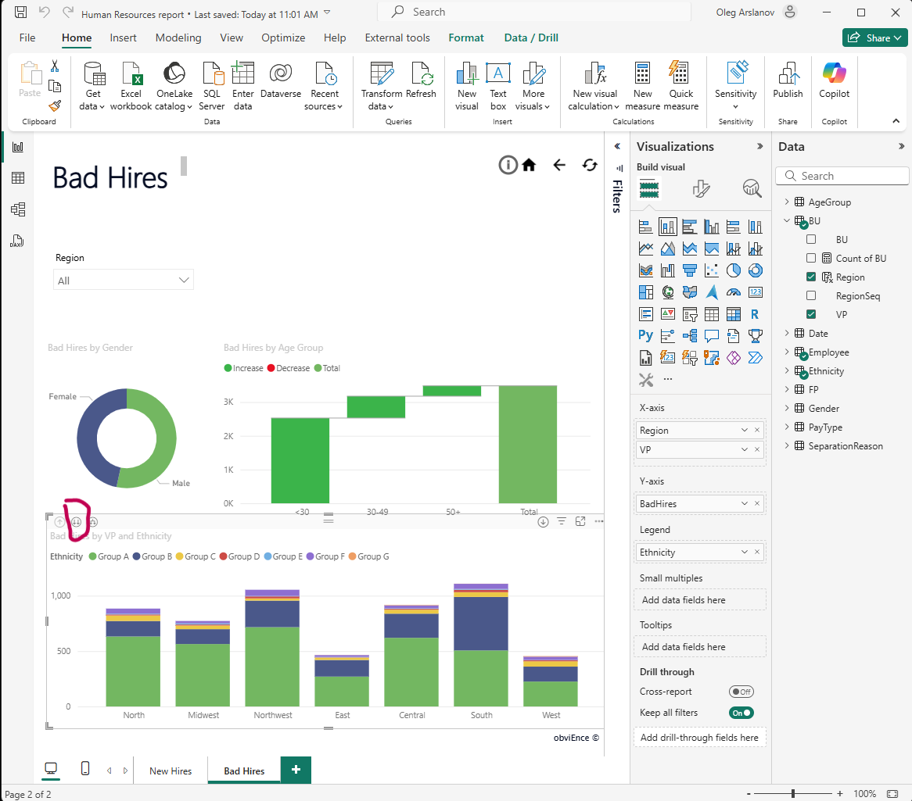
Priority | Medium
Severity | Medium
Assignee | Oleg Arslanov

- Others Bugs
4A. Buttons

Bug 15: Report Info Button ‘i’ Not Working
Summary | Button ‘i’ does not open the Report Info pop-up window  How not to do: Place an ‘i’ button on the page that doesn't respond when clicked  How to do: The ‘i’ button should open a pop-up window with report information when pressed
Description | According to the requirements, pressing the ‘i’ button should display a pop-up window with report details. Currently, clicking the button does not trigger any action  STR (Steps to Reproduce):  1. Open the report  2. Locate the ‘i’ button on the page (usually in the header)  3. Click the button  4. Observe that no information window appears  AR (Actual Result):  The button does not perform any action  ER (Expected Result):  A pop-up window should appear containing:  – Version of the report  – Created by DQE BI Team  – EPAM + EPAM logo
Environment | PowerBI Version: 2.140.1577.0 64-bit (February 2025)  Windows Version: 11 PRO Version 24H2  Screen Resolution: 1920 x 1080
Attachments | 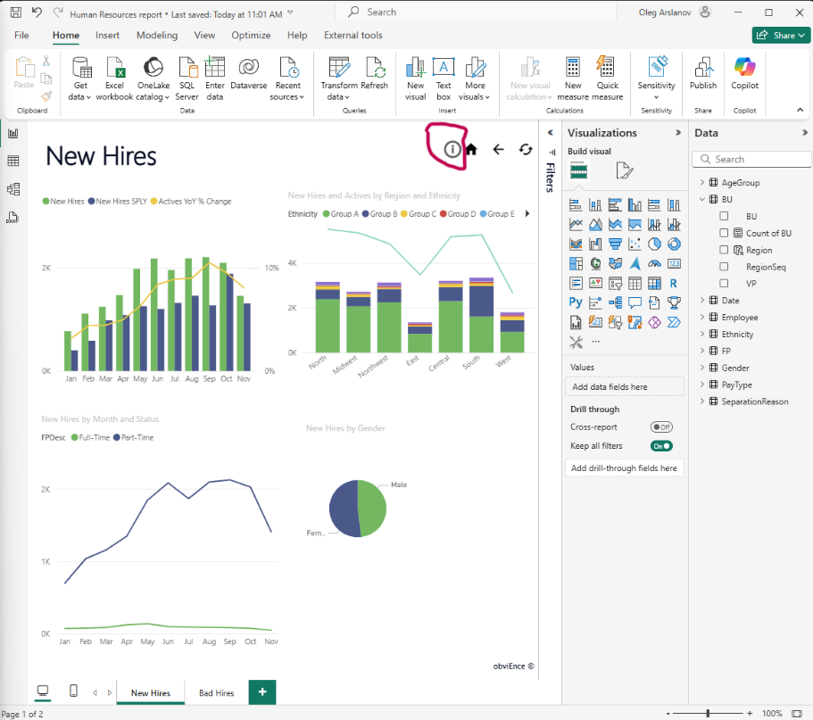
Priority | Medium
Severity | Major
Assignee | Oleg Arslanov

Bug 16: Non-functional Navigation Buttons Implemented as Images

Summary | Navigation buttons are implemented as static images instead of functional buttons on “New Hires” and “Bad Hires” pages  How not to do: Use static images instead of functional navigation buttons, which do not respond to user clicks and break navigation logic  How to do: Implement “Home”, “Back”, and “Reset” as functional navigation buttons with assigned actions according to requirements
Description | According to the requirements, pressing the ‘i’ button should display a pop-up window with report details. Currently, clicking the button does not trigger any action  STR (Steps to Reproduce):  1. Open the report in Power BI Desktop  2. Navigate to the “New Hires” or “Bad Hires” page  3. Locate the top-right corner navigation icons  4. Attempt to click the “Home”, “Back”, or “Reset” icons  AR (Actual Result):  The navigation icons are static images and do not perform any action when clicked  ER (Expected Result):  Navigation buttons should work as follows:  — Home: Navigate to Welcome page  — Back: Navigate to previously opened page  — Reset: Reset filters and visuals to default (no selection)
Environment | PowerBI Version: 2.140.1577.0 64-bit (February 2025)  Windows Version: 11 PRO Version 24H2  Screen Resolution: 1920 x 1080
Attachments | 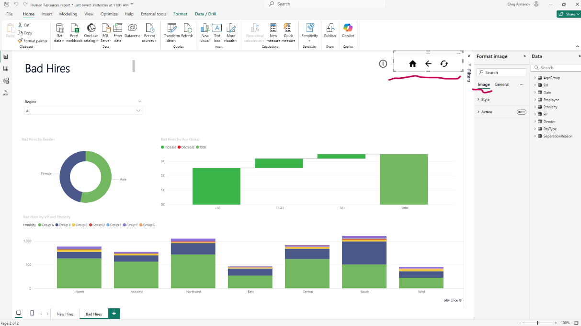
Priority | High
Severity | High
Assignee | Oleg Arslanov

4B. Document Formatting

Bug 17: Incorrect Font Family and Color Used in Visuals

Summary | Incorrect font family and font color used in visuals  How not to do: Use font 'Segoe UI' and grey color for visual titles, legends, and axes  How to do: Use font 'Tahoma', size 9 for visual titles, size 8 for legends and axes, and black color #000000 (RGB: 0,0,0) as per requirements
Description | All visuals currently use 'Segoe UI' font and grey font color. Requirements specify 'Tahoma' with specific sizes and black font color for all textual elements inside visuals  STR (Steps to Reproduce):  1. Open any report page  2. Hover or click on any visual (e.g., bar chart, KPI, line chart)  3. Observe the font style and color used in title, legend, and axes  AR (Actual Result):  Font used: 'Segoe UI', Color: grey  ER (Expected Result):  Font should be 'Tahoma', Color: black #000000
Environment | PowerBI Version: 2.140.1577.0 64-bit (February 2025)  Windows Version: 11 PRO Version 24H2  Screen Resolution: 1920 x 1080
Attachments | -
Priority | Low
Severity | Low
Assignee | Oleg Arslanov

Summary | Page names use incorrect font family  How not to do: Use 'Segoe UI' font for page names  How to do: Use 'Tahoma' font, size 28 for all page names, as per the design standards
Description | All page names in the report use 'Segoe UI' font, while the design specification requires 'Tahoma' with font size 28  STR (Steps to Reproduce):  1. Open the report  2. Look at the page name displayed at the bottom  3. Check the font style used  AR (Actual Result):  Font used for page name: 'Segoe UI'  ER (Expected Result):  Font for page name should be 'Tahoma', size 28
Environment | PowerBI Version: 2.140.1577.0 64-bit (February 2025)  Windows Version: 11 PRO Version 24H2  Screen Resolution: 1920 x 1080
Attachments | 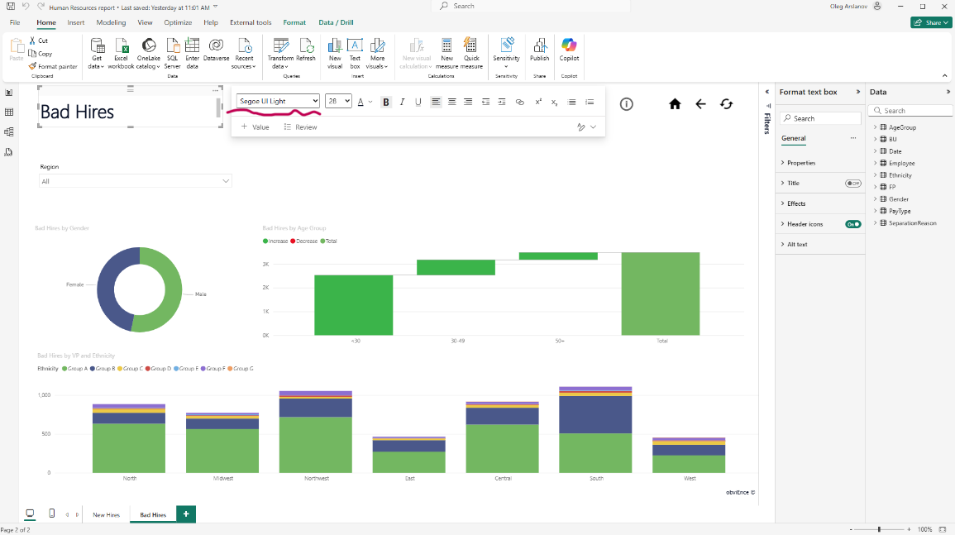
Priority | Low
Severity | Low
Assignee | Oleg Arslanov
Bug 18: Incorrect Font Family for Page Names
Bug 19: Incorrect Footer Text - Missing Report Creator Information

Summary | Footer text shows incorrect information about the report creator in Power BI report  How not to do: Use "obviEnce ©" or any other text that does not align with the specified requirements for report creator  How to do: Replace the footer text with "Created by DQE BI Team" as per the requirement
Description | STR (Steps to Reproduce):  1. Open the Power BI report  2. Scroll to the bottom of the report  3. Observe the footer text  AR (Actual Result):  The footer text shows "obviEnce ©" instead of the required "Created by DQE BI Team"  ER (Expected Result):  The footer should display "Created by DQE BI Team" as specified in the requirements
Environment | PowerBI Version: 2.140.1577.0 64-bit (February 2025)  Windows Version: 11 PRO Version 24H2  Screen Resolution: 1920 x 1080
Attachments | 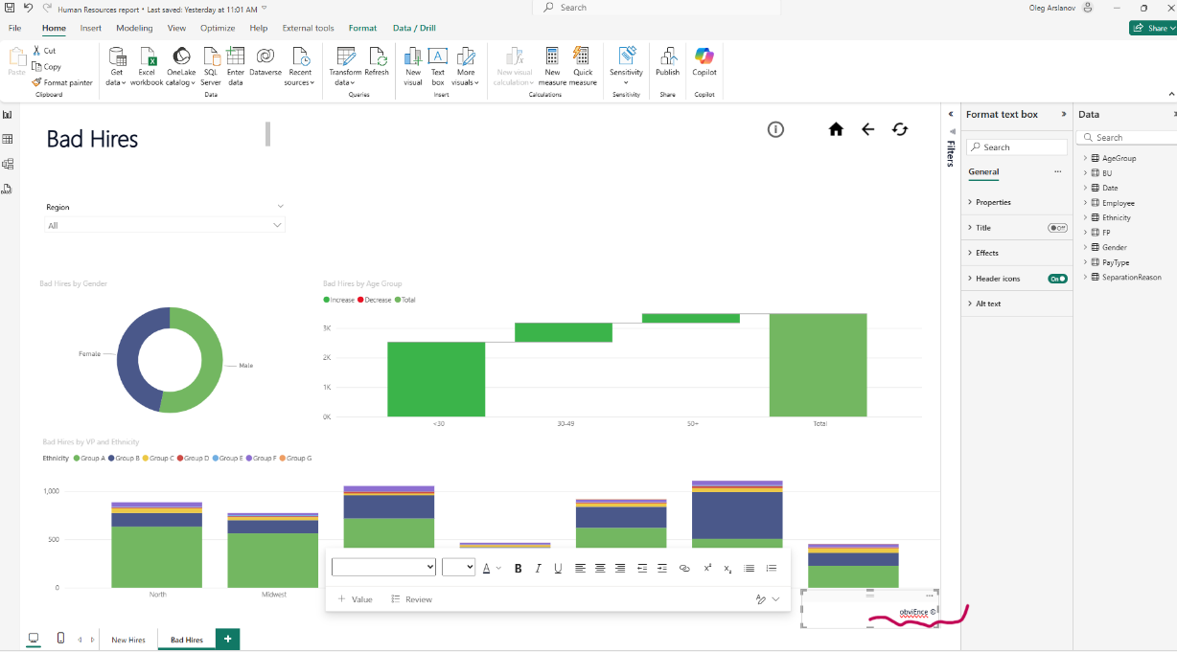
Priority | Medium
Severity | Medium
Assignee | Oleg Arslanov

Clarifications:

- Clarification Request: Drill Mode Button in 'New Hires and Activities by Region and Ethnicity' Visual
Field | Description
Type | Clarification / Question
Topic | Drill Mode Button Functionality in "New Hires and Activities by Region and Ethnicity" Visual
Page / Visual | New Hires / New Hires and Activities by Region and Ethnicity Visual
Description | The visual has a "Expand all down one level in the hierarchy" button which allows further detailing of columns to show managers working in each division. This feature is not mentioned in the requirements. Should this functionality be included in the report?
Impact | Clarification needed to ensure that the functionality aligns with requirements and user expectations.
Expected Outcome | Confirmation on whether this drill-down functionality should be included and whether it aligns with the original report requirements.

- Clarification Request: Drill Mode Button in 'Bad Hires by VP and Ethnicity' Visual
Field | Description
Type | Clarification / Question
Topic | Drill Mode Button Functionality in "Bad Hires by VP and Ethnicity" Visual
Page / Visual | Bad Hires / Bad Hires by VP and Ethnicity
Description | The visual has a "Expand all down one level in the hierarchy" button which allows further detailing of columns to show managers working in each division. This feature is not mentioned in the requirements. Should this functionality be included in the report?
Impact | Clarification needed to ensure that the functionality aligns with requirements and user expectations.
Expected Outcome | Confirmation on whether this drill-down functionality should be included and whether it aligns with the original report requirements.

- Clarification Request: Application of Background Color #E5BCCF (Pure Pink)

Field | Description
Type | Clarification / Question
Topic | Background Color Application – Pure Pink #E5BCCF
Page / Visual | Not specified (applies globally or to specific elements)
Description | The requirements specify the use of background color Pure Pink #E5BCCF / RGB: 229,188,207, but do not clarify where exactly this color should be applied: report page background, visuals, or design elements such as headers, cards, or pop-up sections.
Impact | Without clear guidance, the design may not meet UI/UX expectations or may result in inconsistent styling across pages or visuals.
Expected Outcome | Clarification on which elements should use the specified background color to ensure consistent and correct report formatting.

