Task 4

Row level security
So in our Adventure Works db we have countries. I made RLS with countries.

Create role ‘United States’
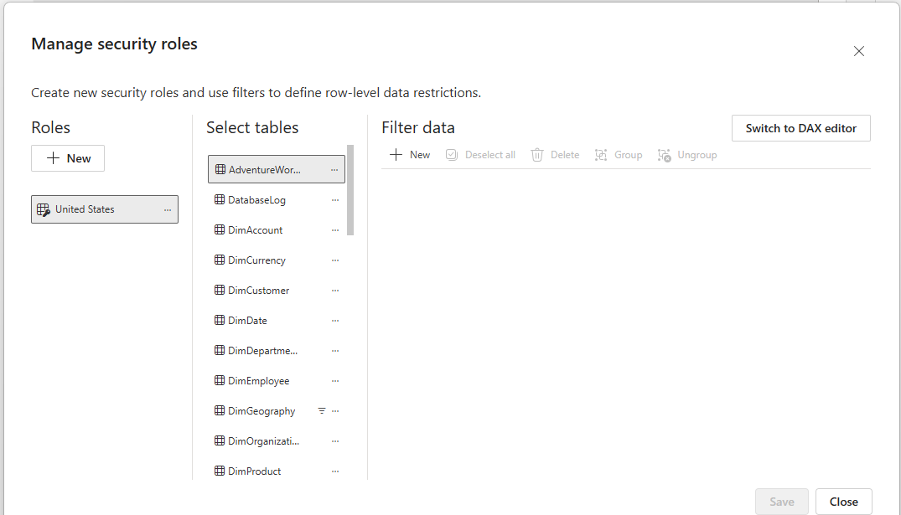
This view without RLS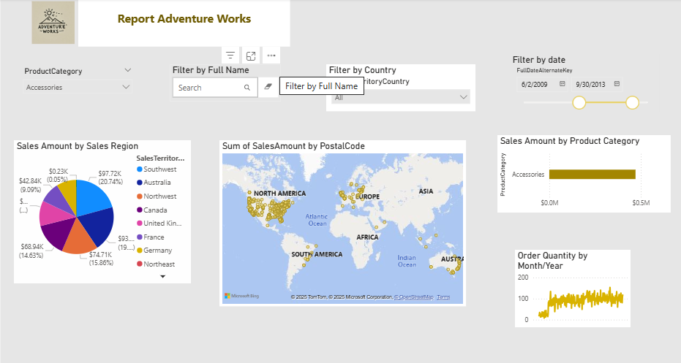
Here viw with RLS (not all diagrams are corectly working I know but don’t have time to looking what is wrong)

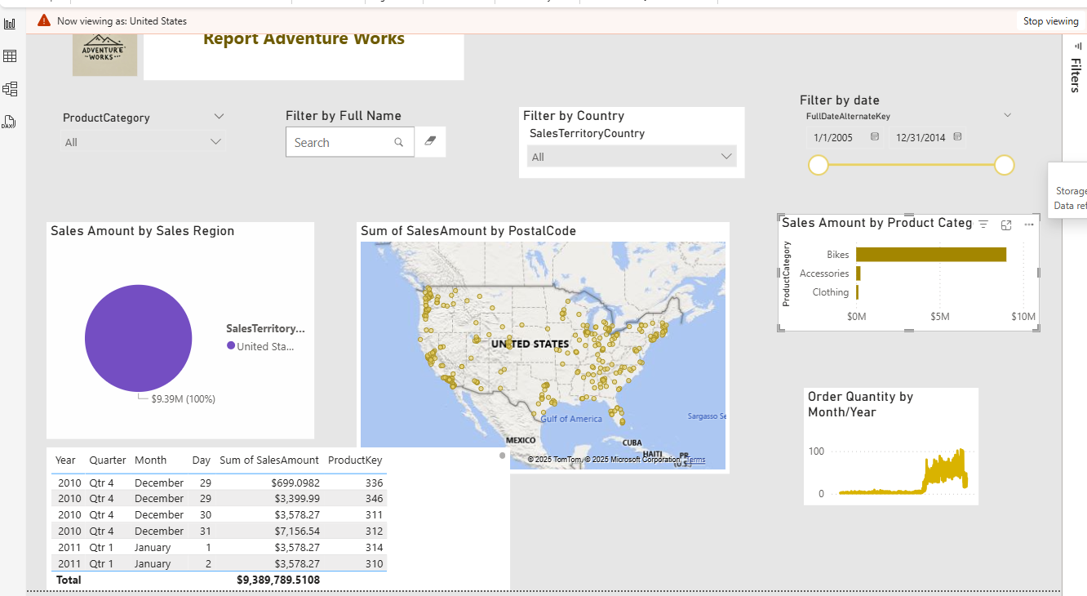

2. Now dynamical RLS
First I got that message
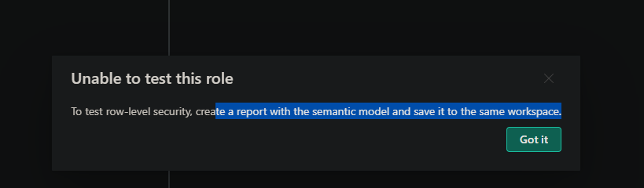
So I need to manage security role and add dynamic RLS
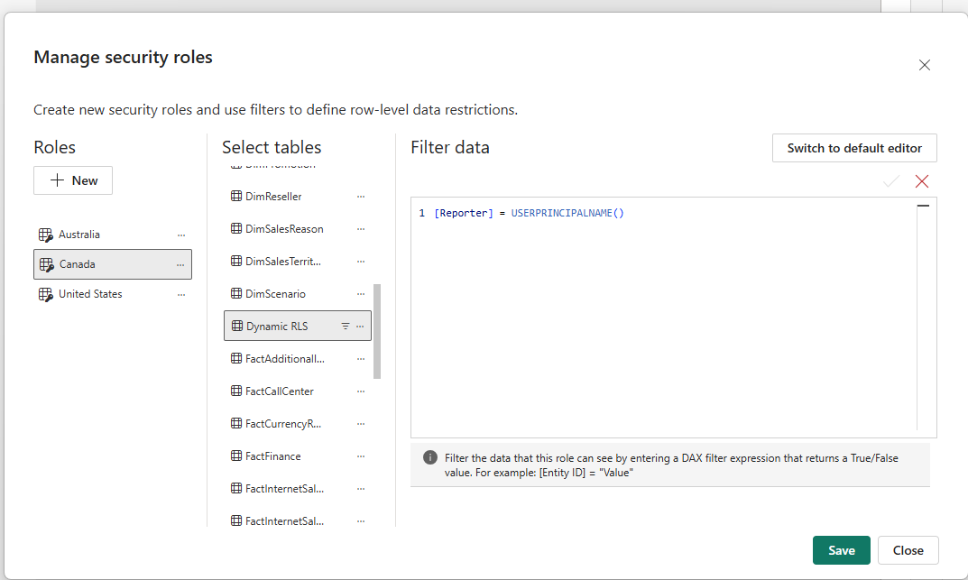

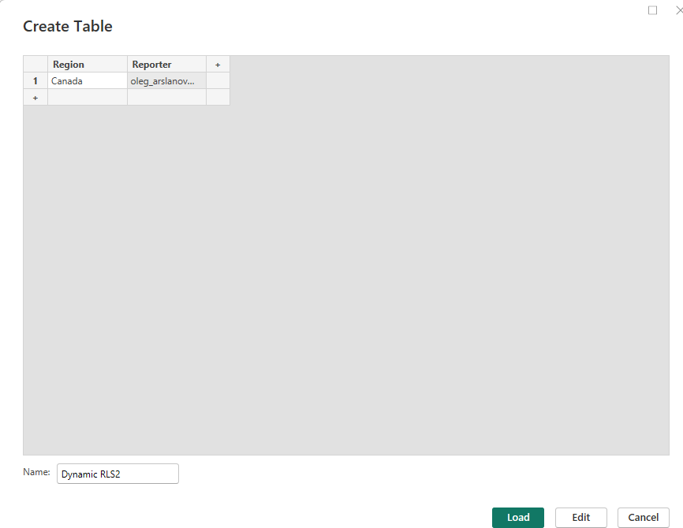

Create dynamic relationship between tables
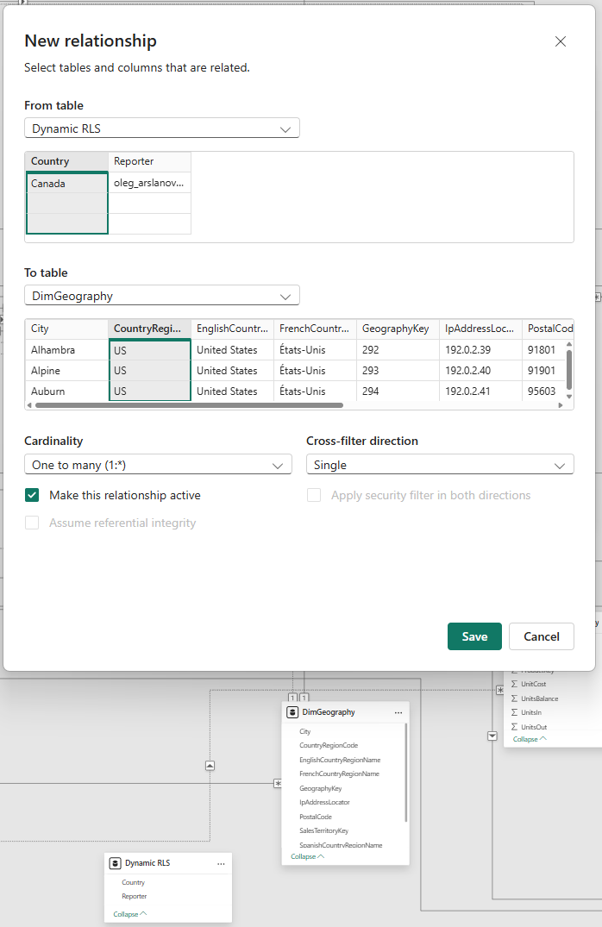
Manage security role

For corectly report I add filters by territory
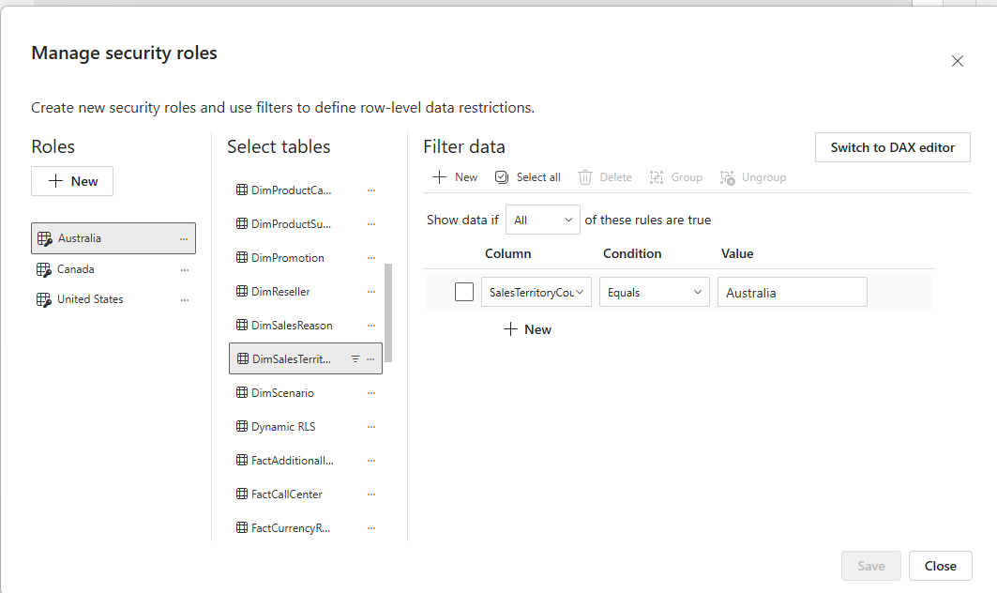

Now go to power Bi service, go to my workspace (where I save my file). Go to Row-Level Security

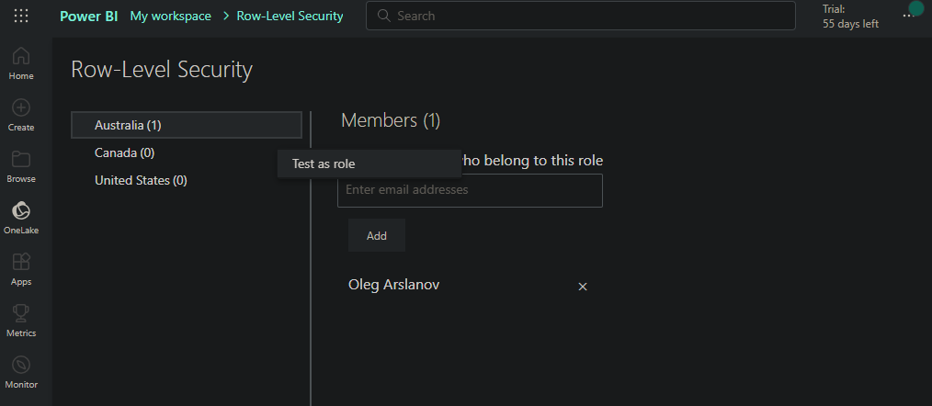

In PowerBi service all is working

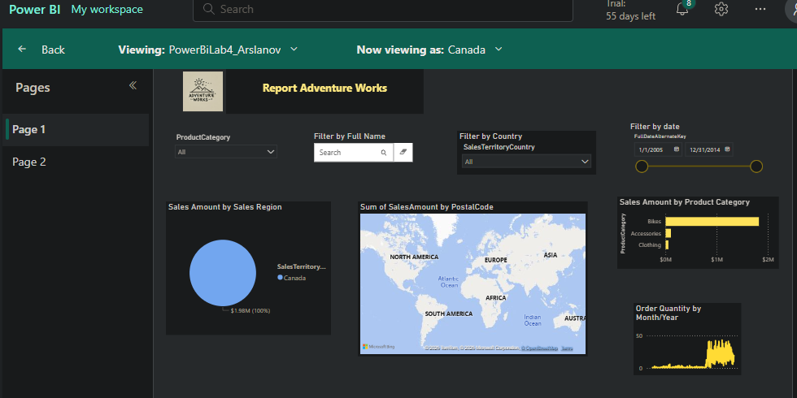

2 Bookmarks

So I made filter on page for United states. Add Bookmark and name it United States.
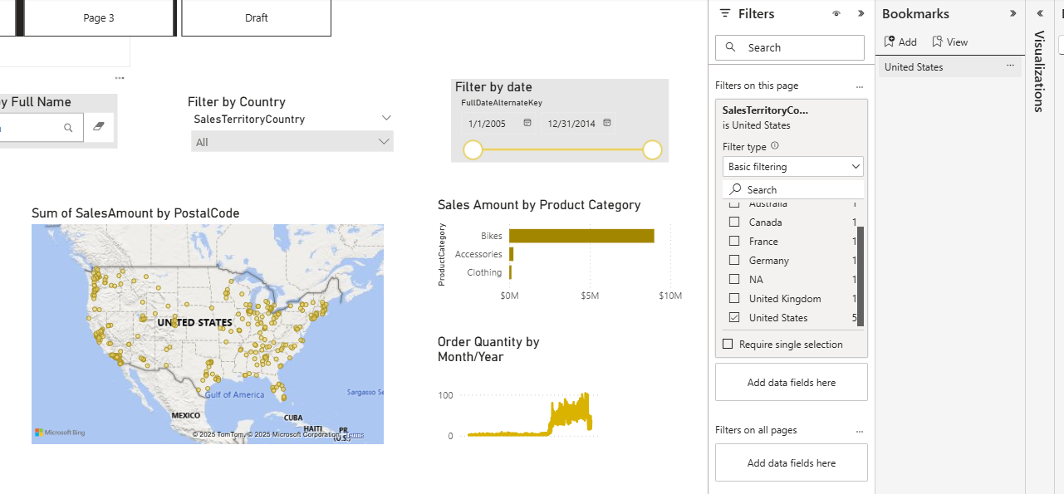
So I made 3 bookmarks and can easily use it for quicly change report country view.
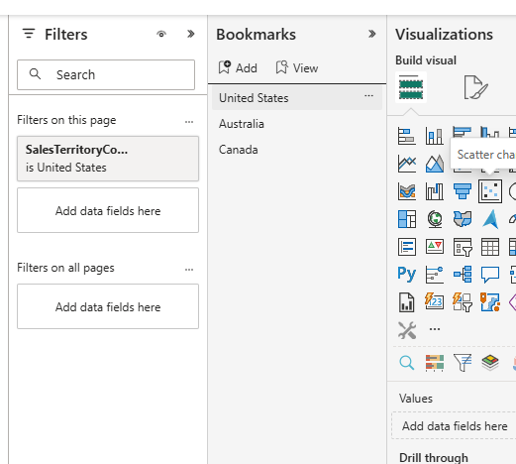

Selection
I can choose priority of object (who be on top of another object)
HereI I use shape (blue color) on top of visuals)
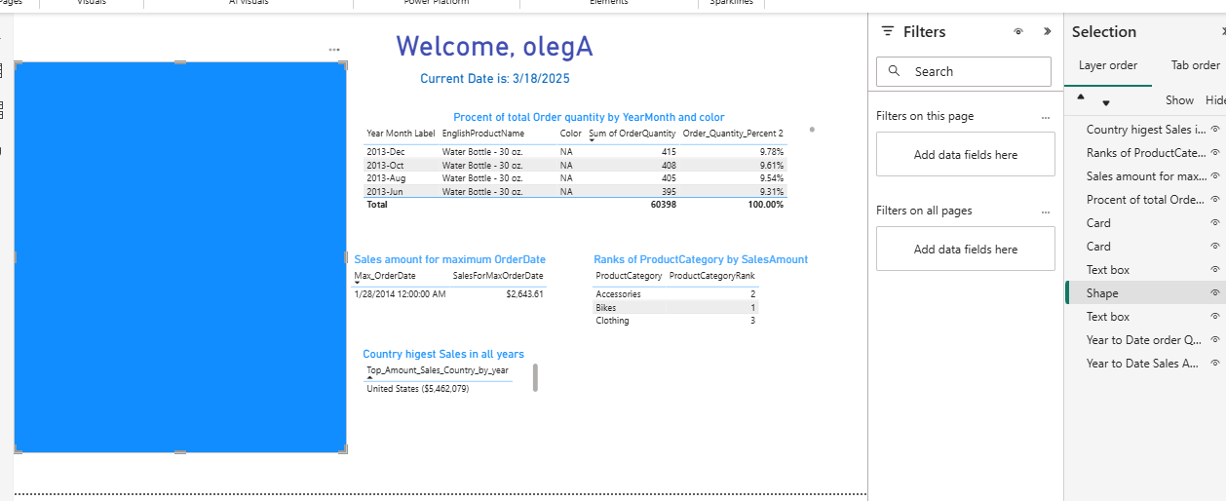

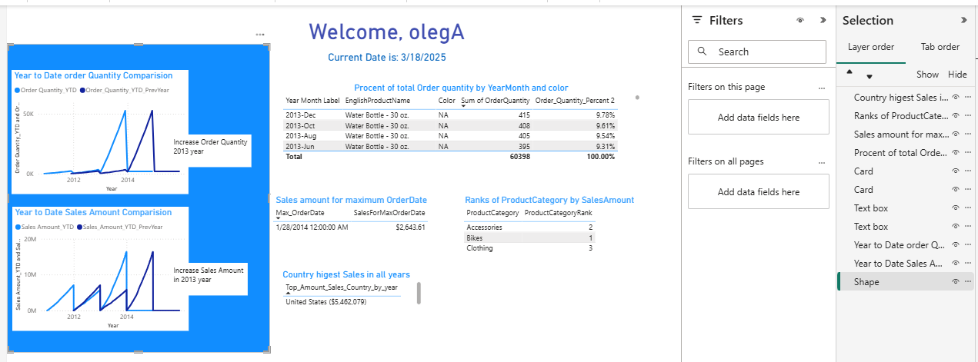
Here I use visuals on top …So we can see nice visual on the top of blue blue shape 😊

Also I can group selections by groups
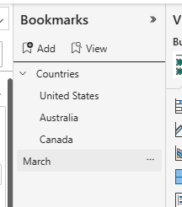

Buttons

So I made buttons for bar chart and map. For do that for Bar chart button first I hide visual Map, then I Add new bookmark in Vookmarks pain. I add buttonFrom Insert menu and in Action choose bookmarks that I create just before.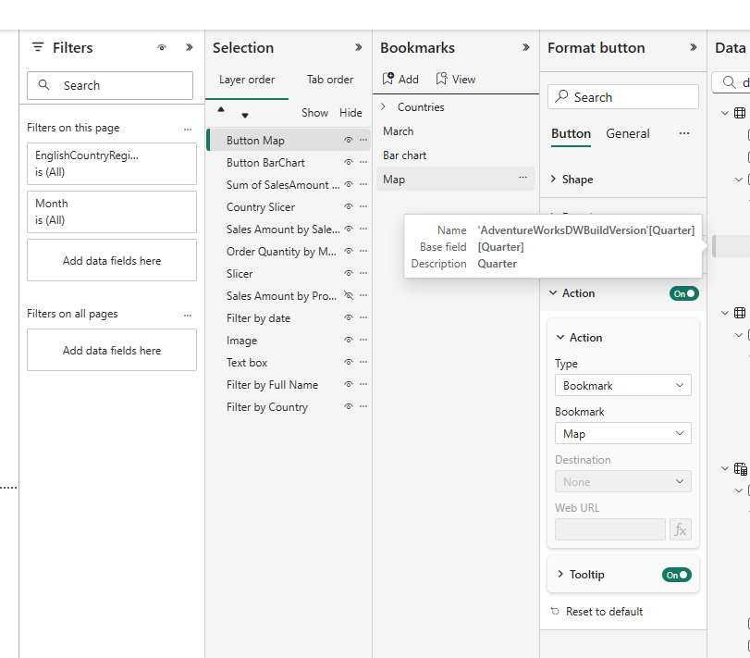
Actuay buttons in that case swith on another Bookmark (and bookmark have some visuals to show). So Buttons do some actions.
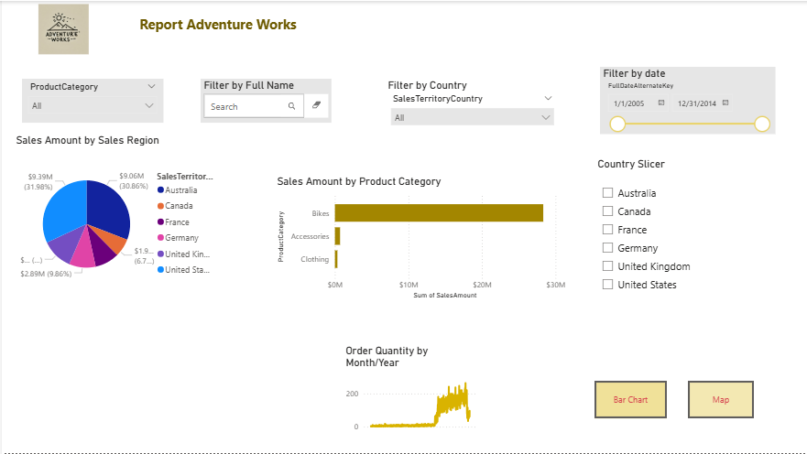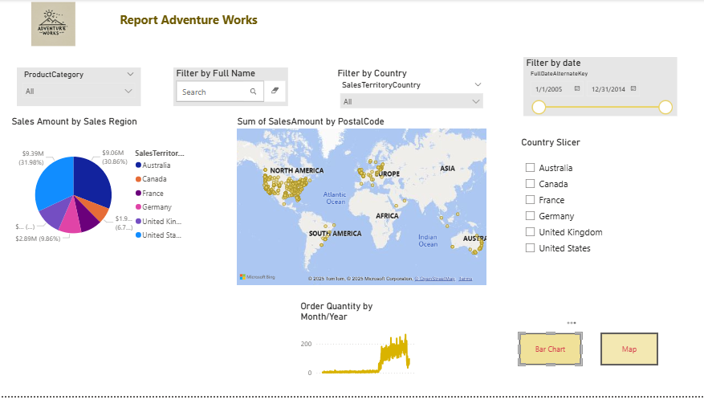

Tooltips
I made advanced tooltip. First I create new page tp_page. Here I store table with data (related to data in page1 Sales Amount by Sales Region)

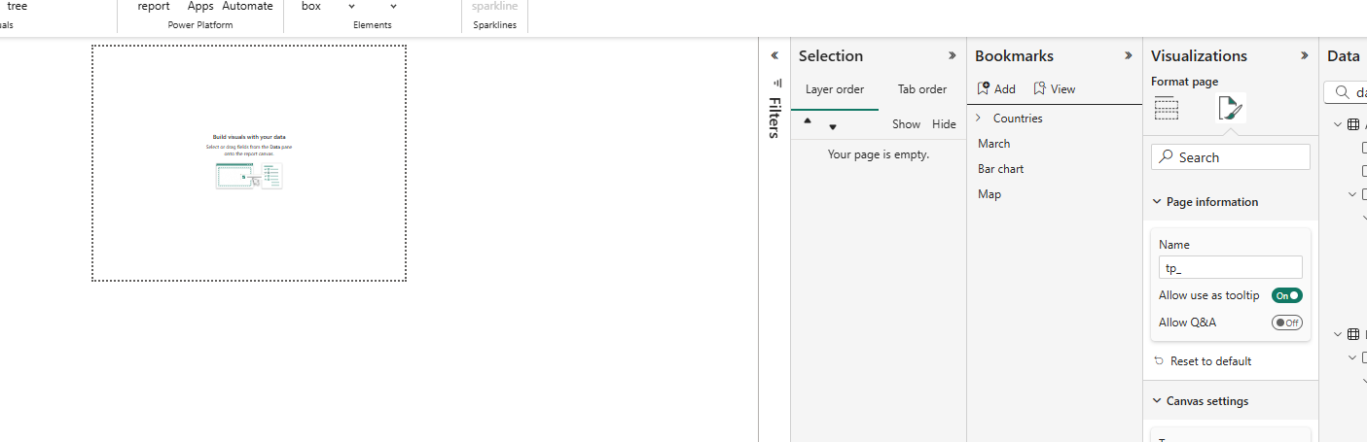
Then I select visual in Visualization pain I select Tooltips and in options select page that I want to additionaly show 😊
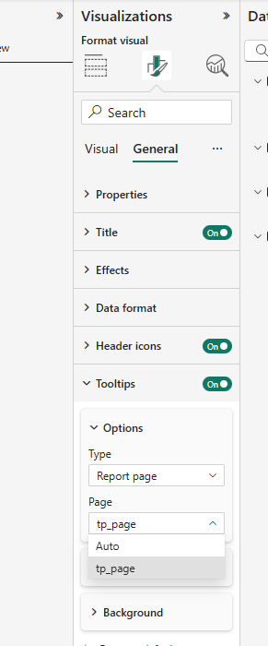
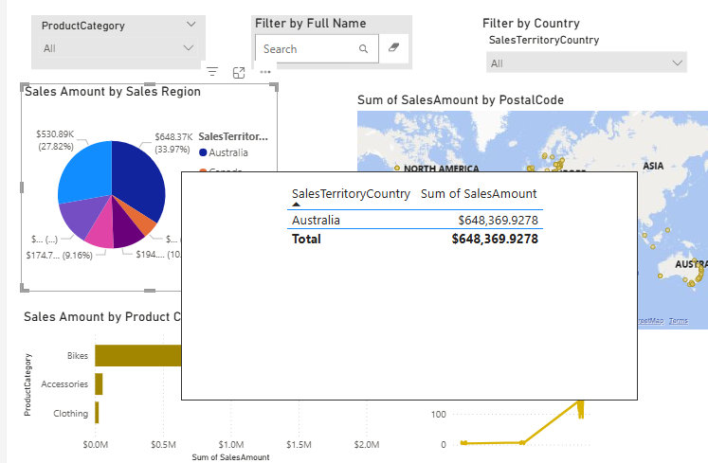

YTD visuals, possibility to switch between MTD, QTD and YTD

So we need use external tools. Install Tabular editor. Then create new table Time inteligence with DAX code for year, quarter, month periods.
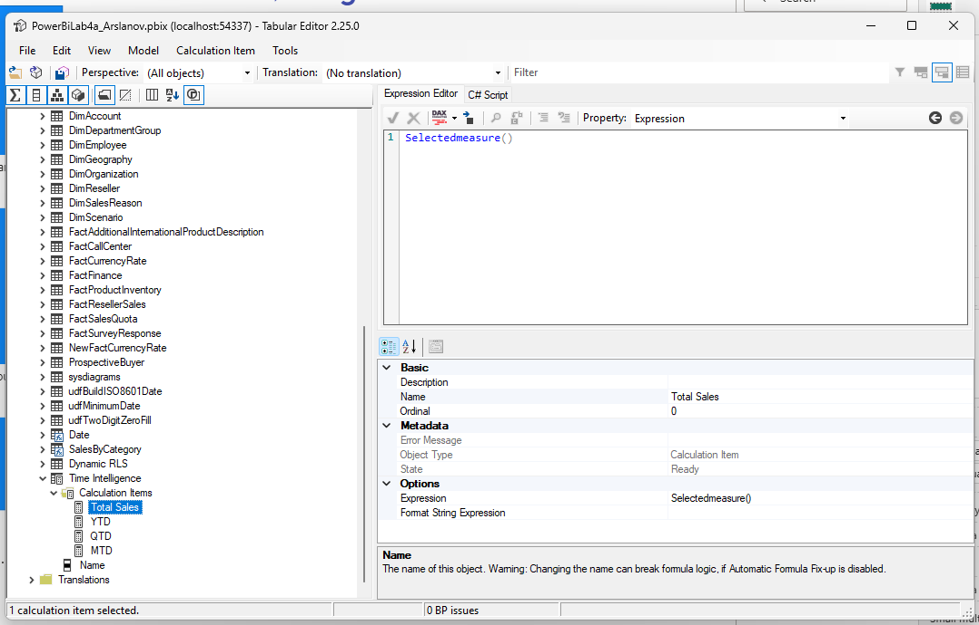
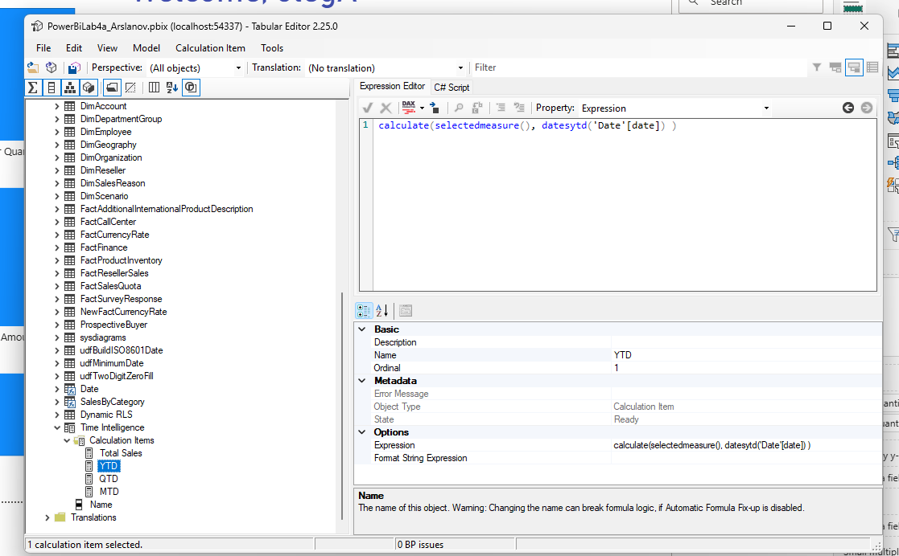

After that we add visual slicer to dashboard and add inside that table … next we need to modify our existing DAX code for YTD visuals, because we use with diferent periods. So in DAX code that need to be used. We use variable created Time intelligence and for return use switch function for different slicers

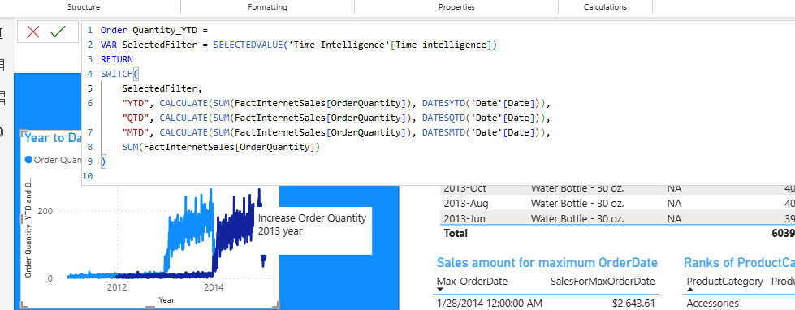

Decomposition tree
