Power BI Final Project

Company Name: NYC Taxi Analytics
Industry: Taxi trip analytics in New York City (based on DWH data)

Business Process Being Analyzed
This report analyzes taxi trips based on various parameters:
- Number of trips at different times of the day
- Average trip cost
- Average trip durability
- Number of passengers at different times

Purpose of the Report
Help taxi companies and customers analyze and optimize trips.

Key questions answered by the report:
- What are the busiest days and hours for taxi trips?
- What is the average trip fare, and how does it change over time?
- What is the average trip distance and duration?

Who Will Use the Report?
Taxi company managers → Analyzing demand and workload
Financial analysts → Revenue and fare analysis
Marketing teams → Measuring the impact of promo codes

Firstly I connect my PostgreSql to PowerBi. I choose import, because our data static and we download data one time to our PowerBi. And it best for speed
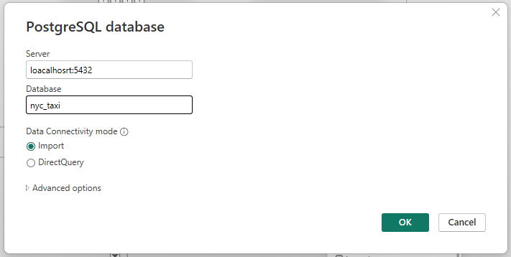

I download only Star schema for quickly (less join) analysis.
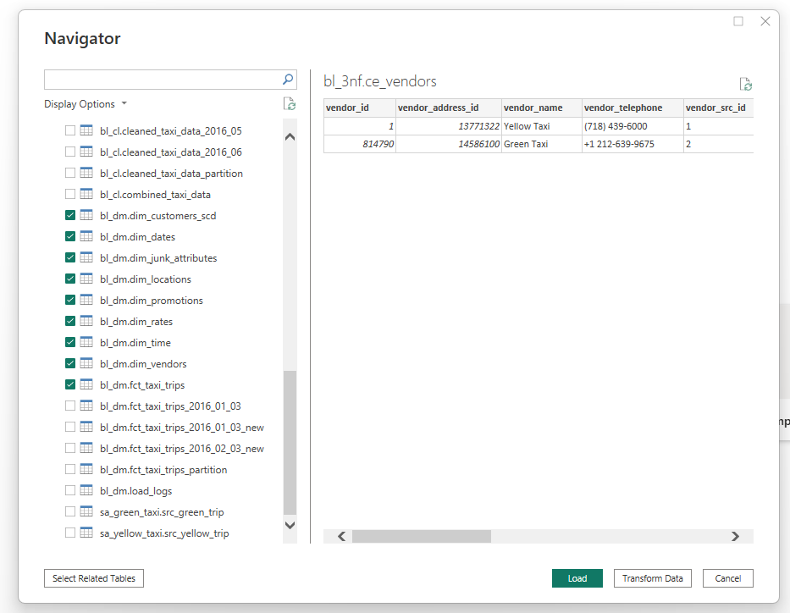
Then I see that relationships imported not ok, because we don’t have physical realtionships In DWH DIM schema (relationships are logical). So I need to make all relationships.
In PowerBi must be one active conection. So for tables Date, Time and location we need made non active connections for powerBi can use multiple relations and use calculate → userelationship (for temporarary connect relationships)
I connect date/time tables with central table with non active realtions and create measures with USERELATIONSHIP functions (example: from date_sur_id → pickup_date_id) . Same with location table. Others dimension tables I connected with relationkeys with active relationship 1 to many

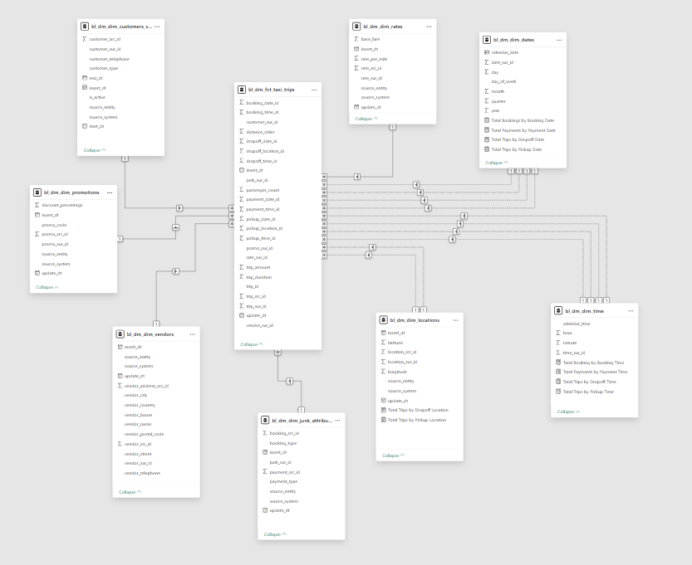

Prepare Dates table for using like Time intelligence for use with YTD, MTD, QTD time periods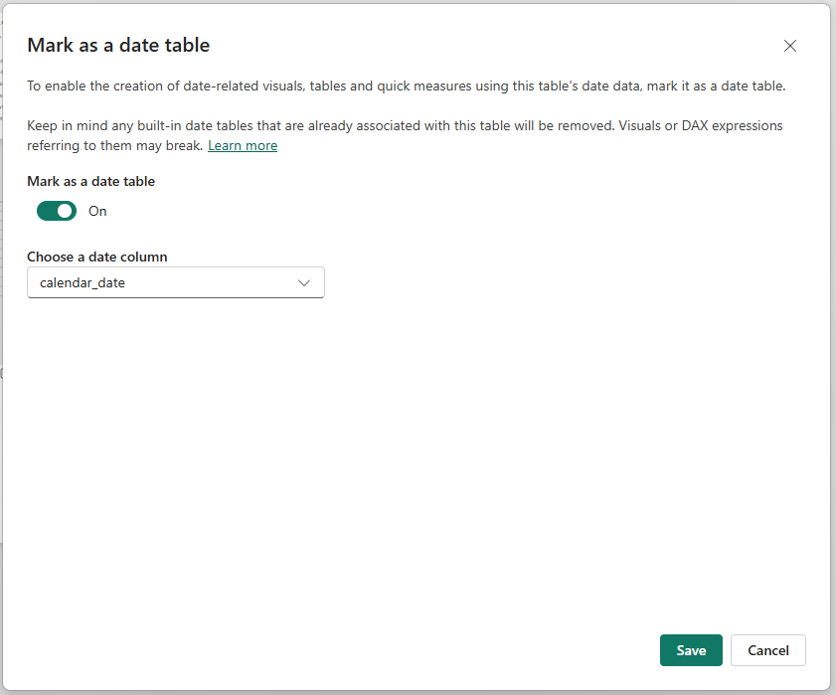

Create calculated column for categories of 24H
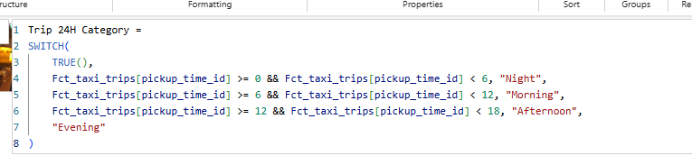

Next I need Clean and Transform data.
I replaced null values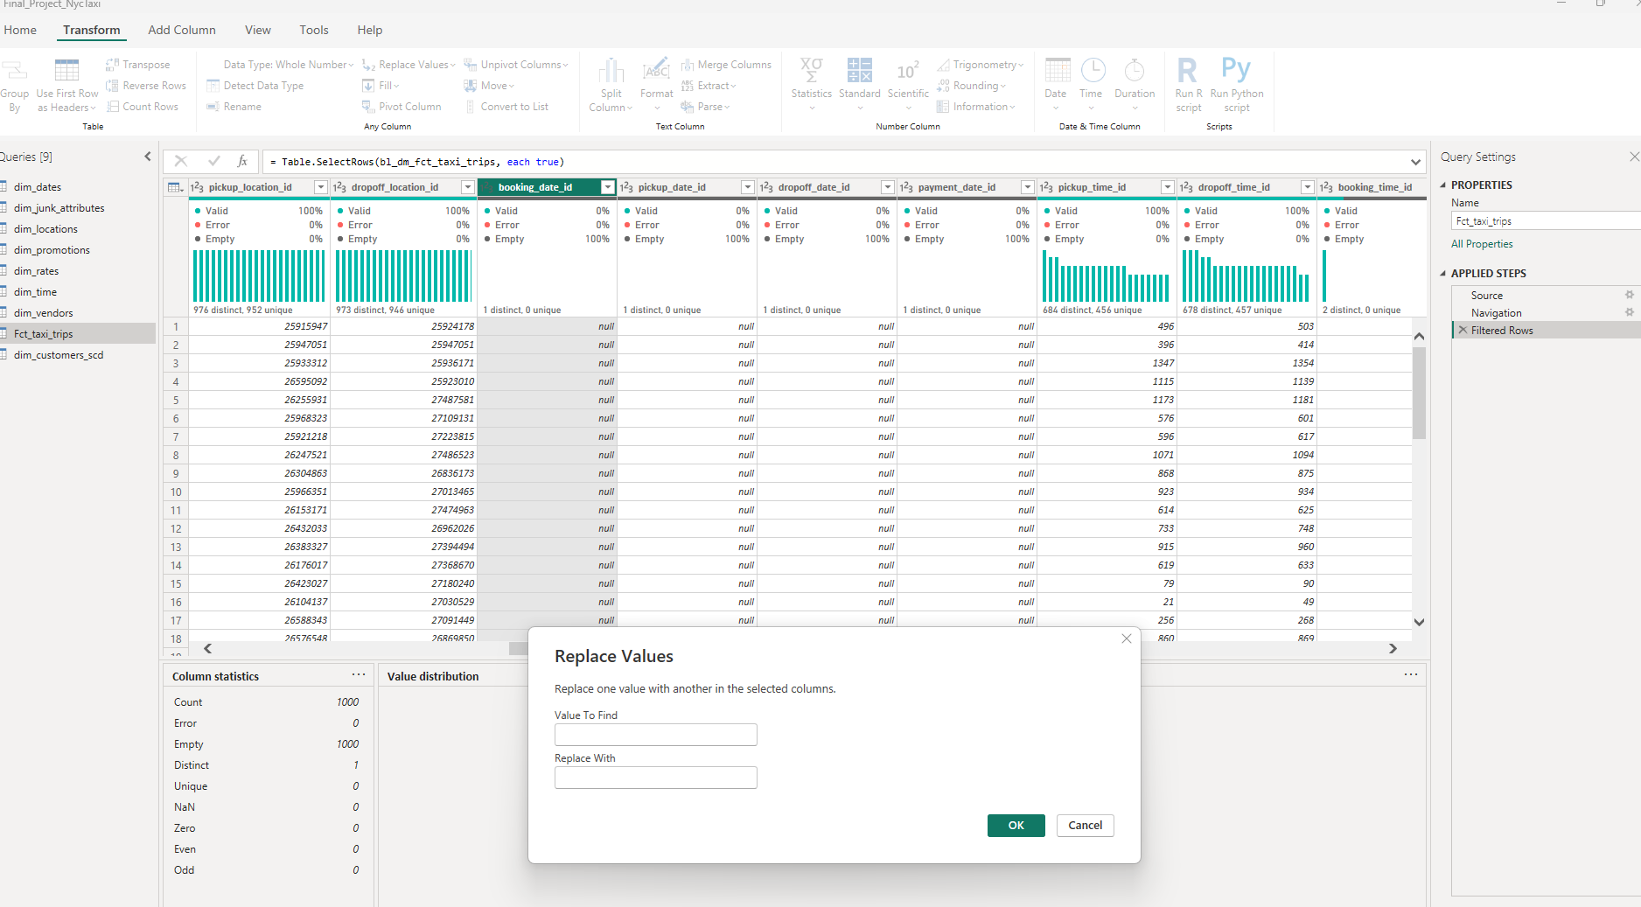

Dashboard

I use here Slicer it use dim_dates[calendar_date]. In that column I have dates from 2010-2030 so it not comfortable to use so I made filter for dates that I got data from DWH. I use on this page filter from between 01/01/2016 and 30/06/2016

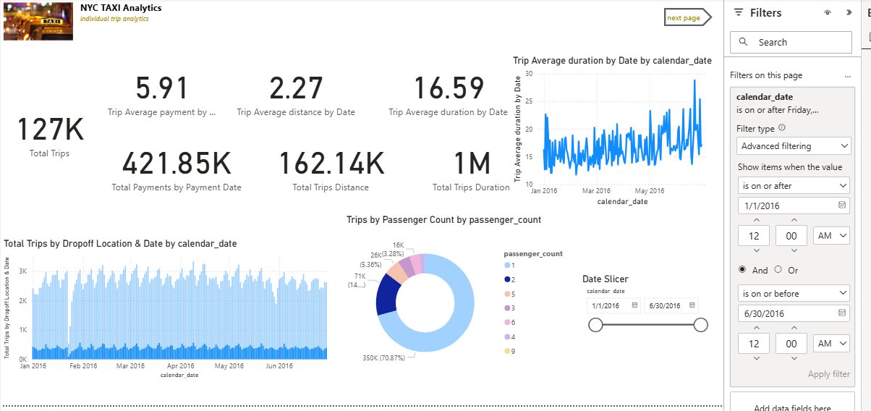

I made extended tooltips like 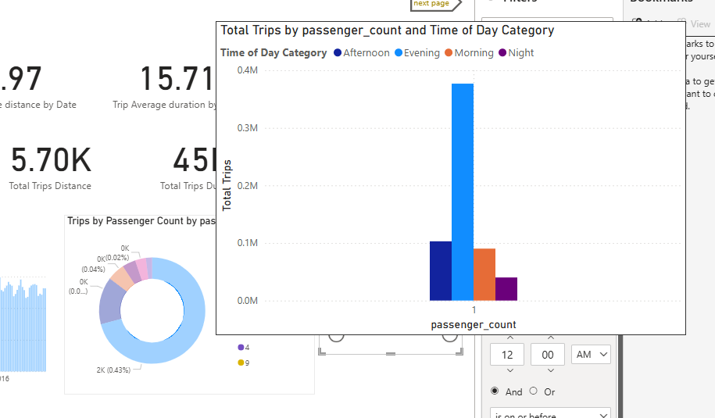

Trip Analysis page

I made here Drill through functionality. For that I made additional page “Drill through” with NYC Borough
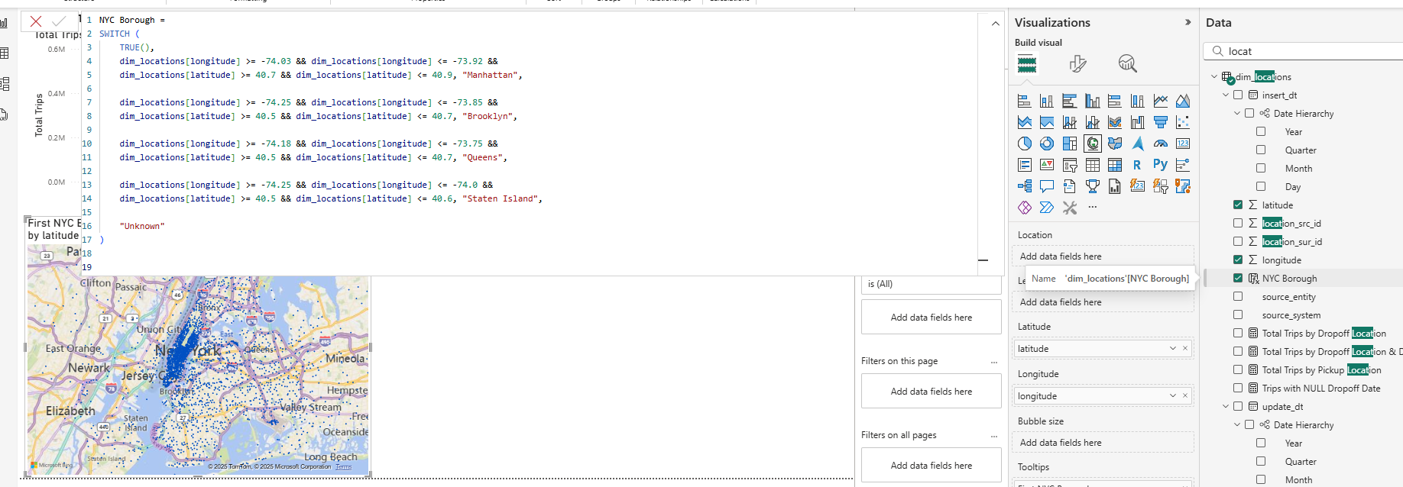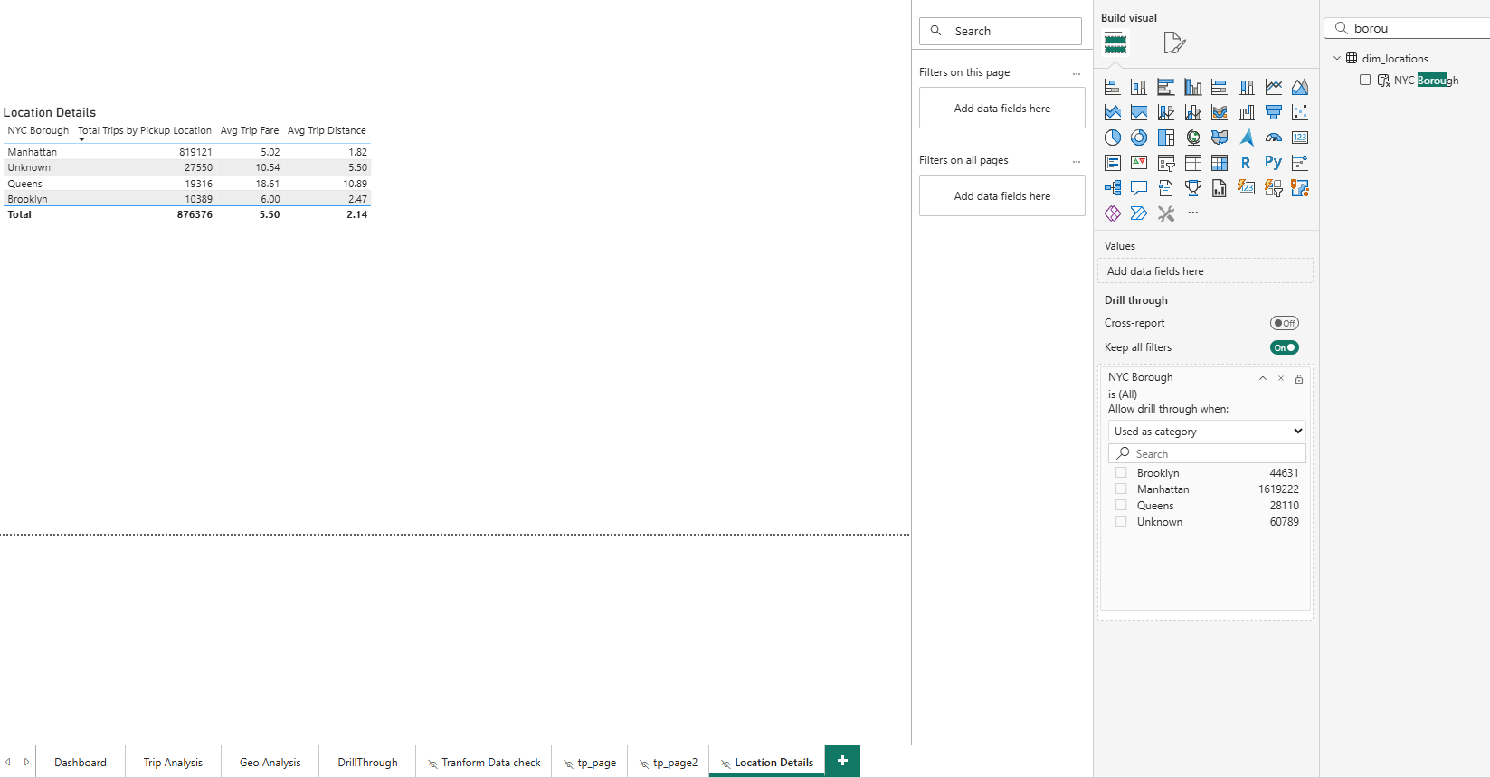
And I can use detalization with data like (in visuals):
- Total Trips by Pickup Location
- Avg Trip Fare
- Avg Trip distance
- NYC Borough

Map Visual
I made map with dropoff longitude and latitude and standart tooltip with reference to average distance by date and average duration by date
I Create new page with visual Table and add Drill through calculated column NYC Borough
So when I choose point of Manhatan I can see additional info in Drill through table.
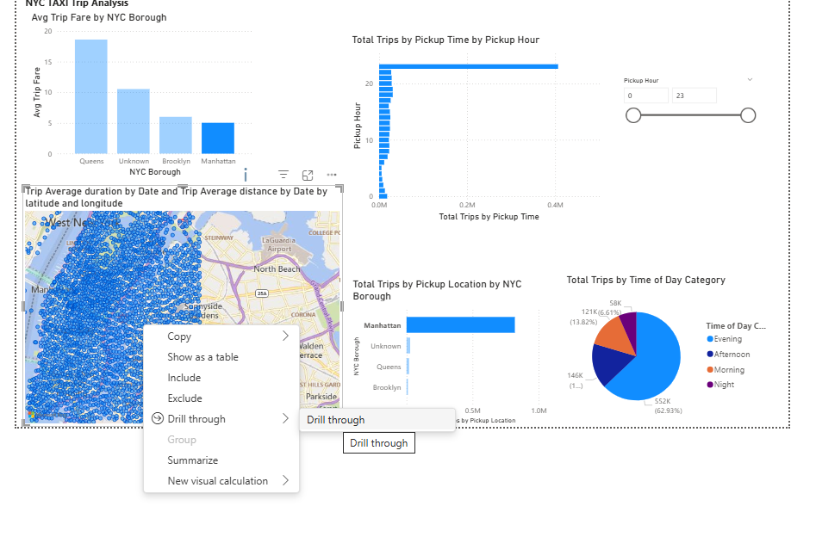
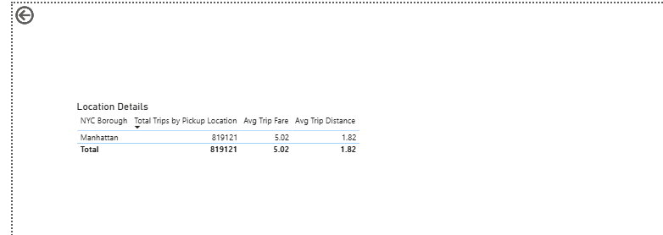

Matrix
I use Bookmarks here and buttons for comfort usage

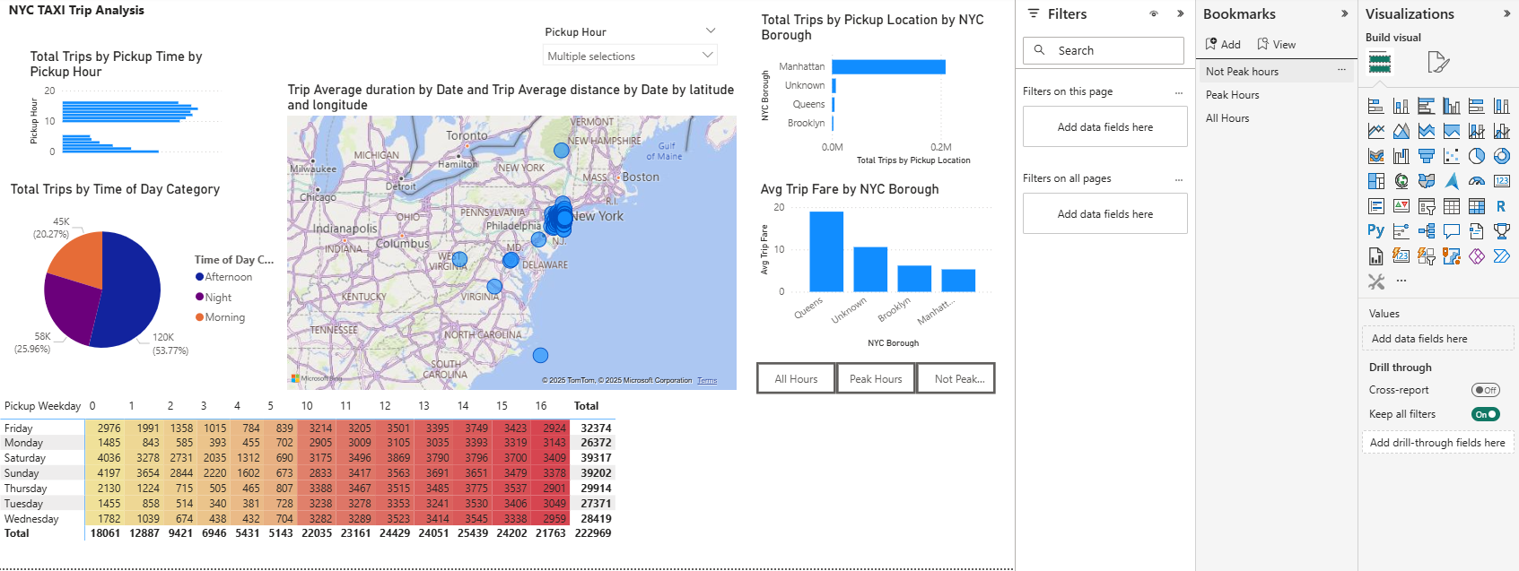

On that page I add plus slicer, another visuals and additional tooltips.

PowerBi service
Firstly I publish to PowerBi service
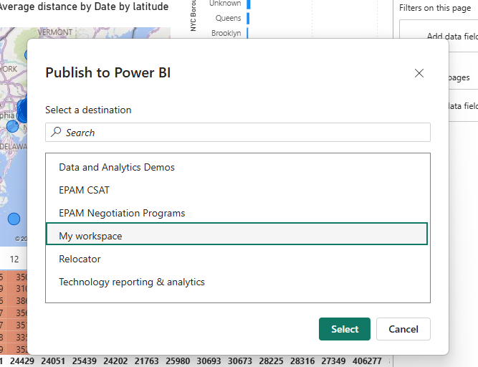

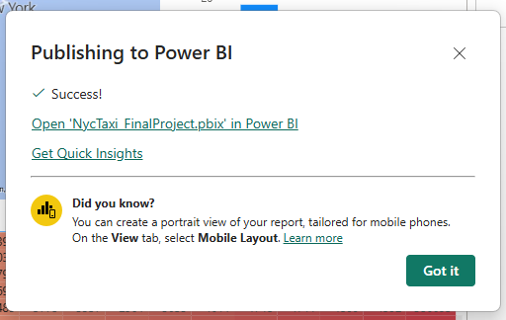

Good luck 😊

