TASK 1: NESTED LOOP JOIN

- Create test tables and populate them with test data:

So before I run explain analyze … Planner choose Hash Join. By Planner it is best way to join. Execution time: 3.361 ms
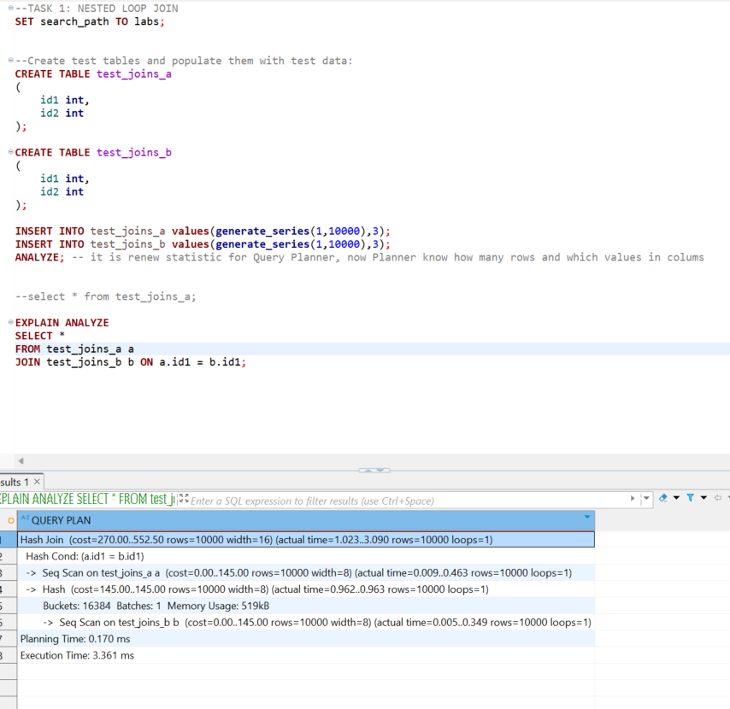

Now I use Nested loop join and time is rised. 8056.956 ms (when I used merge_join time is 4990 ms) .. so planner make good choise and used hash join, quickest way to join this tables
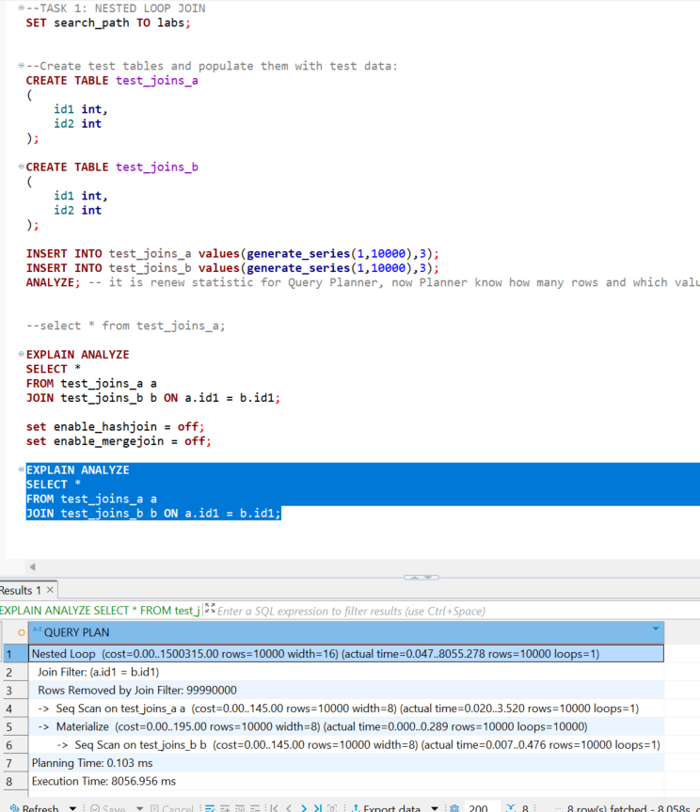

2. Check how NESTED LOOP JOIN method is used in below queries. Why?

Here planner can not use hash because Hash Join working only with =. Merge join asked for ordered values and there is no index …. So it used nestloop, but it is not effective …. Because it not have index and it always be seq scan(all rows must scan)
SELECT *
FROM test_joins_a a, test_joins_b b
WHERE a.id1 > b.id1;
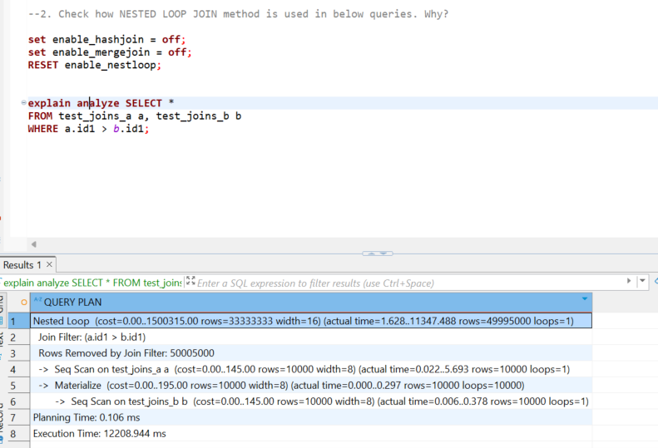

Here planner can not use hash. Can use merge join ………………..it used nestloop.

SELECT *
FROM test_joins_a a
CROSS JOIN test_joins_b b;
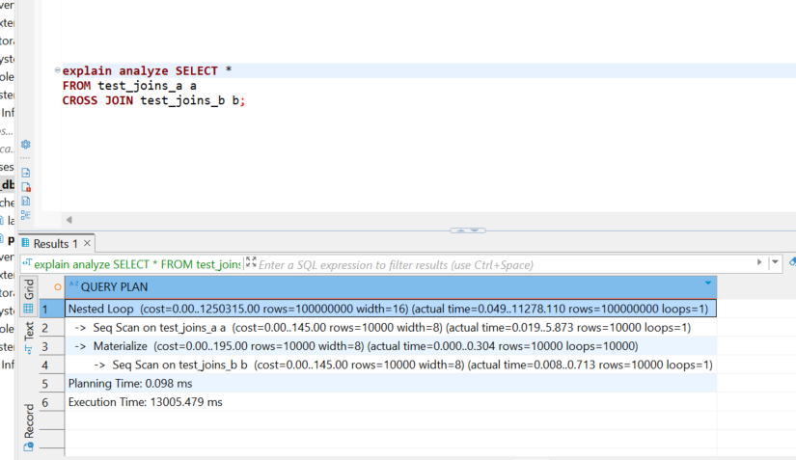

TASK 2: HASH JOIN
--1. Rewrite SELECT to instruct the planner to use HASH JOIN method:
--explain analyze SELECT * FROM test_joins_a a, test_joins_b b
--WHERE a.id1 > b.id1;

explain analyze SELECT *
FROM test_joins_a a
JOIN test_joins_b b
ON a.id1 = b.id1
WHERE a.id1 > b.id1;

So we can use hash when we have ‘=’ and where with > no problem in sorting, because it is another operation. Execution time 3.232 ms.
When I set hashjoin to off then planner use merge join with execution time 6.643 ms
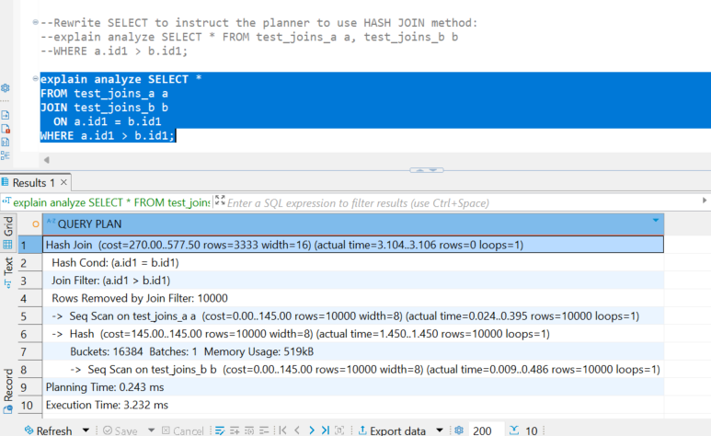

- Create query with SEMI JOIN between tables to get HASH SEMI JOIN in the plan.

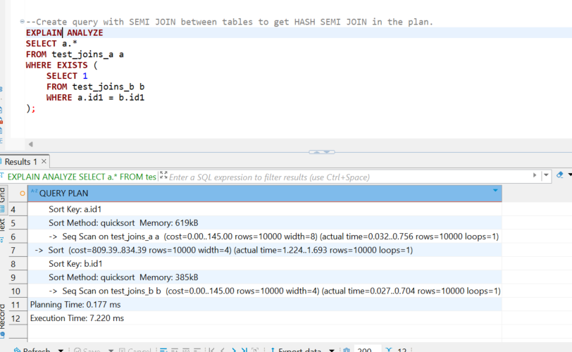

- Set enable_hashjoin to off and recheck plan. Switch on enable_hashjoin.
So when we hashjoin is off. Then planner used merge semi join
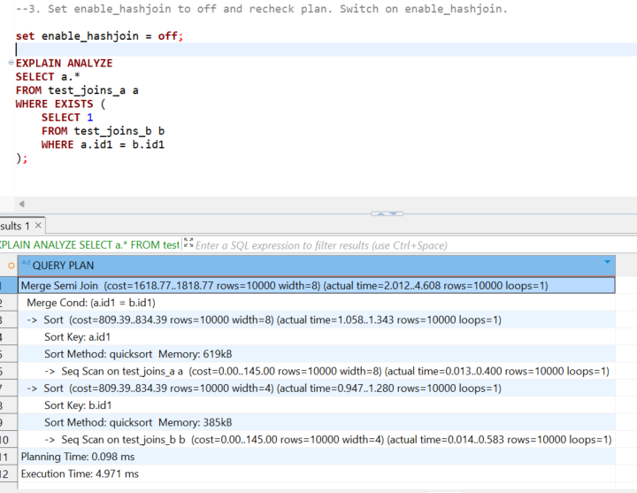
So when enable_hashjoin is on then planner used Hash semi join .Hash semi join there is more effective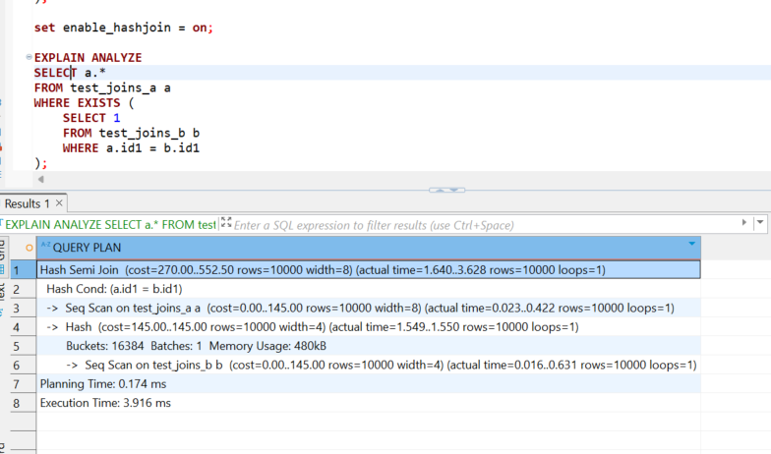
TASK 3: MERGE JOIN
1. Using tables test_joins_a and test_joins_b create a query which is use MERGE JOIN as a join
method. So I use indexes, because order by not enough.
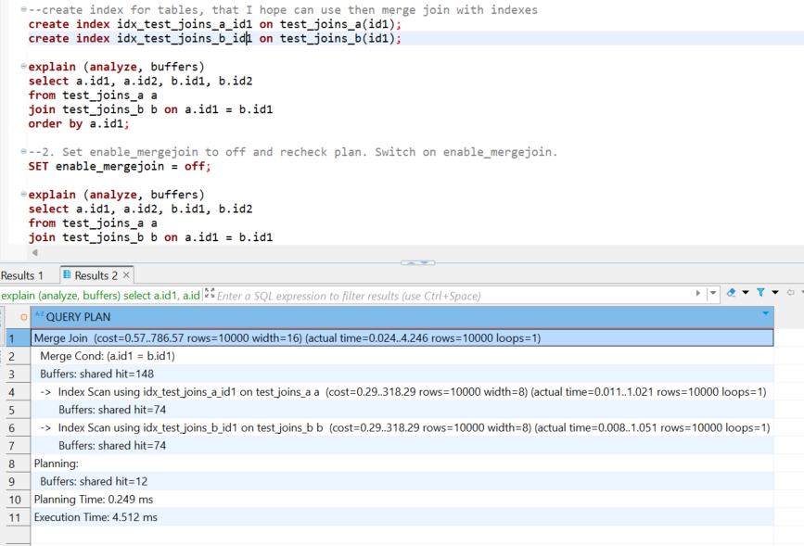

2. Set enable_mergejoin to off and recheck plan. Switch on enable_mergejoin.
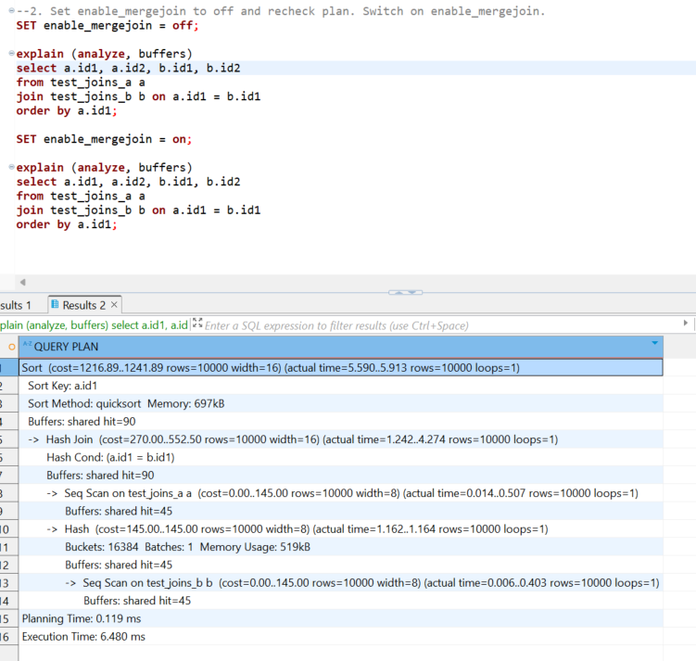
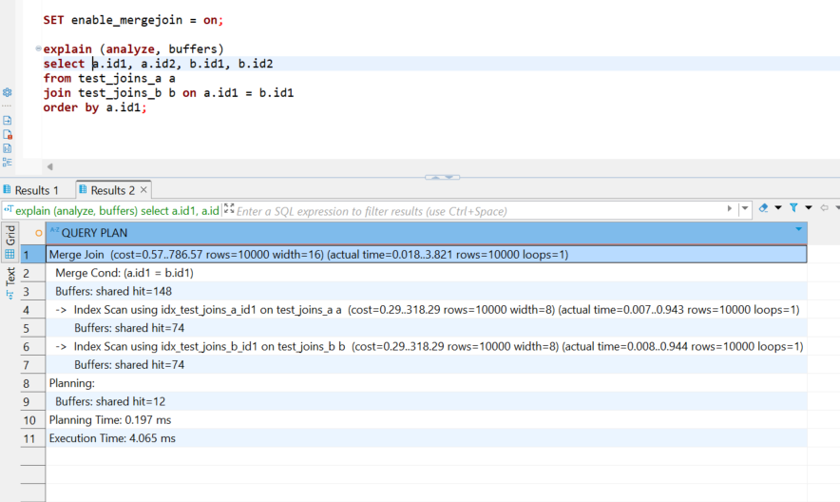
Here when merge join is off planner choose Hashjoin … but when hash join is of planner choose merge join method.

TASK 4: CHANGING JOIN ORDER
Check the plan. Describe the order of tables joining:
So firstly we have join a and b tables on b.id1 = a.id1. But we have id1 indentic in both tables so we have table with all values from a and b. Then we add to this table left join that means that all rows from previos table will be in new table and when we have same c.id1 = b.id1 then we add c.id1 and c.id2 to this row… we have here that all id1 same so we have no NULLs. (I remove from select c.id2 for see all table .. You can see on picture)
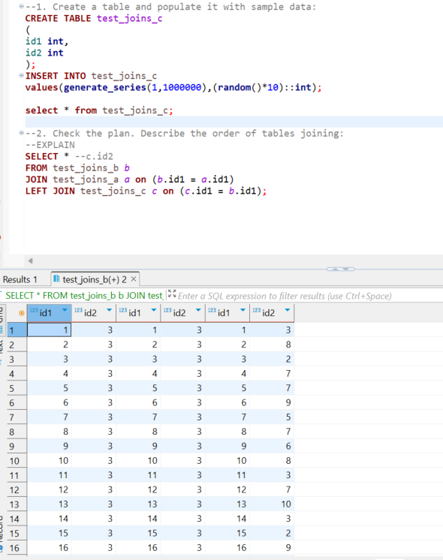

When we use join_collapse_limit = 1. So we don’t do nothing … joining tables like in query
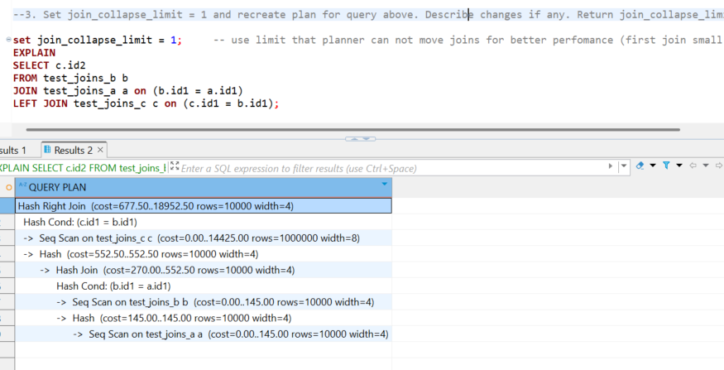

When use join_collapse_limit =8 … I think there will be better performance if we have another a,b =10000 and c = 1000000 . o in wquery we firstly join small tables and only then left join big one. So we don’t need actualy change joinings 😊 ha ha I got it 😊
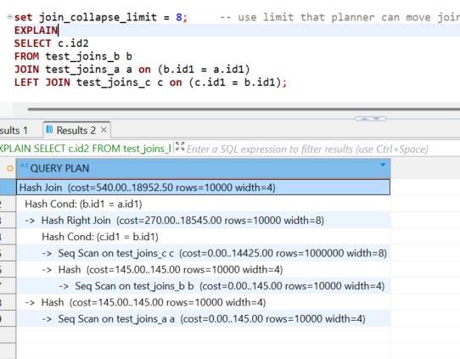

TASK 5: LATERAL JOIN
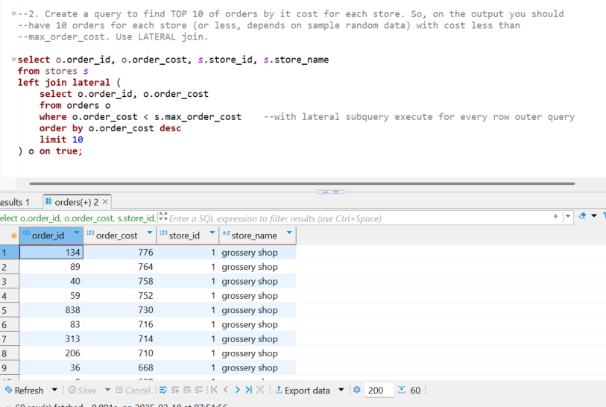

TASK 6: RECURSIVE CTE
Recursive automatically continue working with ‘recursive’ and ‘union all’ reserved words. Building CTE temporary table. Recursive go deep until no rows to add.
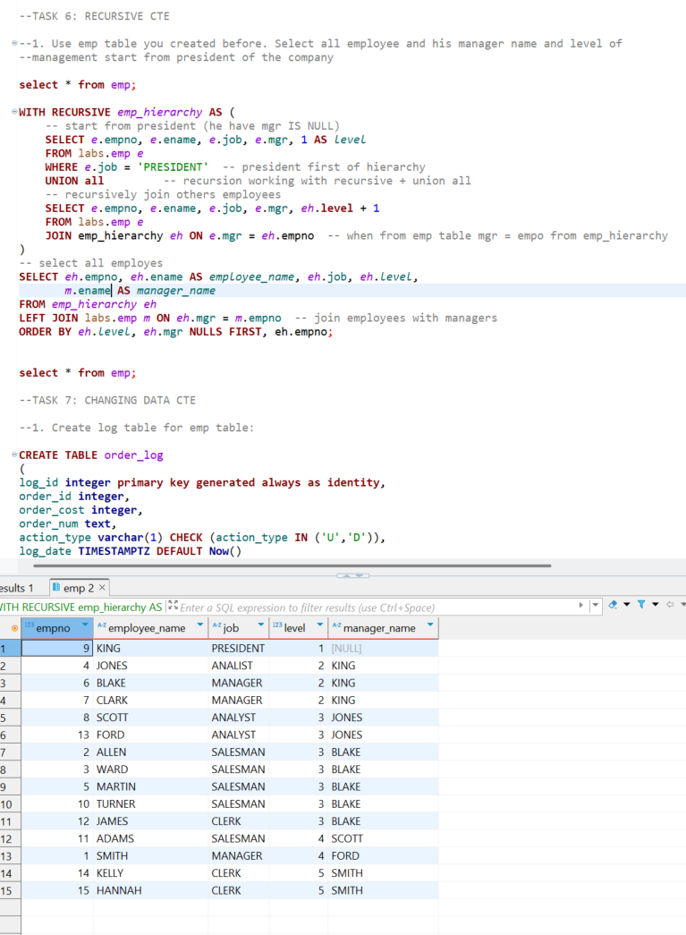

TASK 7: CHANGING DATA CTE

With CTE update and delete orders and from main insert into order_log using union all
