NYC taxi trip



Contents
1 Business Description 3
1.1 Business background 3
1.2 Problems because of poor data management 3
1.3 Benefits from implementing a Data Warehouse 3
1.4 DATASETS DESCRIPTION 3
1.5 GRAIN / DIM / FACT 4
2 Business Layer 3NF 4
2.1 Definitions & Acronyms 3
2.2 Logical Scheme 3
2.3 Objects 3
3 Business Layer Dimensional Model 4
2.1 Logical Scheme 3
2.2 Metrics description 3

4 Logical Scheme 4
5 Data Flow 4
6 Fact Table Partitioning Strategy 4

Business Description

Business background
Taxis are a vital part of the transportation infrastructure in any large city, including New York. In this industry, there are many operators offering taxi services for various types of trips, from short city rides to long trips to airports. Competition in this sector is high, so successful companies must effectively manage their data to improve service and meet customer needs.

Problems because of poor data management
Poor data management hampers effective business operations due to insufficient information for decision-making. Without using data analysis tools, companies cannot develop a strategy focused on customer needs and operational optimization. This can lead to decreased market competitiveness and lower quality of services provided.

Benefits from implementing a Data Warehouse
Implementing a data warehouse can help solve the described problems and answer the following questions:
- What times of day are most in demand for taxi rides?
- Which areas of the city (by longitude and latitude) are most frequently served?
- How does demand for taxis change depending on the day of the week or month?
- Which types of trips (business, private) are more popular?

DATASETS DESCRIPTION

In the dataset, Yellow Taxi is only associated with the Street method, so it will not have a booking_type column but can be inferred by the method of booking. Booking type hierarchical structure can be useful for understanding the relationship between taxi types and booking methods.
Booking Type:
This represents the type of taxi service.
- Values: Green Taxi (Yellow Taxi is only available through the Street method).
- Description: The category of taxi associated with the booking. In this case, Yellow Taxi is always associated with street bookings, while Green Taxi can have multiple booking methods.

Booking Method (Subcategory):
This indicates the method or channel used to book the taxi.
- Values: Street, Phone.
- Description: The specific booking method used for each taxi type. For instance, booking via the street or through a phone call.

Example Hierarchy:
Booking Type = Yellow Taxi
- Street — Booking made through the street (Yellow Taxi can only be booked this way).

Booking Type = Green Taxi
- Street — Booking made through the street.
- Phone — Booking made through a phone call.

Datasets:
The First Dataset: Yellow Taxi Data (SRC_GREEN_TAXI_DATA.csv)

Information about Yellow Taxi trips:

- Vendor Information:
vendor_src_id: unique identifier
vendor_name: Vendor name
street: Vendor street, part of the vendor’s address
house: Vendor house, part of the vendor’s address
city: Vendor city, part of the vendor’s address
house: Vendor house, part of the vendor’s address
postal_code: Vendor postal code, part of the vendor’s address
vendor_telephone: Vendor telephone

- Payment Information:
payment_src_id: unique identifier
payment_type: card or cash
payment_time: payment time

- Rate Information:
rate_src_id: unique identifier
base_fare: base fare
rate_per_mile: rate per mile

- Trip Information:
trip_src_id: unique identifier
pickup_longitude: pickup longitude
pickup_latitude: pickup latitude
dropoff_longitude: dropoff longitude
dropoff_latitude: dropoff latitude
pickup_datetime: Pickup date and time
dropoff_datetime: Dropoff date and time
passenger_count: Number of passengers
distance_miles: distance_miles
trip_duration: trip duration

The Second Dataset: Green Taxi Data (SRC_YELLOW_TAXI_DATA.csv)

Information about Green Taxi trips:

- Vendor Information:
vendor_src_id: unique identifier
vendor: Vendor name
street: Vendor street, part of the vendor’s address
house: Vendor house, part of the vendor’s address
city: Vendor city, part of the vendor’s address
house: Vendor house, part of the vendor’s address
postal_code: Vendor postal code, part of the vendor’s address
vendor_telephone: Vendor telephone

- Customer Information:
customer_src_id: unique identifier
customer_type: individual, or business
customer telephone: telephone number used to place the ordrer

- Booking Information:
booking_src_id: unique identifier
booking_type: phone, or street
booking_datetime: booking time

- Payment Information:
payment_src_id: unique identifier
payment_type: card or cash

- Rate Information:
rate_src_id: unique identifier
base_fare: base fare
rate_per_mile: rate per mile

- Promotion Information:
promo_src_id: unique identifier
promo code: promo code
discount_percentage: 10%, 20%, none

- Trip Information:
trip_src_id: unique identifier
pickup_datetime: Pickup date and time
dropoff_datetime: Dropoff date and time
passenger_count: Number of passengers
trip_duration: Duration of the trip
pickup_longitude: Pickup longitude
pickup_latitude: Pickup latitude
dropoff_longitude: Dropoff longitude
dropoff_latitude: Dropoff latitude

GRAIN / DIM / FACT

Grain
Each record represents one taxi trip. This will be the finest level of detail. We will be analyzing this in this assignment.

Dimensions
The granularity of the datasets is defined at the level of individual trips. Each row in the fact table represents one taxi trip: vendor_id, customer_id, booking_id, payment_id, transmission_id, rate_id, promo_id, trip_id

- DIM_VENDORS
The taxi company transports people from point A to point B

Column name | Description | Data Type
vendor_src_id | unique identifier for vendor | bigint
vendor_name | vendor name | varchar
vendor_street | part of full address | varchar
vendor_house | part of full address | varchar
vendor_city | part of full address | varchar
vendor_country | part of full address | varchar
vendor_postal code | address postal code | varchar
vendor_telephone | telephone number | varchar

vendor_id | vendor_name | street | house | city | country | postal code | vendor_telephone
3 | Green Taxi | Beaver Street | 33 | New York | USA | NY 10004 | +1 212-639-9675
Example with filled data

- DIM_CUSTOMERS
A Customer is a client who can be either an individual or a business.

Column name | Description | Data Type
customer_src_id | unique identifier for customer | bigint
customer_type | Business/Individual | varchar
customer_telephone | telephone number | varchar

customer_id | customer_type | customer_telephone
101 | Business | +1 212-639-9675
1 | Individual | NULL
Example with filled data

- DIM_BOOKINGS
Green Taxi can be ordered from the street and via phone. Yellow Taxi can only be ordered from the street, therefore, the call is only made on the street.

Column name | Description | Data Type
booking_src_id | unique identifier for booking | bigint
booking_type | phone/street | varchar
booking_datetime | booking time | datetime

booking_id | booking_type | booking_datetime
52 | Phone | 3/26/2016 13:18
Example with filled data

- DIM_PAYMENTS
For ride can by paid card or cash

Column name | Description | Data Type
payment_src_id | unique identifier for payment | bigint
payment_type | Card/Cash | varchar
payment_datetime | payment time | datetime

payment_id | payment_type | payment_time
1015 | Card | 6/12/2016 0:57
1158 | Cash | NULL
Example with filled data

- DIM_RATES
Taxi rates base fare plus rate per mile.

Column name | Description | Data Type
rate_src_id | unique identifier for rate | bigint
base_fare | base fare | decimal(10,2)
rate_per_mile | rate per mile | decimal(10,2)

rate_id | base_fare | rate_per_mile
888 | 2.50 | 1.50
Example with filled data

- DIM_PROMOTIONS
Taxi promo codes. With discount: 10%, 20%.

Column name | Description | Data Type
promo_src_id | unique identifier for promotion | int
promo_code | promo code with discount | varchar
discount_percentage | discount percentage | decimal(5,2)

promo_id | promo_code | discount_percentage
666 | Promo10 | 10
Example with filled data

- DIM_TRIP_LOCATIONS
Information about taxi trip locations point A and point B

Column name | Description | Data Type
location_src_id | unique identifier for location | varchar
pickup_longitude | pickup longitude | decimal (10, 6)
pickup_latitude | pickup latitude | decimal (10, 6)
dropoff_longitude | dropoff longitude | decimal (10, 6)
dropoff_latitude | dropoff latitude | decimal (10, 6)
pickup_datetime | pickup datetime | datetime
dropoff_datetime | dropoff datetime | datetime

trip_id | pickup_longitude | pickup_latitude | dropoff_longitude | dropoff_latitude | pickup_datetime | dropoff_datetime
id18133569 | -73.98041534 | 40.73856354 | -73.9994812 | 40.73115158 | 6/12/2016 0:43 | 6/12/2016 0:54
Example with filled data

Facts

- FCT_TAXI_TRIPS
Fact table with references on all dimensional tables (context). Plus measurements: distance, duration (fact table = context + measurements)

Column name | Description | Data Type
vendor_src_id | vendor id (FK) | bigint
customer_id | customer id (FK) | bigint
booking_id | booking id (FK) | bigint
payment_id | payment id (FK) | bigint
rate_id | rate id (FK) | bigint
promo_id | promotion id (FK) | bigint
location_id | location id pickup and dropoff (FK) | bigint
distance_miles | measure; trip distance | decimal(10, 2)
amount | measure; trip amount | decimal(10,2)

Example with filled data
vendor_id | customer_id | booking_id | payment_id | rate_id | promo_id | trip_id | distance_miles | amount
1 | 101 | 5001 | 2001 | 5 | 7001 | 9001 | 12.5 | 25.75

Business Layer 3NF

Definitions & Acronyms
• SQL (Structured Query Language): The standard language used to communicate with and manipulate databases.
• PK (Primary Key): A unique identifier for a record in a table.
• FK (Foreign Key): A field in one table that uniquely identifies a row of another table, creating a relationship between the two tables.
NOT NULL: attribute in a table must have a value.

• PL/pgSQL: A procedural language supported by PostgreSQL that allows for more complex operations and control structures in SQL scripts.
m:m
: Many-to-many relationship in the database, where multiple records from one table can be associated with multiple records from another table.
1:m (m:1)
: One-to-many (many-to-one) relationship in the database, where one record from a table is associated with many records from another table.
1:1
: One-to-one relationship in the database, where one record from a table is associated with one record from another table.
1:0...1
: Indicates an optional one-to-one relationship. In SQL, this means that each record in Table A can be associated with at most one record in Table B, but the association is optional.

Logical Scheme

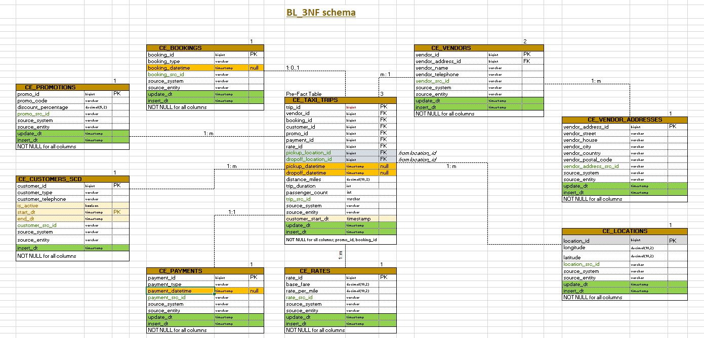

Objects

- CE_VENDORS table description

This table stores information about taxi companies. It also includes metadata for tracking the source of the data and the entity within the source system.

Table Name | Field name | Field Description | Data Type
CE_VENDORS | vendor_id | surrogate key for for each vendor (PK) | bigint
 | vendor_address_id | reference to the vendor record in ce_vendor_addresses (FK) | bigint
 | vendor_name | vendor name | varchar
 | vendor_telephone | vendor telephone number | varchar
 | vendor_src_id | business key of the vendor record from the source system | varchar
 | source_system | system where the data originates from (datasets) | varchar
 | source_entity | entity within the source system | varchar
 | update_dt | date of update data | timestamp
 | insert_dt | date of first insert of data | timestamp

Comments on table relationships:
- CE_VENDORS ↔ CE_TAXI_TRIPS: one-to-many (1:m) relationship;
- CE_VENDORS ↔ CE_VENDOR_ADDRESSES: one-to-many (1:m) relationship.

Additional constraints: NOT NULL for all columns

- CE_VENDOR_ADDRESSES table description

This table stores information about taxi companies. It also includes metadata for tracking the source of the data and the entity within the source system.

Table Name | Field name | Field Description | Data Type
CE_VENDOR_ADDRESSES | vendor_address_id | surrogate key for each vendor address (PK) | bigint
 | vendor_street | vendor street | varchar
 | vendor_house | vendor telephone house | varchar
 | vendor_city | vendor city | varchar
 | vendor_country | vendor country | varchar
 | vendor_postal_code | vendor postal code | varchar
 | vendror_address_src_id | business key of the vendor address record from the source system | varchar
 | source_system | system where the data originates from (datasets) | varchar
 | source_entity | entity within the source system | varchar
 | update_dt | date of update data | timestamp
 | insert_dt | date of first insert of data | timestamp

Comments on table relationships:
- CE_VENDORS ↔ CE_VENDOR_ADDRESSES: one-to-many (1:m) relationship.

Additional constraints: NOT NULL for all columns

- CE_CUSTOMERS_SCD table description

The CE_CUSTOMERS table stores information about customers, including a unique identifier, customer type, number of passengers, and contact details. It also includes metadata for tracking the source of the data and the entity within the source system.

Table Name | Field name | Field Description | Data Type
CE_CUSTOMERS_SCD | customer_id | surrogate key for the customer record (PK) | bigint
 | customer_type | Individual/Business | varchar
 | customer_telephone | customer telephone | varchar
 | is_active | Indicates if the rate is currently active | boolean
 | start_dt | Start date of the rate's validity (SCD Type 2 field) (PK) | timestamp
 | end_dt | End date of the rate's validity (SCD Type 2 field) | timestamp
 | customer_src_id | business key of the customer record from the source system | varchar
 | source_system | system where the data originates from (datasets) | varchar
 | source_entity | entity within the source system | varchar
 | insert_dt | date of first insert of data | timestamp

Comments on table relationships:
- CE_CUSTOMERS ↔ CE_TAXI_TRIPS: one-to-many (1:m) relationship.
Additional constraints: NOT NULL for all columns

- CE_BOOKINGS table description

The CE_BOOKINGS table contains information about customer bookings, including a unique identifier, associated customer, trip, rate and promo IDs, booking type, and the time of booking. It also tracks the source of the data and the entity within the source system.

Table Name | Field name | Field Description | Data Type
CE_BOOKINGS | booking_id | surrogate key for each booking (PK) | bigint
 | booking_type | business key of the booking record from the source system (natural key) | varchar
 | booking_datetime | booking time | timestamp
 | booking_src_id | business key of the booking record from the source system | varchar
 | source_system | system where the data originates from (datasets) | varchar
 | source_entity | entity within the source system | varchar
 | update_dt | date of update data | timestamp
 | insert_dt | date of first insert of data | timestamp

Comments on table relationships:
- CE_BOOKINGS ↔ CE_TAXI_TRIPS: many-to-one (m:1) relationship.
Additional constraints: NOT NULL for all columns

- CE_PAYMENTS table description

The CE_PAYMENTS table stores information about payments made for bookings, including a unique payment identifier, the booking ID it relates to, payment type, and the time of payment. It also includes metadata for tracking the source of the data and the entity within the source system.

Table Name | Field name | Field Description | Data Type
CE_PAYMENTS | payment_id | surrogate key for each payment (PK) | bigint
 | payment_type | payment type | varchar
 | payment_datetime | payment time | timestamp
 | payment_src_id | business key of the payment record from the source system | varchar
 | source_system | system where the data originates from (datasets) | varchar
 | source_entity | entity within the source system | varchar
 | update_dt | date of update data | timestamp
 | insert_dt | date of first insert of data | timestamp

Comments on table relationships:
- CE_TAXI_TRIPS ↔ CE_PAYMENTS: one-to-one (1: 1) relationship.
Additional constraints: NOT NULL for all columns

- CE_RATES table description

The CE_RATES table stores pricing information for taxi trips, including base fare, per-mile rates.

Table Name | Field name | Field Description | Data Type
CE_RATES | rate_id | surrogate key for each rate (PK) | bigint
 | base_fare | base fare for the transportation service | decimal(10,2)
 | rate_per_mile | Rate per mile for the transportation service | decimal(10,2)
 | rate_src_id | business key of the rate record from the source system | varchar
 | source_system | system where the data originates from (datasets) | varchar
 | source_entity | entity within the source system | varchar
 | update_dt | date of update data | timestamp
 | insert_dt | date of first insert of data | timestamp

Comments on table relationships:
• CE_TAXI_TRIPS ↔ CE_RATES_SCD: many-to-one (m:1) relationship.

Additional constraints: NOT NULL for all columns

- CE_PROMOTIONS table description

This table stores promotional information related to transportation services. It tracks active and past promotions, including the promotional code, the discount offered, and metadata about the source system from which the data originates.

Table Name | Field name | Field Description | Data Type
CE_PROMOTIONS | promo_id | surrogate key for each promotion (PK) | bigint
 | promo_code | promotion code | varchar
 | discount_percentage | discount percentage | decimal(5,2)
 | promo_src_id | business key of the promo record from the source system | varchar
 | source_system | system where the data originates from (datasets) | varchar
 | source_entity | entity within the source system | varchar
 | update_dt | date of update data | timestamp
 | insert_dt | date of first insert of data | timestamp

Comments on table relationships:
• CE_TAXI_TRIPS ↔ CE_PROMOTIONS: many-to-one (m:1) relationship.
Additional constraints: NOT NULL for all columns

- CE_TAXI_TRIPS table description

This table stores information about individual trips, including geographic data related to pickup and drop-off locations, as well as timestamps for the trip's start and end. It serves as a core component for tracking the details of transportation journeys. It also includes metadata for tracking the source of the data and the entity within the source system.

Table Name | Field name | Field Description | Data Type
CE_TRIPS | trip_id | surrogate key for each trip (PK) | bigint
 | vendor_id | Reference to the vendor record in CE_VENDORS (FK) | bigint
 | booking_id | Reference to the booking record in CE_BOOKING (FK) | bigint
 | customer_id | Reference to the customer record in CE_CUSTOMERS_SCD (FK) | bigint
 | promo_id | promotion id (FK) | bigint
 | payment_id | Reference to the payment record in CE_PAYMENTS (FK) | bigint
 | rate_id | Reference to the rates record in CE_RATES (FK) | bigint
 | pickup_location_id | Foreign key referencing the location_src_id in the CE_LOCATIONS tabl e(FK) | bigint
 | dropoff_location_id | Foreign key referencing the location_src_id in the CE_LOCATIONS table (FK) | bigint
 | pickup_datetime | Date and time when the trip was picked up | timestamp
 | dropoff_datetime | Date and time when the trip was completed (dropped off) | timestamp
 | distance_miles | The total distance traveled during the trip (in miles) | decimal(10,2)
 | trip_duration | Total duration of the trip (in seconds) | int
 | passenger_count | Number of passengers in the trip | int
 | trip_src_id | business key of the trip record from the source system | varchar
 | source_system | system where the data originates from (datasets) | varchar
 | source_entity | entity within the source system | varchar
 | customer_start_dt | reference to customers start_dt | timestamp
 | update_dt | date of update data | timestamp
 | insert_dt | date of first insert of data | timestamp

Comments on table relationships:
- CE_TAXI_TRIPS ↔ CE_VENDORS: many-to-one (m:1) relationship;
- CE_BOOKINGS ↔ CE_TAXI_TRIPS: many-to-one (m:1) relationship;
- CE_PROMOTIONS ↔ CE_TAXI_TRIPS: one-to-one (1:m) relationship;
- CE_TAXI_TRIPS ↔ CE_LOCATIONS: one-to-many (1:m) relationship;
- CE_TAXI_TRIPS ↔ CE_RATES: many-to-one (m:1) relationship;
- CE_TAXI_TRIPS ↔ CE_PAYMENTS: one-to-one (1:1) relationship;
- CE_TAXI_TRIPS ↔ CE_CUSTOMERS_SCD: many-to-one (m:1) relationship.

Additional constraints: NOT NULL for all columns; promo_id and booking_id NULL

- CE_LOCATIONS table description

The CE_LOCATIONS table is a dimension table that stores information about geographical locations, including their coordinates (latitude and longitude) and unique identifiers from various source systems. It is used to standardize location data across different trips, bookings, and vendors.

Table Name | Field name | Field Description | Data Type
CE_LOCATIONS | location_id | Surrogate key for the location, uniquely identifying each record in this table (PK) | bigint
 | longitude | The longitude coordinate of the location | decimal(10,2)
 | latitude | The latitude coordinate of the location | decimal(10,2)
 | location_src_id | The original location identifier from the source system | varchar
 | source_system | The system that provided the location data | varchar
 | source_entity | The specific entity within the source system that generated the location data | varchar
 | update_dt | date of update data | timestamp
 | insert_dt | date of first insert of data | timestamp

Comments on table relationships:
- CE_TAXI_TRIPS ↔ CE_LOCATIONS: one-to-many (1:m) relationship.

Additional constraints: NOT NULL for all columns

Business Layer Dimensional Model

Logical Scheme
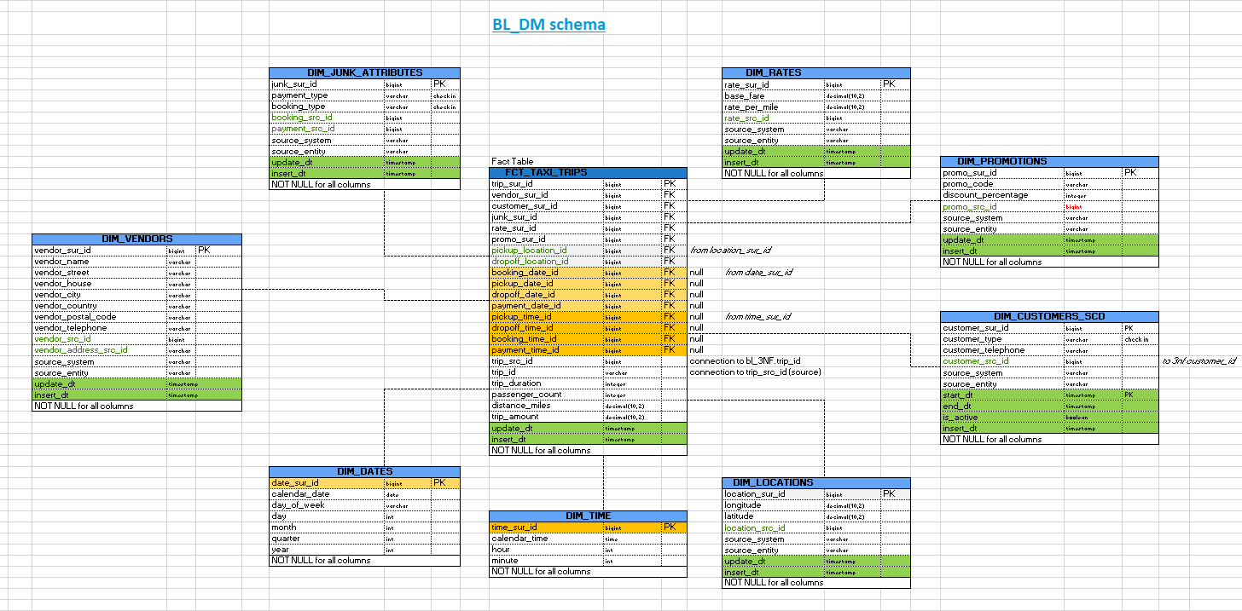

METRICS Description

What Are Metrics in BL_DM?
Metrics are measurable quantitative indicators used for analysis, evaluation, and monitoring of data. In the context of the BL_DM schema, metrics are stored in fact tables and represent numerical or categorical information that helps analyze business data.

Key Properties of Metrics:
Measurable: Metrics are numerical or have fixed categories (e.g., sums, counts, durations).
Aggregation: Metrics can be aggregated using functions like SUM, COUNT, AVG, MAX, MIN.
Stored in Fact Tables: Metrics are typically found in fact tables (e.g., FCT_TAXI_TRIPS) and are linked to dimensions (dimension tables) that provide analytical context.

Metrics in my tables:
1. DIM_JUNK_ATTRIBUTES
This table does not directly contain metrics but holds categorical attributes like payment_type and booking_type that can be used for filtering or grouping data in analytical queries.
2. DIM_RATES
This dimension contains no direct metrics but provides reference values such as:
- base_fare: Base cost for a trip.
- rate_per_mile: Cost per mile traveled.
These attributes are used in calculating metrics in the fact table, such as trip_amount.
3. DIM_PROMOTIONS
No direct metrics in this table. However, discount_percentage is a key attribute used for calculating the final trip cost (trip_amount) in the fact table.
4. DIM_VENDORS
No direct metrics in this table. It contains descriptive data like vendor details, which can be used to analyze vendor-specific metrics in the fact table.
5. DIM_CUSTOMERS_SCD
This table does not store metrics. It is primarily used for tracking customer attributes (e.g., type, telephone) and managing historical data with start_dt and end_dt.
6. DIM_DATES
Contains no direct metrics. It is a date reference table used to connect and analyze metrics in the fact table by day, month, quarter, or year.
7. DIM_TIME
Contains no direct metrics. It is a time reference table used to analyze time-related metrics in the fact table, such as trip_duration.
8. DIM_LOCATIONS
Contains no direct metrics. It provides reference information for trip pickup and dropoff locations.

9. FCT_TAXI_TRIPS (Fact Table)
This is the primary table containing metrics for analysis. Metrics include:
- trip_duration: Duration of the trip (in minutes).
- passenger_count: Number of passengers for the trip.
- distance_miles: Distance covered during the trip (in miles).
- trip_amount: Total cost of the trip (calculated using base fare, rate per mile, and any promotions).
The fact table is linked to the dimension tables to enable multidimensional analysis of these metrics.
Metrics in BL_DM are primarily stored in the fact table (FCT_TAXI_TRIPS).
Dimension tables do not directly store metrics but provide descriptive or categorical data that enrich and contextualize the metrics in the fact table.
Metrics such as trip_duration, trip_amount, and distance_miles are the primary values analyzed for insights, using the dimensions for filtering and aggregation.
These metrics cover the various elements of a taxi trip, such as rates, vendors, customers, locations, time and promotions. The main fact table (FCT_TAXI_TRIPS) will likely be used to store transactional data about each trip.

Logical Scheme

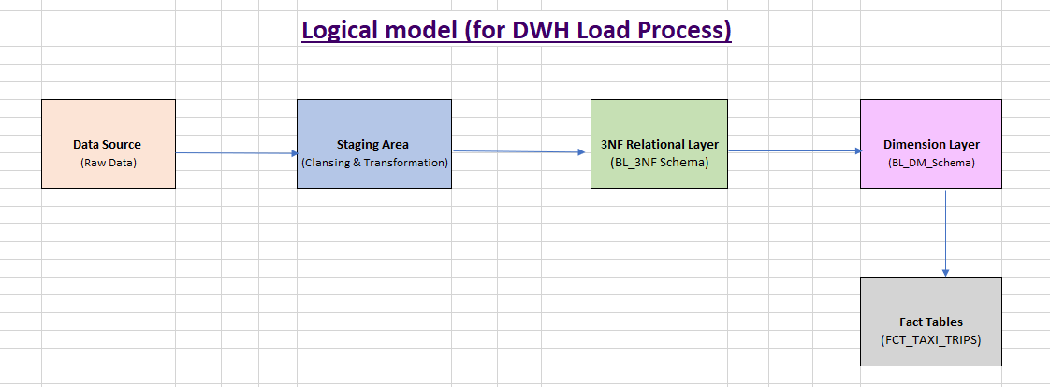

Data Flow

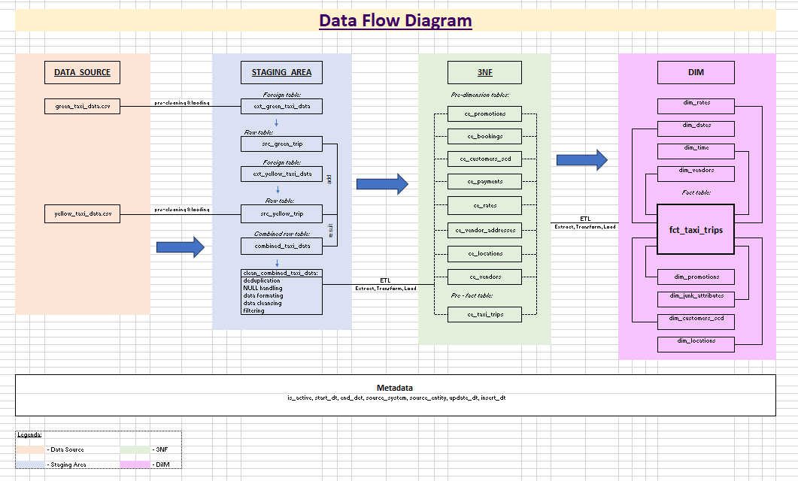

Fact Table Partitioning Strategy

For our taxi data warehouse solution, we partition the fact table by month. We split the cleaned_taxi_data into 6 partitions, one for each month, and then perform the full load in 6 separate transactions. By processing each month separately, we significantly reduce the data volume per transaction, which improves the overall performance and speeds up the load process.
In addition, we use temporary tables for our pre-dimension (staging) tables, which simplifies the data transformation and ensures a cleaner load into the fact table. We also create indexes on the columns used in our JOIN conditions and WHERE clauses to further optimize data retrieval during the ETL process.
When we load data in smaller batches rather than in one huge transaction, the system only needs to process a limited amount of data at a time. This approach helps reduce memory usage and minimizes lock contention, which in turn prevents the system from getting overwhelmed and hanging. Additionally, if any error occurs, only a small portion of the data is affected, making error recovery much easier and more efficient.
This approach not only makes the loading process faster and more manageable but also improves scalability and maintainability of our data warehouse solution.
+--------------------------+
| Cleaned Taxi Data |
+--------------------------+
|
| Split by Month
v
+---------+ +---------+ +---------+ ... +---------+
| Partition| | Partition| | Partition| | Partition|
| Jan 2016 | | Feb 2016 | | Mar 2016 | | Jun 2016 |
+---------+ +---------+ +---------+ +---------+
| | | |
| Batch | Batch | Batch | Batch
| Load | Load | Load | Load
| (separate transactions with COMMIT after each batch)
v v v v
+------------------------------------------------------------------------+
| Fact Table: ce_taxi_trips (partitioned by month) |
+------------------------------------------------------------------------+

