

|  |
| --- |
| , RD Dep.  **installation instructions** |
|  |

# installation process

Depending on your system, select the required version and install the following programs *:

## [7-zip](https://www.7-zip.org/download.html) (optional)

## [Notepad++](https://notepad-plus-plus.org/downloads/v7.8.4/) (optional)

*example for 64-bit OS*

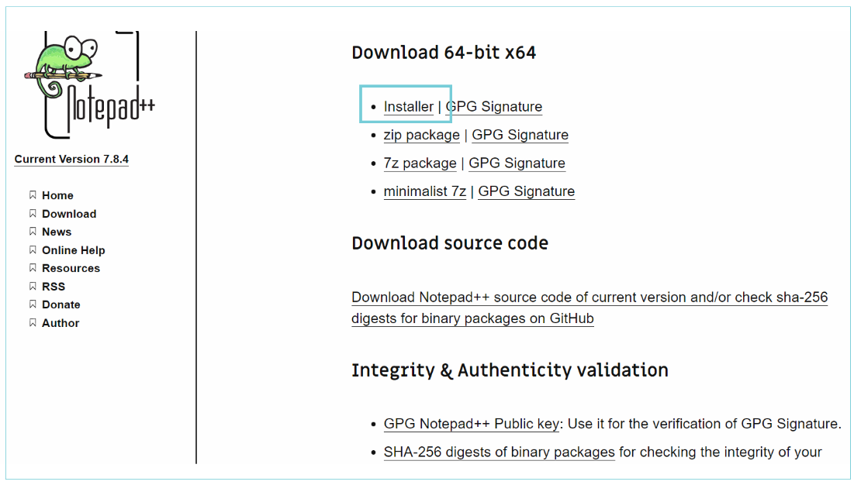

## [PostgreSQL](https://www.postgresql.org/download/)

Choose the installer (all steps will be the same for Windows and Mac)

The steps below show the installation for Windows (if you have Mac – please choose macOS)

***example for windows, 64-bit OS***

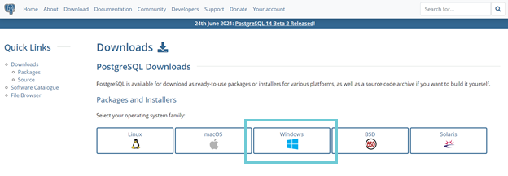

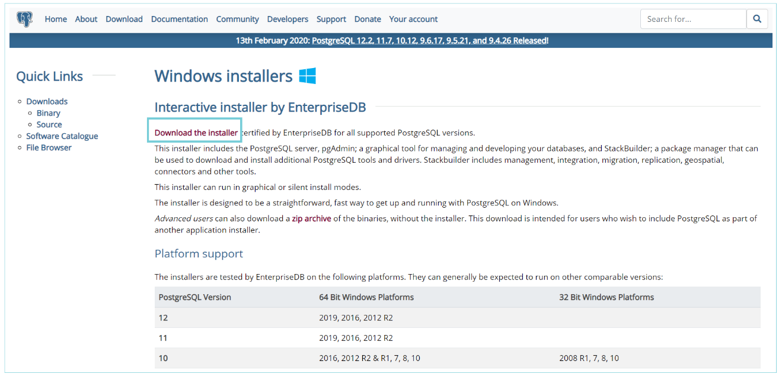

**Select last available version (not beta)**

Start installation (instead of 14 - **you will see your version**)

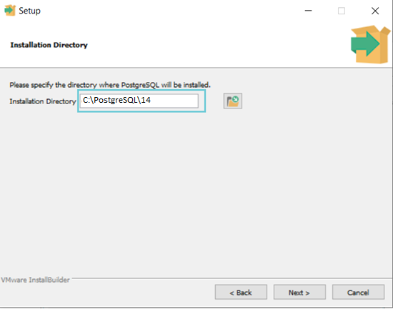

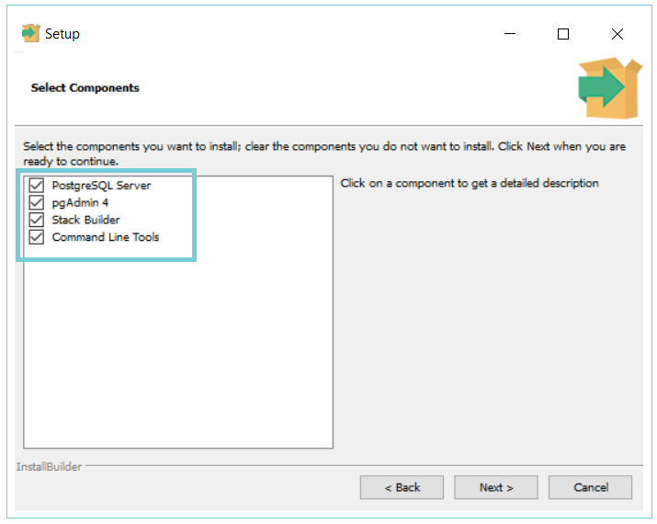

Select directory when you have **enough** **space**

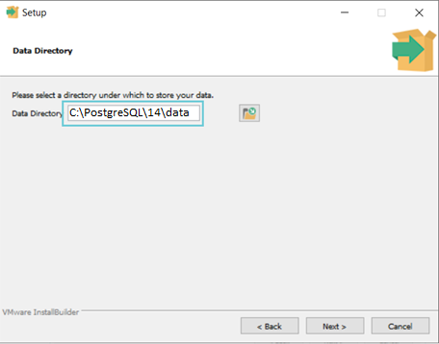

Create a password for the superuser

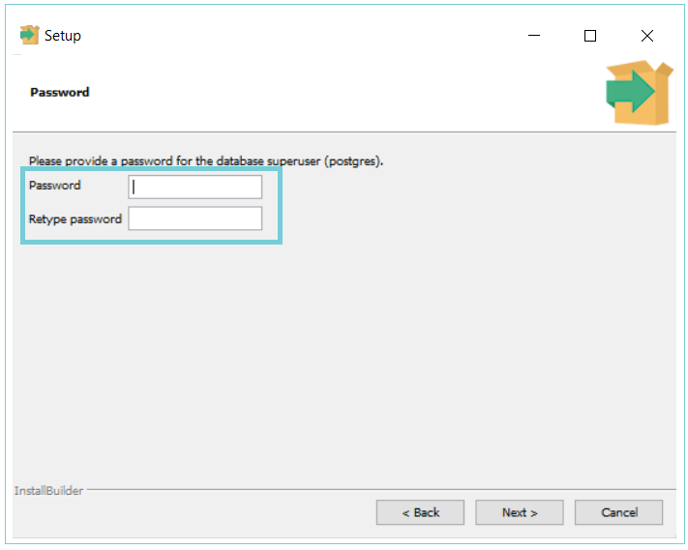

**Leave the port by default** – as example **5432**

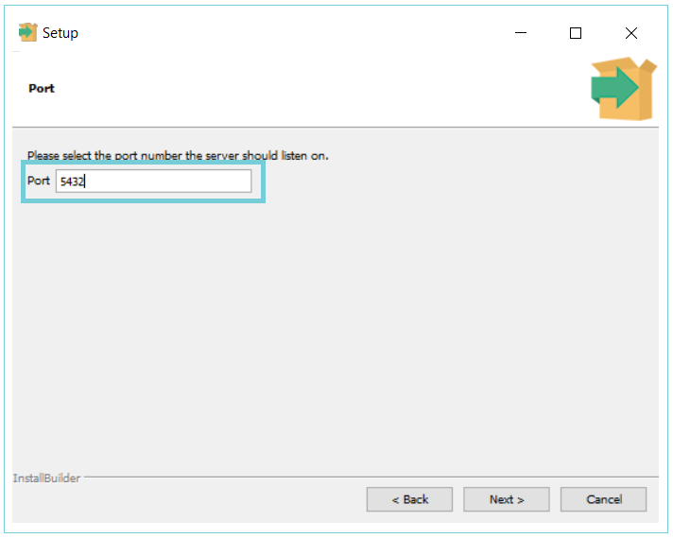

Leave the local by default

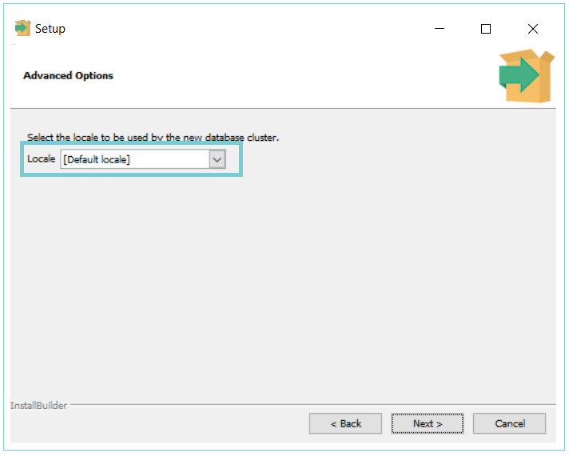

## [DBeaver](https://dbeaver.io/download/)

Choose OS: ‘Windows (installer)’ or if you have a Mac and you are not sure which installer to select, click on the Apple logo in the top left of your screen and then click on "About This Mac". If the "Chip" is "Intel", select the "MacOS for Intel installer", otherwise select the "MacOS for Apple Silicon installer".

The steps below show the installation for Windows

Run the DBeaver and allow access

# DB setup

Download and **unzip** DB **‘dvdrental’**.

The following shows you step by step on how to use the pgAdmin tool to restore the dvdrental sample db from the database file.

* Launch the **pgAdmin** tool.
* right click the **Databases** and select the **Create > Database…** menu option:

* Enter the database name dvdrental and click the **Save**button:

You’ll see the new empty database created under the Databases node

* Right-click on the dvdrental database and choose **Restore…** menu item to restore the database from the downloaded database file:

* enter the path to the sample database file e.g.,

For Windows: **c:\sampledb\dvdrental.tar**

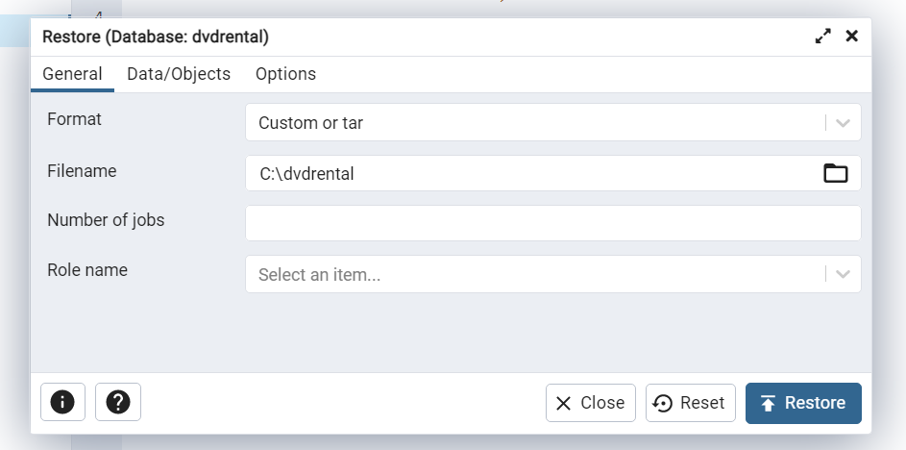

For Mac: directory

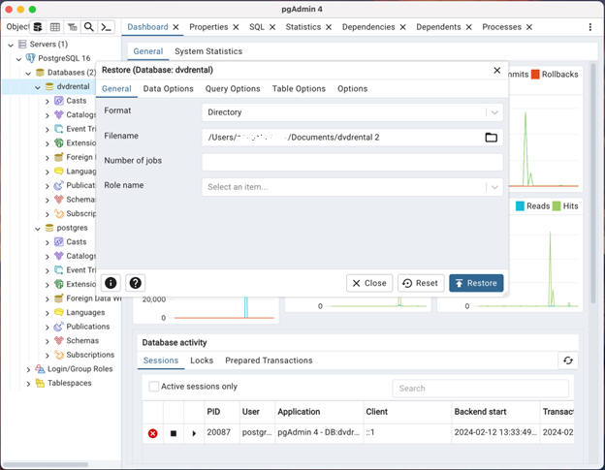

**and click the Restore button**

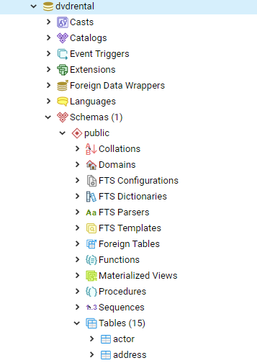

* the restoration process will complete in few seconds and shows the dialog with completion status

If you encounter an error while installing, try watching the video—it might assist you in resolving the issue. If the problem persists, please reply to the invitation mail and describe your problem.

<https://www.youtube.com/watch?v=vEtYJbHCsmo>

* open the dvdrental database from DBeaver

Create New DB Connection -> select PostgreSQL -> Next

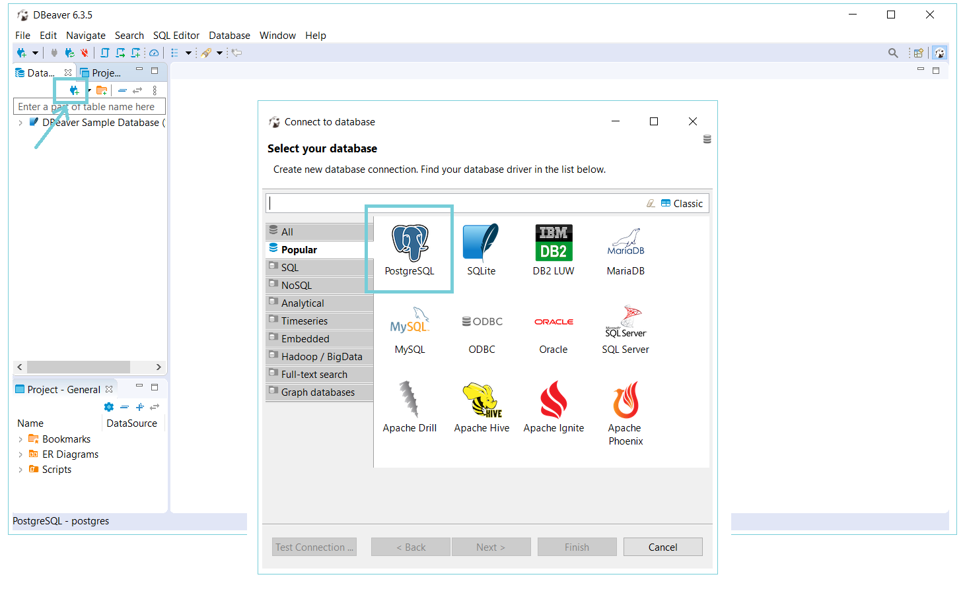

Enter the password that you specified during the installation PostgreSQL

Click on the Connection details

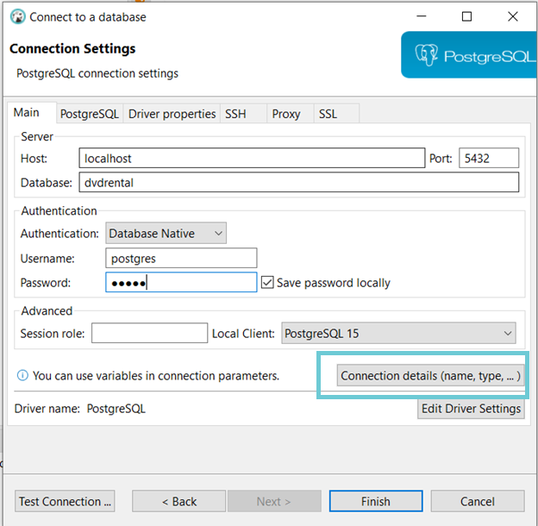

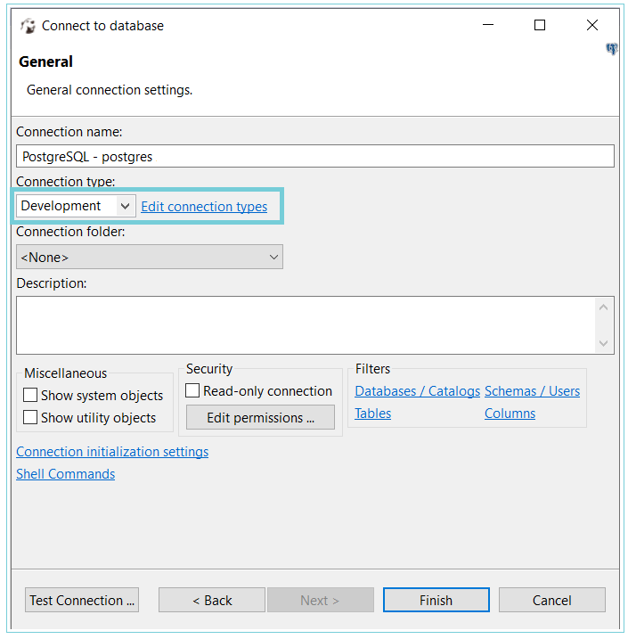

Check the box ‘Auto-commit by default’

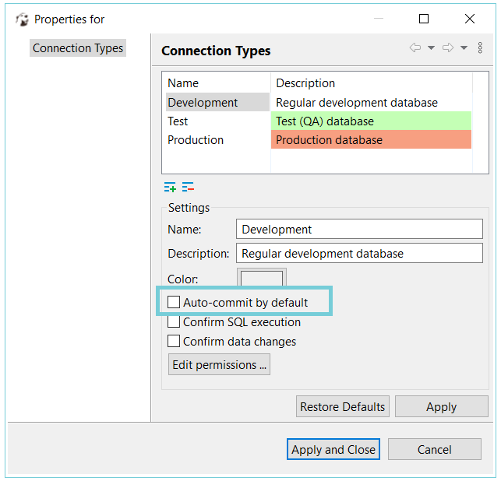

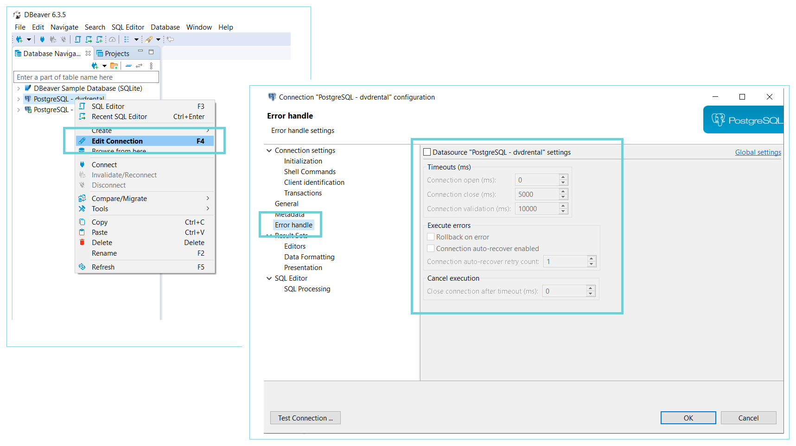

Try to run next query as example (hot key ALT+X)

**select** * **from** public.actor

Don't forget to choose the right connection

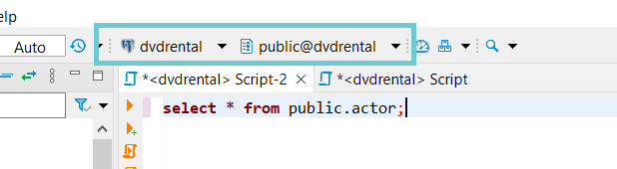

You should receive next result

