**RBC (Rounded Buttons Calculator)**

Contents

Overview 2

Required knowledge to implement the project 2

Detailed description. 2

RoundedButton 2

Main features of the calculator 3

# Overview

**rbc** – GUI calculator which view is similar to calculator on Sumsung smartphone.

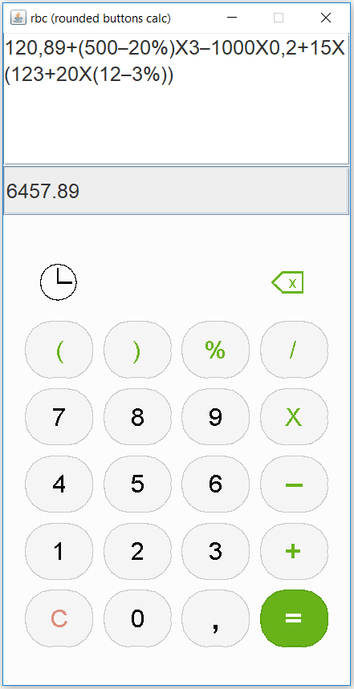

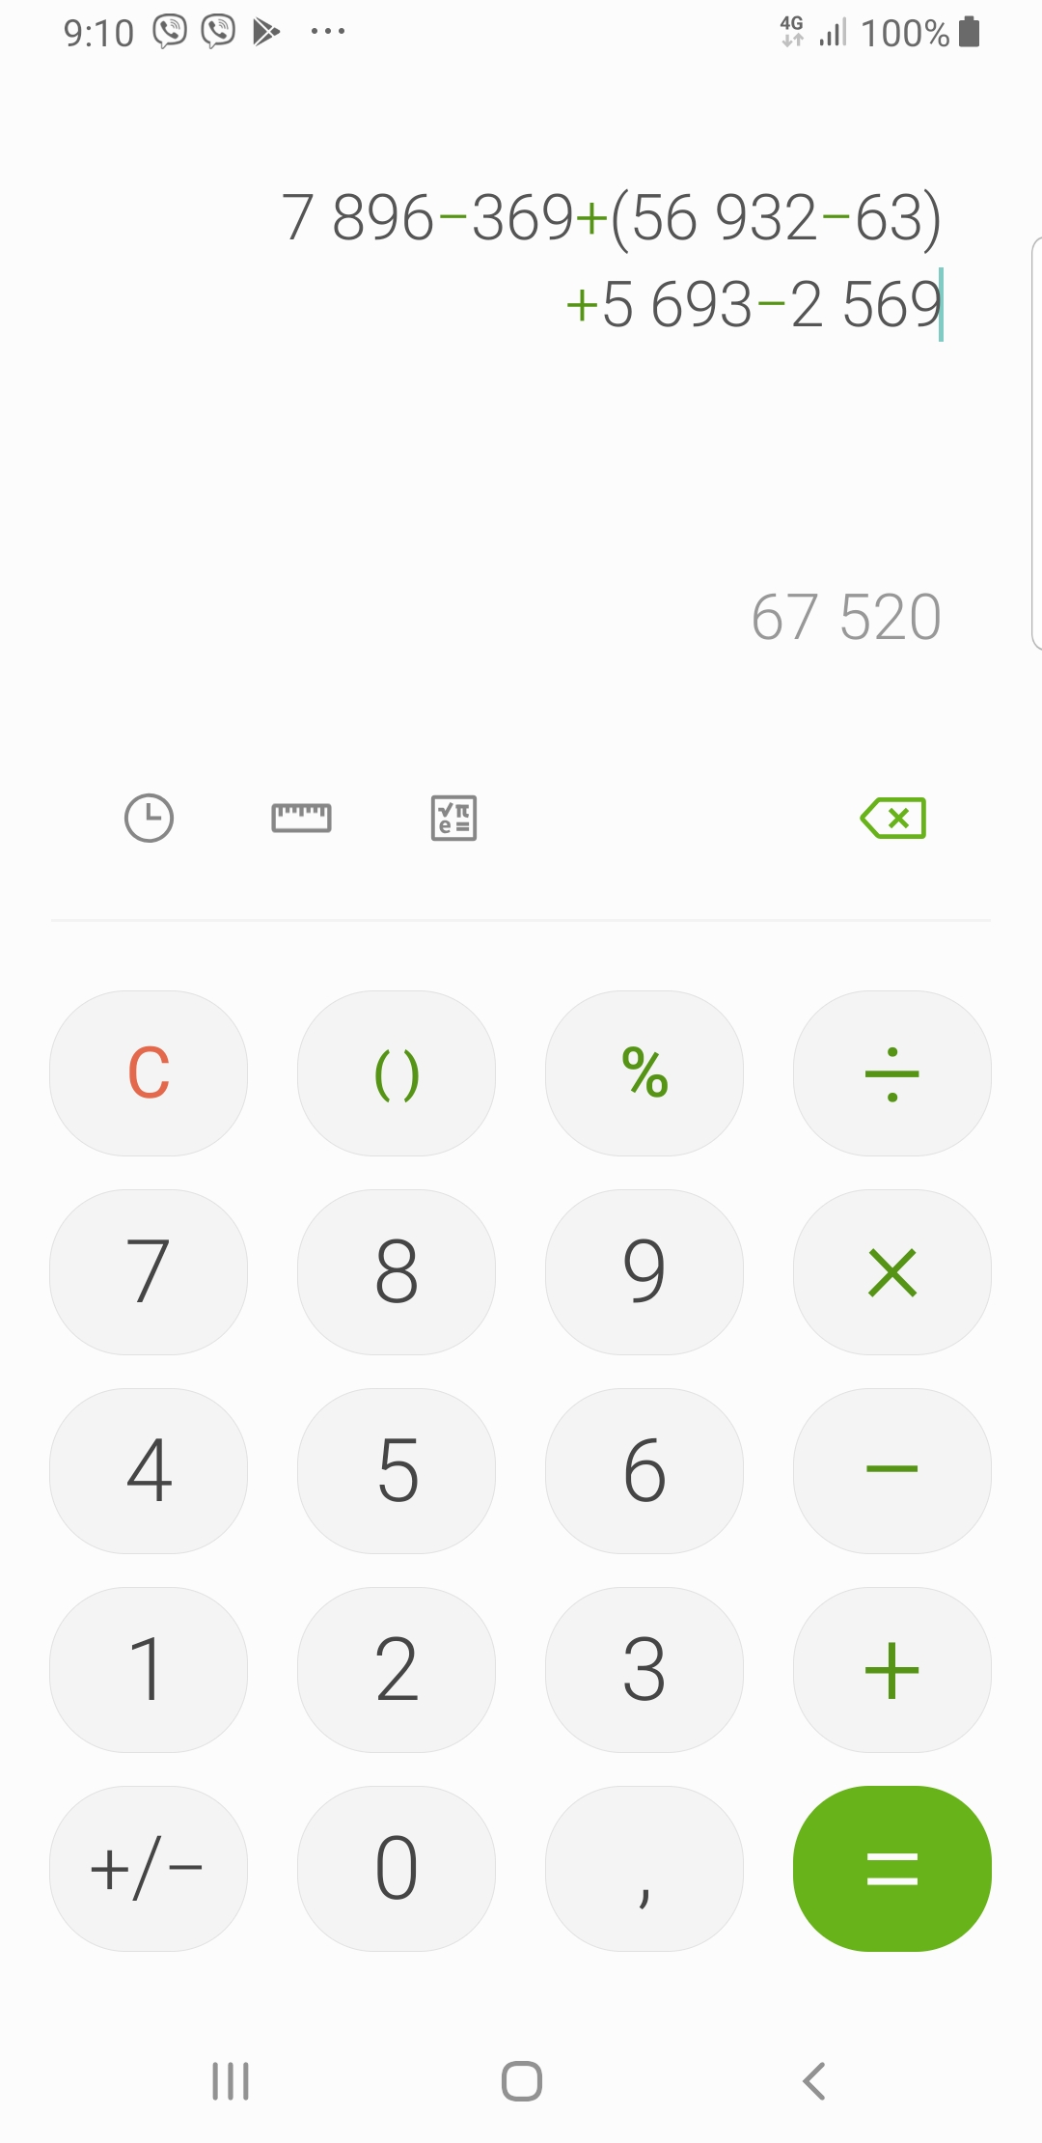

# 

# Required knowledge to implement the project

1. Base knowledge of Java SE
2. Swing
3. Collection API
4. Preferences API

# Detailed description.

## RoundedButton

To implement interface similar to sumsung calculator new component - RoundedButton was developed.

RoundedButton supports:

1. Animation on pressing
2. Multiline text (used in journal dialog).
3. Opportunity to draw some shapes on the button.

## Main features of the calculator

1. Calculator may calculate complex expression containing many different operations and subexpressions in brackets and even nested brackets.
2. Expression checker shows user where the error in the expression.
3. Auto calculation of the expression (result is updated if new operators are added to the expression).
4. Of cause keyboard key accelerators.
5. Journal of operations. On pressing corresponding button in the journal the expression from the history will be put to the calculator expression field for further editing and recalculating.

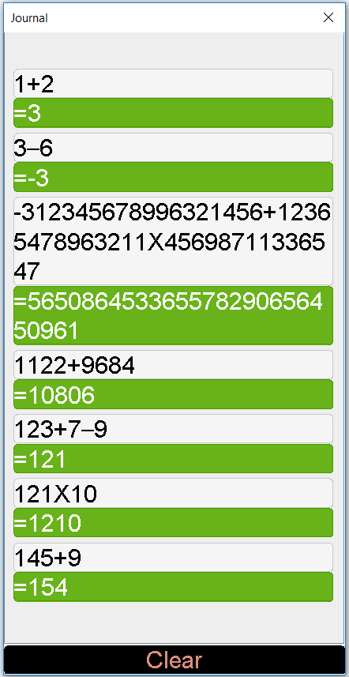

1. Operation history is saved using the Preferences API.