Contents
This document contains the documentation for the VIs contained in LVWUTIL32.ZIP. It is broken down by VI library. A brief listing of the contents is:

Window Management VIs (winutil.llb)
Window Refnum (control)
Not a Window Refnum
Get Window Refnum.vi
Get Window Name.vi
Get Window Rectangle.vi
Minimize Window.vi
Maximize Window.vi
Resize Window.vi
Restore Window.vi
Move Window.vi
Rename Window.vi
Hide Window.vi
Show Window.vi
Flash Title Bar.vi
Move Window to Top.vi
Make Window Always on Top.vi
Revoke Window Always on Top.vi
Move Window to Bottom.vi

Windows Interaction VIs (winevent.llb)
FileMan Open File.vi
FileMan Print File.vi
System Exec+.vi
Run Application.vi
Quit Application.vi
Start Windows Screen Saver.vi
Get Windows Task List.vi
Show Windows Task List.vi
Exit Windows.vi
Call WinHelp.vi
Message Window Dialog Box w/ Sound.vi

Windows Keyboard Filter VIs (winkey.llb) (NOT FUNCTIONAL IN WIN32)
Install Keyboard Filter.vi
Remove Keyboard Filter.vi

Windows Networking VIs (winnet.llb)
Disconnect Network Resource.vi
Add Network Resource.vi

Windows System Utility VIs (winsys.llb)
Get Cursor Position.vi
System Information.vi
Get Screen Size.vi
Get System Path.vi
Get Windows Path.vi
Screen Saver Control.vi

Windows Display VIs (windisplay.llb)
WIN_GetDisplayMode.vi
WIN_SetDisplayMode.vi
WIN_ListDisplayModes.vi

Error Codes

Window Management VIs
These VIs offer the user some direct control over the behavior of application windows in Windows. Such features include the ability to hide and show windows, maximize and minimize, move and resize them, or change the text appearing in the title bar. Many of these functions extend the abilities of some of those found with the VI Control VIs to all Windows.

Window Refnum Control

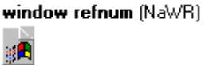

This control is used to pass a window refnum between VIs. A window refnum is a unique identifier for a window in Windows. Its default value is Not a Window Refnum (abbreviated as NaWR).

Not a Window Refnum



This block diagram ‘constant’ generates an invalid window refnum. It is abbreviated NaWR.

Get Window RefNum

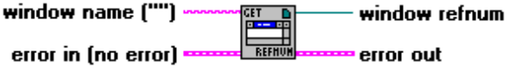

This function will get a window refnum for the window named in the window name input. This window refnum can be used to target a specific window when using the various utilities in this library.

window name is the name of the window whose window refnum is to be retrieved. This string must exactly match the text appearing in the title bar of the window.
error in describes any error conditions prior to this VI’s execution.

window refnum is the refnum for the window if window name was valid. If an error occurred, window refnum is set to Not a Window Refnum.
error out contains error information. If the error in cluster indicated an error, the error out cluster contains the same information. Otherwise, error out describes this VI’s error status.

Get Window Name

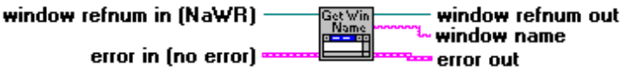

This function will get the name of the window identified in the window refnum in input. This window refnum must be valid. This is most frequently used if the name of a window has been changed.

window refnum in identifies the window whose name is to be found. If it has the value Not a Window Refnum (the default), an error will occur.
error in describes any error conditions prior to this VI’s execution.

window refnum out is the same as window refnum in on success. If an error occurred, window refnum out is set to Not a Window Refnum.
window name is the name of the window identified by window refnum in. It will be empty if an error occurred.
error out contains error information. If the error in cluster indicated an error, the error out cluster contains the same information. Otherwise, error out describes this VI’s error status.

Get Window Rectangle

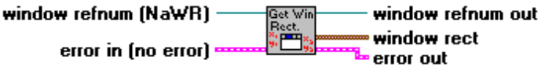

This function will get the location and size of the window identified in the window refnum input. This window refnum must be valid.

window refnum identifies the window whose location and size is to be found. If it has the value Not a Window Refnum (the default), an error will occur.
error in describes any error conditions prior to this VI’s execution.

window refnum out is the same as window refnum on success. If an error occurred, window refnum out is set to Not a Window Refnum.
window rect provides the location of the window identified by window refnum in pixels.
left is the distance from the left edge of the screen to the left edge of the window.
top is the distance from the top of the screen to the top of the window.
right is the distance from the left edge of the screen to the right edge of the window.
bottom is the distance from the top of the screen to the bottom edge of the window.
error out contains error information. If the error in cluster indicated an error, the error out cluster contains the same information. Otherwise, error out describes this VI’s error status.

Minimize Window

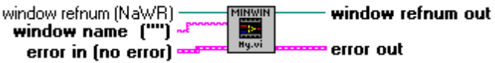

This function will minimize the target window to an icon appearing at the bottom of the screen.

Possible Applications
This allows you to programmatically minimize a VI (or other) window, and may prove to be a safer alternative to hiding a window, since it does not hide objects from the user. By minimizing the window of a VI that is updating a graph, for example, redraws will be kept to a minimum. For example, if you don’t always need to see a plot that is ‘live’, you can minimize it for a time. This can also be useful in cases where another application is launched, and at some point (e.g. after a certain amount of data has been sent to a window via DDE) you want to emphasize the window. You can programmatically minimize and restore the window (see the Restore Window function below).

window refnum identifies the window to be minimized. If it has the value Not a Window Refnum (the default), the function will use the window name input to get a window refnum (if the window name is valid) and return it in window refnum out.
window name is the name of the window to be minimized. It will be used if window refnum is equal to Not a Window Refnum. This string must exactly match the text appearing in the title bar of the window.
error in describes any error conditions prior to this VI’s execution.

window refnum out is the same as window refnum if window refnum was valid. If window refnum was Not a Window Refnum, but window name was valid, then it is the refnum for the window that was minimized. If an error occurred, window refnum out is Not a Window Refnum.
error out contains error information. If the error in cluster indicated an error, the error out cluster contains the same information. Otherwise, error out describes this VI’s error status.

Maximize Window

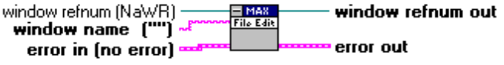

This function will maximize the target window so it covers the entire screen. If the window cannot be found, an error will be returned.

Possible Applications
Dynamically maximizing a window allows you to emphasize a VI window (or any other window) or prevent the user from clicking in another window. Or, if used with other applications, it’s a good way to indicate to the user to ‘only work in this window for now...’

window refnum identifies the window to be maximized. If it has the value Not a Window Refnum (the default), the function will use the window name input to get a window refnum (if the window name is valid) and return it in window refnum out.
window name is the name of the window to be maximized. It will be used if window refnum is equal to Not a Window Refnum. This string must exactly match the text appearing in the title bar of the window.
error in describes any error conditions prior to this VI’s execution.

window refnum out is the same as window refnum if window refnum was valid. If window refnum was Not a Window Refnum, but window name was valid, then it is the refnum for the window that was maximized. If an error occurred, window refnum out is Not a Window Refnum.
error out contains error information. If the error in cluster indicated an error, the error out cluster contains the same information. Otherwise, error out describes this VI’s error status.

Resize Window

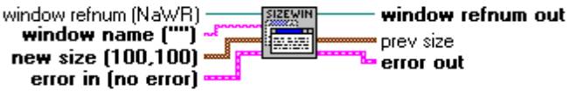

This function will resize (without moving) the target window. Window size is set in units of pixels. If the window cannot be found, an error will be returned.

Possible Applications
This will allow you to programmatically resize a VI (or other) window. Although you can already resize a VI’s front panel, you must know the origin of the panel when using the Resize Panel function, making its use a bit frustrating.

window refnum identifies the window to be resized. If it has the value Not a Window Refnum (the default), the function will use the window name input to get a window refnum (if the window name is valid) and return it in window refnum out.
window name is the name of the window to be resized. It will be used if window refnum is equal to Not a Window Refnum. This string must exactly match the text appearing in the title bar of the window.
new size provides the new size of the window in pixels.
width is the new width of the window in pixels.
height is the new height of the window in pixels.
error in describes any error conditions prior to this VI’s execution.

window refnum out is the same as window refnum if window refnum was valid. If window refnum was Not a Window Refnum, but window name was valid, then it is the refnum for the window that was resized. If an error occurred, window refnum out is Not a Window Refnum.
prev size provides the size of the window in screen pixels before it was resized.
width is the width of the window before resizing.
height is the height of the window before resizing.
error out contains error information. If the error in cluster indicated an error, the error out cluster contains the same information. Otherwise, error out describes this VI’s error status.

Restore Window

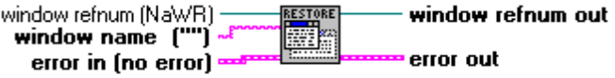

This function will return the target window to its previous size if it has been minimized or maximized. If the window cannot be found, an error will be returned. If a window has been hidden with the Hide Window function, it will be shown (made visible) and removed from the list of hidden windows maintained in LVWUTIL32.DLL.

Possible Applications
This function offers a convenient means to ‘toggle’ a window between being minimized or maximized and its previous size.

window refnum identifies the window to be restored to its previous size. If it has the value Not a Window Refnum (the default), the function will use the window name input to get a window refnum (if the window name is valid) and return it in window refnum out.
window name is the name of the window to be restored to its previous size. It will be used if window refnum is equal to Not a Window Refnum. This string must exactly match the text appearing in the title bar of the window.
error in describes any error conditions prior to this VI’s execution.

window refnum out is the same as window refnum if window refnum was valid. If window refnum was Not a Window Refnum, but window name was valid, then it is the refnum for the window that was restored. If an error occurred, window refnum out is Not a Window Refnum.
error out contains error information. If the error in cluster indicated an error, the error out cluster contains the same information. Otherwise, error out describes this VI’s error status.

Move Window

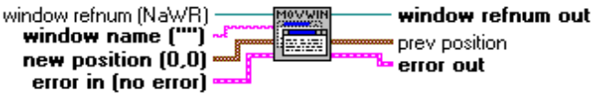

This function will move the target window from its present location to that defined in the new position cluster. Coordinates are in pixels relative to upper left corner of the screen, with positive y-axis values moving the window lower on the screen.

Possible Applications
This will allows you to programmatically move a VI (or other) window. Although you can already move a VI’s front panel, you must know the size of the panel when using the Resize Panel function, making its use a bit frustrating.

NOTE: To move VI windows, you should use the VI Control VIs Get Panel Size.vi and Resize Panel.vi that ship with LabVIEW 4.0.

window refnum identifies the window to be moved. If it has the value Not a Window Refnum (the default), the function will use the window name input to get a window refnum (if the window name is valid) and return it in window refnum out.
window name is the name of the window to be moved. It will be used if window refnum is equal to Not a Window Refnum. This string must exactly match the text appearing in the title bar of the window.
new position provides the new X-Y coordinates (in screen pixels) for the new origin of the window. The window origin is its upper left corner.
left is the X-coordinate of upper left corner of window.
top is the Y-coordinate of upper left corner of window.
error in describes any error conditions prior to this VI’s execution.

window refnum out is the same as window refnum if window refnum was valid. If window refnum was Not a Window Refnum, but window name was valid, then it is the refnum for the window that was moved. If an error occurred, window refnum out is Not a Window Refnum.
prev position provides the X-Y coordinates (in screen pixels) of the origin of the window before it was moved.
left is the X-coordinate of upper left corner of window before it was moved.
top is the Y-coordinate of upper left corner of window before it was moved.
error out contains error information. If the error in cluster indicated an error, the error out cluster contains the same information. Otherwise, error out describes this VI’s error status.

Rename Window

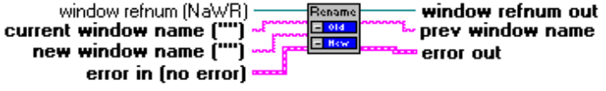

This VI will rename the target window and return the previous name of the window in the prev window name output.

Possible Applications
This will allow you to programmatically rename a VI (or other) window. With this capability, you can use the title bar of a VI to dynamically provide information to the user, as some Windows applications currently do. Note that the VI Control functions still must use the original name of the VI, not the text appearing in the title bar.

window refnum identifies the window to be renamed. If it has the value Not a Window Refnum (the default), the function will use the window name input to get a window refnum (if the window name is valid) and return it in window refnum out.
current window name is the name of the window to be renamed. It will be used if window refnum is equal to Not a Window Refnum. This string must exactly match the text currently appearing in the title bar of the window.
new window name is new text to be placed in the window’s title bar.
error in describes any error conditions prior to this VI’s execution.

window refnum out is the same as window refnum if window refnum was valid. If window refnum was Not a Window Refnum, but window name was valid, then it is the refnum for the window that was renamed. If an error occurred, window refnum out is Not a Window Refnum.
prev window name contains the previous text in the window’s title bar. It will be the same as current window name if the window name is valid and the function succeeds and current window name was used to target the window. If an error occurs, the string will be empty. Note that is may be possible to have an empty string for prev window name without an error if the title bar is not shown.
error out contains error information. If the error in cluster indicated an error, the error out cluster contains the same information. Otherwise, error out describes this VI’s error status.

Hide Window

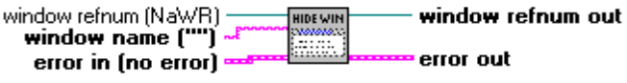

This function will hide the target window, making it ‘invisible’. LVWUTIL32.DLL will maintain a list of all of the windows that are hidden by this VI. Any hidden windows not again shown by the Show Window function will be shown when the DLL is removed from memory. The DLL is removed from memory when all VIs making use of DLL are removed from memory.

Possible Applications
This may be useful when launching other applications that perform background work but are not necessary for the user to see. Because we have Close Panel for LabVIEW VIs, this function is really only needed to hide other application windows. Minimizing an application instead of hiding it serves nearly the same purpose, and does not hide information from the user.

window refnum identifies the window to be hidden. If it has the value Not a Window Refnum (the default), the function will use the window name input to get a window refnum (if the window name is valid) and return it in window refnum out.
window name is the name of the window to be hidden. It will be used if window refnum is equal to Not a Window Refnum. This string must exactly match the text appearing in the title bar of the window.
error in describes any error conditions prior to this VI’s execution.

window refnum out is the same as window refnum if window refnum was valid. If window refnum was Not a Window Refnum, but window name was valid, then it is the refnum for the window that was hidden. If an error occurred, window refnum out is Not a Window Refnum.
error out contains error information. If the error in cluster indicated an error, the error out cluster contains the same information. Otherwise, error out describes this VI’s error status.

Show Window

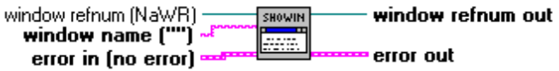

This function will show the target window. If a window has been hidden, it will be made visible and removed from the list of hidden windows maintained in LVWUTIL32.DLL. This function acts as the inverse to Hide Window.

Possible Applications
This function offers a convenient means to ‘toggle’ a window between hidden and visible when used with the Hide Window VI.

window refnum identifies the window to be shown. If it has the value Not a Window Refnum (the default), the function will use the window name input to get a window refnum (if the window name is valid) and return it in window refnum out.
window name is the name of the window to be shown. It will be used if window refnum is equal to Not a Window Refnum. This string must exactly match the text appearing in the title bar of the window.
error in describes any error conditions prior to this VI’s execution.

window refnum out is the same as window refnum if window refnum was valid. If window refnum was Not a Window Refnum, but window name was valid, then it is the refnum for the window that was shown. If an error occurred, window refnum out is Not a Window Refnum.
error out contains error information. If the error in cluster indicated an error, the error out cluster contains the same information. Otherwise, error out describes this VI’s error status.

Flash Title Bar

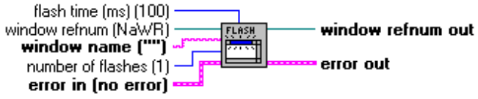

This function will flash the title bar of the target window number of flashes of times, waiting flash time milliseconds between inversions of the window’s title bar color. Note that the VI will not return until it has executed number of flashes flashes of the title bar.

Possible Applications
This function offers a convenient means highlight a particular window.

window refnum identifies the window whose title bar is to be flashed. If it has the value Not a Window Refnum (the default), the function will use the window name input to get a window refnum (if the window name is valid) and return it in window refnum out.
window name is the name of the window whose title bar is to be flashed. It will be used if window refnum is equal to Not a Window Refnum. This string must exactly match the text appearing in the title bar of the window.
flash time (ms) controls how long the VI waits between toggling color of the target window’s title bar between active and inactive.
number of flashes controls how many times the title bar of the window will blink.
error in describes any error conditions prior to this VI’s execution.

window refnum out is the same as window refnum if window refnum was valid. If window refnum was Not a Window Refnum, but window name was valid, then it is the refnum for the window whose title bar was flashed. If an error occurred, window refnum out is Not a Window Refnum.
error out contains error information. If the error in cluster indicated an error, the error out cluster contains the same information. Otherwise, error out describes this VI’s error status.

Move Window to Top

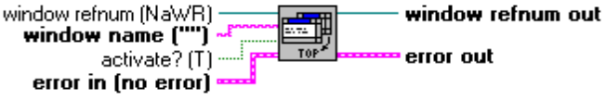

This function will make the target window the top window, optionally making it the active window.

window refnum identifies the window to be placed on top. If it has the value Not a Window Refnum (the default), the function will use the window name input to get a window refnum (if the window name is valid) and return it in window refnum out.
window name is the name of the window to be placed on top. It will be used if window refnum is equal to Not a Window Refnum. This string must exactly match the text appearing in the title bar of the window.
activate? if TRUE, will make the target window also the active window. Otherwise, the currently active window will remain the active window.
error in describes any error conditions prior to this VI’s execution.

window refnum out is the same as window refnum if window refnum was valid. If window refnum was Not a Window Refnum, but window name was valid, then it is the refnum for the window that was placed on top. If an error occurred, window refnum out is Not a Window Refnum.
error out contains error information. If the error in cluster indicated an error, the error out cluster contains the same information. Otherwise, error out describes this VI’s error status.

Make Window Always on Top

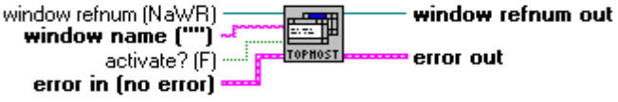

This function will make the target window appear on top of all other windows (except possibly other ‘always on top’ windows), optionally making it the active window. Even when other windows are the active window, the window will remain on top of them (similar to LabVIEW’s Help window).

window refnum identifies the window to be made ‘always on top’. If it has the value Not a Window Refnum (the default), the function will use the window name input to get a window refnum (if the window name is valid) and return it in window refnum out.
window name is the name of the window to be made ‘always on top’. It will be used if window refnum is equal to Not a Window Refnum. This string must exactly match the text appearing in the title bar of the window.
activate? if TRUE, will make the target window also the active window. Otherwise, the currently active window will remain the active window.
error in describes any error conditions prior to this VI’s execution.

window refnum out is the same as window refnum if window refnum was valid. If window refnum was Not a Window Refnum, but window name was valid, then it is the refnum for the window that was made ‘always on top’. If an error occurred, window refnum out is Not a Window Refnum.
error out contains error information. If the error in cluster indicated an error, the error out cluster contains the same information. Otherwise, error out describes this VI’s error status.

Revoke Window Always on Top

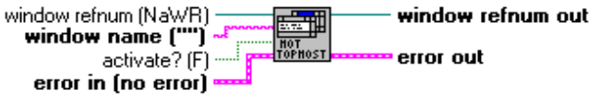

This function will remove the target window’s ‘always on top’ status, optionally making it the active window. If the window is not an ‘always on top’ window, the function does nothing.

window refnum identifies the window to be made no longer ‘always on top’. If it has the value Not a Window Refnum (the default), the function will use the window name input to get a window refnum (if the window name is valid) and return it in window refnum out.
window name is the name of the window to be made no longer ‘always on top’. It will be used if window refnum is equal to Not a Window Refnum. This string must exactly match the text appearing in the title bar of the window.
activate? if TRUE, will make the target window also the active window. Otherwise, the currently active window will remain the active window.
error in describes any error conditions prior to this VI’s execution.

window refnum out is the same as window refnum if window refnum was valid. If window refnum was Not a Window Refnum, but window name was valid, then it is the refnum for the window that was made no longer ‘always on top’. If an error occurred, window refnum out is Not a Window Refnum.
error out contains error information. If the error in cluster indicated an error, the error out cluster contains the same information. Otherwise, error out describes this VI’s error status.

Move Window to Bottom

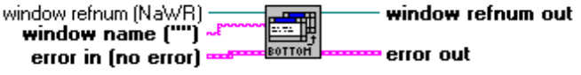

This function will remove the target window to be the last item in the Task List, deactivating the window.

window refnum identifies the window to be moved to the bottom. If it has the value Not a Window Refnum (the default), the function will use the window name input to get a window refnum (if the window name is valid) and return it in window refnum out.
window name is the name of the window to be moved to the bottom. It will be used if window refnum is equal to Not a Window Refnum. This string must exactly match the text appearing in the title bar of the window.
error in describes any error conditions prior to this VI’s execution.

window refnum out is the same as window refnum if window refnum was valid. If window refnum was Not a Window Refnum, but window name was valid, then it is the refnum for the window that was moved to the bottom. If an error occurred, window refnum out is Not a Window Refnum.
error out contains error information. If the error in cluster indicated an error, the error out cluster contains the same information. Otherwise, error out describes this VI’s error status.

Windows Interaction VIs
These VIs offer some basic utilities such as opening or printing a file via the application that created it, and an enhanced version of System Exec, which allows the user to use the function ‘synchronously’. There are two version of this, System Exec+ and Run Application. Run Application offers a list of windows created by an application when launched (if not executed ‘synchronously’) and better multitasking performance than System Exec+ when waiting for the application that was launched to be terminated. The Quit Application function will also be useful in cases where a fully automated ‘launch-execute-close’ sequence is desired. For example, start Excel, run a DDE session, save changes, and quit Excel. Other functions are basic Windows utilities, and their placement in this library is arbitrary.

FileMan Open File

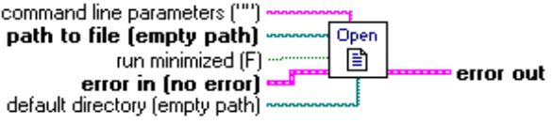

This VI will open a file whose extension is associated with an application, as available in Windows’ File Manager, just as if you double-clicked on the file in File Manager. Files can be associated with a particular application using File Manager’s Associate... command. For example, files with the .wri extension are usually associated with the Windows application Write (write.exe). A file with the extension .wri would be opened by Microsoft Write.

File Manager does not need to be running for this VI to function. Attempting to open files whose extensions are not associated with an application in the File Manager will result in an error.

Possible Applications
This function offers a simple way to open files in the application that created them, starting the application if it is not already running.

command line parameters contains any command line arguments to the application that opens the file given in path to file.
path to file is the full path to the file that is to be opened.
run minimized allows you to indicate if the application should be started normally or shown minimized. Note that this applies only to Windows applications, not DOS programs. DOS programs executed from a Windows PIF configured to run the program in a Window will use the run minimized setting appropriately.
default directory sets the working directory of the application that starts when the document or program listed in path to file launches.
error in describes any error conditions prior to this VI’s execution.

error out contains error information. If the error in cluster indicated an error, the error out cluster contains the same information. Otherwise, error out describes this VI’s error status.

FileMan Print File

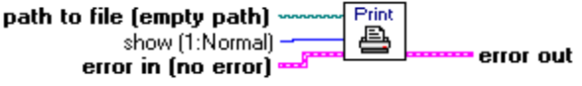

This VI will print a file whose extension is associated with an application, as available in Windows’ File Manager. For example, files with the .wri extension are usually associated with the Windows application Write (write.exe). A file with the extension .wri will then be printed using Microsoft Write. This VI acts just as if you selected the file in File Manager and executed the Print... option from the File menu, with some additional control over whether the application that prints the file is shown normally, minimized, or hidden.

File Manager does not need to be running for this VI to function. Files whose extensions are not associated with an application, or applications which do not support file printing from the File Manager, will return an error.

Possible Applications
This function gives you the ability to print files created in other applications, using that application to print the file. Thus, if you want to print a bitmap image, usually by default .bmp files will be printed by Paintbrush. Because using other applications to print the files may require user input to a Print dialog box, this VI may not offer unsupervised programmatic printing of some files. Some applications, like Notepad, display a ‘Cancel’ dialog, but do not require user input.

path to file is the full path to the file that is to be printed.
show determines if the application should be started normally, shown minimized, or hidden while printing. Note that this applies only to Windows applications, not DOS programs. Some applications will still generate a print dialog box which requires user input. 0: Hide 1: Show normally 2: Show minimized
error in describes any error conditions prior to this VI’s execution.

error out contains error information. If the error in cluster indicated an error, the error out cluster contains the same information. Otherwise, error out describes this VI’s error status.

System Exec+

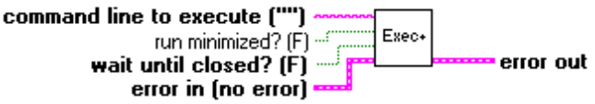

This VI is similar to the original System Exec VI, with the additional option that the VI can wait until the application launched is closed. Note that this VI uses a different method to wait for the other application to quit which requires more overhead, but does not require LVWUTIL32.DLL.

NOTE: May not function correctly!

command line to execute follows exactly the same conventions as those used by the Run... command in Windows Program Manager or File Manager. Essentially, it is the path including the name of the executable and any command line parameters the executable may accept.
run minimized? is used to control the state of the window created when the application is started. Note that for DOS applications, this input is ignored. To have a DOS application, such as a batch program, run minimized, create a PIF for the file and have it run in a window.
wait until closed?, when TRUE, will cause LabVIEW remain in the VI until the application that was launched is no longer running. Otherwise, LabVIEW will start the application and continue.
error in describes any error conditions prior to this VI’s execution.

error out contains error information. If the error in cluster indicated an error, the error out cluster contains the same information. Otherwise, error out describes this VI’s error status.

Run Application

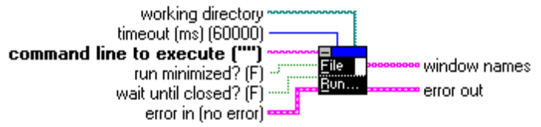

This VI will launch another application as if you used the Run... command from Program Manager’s or File Manager's File menu.

If wait until closed? is TRUE, the VI will wait until you close the application launched by the VI before continuing, or until timeout milliseconds have elapsed. Setting timeout to -1 will cause the VI to wait indefinitely, until the application is terminated. If the application that is launched simply starts other programs and then quits, the VI will not wait until the additional applications are closed. Note that because this VI uses a LabVIEW occurrence to detect when an application has been terminated, other LabVIEW VIs in parallel with this one will continue to execute.

You can also choose how the window for the application will appear (for Windows applications only) with the run minimized? input.

The names of new Task List windows created when the application launches are returned in the window names array if wait until closed? is FALSE. Note that this list may not always be accurate.

NOTE: This VI has changed slightly from the Windows 3.1 version!

command line to execute follows exactly the same conventions as those used by the Run... command in Windows Program Manager or File Manager. Essentially, it is the path including the name of the executable and any command line parameters the executable may accept.
run minimized? is used to control the state of the window created when the application is started. Note that for DOS applications, this input is ignored. To have a DOS application, such as a batch program, run minimized, create a PIF for the file and have it run in a window.
wait until closed?, when TRUE, will cause LabVIEW remain in the VI until the application that was launched is no longer running. Otherwise, LabVIEW will start the application and continue.

timeout (ms) determines how long the VI waits for an application to terminate. The default value is 60,000 ms (1 minute). A value of -1 means the VI will never time out.

working directory sets the working directory of the application launced via the command line.

error in describes any error conditions prior to this VI’s execution.

window names is an array of strings containing the names of all windows that are visible and have no owner that were created when the application identified by command line to execute was started. It is empty if the VI was instructed to wait until the indicated application was closed or if an error occurred.
error out contains error information. If the error in cluster indicated an error, the error out cluster contains the same information. Otherwise, error out describes this VI’s error status.

Quit Application

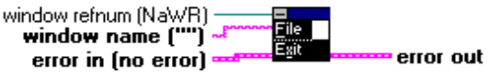

This VI will close the application identified by window name if window refnum is unwired (Not a Window Refnum). Note that the window to be closed must have no owner or parent window.

This VI will not work if sent to a LabVIEW VI window. Use LabVIEW’s built-in Exit function to quit LabVIEW, or the Close Panel function available in the VI Control palette of the Utility menu to close a VI.

Possible Applications
This VI is a useful counterpart for the Run Application, System Exec or System Exec+ VIs.

window refnum identifies the main window of the application to be closed. If it is unwired, or set to Not a Window Refnum, the function will use window name to identify the window.
window name is the name of the application window that will be closed. This will be used if window refnum is unwired or set to Not a Window Refnum.
error in describes any error conditions prior to this VI’s execution.

error out contains error information. If the error in cluster indicated an error, the error out cluster contains the same information. Otherwise, error out describes this VI’s error status.

Start Windows Screen Saver



This VI will start the Windows screen saver (if any is installed).

Possible Applications
Basic Windows utility - handy if you want to start the screen saver at some point in an application.

error in describes any error conditions prior to this VI’s execution.

error out contains error information. If the error in cluster indicated an error, the error out cluster contains the same information. Otherwise, error out describes this VI’s error status.

Get Windows Task List

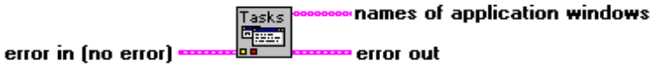

This VI lists Windows’ currently running tasks. The list is returned as an array of strings. LabVIEW VIs will not be included in this list. In order to appear in the list, a window must meet the following criteria:
1) The window must have a name, i.e. it’s title is not an empty string
2) The window must not have an owner
3) The window must be visible

LabVIEW VIs will not appear in the list because they have an owner.

Possible Applications
This VI can be useful for monitoring whether an application that was launched with the Run Application, System Exec, or System Exec+ VIs is still running, or other basic system information purposes.

error in describes any error conditions prior to this VI’s execution.

names of application windows is an array of strings containing the names of the windows that meet the criteria listed above.

error out contains error information. If the error in cluster indicated an error, the error out cluster contains the same information. Otherwise, error out describes this VI’s error status.

Show Windows Task List



This VI will show the Windows Task List. If the Install Keyboard Filter VI has been used to disable the Task List, this VI will not display the Task List.

Possible Uses
Basic Windows utility - handy if you want to prompt the user to switch to another application.

error in describes any error conditions prior to this VI’s execution.

error out contains error information. If the error in cluster indicated an error, the error out cluster contains the same information. Otherwise, error out describes this VI’s error status.

Exit Windows

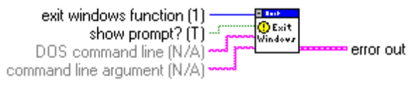

You can use this VI to exit windows in various ways.

Possible Applications
You could use this function if you write a LabVIEW application that installs certain drivers for Windows and must restart Windows for the changes to take effect. Another possible use could stem from applications which monitor certain system resources, and when finding the machine in a state that may be unstable for the application, clean up and restart Windows.

NOTE: This VI has changed slightly from the Windows 3.1 version!

exit windows function selects which type of exit windows function is to be performed.
0: Log off Windows
1: Shut Down Windows
2: Exit Windows and reboot the computer

show prompt? controls whether or not a dialog box prompt is shown requesting that the user confirm the exit windows operation.

DOS command line is no longer used.

command line argument is no longer used.

error out describes this VI’s error status.

Call WinHelp

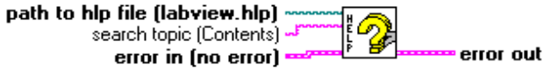

This VI executes winhelp.exe, opening the given help (.hlp) file and displaying the information indicated by search topic. search topic must be a defined jumpable location within the help file.

If path to hlp file is left empty, the VI finds the lvhelp.hlp file, assuming a standard LabVIEW configuration.

If an invalid help file or unknown search topic is entered, the Help engine is started but a dialog box displays a message concerning the problem.

path to file is the full path to the help file that is to be opened.

search topic contains valid search topic in the help file. It is case sensitive.

error in describes any error conditions prior to this VI’s execution.

error out contains error information. If the error in cluster indicated an error, the error out cluster contains the same information. Otherwise, error out describes this VI’s error status.

Message Window Dialog Box w/ Sound

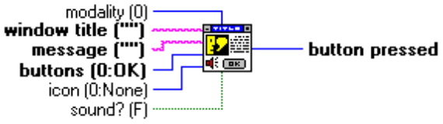

This VI calls the Windows functions MessageBox and MessageBeep to display a message dialog box and, optionally, play a sound effect. If your computer is not equipped with a sound driver, a short “beep” will be played through the PC’s speaker. Various types of dialog boxes are possible, depending on the combination of the modality, buttons and icon inputs. The buttons input selects which buttons are displayed in the dialog box, the icon input determines the icon, if any, and the modality determines whether the dialog box is system, application, or task modal. If sounds are enabled, the icon option determines the sound effect played, as defined in the Sounds section of Windows’ Control Panel.

Possible Applications
This offers a dialog box that is not available in LabVIEW, and allows the user to create dialog boxes that mimic standard Windows dialog boxes. You can provide a title, and also create a three-button dialog box. The button names cannot be changed, and the dialog box is ‘synchronous’ in that LabVIEW will halt execution until it is closed. Be aware of this if you are using any DAQ VIs running at the same time as this dialog box VI.

modality selects the modality of the message box:
0: Application
1: System
2: TaskModality basically refers to whether you can switch to other applications or click the mouse outside the dialog box. Because of how the function is implemented in the VI, application modality will allow you to click the mouse anywhere or switch to any Windows application. System modality will not allow you to click the mouse in any other window in Windows, nor switch to another application, while task modality will allow you to switch to other applications, you cannot click the mouse in another LabVIEW VI window.
window title is the title for the message box.
message is the message displayed in the message box.
buttons selects the grouping of buttons displayed in the message box:
0: OK
1: OK / Cancel
2: Abort / Retry / Ignore
3: Yes / No / Cancel
4: Yes / No
5: Retry / Cancel
icon selects the style of icon displayed in the message box:
0: None
1: STOP
2: Question mark (?)
3: Exclamation mark (!)
4: Information (i)
sound? determines whether or not a sound effect will be played. The sound is determined by the icon input.

button pressed indicates which button in the dialog box was pressed:
0: OK
1: Cancel
2: Abort
3: Retry
4: Ignore
5: Yes
6: No

Windows Keyboard Filter VIs
THESE VIS DO NOT FUNCTION IN WIN32. THEY ARE PROVIDED FOR COMPATIBILITY ONLY.

Install Keyboard Filter

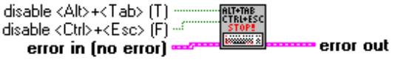

Remove Keyboard Filter



NEW! Windows Networking VIs
These VIs can connect and disconnect network drives.

Add Network Resource
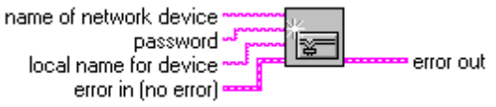
This VI will connect a network drive or printer to a local device (e.g. F: or LPT3). The network name is the UNC name of the network resource. For example, if LabVIEW was installed on a shared network volume with a machine name of APPLICATIONS, on which the LabVIEW directory resided in a directory called WINAPPS, the UNC name for the "name of network device" would be: \\APPLICATIONS\WINAPPSS\LABVIEW

name of network device specifies which network device to which a connection will be added.
password is the network password for the specified network device.
local name for device is the name of redirected local device (e.g. D: or LPT1).

error in describes any error conditions prior to this VI's execution.

error out contains error information. If the error in cluster indicated an error, the error out cluster contains the same information. Otherwise, error out describes this VI's error status.

Disconnect Network Resource
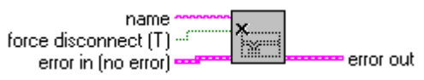
This VI will disconnect the local machine from a network drive or printer (e.g. F: or LPT3). If the "force disconnect" input is FALSE and open files or print jobs on the specified resource exist, error 49 is returned (WN_OPEN_FILES).

name identivies the redirected local device to disconnect (e.g. D: or LPT1).
force disconnect specifies whether any open files or open print jobs on the device should be closed before the connection is canceled. If this is set to FALSE and there are open files or jobs, the connection should not be canceled and the function should return the WN_OPEN_FILES error value (0x31, 49 decimal).

error in describes any error conditions prior to this VI's execution.

error out contains error information. If the error in cluster indicated an error, the error out cluster contains the same information. Otherwise, error out describes this VI's error status.

Windows System Utility VIs
These VIs provide information about your Windows environment.

Get Cursor Position


This VI returns the position of the cursor on the screen in screen coordinates (pixels).

cursor position is a cluster containing the location of the cursor on the screen.
x is the horizonal location of the cursor in pixels, measured from the right edge of the screen.
y is the vertical location of the cursor in pixels, measured from the top edge of the screen.

System Information

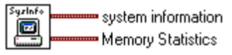

This VI provides basic system information such as the percentage of free resources, the amount of free RAM, versions of Windows and DOS, etc. Due to limitations of the Windows API, the function incorrectly reports a Pentium processor as a 486.

NOTE: This VI has changed from the Windows 3.1 version.

system information is a cluster containing information about the computer and the operating environment.
processor reports which processor you computer uses.
coprocessor? is nonzero for 486 and above. (NOTE that this may be incorrect).
Windows Version contains the version of Windows that is running.
Is NT? is nonzero if the VI is run in NT.
386 Enhanced? is nonzero in Win32.
virtual memory? is nonzero in Win32.
bytes free is zero. See the Memory Statistics output cluster.
% free system resources N/A in Win32.
% free GDI resources N/A in Win32.
% free USER resources N/A in Win32.
Memory Statistics is a cluster containing information about the computer's memory.
 % mem used reports the percentage of physical RAM in use.
Total Physical Memory reports physical memory installed in the system in MB.
Available Physical memory reports available physical memory in MB.
Total Page File reports page file size in MB.
Available Page File reports available page file space in MB.
Total Virtual Memory reports total virtual memory in MB.
Available Virtual Memory reports available virtual memory in MB.

Get Screen Size

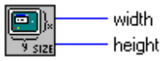

This VI returns the width and height of the screen in pixels.

width is the width of the screen in pixels.
height is the height of the screen in pixels.

Get System Path



This VI returns the path to the Windows System directory.

error in describes any error conditions prior to this VI’s execution.

system directory is the path to the system directory.
error out contains error information. If the error in cluster indicated an error, the error out cluster contains the same information. Otherwise, error out describes this VI’s error status.

Get Windows Path

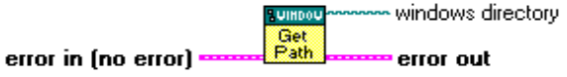

This VI returns the path to the Windows directory.

error in describes any error conditions prior to this VI’s execution.

windows directory is the path to the Windows directory.
error out contains error information. If the error in cluster indicated an error, the error out cluster contains the same information. Otherwise, error out describes this VI’s error status.

Screen Saver Control

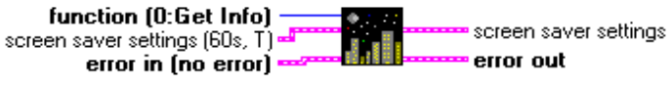

You can use this VI to enable or disable the Windows screen saver, and retrieve or set its timeout setting. The new settings are updated in win.ini.

 function is an enumerated type (U8) that controls whether the VI gets or sets the screen saver configuration:Get Screen Saver Info will return the current configuration in the screen saver settings outputSet Screen Saver Info will set the configuration to that provided in the screen saver settings input cluster
screen saver settings is a cluster containing the timeout value and activity for the screen saver.
 timeout value is the time in seconds before the screen saver starts.
active? determines whether the screens saver starts after timeout value seconds of inactivity have elapsed.
error in describes any error conditions prior to this VI’s execution.

screen saver settings indicates what the current screen saver configuration is.
timeout value indicates how many seconds of inactivity must elapse before the screen saver will start.
active? indicates whether or not the screen saver will start after timeout value seconds of inactivity have passed.
error out contains error information. If the error in cluster indicated an error, the error out cluster contains the same information. Otherwise, error out describes this VI’s error status.

Windows Display VIs
These VIs can be used to list, query, and set the display mode of your screen.

Error Codes

Code Description
-43 User canceled the operation
0 No error
6000 memory allocation error
6001 an empty string was supplied for a window name
6002 invalid window refnum, or window not found
6003 invalid function
6004 failed to install hook procedure,
6005 failed to post message
6006 window has an owner,
6007 window has a parent
6019 failed to get window rectangle
6020 failed to resize window
6021 failed to move window
6030 setwindowpos failed
6040 winhelp failed to execute
6050 failed to get screen saver active?
6051 failed to get screen saver timeout
6052 failed to set screen saver active
6053 failed to set screen saver timeout
6060 failed to get windows path
6061 failed to get windows system path
6400 An application refused to terminate, or a memory allocation error occurred
6401 DOS command line or command line argument string too long
6500 System was out of memory, executable file was corrupt, or relocations were invalid 6502 File was not found
6503 Path was not found
6505 Attempt was made to dynamically link to a task, or there was a sharing or network-protection error
6506 Library required separate data segments for each task
6508 There was insufficient memory to start the application
6510 Windows version was incorrect
6511 Executable file was invalid. Either it was not a Windows application or there was an error in the
.EXE image
6512 Application was designed for a different operating system
6513 Application was designed for MS-DOS 4.0
6514 Type of executable file was unknown
6515 Attempt was made to load a real-mode application (developed for an earlier version of Windows)
6516 Attempt was made to load a second instance of an executable file containing multiple data
segments that were not marked read-only
6519 Attempt was made to load a compressed executable file. The file must be decompressed before it
can be loaded
6520 Dynamic-link library (DLL) file was invalid. One of the DLLs required to run this application was
corrupt
6521 Application requires 32-bit extensions

