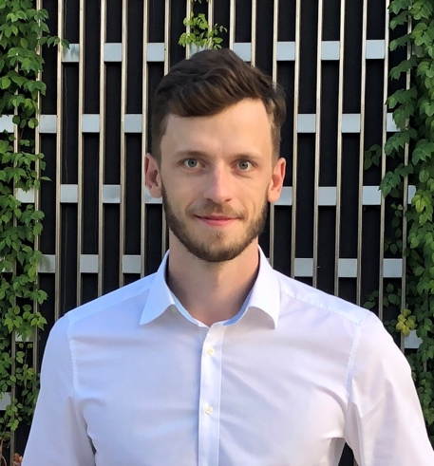**Oleg Grigoryev, Data Analyst**

Telegram: [@olegcitizen](https://t.me/olegcitizen)

WhatsApp: +7-960-4722220

E-mail: [grigoryev.team@gmail.com](mailto:grigoryev.team@gmail.com)

Portfolio: [github.com/oleggrigoryev/public_projects](https://github.com/oleggrigoryev/public_projects)

Specialist with 9 years of experience in project management, data analytics, sales and negotiations. I’m goal oriented and have strong learning agility.

**Technical skills experienced:**

• **SQL** Postgres • Excel, Power Queries

• **Python**: data analysis (Pandas, Numpy, Matplotlib, Seaborn, Plotly, statistical methods),

• **ML**: Scikit Learn, Natural Language, Computer Vision (Keras, PyTorch), Neural networks etc.

• **BI**: Tableau, Power BI • **A/B** testing

**Last experience:**

|  |  |
| --- | --- |
| Position | Description |
| **Mars Inc.,** FMCG  *Oct ‘21 — now*  Performance Data Analyst | I’ve helped the Sales department heighten its efficiency:   * automatization projects:   + BI dashboard development for KPI performance monitoring; #PowerBI   + created method of data collection from field force; #PowerBI   + created dataflows for modelling and transform data; # Tableau   + developed script for parsing and transform data from excel; #Python * searching insights in KPI for improve efficiency of Sales department; #Excel * Business Owner: clusterization model for trade, correlation: sales – KPI dynamics, #sklearn   planning model for KPI   * responsible for processes:   + key metric of product availability: find reasons of gap, improvements;   + Sales Incentive Program: calculating targets, analyzing progress, showing results;   + confirming all plans and payments with top-management; * integrating SCRUM for stakeholders; |
| *Nov ‘18 — Oct ‘21*  Customer Development Executive | * negotiating with regional key retailers and distributors: 6 agreements, improvements of presence, sales value growth x2 for 3 years; * built inner analytical review system for 11 key accounts.   Projects:   * acting manager: 11 retailers; write team strategy for 2 years perspective; * built a new brand (healthy snacks Be-Kind) in South of Russia; |
| *Jun ‘17 — Oct ‘18*  Territory Supervisor | * managing Mars Choco segment in Voronezh area; * responsible for one KPI analysis in Chernozemye; |
|  |  |
| **EcoMaster**  *Nov ‘13 г. –– Jun ‘17 г.*  Founder | * sales and negotiations, sales value year-on-year growth +30%, * launched digital marketing, make 3 web-sites and 1 online store; |
|  |  |

**Education**

*2021-2022* |Yandex.Practicum | Data Scientist

Data Analytics, Statistics, Python, SQL, ML, Computer vision, 8 projects based on real data

*2013-2015* |Kuban State University | Master’s degree

Economics – Strategic Management

*2009-2013* |Kuban State University | Bachelor’s degree

Economics – Business Informatics