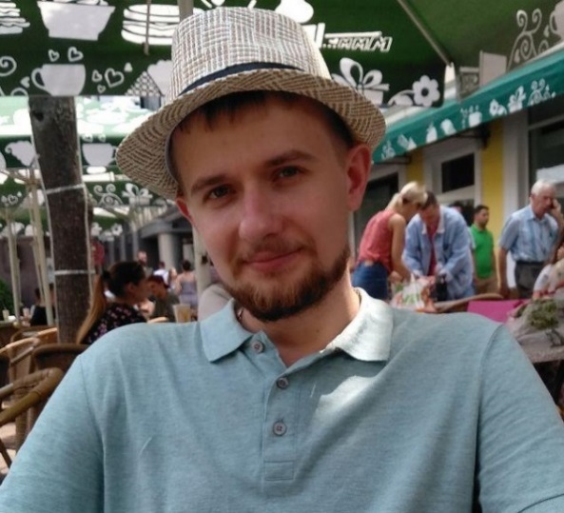Kobzar Oleh

14.01.1995

**Objective:**  :

city: Kharkiv;

e-mail: olegkobzar2209@gmail.com;

phone, viber, telegram: +380663804909;

skype: rubak_1995;

linkedIn: <https://u.to/w4ehFA>;

**Objective:**  :

Get a position Front-end developer and develop in the Front-end direction.

**Skills:** :

Good knowledge HTML5, CSS3;

Worked with JQuery, JavaScript, React;

Responsive and adaptive markups;

Pixel perfect;

Goods experience BEM, SCSS, SVG, Gulp;

Version control systems: Git, SVN;

Graphic editor: Photoshop, Illustrator, Zeplin, Figma.

**Experience:**  :

July 2021 - now;

**KopenTech**Markup developer;

Working on a product project. Layout of new blocks and support for old ones.  
  
October 2020 – June 2021;

**IT Craft**

Markup developer;

Working on a product project. Layout of new blocks and support for old ones.

April 2019 – October 2020;

**IdeaSoft**

Markup developer;

Work on large projects written in Angular and React. Layout under Wordpress. Writing simple scripts. Using Material design for Angular and Ant design for React. Participation in React projets as a developer. Teamwork.

January 2018 - April 2019;

**QuickMarkuper (Deming)**

Markup developer;

Layout of multipage sites and landings of various complexity using the GULP and SCSS preprocessor. Connection of plug-ins, as well as their customization according to layouts. Writing your own scripts, layout and implementation of calculator logic. Support for existing projects.

October 2017 – December 2017;

**Ремонт экспресс,** remote

HTML/CSS coder, content manager;

Adding, changing and filling content on existing sites. The layout of new blocks and their placement on the server.

June 2016 – May 2017;

**LTD TG “Sous”**

trading agent;

Fulfillment of planned sales of goods on the territory provided to me.

**Education:** :

**University:**

Simon Kuznets Kharkiv National University of Economics;

Finance Department;

2012 – 2016 bachelor;

2017 – 2018 magistracy;

**Additional:** informa tion

level of English: Pre-Intermediate;

marital status: married;

hobby: fishing, poker.