# Math Questions

### Question 1:

If ½ x + ½ (½ x + ½ (½ x + ½ (½ x + … = y, then x = ?  
 Choose One: a) x= 1/16 b) x=½ c) x = ⅛ d) x = y

Answer: X=y

### Question 2:

Numbers 1, 2, . . . , 100 are randomly divided in two groups 50 numbers in each. In the first group the numbers are written in increasing order and denoted a1, a2, . . . , a50. In the second group the numbers are written in decreasing order and denoted b1, b2, . . . , b50. Thus, a1 < a2 < . . . < a50 and b1 > b2 > . . . > b50. Evaluate

|a1 − b1| + |a2 − b2| + . . . + |a50 − b50|.

Answer: Divide the numbers a1, a2, . . . , a50 in two groups: less than or equal to 50 and greater than 50. Let the first group contains n numbers. Thus, a1 < a2 < · · · < an ≤ 50 < an+1 < an+2 < · · · < a50. Now, let us divide the numbers b1, b2, . . . , b50 in two groups: less than or equal to 50 and greater than 50. Then the first group contains 50 − n numbers, and the second group n numbers. Thus, b1 > b2 > · · · > bn > 50 ≥ bn+1 > bn+2 > · · · > b50. Therefore, |a1 − b1| + |a2 − b2| + · · · + |a50 − b50| = (b1−a1)+. . .(bn−an)+(an+1−bn+1)+· · ·+(a50−b50). In the last sum all terms with plus are greater than 50 and all terms with minus are less than or equal to 50 (absolute values). Thus the last sum equals (51 + 52 + · · · + 100) − (1 + 2 + · · · + 50) = 50(51 + 100) 2 − 50(1 + 50) 2 = 2500. Answer: 2500.

### Question 3:

In the trapezoid ABCD (AD || BC) |AD|+|AB| = |BC|+|CD|. Find the ratio of the length of the sides AB and CD (|AB|/|CD|).

Answer: Let DE be parallel to AB. The point E may be to the left from the point C, or to the right, or both points may coincide. First case (the left picture). The point E is to the left from the point C. Since ABED is a parallelogram, |BE| = |AD|, |AB| = |DE|. Given, |AD| + |AB| = |BC| + |CD|, one gets |BE| + |DE| = |BC| + |CD| = |BE| + |EC| + |CD|. Therefore, |DE| = |EC| + |CD|. But this cannot happen since in a triangle (in our case the triangle CDE) the length of every side is strictly less than the sum of the lengths of the other two sides.

Second case (the right picture). The point E is to the right from the point C. Then |AD| + |AB| = |BC| + |CD| = |BE| − |CE| + |CD| = |AD| − |CE| + |CD|. Therefore, |DE| = |AB| = −|CE| + |CD| and |CD| = |DE| + |CE|. This cannot happen either. So, the points C and E coinside, and |AB| |CD| = 1.

### Question 4:

Find all positive integer solutions n and k of the following equation:

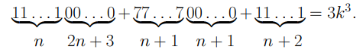

Answer:

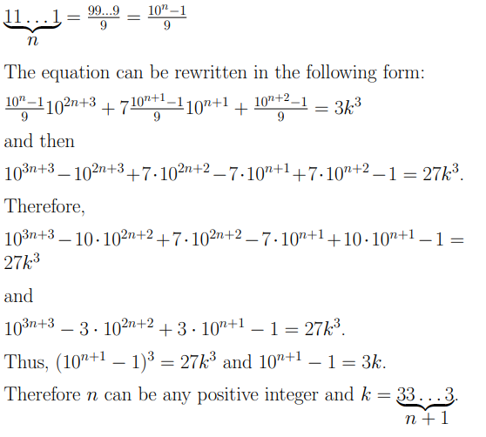

### Question 5:

An equilateral triangle is inscribed in a circle of area 1 . Then the second circle is inscribed in the triangle. Find the radius of the second circle.

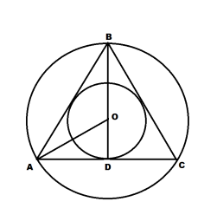

Answer: 

### Question 6:

Peter and John played a game. Peter wrote on a blackboard all integers from 1 to 18 and offered John to choose 8 different integers from this list. To win the game John had to choose 8 integers such that among them the difference between any two is either less than 7 or greater than 11. Can John win the game? Justify your answer.

Answer: 8 integers cannot be chosen

### Question 7:

Prove that given 100 different positive integers such that none of them is a multiple of 100, it is always possible to choose several of them such that the last two digits of their sum are zeros.

Answer: Let a1, a2, . . . , a100 be those numbers. Consider the following sums: S1 = a1, S2 = a1 + a2, . . . , Sk = a1 + a2 + · · · + ak, . . . , S100 = a1 + a2 + · · · + a100. Consider the last two digits of S1, S2,. . . , S100. If the last two digits of one of these sums are zeros, we are done. Otherwise, there remain only 99 combinations of the last two digits, therefore, two sums, say Sk and Sm, k < m, have the same last two digits. Thus the last two digits of Sm − Sk = ak+1 + · · · + am are zeros.

### Question 8:

The integers from 1 to 2015 are written on the blackboard. Two randomly chosen numbers are erased and replaced by their differences giving a sequence with one less number. This process is repeated until there is only one number remaining. Is the remaining number even or odd? Justify your answer.

Answer: The sequence of integers from 1 to 2015 contains 1007 even numbers and 1008 odd numbers. Consider 3 cases: 1) If both erased numbers are even they are replaced by an even number. So the number of odd numbers does not change. 2) If one number is even and another one is odd they are replaced by an odd number. So the number of odd numbers does not change. 3) If both erased numbers are odd they are replaced by an even number. So the number of odd numbers decreases by two. Thus at every step the number of odd numbers either remains the same or decreases by two. Since originally it was even, it will remain even. Therefore, when there is one number remaining this number is even.

### Question 9:

Let ABCD be a convex quadrilateral such that the length of the segment connecting midpoints of the two opposite sides AB and CD equals (|AD|+|BC|) / 2 . Prove that AD is parallel to BC.

Answer:

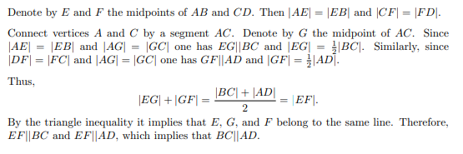

### Question 10:

Divide the following figure into four equal parts (parts should be of the same shape and of the same size, they may be rotated by different angles however they may not be disjoint and reconnected).

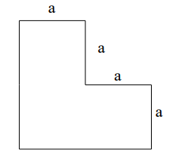

Answer:

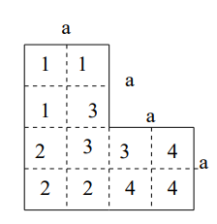

### Question 11:

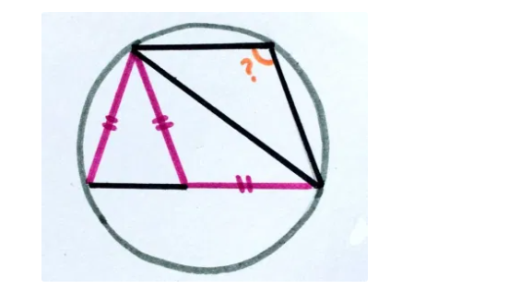

### Question 12:

Nick and John play the following game. They put 100 pebbles on the table. During any move a player takes at least one and not more than eight pebbles. Nick makes the first move, then John makes his move, then Nick makes a move again and so on. The player who takes the last pebble is the winner of the game. Can you offer Nick some strategy to win the game, can you offer John such a strategy?

Answer: We show that since Nick goes first, there is a guaranteed strategy for him to win. Let Nick takes 1 pebble on his first turn, leaving 99. now, if John takes x pebbles (1 ≤ x ≤ 8), Nick will take 9 − x pebbles. So for each pair of turns, 9 pebbles will be removed. After 10 turns, there will be 99 − 9(10) = 0 pebbles left. Whatever number, between 1 and 8, of pebbles John takes, Nick can take the remaining number and win. John can only be guaranteed to win if Nick doesn’t take 1 pebble on the first turn. If Nick takes between 2 and 8 pebbles, there will be between 92 and 98 pebbles left. John should take enough to be left with 90. Thereafter, John should take 9 − x, where x is the number of pebbles that Nick took. Again, we will be down to 9 pebbles when it is Nick’s turn, guaranteeing John a win. In general, either player should try to leave a multiple of 9 pebbles for his opponent. The first to do so wins by following the strategy above.

### Question 13:

Nick played the following game. He took 7 pieces of paper and cut some of them in 7 pieces each. Then he mixed all the pieces together, took some of them and cut again in 7 pieces each, and so on. After finishing this game he counted the number of all the pieces of paper (of different size) and told his older brother John that the number of pieces 2000. After thinking a while John told Nick that the number of pieces could not be 2000. Why did John decide that there was an error?

Answer: Nick starts off with 7 pieces. Suppose Nick cuts n1 pieces. Then he now has: 7 − n1 + 7n1 = 7 + 6n1 pieces. In the next turn, Nick cuts n2 pieces. He now has: (7 + 6n1) − n2 + 7n2 = 7 + 6(n1 + n2) pieces. In the kth turn, Nick cuts nk pieces. He now has: [(7 + 6(n1 + n2 + · · · + nk−1)] − nk + 7nk = 7 + 6(n1 + n2 + · · · nk) pieces. Nick claims that he now has 2000 pieces. That is, 7 + 6(n1 + n2 + · · · nk) = 2000 ⇒ 6(n1 + n2 + · · · nk) = 1993. Since 1993 is not divisible by 6, no integer values n1, n2, . . . nk satisfies the above. Thus John concludes that Nick made an error.

### Questions 14:

Three hexagons of increasing size are shown below. Suppose the dot pattern continues so that each successive hexagon contains one more band of dots. How many dots are in the 20th hexagon?

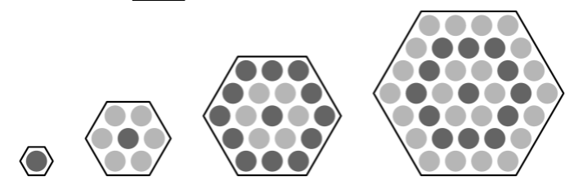

Answer: 1 + (n + 1) * n / 2 * 6 => 1 + (20 + 1) * 20 / 2 * 6 = 1 + 21 * 10 * 6 = 1261

### Question 15:

How many integers between 2020 and 2040 have four distinct digits arranged in increasing order? (For example, 2347 is one integer.)

1. 9
2. 10
3. 15
4. 21
5. 28

Answer: 15

### Question 16:

Ricardo has 2020 coins, some of which are pennies (1-cent coins) and the rest of which are nickels (5-cent coins). He has at least one penny and at least one nickel. What is the difference in cents between the greatest possible and least amounts of money that Ricardo can have?

1. 8062
2. 8068
3. 8072
4. 8082

Answer: 8072

### Question 17:

Samuel's birthday cake is in the form of a 4 X 4 X 4 inch cube. The cake has icing on the top and the four side faces, and no icing on the bottom. Suppose the cake is cut into 64 smaller cubes, each measuring 1 X 1 X 1 inch, as shown below. How many of the small pieces will have icing on exactly two sides? What about 10 X 10 X 10 cube?

Answer: 20, 68

### Question 18:

In how many ways can the letters in BEEKEEPER be rearranged so that two or more Es do not appear together?

1. 1
2. 4
3. 12
4. 24
5. 120

Answer: 24

### Question 19:

Each of the points A, B, C, D, E, and F in the figure below represents a different digit from 1 to 6 Each of the five lines shown passes through some of these points. The digits along each line are added to produce five sums, one for each line. The total of the five sums is 47. What is the digit represented by B?

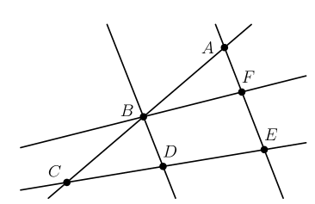

1. 1
2. 2
3. 3
4. 4
5. 5
6. 6

Answer: 5

### Question 20:

How many positive integer factors of 2020 have more than 3 factors? (As an example, 12 has 6 factors, namely 1, 2, 3, 4, 6 and 12.)

1. 6
2. 7
3. 8
4. 9
5. 10

Answer: 7

### Question 21:

A number is called flippy if its digits alternate between two distinct digits. For example, 2020 and 37373 are flippy, but 3883 and 123123 are not. How many five-digit flippy numbers are divisible by 15?

1. 3
2. 4
3. 5
4. 6
5. 8

Answer: 4 (50505, 53535, 56565, 59595)

# Cognitive Test Questions

## Numerical Reasoning

### Question 1:

What should come in place of the question mark(?) in the following number series?

9 10 24 81 340 ?

A)1376 B)1780 C)1570 D)1725 E) None of these

Answer: D

### Question 2:

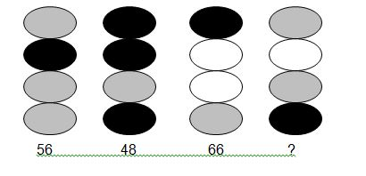

A)76 B)64 C)58 D)61 E) None of these

Answer: D

### Question 3:

A newspaper made of 16 large sheets of paper folded in half. The newspaper has 64 pages altogether. The first sheet contains pages 1, 2, 63, 64.

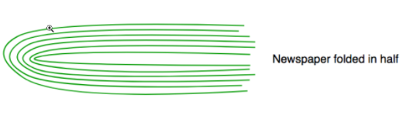

If we pick up a sheet containing page number 45, what are the other pages that this sheet contains?

Answer: 19, 20, 45, 46

### Question 4:

There are 3 ants sitting on three corners of a triangle. All ants randomly pick a direction and start moving along the edge of the triangle. What is the probability that any two ants collide?

Answer: 6/8

### Question 5:

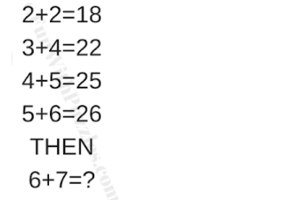

A)25 B)34 C)38 D)47

Answer: A)

### Question 6:

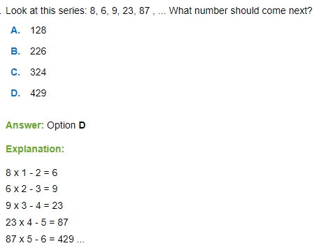

### Question 7:

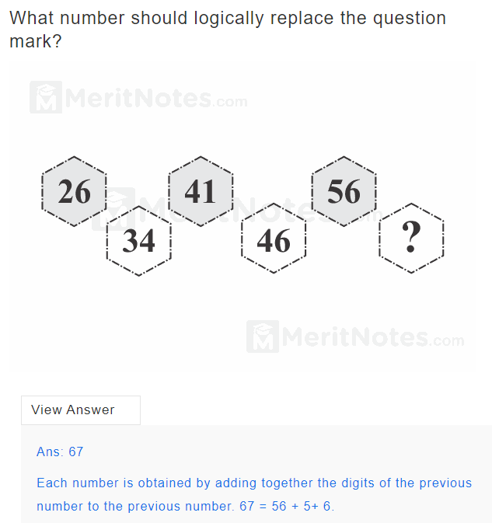

### Question 8:

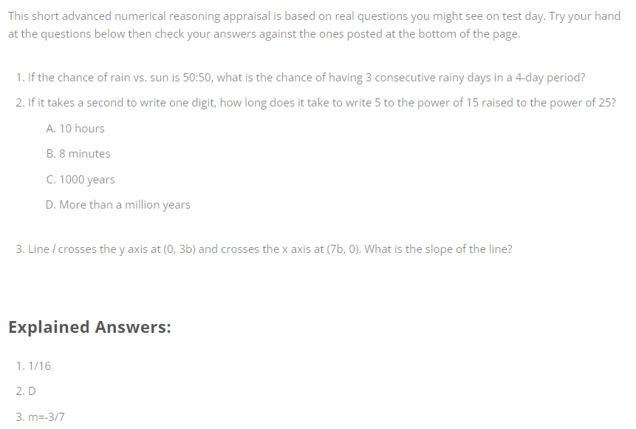

### Question 9:

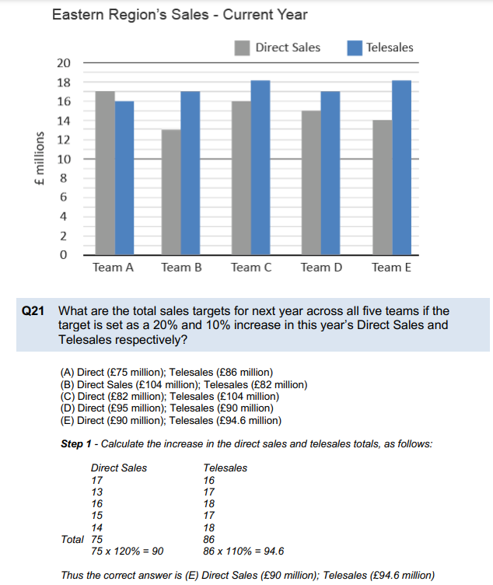

### Question 10:

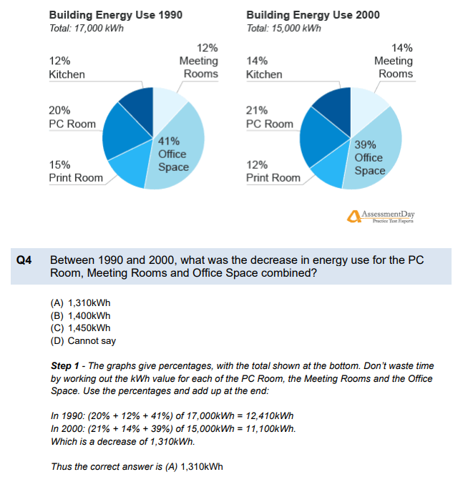

### Question 11:

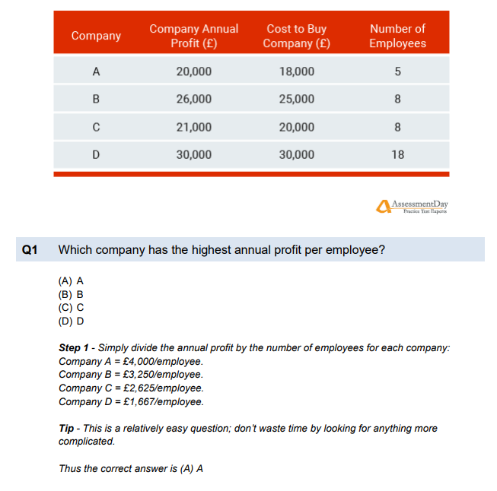

### Question 12:

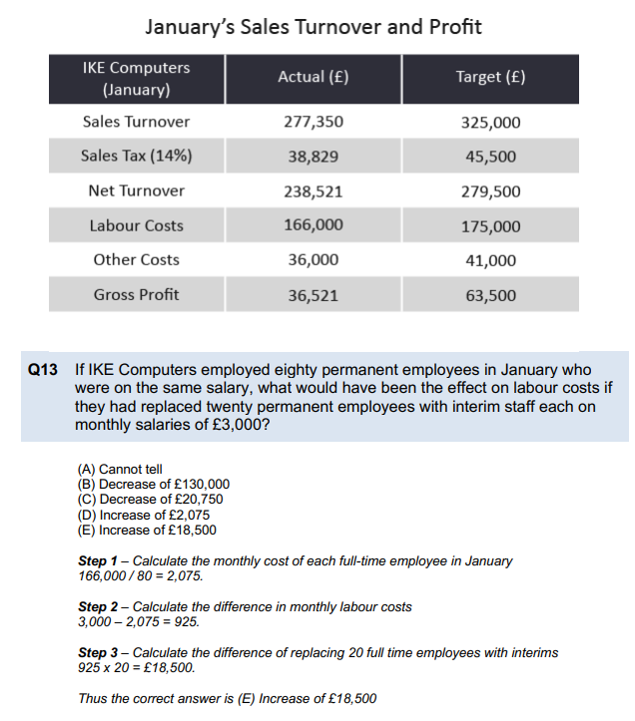

### Question 13:

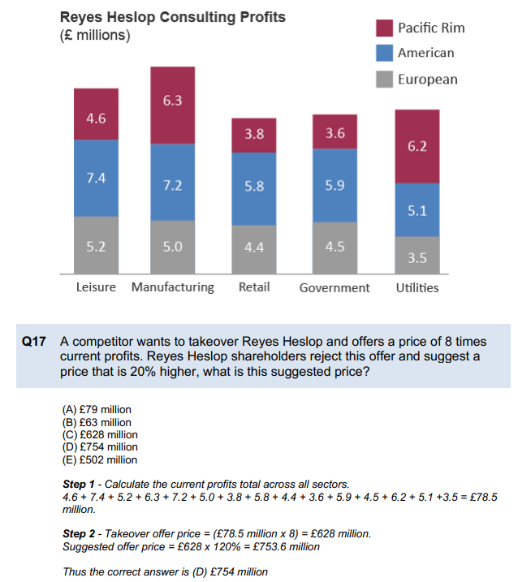

### Question 14:

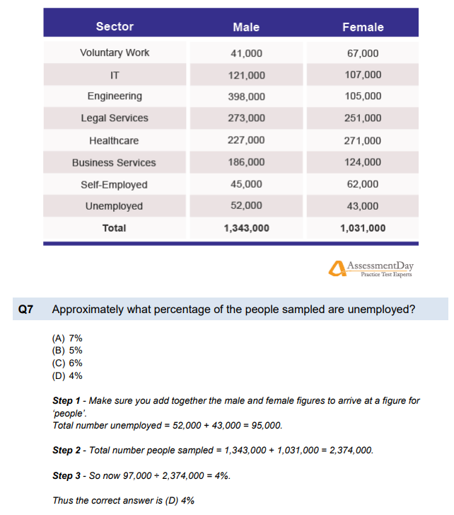

### Question 15:

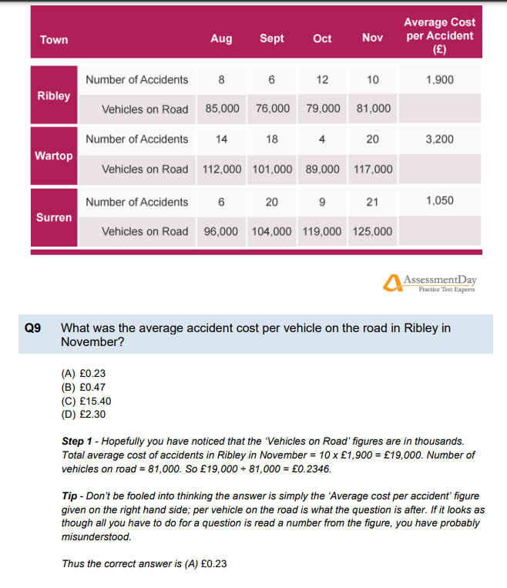

### Question 16:



### Question 17:

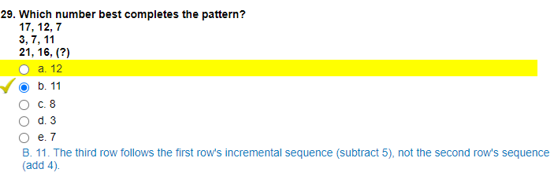

### Question 18:

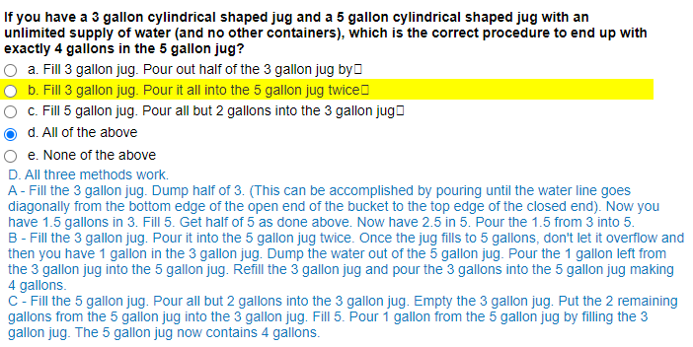

### Question 19:

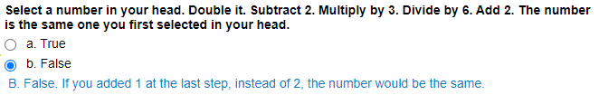

### Question 20:

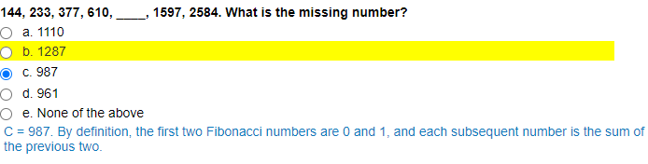

## Spatial Reasoning

### Question 1:

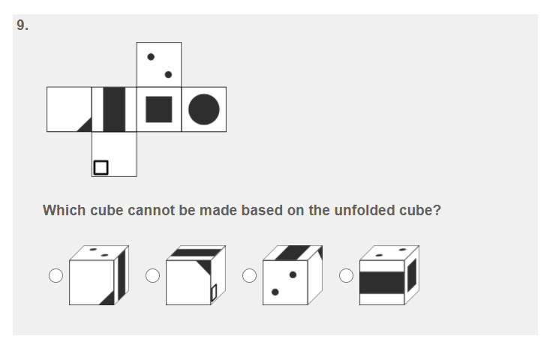

### Question 2:

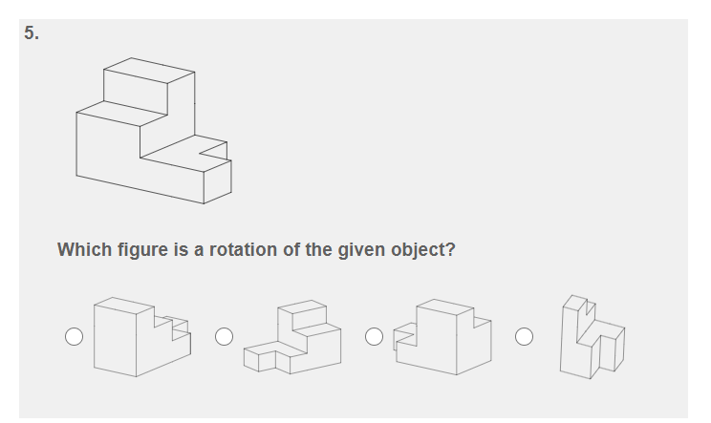

### Question 3:

What is the missing drawing?

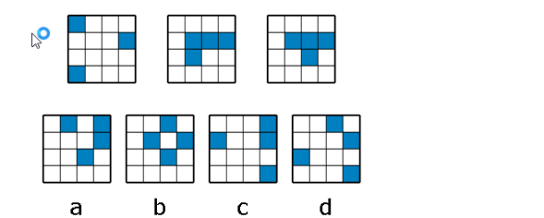

Answer: C

### Question 4:

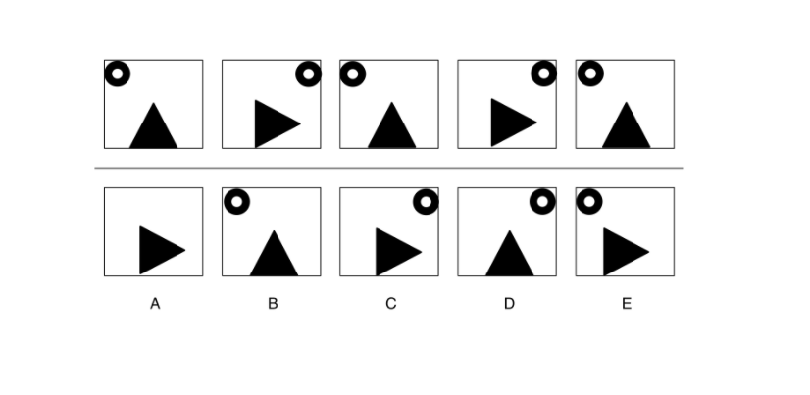

### Question 5:

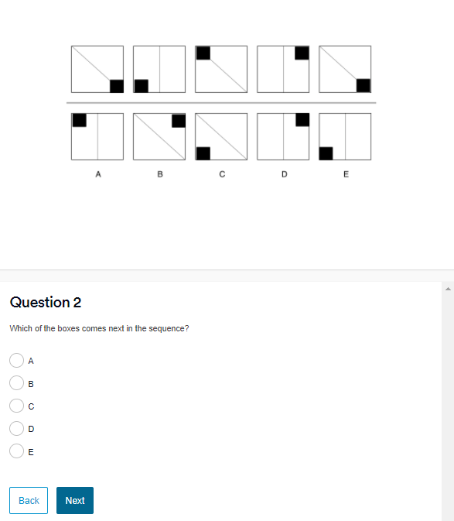

### Question 6:

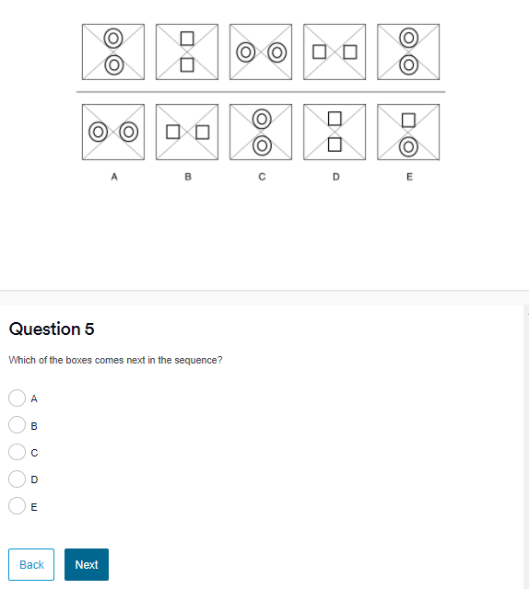

### Question 7:

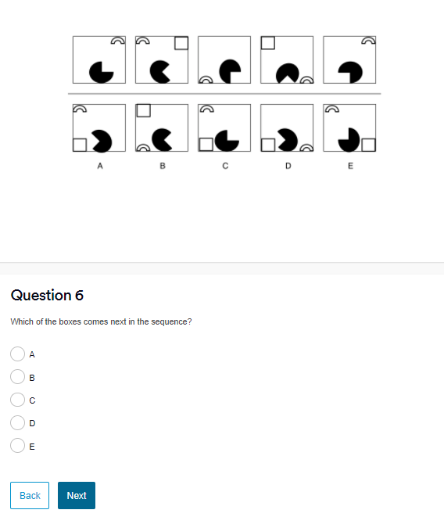

### Question 8:

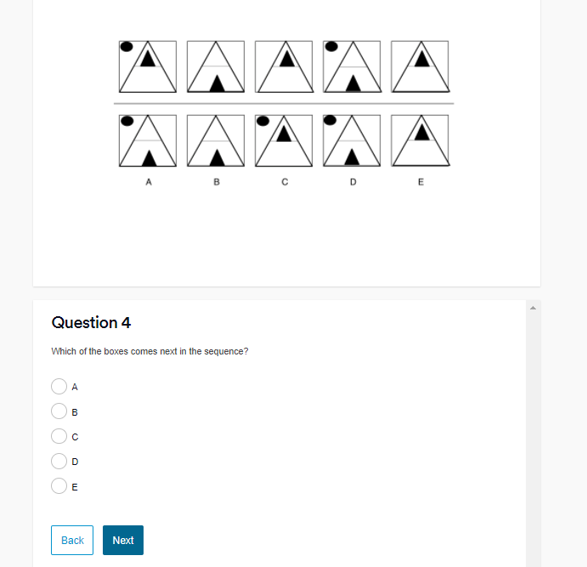

### Question 9:

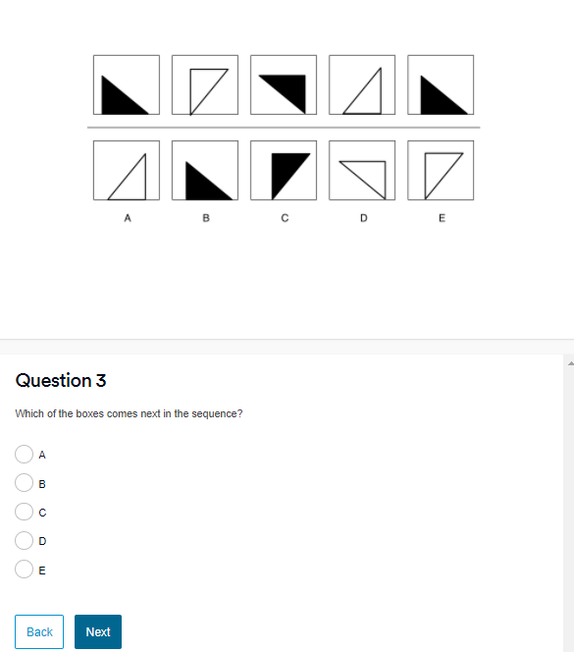

### Question 10:

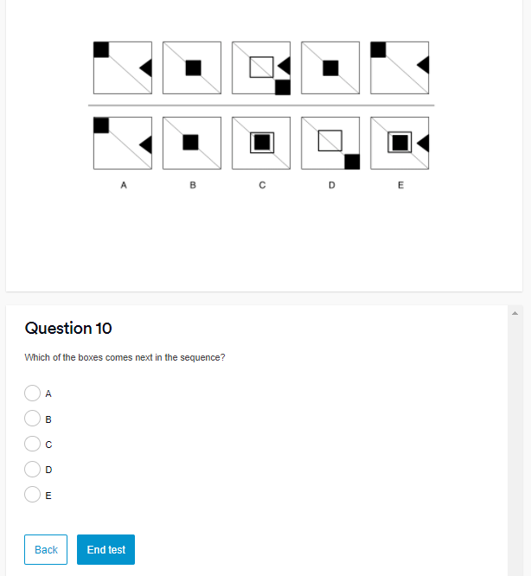

### Question 11

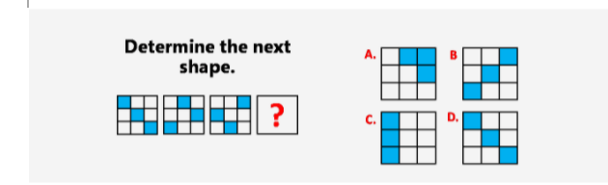

Answer: D

### Question 12

Answer: A

### Question 13

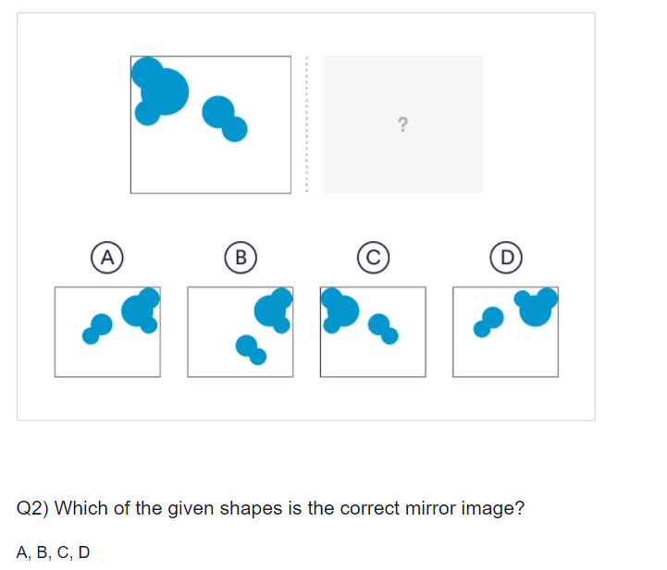

Answer: A

### Question 14

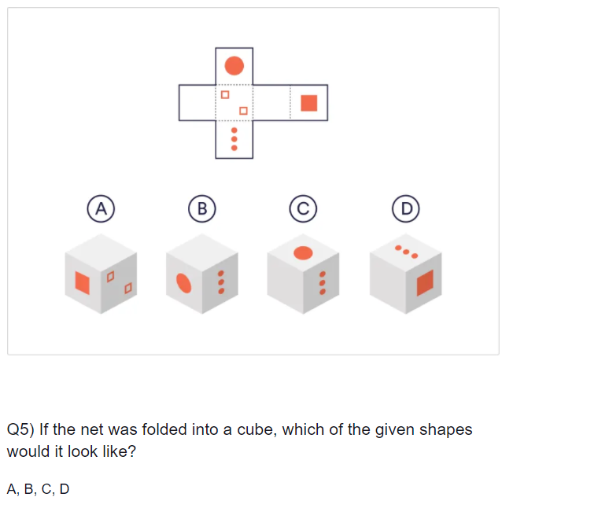

Answer: D

### 

### Question 15

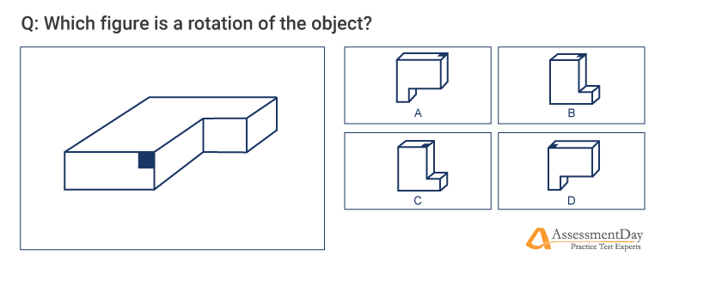

Answer: B

### Question 16

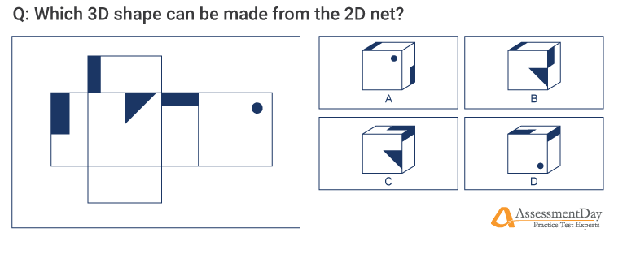

Answer: C

### Question 17

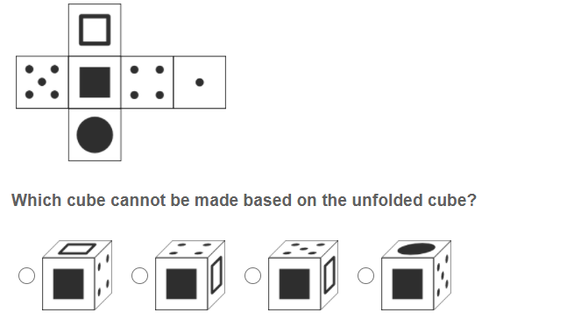

### Question 18

### 

### Question 19

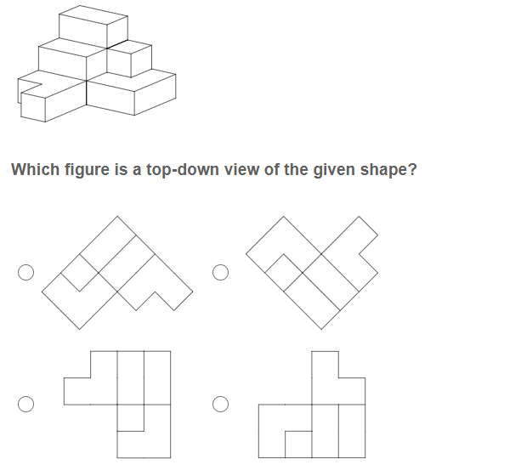

### Question 20

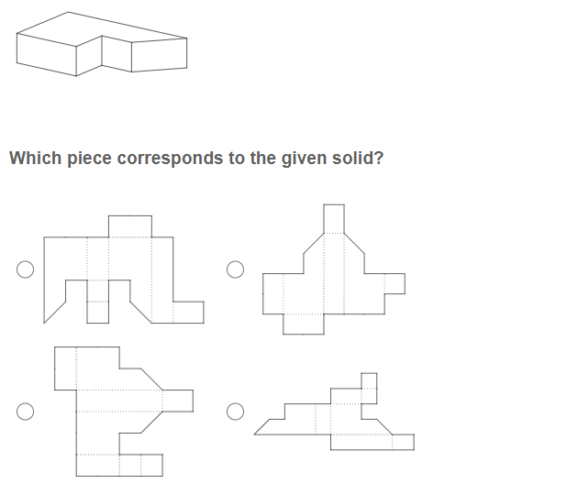

## Deductive Reasoning

### Question 1:

All footballers are fit and healthy.

All famous sports players are footballers.

Given that the above is true, which of the following is the logical deduction?

1. All footballers are famous sports people
2. All famous people are fit and healthy
3. All famous sports players are fit and healthy
4. All fit and healthy people are footballers
5. All football players are men

Answer: 3

### Question 2:

In our Sixth Form this year, 94% of students achieved A* to C grades. Last year, 95% of students achieved A* to C grades. The school has said that its new approach to mentoring students has had a brilliant impact on student performance.

Based on the information above, which of the following statements are true?

1. Next year, student performance will be less than this year.
2. All students taking A-Levels achieved A* to C
3. Before last year, no students achieved A* to C
4. Before last year, less than 94% of students achieved A* to C
5. Every school has seen a rise in student performance.

Solution: 4.

### Question 3:

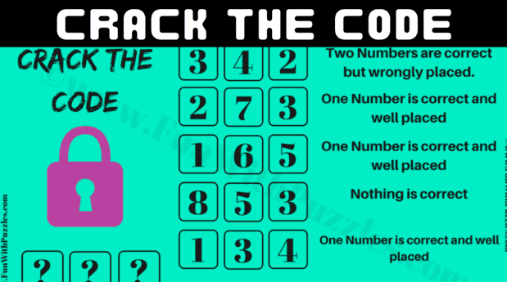

Answer: 264

### Question 4:

Statements: Some eyes are ears. Some ears are lungs. All lungs are hands

Conclusion

1. Some hands are eyes.

2. Some hands are ears

3. Some lungs are eyes

4. No hand is eye

1. None follow
2. Only 4 follows
3. Only 2 follows
4. Only 3 follows

Answer: C

### Question 5:

Statements: All liquids are solids. Some solids are gases. All gases are clouds

Conclusion:

1. Some clouds are solids

2. Some clouds are liquids

3. Some gases are liquids

4. Some solids are clouds

1. None follows
2. Only 1 and 2 follow
3. Only 3 and 4 follows
4. Only 1 and 4 follows

Answer: D

### Question 6:

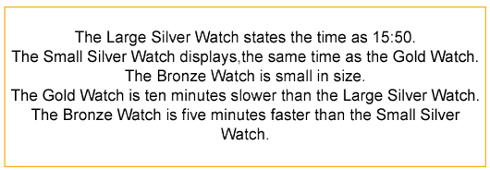

The Small Silver Watch displays the time as 16:00.

* A.True
* B.False
* C.Insufficient Information

### Question 7:

The Gold Watch displays the time as 15:40.

* A.True
* B.False
* C.Insufficient Information

### Question 8:

The Bronze Watch is the same size as the Silver Watch.

* A.True
* B.False
* C.Insufficient Information

### Question 9:

The Gold Watch shows the same time as the Bronze Watch.

* A.True
* B.False
* C.Insufficient Information

### Question 10:

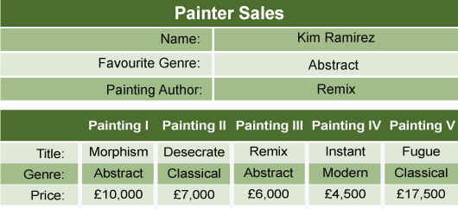

The paintings in the museum are to be filed, by genre, then title, in alphabetical order. Which painting would be positioned fourth?

* A.Painting I
* B.Painting II
* C.Painting III
* D.Painting IV
* E.Painting V

### Question 11:

Kim Ramirez sold her painting and used this money to purchase Instant. How much does she have remaining from the original sale?

* A.£500
* B.£1,000
* C.£1,500
* D.£2,000
* E.£2,500

### Question 12:

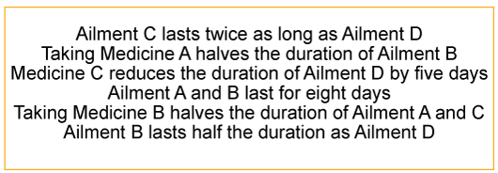

Taking Medicine B will reduce the duration of Ailment C by twelve days.

* A.True
* B.False
* C.Insufficient Information

### Question 13:

Ailment D lasts for 18 days.

* A.True
* B.False
* C.Insufficient Information

### Question 14:

Taking Medicine C will reduce the duration of Ailment D to eleven days.

* A.True
* B.False
* C.Insufficient Information

### Question 15:

Taking appropriate Medicine, Ailment D lasts longer than Ailment A.

* A.True
* B.False
* C.Insufficient Information

### Question 16:

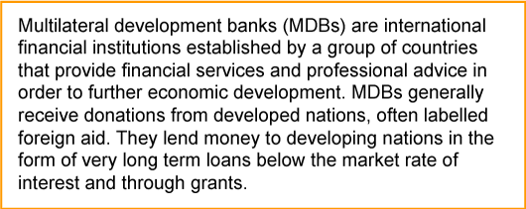

Taking each line in the argument to be true, which statement must be demonstrably false?

* A.Developing nations will eventually pay back their loans.
* B.Loans from MDBs are below the market rate of interest.
* C.MDBs lend money as typically short-term loans.
* D.MDBs are established as international ventures.
* E.An aim of MDBs is to provide economic development.

### Question 17:

https://www.practicereasoningtests.com/deductive-reasoning-questions/



Answer:

Conclusion Follows.

### Question 18:

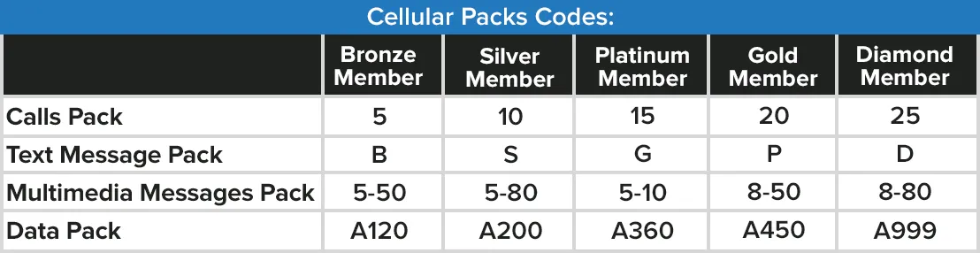

Which of the following are the correct codes for a Platinum Member customer?

A. A360, 5-10, G, 15

B. A360, 5-80, P, 20

C. A450, G-50, G, 15

D. 10, S, 5-80

E. A200

Answer:

A. A360, 5-10, G, 15

### Question 19:

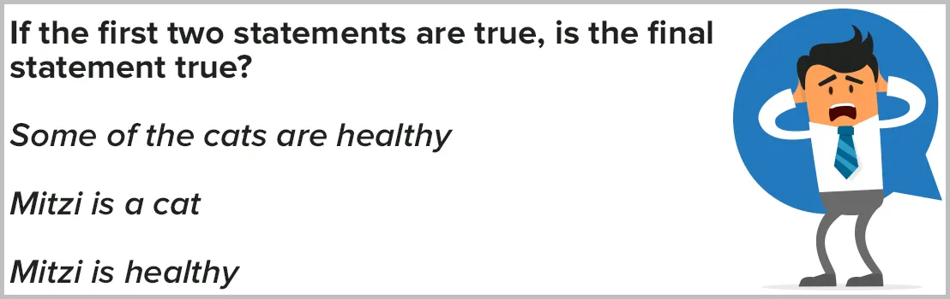

Which of the following answers is correct?

A. Yes

B. No

C. Uncertain

Answer:

C. Uncertain

### Question 20:

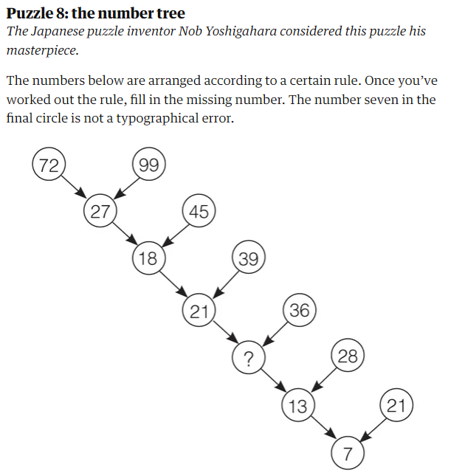

### Question 21:

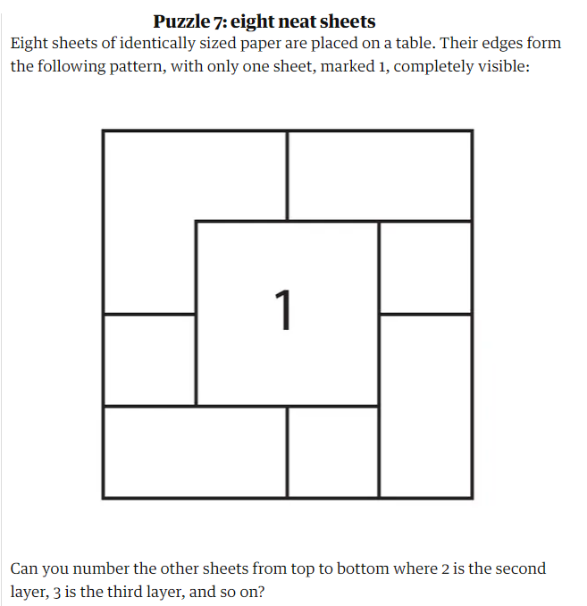

### Question 22:

1 dollar = 100 cent

= 10 cent x 10 cent

= 1/10 dollar x 1/10 dollar

= 1/100 dollar

= 1 cent

=> 1 dollar = 1 cent

solve this tricky problem ?

Answer:

step 3 is wrong

### Question 23:

From a pack of 52 cards, I placed 4 cards on the table.

I will give you 4 clues about the cards:

Clue 1: Card on left cannot be greater than the card on the right.

Clue 2: Difference between the 1st card and 3rd card is 8.

Clue 3: There is no card of an ace.

Clue 4: There are no face cards (queen, king, jacks).

Clue 5: Difference between the 2nd card and 4th card is 7.

Identify four cards?

Answer:

2 3 10 10

The 1st card has to be 2 and the last card has been 10 as there is no other way difference can be 8.

=> 2 ? 10 ?

because of clue 4, we know the 4th card is 10

=> 2 ? 10 10

because of clue 5, we know the 1st card is 3

=> 2 3 10 10

### Question 24:

I saw a Jeans for Rs97. I dont have enough money , so i borrowed Rs50 from my mom and 50 from my dad = Rs100.

I bought the jeans, and had Rs3 change. I gave dad Rs1 and my mom Rs1 and kept the other Rs1 for myself. Now I owe my mum Rs49 and my dad Rs49. 49+49 = 98 + my Rs1 = 99. Where is the missing Rs1?

Answer:

It was only a trick:

I borrowed my parents (Rs50 + Rs50 = Rs100).

I bought the jeans for Rs97 and i had Rs3 change.

So, the money that i borrowed and bought the jeans are Rs100 (borrowing money)

and the change Rs3 also the borrowing money the jeans is Rs97

Total: Rs97 + Rs3(the change) = Rs100

The money that i used to buy the jeans all i borrowed.

Rs97 is the borrowing money, change: Rs3 also the borrowing money. Rs97 + Rs3 = Rs100

### 

### Question 25:

There is a bag which have 21 blue balls and 23 red balls. You also have 22 red balls outside the bag.

Randomly remove two balls from the bag.

* If they are of different colors, put the blue one back in the bag.

* If they are the same color, take them out and put a red marble back in the bag.

Repeat this until only one marble remains in the bag.

What is the color of the sole marble left in the bag ?

Answer:

The last marble will be blue.

Since balls can only be taken out in pairs and you started off with an odd number of blues there is always going to be one blue left over that you'll keep putting back in the box until it's left on it's own.

### Question 26:

There are 3 bags and all are labeled incorrectly as follow:

Bag1 : Silver

Bag2 : Gold

Bag3 : Silver and Gold.

You need to label all bags correctly by opening just one bag.

How come ?

Answer:

It have already mention that all bag have labeled in correctly

let consider

bag A-silver

bag B-gold

bag C-gold and silver

if i open bag C ..i:e gold and silver

then i should get somthing else(silver or gold) ....becouse it have already mention that all bag are labeled in correctly

so the rest 2 bag A and B should also cantain wrong item.

So.... If i assume that bag c ....cantain silver.

Then bag A(labeled silver) should cantain gold

and bag b(labeled gold)should cantain gold and silver

becouse it have mention that all bag are labeled incorrectly

### Question 27

2 ladies and 2 girls need to cross a river in a boat big enough for 1 LADY or 2 girls. How do they do it?

GIRL and GIRL ->

<- GIRL

LADY ->

<- GIRL

GIRL and GIRL ->

<- GIRL

LADY ->

<- GIRL

GIRL and GIRL ->