Population Estimates Categorical Variables: 2000-2010 Intercensal

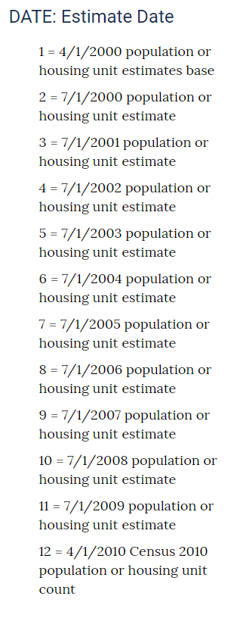

Population Estimates Categorical Variables: Vintage 2017

