Literature review.

Ostapovich Oleg

<https://youtu.be/dOn0oJuQ3VQ>

Introduction

Automation is necessary in every part of the modern world. Automation in greenhouses is not an exclusion. Research in this area continues and various methods were implemented in ordinary greenhouses to solve problems with lack of workers and productivity. Methods of automation consist internet of things and robots for harvesting with computer vision. In this literature review some types of robots for greenhouse applications will be shown.

Related work

Different types of harvesting robots were introduced by many scholars in recent years to solve the lack of robot productivity compared to humans in greenhouse.

In recent years scientific researchers continue work on rail-based robots [1]-[4]. Placing the robot on the rails allows to increase the accuracy and speed of its work as the rails remove the irregularities of the ground in the greenhouse. At the same time, the placement of rails requires additional costs of money and free space between the planting areas. Also, the distance between the rails must comply with the requirements of the robot and fit between rows of plants.

Grimstad in [1] and Arad in [2] suggested using heating pipes for plants in the greenhouse as rails. This leads to a reduction in the cost of implementing the robot on the farm, but also leads to faster wear of pipes that are not designed to withstand the weight of the robot. Proposed by Grimstad and Arad harvesting robots. They also have the ability to ride off the rails, but only on a flat surface. The need for this is caused by that the heating pipes are not a single circuit, but are connected to the main pipe in parallel.

The use of the monorail proposed by the authors in [3] as in previous solutions, it leads to cheaper placement of the robot in the greenhouse in compare with double rails. Heravi used a 0.06 m wide monorail, which can be placed without restrictions on the distance between planting areas. Among the weaknesses, the authors report difficulties in balancing the robot's center of gravity.

Recent work has shown large robot for mushroom harvesting in greenhouse [4]. Mobile platform with length of 7.7 m cover two planting areas at once. Robot frame moves along three rails located between the rows at the same time. This can be considered as three monorails from [3]. The authors have developed a robot for moving only forward and backward, so it is quite possible that there will be problems with moving the robot to other rails or with turning. Among the advantages of this design, it is stability and the ability to work simultaneously with two planting areas.

Another important section in the task of developing a greenhouse robot is computer vision (CV) systems.

Authors in [5] use an Otsu algorithm to process a gray image and recognize of ripe tomatoes. CV system uses binocular vision to operate the algorithm and calculate the length. Authors report that recognition success rate of tomatoes is 99.3%. The algorithm gives great accuracy but cannot detect and classify unripe fruits.

Afonso introduced another solution of CV with MaskRCNN algorithm in [6]. Neural network with ResNet structure trained on dataset of ripe and unripe tomatoes have metrics around 80%. The authors think that this algorithm can be improved and supplemented with the classification of not only ripe and unripe fruits but also pedicels and stems.

Another system was implemented by the Department of Engineering, University of Cambridge [7]. Localization and Classification datasets was used to train YOLOv3 and Darknet Classifier structures. This system gives to authors the coordinates of the object in the image and immediately classifies it to Harvest-Ready, Immature and Infected classes. The accuracy of finding the coordinates of this system is 91% with 100% classification task accuracy on tests in the field. This system is more demanding on computing resources, which can significantly affect the price, but at the same time gives good results on metrics.

In summary, both sections: robot design and CV are necessary for the successful operation of the robot. The stability and smoothness of the robot's movements helps the CV to detect objects faster and more accurately. Each system has pros and cons. Further study of the topic is required to select the most suitable system.

Proposed method

The project of a robot for harvesting in a greenhouse should be cheap and efficient. For this reason, the design of the robot has been simplified while the software part concentrates on accuracy. This solution is due to the tasks of the robot in the greenhouse. While in the greenhouse, the robot must move steadily between the planting areas and cut the fruits from the bush using a CV system.

Using the greenhouse heating pipes as rails is the optimal method for solving robot movement problems. When Grimstad in [1] and Arad in [2] described similar method, they also faced problems created by the design of heating pipes. For this reason, some improvements can be implemented in the previously described solution.

Greenhouses are deigned to keep heat inside during whole year. To warm up the soil are usually used heating pipes as cheap and effective way. In most cases, the pipes are connected to the main pipe. This prevents the robot from moving from one pipeline to another and the robot needs to be equipped with an additional pair of wheels to move outside the pipes. For project of harvesting robot, the end of the pipe attached to the main pipeline could be modified by lowering it under the soil. This will allow to attach additional guides to the pipe to move the robot between planting areas. The described modification will combine the task of heating the greenhouse and solve the problem of stable movement of the robot on the ground. Concept of this modification can be seen in figure 1.

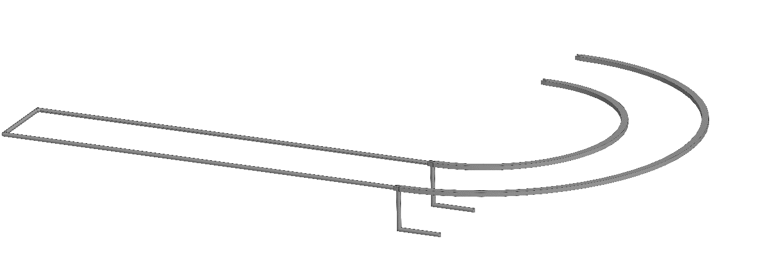

Figure 1. Proposed modification of heating pipes.

The precise positioning of the robot platform is not important for correct performance. The manipulator located on the platform must cope with the random distribution of fruits on the plant. In this regard, the robot wheels designed to move through pipes can be simplified because the robot does not need to be on the guides with high accuracy. Classic wheelset for railroad vehicle may be a sufficient and cheap solution.

From the other side, pipe positioning accuracy is important for harvesting robots. Changing the position of the pipelines can cause the robot to derail. To prevent this, the pipes need to be fixed on the foundation or supports of the greenhouse. Precise positioning on rails makes it possible to simplify the design of wheels, turn control systems and computer vision systems.

For the task of developing a universal fruit harvesting robot, computer vision based on deep neural networks (DNN) was chosen. Object detection using DNN solves the problem of lack of contrast in the image when the desired object merges with the background, as well as the problem when only part of the object is visible to the camera and the rest is covered, for example, by a leaf.

YOLOv5 neural network structure was chosen as the basis for the proposed CV system. The created neural network was trained on a dataset of 300 images of cucumbers in a greenhouse. The dataset was placed for four classes: flower, fruit, peduncle and unripe fruit. The result of the CV system is shown in Figure 2. At the output, the neural network gives the coordinates of the frame in which the object is defined, the class of the object and the probability of this object in the frame.

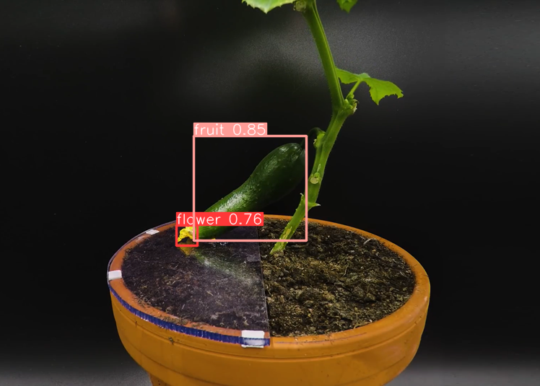

Figure 2. Results of trained on cucumbers YOLOv5.

Due to the presence of leaves on the plant at the time of harvesting, the robot needs to scan the bush for the presence of fruits, for this the manipulator with a fixed camera performs movements from the lower position to the upper one until the CV system receives coordinates. It was estimated that the image processing on the Nvidia MX150 video card takes approximately 0.23 seconds for each frame. For this reason, scanning may take a long time but solves the problem of identifying fruits in the image. Similar results have been obtained by other researchers who used DNN in their projects [6,7].

References

1. Grimstad, Lars & Zakaria, Remy & Le, Tuan & From, Pål. (2018). A Novel Autonomous Robot for Greenhouse Applications. 1-9.
2. Arad, Boaz & Balendonck, Jos & Barth, Ruud & Ben-Shahar, Ohad & Edan, Yael & Hellström, Thomas & Hemming, Jochen & Kurtser, Polina & Ringdahl, Ola & Tielen, Toon & Tuijl, Bart. (2020). Development of a sweet pepper harvesting robot. Journal of Field Robotics. 37.
3. Heravi, Amid & Ahmad, Desa & Hameed, Ibrahim & Shamshiri, Redmond & Balasundram, Siva & Yamin, Muhammad. (2018). Development of a Field Robot Platform for Mechanical Weed Control in Greenhouse Cultivation of Cucumber.
4. Rong, Jiacheng & Wang, Pengbo & Yang, Qian & Huang, Feng. (2021). A Field-Tested Harvesting Robot for Oyster Mushroom in Greenhouse. Agronomy.
5. Wang, L.L. & Zhao, B. & Fan, J.W. & Hu, X.A. & Wei, S. & Li, Y.S. & Zhou, Q.B. & Wei, C.F.. (2017). Development of a tomato harvesting robot used in greenhouse. International Journal of Agricultural and Biological Engineering.
6. Afonso, Manya & Fonteijn, Hubert & Schadeck Fiorentin, Felipe & Lensink, Dick & Mooij, Marcel & Faber, Nanne & Polder, Gerrit & Wehrens, Ron. (2020). Tomato Fruit Detection and Counting in Greenhouses Using Deep Learning. Frontiers in Plant Science.
7. Birrell, Simon & Hughes, Josie & Cai, Julia & Iida, Fumiya. (2019). A field‐tested robotic harvesting system for iceberg lettuce. Journal of Field Robotics.