Proposed method

The project of a robot for harvesting in a greenhouse should be cheap and efficient. For this reason, the design of the robot has been simplified while the software part concentrates on accuracy. This solution is due to the tasks of the robot in the greenhouse. While in the greenhouse, the robot must move steadily between the planting areas and cut the fruits from the bush using a CV system.

Using the greenhouse heating pipes as rails is the optimal method for solving robot movement problems. When Grimstad in [1] and Arad in [2] described similar method, they also faced problems created by the design of heating pipes. For this reason, some improvements can be implemented in the previously described solution.

Greenhouses are deigned to keep heat inside during whole year. To warm up the soil are usually used heating pipes as cheap and effective way. In most cases, the pipes are connected to the main pipe. This prevents the robot from moving from one pipeline to another and the robot needs to be equipped with an additional pair of wheels to move outside the pipes. For project of harvesting robot, the end of the pipe attached to the main pipeline could be modified by lowering it under the soil. This will allow to attach additional guides to the pipe to move the robot between planting areas. The described modification will combine the task of heating the greenhouse and solve the problem of stable movement of the robot on the ground. Concept of this modification can be seen in figure 1.

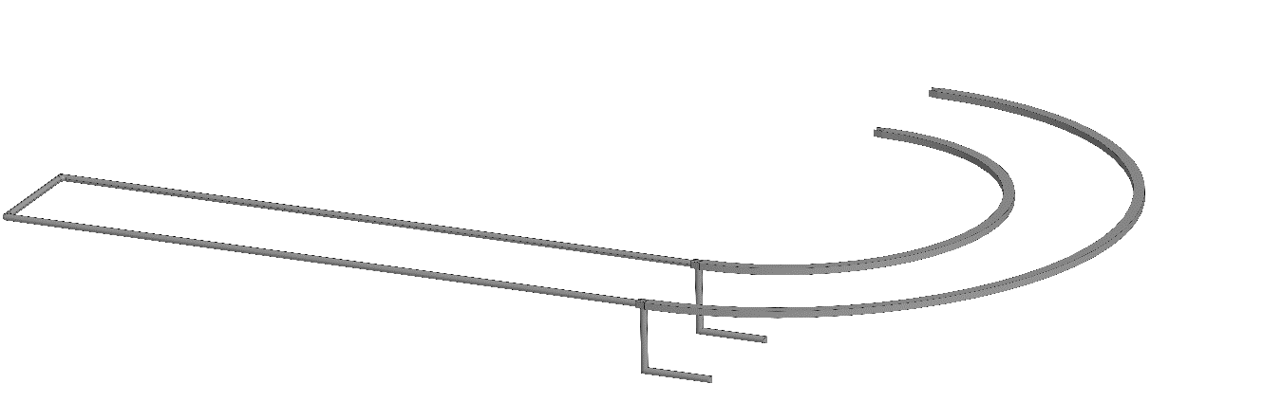

Figure 1. Proposed modification of heating pipes.

The precise positioning of the robot platform is not important for correct performance. The manipulator located on the platform must cope with the random distribution of fruits on the plant. In this regard, the robot wheels designed to move through pipes can be simplified because the robot does not need to be on the guides with high accuracy. Classic wheelset for railroad vehicle may be a sufficient and cheap solution.

From the other side, pipe positioning accuracy is important for harvesting robots. Changing the position of the pipelines can cause the robot to derail. To prevent this, the pipes need to be fixed on the foundation or supports of the greenhouse. Precise positioning on rails makes it possible to simplify the design of wheels, turn control systems and computer vision systems.

For the task of developing a universal fruit harvesting robot, computer vision based on deep neural networks (DNN) was chosen. Object detection using DNN solves the problem of lack of contrast in the image when the desired object merges with the background, as well as the problem when only part of the object is visible to the camera and the rest is covered, for example, by a leaf.

YOLOv5 neural network structure was chosen as the basis for the proposed CV system. The created neural network was trained on a dataset of 300 images of cucumbers in a greenhouse. The dataset was placed for four classes: flower, fruit, peduncle and unripe fruit. The result of the CV system is shown in Figure 2. At the output, the neural network gives the coordinates of the frame in which the object is defined, the class of the object and the probability of this object in the frame.

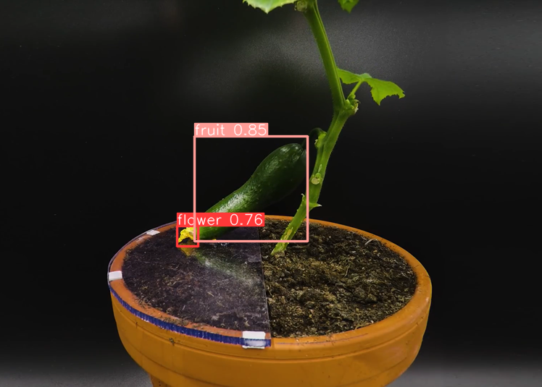

Figure 2. Results of trained on cucumbers YOLOv5.

Due to the presence of leaves on the plant at the time of harvesting, the robot needs to scan the bush for the presence of fruits, for this the manipulator with a fixed camera performs movements from the lower position to the upper one until the CV system receives coordinates. It was estimated that the image processing on the Nvidia MX150 video card takes approximately 0.23 seconds for each frame. For this reason, scanning may take a long time but solves the problem of identifying fruits in the image. Similar results have been obtained by other researchers who used DNN in their projects [3,4].

References

1. Grimstad, Lars & Zakaria, Remy & Le, Tuan & From, Pål. (2018). A Novel Autonomous Robot for Greenhouse Applications. 1-9.
2. Arad, Boaz & Balendonck, Jos & Barth, Ruud & Ben-Shahar, Ohad & Edan, Yael & Hellström, Thomas & Hemming, Jochen & Kurtser, Polina & Ringdahl, Ola & Tielen, Toon & Tuijl, Bart. (2020). Development of a sweet pepper harvesting robot. Journal of Field Robotics. 37.
3. Afonso, Manya & Fonteijn, Hubert & Schadeck Fiorentin, Felipe & Lensink, Dick & Mooij, Marcel & Faber, Nanne & Polder, Gerrit & Wehrens, Ron. (2020). Tomato Fruit Detection and Counting in Greenhouses Using Deep Learning. Frontiers in Plant Science.
4. Birrell, Simon & Hughes, Josie & Cai, Julia & Iida, Fumiya. (2019). A field‐tested robotic harvesting system for iceberg lettuce. Journal of Field Robotics.