Adjustment and external replication of drug–hearing-loss signals: a disproportionality analysis of FAERS and Canada Vigilance
Oleg Tropynin
Independent researcher, Karaganda, Kazakhstan
tropininoleg@gmail.com ORCID: 0009-0006-5431-4285
Abstract
Aim: Recent analyses of the US Food and Drug Administration Adverse Event Reporting System (FAERS) reported many drug–hearing-loss signals absent from labels. We assessed which survive adjustment for hearing-specific biases and external replication.
Methods: Disproportionality analysis of 19.9 million deduplicated FAERS reports (2004–2026) and 1.2 million Canada Vigilance reports, following a protocol committed before analysis. For hearing loss and tinnitus, crude reporting odds ratios (signal: lower 95% bound $>1$, $≥$3 cases) were compared with Mantel–Haenszel estimates stratified by age, sex and period after excluding ear-related indications, reports naming established ototoxic drugs and lawyer reports. Methods were compared on a label-derived reference set (area under the receiver operating characteristic curve, AUC) and by replication in Canada; robust unlabelled signals underwent case-by-case review.
Results: Adjustment substantially changed the hearing-loss signal list (63 of 300 crude signals lost, 73 gained) but not agreement with labels (AUC, crude vs adjusted lower bound: 0.718 vs 0.723). Unlabelled signals replicated in Canada more than background, less than labelled ones; power-calibrated (post hoc), labelled signals replicated as predicted (observed/expected 1.02, 95% CI 0.77–1.32) and unlabelled ones did not (0.44, 0.29–0.62), even within consumer-reporting strata. Solicited reports, report clusters and shared co-medication produced spurious replications. Of 22 robust unlabelled signals (post hoc), 15 had artefactual or known explanations; 7 remained (2–9 under alternative choices).
Conclusion: Most unlabelled FAERS hearing-loss signals do not survive adjusted replication and provenance review. Findings are hypothesis-generating; cross-database replication needs adjusted estimates and explicit handling of solicited reports.
Keywords: adverse drug reaction reporting systems; pharmacovigilance; hearing loss; tinnitus; ototoxicity; signal detection

What is already known about this subject
- Screens of FAERS using crude disproportionality have reported many drug–hearing-loss signals absent from labels.
- These screens rarely address hearing-specific biases or test their signals in an independent database.

What this study adds
- Adjustment changed which drugs were flagged but not agreement with labels.
- Labelled signals replicated in Canada Vigilance as predicted; unlabelled signals less than half as often.
- After review of report provenance, 7 of 22 robust unlabelled signals remained, as hypotheses only.

Introduction
The classical ototoxic drugs—aminoglycosides, platinum agents, loop diuretics, quinine, salicylates—were identified mainly through clinical observation and case series [1]. For newer drugs, spontaneous reports are often the first evidence, and recent studies have screened the FDA Adverse Event Reporting System (FAERS) across all drugs for hearing-loss signals [2–4] and for tinnitus [5,6], as have national databases in Japan and France [7,8]. These screens identify many unlabelled signals, but few evaluate whether those signals survive adjustment and independent replication.
The FAERS screens share a design: crude disproportionality across all reports, with novelty defined as absence from the label. This design is open to biases specific to hearing outcomes. Corticosteroids, vasodilators and antivirals are prescribed for sudden hearing loss and tinnitus, and several diseases cause hearing loss themselves (confounding by indication). A drug routinely given with a strongly ototoxic one—an antiemetic with cisplatin, an antibiotic with an aminoglycoside—inherits part of the association (co-medication bias). Reporting can be stimulated by safety communications, litigation or media attention [9]. Editorials have questioned disproportionality analyses that ignore such biases [10], and signal lists are rarely tested against an independent data source or a reference set, as is done in evaluations of signal-detection methods [11].
We therefore asked a narrower question than “which drugs are ototoxic?”: which hearing-loss and tinnitus signals remain after adjustment for these biases, and do the signals that remain replicate in an independent national database and over time? We compared crude and adjusted detection against a reference set derived from US labels, replicated every signal in Canada Vigilance, re-tested the signals reported by previous FAERS screens, and reviewed the report provenance of every robust unlabelled signal.

Methods
The study is reported according to the READUS-PV guideline [12,13]; the checklist is given in Supplementary Table S1. Primary analysis decisions were committed before the first result was computed; all later analyses are labelled post hoc. The protocol, with all definitions and thresholds of the primary analysis, was committed to a version-controlled repository at 02:05 UTC+5 on 26 October 2026 (git commit ff77c40). The first disproportionality estimates were produced at 02:47–02:49 the same night; before that, only data preparation, the label reference set and tests on simulated data had been run. The repository is controlled by the author and the protocol was not registered with a third party. Every later change is dated and labelled in the protocol file (PROTOCOL.md). Figure 1 separates the pre-specified analyses from those added after the primary results were seen.
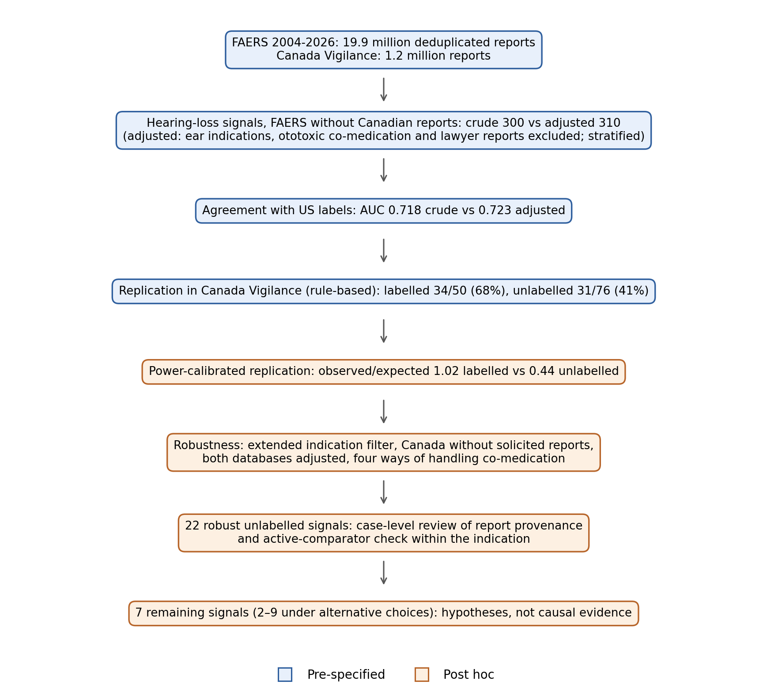
Study workflow. Blue: pre-specified analyses (protocol committed before the first result). Orange: analyses added after the primary results were seen (post hoc). The remaining signals are hypotheses, not evidence of causation.

Data sources
We used all 90 quarterly ASCII extracts of the legacy Adverse Event Reporting System (2004Q1–2012Q3) and FAERS (2012Q4–2026Q2), published by the US Food and Drug Administration; the Canada Vigilance Adverse Reaction Online Database extract (Health Canada; reports received 1965 to 30 June 2026); and the openFDA bulk export of structured product labels (23 October 2026) [14]. Events are coded in MedDRA preferred terms (PTs), at the version current when each quarter was released (FAERS) and version 29.0 (Canada Vigilance); outcome terms were matched by preferred-term name, which is stable across these versions for the terms used. All data are public and de-identified.

Pre-processing and deduplication
In FAERS we kept the most recent version of each case (by FDA receipt date, preferring FAERS over legacy records, then case version), removed cases on FDA deletion lists, removed report identifiers recorded under two case numbers, and collapsed content duplicates: reports with identical sex, age, event date, country, set of suspect ingredients and set of reactions (applied only when event date and age were present). Drug names were mapped to active ingredients: the prod_ai field was split into ingredients; salt and hydrate words were removed when the remaining base was itself an observed ingredient; free-text names in records without prod_ai were mapped to the dominant ingredient recorded for that name ($≥$70% of $≥$5 records); INN/USAN synonyms were merged (for example glycopyrronium and glycopyrrolate); four-letter biologic suffixes were removed; and non-specific entries (for example “vitamins”, “minerals”, “… NOS”) were dropped. Combination products contribute to each of their ingredients. In Canada Vigilance, reports flagged as duplicates of a report present in the extract were removed and product ingredients were normalised with the same rules.

Outcomes, exposure and comparator
The primary outcome, hearing loss, comprised the MedDRA PTs Deafness; Deafness unilateral, bilateral, neurosensory, transitory, permanent and mixed; Hypoacusis; Neurosensory hypoacusis; Sudden hearing loss; Ototoxicity; Hearing impaired; Hearing disability; and High frequency hearing loss. Conductive and congenital deafness were excluded. The secondary outcome was Tinnitus. An ingredient was exposed when reported as a suspect drug (FAERS primary suspect, secondary suspect or interacting; Canada suspect or interacting). The comparator for each ingredient was all other reports in the same population. Missing age and sex formed their own strata; missing indication or country was treated as not meeting the corresponding exclusion.

Disproportionality
For each ingredient we computed the reporting odds ratio (ROR) with a Woolf 95% confidence interval [15,16] and the information component (IC) with its lower credibility bound IC$​_{025}$ [17]. A crude signal required at least three cases, a lower ROR bound above 1 and IC$​_{025}>0$.
The pre-specified adjusted analysis was run in a restricted population and stratified. We excluded (i) reports in which any drug had an ear or hearing indication (deafness, hearing, tinnitus, ototoxicity, Ménière’s disease, otitis, vertigo, vestibular, labyrinthine and cochlear terms); (ii) reports that mentioned, in any role, a drug from an a-priori list of 29 drugs from the established ototoxic classes [1] (aminoglycosides, capreomycin and vancomycin; cisplatin, carboplatin and oxaliplatin; loop diuretics; quinine and related antimalarials; aspirin; macrolides; deferoxamine; vincristine; eflornithine) other than the drug under study; and (iii) FAERS reports submitted by lawyers (Canada Vigilance does not record this). For a drug on the list, reports naming the drug itself in a non-suspect role were also removed from its population. We then computed the Mantel–Haenszel (MH) OR [18] over 60 strata (five age bands $×$ sex [male, female, unknown] $×$ four periods of report receipt: before 2004, 2004–2012, 2013–2018, 2019–2026) with the Robins–Breslow–Greenland variance [19]. An adjusted signal required at least three cases in the restricted population and a lower 95% bound above 1. The implementation reproduces statsmodels estimates on simulated data to nine decimal places.

Reference set
From single-ingredient US labels we classified each ingredient as label-positive when a hearing-loss term appeared in a safety section (boxed warning, warnings, precautions, adverse reactions, post-marketing experience, contraindications, overdosage, drug abuse and dependence, or the corresponding over-the-counter sections) of at least half of its prescription labels, and label-negative when no label mentioned hearing loss or tinnitus; other ingredients were left out. Phrases that contain a hearing word without describing an adverse effect (for example the disease name “maternally inherited diabetes and deafness” and telephone lines for deaf users) were removed first. Discrimination was measured by the area under the ROC curve (AUC) among ingredients with $≥$1,000 suspect FAERS reports, comparing the crude and adjusted lower 95% bounds (the like-for-like pair; the protocol pre-specified the crude IC$​_{025}$, which is also reported) and point estimates; the difference was bootstrapped (2,000 resamples). Because labels are partly informed by spontaneous reports, the reference set compares methods with each other; it does not estimate absolute accuracy.

Replication
For external replication, signals were derived in FAERS after removing reports of Canadian origin and tested in Canada Vigilance. Pre-specified rule: an ingredient was testable when the observed or expected number of Canadian cases was at least three, and replicated when the Canadian lower ROR bound exceeded 1 with at least three cases. The same rule applied to label-negative ingredients that were neither crude nor adjusted FAERS signals gave the background rate of replication without a known association; label-negative ingredients that were adjusted signals form a second reference group. Because the testability rule depends on the observed count, we also computed a power-calibrated comparison (post hoc): for every ingredient with a Canadian expected count $E>0$, replication was defined as an observed count of at least $a_{crit}$, the smallest count $≥3$ with Poisson $P(X≥a∣E)<0.025$, and the expected number of replications was the sum over ingredients of the Poisson probability of reaching $a_{crit}$ when the mean is $E_{i}$ times OR$​_{i}$, with OR$​_{i}$ the adjusted FAERS estimate shrunk towards the null by empirical Bayes (log OR $× τ^{2}/(τ^{2}+{se}^{2})$, with $τ^{2}$ estimated across all ingredients) to counter the selection of signals on their estimate; observed-to-expected ratios near 1 indicate that signals replicate as often as their FAERS strength predicts. Confidence intervals were bootstrapped over ingredients (2,000 resamples). In the post-hoc adjusted-to-adjusted analysis the Canadian adjusted case count was compared with its stratified expected count. For temporal replication, signals derived from reports received up to 2014 were tested in reports received from 2015 onwards. Rates were compared with Fisher’s exact test.

Post-hoc and sensitivity analyses
After the primary results were seen we added: Canada Vigilance without solicited reports (“Study” report type, which includes manufacturers’ patient-support programmes); an extended indication filter (further ear terms; diseases that themselves cause hearing loss, such as Fabry disease, mucopolysaccharidoses, cryopyrin-associated syndromes, meningitis, giant cell arteritis and thyroid eye disease; and reports of prenatal exposure); and replication in which the Canadian estimate is adjusted in the same way as the FAERS one (adjusted-to-adjusted). In this post-hoc framework, ototoxic co-medication was handled in three further ways: as a stratum dimension instead of an exclusion (because restricting on a variable that reporters may add after observing hearing loss can introduce selection bias), with a short list of strongly ototoxic drugs only, and after excluding reports that list 15 or more drugs (report clusters). Canada Vigilance was also restricted to reports received from 2004.

Robust signals and case-level review
A robust signal (post hoc) was an adjusted FAERS signal that replicated adjusted-to-adjusted in Canada Vigilance without solicited reports. Throughout, a signal is labelled when the event is mentioned in any safety section of any US label of a product containing the drug (single-ingredient or combination) and unlabelled otherwise, including drugs with no US label in the export; label-positive and label-negative refer to the stricter reference-set classes. Robust unlabelled signals were reviewed. For each we profiled the FAERS case series (without Canadian reports): share of cases from the most frequent country and receipt year, consumer reports, reports listing $≥$15 drugs, reports co-naming an established ototoxic drug, prenatal exposure and leading indications; we searched PubMed for the drug with hearing terms. Each signal was assigned the first applicable category of a written rubric: K, established ototoxic class or association documented by a prospective or cohort clinical series; A, report cluster ($≥$50% of cases in reports listing $≥$15 drugs); B, ototoxic co-medication ($≥$50% of cases co-name an established ototoxic drug); C, stimulated or solicited reporting documented for the drug; D, main indication itself associated with the event; E, none of these. The rubric distinguishes C from D only on documented evidence; a high consumer share alone does not make a signal C. Because confounding by indication remained plausible after the indication exclusions (reported indications are often missing or non-specific), for category D we additionally required that the signal not persist against other drugs used for the same indication: within FAERS reports (without Canadian origin) whose indication matched the drug’s main indication, we computed the ROR of the drug against all other suspect drugs (active-comparator check, post hoc). The author applied the rubric, and a second, AI-based assessor applied it blind to the author’s assignments, with the same profiles and literature access; agreement is reported as Cohen’s $κ$.

Software and use of AI tools
Analyses used Python 3.10 (numpy 2.2.6, pandas 2.3.3, scipy 1.15.3, statsmodels 0.15.0, matplotlib 3.10.9). An AI assistant (Claude, Anthropic) wrote the code and the first draft of the manuscript under the author’s direction, and AI reviewers critiqued the methods, clinical interpretation and text; changes made in response are recorded in the protocol file. The second assessor of the case-level review was also AI-based. The author reviewed the code, results and text and is responsible for them.

Results

Data
The 90 FAERS extracts held 24,812,424 report versions, from which 20,692,682 cases remained after keeping the latest version; 104,186 cases on FDA deletion lists, cases without a reaction or mappable ingredient, 1,681 report identifiers recorded under two cases and 510,312 content duplicates were then removed, leaving 19,876,330 reports (4% of drug rows could not be mapped; Supplementary Figure S1). They contained 83,883 hearing-loss and 42,900 tinnitus reports; hearing-loss reports came more often from consumers and from patients aged $≥$65 years than other reports (Supplementary Table S4). Without Canadian reports, the population used for signal detection held 19,135,329 reports and 8,122 suspect ingredients; its adjusted subset excluded 18,735 reports with an ear or hearing indication, 1,712,914 reports naming a listed ototoxic drug and 484,957 lawyer reports, leaving 16,962,022 reports (67,913 hearing-loss cases). Canada Vigilance contributed 1,210,857 reports after removing 58,623 duplicates (4,000 hearing-loss and 3,284 tinnitus reports).
Drugs of the established ototoxic classes gave strong signals in both databases (Supplementary Table S2), for example amikacin (FAERS adjusted OR 12.7 (11.6–13.9)), gentamicin (11.4 (9.8–13.2)) and cisplatin (4.3 (4.0–4.6)); so did the PDE5 inhibitors sildenafil (3.9 (3.7–4.2)) and tadalafil (4.2 (3.9–4.6)), whose labels carry hearing-loss warnings, and teprotumumab (59.8 (55.4–64.5)). Some label-positive drugs did not signal: oxaliplatin (crude ROR 0.44) and vardenafil (6 cases); carboplatin was a crude signal that fell below 1 after adjustment (1.96 to 0.82), as did vincristine’s estimate, an example of the sensitivity that the co-medication filter costs.

Adjustment changes the signal list but not its agreement with labels
In FAERS without Canadian reports the crude rule flagged 300 ingredients for hearing loss and the adjusted rule 310; 63 crude signals were lost and 73 appeared (Table 1). Against the reference set (106 label-positive and 927 label-negative ingredients with $≥$1,000 suspect reports), discrimination was moderate and practically identical. For the like-for-like pair, crude versus adjusted lower bound, the AUC was 0.718 vs 0.723 (difference 0.005, 95% CI -0.023 to 0.030); for the pre-specified pair, crude IC$​_{025}$ versus adjusted lower bound, it was 0.720 vs 0.723. Adjustment thus changed which drugs were flagged but brought almost no improvement in agreement with labels. The same held for point estimates (0.700 vs 0.705), after excluding the 83 ingredients without an estimable adjusted bound (0.698 vs 0.703), at lower report thresholds, without the 29 listed drugs, and for tinnitus (0.775 vs 0.777). Adjustment lowered sensitivity (0.40 to 0.35) with little change in specificity (0.866 to 0.873).

Replication in Canada Vigilance
Under the pre-specified rule, adjusted hearing-loss signals already on a label replicated in 34/50 (68%) of testable cases and unlabelled adjusted signals in 31/76 (41%) (Table 1). Label-negative adjusted signals replicated in 21/54 (39%) and crude-only signals in 9/21 (43%). The background—label-negative ingredients that were neither crude nor adjusted signals—replicated in 43/214 (20%) (all label-negative ingredients, as literally specified in the protocol: 68/281 (24%)). In this pre-specified comparison unlabelled signals replicated more often than the background (odds ratio 2.74, Fisher $p<0.001$) but less often than labelled signals.
The power-calibrated comparison (post hoc) placed this contrast on a common scale (Figure 2). Labelled signals (n=70 ingredients) replicated about as often as their shrunken FAERS estimates predicted (31 observed vs 30.5 expected; O/E 1.02, 95% CI 0.77–1.32). Unlabelled signals (n=201) replicated less than half as often (25 observed vs 56.8 expected; O/E 0.44, 95% CI 0.29–0.62); the ratio of the two was 0.43 (95% CI 0.26–0.66). The label-negative signals, a subset of the unlabelled group, behaved alike (18 observed vs 37.5 expected; O/E 0.48, 95% CI 0.27–0.72). Results were the same with unshrunken estimates, with the pre-specified label definition, and for tinnitus (60 observed vs 63.2 expected; O/E 0.95, 95% CI 0.79–1.14 for labelled and 22 observed vs 46.4 expected; O/E 0.47, 95% CI 0.29–0.66 for unlabelled signals).
Unlabelled signals were more often reported by consumers (median share of FAERS cases 58% vs 39% for labelled signals) and more often from the United States (67% vs 50%), so provenance could explain the contrast. It did not: among signals with a consumer share at or below the median, O/E was 1.01 for labelled and 0.57 (95% CI 0.27–0.93) for unlabelled signals, and above the median 1.04 and 0.36. Pooled across ingredients (random effects), the Canadian ROR was 3.60 (2.47–5.26) for labelled and 1.59 (1.28–1.96) for unlabelled signals: as a group, unlabelled signals were attenuated rather than absent.
The replication test was not conservative: label-negative non-signals replicated 4.2 times as often as expected without any association (36 vs 8.5). Solicited reports explained much of this: Study reports, which include manufacturers’ patient-support programmes, made up 61% of Canadian hearing-loss cases for the background drugs that replicated, against 14% for replicated labelled signals and 36% overall; for ocrelizumab, mepolizumab and omalizumab the share was 93%, 93% and 86%, against 1% for gentamicin and 1% for cisplatin. The mirror image appeared in FAERS: tafamidis (adjusted OR 4.3 (3.8–4.8)) had 361 hearing-loss reports in FAERS (86% from consumers, 97% from the United States) but none in Canada Vigilance against 3.4 expected, and sacubitril (2,801 FAERS hearing-loss reports; 88% from consumers) none against 1.9 expected (too few to be testable).
Co-medication bias can also replicate when crude estimates are compared. Etoposide, given in cisplatin-containing regimens, was a crude signal in both databases (FAERS ROR 2.09 (1.91–2.28); Canada 5.13 (3.68–7.14)); after adjustment the FAERS estimate reversed (0.67 (0.46–0.98)) and the Canadian one rested on 2 cases (1.15 (0.29–4.64)). Temporal replication within FAERS did not favour adjustment for hearing loss: early crude-only signals recurred after 2014 at least as often (18/28 (64%)) as early adjusted signals (81/155 (52%); background 137/938 (15%)), consistent with biases that persist within one database; for tinnitus adjusted signals recurred more often (100/121 (83%) vs 9/15 (60%)).

Post-hoc analyses
The post-hoc framework combined the extended indication filter, Canada Vigilance restricted to unsolicited reports and adjusted estimates in both databases (Table 2). In it, labelled hearing-loss signals replicated in 26/44 (59%), unlabelled signals in 10/51 (20%) and the background in 19/158 (12%) (Fisher $p=0.24$). Calibrated on adjusted Canadian counts, O/E was 1.10 (95% CI 0.79–1.48) for labelled and 0.26 (0.11–0.43) for unlabelled signals (ratio 0.24, 95% CI 0.09–0.44); the pooled Canadian adjusted OR was 4.25 (2.73–6.64) for labelled, 1.37 (1.03–1.83) for unlabelled and 1.29 (1.00–1.66) for label-negative signals. For tinnitus, labelled signals replicated less fully in this framework (O/E 0.70, 95% CI 0.54–0.88), with unlabelled signals lower still (0.21). Across the co-medication variants and the restriction of Canada Vigilance to reports from 2004, unlabelled O/E ranged 0.23–0.28 and labelled 0.94–1.18. The comparison with the background depended on report clusters: after excluding reports that list $≥$15 drugs, the background fell to 5/159 (3%) and unlabelled signals (8/48 (17%)) exceeded it (Fisher $p=0.002$), although still replicating far below expectation (O/E 0.27). Handling co-medication as a stratum rather than an exclusion removed the below-1 estimates of label-positive drugs (carboplatin 0.79 to 1.34; vincristine 0.48 to 1.04), consistent with selection bias from the exclusion, but did not remove the etoposide association (1.57), consistent with residual co-medication bias under a binary stratum.

Signals from previous screens
Of the 23 hearing-loss signals that Li et al. classified as unlabelled [2], 16 were crude and 16 adjusted signals in FAERS without Canadian reports, 6 were testable in Canada and 2 replicated; 1 met the post-hoc robust definition (glycopyrrolate). Their strongest unlabelled signals included sacubitril/valsartan and tafamidis. Of the 28 unlabelled paediatric signals of Liu et al. [4], 11 were adjusted signals in our all-age data and 1 met the robust definition (azithromycin, which is on the a-priori ototoxic list); cefixime, ceftriaxone, etoposide and isoniazid were lost on adjustment (Table 3). Only abstract-level lists were available for the other screens (Supplementary Table S6).

Case-level review
Under the post-hoc definition, 10 hearing-loss and 12 tinnitus signals were robust and absent from every US label (Table 4, Figure 3). The review attributed 4 to report clusters (for example candesartan–tinnitus: 80% of cases from the United Kingdom, median 42 drugs per report), 6 to stimulated or mass-exposure reporting (mRNA COVID-19 vaccines, rofecoxib, finasteride), 1 to an established ototoxic class (oral paromomycin) and 4 to an indication, with an active-comparator estimate consistent with it (etanercept against other rheumatoid-arthritis drugs, ROR 0.93 (0.87–1.00); insulin aspart within diabetes, 1.17 (1.00–1.37); galcanezumab within migraine, 0.82 (0.63–1.06); and chlorthalidone within hypertension, 1.04 (0.43–2.51), which is indeterminate with 5 cases). For seven signals the indication did not account for the association, because it persisted against other drugs for the same indication: tofacitinib, pregabalin, amlodipine, glycopyrrolate and travoprost for hearing loss (for example pregabalin within pain and neuropathy, ROR 3.27 (3.04–3.52); amlodipine within hypertension, 1.89 (1.69–2.10)) and doxycycline and liothyronine for tinnitus (doxycycline, 3.63 (2.98–4.42)). A second, AI-based assessor applying the same rubric to the same profiles agreed on 19 of 22 assignments before the active-comparator step (Cohen’s $κ=0.82$) and on 19 after the same mechanical rule was applied to both ($κ=0.82$); with its assignments, nine signals would remain unexplained (Supplementary Table S3). Before the post-hoc active-comparator rule, only two (pregabalin and doxycycline) were unexplained; the residual count therefore ranges from 2 to 9 depending on post-hoc choices and assessor.
Crude versus adjusted detection (pre-specified analyses). Replication counts are replicated/testable ingredients.
 | Crude | Adjusted
Hearing loss
Reference set, positive/negative ingredients | 106/927
AUC, lower 95% bound | 0.718 | 0.723
difference (95% CI) | 0.005 (-0.023 to 0.030)
Sensitivity / specificity of the signal rule | 0.40 / 0.87 | 0.35 / 0.87
Signals (FAERS without Canadian reports) | 300 | 310
Replicated in Canada$​^{a}$: labelled adjusted signals | 34/50 (68%)
unlabelled adjusted signals | 31/76 (41%)
label-negative adjusted signals | 21/54 (39%)
crude-only signals | 9/21 (43%)
background (label-negative non-signals) | 43/214 (20%)
all label-negative ingredients (protocol wording) | 68/281 (24%)
Observed/expected replications$​^{b}$: labelled | 31/30.5 = 1.02 (0.77–1.32)
unlabelled | 25/56.8 = 0.44 (0.29–0.62)
label-negative | 18/37.5 = 0.48 (0.27–0.72)
Tinnitus
Reference set, positive/negative ingredients | 186/927
AUC, lower 95% bound | 0.775 | 0.777
difference (95% CI) | 0.002 (-0.016 to 0.018)
Sensitivity / specificity of the signal rule | 0.51 / 0.85 | 0.50 / 0.87
Signals (FAERS without Canadian reports) | 399 | 349
Replicated in Canada$​^{a}$: labelled adjusted signals | 65/89 (73%)
unlabelled adjusted signals | 24/56 (43%)
label-negative adjusted signals | 17/43 (40%)
crude-only signals | 13/30 (43%)
background (label-negative non-signals) | 31/193 (16%)
all label-negative ingredients (protocol wording) | 53/252 (21%)
Observed/expected replications$​^{b}$: labelled | 60/63.2 = 0.95 (0.79–1.14)
unlabelled | 22/46.4 = 0.47 (0.29–0.66)
label-negative | 16/33.8 = 0.47 (0.27–0.72)
$​^{a}$ Pre-specified rule: FAERS without Canadian reports; Canada crude ROR, all reports. $​^{b}$ Power-calibrated (post hoc): observed replications vs those expected if each FAERS adjusted estimate were true.
Post-hoc analyses: extended indication filter, Canada Vigilance without solicited reports, both estimates adjusted, with four ways of handling ototoxic co-medication and a restriction of Canada Vigilance to reports from 2004. Fisher $p$: unlabelled vs background replication. O/E: observed/expected replications (adjusted counts). Robust: adjusted signals replicated adjusted-to-adjusted (unlabelled in brackets).
Co-medication handling | Signals | AUC | Labelled repl. | Unlabelled repl. | Background repl. | Fisher $p$ | O/E lab./unlab. | Robust
Hearing loss
Exclusion (as primary) | 295 | 0.719 | 26/44 (59%) | 10/51 (20%) | 19/158 (12%) | 0.242 | 1.10 / 0.26 | 36 (10)
Co-medication as stratum | 323 | 0.718 | 28/43 (65%) | 17/57 (30%) | 28/158 (18%) | 0.060 | 0.94 / 0.25 | 45 (17)
Strong ototoxic list only | 303 | 0.714 | 26/43 (60%) | 14/54 (26%) | 22/158 (14%) | 0.058 | 1.03 / 0.28 | 40 (14)
Without reports listing $≥$15 drugs | 269 | 0.725 | 26/41 (63%) | 8/48 (17%) | 5/159 (3%) | 0.002 | 1.18 / 0.27 | 34 (8)
Exclusion; Canada from 2004 | 295 | 0.719 | 18/37 (49%) | 10/48 (21%) | 15/125 (12%) | 0.152 | 1.03 / 0.23 | 28 (10)
Tinnitus
Exclusion (as primary) | 346 | 0.776 | 52/89 (58%) | 12/50 (24%) | 8/153 (5%) | $<$0.001 | 0.70 / 0.21 | 64 (12)
Co-medication as stratum | 434 | 0.762 | 59/96 (61%) | 20/66 (30%) | 15/154 (10%) | $<$0.001 | 0.62 / 0.17 | 79 (20)
Strong ototoxic list only | 410 | 0.769 | 54/97 (56%) | 12/60 (20%) | 14/154 (9%) | 0.036 | 0.62 / 0.12 | 66 (12)
Without reports listing $≥$15 drugs | 317 | 0.786 | 47/86 (55%) | 7/45 (16%) | 1/153 (1%) | $<$0.001 | 0.94 / 0.32 | 54 (7)
Exclusion; Canada from 2004 | 346 | 0.776 | 41/81 (51%) | 14/44 (32%) | 8/111 (7%) | $<$0.001 | 0.72 / 0.29 | 55 (14)

Previously reported FAERS hearing-loss signals re-tested here (FAERS without Canadian reports). Columns: reported, crude signal, adjusted signal, adjusted and testable in Canada, adjusted and replicated, robust (post hoc).
Study | Authors’ label status | Reported | Crude | Adjusted | Testable | Replicated | Robust
Li et al. 2024 (all ages) | labelled | 18 | 18 | 15 | 10 | 10 | 8
Li et al. 2024 (all ages) | unlabelled | 23 | 16 | 16 | 6 | 2 | 1
Liu et al. 2025 (children) | labelled | 29 | 16 | 15 | 13 | 11 | 11
Liu et al. 2025 (children) | unlabelled | 28 | 14 | 11 | 9 | 7 | 1

Robust signals absent from all US labels, with case-level review category: A report cluster; C stimulated or solicited reporting; D indication associated with the event; K established ototoxic class; E none of these (bold). FAERS cases: reports without Canadian origin naming the drug as suspect with the event. Consumer and $≥$15 drugs: share of those cases. Hypotheses only, not evidence of causation.
Drug | Event | FAERS cases | FAERS adj. OR (95% CI) | Canada adj. OR (95% CI) | Consumer | $≥$15 drugs | Cat.
Rofecoxib | HL | 243 | 2.39 (2.02–2.82) | 4.42 (2.35–8.31) | 7% | 14% | C
Tozinameran | HL | 57 | 2.36 (1.76–3.15) | 7.04 (5.70–8.69) | 72% | 26% | C
Elasomeran | HL | 20 | 2.36 (1.44–3.86) | 3.30 (2.01–5.44) | 75% | 35% | C
Etanercept | HL | 2095 | 1.15 (1.10–1.21) | 2.28 (1.71–3.05) | 49% | 3% | D
Insulin Aspart | HL | 250 | 2.27 (2.00–2.58) | 2.69 (1.11–6.50) | 82% | 5% | D
Tofacitinib | HL | 1728 | 3.27 (3.11–3.45) | 1.39 (1.05–1.84) | 82% | 4% | E
Pregabalin | HL | 1703 | 3.25 (3.09–3.43) | 2.06 (1.24–3.44) | 62% | 12% | E
Amlodipine | HL | 792 | 2.39 (2.21–2.57) | 2.70 (1.65–4.44) | 70% | 9% | E
Glycopyrrolate | HL | 315 | 3.08 (2.74–3.45) | 4.40 (1.82–10.67) | 50% | 3% | E
Travoprost | HL | 140 | 3.71 (3.13–4.40) | 4.96 (1.58–15.54) | 75% | 0% | E
Candesartan | Tin | 422 | 11.72 (10.40–13.22) | 2.80 (1.68–4.68) | 38% | 83% | A
Propranolol | Tin | 189 | 1.79 (1.40–2.28) | 2.31 (1.03–5.17) | 24% | 66% | A
Tozinameran | Tin | 109 | 6.53 (5.01–8.50) | 10.11 (8.46–12.07) | 46% | 51% | A
Indapamide | Tin | 44 | 2.05 (1.29–3.26) | 3.44 (1.53–7.71) | 18% | 55% | A
Finasteride | Tin | 293 | 9.73 (8.63–10.95) | 3.04 (1.26–7.37) | 60% | 0% | C
Rofecoxib | Tin | 189 | 2.53 (2.13–3.02) | 2.26 (1.12–4.54) | 8% | 21% | C
Elasomeran | Tin | 13 | 3.62 (1.94–6.74) | 3.50 (2.26–5.43) | 69% | 31% | C
Galcanezumab | Tin | 96 | 1.86 (1.52–2.28) | 16.70 (6.73–41.48) | 88% | 0% | D
Chlorthalidone | Tin | 10 | 1.94 (1.04–3.62) | 4.57 (1.70–12.29) | 90% | 0% | D
Doxycycline | Tin | 220 | 4.54 (3.88–5.31) | 2.36 (1.12–4.97) | 48% | 6% | E
Liothyronine | Tin | 40 | 4.90 (3.56–6.75) | 16.73 (5.22–53.59) | 78% | 32% | E
Paromomycin | Tin | 3 | 27.75 (8.63–89.29) | 262.76 (53.09–1300.46) | 67% | 0% | K
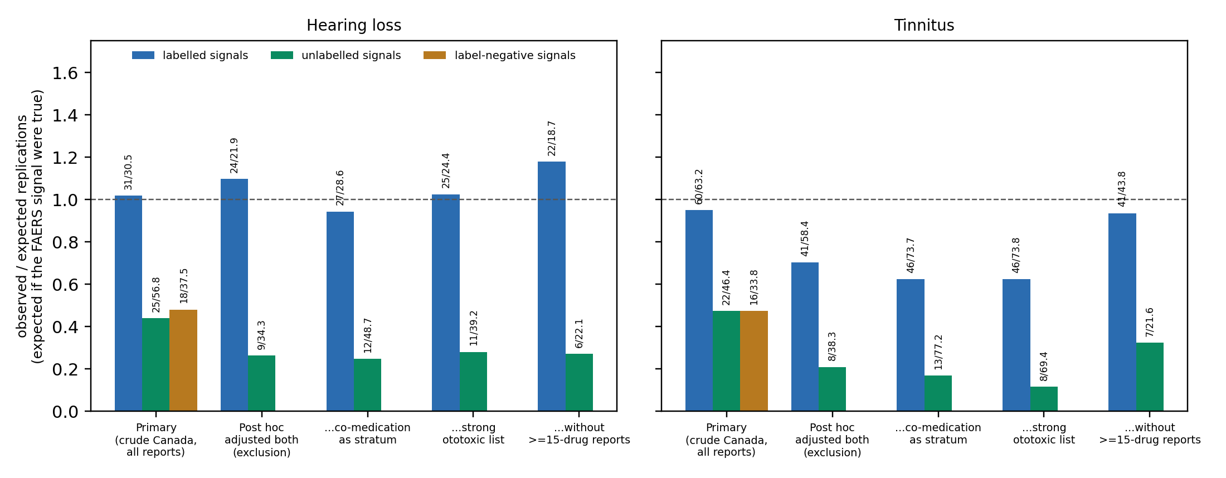
Power-calibrated replication in Canada Vigilance: observed replications divided by those expected if each FAERS adjusted estimate were true (labels give observed/expected counts). Primary: pre-specified signals, Canada crude estimates, all reports. Post hoc: both databases adjusted, Canada without solicited reports, four ways of handling co-medication. A ratio near 1 means signals replicate as their FAERS strength predicts.
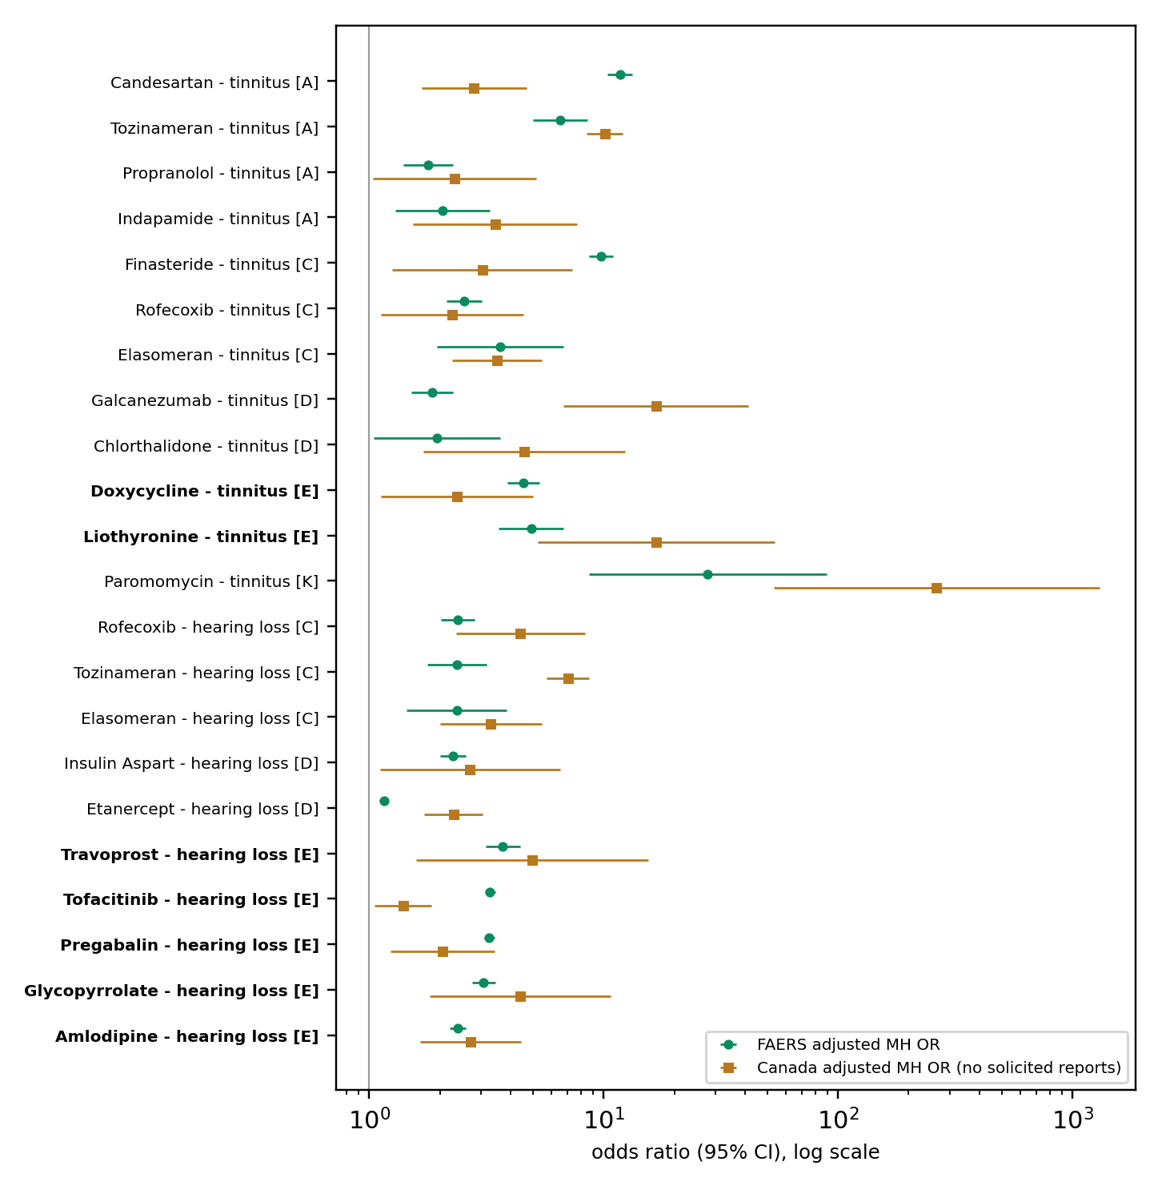
Robust signals absent from all US labels: FAERS and Canada Vigilance adjusted estimates, with case-review category (A report cluster; C stimulated reporting; D indication; K established class; E none, bold).

Discussion
Three findings matter for anyone screening spontaneous reports for ototoxicity. First, adjusting for indication, ototoxic co-medication, lawyer reports and demographics changed a substantial part of the hearing-loss signal list (63 of 300 crude signals lost, 73 gained) but did not improve agreement with labels. Second, replication in an independent national database behaved as a validation test should for labelled hearing-loss associations—they replicated about as often as their strength predicted—whereas unlabelled signals replicated less than half as often, a contrast that held within strata of consumer reporting and whose pooled Canadian estimate (attenuated, not absent) was close to that of signals for drugs whose labels are silent on hearing. Third, replication is not a clean validator on its own: solicited patient-support-programme reports and report clusters produced “replications” for drugs with no known association, and co-medication bias can replicate when crude estimates are compared. For regulators and signal-management teams, the practical consequence is that replication in a second database does not strengthen a signal unless reporting artefacts are explicitly addressed. After adjusted replication, a review of report provenance and an active-comparator check, 7 of 22 robust unlabelled signals remained (2 to 9 under alternative post-hoc choices and assessors). For tinnitus the same pattern held, but labelled signals also replicated less fully once both databases were adjusted, so the evidence there is weaker.
These results qualify the previous all-drug screens [2–4] rather than contradict them. Their labelled signals largely held; their unlabelled signals mostly did not, and several of the strongest are consistent with how reports were collected rather than with pharmacology. Tafamidis and sacubitril/valsartan are examples: hundreds to thousands of FAERS hearing-loss reports, mostly from US consumers and consistent with manufacturer programmes, and none in Canada. The same mechanism produced spurious Canadian “replications” for biologics. Solicited reports are known to distort disproportionality [20], and their share differs between databases, so report provenance can manufacture both a signal and its replication.
In this study three steps did most of the work: comparing adjusted estimates in both databases; profiling each case series for concentration—solicited or consumer reports, a single country or year, very drug-dense reports; and comparing the drug with others used for the same indication. The power-calibrated comparison is simple and avoids the outcome-dependent testability of rules based on observed counts; it remains sensitive to overdispersion, and empirical calibration against negative controls [21] or regression-based adjustment for co-reported drugs [22] would be natural extensions. We suggest that screens for hearing outcomes report these provenance indicators for every signal, in line with the case-by-case item of READUS-PV [12,13].
The remaining candidates are hypotheses. Pregabalin, an $α_{2}δ$ ligand, had 1,703 FAERS hearing-loss reports (adjusted OR 3.25 (3.09–3.43)) that replicated in Canada and persisted against other drugs for pain and neuropathy; a case of reversible, dose-related hearing loss has been described [23], but age and diabetes confound [24], and its labels list tinnitus and hyperacusis. For amlodipine, hypertension is associated with hearing loss [25], yet the signal persisted against other antihypertensives, while a large cohort found a lower risk of sensorineural hearing loss with calcium-channel blockers [26], which argues against a causal effect. Tofacitinib, travoprost and glycopyrrolate persisted within rheumatoid arthritis, glaucoma and COPD, diseases themselves linked to hearing loss [27–29], so residual confounding by disease severity remains possible. Doxycycline can cause intracranial hypertension, of which pulsatile tinnitus is a symptom [30], although few cases reported it. None of these should change practice without studies that have exposure data.

Limitations.
Spontaneous reports lack exposure denominators, and disproportionality measures reporting, not risk or incidence. The label reference set is imperfect: labels are partly informed by spontaneous reports, list rare events without causal assessment, and route-specific labels (for example topical gentamicin) blur ingredient-level status; we used it only to compare methods. Excluding reports with an ototoxic co-medication conditions on a variable that reporters may add after observing the event, which pushed some label-positive drugs below 1; stratifying instead removed that artefact but left residual co-medication bias, and both gave the same replication contrast. Indications are often missing; unreported co-treatment (for example aminoglycosides in mycobacterial disease) remains; content deduplication was not applied to Canada Vigilance and cannot catch near-duplicate series, which the report-cluster indicator only partly addresses; and combination products contribute to each ingredient (valsartan inherits sacubitril/valsartan reports). Canadian reports were removed from FAERS by occurrence country, or reporter country when missing. The Canada Vigilance documentation does not state that the extract is domestic; restricting it to reports sent directly to Health Canada gave similar results (39/72 (54%) of adjusted signals replicated, background 12/58 (21%)). About 8,100 ingredients were screened without multiplicity correction; the replication and calibration analyses, rather than individual $p$-values, carry the conclusions, and the calibration’s expected counts depend on Poisson assumptions that the background shows to be optimistic. Corrections made after the first results (ingredient synonyms, comparator handling for listed drugs, label sections) changed the primary numbers slightly; they are listed in the protocol file. The solicited-report exclusion, the extended indication filter, adjusted-to-adjusted and calibrated replication, the co-medication variants, the active-comparator check and the case-level review were added after the primary results were seen, partly in response to internal review, and are labelled post hoc. The case-level review was applied by the author and by an AI assessor that used the same profiles and search tools, not by independent clinicians; the two assessments are therefore not fully independent, and the agreement statistic should be read in that light. Within-indication comparisons can be affected by channelling (for example tofacitinib as a second-line drug). FAERS report-source codes that would identify solicited reports directly were not used.

Conclusions.
In FAERS, most drug–hearing-loss signals that are not already on a label do not survive adjusted replication in Canada Vigilance and a review of report provenance; disproportionality analysis remains a hypothesis-generating tool. Replication in a second spontaneous-reporting database is informative only when both estimates are adjusted and solicited reports and report clusters are handled explicitly. The few remaining candidates, with pregabalin the strongest, are hypotheses that merit study with exposure-based designs, not established adverse effects.

Statements and declarations
Funding: no funding was received for this study. Competing interests: until October 2026 the author was employed as a software engineer at Suno, a company that develops practice-management software for hearing clinics; the company had no role in the design, analysis or reporting of this study, and the author has no financial relationship with manufacturers of the drugs studied. Ethics approval: not applicable; the study used public, de-identified data. Consent to participate and for publication: not applicable. Data availability: FAERS and Canada Vigilance data are publicly available from the FDA and Health Canada; result tables are in the repository below. Code availability: code, protocol (PROTOCOL.md, with commit history) and results: https://github.com/olegtropinin/faers-ototoxicity, archived at Zenodo, doi:10.5281/zenodo.23659658. Author contributions: OT conceived and designed the study, directed and checked the analysis, and wrote and approved the manuscript.
1. Lanvers-Kaminsky C, Zehnhoff-Dinnesen AG am, Parfitt R, Ciarimboli G. Drug-induced ototoxicity: Mechanisms, pharmacogenetics, and protective strategies. Clinical Pharmacology & Therapeutics. 2017;101:491–500. https://doi.org/10.1002/cpt.603
2. Li B, Hu X, Yue Z. Drug-induced hearing disorders: A disproportionality analysis of the FAERS database. Frontiers in Pharmacology. 2024;15:1480994. https://doi.org/10.3389/fphar.2024.1480994
3. Wu T, Zhao Z, Wang P, Du Q, Shi Y, Zhu B, et al. Drug-induced hearing loss: A real-world pharmacovigilance study using the FDA adverse event reporting system database. Hearing Research. 2025;461:109262. https://doi.org/10.1016/j.heares.2025.109262
4. Liu J, Tan J, Xiao Q, Bai Y, Chang E, Su C, et al. Drug-associated hearing impairment in children: A disproportionality analysis of the FDA adverse event reporting system. Frontiers in Pharmacology. 2025;16:1532461. https://doi.org/10.3389/fphar.2025.1532461
5. Narasimhaswamy N, Ganesan S, Poojar B. Disproportionality analysis of drug-associated tinnitus safety signals: A 43-year pharmacovigilance study. Naunyn-Schmiedeberg’s Archives of Pharmacology. 2026;399:19173–86. https://doi.org/10.1007/s00210-026-05556-7
6. Wang L, Tang Y, Zhuge P. Analysis of drug-related tinnitus based on the FDA adverse event reporting system database. British Journal of Hospital Medicine. 2024;85:1–12. https://doi.org/10.12968/hmed.2024.0380
7. Tanaka M, Hasegawa S, Nakao S, Shimada K, Mukai R, Matsumoto K, et al. Analysis of drug-induced hearing loss by using a spontaneous reporting system database. PLoS ONE. 2019;14:e0217951. https://doi.org/10.1371/journal.pone.0217951
8. Favrelière S, Delaunay P, Lebreton JP, Rouby F, Atzenhoffer M, Lafay-Chebassier C, et al. Drug-induced hearing loss: A case/non-case study in the French pharmacovigilance database. Fundamental & Clinical Pharmacology. 2020;34:397–407. https://doi.org/10.1111/fcp.12533
9. Pariente A, Gregoire F, Fourrier-Reglat A, Haramburu F, Moore N. Impact of safety alerts on measures of disproportionality in spontaneous reporting databases: The notoriety bias. Drug Safety. 2007;30:891–8. https://doi.org/10.2165/00002018-200730100-00007
10. Ramessur R, Gelfand JM. Facing our FAERS: Disproportionality analyses, signal detection, and interpretation. Journal of Investigative Dermatology. 2025;145:2115–7. https://doi.org/10.1016/j.jid.2025.06.1579
11. Harpaz R, DuMouchel W, LePendu P, Bauer-Mehren A, Ryan P, Shah NH. Performance of pharmacovigilance signal-detection algorithms for the FDA adverse event reporting system. Clinical Pharmacology & Therapeutics. 2013;93:539–46. https://doi.org/10.1038/clpt.2013.24
12. Fusaroli M, Salvo F, Begaud B, AlShammari TM, Bate A, Battini V, et al. The reporting of a disproportionality analysis for drug safety signal detection using individual case safety reports in PharmacoVigilance (READUS-PV): Development and statement. Drug Safety. 2024;47:575–84. https://doi.org/10.1007/s40264-024-01421-9
13. Fusaroli M, Salvo F, Begaud B, AlShammari TM, Bate A, Battini V, et al. The REporting of A disproportionality analysis for DrUg safety signal detection using individual case safety reports in PharmacoVigilance (READUS-PV): Explanation and elaboration. Drug Safety. 2024;47:585–99. https://doi.org/10.1007/s40264-024-01423-7
14. Kass-Hout TA, Xu Z, Mohebbi M, Nelsen H, Baker A, Levine J, et al. OpenFDA: An innovative platform providing access to a wealth of FDA’s publicly available data. Journal of the American Medical Informatics Association. 2016;23:596–600. https://doi.org/10.1093/jamia/ocv153
15. Woolf B. On estimating the relation between blood group and disease. Annals of Human Genetics. 1955;19:251–3. https://doi.org/10.1111/j.1469-1809.1955.tb01348.x
16. Rothman KJ, Lanes S, Sacks ST. The reporting odds ratio and its advantages over the proportional reporting ratio. Pharmacoepidemiology and Drug Safety. 2004;13:519–23. https://doi.org/10.1002/pds.1001
17. Norén GN, Bate A, Orre R, Edwards IR. Extending the methods used to screen the WHO drug safety database towards analysis of complex associations and improved accuracy for rare events. Statistics in Medicine. 2006;25:3740–57. https://doi.org/10.1002/sim.2473
18. Mantel N, Haenszel W. Statistical aspects of the analysis of data from retrospective studies of disease. Journal of the National Cancer Institute. 1959;22:719–48. https://doi.org/10.1093/jnci/22.4.719
19. Robins J, Breslow N, Greenland S. Estimators of the Mantel-Haenszel variance consistent in both sparse data and large-strata limiting models. Biometrics. 1986;42:311–23. https://doi.org/10.2307/2531052
20. Jokinen JD, Walley RJ, Colopy MW, Hilzinger TS, Verdru P. Pooling different safety data sources: Impact of combining solicited and spontaneous reports on signal detection in pharmacovigilance. Drug Safety. 2019;42:1191–8. https://doi.org/10.1007/s40264-019-00843-0
21. Schuemie MJ, Ryan PB, DuMouchel W, Suchard MA, Madigan D. Interpreting observational studies: Why empirical calibration is needed to correct p-values. Statistics in Medicine. 2014;33:209–18. https://doi.org/10.1002/sim.5925
22. Caster O, Norén GN, Madigan D, Bate A. Large-scale regression-based pattern discovery: The example of screening the WHO global drug safety database. Statistical Analysis and Data Mining. 2010;3:197–208. https://doi.org/10.1002/sam.10078
23. Yılmaz R, Türk Ş, Reisli R, Tuncer Uzun S. A probable case of pregabalin-related reversible hearing loss. Ağrı. 2020;32:103–5. https://doi.org/10.5505/agri.2018.48753
24. Horikawa C, Kodama S, Tanaka S, Fujihara K, Hirasawa R, Yachi Y, et al. Diabetes and risk of hearing impairment in adults: A meta-analysis. The Journal of clinical endocrinology and metabolism. 2013;98:51–8. https://doi.org/10.1210/jc.2012-2119
25. Jin X, Xu X, Wang J, Liu X, Deng X, Xie H. Association between hypertension and hearing loss: A systemic review and meta-analysis. Frontiers in neurology. 2024;15:1470997. https://doi.org/10.3389/fneur.2024.1470997
26. Sutton SS, Magagnoli J, Cummings TH, Hardin JW. Calcium channel blockers and the risk of sensorineural hearing loss. Otology & Neurotology. 2022;43:e140–7. https://doi.org/10.1097/MAO.0000000000003419
27. Chaitidis N, Theocharis P, Festas C, Aritzi I. Association of rheumatoid arthritis with hearing loss: A systematic review and meta-analysis. Rheumatology International. 2020;40:1771–9. https://doi.org/10.1007/s00296-020-04609-1
28. Kim JM, Lee MY, Kim JW, Lee J, Kim HJ, Cha SC, et al. Open-angle glaucoma and sensorineural hearing impairment in the Korean population. Current Eye Research. 2020;45:992–9. https://doi.org/10.1080/02713683.2020.1712424
29. Choi HG, Kwon MJ, Kim JH, Kim J-H, Kim Y, Kim SY. Association between COPD and hearing loss. The Laryngoscope. 2024;134:4716–22. https://doi.org/10.1002/lary.31548
30. Ali NS, Long BD, Manzoor NF, Sismanis A, Coelho DH. Doxycycline-induced intracranial hypertension presenting as unilateral pulsatile tinnitus. Otology & neurotology open. 2023;3:e043. https://doi.org/10.1097/ONO.0000000000000043

