How much recorded intraoperative hypotension is arterial-line artefact, and does it bias the association with creatinine-defined acute kidney injury? A waveform-referenced cohort study
Running title: Arterial-line artefact and intraoperative hypotension
Author: Oleg Tropynin (ORCID 0009-0006-5431-4285)
Affiliation: Independent researcher, Karaganda, Kazakhstan
Correspondence: Oleg Tropynin, tropininoleg@gmail.com
Keywords: intraoperative hypotension; arterial pressure monitoring; artefacts; acute kidney injury; measurement error; VitalDB

Key points
- In 3,249 patients with continuous arterial monitoring, 2.3% of monitored time was waveform-flagged artefact. With per-minute medians and a range filter, 0.7% of recorded minutes with mean arterial pressure (MAP) below 65 mmHg were spurious against the waveform reference.
- For ≥ 10 min of MAP below 65 mmHg, which was not associated with acute kidney injury (AKI, by creatinine) after adjustment, artefact handling did not change the estimate (ratio of odds ratios 0.96, 0.86–1.06). This verdict rested on 33 discordant patients and would not have survived two AKI cases among them. Post hoc, for exposures that were associated with AKI, pipeline and reference estimates were within a few per cent.
- Running-median smoothing and unfiltered area-under-threshold exposures distorted measured hypotension. Over a third of the unfiltered area below 55 mmHg was artefact (post hoc).
- Many brief, very deep recorded falls were waveform-flagged in retrospect (post hoc). Even so, one in five falls to 20–39 mmHg was not flagged at 10 s. A sudden fall should be treated as real until the waveform shows otherwise.
- Arterial artefact rose sixfold during the non-invasive cuff cycle, mostly as a non-pulsatile trace. This is consistent, in part, with occlusion of the cannulated arm.

Abstract
Purpose. Evidence linking intraoperative hypotension to acute kidney injury (AKI) rests on monitor numbers that include arterial-line artefacts. We asked how much recorded hypotension is artefact and whether it biases the association.
Methods. In 3,249 adults from VitalDB, each 2-s monitor value was labelled from the 500 Hz arterial waveform, giving a waveform reference, and compared with 420 retrospective processing pipelines. The primary estimand was the ratio of adjusted odds ratios (ROR) for AKI by KDIGO creatinine criteria with ≥ 10 min of mean arterial pressure below 65 mmHg, comparing per-minute medians with a range filter against the reference. The pre-specified equivalence margin was 0.80–1.25.
Results. Of monitored time, 96.3% was not waveform-flagged. With per-minute medians, 0.7% of recorded hypotensive minutes were spurious against the reference; with one value per minute, 3.3%. AKI occurred in 91 of 2,563 patients (3.6%). Adjusted odds ratios were 0.94 (95% CI 0.60–1.48) with the reference and 0.90 (0.57–1.42) with the pipeline: ROR 0.96 (0.86–1.06), within the margin. Exposure differed in 33 patients, none with AKI; two AKI cases among the 28 reclassified upwards would have made the verdict inconclusive. Spurious hypotension showed no detectable association with AKI. Arterial artefact rose from 4% to 26% during cuff measurement.
Conclusion. With per-minute medians and a range filter, artefact handling did not detectably change the association between hypotension and AKI, but this verdict rests on few discordant patients. Post hoc, the same held for exposures associated with AKI. Running-median smoothing and unfiltered area-based exposures should be avoided.

Introduction
Intraoperative hypotension is associated with acute kidney injury (AKI), myocardial injury and death [1–4]. Thresholds derived from these studies, typically a mean arterial pressure (MAP) below 65 mmHg for more than a few minutes, now appear in consensus statements and quality metrics [5]. Almost all of this evidence comes from retrospective analyses of numbers stored by anaesthesia information management systems. These are one value per minute or less, taken from the monitor rather than from the waveform the clinician sees.
Invasive arterial pressure is the reference standard of these studies, yet the stored numbers inherit every event that disturbs an arterial line: flushing, blood sampling through a stopcock, zeroing, a kinked or damped catheter and cuff inflation on the same limb [6–9]. Choosing among published artefact filters changes the measured incidence of hypotension up to twofold but the association with myocardial injury little [10]; coarser sampling inflates the measured burden of hypotension against a waveform reference, although its effect on outcome associations has only been extrapolated [11]; and how hypotension is modelled changes the estimated odds ratios [12].
Recent studies of the open VitalDB dataset relating arterial pressure to kidney injury applied a single cleaning rule or did not describe one [13–15].
Four questions remain open. How much of recorded hypotension is artefact when artefacts are identified from the waveform? Do the artefact rule and the data resolution change the association between hypotension and AKI when it is estimated directly? Is misclassification differential: arterial blood is sampled more often in sicker patients, and if sampling artefact were recorded as hypotension preferentially in patients who later develop AKI, it would bias associations away from the null? And which recorded low-pressure episodes are artefact, and how quickly can this be recognised?
We used the two parallel recordings in VitalDB, the 500 Hz waveform and the monitor’s 2-s numbers, to build a waveform-referenced MAP series. We compared it with 420 pipelines that a retrospective study could plausibly use, in a pre-specified multiverse analysis [16,17].

Methods

Design, data and reporting
We performed a retrospective cohort study of the open VitalDB dataset: 6,388 non-cardiac surgical cases at Seoul National University Hospital in 2016–2017, with anaesthesia records, laboratory results, monitor numerics (GE Solar 8000) and high-resolution waveforms [18]. Reporting follows STROBE and RECORD [19,20].
The analysis protocol was written before any exposure–outcome association was computed, revised after an adversarial methods review, and frozen by a tagged commit after the whole analysis had run end to end on a randomly permuted outcome. The protocol in Online Resource 1 lists every amendment before the freeze, and every change and post hoc analysis after unblinding, with dates and reasons. Post hoc analyses are labelled as such throughout.
A large language model (Claude Opus 5.5, Anthropic) was used under the author’s direction to write the analysis code, review the methods adversarially before the freeze, simulate peer review and draft the text, and as a secondary blinded rater. The author checked all code, outputs and text.

Participants
We included adults under general anaesthesia whose record contained the 500 Hz arterial pressure waveform (radial in 95%) and at least 30 min of reference-valid monitoring, using the first eligible case per patient. For the AKI analysis we further excluded transplantation and patients without a baseline creatinine, with a baseline estimated glomerular filtration rate (eGFR, CKD-EPI 2021 [21]) below 15 mL min⁻¹ 1.73 m⁻², or without a creatinine measurement within 7 days after anaesthesia.

Waveform classification and the reference series
The monitor stores arterial pressures every 2 s; this is the stream that anaesthesia information systems store and retrospective studies analyse. We used the waveform only to decide whether each 2-s monitor value was trustworthy, never to replace it, so calibration differences between monitor and waveform could not enter the comparison.
Each 2-s waveform window was labelled zero (mean below 15 mmHg with a range below 10 mmHg: transducer open to air), high (maximum above 250 or mean above 200 mmHg: fast flush), non-pulsatile (range below 8 mmHg, interdecile range below 3 mmHg, or no systolic upstroke in the centred 6-s window: stopcock off to the patient or occluded line), noise (minimum below −10 mmHg or a large median second difference) or otherwise valid (Online Resource 1).
Hereafter, “artefact” means a value flagged by this classifier. Because the monitor averages over several beats, windows from 2 s before to 8 s after any artefact run were labelled guard; 8 s was the 95th centile of the time the monitor took to rejoin the waveform. Thresholds were set on outcome-free data. A beat-to-beat autocorrelation criterion was discarded before the freeze because it labelled atrial fibrillation as artefact. Fig. 1 shows examples.
Monitor numerics lag the waveform; the lag was estimated per case by maximising the correlation between monitor MAP and the waveform window mean (4 s in 62% of cases, 6 s in 35%). The monitoring period ran from the first to the last uninterrupted 60 s of valid waveform within anaesthesia. It began a median of 9.9 min (IQR 6.3–15.8) after the start of anaesthesia, so much post-induction hypotension falls outside it [22].
The reference was the lag-aligned monitor MAP restricted to valid windows. Gaps of up to 3 min, bounded on both sides by at least 30 s of valid data, were bridged linearly between the medians before and after, which avoids a systematic loss of true hypotension that coincides with blood sampling. A minute was valid if at least half of its windows were valid or bridged.

Retrospective pipelines
A pipeline turns the monitor numbers into an exposure, using the numbers alone. Seven filters reproduced published rules: none (F0); range filters on MAP of 20–250 mmHg (F1)[13] and 30–200 mmHg (F2) [23]; a multi-signal rule (F3) [11]; a physiological-consistency rule (F4); F4 with removal of values differing from both neighbours by more than 30 mmHg (F5) [24]; and F4 with a 7-point running median (F6) [10]. Full definitions are in Online Resource 1. Five resolutions were every 2-s value (R1), one instantaneous value per minute (R2), the per-minute median (R3), and a value charted every 5 min (R4) or 15 min (R5) and held; R4 and R5 were averaged over phase offsets.
Exposures at thresholds of 55, 60 and 65 mmHg were cumulative minutes below the threshold (per 10 min, capped at 120 min), area under the threshold (per 100 mmHg·min, capped at the reference’s 99th centile), time-weighted average below the threshold (per mmHg) and the binary “≥ 10 min below the threshold”. Each of the 420 pipeline specifications was compared with the reference processed the same way at the same resolution, so the contrast isolates waveform-based cleaning.

Outcomes and covariates
The primary outcome was AKI by the KDIGO creatinine criteria [25]: an increase of ≥ 0.3 mg dL⁻¹ within 48 h, or ≥ 1.5 times baseline within 7 days. Baseline was the last creatinine within 30 days before surgery, otherwise the preoperative value.
Models were adjusted for age and eGFR (restricted cubic splines), sex, body mass index, ASA physical status ≥ 3, emergency surgery, hypertension, diabetes, preoperative haemoglobin and albumin, department, surgical approach and log anaesthesia duration. Vasopressors, fluids and blood loss were not included, because they may lie on the causal path. With 91 events and 21 parameters there were 4.3 events per parameter. We used Firth-penalised logistic regression with Wald intervals [26], and the two models that form each ratio share the same adjustment set.

Statistical analysis
Measurement error. Each recorded minute with MAP below 65 mmHg was classed against the reference at the same resolution as spurious (reference ≥ 65 mmHg), confirmed (reference < 65 mmHg) or indeterminate (no valid reference; never counted as artefact). Masked minutes were the converse. For the binary exposure we report κ and the number of patients whose category differed; proportions have patient-cluster bootstrap CIs.
Primary estimand. The primary estimand was the ratio of odds ratios, ROR = OR_{pipeline} / OR_{reference}, for AKI with the binary exposure “≥ 10 min below 65 mmHg”. It compared F1 × R3 with the reference at R3, using the same adjustment set and the same patients, so it is largely insensitive to confounding that the two series share. We pre-specified an equivalence margin of 0.80–1.25, the conventional margin symmetric on the log scale: an interval inside the margin meant equivalent; an interval excluding 1 with a point estimate outside the margin meant material change; anything else was inconclusive.
Because the two exposures differ in only a few patients, the percentile bootstrap interval covered the true ROR of 1 in only 51% of 100 outcome permutations. A rule written before the real outcome was examined therefore set every ROR-type interval to:
log ROR ± 1.96 × max(paired-bootstrap SE, SD over 200 outcome permutations).
We checked this interval by its coverage under independent permutations and by simulating outcomes from the adjusted reference model with differential error placed at the margin (Online Resource 1).
Secondary analyses were the ROR for all 35 filter × resolution cells with simultaneous 95% bands, the slope per 10 min below 65 mmHg, the specification curve and the effect of resolution on the reference itself.
Differential misclassification. We regressed AKI on log(1 + spurious minutes per monitored hour), adjusting for the reference exposure (linear and spline terms), log monitored hours and the adjustment set. We used the raw 2-s stream (F0 × R1), because at F1 × R3 spurious minutes were non-zero in too few patients (amendment A14, before the freeze). The negative control was spurious hypertensive minutes: pipeline MAP above 120 mmHg while the reference was ≤ 100 mmHg.
Episodes. Each run of monitor MAP below 65 mmHg was classed as waveform-flagged (≥ 50% of its windows labelled artefact), guard-dominated or physiological, and the probability of being flagged was tabulated by final duration and nadir; a pre-specified depth-2 tree searched for a simple rule. Post hoc, we also tabulated it by elapsed duration and nadir so far.
Validation of the reference. We compared flagged and physiological episodes against independent signals (cuff MAP, ECG and plethysmographic pulse rate). Injection–recovery of synthetic artefacts after Li et al [27]. checked the implementation only, and a blinded AI rater scored 152 snippets (Online Resource 1).
Sensitivity analyses. Pre-specified sensitivity analyses varied the reference definition, the monitoring period, the adjustment set and the outcome (Online Resource 1). Two of them, S4 and S6, had been omitted by error and were run after unblinding.
Analyses used Python 3.10 (NumPy, SciPy, pandas), with study code that was unit-tested.

Results

Participants
Of 3,645 cases with an arterial waveform track, 3,429 had a retrievable waveform and a monitoring period. The descriptive cohort comprised 3,249 patients with a median of 193 min of monitoring (IQR 134–272). The AKI analysis set comprised 2,563 patients, of whom 91 (3.6%) developed AKI (Table 1; Fig. S1 in Online Resource 1). Inclusion in the AKI set depended on postoperative creatinine testing: it included 85–97% of non-transplant patients in general, thoracic and urological surgery but 28% in gynaecology.

How much of the arterial record is artefact
Within the monitoring period, 96.3% of 2-s windows were valid. Artefact proper accounted for 2.3% (high 1.2%, non-pulsatile 0.7%, noise 0.2%, zero 0.07%) and guard margins for a further 1.4%. Artefact events were nonetheless common: 98% of patients had at least one flush and 90% a non-pulsatile run (Online Resource 1).
Artefact around cuff measurements (Fig. 2). In 2,579 patients with both arterial and cuff pressure, 14.0% of arterial windows in the 60 s before a new cuff value were labelled artefact, against 1.8% at other times (19,560 readings). The excess peaked 22 s before the value appeared, during the oscillometric cycle, at 25.8% of windows, and was almost entirely non-pulsatile trace (22.4% against 1.7% at baseline). Post hoc, it was larger with radial catheters (13.9% vs 1.8%; 2,219 patients) than with pedal or femoral catheters, which an arm cuff cannot occlude (9.7% vs 3.4%; 58 patients; p < 0.001), and with right than left radial catheters (Online Resource 1). The cuff arm is not recorded in VitalDB.

Spurious and masked hypotension
At the per-minute median resolution (R3) with filter F1, 0.66% (95% CI 0.58–0.74) of recorded minutes with MAP below 65 mmHg were spurious (Fig. 3; Table S1). With one instantaneous value per minute (R2) the fraction was 3.3% (3.0–3.6), 4–10 times the R3 value for filters F0–F5, and with the raw 2-s stream (R1) 2.0% (1.9–2.2). Filters F3–F5 removed most spurious minutes at R1 and R3 (0.3–0.9%), but not at R2 (1.8–3.3%). The 7-point running median (F6) behaved differently from every other filter: it created spurious minutes (7.5% at R3, 9.9% at R2) and masked 20% (R3) to 24% (R2) of true hypotensive minutes.
Binary exposure. Against the reference at the same resolution, “≥ 10 min below 65 mmHg” was classified with κ 0.95–0.99 by every filter except F6 at R2–R5 (Table S2). With F1 × R3, 38 of 3,249 patients (1.2%; 33 in the AKI set) changed exposure category, 32 of them upwards; 30 of the 38 had 5–10 reference minutes. Resolution changed exposure prevalence more than any filter: in the reference itself, 42.4% of patients were exposed at R3, 51.2% at R4 and 53.2% at R5. The 7-point median applied to charted data erased most exposure (κ 0.39 at R4, 0.20 at R5).

Which recorded low-pressure episodes are waveform-flagged
Of 106,725 recorded episodes of MAP below 65 mmHg in 3,123 patients, 8,471 (7.9%) were waveform-flagged; they accounted for 4.3% of hypotensive minutes. The proportion flagged depended steeply on final duration and nadir (Table 2): 65–90% of episodes lasting ≤ 60 s with a nadir below 40 mmHg, but ≤ 2.4% of episodes with a nadir of 55–64 mmHg and ≤ 2% of episodes lasting more than 1 min with a nadir ≥ 40 mmHg.
Because final duration is not known while an episode unfolds, we also looked post hoc at episodes still below 65 mmHg after a given time (Table S3). Of falls to 20–39 mmHg, 79% were flagged at 10 s, 57% at 30 s and 8% at 60 s; falls below 20 mmHg were still flagged in 29% at 2 min.
A single rule, a fall of more than 20 mmHg from the preceding 30-s maximum, identified flagged episodes in a validation half of patients with sensitivity 0.89, specificity 0.92 and positive predictive value 0.46. This specificity came from trivial dips: across episodes with a nadir below 40 mmHg it was 0.07.

Validation of the reference
Cuff pressure. A cuff MAP within 3 min of an episode was ≥ 70 mmHg in 84% (95% CI 83–85) of 4,506 flagged episodes and 46% (45–47) of 10,967 physiological episodes. Restricting post hoc to deep episodes (nadir below 40 mmHg) and a cuff value within 60 s, the proportions were 81% (79–82) of 2,081 flagged and 28% (24–32) of 443 physiological episodes. About one flagged deep episode in five may therefore have been real, and some “physiological” deep episodes were probably missed artefact.
Other checks (Online Resource 1). In non-pulsatile windows the ECG rate was 40–150 min⁻¹ in 97.8% and the plethysmographic pulse rate in 92.6% of 153,662 windows, and the non-pulsatile fraction was not higher in atrial fibrillation. Injection–recovery detected flushes lasting ≥ 2 s or reaching 250 mmHg, open-transducer levels up to 25 mmHg and sampling, but rarely over-damping, partial occlusion, drift or ringing (Table S8). The blinded AI rater agreed with the classifier in 97.7% of snippets (κ 0.95; n = 131; Table S9).

Association with acute kidney injury
The reference association. For ≥ 10 min below 65 mmHg the odds ratio for AKI was 1.65 (1.09–2.51) crude, 1.46 (0.95–2.25) adjusted for age, eGFR, ASA and emergency, 0.94 (0.60–1.48) fully adjusted and 1.10 (0.70–1.71) fully adjusted without anaesthesia duration; because this exposure is cumulative, adjusting for duration removes part of its variance. Other exposures were associated with AKI after full adjustment (Table S11): ≥ 10 min below 60 mmHg, 1.71 (1.04–2.79); area below 65 mmHg, 1.24 per 100 mmHg·min (1.07–1.45); and time-weighted average below 65 mmHg, 1.27 per mmHg (1.00–1.60).
Primary estimand. With F1 × R3 the fully adjusted odds ratio was 0.90 (0.57–1.42). The ROR was 0.96 (95% CI 0.86–1.06; permutation p = 0.42), and the pre-specified verdict was equivalent.
The contrast rested on the 33 patients in the AKI set whose exposure category differed: 28 moved up and 5 moved down. None developed AKI, against 1.6 expected from the adjusted reference model. Post hoc, with one AKI case among the 28 upward-moved patients the ROR would have been 1.01 (0.90–1.14), still equivalent, and with two 1.07 (0.90–1.27), inconclusive (Table S7). Two or more cases had probability 0.36 under the reference model, so the equivalence verdict is fragile. In simulations from the adjusted reference model, the interval rule declared equivalence in 82% of datasets without differential error and in 5% of datasets where differential error placed the median ROR at 1.24.
Where the reference association was present (post hoc), pipeline and reference estimates were close: ROR 0.98 (0.85–1.15) for ≥ 10 min below 60 mmHg, 1.00 (0.97–1.03) for area below 65 mmHg and 1.01 (0.95–1.06) for time-weighted average below 65 mmHg. At 55 mmHg the binary ROR was imprecise: 1.28 (0.81–2.02) with F1 and 1.10 (0.84–1.45) with F3; the pipeline odds ratio, 2.49 (1.22–5.08), crossed nominal significance where the reference, 1.95 (0.89–4.27), did not.
All 35 filter × resolution cells (Table 3; Fig. 4). No 95% interval or simultaneous band excluded 1. Twenty-five cells were equivalent pointwise and 19 under simultaneous bands; the ten inconclusive cells were F0–F2 at R1, F2–F4 and F6 at R2, and F6 at R3–R5. Coarser resolution of the reference itself did not detectably change the odds ratio (0.93–1.10 relative to R3).
Exposure metric (Figs. S2–S4; Table S4). Across 420 specifications the median ROR was 0.99 (IQR 0.95–1.01), and minute-based exposures were insensitive to processing (0.92–1.02). Area-based exposures below 55 mmHg were not: without a filter, 37% of the total area below 55 mmHg was artefact, half of it in 1% of patients (13% with F1, none with F3), and the corresponding RORs were large but imprecise (post hoc). In 90 of 420 specifications, mostly area-based, pipeline and reference differed in statistical significance.
Sensitivity analyses (Table S5). Of 16 sensitivity analyses with an interval, 14 were equivalent (RORs 0.94–0.97), including the pre-specified S4 and S6. The two inconclusive ones were the waveform-mean reference (0.74, 0.48–1.16), which also changes calibration, and the numerics-defined monitoring period (0.91, 0.75–1.11).
Differential misclassification (Table S6). Spurious hypotension on the raw stream was unrelated to how often arterial blood was sampled (Spearman ρ 0.005, p = 0.81). Adjusted for reference exposure, the odds ratio for AKI was 0.93 (0.74–1.16) per SD of spurious minutes; the negative control gave 1.17 (0.96–1.43). These estimates show no evidence of differential error but cannot exclude a modest amount.

Discussion

Principal findings
Artefacts were frequent events but a small part of recorded hypotension: with a per-minute median and a range filter, fewer than 1% of hypotensive minutes were spurious, and the exposure category changed in 1.2% of patients.
For the pre-specified exposure, ≥ 10 min below 65 mmHg, the adjusted association with AKI was null (odds ratio 0.94), so non-differential error had little to act on. The equivalence of pipeline and reference (ROR 0.96) therefore mainly tests differential error: artefact recorded preferentially in patients destined for AKI, which would manufacture an association. We found no evidence of it. None of the 33 patients whose category changed developed AKI, and spurious hypotension was unrelated to blood sampling and to AKI. The verdict is fragile, however: two AKI cases among the 28 patients moved upwards would have made it inconclusive, an outcome with a probability of about one in three under the reference model. Where the reference did show an association (≥ 10 min below 60 mmHg; area and time-weighted average below 65 mmHg), the pipeline estimates were within a few per cent of the reference (post hoc).
Three processing choices mattered more than the filter. The 7-point running median created spurious hypotension and masked a fifth of true hypotension. Unfiltered area-based exposures below 55 mmHg were inflated by zero and flush values in a few patients: over a third of the area was artefact. Resolution changed the share of exposed patients by a fifth, without a detectable change in the odds ratio.

Comparison with previous work
Pasma et al. found that the choice among eight filters changed the incidence of hypotension up to twofold but the association with myocardial injury little [10]; Jacobsson et al. showed against a waveform reference that coarse sampling inflates measured hypotension [11]. We add a waveform-referenced comparator at every resolution, a pre-specified estimate of the outcome effect and a test for differential error. We agree with both on duration-based exposures; unlike Pasma et al., we found that the 7-point median distorts exposure substantially even when the ratio of odds ratios stays near 1. The AWAKE trial showed that the monitoring method changes measured and treated hypotension at induction [28]; our resolution results are the retrospective counterpart.
Wax et al [29]. and a recent preprint from the MOVER cohort [30] treated disagreement between cuff and arterial pressure as clinical information. Arterial artefact rose sixfold during the cuff cycle, mostly as a non-pulsatile trace, which is a measurement mechanism that generates such disagreement. The pattern by catheter site fits occlusion of the cannulated arm in part, but a smaller excess with pedal and femoral catheters shows that this is not the whole explanation, and because VitalDB does not record the cuff arm, occlusion remains a hypothesis. Studies of discordance should check whether their results survive excluding arterial values from the cuff cycle.
Earlier work compared artefact algorithms with human annotation of stored values [7, 31], and no reference standard for arterial artefact is agreed [32]. Our approach uses the waveform only to decide whether a monitor value can be trusted, and can be reproduced on any dataset that stores both.

Implications
Investigators should use a per-minute median with a range filter, or a rule such as F3, report resolution as carefully as threshold, and avoid running-median smoothing and unfiltered area- or time-weighted exposures below 55 mmHg. Paired multiverse comparisons should check the coverage of their intervals before unblinding: here, percentile intervals covered the truth in half of null datasets.
The episode probabilities are retrospective and describe a population. They must not be used to delay treatment: a sudden fall should be treated as real until the waveform shows otherwise. At 10 s, one in five falls to 20–39 mmHg was not flagged, and one in five flagged deep episodes had a low cuff pressure within a minute. An automated system could use such probabilities to annotate a probable artefact, never to suppress an alarm; a simple drop rule does not separate deep artefacts from deep real events (specificity 0.07 below 40 mmHg). Where possible, the cuff should be placed on the limb opposite an arterial line [9], and it remains an essential cross-check of the line.

Strengths and limitations
The reference comes from the waveform recorded alongside the numbers and never replaces monitor values; the protocol was frozen after a permuted dry run, and all data and code are public.
Limitations:
- The equivalence verdict rests on few patients (33 discordant) and would not have survived two AKI cases among them. It may not transfer to cohorts with more artefact or a stronger association.
- No human rater adjudicated the reference. The AI rater shares its model family with the classifier’s designer; a 400-snippet set with a hidden key is released for human raters.
- The reference is waveform-screened, not error-free. The classifier cannot see levelling errors and zero drift (about 7 mmHg per 10 cm), most over-damping, partial occlusion or very short flushes, and 28% of deep “physiological” episodes had a cuff MAP ≥ 70 mmHg nearby.
- AKI was defined by creatinine alone, without urine output; postoperative creatinine testing varied by department, and end-tidal carbon dioxide and vasopressor data were not examined around deep episodes.
- Much post-induction hypotension was missed, because monitoring started a median of 10 min after the start of anaesthesia [22].
- One centre, few events (2016–2017, mainly general and thoracic surgery, 3.6% AKI), with adjusted odds ratios that depend on adjustment for anaesthesia duration. Charted resolutions were simulated, not taken from real records [6], and artefact frequencies depend on local practice, although the mechanisms should transfer.

Conclusions
Arterial-line artefacts were frequent events but a small part of recorded hypotension. With per-minute medians and a range filter, artefact handling did not detectably change the association between hypotension and AKI. We found no evidence that artefact was recorded preferentially in patients who developed AKI, although the equivalence verdict rested on few discordant patients.
Running-median smoothing and unfiltered area-based exposures distort measured hypotension. Brief, very deep recorded falls are often artefact in retrospect, but a sudden fall should prompt a look at the waveform, never a delay in treatment.

References
- Walsh M, Devereaux PJ, Garg AX, Kurz A, Turan A, Rodseth RN, et al. Relationship between intraoperative mean arterial pressure and clinical outcomes after noncardiac surgery: toward an empirical definition of hypotension. Anesthesiology. 2013;119(3):507-15. doi:10.1097/ALN.0b013e3182a10e26
- Salmasi V, Maheshwari K, Yang D, Mascha EJ, Singh A, Sessler DI, et al. Relationship between intraoperative hypotension, defined by either reduction from baseline or absolute thresholds, and acute kidney and myocardial injury after noncardiac surgery. Anesthesiology. 2017;126(1):47-65. doi:10.1097/ALN.0000000000001432
- Sun LY, Wijeysundera DN, Tait GA, Beattie WS. Association of intraoperative hypotension with acute kidney injury after elective noncardiac surgery. Anesthesiology. 2015;123(3):515-23. doi:10.1097/ALN.0000000000000765
- Wesselink EM, Kappen TH, Torn HM, Slooter AJC, van Klei WA. Intraoperative hypotension and the risk of postoperative adverse outcomes: a systematic review. Br J Anaesth. 2018;121(4):706-21. doi:10.1016/j.bja.2018.04.036
- Sessler DI, Bloomstone JA, Aronson S, Berry C, Gan TJ, Kellum JA, et al. Perioperative Quality Initiative consensus statement on intraoperative blood pressure, risk and outcomes for elective surgery. Br J Anaesth. 2019;122(5):563-74. doi:10.1016/j.bja.2019.01.013
- Kool NP, van Waes JAR, Bijker JB, Peelen LM, van Wolfswinkel L, de Graaff JC, et al. Artifacts in research data obtained from an anesthesia information and management system. Can J Anaesth. 2012;59(9):833-41. doi:10.1007/s12630-012-9754-0
- Pasma W, Wesselink EM, van Buuren S, de Graaff JC, van Klei WA. Artifacts annotations in anesthesia blood pressure data by man and machine. J Clin Monit Comput. 2021;35(2):259-67. doi:10.1007/s10877-020-00574-z
- Gardner RM. Direct blood pressure measurement—dynamic response requirements. Anesthesiology. 1981;54(3):227-36. doi:10.1097/00000542-198103000-00010
- Saugel B, Kouz K, Meidert AS, Schulte-Uentrop L, Romagnoli S. How to measure blood pressure using an arterial catheter: a systematic 5-step approach. Crit Care. 2020;24(1):172. doi:10.1186/s13054-020-02859-w
- Pasma W, Peelen LM, van Buuren S, van Klei WA, de Graaff JC. Artifact processing methods influence on intraoperative hypotension quantification and outcome effect estimates. Anesthesiology. 2020;132(4):723-37. doi:10.1097/ALN.0000000000003131
- Jacobsson M, Valadkhani A, Winski G, Bell M. Accuracy of quantifying hypotension during surgery using physiological sensor data. IEEE J Transl Eng Health Med. 2026;14:265-73. doi:10.1109/JTEHM.2026.3698197
- Vernooij LM, van Klei WA, Machina M, Pasma W, Beattie WS, Peelen LM. Different methods of modelling intraoperative hypotension and their association with postoperative complications in patients undergoing non-cardiac surgery. Br J Anaesth. 2018;120(5):1080-9. doi:10.1016/j.bja.2018.01.033
- Lee SB. Causal effect and personalization of intraoperative hypotension burden on postoperative acute kidney injury: a doubly robust analysis of the VitalDB cohort. J Pers Med. 2026;16(7):371. doi:10.3390/jpm16070371
- Ensarioğlu M, Yıldırım AK. Intraoperative arterial waveform morphology trajectories and prediction of postoperative acute kidney injury: a latent-class analysis of the VitalDB registry. J Clin Med. 2026;15(17):6871. doi:10.3390/jcm15176871
- Folks R, Tsang S, Brown DE, Blanks ZD, Moradinasab N, Mazzeffi M, et al. Intraoperative short-term blood pressure variability and postoperative acute kidney injury: a single-center retrospective cohort study using sample entropy analysis. BMC Anesthesiol. 2024;24(1):395. doi:10.1186/s12871-024-02784-3
- Steegen S, Tuerlinckx F, Gelman A, Vanpaemel W. Increasing transparency through a multiverse analysis. Perspect Psychol Sci. 2016;11(5):702-12. doi:10.1177/1745691616658637
- Simonsohn U, Simmons JP, Nelson LD. Specification curve analysis. Nat Hum Behav. 2020;4(11):1208-14. doi:10.1038/s41562-020-0912-z
- Lee HC, Park Y, Yoon SB, Yang SM, Park D, Jung CW. VitalDB, a high-fidelity multi-parameter vital signs database in surgical patients. Sci Data. 2022;9(1):279. doi:10.1038/s41597-022-01411-5
- von Elm E, Altman DG, Egger M, Pocock SJ, Gøtzsche PC, Vandenbroucke JP. The Strengthening the Reporting of Observational Studies in Epidemiology (STROBE) statement: guidelines for reporting observational studies. Lancet. 2007;370(9596):1453-7. doi:10.1016/S0140-6736(07)61602-X
- Benchimol EI, Smeeth L, Guttmann A, Harron K, Moher D, Petersen I, et al. The REporting of studies Conducted using Observational Routinely-collected health Data (RECORD) statement. PLoS Med. 2015;12(10):e1001885. doi:10.1371/journal.pmed.1001885
- Inker LA, Eneanya ND, Coresh J, Tighiouart H, Wang D, Sang Y, et al. New creatinine- and cystatin C-based equations to estimate GFR without race. N Engl J Med. 2021;385(19):1737-49. doi:10.1056/NEJMoa2102953
- Südfeld S, Brechnitz S, Wagner JY, Reese PC, Pinnschmidt HO, Reuter DA, et al. Post-induction hypotension and early intraoperative hypotension associated with general anaesthesia. Br J Anaesth. 2017;119(1):57-64. doi:10.1093/bja/aex127
- Khan JM, Maslove DM, Boyd JG. Optimized arterial line artifact identification algorithm cleans high-frequency arterial line data with high accuracy in critically ill patients. Crit Care Explor. 2022;4(12):e0814. doi:10.1097/CCE.0000000000000814
- Du CH, Glick D, Tung A. Error-checking intraoperative arterial line blood pressures. J Clin Monit Comput. 2019;33(3):407-12. doi:10.1007/s10877-018-0167-7
- Kidney Disease: Improving Global Outcomes (KDIGO) Acute Kidney Injury Work Group. KDIGO clinical practice guideline for acute kidney injury. Kidney Int Suppl. 2012;2(1):1-138.
- Firth D. Bias reduction of maximum likelihood estimates. Biometrika. 1993;80(1):27-38. doi:10.1093/biomet/80.1.27
- Li Q, Mark RG, Clifford GD. Artificial arterial blood pressure artifact models and an evaluation of a robust blood pressure and heart rate estimator. Biomed Eng Online. 2009;8:13. doi:10.1186/1475-925X-8-13
- Kouz K, Wegge M, Flick M, Bergholz A, Moll-Khosrawi P, Nitzschke R, et al. Continuous intra-arterial versus intermittent oscillometric arterial pressure monitoring and hypotension during induction of anaesthesia: the AWAKE randomised trial. Br J Anaesth. 2022;129(4):478-86. doi:10.1016/j.bja.2022.06.027
- Wax DB, Lin HM, Leibowitz AB. Invasive and concomitant noninvasive intraoperative blood pressure monitoring: observed differences in measurements and associated therapeutic interventions. Anesthesiology. 2011;115(5):973-8. doi:10.1097/ALN.0b013e3182330286
- Liu Z, Zhuang Z, Wang S, Xu X, Wu E, Ma F, et al. Intraoperative cuff–arterial pressure discordance and postoperative creatinine doubling: a retrospective MOVER cohort study [Preprint]. Research Square. 2026. doi:10.21203/rs.3.rs-11148992/v1
- Maleczek M, Laxar D, Kapral L, Kuhrn M, Abulesz YT, Dibiasi C, et al. A comparison of five algorithmic methods and machine learning pattern recognition for artifact detection in electronic records of five different vital signs: a retrospective analysis. Anesthesiology. 2024;141(1):32-43. doi:10.1097/ALN.0000000000004971
- Bergmann T, Vakitbilir N, Nemoga-Stout X, Sainbhi AS, Stein KY, Silvaggio N, et al. Artifact management methodologies for arterial blood pressure signals: a systematic scoping review of human and animal literature. Physiol Rep. 2025;13(19):e70533. doi:10.14814/phy2.70533

Statements and Declarations
Funding. No funding was received for conducting this study.
Competing interests. The author has no relevant financial or non-financial interests to disclose.
Ethics approval. This is a secondary analysis of the de-identified, publicly released VitalDB dataset. The acquisition and public release of the data were approved by the Institutional Review Board of Seoul National University Hospital (H-1408-101-605) [18]. No further ethics approval was required for this analysis.
Consent to participate. Written informed consent was waived by the same board because the data are anonymous.
Consent to publish. Not applicable: no individual person’s data that could identify them are reported.
Data and code availability. VitalDB is openly available at https://vitaldb.net. The analysis code, the frozen protocol with all amendments, the permuted dry run, aggregate results and the 400-snippet adjudication set are available at https://github.com/olegtropinin/ioh-artifact-study (archived at Zenodo, https://doi.org/10.5281/zenodo.23726000). The adjudication key is available from the author on request, to preserve blinding of future raters.
Use of artificial intelligence. The author used an AI system (Claude Opus 5.5, Anthropic) for substantial parts of this work, under the author’s direction: writing the analysis code; an adversarial review of the methods before the protocol was frozen; three simulated peer reviews of the draft (statistical, clinical, signal processing), which led to the post-unblinding changes listed in the protocol in Online Resource 1; drafting the manuscript; and, as a separate instance, blinded secondary rating of waveform snippets. The author checked the code, outputs and text, and takes full responsibility for the content. The AI system is not an author.
Author contribution. O.T. conceived and designed the study, performed the analysis, interpreted the results and wrote the manuscript.
Acknowledgements. The author thanks the VitalDB team at Seoul National University Hospital for making the dataset openly available.

Table 1. Patient characteristics
Characteristic | Descriptive cohort | AKI set: no AKI | AKI set: AKI
n | 3249 | 2472 | 91
Age, years | 61 (51–69) | 62 (54–70) | 63 (56–72)
Female | 1444 (44.4) | 1053 (42.6) | 19 (20.9)
BMI, kg m⁻² | 23.0 (20.8–25.2) | 23.1 (20.9–25.2) | 22.6 (20.4–26.0)
ASA physical status ≥ 3 | 492 (15.1) | 283 (11.4) | 28 (30.8)
Emergency surgery | 413 (12.7) | 266 (10.8) | 19 (20.9)
Hypertension | 1085 (33.4) | 835 (33.8) | 42 (46.2)
Diabetes | 398 (12.2) | 318 (12.9) | 18 (19.8)
Baseline eGFR, mL min⁻¹ 1.73 m⁻² | 95 (82–104) | 95 (83–103) | 94 (74–104)
Preoperative haemoglobin, g dL⁻¹ | 13.0 (11.6–14.2) | 13.1 (11.8–14.3) | 11.7 (10.4–13.6)
General surgery | 2017 (62.1) | 1430 (57.8) | 67 (73.6)
Thoracic surgery | 1001 (30.8) | 943 (38.1) | 17 (18.7)
Gynaecology / urology | 231 (7.1) | 99 (4.0) | 7 (7.7)
Open approach | 1318 (40.6) | 908 (36.7) | 61 (67.0)
Anaesthesia duration, h | 3.8 (2.8–5.2) | 3.8 (2.8–4.9) | 4.3 (3.2–6.3)
Monitored time, min | 193 (134–272) | 188 (135–258) | 223 (157–346)
Reference minutes MAP < 65 mmHg | 7 (1–19) | 7 (1–18) | 11 (4–39)
Reference ≥ 10 min MAP < 65 mmHg | 1377 (42.4) | 1021 (41.3) | 49 (53.8)
Values are median (IQR) or n (%). Reference = waveform-referenced monitor MAP, 1-min median.

Table 2. Probability that a recorded low-MAP episode is waveform-flagged artefact
Nadir duration | <=10 s | 11-30 s | 31-60 s | 1-2 min | 2-5 min | >5 min
<20 mmHg | 79 (77–81) [1569] | 77 (74–80) [905] | 65 (58–71) [201] | 43 (34–52) [122] | 23 (16–31) [150] | 11 (4–21) [116]
20-39 mmHg | 67 (64–70) [755] | 90 (89–92) [1813] | 75 (70–80) [386] | 12 (6–18) [125] | 1 (0–3) [232] | 4 (1–6) [248]
40-54 mmHg | 59 (56–63) [1391] | 65 (61–69) [1508] | 13 (10–16) [661] | 2 (1–4) [903] | 1 (0–1) [1578] | 1 (0–2) [1177]
55-64 mmHg | 2 (2–3) [66981] | 1 (1–2) [13525] | 1 (0–2) [5286] | 1 (0–2) [3346] | 0 (0–1) [2867] | 1 (0–1) [880]
Episode: contiguous run of monitor MAP < 65 mmHg. Cells: % flagged (patient-cluster bootstrap 95% CI) [number of episodes].

Table 3. Every filter × resolution: measurement error and its effect on the AKI association
F | R | Spurious % | Masked % | Exposed % P / R | κ | ROR (95% CI) | Simult. band
F0 | R1 | 2.3 | 1.0 | 44.1 / 42.3 | 0.96 | 1.12 (0.92–1.36) | 0.82–1.54
F0 | R2 | 3.4 | 1.8 | 46.5 / 44.5 | 0.95 | 1.06 (0.89–1.25) | 0.80–1.39
F0 | R3 | 0.8 | 1.3 | 43.4 / 42.4 | 0.97 | 0.99 (0.88–1.11) | 0.82–1.20
F0 | R4 | – | – | 53.1 / 51.2 | 0.95 | 0.94 (0.86–1.04) | 0.81–1.10
F0 | R5 | – | – | 54.4 / 53.2 | 0.96 | 0.99 (0.92–1.07) | 0.87–1.12
F1 | R1 | 2.0 | 0.8 | 43.7 / 42.3 | 0.96 | 1.09 (0.91–1.31) | 0.81–1.47
F1 | R2 | 3.3 | 1.8 | 46.3 / 44.5 | 0.96 | 1.06 (0.89–1.25) | 0.80–1.39
F1 | R3 | 0.7 | 1.1 | 43.2 / 42.4 | 0.98 | 0.96 (0.86–1.06) | 0.80–1.14
F1 | R4 | – | – | 52.9 / 51.2 | 0.95 | 0.95 (0.87–1.03) | 0.82–1.09
F1 | R5 | – | – | 54.2 / 53.2 | 0.97 | 1.00 (0.93–1.08) | 0.88–1.13
F2 | R1 | 1.8 | 0.6 | 43.5 / 42.3 | 0.97 | 1.12 (0.94–1.34) | 0.83–1.50
F2 | R2 | 3.3 | 1.7 | 46.3 / 44.5 | 0.96 | 1.06 (0.90–1.25) | 0.81–1.39
F2 | R3 | 0.5 | 0.9 | 43.0 / 42.4 | 0.98 | 0.97 (0.87–1.08) | 0.82–1.15
F2 | R4 | – | – | 53.0 / 51.2 | 0.95 | 0.94 (0.87–1.02) | 0.82–1.08
F2 | R5 | – | – | 54.3 / 53.2 | 0.97 | 1.01 (0.93–1.08) | 0.89–1.13
F3 | R1 | 0.6 | 0.4 | 42.5 / 42.3 | 0.98 | 1.05 (0.93–1.19) | 0.86–1.28
F3 | R2 | 3.1 | 1.6 | 46.1 / 44.5 | 0.96 | 1.07 (0.91–1.26) | 0.81–1.40
F3 | R3 | 0.3 | 0.8 | 42.9 / 42.4 | 0.98 | 0.98 (0.89–1.08) | 0.83–1.15
F3 | R4 | – | – | 53.1 / 51.2 | 0.95 | 0.95 (0.88–1.03) | 0.83–1.08
F3 | R5 | – | – | 54.3 / 53.2 | 0.97 | 1.01 (0.94–1.09) | 0.90–1.14
F4 | R1 | 0.9 | 0.6 | 42.8 / 42.3 | 0.98 | 1.03 (0.91–1.16) | 0.84–1.26
F4 | R2 | 3.3 | 1.7 | 46.4 / 44.5 | 0.96 | 1.06 (0.89–1.25) | 0.80–1.39
F4 | R3 | 0.4 | 0.9 | 42.9 / 42.4 | 0.98 | 0.97 (0.88–1.07) | 0.82–1.14
F4 | R4 | – | – | 53.3 / 51.2 | 0.95 | 0.94 (0.86–1.02) | 0.82–1.08
F4 | R5 | – | – | 54.4 / 53.2 | 0.97 | 1.00 (0.93–1.08) | 0.89–1.13
F5 | R1 | 0.9 | 0.6 | 42.8 / 42.3 | 0.98 | 1.03 (0.91–1.16) | 0.84–1.26
F5 | R2 | 1.8 | 0.8 | 45.5 / 44.5 | 0.97 | 1.00 (0.83–1.20) | 0.74–1.34
F5 | R3 | 0.3 | 0.7 | 42.8 / 42.4 | 0.98 | 0.97 (0.88–1.07) | 0.82–1.14
F5 | R4 | – | – | 51.8 / 51.2 | 0.96 | 0.95 (0.87–1.03) | 0.82–1.09
F5 | R5 | – | – | 52.1 / 53.2 | 0.95 | 1.03 (0.95–1.12) | 0.90–1.19
F6 | R1 | 3.0 | 3.5 | 42.4 / 42.3 | 0.98 | 0.99 (0.89–1.09) | 0.84–1.17
F6 | R2 | 9.9 | 24.0 | 36.1 / 44.5 | 0.82 | 1.13 (0.83–1.54) | 0.68–1.88
F6 | R3 | 7.5 | 19.9 | 36.2 / 42.4 | 0.86 | 1.22 (0.92–1.61) | 0.77–1.92
F6 | R4 | – | – | 20.3 / 51.2 | 0.39 | 1.54 (0.97–2.44) | 0.72–3.28
F6 | R5 | – | – | 11.0 / 53.2 | 0.20 | 1.18 (0.67–2.07) | 0.46–2.99
F, filter: F0 none; F1 MAP 20–250; F2 MAP 30–200; F3 Jacobsson rule; F4 physiological consistency; F5 F4 + neighbour rule; F6 F4 + 7-point running median. R, resolution: R1 2-s stream; R2 one instantaneous value per minute; R3 1-min median; R4 5-min chart; R5 15-min chart. P / R, pipeline / reference. Spurious: pipeline minute < 65 mmHg with reference ≥ 65. Masked: share of reference minutes < 65 that the pipeline records ≥ 65; neither is defined for charted resolutions. Exposure: ≥ 10 min with MAP < 65 mmHg; exposure prevalence and κ from the descriptive cohort (charted resolutions at phase offset 0). ROR (ratio of odds ratios, pipeline / reference at matched resolution) from the AKI set; 95% CI = log ROR ± 1.96 × max(paired-bootstrap SE, permutation-null SD); simultaneous band: bootstrap max-|z| critical value over all 35 cells applied to the same SE.

Figure legends
Fig. 1 Recorded hypotension that is waveform-flagged artefact. Each panel shows the 500 Hz arterial waveform (grey) and the lag-aligned 2-s monitor MAP (orange) around the start of a recorded MAP below 65 mmHg (time 0). Shaded windows are labelled artefact or guard. From top to bottom: a transducer open to air (zeroing); a stopcock turned off to the patient during blood sampling; a fast flush followed by recovery; a non-pulsatile trace with a cuff reading within 3 min
Fig. 2 Arterial artefact around non-invasive cuff measurements, by artefact type. The plot shows the percentage of 2-s arterial windows with each label, by time relative to the moment a new cuff value appears (14,307 readings with a complete −300 to +30 s window)
Fig. 3 Spurious minutes among recorded minutes with MAP below 65 mmHg, by filter and resolution: R1, 2-s stream; R2, one value per minute; R3, 1-min median. Orange: spurious (reference ≥ 65 mmHg), with patient-cluster bootstrap 95% CI. Blue: indeterminate (no valid reference), never counted as artefact
Fig. 4 Ratio of odds ratios for AKI (≥ 10 min below 65 mmHg) for every filter × resolution combination, each against the reference at the same resolution. Points: ratio of odds ratios. Thin lines: 95% CI, log ROR ± 1.96 × max(bootstrap SE, permutation-null SD). Wide bands: simultaneous 95% bands over 35 cells. Grey: equivalence margin 0.80–1.25
Legends of Figures S1–S4 are in Online Resource 1.

Figures
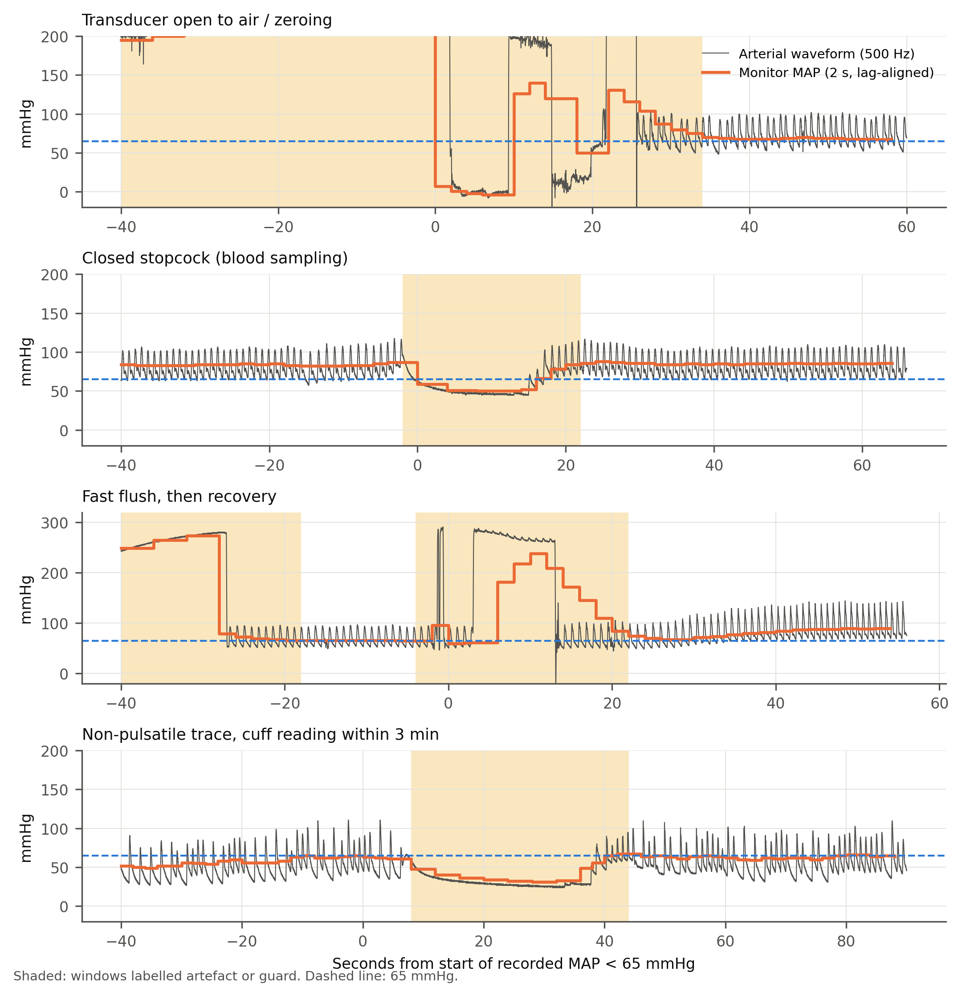
Fig. 1 Recorded hypotension that is waveform-flagged artefact: waveform and monitor MAP
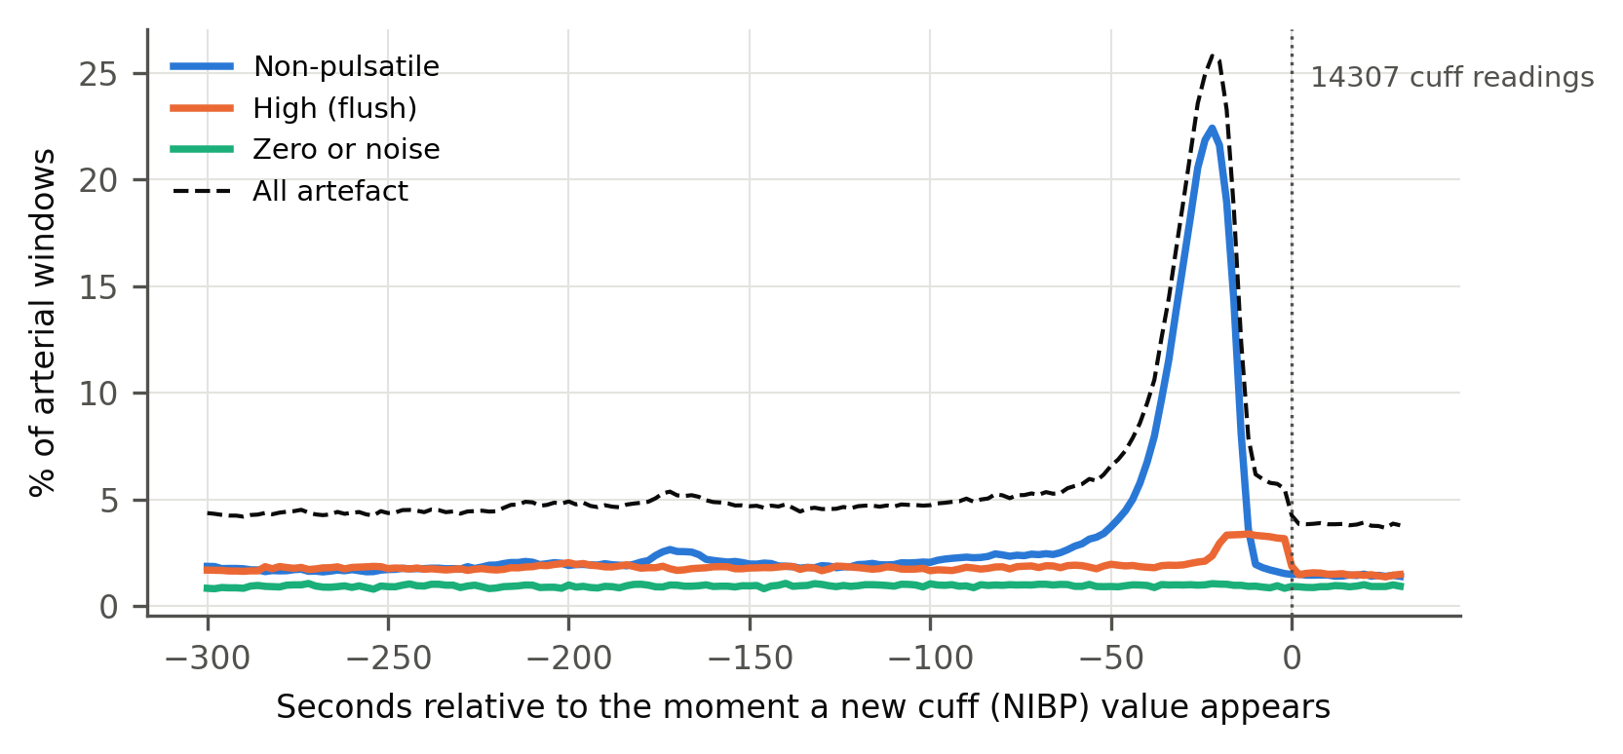
Fig. 2 Arterial artefact around non-invasive cuff measurements, by artefact type
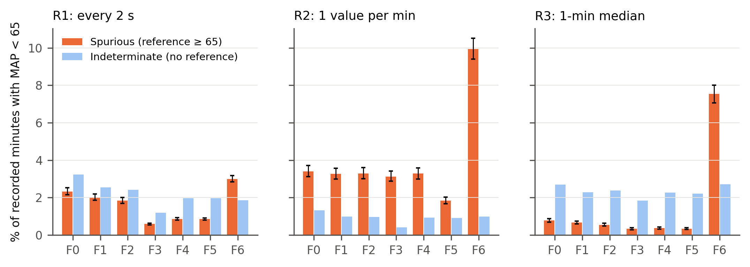
Fig. 3 Spurious minutes among recorded minutes with MAP < 65 mmHg, by filter and resolution
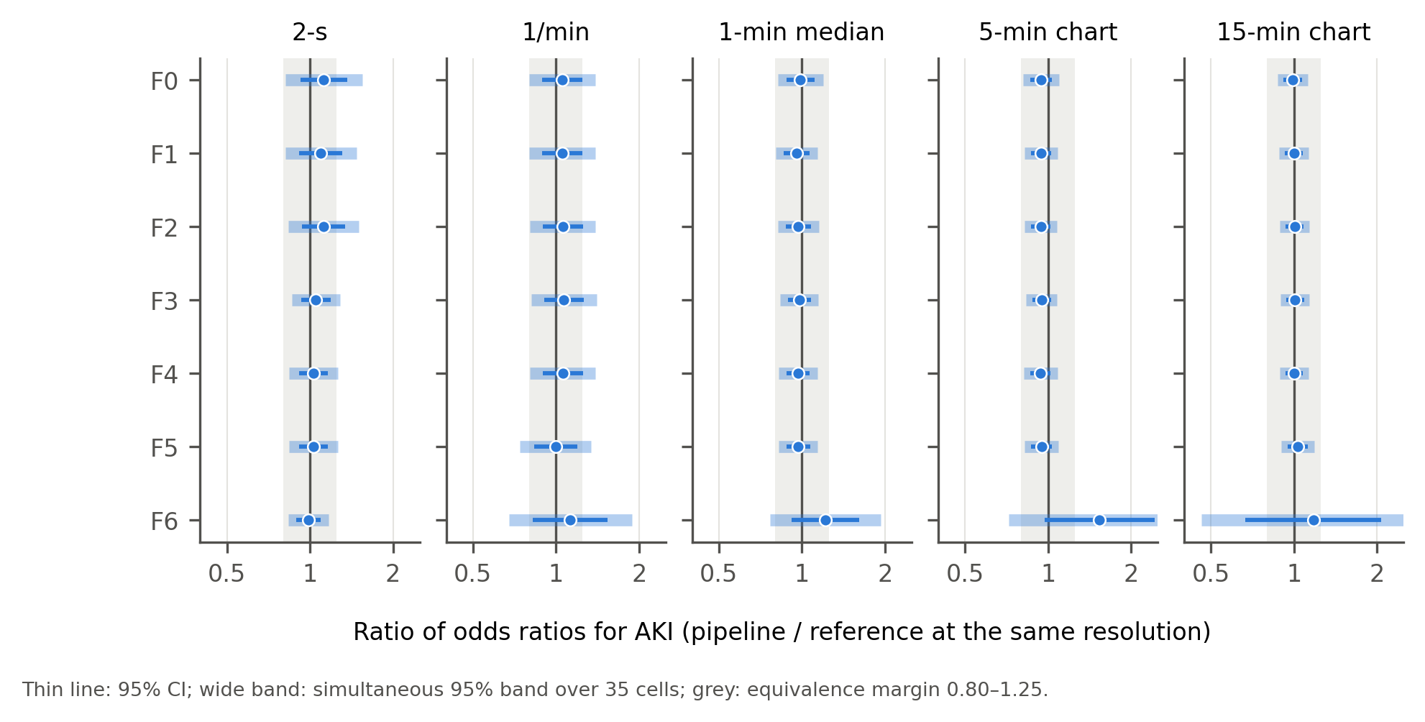
Fig. 4 Ratio of odds ratios for AKI for every filter × resolution combination

