Supplementary Methods

S1. Waveform features and classifier
Features. For every 2-s window of the 500 Hz waveform we computed: - the fraction of finite samples; - the mean, minimum, maximum, 2nd, 10th, 90th and 98th centiles; - the median absolute second difference; - the number of systolic upstrokes in the window and in the centred 6-s window.
An upstroke is a rise of more than 8 mmHg within 100 ms after 20-ms smoothing; successive upstrokes are at least 250 ms apart.
Labels. The labels, thresholds and guard margins are given in the Methods.
Cases without a waveform. Of 3,645 cases with a listed waveform track, 211 returned no waveform through the VitalDB API on 26 October 2026. Their case identifiers are released with the code.
Threshold tuning. The noise threshold, the upstroke rule and the guard length were set by inspecting outcome-free descriptive data from fewer than 600 cases during development. The rule discarded before the freeze (beat-lag autocorrelation) labelled 12% of windows as non-pulsatile in patients with atrial fibrillation against 1% in sinus rhythm, at pulse pressures of 56–83 mmHg.

S2. Interval for the ratio of odds ratios (amendment A15)
Why the bootstrap failed. Exposure categories under F1 × R3 and the reference differed in 33 of 2,563 patients. Bootstrap resamples change few of these patients, so the bootstrap distribution of log ROR is spiky and its central 95% is narrow. In 100 permutations of the outcome, under which the true ROR is exactly 1, the percentile interval covered 1 in 51% of datasets for F1 × R3, 79% for F0 × R1, 89% for F3 × R2 and 91% for F6 × R3.
The rule. Before the real outcome was examined, a written rule set every ROR-type interval to log ROR ± z × max(bootstrap SE, permutation-null SD). The permutation-null SD came from 200 permutations of the analysed outcome. The same SE was used for the simultaneous bands, whose critical value is the bootstrap max-|z| over the 35 cells (3.22).
Coverage check. The SD was estimated from 200 permutations in the dry run, independent of the 100 calibration datasets. With that SD, the interval covered 1 in 100%, 99%, 100% and 97% of calibration datasets for the four pairs.
Operating characteristics at the margin. Outcomes were simulated from the fully adjusted reference model, adding a log-odds shift γ in the patients moved upwards by the pipeline. We chose γ = 1.91 so that the median simulated ROR was 1.24. In 200 datasets, each analysed with the full rule (200 bootstrap resamples and 200 permutations), equivalence was declared in 5%. Without differential error (γ = 0) it was declared in 82%, and the interval covered 1 in 97%.
Reaching the lower margin requires almost all five downward-moved patients to develop AKI. The SD of log ROR under the simulated alternative (0.098) exceeded that under the null (0.062). The bootstrap SE, which grows with the number of cases among the discordant patients, then dominates the rule.

S3. Blinded AI rating
The 400-snippet adjudication set has five strata: - 100 low-MAP windows flagged as artefact; - 50 low-MAP windows labelled guard only; - 100 low-MAP windows labelled valid; - 100 random valid windows; - 50 flagged windows with MAP ≥ 65 mmHg.
There are at most two snippets per patient. A subset of 152 snippets was shown, as 26 grids of six 40-s waveform panels, to two independent instances of an AI model (Claude, Anthropic). The grids were in a folder that contained no key, code or labels. The raters could read files, were instructed to open only the listed images, and saw only the waveform.
The prompt is released with the code. The subset is enriched for artefact (43% against 3.7% in the data), which inflates κ.

S4. Injection–recovery
The implementation check used 296 clean 2-min segments from 100 cases. Synthetic flush, zeroing, sampling, damping, noise and offset artefacts, after Li et al., were injected in the middle 20 s.
The post hoc sweep used 119 segments from 60 cases. It varied: - flush amplitude (120–300 mmHg) and duration (0.5–4 s); - open-transducer level (0–25 mmHg); - damping cut-off (1.5–10 Hz); - partial occlusion (pulse pressure scaled to 0.5–0.15); - linear drift (10–40 mmHg over 20 s); - 18-Hz ringing (5–20 mmHg); - sampling without a terminal flush.
Detection counted only artefact labels, not guard. Clean segments were selected as valid by the classifier, so the absence of false labels in uninjected segments holds by construction.

S5. Real-time episode table
For each episode and each elapsed time t (10, 30, 60 and 120 s), the nadir so far was the lowest monitor MAP in the first t seconds. Episodes shorter than t were not counted at t. The table therefore gives the probability that an episode is flagged, given that it has lasted at least t seconds and reached a given nadir.

Supplementary tables

Table S1. Recorded minutes with MAP < 65 mmHg classified against the reference (descriptive cohort)
res | filter | low_min | spurious_frac | lo | hi | confirmed_frac | bridged_low_frac | indeterminate_frac | patients_with_spurious
R1 | F0 | 6.16e+04 | 0.023 | 0.021 | 0.025 | 0.932 | 0.012 | 0.032 | 2196
R1 | F1 | 6.09e+04 | 0.020 | 0.019 | 0.022 | 0.943 | 0.012 | 0.025 | 2104
R1 | F2 | 6.06e+04 | 0.018 | 0.017 | 0.020 | 0.947 | 0.011 | 0.024 | 2060
R1 | F3 | 5.84e+04 | 0.006 | 0.005 | 0.006 | 0.974 | 0.008 | 0.012 | 1921
R1 | F4 | 5.96e+04 | 0.009 | 0.008 | 0.009 | 0.963 | 0.009 | 0.020 | 2041
R1 | F5 | 5.96e+04 | 0.009 | 0.008 | 0.009 | 0.963 | 0.009 | 0.020 | 2029
R1 | F6 | 5.91e+04 | 0.030 | 0.028 | 0.032 | 0.942 | 0.010 | 0.019 | 2683
R2 | F0 | 6.22e+04 | 0.034 | 0.031 | 0.037 | 0.934 | 0.019 | 0.013 | 1108
R2 | F1 | 6.19e+04 | 0.033 | 0.030 | 0.036 | 0.938 | 0.019 | 0.010 | 1065
R2 | F2 | 6.2e+04 | 0.033 | 0.030 | 0.036 | 0.938 | 0.020 | 0.010 | 1081
R2 | F3 | 6.13e+04 | 0.031 | 0.029 | 0.034 | 0.946 | 0.019 | 0.004 | 1079
R2 | F4 | 6.2e+04 | 0.033 | 0.030 | 0.036 | 0.938 | 0.020 | 0.009 | 1098
R2 | F5 | 6.09e+04 | 0.018 | 0.017 | 0.020 | 0.953 | 0.019 | 0.009 | 754
R2 | F6 | 5.15e+04 | 0.099 | 0.094 | 0.105 | 0.868 | 0.023 | 0.010 | 1338
R3 | F0 | 5.96e+04 | 0.008 | 0.007 | 0.009 | 0.960 | 0.006 | 0.027 | 363
R3 | F1 | 5.93e+04 | 0.007 | 0.006 | 0.007 | 0.964 | 0.006 | 0.023 | 311
R3 | F2 | 5.94e+04 | 0.005 | 0.005 | 0.006 | 0.963 | 0.008 | 0.024 | 271
R3 | F3 | 5.88e+04 | 0.003 | 0.003 | 0.004 | 0.970 | 0.009 | 0.018 | 170
R3 | F4 | 5.92e+04 | 0.004 | 0.003 | 0.004 | 0.966 | 0.008 | 0.023 | 195
R3 | F5 | 5.92e+04 | 0.003 | 0.003 | 0.004 | 0.967 | 0.008 | 0.022 | 177
R3 | F6 | 5.19e+04 | 0.075 | 0.071 | 0.080 | 0.887 | 0.011 | 0.027 | 1105
low_min: pipeline minutes < 65; fractions are of low_min; lo/hi: patient-cluster bootstrap 95% CI of the spurious fraction.

Table S2. Agreement of the binary exposure (≥ 10 min MAP < 65) with the reference (descriptive cohort)
filter | res | prev_ref | prev_pipe | sens | spec | kappa | flips | up | down | mean_diff | loa_lo | loa_hi
F0 | R1 | 0.423 | 0.441 | 0.999 | 0.967 | 0.960 | 64 | 62 | 2 | 0.859 | -6.257 | 7.975
F0 | R2 | 0.445 | 0.465 | 0.997 | 0.962 | 0.955 | 73 | 69 | 4 | 0.568 | -5.920 | 7.056
F0 | R3 | 0.424 | 0.434 | 0.995 | 0.979 | 0.971 | 46 | 39 | 7 | 0.406 | -6.755 | 7.567
F0 | R4 | 0.512 | 0.531 | 0.993 | 0.955 | 0.949 | 83 | 72 | 11 | 0.505 | -7.270 | 8.280
F0 | R5 | 0.532 | 0.544 | 0.994 | 0.968 | 0.963 | 59 | 49 | 10 | 0.548 | -10.472 | 11.567
F1 | R1 | 0.423 | 0.437 | 0.996 | 0.973 | 0.965 | 56 | 51 | 5 | 0.643 | -5.850 | 7.135
F1 | R2 | 0.445 | 0.463 | 0.997 | 0.965 | 0.958 | 67 | 63 | 4 | 0.472 | -5.447 | 6.392
F1 | R3 | 0.424 | 0.432 | 0.996 | 0.983 | 0.976 | 38 | 32 | 6 | 0.330 | -6.309 | 6.969
F1 | R4 | 0.512 | 0.529 | 0.994 | 0.959 | 0.954 | 75 | 65 | 10 | 0.440 | -7.039 | 7.919
F1 | R5 | 0.532 | 0.542 | 0.994 | 0.970 | 0.966 | 55 | 45 | 10 | 0.489 | -10.309 | 11.288
F2 | R1 | 0.423 | 0.435 | 0.996 | 0.976 | 0.968 | 51 | 45 | 6 | 0.554 | -5.764 | 6.872
F2 | R2 | 0.445 | 0.463 | 0.997 | 0.966 | 0.959 | 66 | 62 | 4 | 0.481 | -5.389 | 6.352
F2 | R3 | 0.424 | 0.430 | 0.995 | 0.986 | 0.979 | 34 | 27 | 7 | 0.361 | -6.270 | 6.992
F2 | R4 | 0.512 | 0.530 | 0.995 | 0.959 | 0.954 | 74 | 65 | 9 | 0.468 | -7.003 | 7.939
F2 | R5 | 0.532 | 0.543 | 0.995 | 0.970 | 0.966 | 55 | 46 | 9 | 0.522 | -10.193 | 11.236
F3 | R1 | 0.423 | 0.425 | 0.993 | 0.992 | 0.985 | 24 | 15 | 9 | -0.119 | -4.023 | 3.786
F3 | R2 | 0.445 | 0.461 | 0.997 | 0.968 | 0.962 | 61 | 57 | 4 | 0.291 | -3.688 | 4.270
F3 | R3 | 0.424 | 0.429 | 0.996 | 0.987 | 0.981 | 30 | 24 | 6 | 0.184 | -2.590 | 2.958
F3 | R4 | 0.512 | 0.531 | 0.995 | 0.958 | 0.954 | 75 | 67 | 8 | 0.373 | -5.929 | 6.674
F3 | R5 | 0.532 | 0.543 | 0.995 | 0.970 | 0.967 | 54 | 45 | 9 | 0.413 | -9.428 | 10.253
F4 | R1 | 0.423 | 0.428 | 0.996 | 0.989 | 0.983 | 27 | 21 | 6 | 0.249 | -4.599 | 5.098
F4 | R2 | 0.445 | 0.464 | 0.997 | 0.965 | 0.958 | 68 | 64 | 4 | 0.478 | -5.146 | 6.102
F4 | R3 | 0.424 | 0.429 | 0.995 | 0.988 | 0.981 | 30 | 23 | 7 | 0.305 | -5.850 | 6.460
F4 | R4 | 0.512 | 0.533 | 0.995 | 0.953 | 0.949 | 82 | 74 | 8 | 0.471 | -6.860 | 7.802
F4 | R5 | 0.532 | 0.544 | 0.995 | 0.969 | 0.966 | 55 | 47 | 8 | 0.505 | -9.917 | 10.927
F5 | R1 | 0.423 | 0.428 | 0.996 | 0.989 | 0.983 | 27 | 21 | 6 | 0.248 | -4.601 | 5.096
F5 | R2 | 0.445 | 0.455 | 0.996 | 0.979 | 0.973 | 43 | 37 | 6 | 0.152 | -5.131 | 5.436
F5 | R3 | 0.424 | 0.428 | 0.995 | 0.988 | 0.982 | 29 | 22 | 7 | 0.290 | -5.847 | 6.427
F5 | R4 | 0.512 | 0.518 | 0.986 | 0.973 | 0.959 | 66 | 42 | 24 | -0.051 | -6.648 | 6.546
F5 | R5 | 0.532 | 0.521 | 0.966 | 0.985 | 0.950 | 81 | 23 | 58 | -0.322 | -10.248 | 9.605
F6 | R1 | 0.423 | 0.424 | 0.991 | 0.991 | 0.981 | 30 | 17 | 13 | 0.095 | -4.794 | 4.984
F6 | R2 | 0.445 | 0.361 | 0.806 | 0.996 | 0.818 | 287 | 7 | 280 | -2.736 | -12.533 | 7.062
F6 | R3 | 0.424 | 0.362 | 0.846 | 0.995 | 0.857 | 222 | 10 | 212 | -1.934 | -11.830 | 7.961
F6 | R4 | 0.512 | 0.203 | 0.395 | 0.999 | 0.388 | 1009 | 2 | 1007 | -8.671 | -32.380 | 15.038
F6 | R5 | 0.532 | 0.110 | 0.207 | 0.999 | 0.195 | 1372 | 2 | 1370 | -11.952 | -47.877 | 23.973
flips: patients whose category differs (up: exposed by pipeline only). R4/R5 at phase offset 0. mean_diff and limits of agreement in minutes below 65 mmHg.

Table S3. POST HOC: probability that an episode is waveform-flagged, by elapsed time and nadir so far
still < 65 mmHg after (s) | nadir_so_far | episodes | p_flagged
10 | <20 | 1406 | 0.747
10 | 20-39 | 2046 | 0.792
10 | 40-54 | 3301 | 0.478
10 | 55-64 | 33017 | 0.016
30 | <20 | 384 | 0.594
30 | 20-39 | 704 | 0.574
30 | 40-54 | 2057 | 0.070
30 | 55-64 | 15900 | 0.009
60 | <20 | 224 | 0.442
60 | 20-39 | 300 | 0.080
60 | 40-54 | 2018 | 0.017
60 | 55-64 | 9413 | 0.007
120 | <20 | 159 | 0.289
120 | 20-39 | 248 | 0.024
120 | 40-54 | 1993 | 0.010
120 | 55-64 | 4911 | 0.006
Among episodes that had lasted at least the stated time; nadir so far = lowest monitor MAP up to that time.

Table S4. POST HOC: depth-weighted exposures and lower thresholds (1-min median resolution)
metric | thr | filter | res | or_ref | or_pipe | ror | lo | hi | p_perm
twa | 55 | F0 | R3 | 3.893 | 1.186 | 0.305 | 0.061 | 1.531 | 0.105
twa | 55 | F1 | R3 | 3.893 | 4.065 | 1.044 | 0.401 | 2.715 | 0.880
twa | 55 | F3 | R3 | 3.893 | 4.767 | 1.224 | 0.546 | 2.744 | 0.470
twa | 65 | F0 | R3 | 1.266 | 1.169 | 0.923 | 0.788 | 1.083 | 0.235
twa | 65 | F1 | R3 | 1.266 | 1.273 | 1.005 | 0.953 | 1.060 | 0.780
twa | 65 | F3 | R3 | 1.266 | 1.269 | 1.002 | 0.958 | 1.048 | 0.870
auc | 55 | F0 | R3 | 3.990 | 2.413 | 0.605 | 0.197 | 1.853 | 0.335
auc | 55 | F1 | R3 | 3.990 | 3.339 | 0.837 | 0.406 | 1.726 | 0.565
auc | 55 | F3 | R3 | 3.990 | 3.812 | 0.955 | 0.653 | 1.398 | 0.730
auc | 65 | F0 | R3 | 1.242 | 1.217 | 0.980 | 0.911 | 1.054 | 0.605
auc | 65 | F1 | R3 | 1.242 | 1.242 | 1.000 | 0.968 | 1.033 | 0.995
auc | 65 | F3 | R3 | 1.242 | 1.247 | 1.004 | 0.981 | 1.028 | 0.705

item | value
auc55_F0xR3_total_ratio | 1.5926511038398004
auc55_F0xR3_excess_share | 0.3721160914722307
auc55_F0xR3_top1pct_share_of_excess | 0.5633518466768042
auc55_F1xR3_total_ratio | 1.1474727971391918
auc55_F1xR3_excess_share | 0.12851964552611783
auc55_F1xR3_top1pct_share_of_excess | 0.5537390027342186
auc55_F3xR3_total_ratio | 0.9909324504685909
auc55_F3xR3_excess_share | -0.009150522346019763
auc55_F3xR3_top1pct_share_of_excess | -2.0514721232838955
auc65_F0xR3_total_ratio | 1.1250310833187709
auc65_F0xR3_excess_share | 0.11113567009183167
auc65_F0xR3_top1pct_share_of_excess | 0.5190926964251571
auc65_F1xR3_total_ratio | 1.0485801543205124
auc65_F1xR3_excess_share | 0.04632946191127629
auc65_F1xR3_top1pct_share_of_excess | 0.5245433707005375
auc65_F3xR3_total_ratio | 1.0101195139055774
auc65_F3xR3_excess_share | 0.01001813524664108
auc65_F3xR3_top1pct_share_of_excess | 0.7610090577627407
binary55_F0xR3 | ROR 1.19 (0.66–2.15)
binary55_F1xR3 | ROR 1.28 (0.81–2.02)
binary55_F3xR3 | ROR 1.10 (0.84–1.45)
binary60_F0xR3 | ROR 0.95 (0.79–1.14)
binary60_F1xR3 | ROR 0.98 (0.85–1.15)
binary60_F3xR3 | ROR 0.98 (0.84–1.13)
TWA per mmHg; AUC (area under the threshold) per 100 mmHg·min, capped at the reference 99th centile. excess_share: fraction of the pipeline total area in excess of the reference total; top1pct_share: share of that excess contributed by the 1% of patients with the largest excess. Intervals as in A15.

Table S5. Sensitivity analyses of the primary ROR (F1 × R3)
analysis | ror | lo | hi | or_pipe | or_ref | events
reference=unbridged | 0.938 | 0.834 | 1.055
reference=guard0 | 0.968 | 0.880 | 1.065
reference=guard30 | 0.962 | 0.838 | 1.103
reference=pp5 | 0.961 | 0.861 | 1.072
reference=pp12 | 0.954 | 0.851 | 1.070
reference=valid25 | 0.969 | 0.865 | 1.086
reference=valid75 | 0.944 | 0.834 | 1.069
reference=wavemean | 0.743 | 0.476 | 1.159
S10 numerics-defined period | 0.910 | 0.747 | 1.107
S5 + blood loss | 0.961 |  |  | 0.904 | 0.941
S11 + number of postoperative creatinines | 0.949 |  |  | 0.845 | 0.890
S7 AKI stage >= 2 (reduced set) | 0.968 |  |  | 2.143 | 2.215 | 24.000
S4 missing postoperative creatinine = no AKI (pre-specified) | 0.963 | 0.865 | 1.071 |  |  | 91.000
S6 transplantation included (pre-specified) | 0.958 | 0.866 | 1.060 |  |  | 122.000
without gynaecology (low creatinine testing) | 0.959 | 0.857 | 1.073 |  |  | 89.000
disease risk score, 2 df | 0.958 | 0.852 | 1.077 |  |  | 91.000
reference=concord | 0.963 | 0.854 | 1.087 |  |  | 91.000
reference=valid25_obs | 0.949 | 0.850 | 1.060 |  |  | 91.000
reference=valid75_obs | 0.952 | 0.832 | 1.090 |  |  | 91.000
Rows from the frozen run first; S4, S6 (pre-specified, run after unblinding) and post hoc rows after. Rows without lo/hi are point estimates.

Table S6. Differential misclassification: AKI on spurious minutes per hour, adjusted for reference exposure
pipeline | model | term | nonzero | or_per_sd | lo | hi | or_per_log1p | lo_u | hi_u
F1xR3 | b_g1_zero_high | 0 | 19.000 | 1.022 | 0.829 | 1.259 | 1.892 | 0.004 | 966.903
F1xR3 | b_g2_nonpuls_noise | 0 | 168.000 | 0.895 | 0.695 | 1.153 | 0.266 | 0.013 | 5.480
F1xR3 | b_all | 0 | 241.000 | 0.831 | 0.626 | 1.102 | 0.159 | 0.010 | 2.614
F1xR3 | c_negative_control | 0 | 241.000 | 0.832 | 0.628 | 1.103 | 0.161 | 0.010 | 2.641
F1xR3 | c_negative_control | 1 | 688.000 | 1.135 | 0.936 | 1.376 | 2.039 | 0.690 | 6.027
F1xR3 | d_mechanism | 0 | 241.000 | 0.837 | 0.632 | 1.107 | 0.170 | 0.011 | 2.740
F1xR3 | d_mechanism | 1 | 2.49e+03 | 0.978 | 0.772 | 1.239 | 0.940 | 0.492 | 1.797
F1xR3 | d_mechanism | 2 | 2.56e+03 | 1.188 | 0.938 | 1.504 | 1.197 | 0.936 | 1.530
F1xR3 | d_mechanism | 3 | 190.000 | 1.025 | 0.927 | 1.134 | 1.001 | 0.996 | 1.007
F0xR1 | b_g1_zero_high | 0 | 789.000 | 1.105 | 0.938 | 1.300 | 17.314 | 0.162 | 1.85e+03
F0xR1 | b_g2_nonpuls_noise | 0 | 1.4e+03 | 0.878 | 0.695 | 1.110 | 0.288 | 0.031 | 2.710
F0xR1 | b_all | 0 | 1.73e+03 | 0.928 | 0.741 | 1.161 | 0.589 | 0.122 | 2.855
F0xR1 | c_negative_control | 0 | 1.73e+03 | 0.916 | 0.731 | 1.148 | 0.539 | 0.110 | 2.636
F0xR1 | c_negative_control | 1 | 1.94e+03 | 1.171 | 0.957 | 1.433 | 2.095 | 0.815 | 5.383
F0xR1 | d_mechanism | 0 | 1.73e+03 | 0.922 | 0.737 | 1.153 | 0.563 | 0.116 | 2.722
F0xR1 | d_mechanism | 1 | 2.49e+03 | 0.971 | 0.766 | 1.231 | 0.923 | 0.482 | 1.768
F0xR1 | d_mechanism | 2 | 2.56e+03 | 1.199 | 0.947 | 1.517 | 1.208 | 0.945 | 1.544
F0xR1 | d_mechanism | 3 | 190.000 | 1.026 | 0.928 | 1.135 | 1.001 | 0.996 | 1.007
F0xR1 (separate model) | spurious_hypo | 0 |  | 0.928 | 0.741 | 1.161 | 0.589 | 0.122 | 2.855
F0xR1 (separate model) | spurious_hyper_negative_control | 0 |  | 1.164 | 0.952 | 1.424 | 2.038 | 0.793 | 5.236
term 0: log(1 + spurious min/h) (or group-specific version); c_negative_control term 1: spurious hypertensive min/h; d_mechanism terms 1–3: blood gases/h, log blood loss, red-cell units. lo/hi per SD; lo_u/hi_u per unit of log(1 + min/h).

Table S7. Discordant patients, operating characteristics of the equivalence decision, and interval coverage
pipeline | up | aki_up | down | aki_down
F1xR3 | 28 | 0 | 5 | 0
F0xR1 | 55 | 4 | 1 | 0
F3xR2 | 50 | 3 | 4 | 0
F6xR3 | 8 | 0 | 178 | 3
F1 × R3: expected AKI among the 33 discordant patients 1.57; probability of none 0.19.
k | ror | lo | hi | n | events | verdict
0 | 0.956 | 0.856 | 1.068 | 2563 | 91 | equivalent
1 | 1.013 | 0.901 | 1.138 | 2563 | 91 | equivalent
2 | 1.070 | 0.900 | 1.272 | 2563 | 91 | inconclusive
3 | 1.129 | 0.938 | 1.358 | 2563 | 91 | inconclusive
4 | 1.195 | 0.957 | 1.492 | 2563 | 91 | inconclusive
5 | 1.269 | 0.982 | 1.641 | 2563 | 91 | inconclusive
ROR and A15 interval if k of the 28 upward-moved patients had developed AKI (outcomes swapped with k concordant cases; 400 bootstrap resamples, 200 permutations). Under the reference model, P(k = 0) = 0.26, P(k = 1) = 0.38, P(k ≥ 2) = 0.36.
scenario | gamma_up | median_ror | p_equivalent | coverage_of_1 | sd_lror | n
null | 0.000 | 1.004 | 0.820 | 0.970 | 0.062 | 200
upper_margin | 1.912 | 1.239 | 0.050 | 0.510 | 0.098 | 200
Simulated outcomes from the fully adjusted reference model; differential error added as a log-odds shift γ in upward-moved patients. Each dataset analysed with the A15 rule (200 bootstrap resamples, 200 permutations). Median ROR by γ: up0.0: 0.99, up1.0: 1.08, up2.0: 1.27, up3.0: 1.52, up4.0: 1.89, down2.0: 0.95, down4.0: 0.86, down8.0: 0.78. Coverage of 1 under independent permutations (SD from the dry run, 100 calibration datasets): F1xR3 1.00, F0xR1 0.99, F3xR2 1.00, F6xR3 0.97.

Table S8. Injection–recovery sweep (post hoc)
kind | param | any_artefact | frac_artefact
flush | (120, 0.5) | 0.000 | 0.000
flush | (120, 1) | 0.000 | 0.000
flush | (120, 2) | 1.000 | 0.100
flush | (120, 4) | 1.000 | 0.200
flush | (150, 0.5) | 0.000 | 0.000
flush | (150, 1) | 0.000 | 0.000
flush | (150, 2) | 1.000 | 0.100
flush | (150, 4) | 1.000 | 0.200
flush | (200, 0.5) | 0.000 | 0.000
flush | (200, 1) | 0.000 | 0.000
flush | (200, 2) | 1.000 | 0.100
flush | (200, 4) | 1.000 | 0.200
flush | (250, 0.5) | 1.000 | 0.100
flush | (250, 1) | 1.000 | 0.100
flush | (250, 2) | 1.000 | 0.100
flush | (250, 4) | 1.000 | 0.200
flush | (300, 0.5) | 1.000 | 0.100
flush | (300, 1) | 1.000 | 0.100
flush | (300, 2) | 1.000 | 0.100
flush | (300, 4) | 1.000 | 0.200
zero_level | 0 | 1.000 | 0.500
zero_level | 5 | 1.000 | 0.500
zero_level | 10 | 1.000 | 0.500
zero_level | 15 | 1.000 | 0.500
zero_level | 20 | 1.000 | 0.500
zero_level | 25 | 1.000 | 0.500
damping_hz | 1.5 | 0.118 | 0.079
damping_hz | 2 | 0.008 | 0.001
damping_hz | 3 | 0.000 | 0.000
damping_hz | 5 | 0.000 | 0.000
damping_hz | 10 | 0.000 | 0.000
partial_occlusion | 0.5 | 0.000 | 0.000
partial_occlusion | 0.3 | 0.025 | 0.010
partial_occlusion | 0.15 | 0.613 | 0.520
drift_mmhg | 10 | 0.008 | 0.001
drift_mmhg | 20 | 0.008 | 0.001
drift_mmhg | 40 | 0.008 | 0.006
ringing_mmhg | 5 | 0.000 | 0.000
ringing_mmhg | 10 | 0.000 | 0.000
ringing_mmhg | 20 | 0.008 | 0.001
sampling_no_flush | mean | 1.000 | 0.700
sampling_no_flush | 20 | 1.000 | 0.700
any_artefact: share of injections with at least one window in the injected 20 s labelled artefact (zero/high/non-pulsatile/noise; guard excluded); 119 clean 2-min segments from 60 cases.

Table S9. Blinded AI rating of 152 snippets (secondary)
item | value
n_rated | 152.000
n | 131.000
agree | 0.977
kappa | 0.954
artefact_share_in_subset | 0.435
alg_artefact_rated_artefact | 1.000
alg_valid_rated_artefact | 0.041
alg_valid_n | 74.000
alg_valid_low_strata_n | 36.000
guard_n | 19.000
guard_rated_artefact | 0.684
unsure | 2.000

Table S10. In-hospital mortality (exploratory, reduced adjustment set)
n = 2962, deaths = 26; OR reference 1.50 (0.69–3.27); OR F1 × R3 1.47 (0.68–3.20); ROR 0.98.

Table S11. Odds ratios for AKI by adjustment level (AKI set, 1-min median)
series | exposure | adjustment | odds_ratio | lo | hi
reference | binary65 | crude | 1.655 | 1.090 | 2.513
reference | binary65 | reduced_set | 1.463 | 0.952 | 2.248
reference | binary65 | full_set | 0.940 | 0.596 | 1.483
reference | binary65 | full_set_without_duration | 1.097 | 0.704 | 1.709
reference | binary55 | crude | 3.813 | 1.865 | 7.794
reference | binary55 | reduced_set | 3.362 | 1.575 | 7.180
reference | binary55 | full_set | 1.954 | 0.894 | 4.270
reference | minutes65 | crude | 1.215 | 1.136 | 1.300
reference | minutes65 | reduced_set | 1.195 | 1.112 | 1.283
reference | minutes65 | full_set | 1.079 | 0.994 | 1.172
F1xR3 | binary65 | crude | 1.593 | 1.049 | 2.419
F1xR3 | binary65 | reduced_set | 1.414 | 0.921 | 2.170
F1xR3 | binary65 | full_set | 0.899 | 0.571 | 1.417
F1xR3 | binary55 | crude | 4.673 | 2.465 | 8.857
F1xR3 | binary55 | reduced_set | 4.106 | 2.068 | 8.151
F1xR3 | binary55 | full_set | 2.494 | 1.224 | 5.080
F1xR3 | minutes65 | crude | 1.221 | 1.142 | 1.305
F1xR3 | minutes65 | reduced_set | 1.200 | 1.119 | 1.288
F1xR3 | minutes65 | full_set | 1.087 | 1.002 | 1.179
reduced_set: age and eGFR splines, ASA ≥ 3, emergency. Wald intervals from Firth fits. AKI-set inclusion by department: General surgery 85% of 1749, Gynecology 28% of 172, Thoracic surgery 96% of 996, Urology 97% of 59.

Supplementary figures
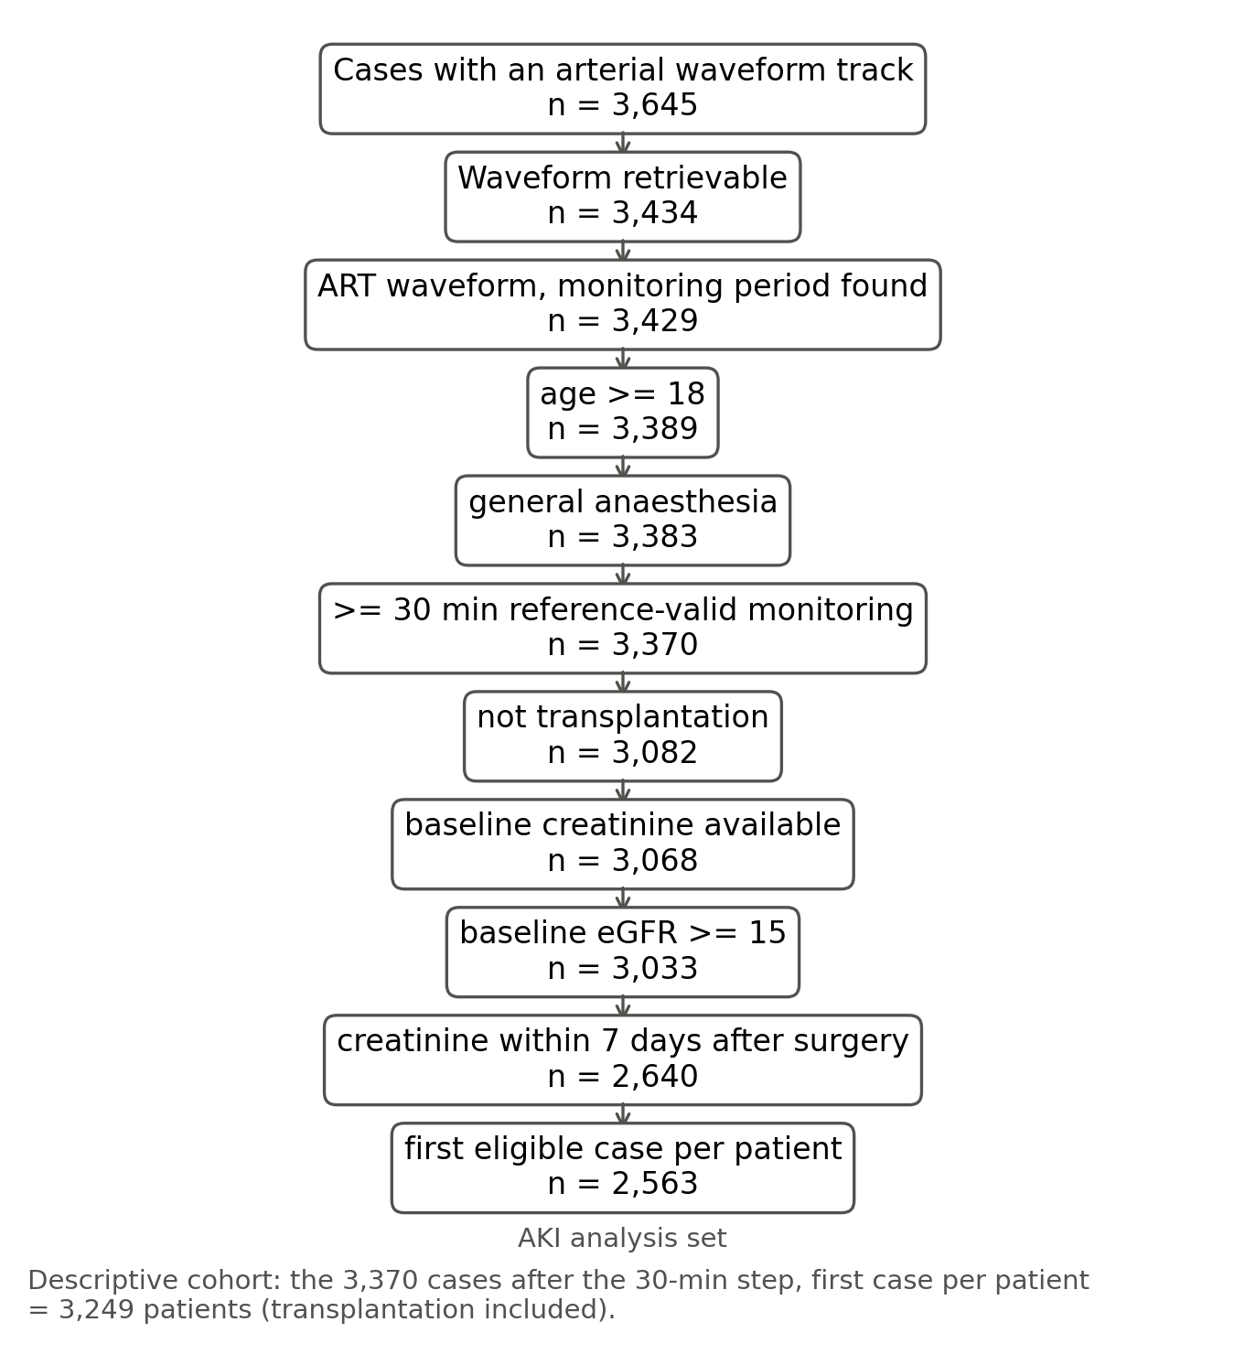
Figure S1. Flow of patients.
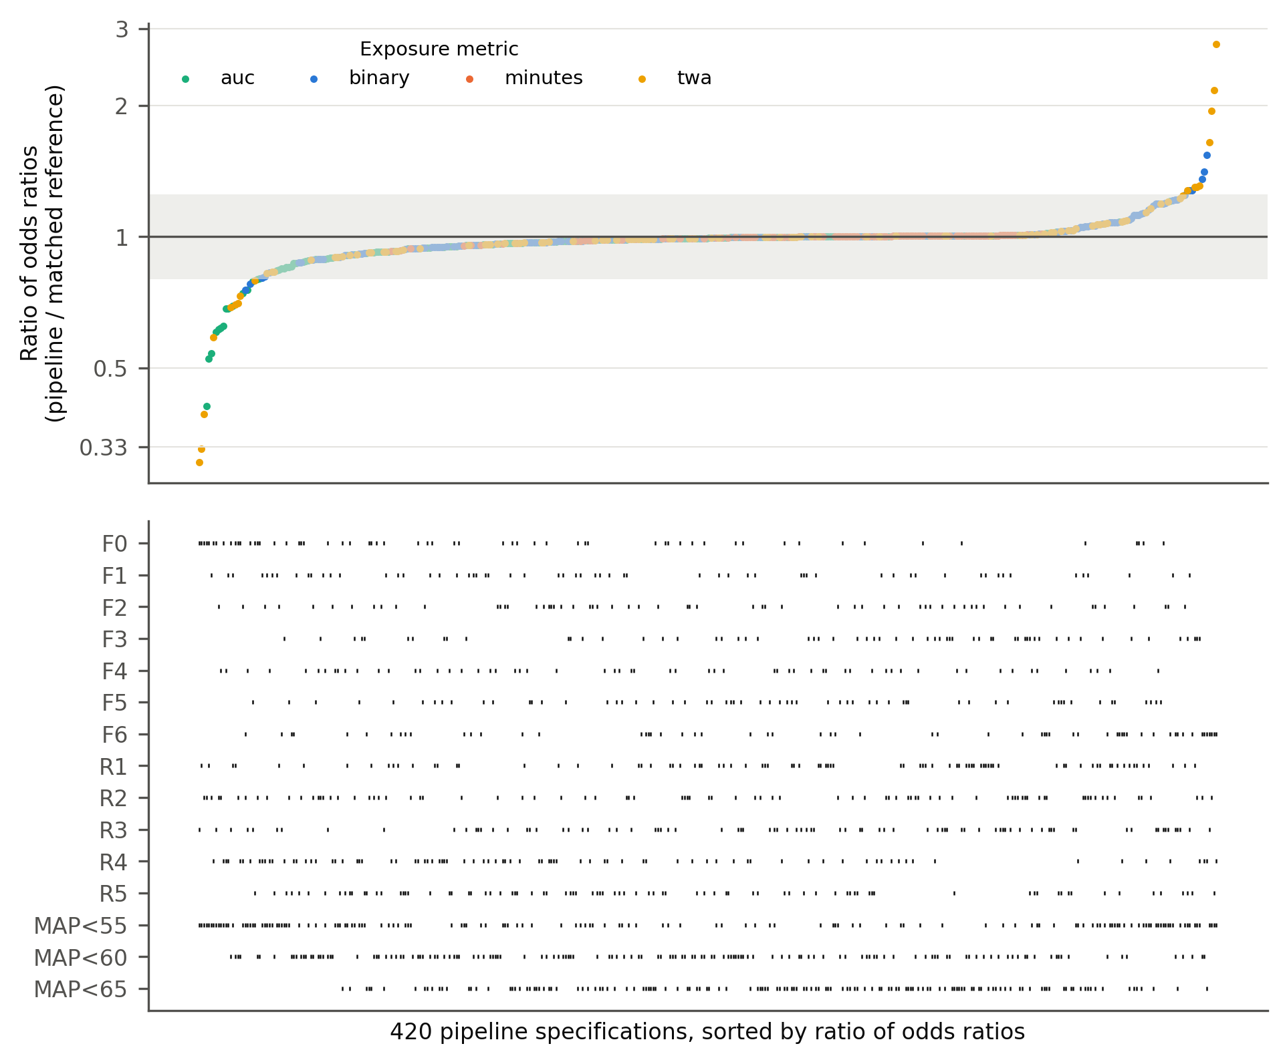
Figure S2. Specification curve of 420 pipeline specifications.
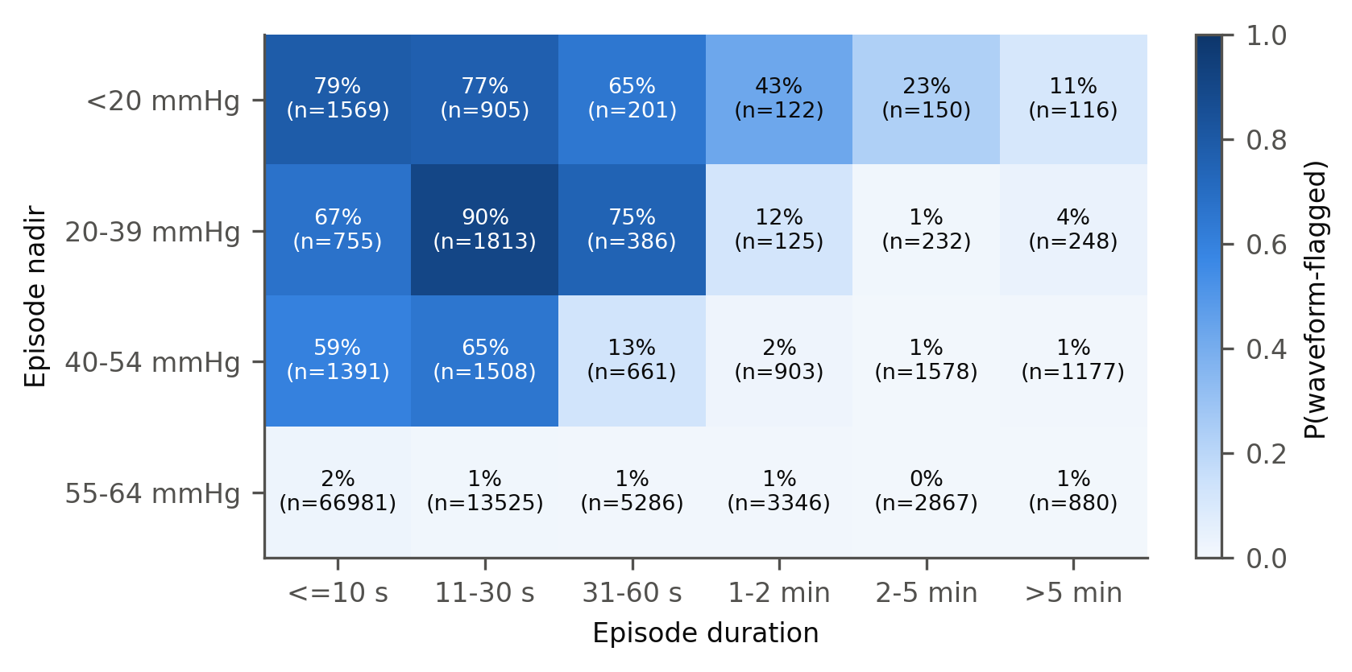
Figure S3. Probability that a recorded episode is waveform-flagged, by final duration and nadir.
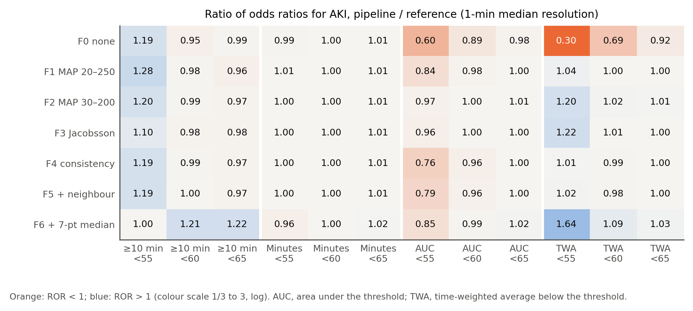
Figure S4. Ratio of odds ratios by filter, exposure metric and threshold (post hoc display).

Supplementary Protocol

Analysis protocol (frozen before any outcome analysis)
Working title. How much of recorded intraoperative hypotension is artefact, and how much does it matter? A waveform-referenced multiverse analysis of arterial-line artefacts, data resolution and the hypotension–acute kidney injury association in VitalDB.
Status at freezing. Window features extracted from the 500 Hz arterial waveform; artefact classifier inspected visually on 20 snippets and descriptive artefact burden computed on ≤ 600 cases. No association between any exposure and any outcome has been computed. The freeze is the git commit containing this file; any later change is recorded in the “Amendments” section with date and reason.
Reporting: STROBE and RECORD. Design: retrospective cohort, secondary analysis of a de-identified open dataset.

1. Objectives
# | Objective | Type
O1 | Artefact burden of the intraoperative arterial line, by artefact type | descriptive
O2 | Fraction of recorded hypotensive minutes that are artefact, for each processing pipeline | descriptive (primary measurement endpoint)
O3 | Per-patient misclassification of hypotension exposure versus the reference | descriptive
O4 | How the adjusted association between hypotension and AKI changes across pipelines (multiverse / specification curve) | primary inferential
O5 | Differential misclassification: is artefact-attributable “hypotension” associated with blood-gas sampling, severity and AKI? | secondary, hypothesis-driven
O6 | Probability that a low monitor MAP episode is artefact, by duration and nadir; a simple bedside rule, derived and validated on separate patients | secondary, clinical

2. Data and cohort
VitalDB (Seoul National University Hospital, 2016–2017; Lee HC et al., Sci Data 2022). Open, de-identified; original collection approved by the SNUH IRB. No new ethics approval needed (to be confirmed against the VitalDB data-use terms and stated in the paper).
Inclusion: SNUADC/ART waveform present; age ≥ 18; general anaesthesia; ≥ 30 min of monitoring period (definition §3). Exclusions for the AKI analysis: missing baseline creatinine; baseline eGFR < 15 (proxy for end-stage renal disease); no creatinine within 7 days after the end of anaesthesia; transplantation procedures (optype == 'Transplantation'; included in sensitivity S6).

3. Reference series (waveform-informed)
- 2-s windows of the 500 Hz waveform are labelled valid, missing, zero, high, nonpulsatile, noise (rules in src/artifact.py, frozen at this commit), plus guard: windows within 10 s of any non-valid window.
- The monitor’s 2-s ART_MBP numerics are aligned to the waveform by a per-case lag (1–4 samples, maximum correlation on valid windows).
- Reference minute MAP = median of the aligned monitor MAP values in valid windows of the minute, if ≥ 50% of the minute’s windows are valid; otherwise missing.
- Rationale: the reference differs from the monitor stream only by removal of waveform-detected artefact, so calibration differences between the monitor and the ADC do not enter the comparison.
- Monitoring period = from the first to the last run of ≥ 60 s of valid windows within anaesthesia (anestart–aneend). All pipelines use the same period.

4. Pipelines (the multiverse)
Pipelines use only the monitor numerics (MAP, SBP, DBP), as a retrospective study would.
Filter (applied to 2-s numerics; F5 and F6 after sampling, see A8):
Code | Rule | Source
F0 | none | —
F1 | drop MAP < 20 or > 250 | Lee 2026 (VitalDB AKI)
F2 | drop MAP < 30 or > 200 | Khan 2022
F3 | drop SBP > 250, DBP < 15, MAP < 35 or > 150, SBP−DBP < 15 | Jacobsson 2026
F4 | drop MAP < 20 or > 200, SBP > 300 or < 20, SBP ≤ DBP, SBP−DBP < 5, DBP < 5 | physiological consistency
F5 | F4 + drop values differing from both neighbours by > 30 mmHg | neighbour comparison (Du 2019 style)
F6 | F4 + 7-point running median on the minute grid | median filter (Pasma 2020)
Resolution: R1 2-s (all values; minutes = count × 2 s / 60); R2 1-min instantaneous (value at the minute mark); R3 1-min median; R4 5-min instantaneous, held; R5 15-min instantaneous, held.
Metric: cumulative minutes < T; area under T (mmHg·min); time-weighted average below T (AUC / monitored minutes); binary “≥ 10 cumulative minutes < T”. Threshold: T in {55, 60, 65} mmHg.
7 × 5 × 4 × 3 = 420 pipeline specifications, each compared with the reference computed with the same metric and threshold (12 reference specifications).

5. Outcomes and covariates
- Primary: AKI by KDIGO creatinine criteria within 7 days (≥ 0.3 mg/dL within 48 h, or ≥ 1.5× baseline within 7 days). Baseline = last creatinine within 30 days before induction, else preop_cr. Urine output not available postoperatively.
- Secondary: AKI stage ≥ 2; in-hospital death.
- Adjustment set (fixed): age, sex, BMI, ASA ≥ 3, emergency, baseline eGFR (CKD-EPI 2021), hypertension, diabetes, preoperative haemoglobin, preoperative albumin, department, surgical approach, log anaesthesia duration. Missing covariates: median (continuous) or mode (categorical) imputation with a missingness indicator if > 5% missing. Intraoperative vasopressors, fluids and blood loss are not adjusted for (potential mediators); sensitivity S5 adds blood loss.

6. Statistical analysis
- O2. Among pipeline-recorded minutes with MAP < 65: proportion where the reference minute is missing because of artefact, or ≥ 65. Reported per pipeline with patient-cluster bootstrap 95% CI (1,000 resamples).
- O3. For the binary exposure, sensitivity, specificity and Cohen’s kappa against the reference. For minutes < 65, the median per-patient difference and Bland–Altman limits.
- O4.
  - For each of the 432 specifications, a logistic regression of AKI on the exposure plus the adjustment set.
  - Units:
    - binary: OR;
    - minutes: per 10 min, truncated at 120 min;
    - AUC: per 100 mmHg·min, truncated at the 99th percentile of the reference distribution;
    - TWA: per 1 mmHg.
  - Primary estimand: the ratio of odds ratios (ROR = OR_pipeline / OR_reference) for the binary exposure “≥ 10 min with MAP < 65”, with patient-level paired bootstrap 95% CI (1,000 resamples, the same resample for both models).
  - Paired bootstrap for all 35 filter × resolution specifications of the primary metric. The other specifications are reported as point estimates in a specification curve.
  - Fragility summaries: range and IQR of ORs; proportion of specifications whose 95% CI excludes 1; the number of specifications that change the qualitative conclusion.
- O5.
  - Artefact-attributable minutes = minutes < 65 (F1, R3) − reference minutes < 65.

    - Spearman correlation with the number of intraoperative arterial blood gases (VitalDB labs with a pH result during anaesthesia) and with ASA.
  - (b) Logistic regression of AKI on artefact-attributable minutes, adjusted for reference minutes and the adjustment set. Any association indicates differential misclassification.
- O6.
  - Episodes are contiguous runs of aligned 2-s monitor MAP < 65 within the monitoring period.
  - An episode is artefactual if ≥ 50% of its windows are non-valid (any label other than valid, including guard).
  - P(artefact) is tabulated by duration (≤ 10 s, 10–30 s, 30–60 s, 1–2 min, 2–5 min, > 5 min) × nadir (< 20, 20–39, 40–54, 55–64), with Wilson CIs.
  - A simple rule is derived on a 50% patient split (hash of caseid) and validated on the other 50%. The rule uses only features visible at the bedside: duration, nadir, and the maximum MAP in the preceding 30 s.
- Mortality (few events, about 40): Firth-penalised logistic regression adjusted for age, ASA ≥ 3, emergency and eGFR. Reported descriptively with the specification spread only.

7. Validation of the reference
- V1 injection–recovery:
  - Clean 2-min segments from 100 randomly selected cases.
  - Inject synthetic artefacts (Li, Mark & Clifford 2009 types): flush square wave to 300 mmHg, zeroing (0 mmHg), sampling (flat line at line pressure, then flush), overdamping (low-pass), high-frequency noise, and a 15 mmHg transducer offset.
  - Report the detection sensitivity per type. Specificity is measured on uninjected clean segments.
  - The transducer offset is expected to be undetectable by design (limitation).
- V2 blinded adjudication: 150 stratified random 40-s snippets, plotted without labels and adjudicated by an independent AI reviewer agent as valid or artefact. Report kappa. The adjudicator is not a human expert, and this is disclosed.
- V3 physiological concordance: |ART − NIBP| at NIBP measurement times, for valid versus non-valid windows; agreement of the waveform HR with the monitor ECG HR.

8. Sensitivity analyses
Code | Change
S1 | guard 0 s and 30 s
S2 | pulse-pressure threshold for non-pulsatile 5 and 12 mmHg
S3 | reference minute validity threshold 25% and 75%
S4 | missing postoperative creatinine treated as no AKI (cohort without the 7-day creatinine requirement)
S5 | add intraoperative blood loss to the adjustment set
S6 | include transplantation
S7 | AKI stage ≥ 2
S8 | reference built on the waveform mean instead of the monitor numerics

9. What this study cannot show
- It cannot detect artefacts that leave a normal-looking waveform, such as transducer height errors. The reference is an improved series, not ground truth.
- It cannot identify the clinical response to artefacts: VitalDB records vasopressor bolus totals only.
- The data come from a single centre in 2016–2017.
- The associations are observational.

Amendments (2026-10-26, before freezing, after an adversarial methods review; no outcome data examined)
Where an amendment conflicts with the text above, the amendment governs.
A1 (adapted) — validation without human adjudicators. Two blinded human anaesthesiologist adjudicators are not available for this version. Validation of the reference therefore rests on (i) physiological concordance with independent sensors (V3, now primary), (ii) injection–recovery (V1), and (iii) a blinded AI rater (V2, explicitly secondary and non-decisive). Throughout the paper, minutes are called “waveform-flagged” rather than “artefact” unless independent evidence supports the stronger term. A stratified 400-snippet adjudication set (strata A–D of the review: 150 monitor MAP < 65 & non-valid incl. 50 guard-only; 100 MAP < 65 & valid; 100 random valid; 50 random non-valid with MAP ≥ 65; at most two per patient, selected by hash of subjectid) is generated and released with blank forms, so that human adjudication can be added later.
A2 — freeze. The freeze is a git tag protocol-freeze on a commit whose code implements §4–§6 with these amendments, passes tests/test_pipelines.py, and has completed an end-to-end run with the AKI and death vectors replaced by a seeded permutation (outputs archived in out/results_permuted/). The SHA-256 of src/*.py is recorded in the tag message. An external registry (OSF) was not available; the local git history is the record. Descriptive artefact statistics before freezing used ≤ 600 cases.
A3 — primary estimand. ROR = OR_P / OR_ref for “≥ 10 cumulative minutes with MAP < 65”, P = F1 × R3 (MAP 20–250 range filter, 1-min median), ref = bridged reference at R3. Paired bootstrap, 2,000 resamples of patients, percentile 95% CI. Decision rule with equivalence margin 0.80–1.25: CI entirely within -> “artefact handling does not materially change the association”; CI excludes 1 and point estimate outside the margin -> “material change”; otherwise “inconclusive”. Under non-differential misclassification of plausible size the ROR is expected near 0.90–0.97, so this estimand detects differential bias large enough to matter. Key secondaries: (a) F0 × R1 vs ref@R1; (b) per-10-min log-OR for cumulative minutes < 65, F1 × R3 vs ref@R3, difference with bootstrap CI and attenuation factor β_P/β_ref.
A4 — gap bridging. Runs of non-valid windows ≤ 3 min bounded by ≥ 30 s of valid windows on both sides are linearly bridged between the median valid MAP of the 30 s before and after. The unbridged reference is a sensitivity analysis. Each pipeline-recorded minute < 65 is spurious (reference ≥ 65), confirmed (reference < 65, ≥ 50% observed), bridged-low (reference < 65, < 50% observed) or indeterminate (reference missing). Primary O2 quantity = spurious / all recorded minutes < 65, reported with indeterminate / all; indeterminate minutes are never counted as artefact.
A5 — missing waveform. missing is not an artefact and creates no guard. Minutes with > 50% missing windows are excluded from every pipeline and the reference (common support).
A6 — patients. Unit = patient (subjectid); first eligible case per patient (lowest caseid). Bootstrap and the O6 split are by patient.
A7 — O5. (a) Spearman of spurious minutes per monitored hour with arterial blood gases per hour and ASA. (b) Firth logistic regression of AKI on log1p(spurious minutes/h), adjusted for reference minutes < 65 (linear + restricted cubic spline), log monitored hours and the §5 set; separately for minutes dominated by zero/high labels (g1) and non-pulsatile/noise labels (g2). (c) Negative-control exposure: spurious hypertensive minutes (pipeline MAP > 120 with reference ≤ 100), in the same model. (d) Mechanism model adding blood gases per hour, log1p(blood loss) and red-cell units.
A8 — resolution. The reference is sampled at every resolution and each pipeline is compared with ref@R; the resolution effect is OR(ref@R)/OR(ref@R3). R4 uses all 5 phase offsets and R5 offsets 0, 3, 6, 9, 12 min; log-ORs are averaged over offsets within each bootstrap resample. A charted value is the first non-missing 2-s value in its interval. F5 and F6 are applied after sampling on the pipeline’s own grid (F6 = 7-point running median). S10: each pipeline uses a numerics-defined monitoring period (first to last 60-s run of monitor MAP 40–150 within anaesthesia), as a retrospective study would.
A9 — classifier calibration (descriptive data only). Noise = waveform minimum < −10 mmHg or median |second difference| ≥ 4 mmHg (the single-spike slope rule is dropped). Guard is asymmetric: 2 s before and 8 s after each artefact run (95th centile of monitor recovery time after zero/high/non-pulsatile runs = 8 s; 99th = 16 s). Sensitivity S1 uses 0/0 s and 6/30 s.
A10 — physiological checks (V3, now primary validation). (i) For monitor MAP < 65 episodes with an NIBP reading within ±3 min: proportion with NIBP MAP ≥ 70, by episode class; (ii) for non-pulsatile windows: proportion with concurrent ECG HR 40–150 and pleth HR 40–150; (iii) non-pulsatile fraction in patients with preoperative atrial fibrillation versus sinus rhythm. V1 specificity is reported as the flag rate outside the injected stretch.
A11 — O6. Probability that a monitor-numerics low-MAP episode is waveform-flagged, for retrospective cleaning and automated systems (not bedside use). Episode classes: flagged (≥ 50% artefact labels), guard-dominated (artefact + guard ≥ 50%, artefact < 50%), physiological (otherwise). Patient-cluster bootstrap CIs. Rule: depth-≤ 2 tree on duration, nadir and maximum MAP in the preceding 30 s, derived on a 50% patient-hash split with leaves called “flagged” only at ≥ 90% specificity; validated on the other half (sensitivity, specificity, PPV with cluster CIs).
A12 — models. Age and eGFR as restricted cubic splines (3 knots). Firth-penalised likelihood for all models; failures counted. Simultaneous 95% bands (bootstrap max-|z|) for the 35 F × R RORs. One analysis set for all specifications. S7 and mortality use a reduced set (age and eGFR splines, ASA ≥ 3, emergency). Mortality: one pre-specified specification (primary P vs ref) in the descriptive cohort, exploratory, no specification curve. S11 adds the number of postoperative creatinine measurements. Precision check before unblinding by simulation with assumed (not estimated) covariate effects and OR_ref = 1.5; if the expected 95% CI half-width of log ROR exceeds 0.22, the equivalence conclusion is declared unattainable in advance.
Cohorts. Descriptive cohort (O1–O3, O6, V3, mortality): adults, general anaesthesia, ≥ 30 min reference-valid monitoring, first case per patient. AKI analysis set (O4, O5, S-analyses): additionally excludes transplantation, missing baseline creatinine, eGFR < 15, and no creatinine within 7 days.
A13 — classifier v2 (before freezing; no outcome data examined). The beat-lag autocorrelation pulsatility criterion was dropped: in descriptive data it labelled 12% of windows in patients with preoperative atrial fibrillation as non-pulsatile (1% in sinus rhythm), and those windows had pulse pressures of 56–83 mmHg; it also fired on bigeminy and slow heart rates. It was replaced by: pulse pressure < 8 mmHg, OR interdecile range < 3 mmHg, OR no systolic upstroke (rise > 8 mmHg within 100 ms) in the centred 6-s window. The noise rule became minimum < −10 mmHg OR median absolute second difference ≥ 4 mmHg (the earlier rule fired on single spikes). Guard is asymmetric: 2 s before and 8 s after an artefact run (95th centile of monitor recovery). All 3,645 waveform cases were re-extracted with these features; 211 had a waveform track listed but not retrievable and are excluded as “waveform not retrievable”.
A14 — O5 power and Firth iterations (before freezing; only the permuted outcome examined). In the permuted dry run, spurious minutes at F1 × R3 were non-zero in 241 of 2,563 patients (zero/flush-dominated in 19), which cannot carry the differential-misclassification test. O5 is therefore run twice: at F1 × R3 as pre-specified, and at F0 × R1 (raw 2-s stream; non-zero in 1,728 patients), with odds ratios also reported per standard deviation of the exposure. The F0 × R1 version is the one interpreted. The Firth iteration limit was raised from 50 to 200: in the dry run 1.7% of bootstrap fits stopped at 50 iterations short of the 1e−7 tolerance, and refitting them changed the estimate only in the eighth decimal.
A15 — null calibration of the ROR interval (written before the calibration result was seen; real outcome never examined). In the dry run several RORs had percentile intervals excluding 1 although the permuted outcome makes the true ROR exactly 1, because the contrast rests on the few dozen patients whose exposure category differs. src/null_calibration.py re-permutes the outcome 100 times and, for F1 × R3, F0 × R1, F3 × R2 and F6 × R3, records how often the paired-bootstrap 95% interval (B = 200) covers 1, and the ratio of the mean bootstrap SE to the SD of log ROR across permutations. Decision rule, fixed now: - if coverage for F1 × R3 is ≥ 0.90, the percentile bootstrap interval stays primary; - otherwise every ROR interval (and simultaneous band) is computed as log ROR ± z × max(bootstrap SE, permutation-null SD of that cell), with the null SD estimated by 200 permutations per cell, and the percentile interval is reported as secondary. The equivalence verdict uses the primary interval.
A15 result (100 permutations, B = 200). Coverage of 1 by the percentile interval: F1 × R3 0.51, F0 × R1 0.79, F3 × R2 0.89, F6 × R3 0.91. The bootstrap distribution of log ROR is spiky — most resamples change few of the patients who drive the contrast — so its central 95% is narrow even where its SD is not (mean bootstrap SE / null SD 0.80 for F1 × R3). The pre-specified rule therefore applies: primary intervals are log ROR ± z × max(bootstrap SE, permutation-null SD), with 200 permutations per cell. Under the same 100 null permutations this interval covered 1 in 0.99, 0.99, 1.00 and 0.97 respectively (conservative). The rule is applied to all ROR-type contrasts: the 35 F × R cells and their simultaneous bands, the resolution effect, the dose-slope differences and the reference-variant sensitivity analyses.

Notes after unblinding
Code hash. The protocol-freeze tag message records the SHA-256 printed by the final permuted dry run (12375fea…). Between that dry run and the freeze commit, only src/figures.py and src/tables.py (plotting and table formatting) were edited, so the hash of src/*.py at the tagged commit is 871bd97e…, which is the hash recorded by the real analysis (out/results_real/summary.json). git diff protocol-freeze -- src/analysis.py src/models.py src/pipelines.py src/artifact.py is empty for the real run.
Post hoc (not pre-specified). src/posthoc_depth.py adds A15-calibrated intervals for the depth-weighted RORs (AUC and TWA below 55 and 65 mmHg, F0/F1/F3 at R3), prompted by their point estimates in the specification curve. Reported as post hoc. The depth-metric heatmap (Figure 3) and forest plot (Figure 6) were added after unblinding.
Post hoc (not pre-specified). src/posthoc_cuff_site.py compares the peri-cuff artefact excess between radial and pedal/femoral catheters (an arm cuff cannot occlude the latter) and between right and left radial catheters, prompted by the C3 result.
Round-1 review changes (2026-10-26, after unblinding). Three AI peer reviewers (statistics, clinical anaesthesia, signal processing/reproducibility; docs/reviews/) led to: - Cuff timing fixed. n_NIBP_MBP had been shifted by the arterial-numerics lag (pipelines.py, figures.py). Cuff values are not delayed like the arterial numerics, so the shift was removed. This affects only C3, V3 and Figure 2 (outcome-free). The primary reference was re-checked after re-running run_all.py: OR_ref and OR_pipe for F1 × R3 are identical to the frozen run (0.9403 and 0.8992). - Reference variants added (sensitivity only; primary unchanged). valid25_obs and valid75_obs apply the minute-validity rule to observed valid windows only (the primary counts bridged values as valid by design of bridging, so the original valid25/valid75 barely tested the rule). concord also removes valid windows where monitor MAP and the waveform mean differ by > 10 mmHg. - Pre-specified S4 and S6 had not been run. They were omitted from analysis.py by error and are now run in src/posthoc_stats.py with the A15 interval. - Post hoc analyses in src/posthoc_review.py, src/posthoc_models.py, src/posthoc_stats.py and src/validate_v1_sweep.py: discordant-patient table, TOST operating characteristics by simulation, split-sample interval coverage, department restriction, disease-risk-score adjustment, crude-to-adjusted OR ladder, real-time episode table, pulse oximetry during deep episodes, cuff subtype/regularity/position, rule performance by nadir, injection sweep.
Round-2 review changes (2026-10-26). A coding error in the post hoc “without duration” model (posthoc_models.py fixed ane_dur_h instead of the log_dur column the model uses) was corrected; the corrected estimate is 1.10 (0.70–1.71). The A11 rule is reported as the single split selected by the tree search. “Artefact” in the text denotes waveform-flagged values (A1). The fragility of the primary verdict to AKI among the discordant patients was quantified post hoc (src/posthoc_k.py).

