WEB – page of A-17’th group student

Oleh Volkov.

“Self-introduction”

This page was made for developing and learning WEB –technologies. Coinciding HTML, CSS, JS technologies was developed to implement this page. Also BOOTSTRAP library (most used front end developing tool in the world) where used for visuals and that’s why mainly class relations where used.

About face part.

So main page includes two half-parts. Left part has four references to Intita, Facebook, Instagram web-pages. CSS style was used for styling this parts using corporative colors for each reference. Right part includes Name, short intro,

RED COLORED SIGN ON THE BOTTOM OF RIGHT SIDE WILL CHANGE IF U WILL SET MOUSE PONTER ON IT. And implementation of this function where made by java-script code.

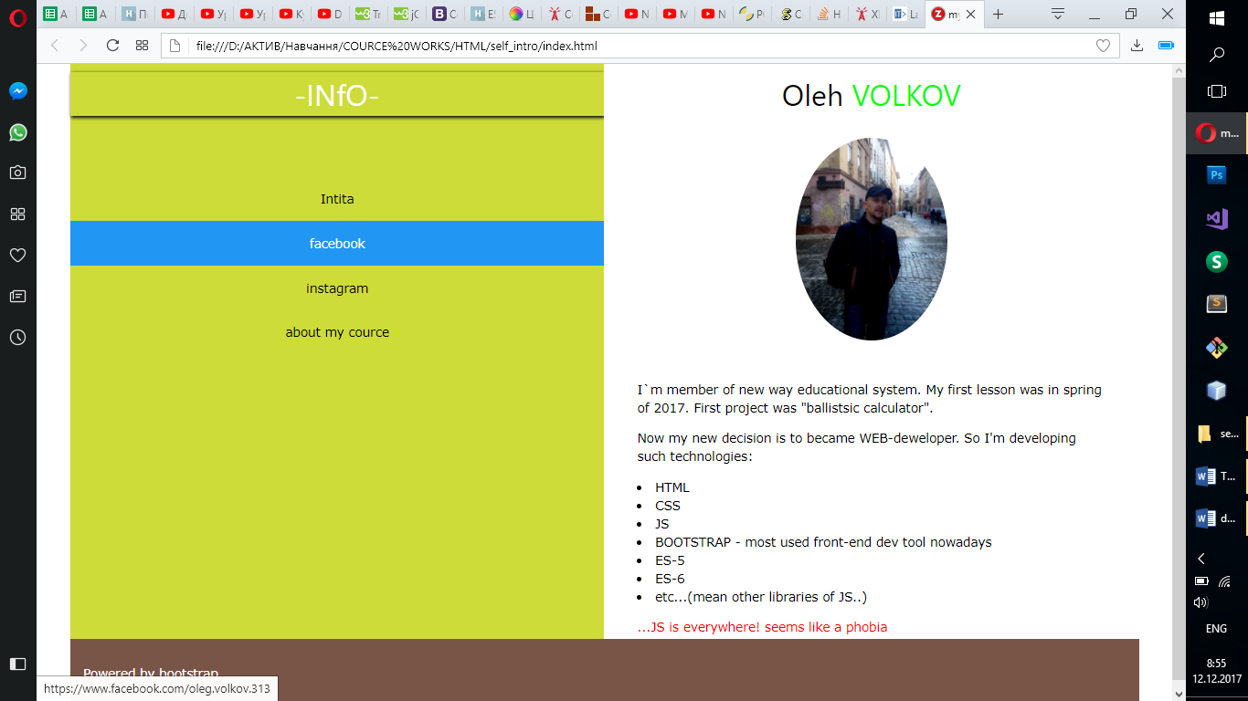

If U will push on “About my course” reference, there will be appearing next page where U will find all other info. Same references of social nets are still present on same places as they were before. Just for ‘pont’ two buttons where implemented.

Button “back to main page” will close current age, other one was made just for test of BOOTSTRAP options for buttons.

On the right side where made list of course subjects and themes for it. This sub menu was made with using java script code. All info where token from Intita web page.

